Simple document

library(tidyverse)

## ── Attaching packages ─────────────────────────────────────── tidyverse 1.3.2 ──  
## ✔ ggplot2 3.3.6 ✔ purrr 0.3.4   
## ✔ tibble 3.1.8 ✔ dplyr 1.0.10  
## ✔ tidyr 1.2.0 ✔ stringr 1.4.1   
## ✔ readr 2.1.2 ✔ forcats 0.5.2   
## ── Conflicts ────────────────────────────────────────── tidyverse_conflicts() ──  
## ✖ dplyr::filter() masks stats::filter()  
## ✖ dplyr::lag() masks stats::lag()

I’m an R Markdown document! Creates a new session everytime you knit. Will add plot in the file.

# Section 1

Here’s a **code chunk** that samples from a *normal distribution*:

samp = rnorm(100)  
length(samp)

## [1] 100

# Section 2

I can take the mean of the sample, too! The mean is -0.0480763.

# Section 3

Going to make a plot. First I generate dataframe and then use ‘ggplot’ to make a scatterplot

plot_df =   
 tibble (  
 x = rnorm(n=1000),  
 y = 1 + 2 * x + rnorm(n=1000)  
 )  
  
  
ggplot(plot_df, aes(x=x, y=y))+ geom_point()

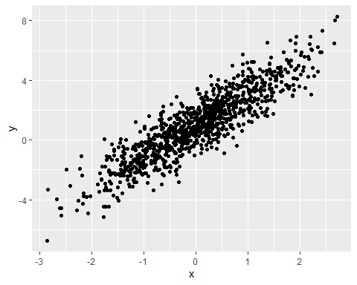

#Section 4

la_df =   
 tibble (  
 norm = rnorm (n = 500, mean = 1),  
 logical = norm > 0,  
 abs_norm = abs(norm)  
 )  
  
ggplot(la_df, aes(x=abs_norm)) + geom_histogram()

## `stat_bin()` using `bins = 30`. Pick better value with `binwidth`.

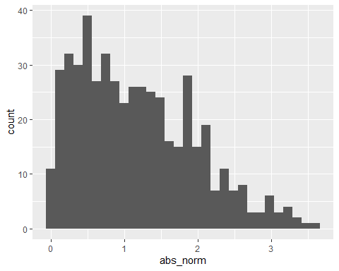

Here’s a list: * list item 1 * list item 2

YAML stands for Yet Another Markup Language