

School of Engineering and Technology, MGM University
Chhatrapati Sambhajinagar
Academic Year 2026–2027
CASE STUDY REPORT
ON
“VEHICLE RENT MANAGEMENT SYSTEM”
Submitted in partial fulfillment of the requirements for
Fifth Semester – B.Tech CSE T.Y. (Regular)
Submitted By
Shivani Pawar – 202456108057
Shital Dhormare – 202456108068
Under the guidance of
Ms. Priyanka Avhad
DEPARTMENT OF COMPUTER SCIENCE AND ENGINEERING

1. Abstract
The Vehicle Rent Management System is a proposed computerized system designed to make vehicle rental activities easier, faster, and more organized. It helps a rental business maintain vehicle details, customer information, bookings, rental duration, payments, and vehicle return records in one place. In a manual system records may be difficult to update and searching for available vehicles can take time. A digital system can reduce paperwork, improve record accuracy, and make it easier to track the status of each vehicle. Authorized staff can register vehicles, manage customer bookings, calculate rental charges, and maintain transaction history. This case study describes the need, proposed workflow, benefits, applications, and future improvements of a Vehicle Rent Management System.
2. Introduction
Vehicle rental services are used by people who need transportation for a short period without purchasing a vehicle. Rental agencies may provide cars, bikes, vans, and other vehicles for personal or business use. Managing these services involves checking vehicle availability, recording customer details, confirming
reservations, calculating charges, and tracking returns. If these tasks are handled manually, they can lead to duplicated bookings, misplaced records, calculation mistakes, and delays. The Vehicle Rent Management system aims to organize these operations through a centralized digital platform. Authorized staff can maintain vehicle and customer records, view booking details, and monitor whether a vehicle is available, booked, or rented. A well-designed system can improve service quality and support more efficient business operations.
3. Course Outcome Integrated
This case study can be connected to course outcomes related to identifying real-world problems, analyzing system requirements, applying computing concepts to propose a solution, organizing data, and communicating technical findings. Add the exact course outcome numbers and official wording according to the course syllabus provided by the institute.
4. Action Plan
The following action plan presents the proposed activities for completing the case study. Dates and responsible team members can be filled in according to the actual project schedule.
Sr.No | Details of Activity | Planned Start Date | Planned Finish Date | Responsible Team Member
 | Study existing rental process |  |  | Shivani/Shital
 | Collect requirements |  |  | Shivani/Shital
 | Prepare workflow and module design |  |  | Shivani/Shital
 | Prepare report |  |  | Shivani/Shital
 | Review and finalize report |  |  | Shivani/Shital

5. Literature Review
Vehicle rental operations commonly require a reliable method to maintain vehicle inventories, customer records, reservations, rental periods, payments, and return information. Manual registers and spreadsheets may be sufficient for very small operations, but they can become difficult to maintain as the number of vehicles and customers increase. A computerized rental management system can bring related records together and provide faster access to current information. A vehicle record may include registration number, model, type, rental rate, and availability status. A booking record may include customer details, selected vehicle, start date, expected return date, and booking status. Payment and return records can support billing and help staff identify overdue rentals. Security measures such as authorized access, data validation, and backups are important to protect business and customer information.
6. Proposed Methodology
The proposed methodology is to study the existing rental process, identify its main problems, list system
requirements, and design a clear workflow for the digital system.
1. Requirement collection: identify the needs of rental staff and customers.
2. Vehicle management: record vehicle details, rental rates, and availability.
3. Customer management: maintain customer contact and required rental information securely.
4. Booking management: check availability and create or update reservations.
5. Rental and return processing: record vehicle handover and return dates, and update vehicle status.
6.Billing: calculate charges based on the rental rate and rental duration, including any applicable additional charges.
7. Testing and review: verify that bookings, calculations, status changes, and records work as expected.
The final technology stack and database design should be selected according to project requirements and the tools taught in the course.
7. Implementation
A possible implementation can include the following modules: • Admin / Staff Login: allows authorized users to access management features.
• Vehicle Module: adds, edits, searches, and updates vehicle records.
• Customer Module: stores and retrieves customer information.
• Booking Module: records reservations and checks whether a vehicle is available for the selected dates.
• Rental Module: records issue and return details.
• Payment Module: calculates the rental amount and records payment status.

• ReportsModule: provides summaries of available vehicles, active rentals, completed bookings, and payments. A database can store vehicle, customer, booking, rental, and payment information in related
c
CODE
8. Output of Case Study
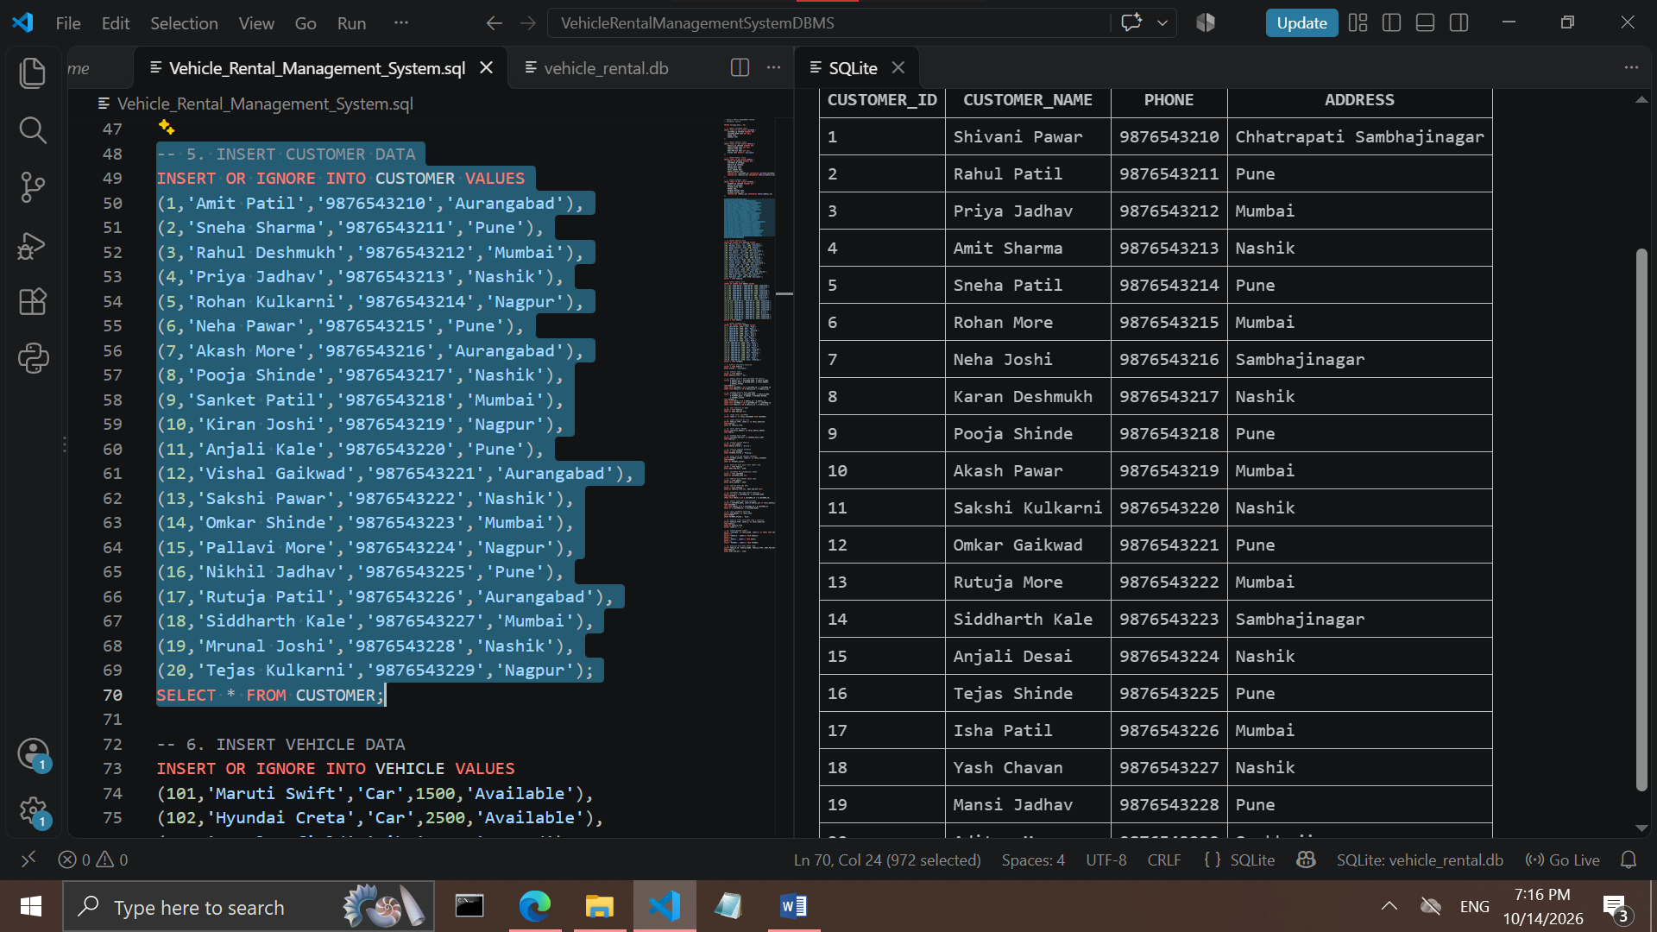
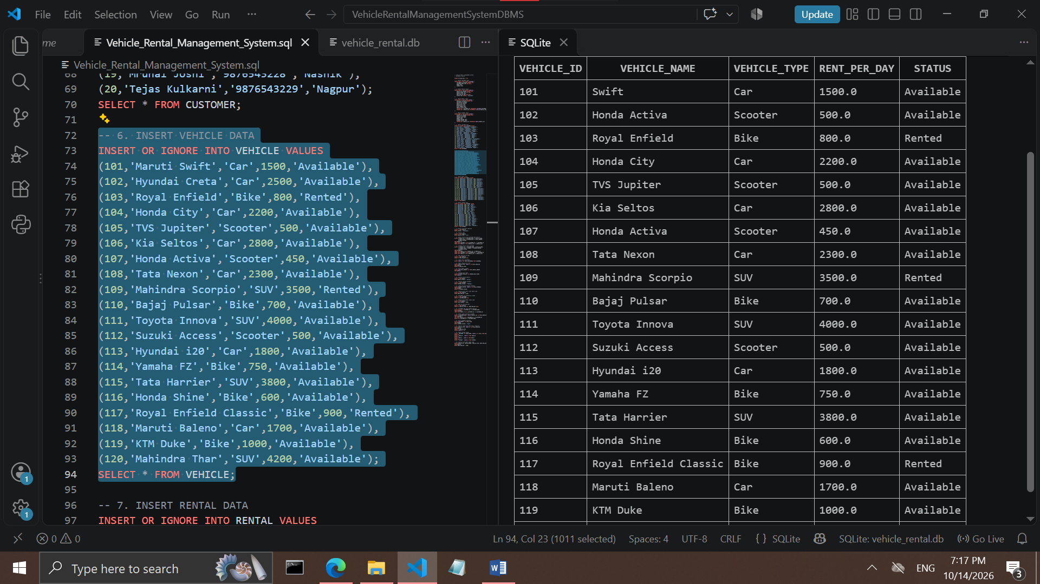
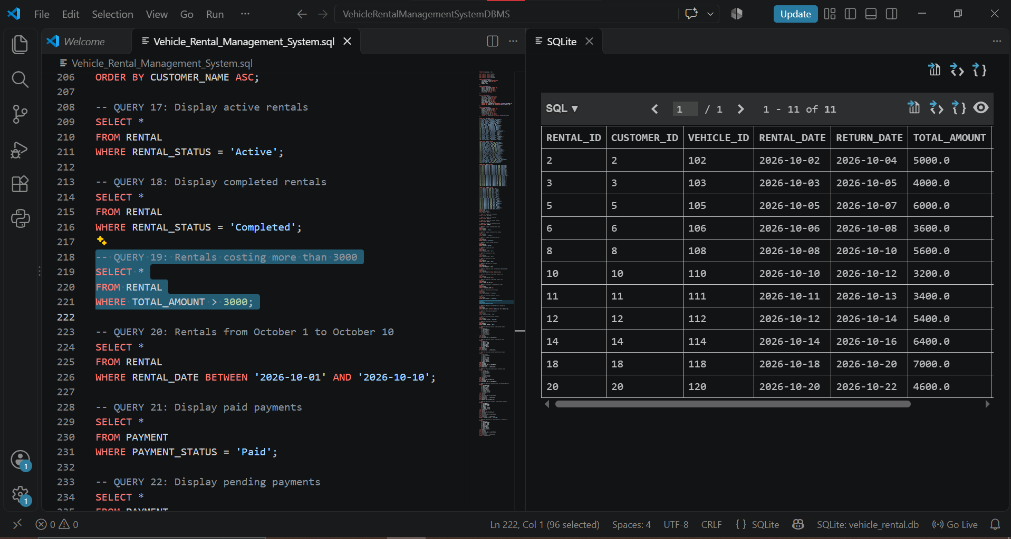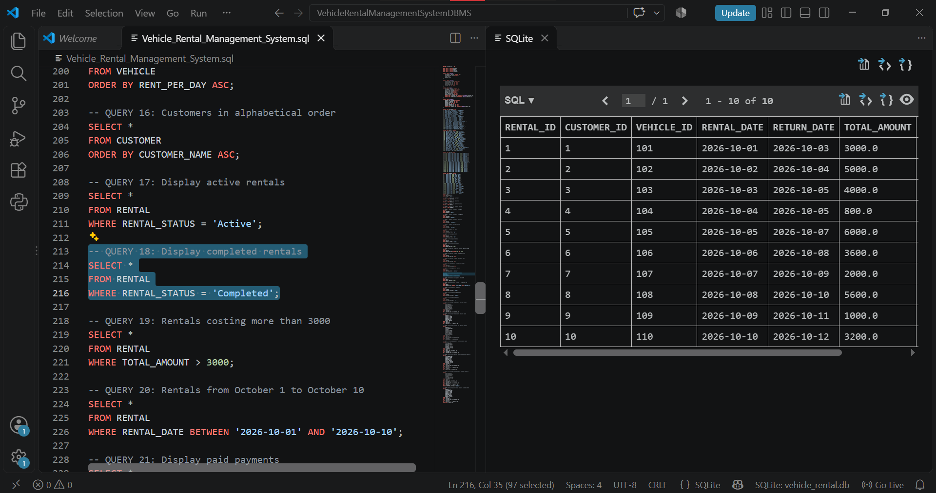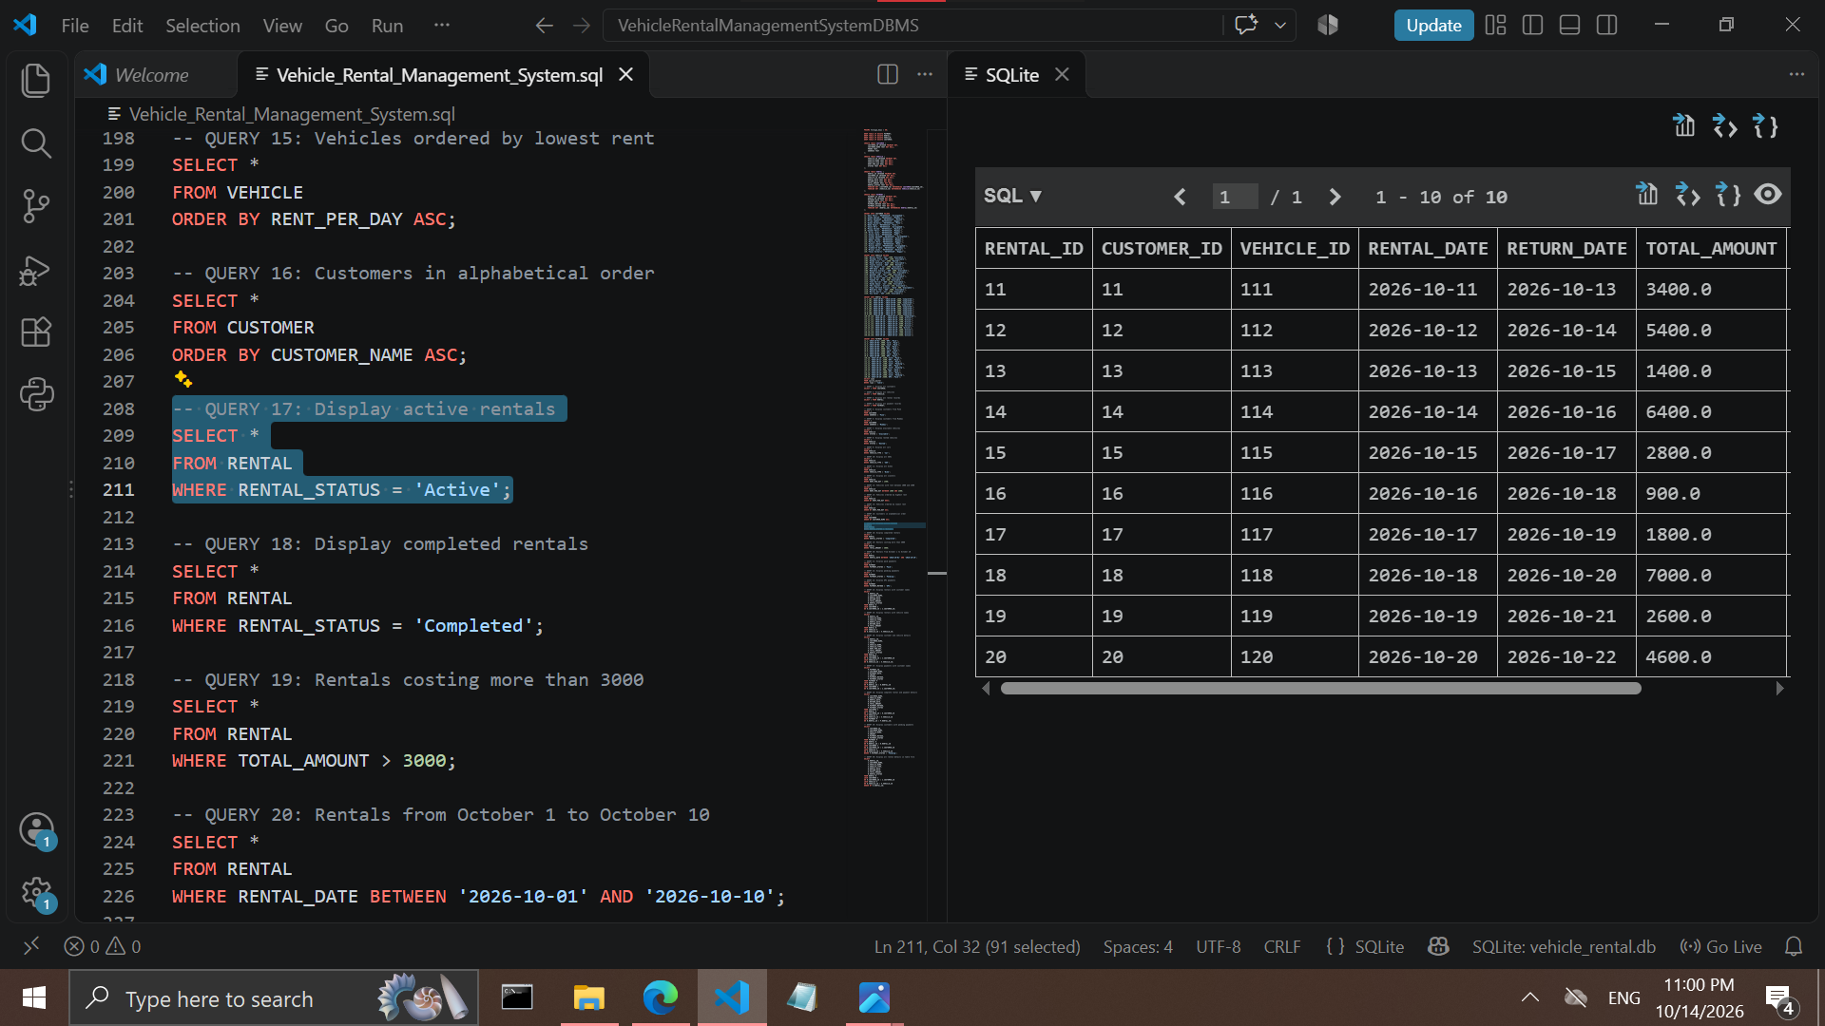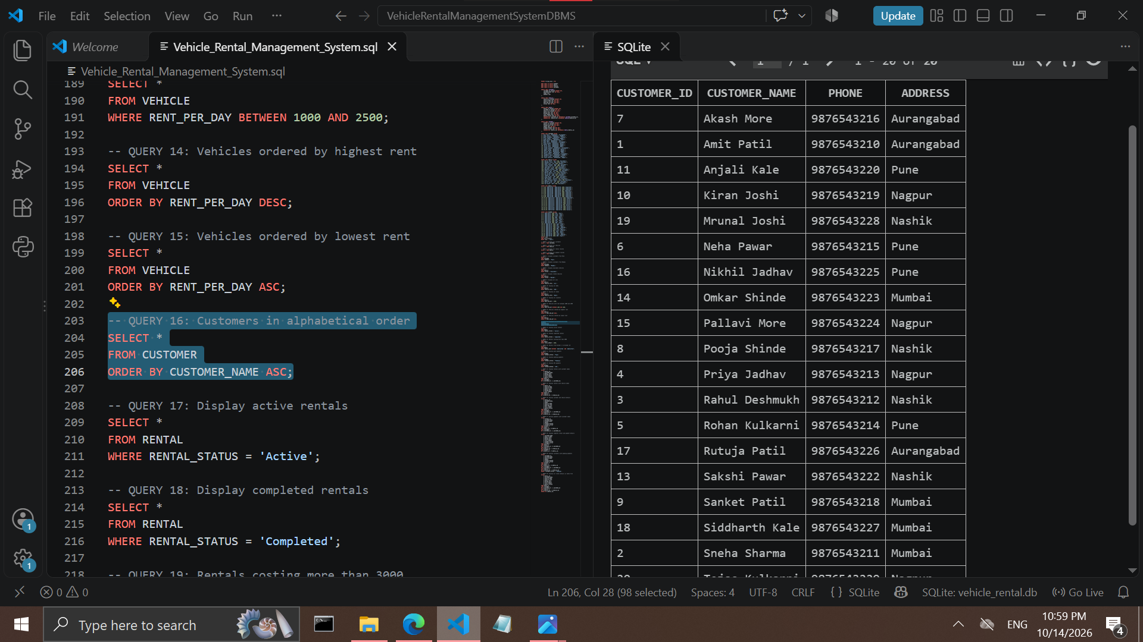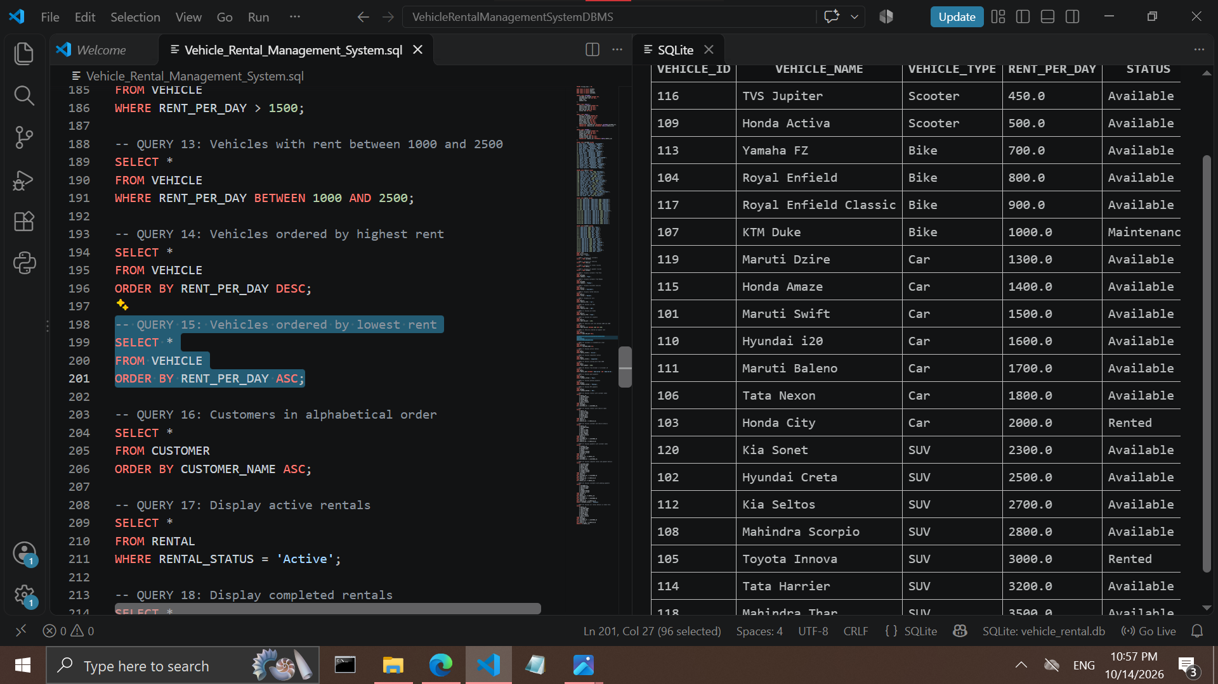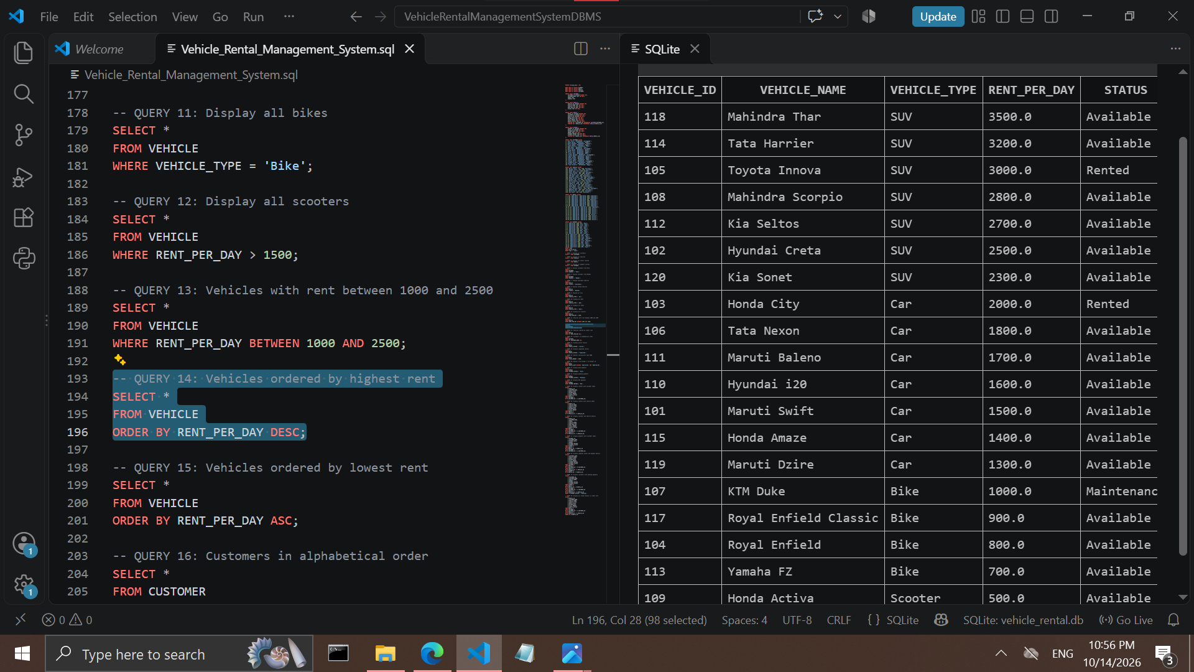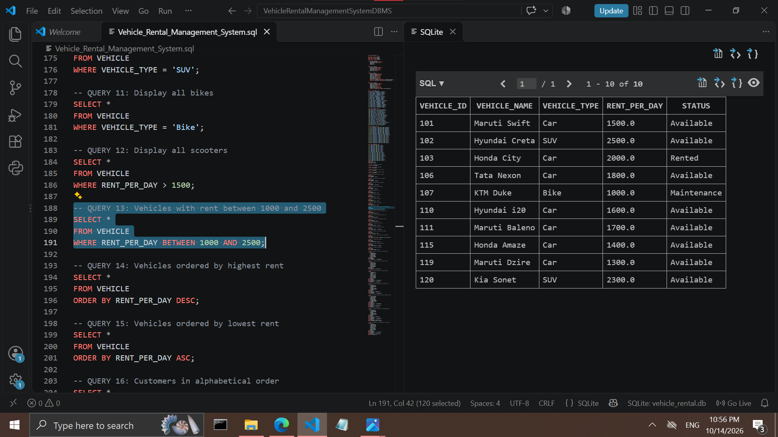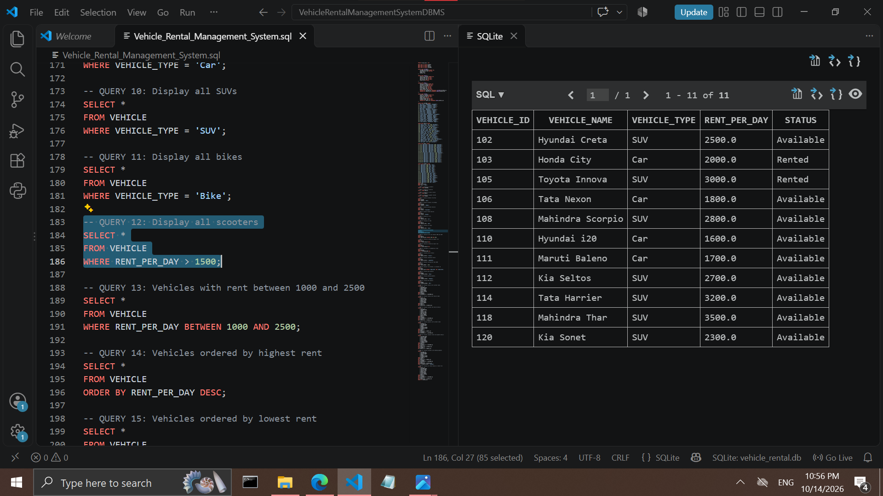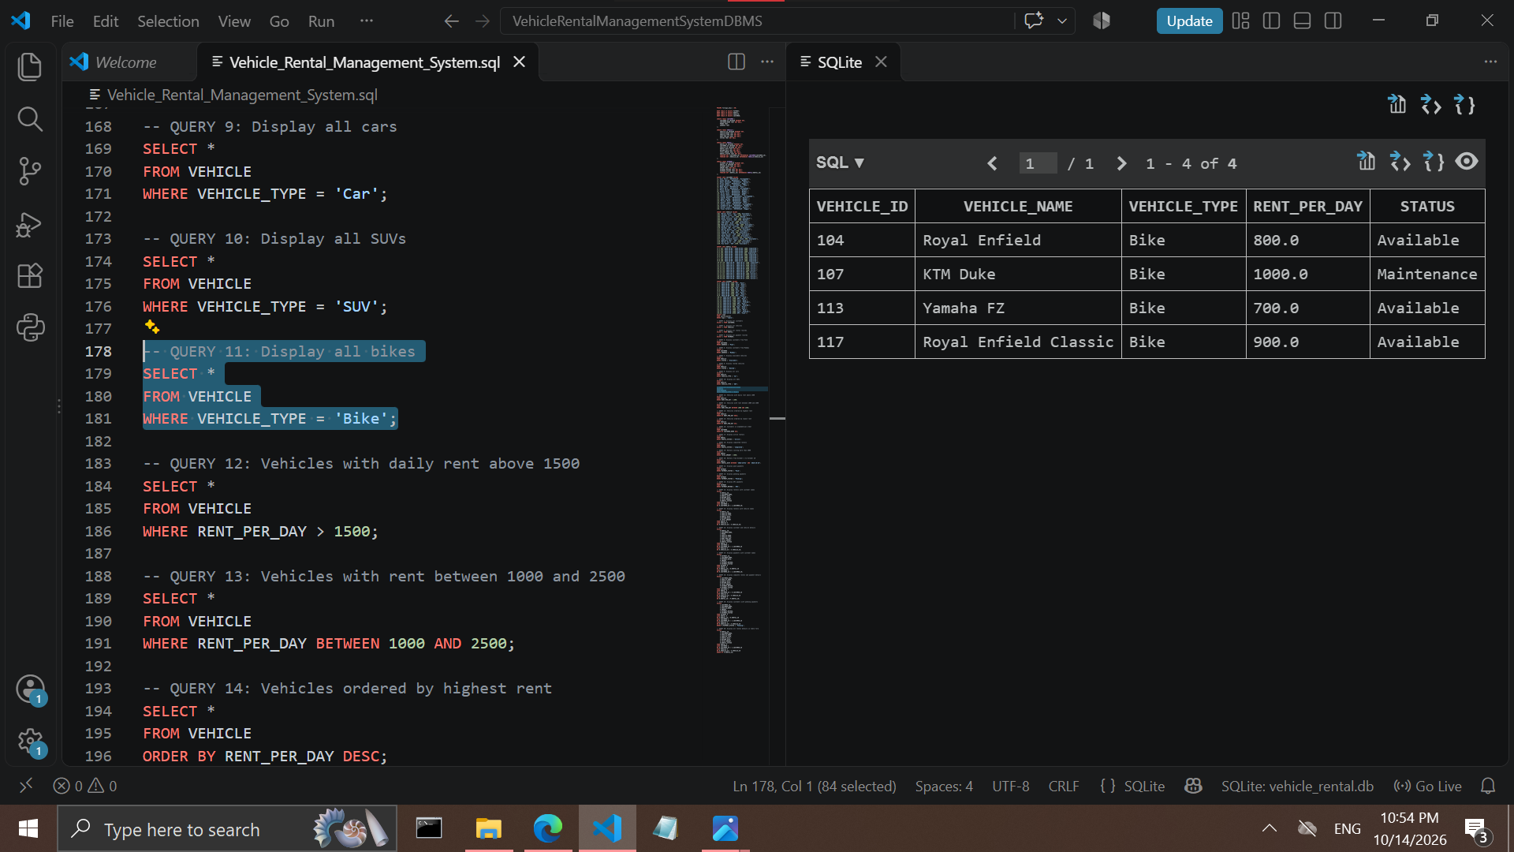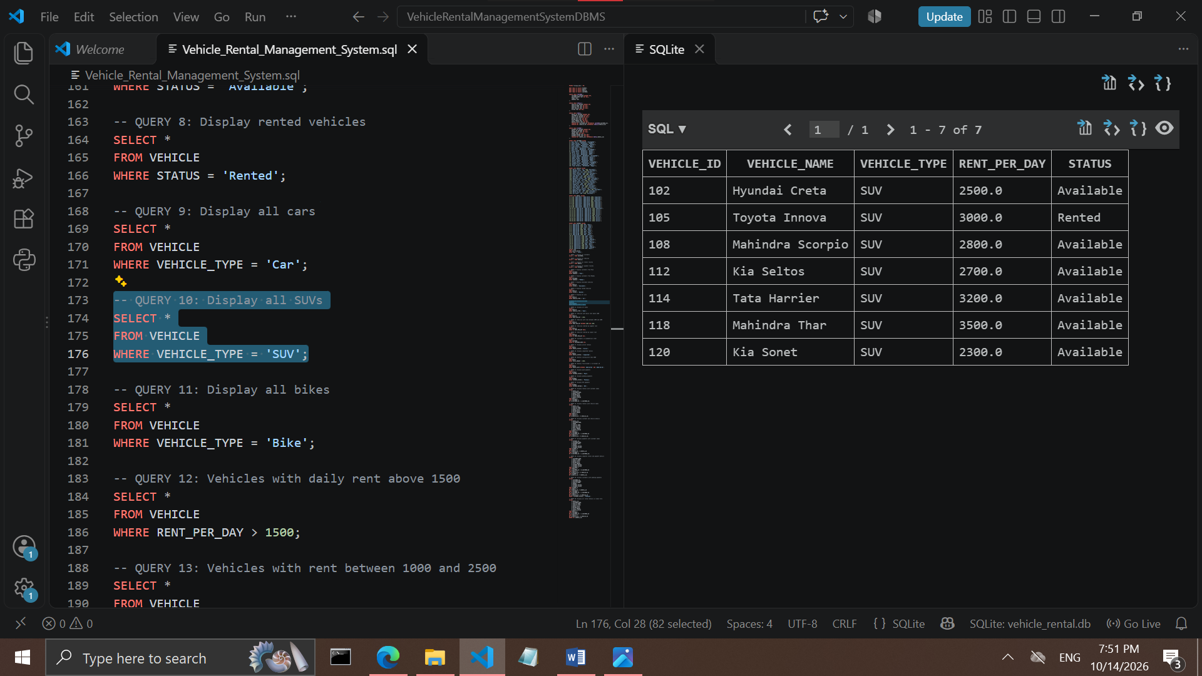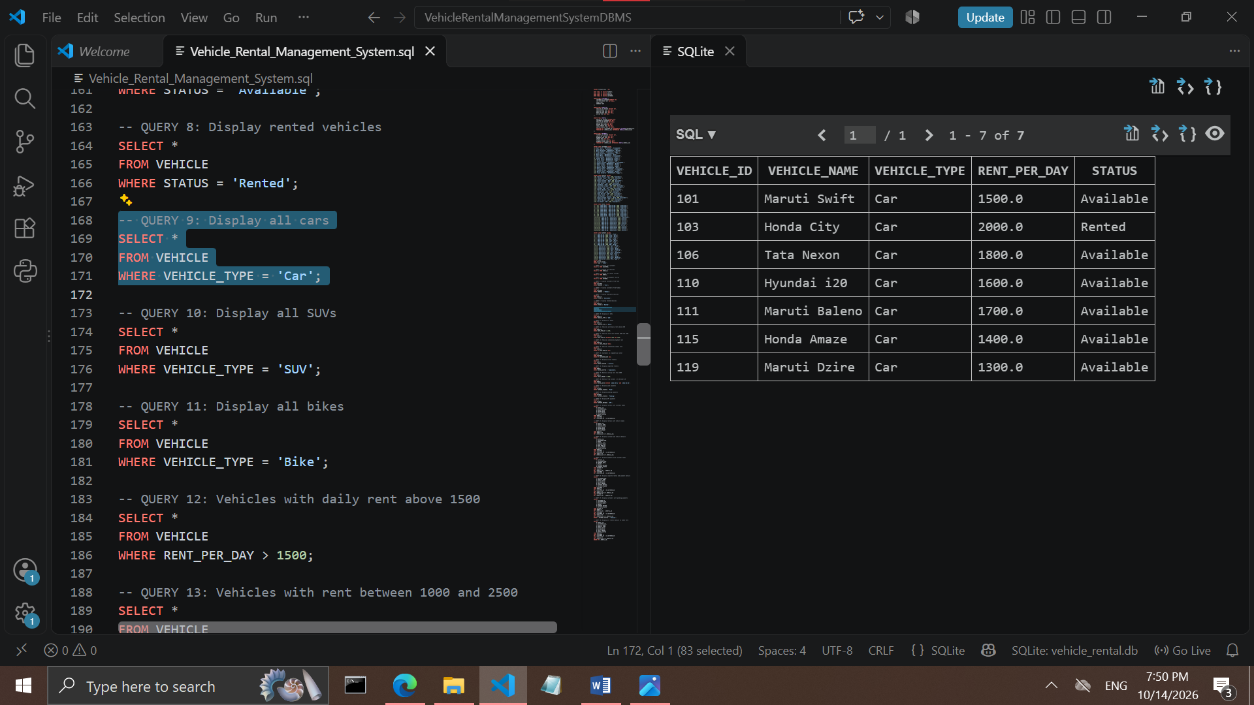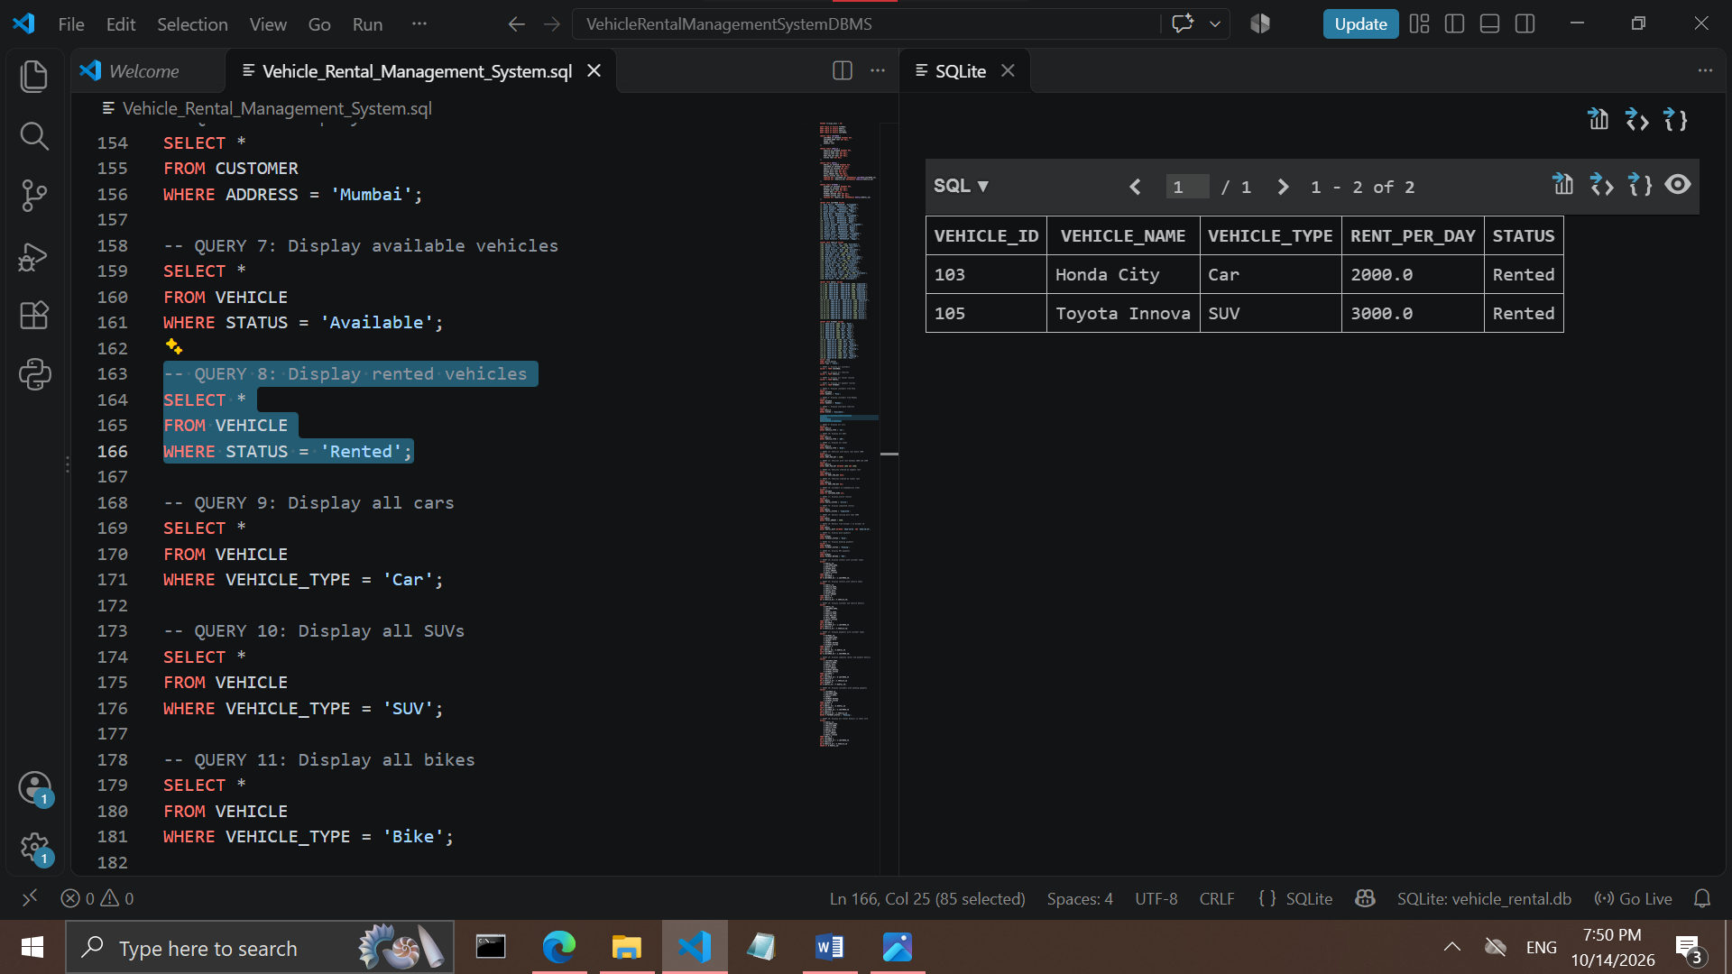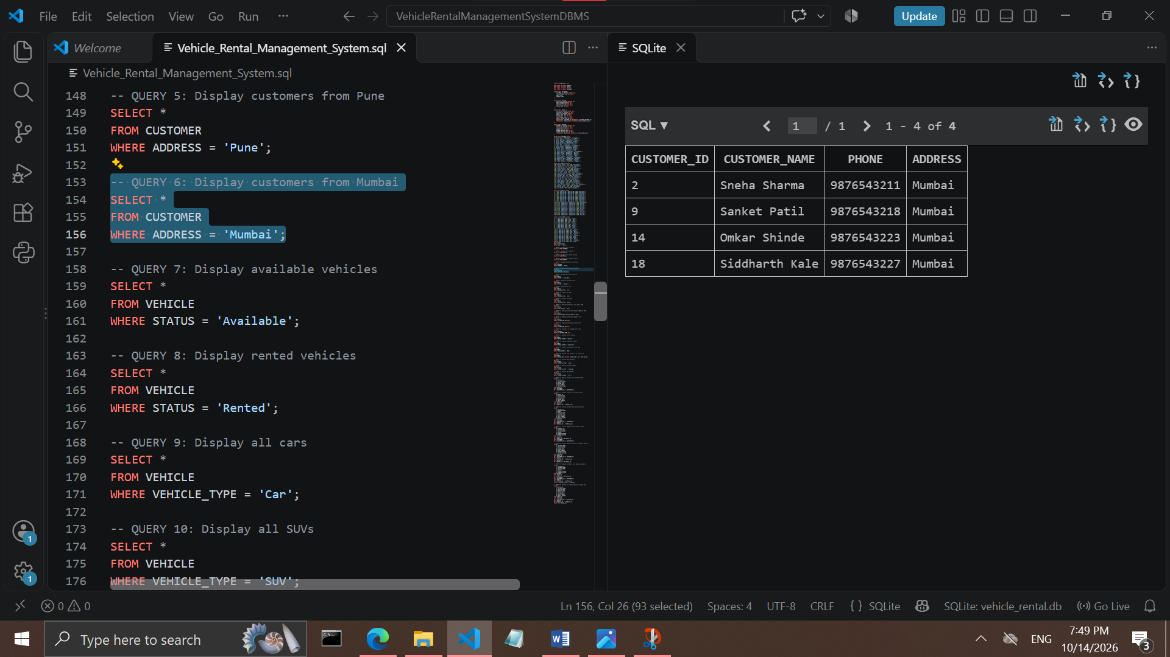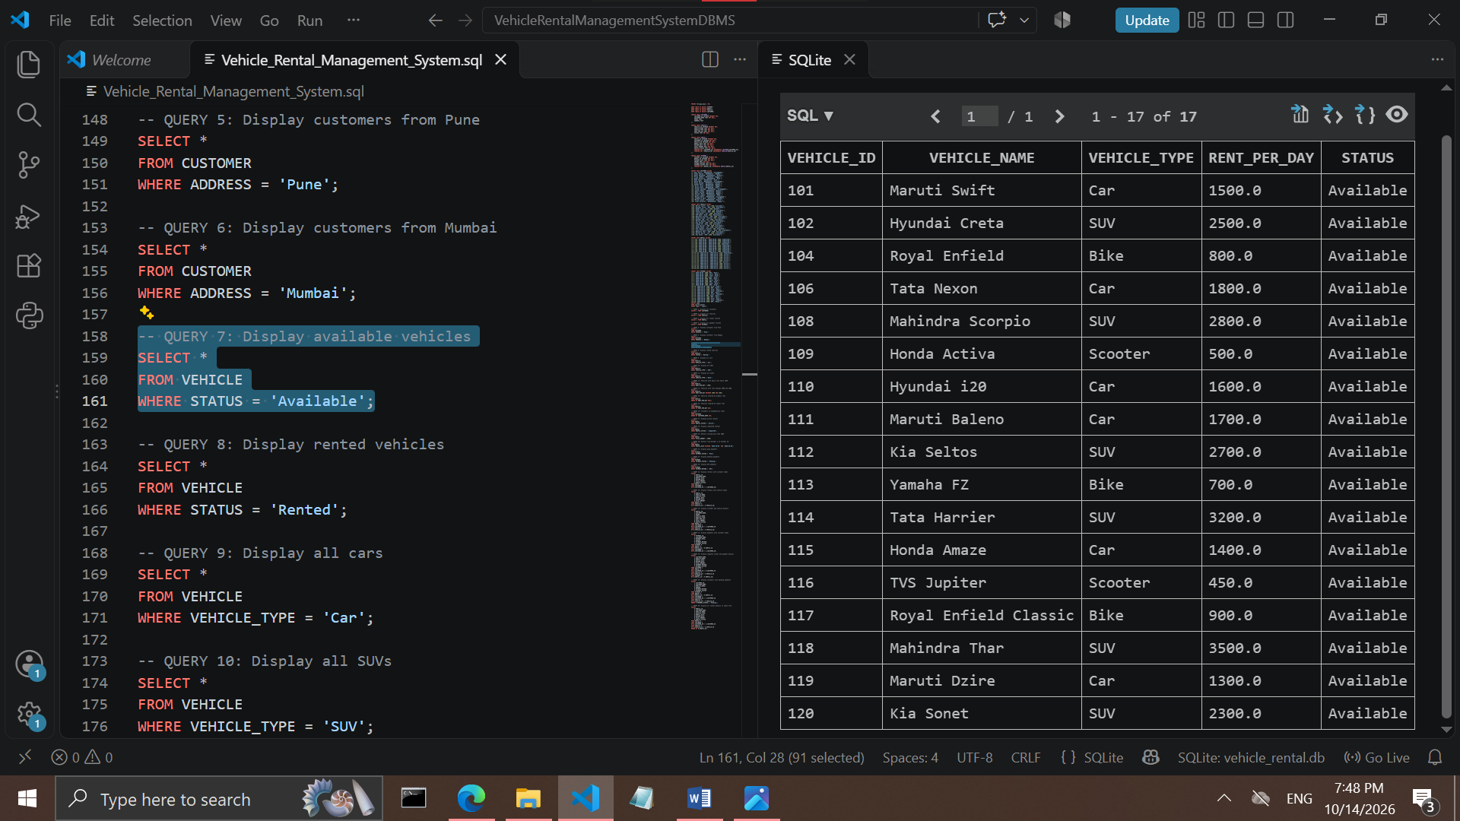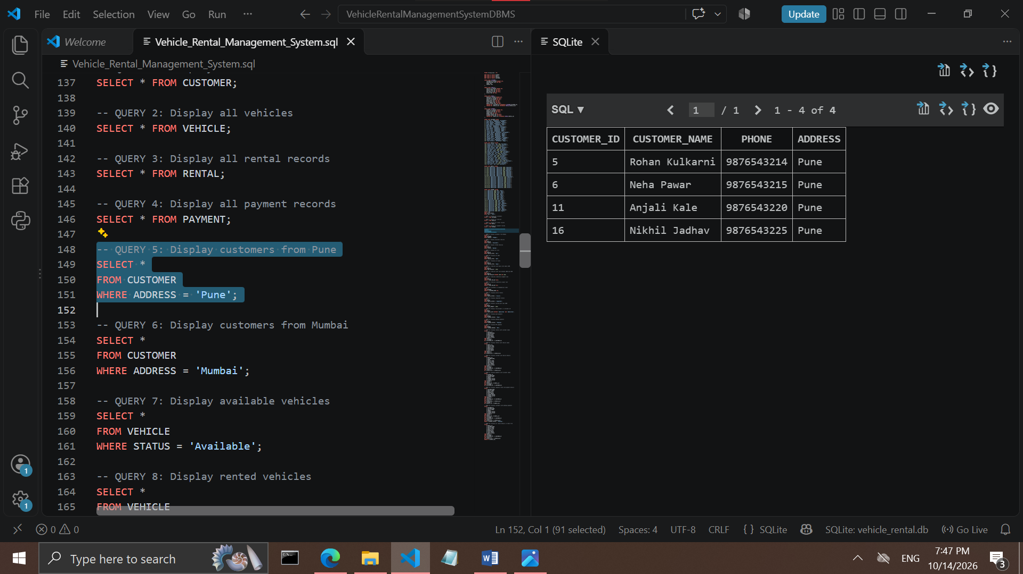

9. Skills Developed / Learning Outcomes
This case study supports learning in problem identification, requirement analysis, workflow design, data organization, and technical report writing. It also develops an understanding of how software systems can address practical business problems. Students can learn to divide a system into modules, consider data accuracy and security, and evaluate the usefulness of a proposed digital solution.
10. Applications of this Case Study
The Vehicle Rent Management System can be applied in car rental agencies, bike and scooter rental services,travel and tourism businesses, corporate vehicle rental services, and local vehicle hire businesses. With suitable changes, the system can support different vehicle categories and different rental policies.
11. Area of Future Improvement
Future versions may include online customer booking, mobile-friendly access, automated booking confirmations, digital payment integration, document verification, GPS-based vehicle tracking, maintenance reminders, and notifications for upcoming or overdue returns. Analytics could help managers understand vehicle demand and rental trends. Any use of customer documents, location information, or payment details should follow appropriate privacy and security practices.
12. Conclusion
The Vehicle Rent Management System is a useful proposed solution for organizing the main operations of a vehicle rental business. By maintaining vehicle, customer, booking, rental, return, and payment records in a centralized system, it can improve access to information and reduce dependence on manual paperwork. The case study demonstrates how a software-based approach can help make rental operations more organized and efficient. The system’s final effectiveness would need to be assessed through implementation and testing against the actual requirements of a rental business.

