**Gamma-ray bursts (GRB)**

**History**

For over three decades GRB has cherished the faith and unshakeable trust of its customers. It has now evolved from a ghee manufacturing entity to a multi-product, multi-brand company. GRB has become synonymous with ‘Purity’ in the Indian market and over the years it has built a reputation and legacy for authentic traditional taste. With a world-wide distribution and sales network, backed by a team of dedicated and skilled professionals, GRB is all set to become a global leader in their product range.

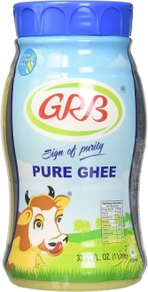The seeds of the iconic ghee brands "GRB" & "Udhayam" that are synonymous with purity, unique granulation and homemade taste were sown in the year 1984 by Mr. G.R. Balasubramaniam, a born genius with exceptional product knowledge and business Mr. G.R. Balasubramaniam's staunch belief in delivering only the high quality products to the consumers with clean business ethics was the foundation of GRB's market success. Today GRB stands as the industry benchmark for quality and clean business practices.

GRB has been cherishing the faith and unshakeable trust of its customers for well over three decades and has now blossomed from a just a ghee manufacturing entity to a multi-product, multi-brand company.

GRB Global

GRB is engaged in the export and supply of its entire range of products. All GRB products are highly accepted and savored across the globe for its quality and taste.

The marketing team at GRB is dedicated to understanding the current trend and helping in offering good quality packaging that is suitable for the global market. Under the able supervision of the leadership team, GRB has emerged as a trustworthy business entity in the competitive global market. GRB has attained the market credibility not only because of its excellent products but also its good business practices.Gamma-ray bursts were first observed in the late 1960s by the U.S. Vela satellites, which were built to detect gamma radiation pulses emitted by nuclear weapons tested in space. The United States suspected that the Soviet Union might attempt to conduct secret nuclear tests after signing the Nuclear Test Ban Treaty in 1963.[15] On July 2, 1967, at 14:19 UTC, the Vela 4 and Vela 3 satellites detected a flash of gamma radiation unlike any known nuclear weapons signature.[16] Uncertain what had happened but not considering the matter particularly urgent, the team at the Los Alamos National Laboratory, led by Ray Klebesadel, filed the data away for investigation. As additional Vela satellites were launched with better instruments, the Los Alamos team continued to find inexplicable gamma-ray bursts in their data. By analyzing the different arrival times of the bursts as detected by different satellites, the team was able to determine rough estimates for the sky positions of 16 bursts[16][17] and definitively rule out a terrestrial or solar origin. Contrary to popular belief, the data was never classified.[18] After thorough analysis, the findings were published in 1973 as an Astrophysical Journal article entitled “Observations of Gamma-Ray Bursts of Cosmic Origin”.

Most early hypotheses of gamma-ray bursts posited nearby sources within the Milky Way Galaxy. From 1991, the Compton Gamma Ray Observatory (CGRO) and its Burst and Transient Source Explorer (BATSE) instrument, an extremely sensitive gamma-ray detector, provided data that showed the distribution of GRBs is isotropic – not biased towards any particular direction in space.[19] If the sources were from within our own galaxy, they would be strongly concentrated in or near the galactic plane. The absence of any such pattern in the case of GRBs provided strong evidence that gamma-ray bursts must come from beyond the Milky Way.[20][21][22][23] However, some Milky Way models are still consistent with an isotropic distribution.[20][24]

Bisibelebhath powder

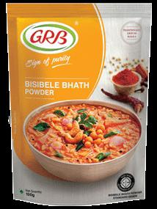Gamma-ray bursts (GRBs) are immensely energetic explosions that have been observed in distant galaxies, described by NASA as “the most powerful class of explosions in the universe”.[1] They are the most energetic and luminous electromagnetic events since the Big Bang.[2] Bursts can last from ten milliseconds to several hours.[3][4] After an initial flash of gamma rays, a longer-lived “afterglow” is usually emitted at longer wavelengths (X-ray, ultraviolet, optical, infrared, microwave and radio).

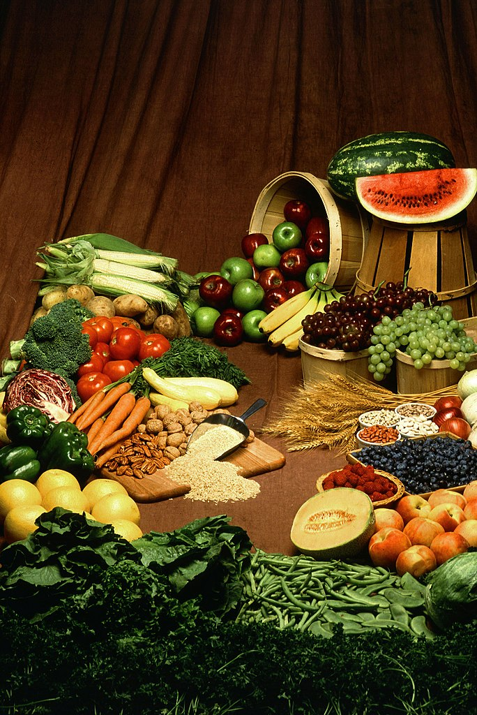*The sources of most GRBs are billions of light years away from Earth, implying that the explosions are both extremely energetic (a typical burst releases as much energy in a few seconds as the Sun will in its entire 10-billion-year lifetime)[7] and extremely rare (a few per galaxy per million years[8]). All observed GRBs have originated from outside the Milky Way galaxy, although a related class of phenomena, soft gamma repeaters, are associated with magnetars within the Milky Way. It has been hypothesized that a gamma-ray burst in the Milky Way, pointing directly towards the Earth, could cause a mass extinction event.[9] The Late Ordovician mass extinction has been hypothesised by some researchers to have occurred as a result of such a gamma-ray burst.*

*GRBs were first detected in 1967 by the Vela satellites, which had been designed to detect covert nuclear weapons tests; after thorough analysis, this was published in 1973.[13] Following their discovery, hundreds of theoretical models were proposed to explain these bursts, such as collisions between comets and neutron stars.[14] Little information was available to verify these models until the 1997 detection of the first X-ray and optical afterglows and direct measurement of their redshifts using optical spectroscopy, and thus their distances and energy outputs. These discoveries, and subsequent studies of the galaxies and supernovae associated with the bursts, clarified the distance and luminosity of GRBs, definitively placing them in distant galaxies.The Italian–Dutch satellite BeppoSAX, launched in April 1996, provided the first accurate positions of gamma-ray bursts, allowing follow-up observations and identification of the sources.*

*Several models for the origin of gamma-ray bursts postulated that the initial burst of gamma rays should be followed by afterglow: slowly fading emission at longer wavelengths created by collisions between the burst ejecta and interstellar gas.[29] Early searches for this afterglow were unsuccessful, largely because it is difficult to observe a burst’s position at longer wavelengths immediately after the initial burst. The breakthrough came in February 1997 when the satellite BeppoSAX detected a gamma-ray burst (GRB 970228[nb 2]) and when the X-ray camera was pointed towards the direction from which the burst had originated, it detected fading X-ray emission. The William Herschel Telescope identified a fading optical counterpart 20 hours after the burst.[30] Once the GRB faded, deep imaging was able to identify a faint, distant host galaxy at the location of the GRB as pinpointed by the optical afterglow.[31][32]*

*Indian food includes an array of healthy spices, due to which the dishes are cooked in a multitude of ways that help retain their nutrients. GRB’s commitmThe ent to excellence and its vision of providing best quality products is unwavering.*

*company takes pride in its three decades old conviction to provide Purity, Taste & Quality. To fulfil this vision, GRB has been continuously investing in state-of-the-art infrastructure for manufacturing, producing, storing, transportation, training professional staff and knowledge sourcing.*

*GRB takes enormous care right from sourcing raw materials to testing, processing to production and packaging to branding…at every step quality is ensured with seamless perfection.*

* *glow After*
* *Because of the very faint luminosity of this galaxy, its exact distance was not measured for several years. Well after then, another major breakthrough occurred with the next event registered by BeppoSAX, GRB 970508. This event was localized within four hours of its discovery, allowing research teams to begin making observations much sooner than any previous burst. The spectrum of the object revealed a redshift of z = 0.835, placing the burst at a distance of roughly 6 billion light years from Earth.[33] This was the first accurate determination of the distance to a GRB, and together with the discovery of the host galaxy of 970228 proved that GRBs occur in extremely distant galaxies.[31][34] Within a few months, the controversy about the distance scale ended: GRBs were extragalactic events originating within faint galaxies at enormous distances. The following year, GRB 980425 was followed within a day by a bright supernova (SN 1998bw), coincident in location, indicating a clear connection between GRBs and the deaths of very massive stars. This burst provided the first strong clue about the nature of the systems that produce GRB*
* *GRB STUIDES*
* *Studios*
* *Company type Privately held company*
* *Industry*
* *Film production*
* *Television production*
* *Founded 1986; 38 years ago*
* *Founder*
* *Gary R. Benz*
* *Michael Branton*
* *Headquarters Sherman Oaks, California, United States*
* *Area served Worldwide*
* *Key people Gary R. Benz (CEO)*
* *Products*
* *Motion pictures*
* *Television programs*
* *Division*
* *ADVANCEGES*

*GRB is a comprehensive commercial retirement benefits calculator platform that is web- based with capabilities to accurately compute various complex estimates needed in assisting employees with their retirement decisions.*

*Aardvark Post Aim / Vision / Mission VISION To manufacture and market the highest quality odairy products and to delight the customer with a promise of consistent taste and purity. MISSION To make the company products available across all major Indian markets by 2010 and to make GRB a national icon for ghee.*

***About G R B Dairy Foods Private Limited***

*GRB Dairy Foods Private Limited was established in 1984 with a vision to manufacture and market the highest quality of dairy products that constantly delights the customers with a promise of consistent taste and purity.*

*The company markets its ghee under the brand names GRB and Udhayam in Karnataka and Tamilnadu. From a humble beginning, GRB has today blossomed into a private limited company with a multi-crore turnover, and strives to make its presence felt across the nation at the cusp of the next decade.*

*Indian food includes an array of healthy spices, due to which the dishes are cooked in a multitude of ways that help retain their nutrients. GRB’s commitment to excellence and its vision of providing best quality products is unwavering.*

*GRB had humble beginnings, and has progressed into a fully grown multi-brand company with the dedicated vision and foresight of its founder.*

*Mr. G.R.Balasubramaniam, Founder & Chairman*

*GRB’ & ‘Udhayam’ are two brands that have carved a niche in the dairy foods market and have become synonymous with purity, a unique granulated texture and unimpeachable homemade taste. These brands are the brain child of Mr. G.R. Balasubramaniam, a visionary with exceptional product knowledge and business acumen.*

*Mr. GRB, as he is fondly called, founded GRB Dairy Foods Private Limited and built this internationally renowned brand from scratch. Today, his empire is present across the globe. His conviction and zeal for continuous quality improvement and growth is infectious and continues to push the boundaries on quality and taste.*

*Mr. B. Dhanraj, Executive Director*

*Mr. Dhanraj is the Head – Sales & Marketing Operations at GRB. He has completed his Masters’ Degree in International Business from London South Bank University, UK.*

*With entrepreneurship running in his veins, Dhanraj has played a pivotal role in the new initiatives of the company like the ‘Instant Mixes’.*

*His vision and innovation are clearly visible in the Expansion of Business, Branding and Advertising initiatives.*

*Mr. Balakarthik is the Head – Production Operations at GRB. He has completed his Master’s Degree in Food Processing Engineering from Illinois Institute of Technology, Chicago.*

*He is an enterprising person and is dedicated to constantly improving the operational progress of various product lines at GRB.*

*He has been actively involved in the new Instant Mixes Business, which includes more than 20 different product lines.*

*About us*

*GRB DAIRY FOODS PVT. LTD., an ISO 22000 company, is a leading food processing company based in India, manufacturing dairy products, Instant mixes, Spices, Snacks, and Indian desserts. We have a strong presence in India and also exporting to USA, Australia, Germany, Middle-East, Singapore and many other countries. We have 5 state-of-the-art manufacturing facilities in Hosur, Tamil Nadu. We have the top quality credentials. GRB was started as a SME with primary focus on Ghee; it has now progressed to a fully grown multi-product company with the dedicated vision and foresight of its founders. GRB has become synonymous with ‘Purity’ in the Indian market and over the years, GRB has built a reputation & legacy for authentic traditional taste. Staying in-line with the vision of providing the best Indian cuisine, GRB has ventured into a wide range of instant, ready-to-cook and ready-to-eat food mixes, in vibrant and youthful packaging; a pure blend of the age-old culinary values with futuristic trends. With a wide network, backed by a team of dedicated and skilled professionals, GRB is all set to become a global leader in their product range. For over three decades GRB has cherished the faith and unshakeable trust of its customers. It has now evolved from a ghee manufacturing entity to a multi-product, multi-brand company.*

*GRB has become synonymous with ‘Purity’ in the Indian market and over the years it has built a reputation and legacy for authentic traditional taste. With a world-wide distribution and sales network, backed by a team of dedicated and skilled professionals, GRB is all set to become a global leader in their product range*

*Bout us*

*Categories*

*Reviews*

*Fact Sheet*

*Nature of Business*

*Manufacturer*

*Company CEO*

*Mohan*

*Legal Status of Firm*

*Limited Company (Ltd./Pvt.Ltd.)*

*Annual Turnover*

*Rs. 100 – 500 Crore*

*GST No.*

*33AACCG0136G1Z8*

*CIN No.*

*U15201TZ2001PTC009698*

*Contact Details*

*GRB Dairy Foods Pvt. Ltd.*

*Mohan*

*B-1, Phase 1 & 2, SIDCO Industrial Estate*

*SIDCO Industrial Estate*

*Hosur – 635126*

*Tamil Nadu, India*

*Get Directions*

*Call Now*

*Contact Seller*

*About Us*

*GRB was started as a SME with primary focus on Ghee; it has now progressed to a fully grown multi-product company with the dedicated vision and foresight of its founders. GRB has become synonymous with ‘Purity’ in the Indian market and over the years, GRB has built a reputation & legacy for authentic traditional taste. Staying in-line with the vision of providing the best Indian cuisine, GRB has ventured into a wide range of instant, ready-to-cook and ready-to-eat food mixes, in vibrant and youthful packaging; a pure blend of the age-old culinary values with futuristic trends. With a wide network, backed by a team of dedicated and skilled professionals, GRB is all set to become a global leader in their product range.*

*Our Infrastructure*

*GRB’s commitment to excellence and its vision of providing best quality products is unwavering. The company takes pride in its three decade old conviction to provide Purity, Taste & Quality.*

*To fulfil this vision, GRB has been continuously investing in state-of-the-art infrastructure for manufacturing, production, storage and transport process, trained and professional staff and knowledge sourcing. GRB takes enormous care right from the sourcing raw materials to testing, processing to production and packaging to branding… at every step quality is ensured with seamless perfection.*

*GRB – Healthy & Tasty all the way*

*GRB GulabJamun is a favourite Indian dessert, which is famous with everyone. It is a melt-in-the-mouth sweet and the correct combination to end a luxurious meal. It is a sweet dumpling prepared of khova, deep-fried and served in sugar syrup. It is a wonderful dessert for all occasions.*

*Gulabjamun (also spelled gulaabjamun; lit. ’Rose water berry’ or ‘Rose berry’) is a sweet confectionary or dessert, originating in the Indian subcontinent and a type of mithai popular in India, Pakistan, Nepal, the Maldives (where it is known as gulabkijanu), and Bangladesh, as well as Myanmar. It is also common in nations with substantial populations of people with South Asian heritage, such as Mauritius, Fiji, Gulf states, the Malay Peninsula, Great Britain, South Africa, and the Caribbean countries of Jamaica, Trinidad and Tobago, Guyana, and Suriname.*

*Gulab jamuna*

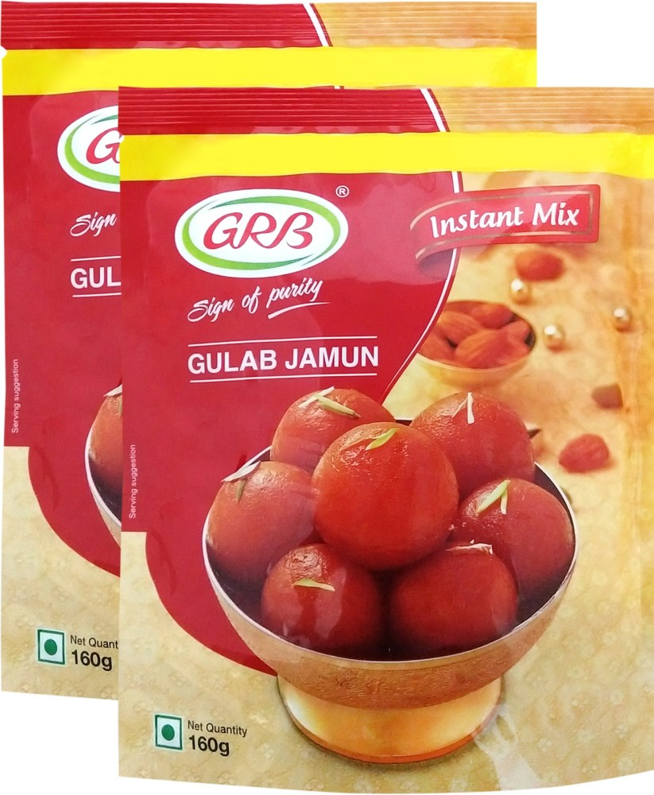

*Gulabjamun topped with almond slivers*

*Alternative names Gulabjaman, LalGulab jam, Gulapjaman*

*Course Dessert*

*Region or state Indian subcontinent, Mauritius, Fiji, southern and eastern Africa, the Caribbean, the Malay Peninsula*

*Serving temperature Hot, cold or at room temperature*