FYND × NMIMS HYDERABAD · CHALLENGE C14
Hackathon Three-Track Implementation Roadmap
FollowThru — from empty repo to judged demo
Team repo: github.com/shivv-14/followthru
Planning window: 17:00 IST 17 Oct → 08:00 IST 18 Oct 2026 (team target)
Version: 1.0 — 17 Oct 2026
Companion: Complete Solution Blueprint · Prompt Playbook (P01–P27)

FollowThru — Chase what's late. Never what's done.

Contents

If the contents list is empty, right-click it in Word and choose Update Field.

1. Purpose and Planning Assumptions
This roadmap turns the Hackathon Complete Solution Blueprint into an executable plan. It uses the same features, priorities and architecture, and maps every build step to a prompt in the FollowThru Prompt Playbook (P01–P27).
Assumption | Value | Status
Hackathon duration | 24 hours (stated by the team) | Team-provided; confirm with organisers
Submission target | 08:00 IST, Sunday 18 Oct 2026 | Team target, not an official deadline from the brief — task 0.01 confirms
Plan start | 17:00 IST, Saturday 17 Oct 2026 | Setup tasks 0.02–0.03 already done
People | Shiva (only developer), Member B (UI review, device testing), Member C (research, QA, demo) | Confirmed by the team
Machines | Laptop A and Laptop B, each with Claude Code (Claude Pro) | Confirmed
Usage limits | A Claude session may pause; the other laptop continues with the CONTINUE prompt | Risk R3
Cost | Free tools only (Vercel Hobby, GitHub, PWABuilder, open-source libraries) | Confirmed

If the official deadline is later than 08:00, keep the plan and use the extra time as buffer for Phase 4 testing — do not add new features.

1.1 How to read this roadmap
- Tasks have IDs like 2.06 (phase 2, task 06). The task table is the single list of work.
- Tracks are workstreams; each task has one owner and one laptop. Shared work names a single owner.
- Milestones M1–M7 are go/no-go gates. IC1, IC2 are integration checkpoints inside phases.
- Prompts (P01–P27) are in the Prompt Playbook; the laptop column here supersedes the playbook where they differ (P12 and P13 move to Laptop B to balance load).

2. The Three Tracks
Track | Scope (adapted to C14) | Human owner | Laptop | Key outputs
T1 — Frontend, UI/UX, user experience | Design system, 3D landing, shell and profiles, dashboard, detail with time travel, queue and recipient review UI, team and member pages, evidence/data/audit pages, polish, client-side error states | Shiva (driver); Member B (reviewer, device tester) | B until merge, then A + B | All screens; mock-data UI before engine; responsive and accessible app
T2 — Backend, data, APIs, infrastructure | Repo, CLAUDE.md, types contract, Zod validation, CSV/JSON, task actions and permissions, IndexedDB storage and audit, REST API, PWA, security checks, deploy, APK, repo hygiene, submission | Shiva | A (contract, API, PWA, deploy); B (tasks, storage, security, APK) | Contract, validated data, persistence, API, live link, APK
T3 — Intelligence, data, testing, demo | Fixture analysis, deadline/timezone engine, extraction, linking, resolver, queue, product change, flows, evaluation and evidence, optional AI, UAT, growth experiment, docs, demo and claims audit | Shiva (engine); Member C (research, UAT, demo) | A (engine); Member C's devices | Scorecard, tests, starting/final evidence, growth log, rehearsed demo

2.1 Shared interfaces and single owners
Shared item | Owner | Supporting | Rule
src/engine/types.ts (contract) | T2 | T1, T3 | Changes announced and pushed first; others pull before continuing
Mock EngineResult | T1 | T2 | Must typecheck against the contract; removed from production paths
Store hooks API | T2 | T1 | Components never call Dexie directly
Evidence folder | T3 | T2 | Only scripts write to evidence/; never hand-edited
CLAUDE.md | T2 | All | Single source of rules for both Claude sessions
Demo script and deck | T3 | T1 | Claims must match evidence files

3. Phase Overview
Phase | Window (IST) | Goal | Ends with
Phase 0 — Problem validation and kickoff | 17:00–18:00 | Brief confirmed, project scaffolded, fixture understood, outreach started | M1
Phase 1 — Foundation and parallel setup | 18:00–19:30 | Contract and validation, time engine, design system, mock data | M2
Phase 2 — Core feature development | 19:30–00:00 | Engine complete with evidence and product change; UI shell and 3D landing; storage, tasks, API | M3
Phase 3 — Integration and functional completion | 00:00–03:00 | Merge; real-data dashboard, detail, queue, team and evidence pages | M4
Phase 4 — Testing, risk reduction, refinement | 03:00–05:00 | Fixes, PWA, polish, security, UAT; feature freeze | M5
Phase 5 — Deployment and demo preparation | 05:00–06:45 | Live link, APK, screenshots, docs, rehearsed demo | M6
Phase 6 — Final submission and judge readiness | 06:45–08:00 | Release check, claims audit, submission | M7

4. Detailed Task Tables
One table per phase. Rows are grouped by track (T1 Frontend/UI, T2 Backend/infra, T3 Intelligence/testing/demo). Effort is an estimate of Claude Code execution plus checking time. Status is for live tracking — update it in Word or copy the table to a sheet.

4.1 Phase 0 — Problem validation and kickoff (17:00–18:00 IST)
ID | Ph | Track | Task | Description | Priority | Effort | Depends | Owner @ laptop | Inputs | Output | Acceptance criteria | Verification | Risk | Status
0.07 | 0 | T1 | Laptop B setup | Clone, git identity, execution policy, settings.json, git checkout -b ui, npm install, Claude login | Must | 0.5 h | 0.04 | Shiva @B | Repo URL | Laptop B on branch ui | npm run dev works on B; branch pushed | git branch -vv | Low | Not started
0.08 | 0 | T1 | Motion moodboard | Collect 6 screenshots/notes of scroll and 3D ideas from scrolltide.co and threeui.com (feel only, no copying) | Could | 0.3 h | – | Member B | Reference sites | docs/moodboard.md with images | 6 references with one-line notes | Shiva review | Low | Not started
0.02 | 0 | T2 | Repo and local environment | Public repo shivv-14/followthru, clone outside OneDrive, git identity, PowerShell execution policy | Must | 0.5 h | – | Shiva @A | GitHub account | Working clone at C:\Users\shiva\projects\followthru | git push works; npm -v works | Terminal check | Low | Done
0.03 | 0 | T2 | Claude Code setup, no co-author | Log in to Claude Code in VS Code; includeCoAuthoredBy: false in ~/.claude/settings.json | Must | 0.15 h | 0.02 | Shiva @A | Claude Pro | Configured settings.json | First commit has no Co-Authored-By line | git log -1 | Med | Done
0.04 | 0 | T2 | P01 project scaffold | Vite + React + TS strict, all libraries, folders, scripts, Vitest | Must | 0.25 h | 0.03 | Shiva @A | Playbook P01 | Running project, 3 commits | npm run dev, npm test, npm run build pass | Terminal output | Low | In progress
0.05 | 0 | T2 | P02 CLAUDE.md project memory | Rules, scoring, golden rules, stack, design language, git rules | Must | 0.1 h | 0.04 | Shiva @A | Playbook P02 | CLAUDE.md | File on GitHub; content matches playbook | Open on GitHub | Low | Not started
0.01 | 0 | T3 | Confirm brief and deadline | Re-read the C14 brief; confirm official submission time, demo length and format with organisers; record in docs/brief-notes.md | Must | 0.25 h | – | Member C | C14 brief | docs/brief-notes.md | Official deadline and demo format written down (or 'not provided') | Note reviewed by Shiva | Low | Not started
0.06 | 0 | T3 | P03 fixture notes | Copy fixture to data/; Claude documents fields, people, timezones, labels, evaluation clock, edge-case catalogue | Must | 0.4 h | 0.05 | Shiva @A | Starter_Data/C14/fixture.json | docs/fixture-notes.md | Lists labelled commitments and every edge case with message ids | Shiva reads summary; shares with Claude chat | High | Not started
0.09 | 0 | T3 | Outreach list | List 15–20 coordinators / team leads / project leads reachable tonight; send the script from the Business Case | Must | 0.5 h | – | Member C | Business Case §11 script | Contact list (roles only) + messages sent | ≥ 15 messages sent by 18:30 | Screenshot of sent list (private) | High | Not started

4.2 Phase 1 — Foundation and parallel setup (18:00–19:30 IST)
ID | Ph | Track | Task | Description | Priority | Effort | Depends | Owner @ laptop | Inputs | Output | Acceptance criteria | Verification | Risk | Status
1.03 | 1 | T1 | P15 design system + 3D stage | Tokens, base components, motion presets, Stage canvas with fallback, /styleguide | Must | 0.7 h | 0.07 | Shiva @B | CLAUDE.md design language | src/styles, src/components/ui, src/three/Stage.tsx | Style guide renders on laptop and phone | Visual check via --host | Med | Not started
1.04 | 1 | T1 | Mock EngineResult for UI | Pull main into ui; create src/mocks/engineResult.ts typed from types.ts (fake but valid data) so UI can be built before the engine | Must | 0.2 h | 1.01 | Shiva @B | types.ts | Typed mock file | Typechecks; used only behind a useMock flag | npm run typecheck | Low | Not started
1.01 | 1 | T2 | P04 types contract + validation + CSV | types.ts (shared contract), Zod schema, validateFixture issues, CSV import/export, tests | Must | 0.6 h | 0.06 | Shiva @A | fixture-notes.md | src/engine/types.ts, src/schema/* | Real fixture 0 errors; broken copies give expected codes; CSV round-trip | npm test | Med | Not started
1.05 | 1 | T2 | Integration rules | Add to CLAUDE.md: folder ownership per laptop, branch policy, 'git pull --rebase first', merge time | Must | 0.1 h | 0.05 | Shiva @A | Roadmap §5 | CLAUDE.md section 'Two laptops' | Both laptops pull it | git log | Low | Not started
1.02 | 1 | T3 | P05 time engine | parseDeadline in speaker timezone, tentative detection, isOverdue, formatting | Must | 0.6 h | 1.01 | Shiva @A | Edge-case catalogue | src/engine/time.ts + 25 tests | IST vs PT, DST, 'maybe Friday' tests pass | npm test | Med | Not started
1.06 | 1 | T3 | Interview script and log | Prepare 5 questions + growth-experiment log sheet (Business Case §11); define 'useful' result | Must | 0.3 h | 0.09 | Member C | Business Case | Sheet with 10 empty rows | Columns match docs/growth-experiment.md | Shiva review | Low | Not started

4.3 Phase 2 — Core feature development (19:30–00:00 IST)
ID | Ph | Track | Task | Description | Priority | Effort | Depends | Owner @ laptop | Inputs | Output | Acceptance criteria | Verification | Risk | Status
2.09 | 2 | T1 | P16 3D landing story | Scroll-driven scene: chaos → scan → status orbits → queue; text sections; fallback | Should | 1.25 h | 1.03 | Shiva @B | Design system | src/pages/Landing.tsx, src/three/StoryScene.tsx | Smooth on laptop; usable on mid-range phone; fallback readable | Member B phone test | Med | Not started
2.10 | 2 | T1 | P17 shell, setup, profiles | Routes, setup screen, profile picker, role nav, layouts, command palette | Must | 0.6 h | 2.09 | Shiva @B | Mock data | Shell + routes | Fresh browser shows setup; nav changes by role | Incognito test | Low | Not started
2.14 | 2 | T1 | Landing device test | Test landing on 2 phones (Android + iPhone if available); report lag/overflow | Should | 0.3 h | 2.09 | Member B | Network URL | Bug list | Issues filed in docs/ui-bugs.md | Screenshots | Low | Not started
2.08 | 2 | T2 | P14 REST API | health, process, evidence endpoints, vercel.json rewrite, tests, docs/api.md | Should | 0.4 h | 2.03 | Shiva @A | runEngine | api/*.ts | 200/422/405 tests pass | npm test | Low | Not started
2.11 | 2 | T2 | P12 task actions + permissions | Pull main into ui first. Manual tasks as commitments, team fan-out, member/coordinator actions with audit objects | Should | 0.65 h | 2.02 | Shiva @B | Engine resolver on main | src/engine/tasks.ts | Member cannot approve own work; approve suppresses draft | npm test | Med | Not started
2.12 | 2 | T2 | P13 storage + audit + evidence files | Dexie tables, repositories, recompute preserving human decisions, audit, SHA-256 uploads, seed | Must | 0.65 h | 2.11 | Shiva @B | Engine + tasks | src/store/* | Refresh keeps data; audit for each action; store tests pass | npm test | Med | Not started
2.01 | 2 | T3 | P06 signals and extraction | Rule signals (commit, request, accept, delegate, done, not done, deadline change, defer, cancel, blocker); deterministic commitment ids | Must | 0.75 h | 1.02 | Shiva @A | fixture-notes | src/engine/signals.ts, extract.ts | One test per signal with real messages; requests without acceptance create nothing | npm test | High | Not started
2.02 | 2 | T3 | P07 linking + history resolver | Cross-thread linking with ambiguity → review; replay events; owner, deadline, status, responseState | Must | 1.0 h | 2.01 | Shiva @A | Edge-case catalogue | src/engine/link.ts, resolve.ts, index.ts | All edge-case describe blocks pass | npm test + printed table | High | Not started
2.03 | 2 | T3 | P08 idempotent queue + suppression | ≤1 draft per commitment, in-place versioning, suppression ledger, templates | Must | 0.7 h | 2.02 | Shiva @A | Resolver output | src/engine/queue.ts, templates.ts | Scoring B and C tests pass | npm test | Med | Not started
2.04 | 2 | T3 | P09 evaluation + starting state | evaluate.ts, npm run evidence, scorecard; save evidence/starting_state with flags off | Must | 0.6 h | 2.03 | Shiva @A | Fixture labels | evidence/latest/scorecard.md, evidence/starting_state/ | Scorecard generated; failures diagnosed before continuing | Open scorecard | High | Not started
2.05 | 2 | T3 | IC1 scorecard checkpoint (~22:30) | Integration checkpoint: decide whether to spend time fixing engine before P10 | Must | 0.1 h | 2.04 | Shiva @A | Scorecard | Go/fix decision noted | Decision recorded in docs/release-check.md draft | SCORECARD CHECK prompt | High | Not started
2.06 | 2 | T3 | P10 stale suppression + recipient review | Scope doc first, freshness check, recipient warnings, approve gate, draft actions, tests, final evidence | Must | 0.85 h | 2.05 | Shiva @A | starting_state | docs/product-change.md, stale.ts, recipient.ts, evidence/final/ | AC1–AC5 tests pass; before/after README written | npm test; files on GitHub | Med | Not started
2.07 | 2 | T3 | P11 follow-up flows | Default flows, pickFlow, stages update same draft, validateFlow | Should | 0.5 h | 2.06 | Shiva @A | Queue | src/engine/flows.ts | Stage change keeps one draft (test) | npm test | Low | Not started
2.13 | 2 | T3 | Run interviews | Show 2–3 example drafts per person; record role, response, would-send, useful | Must | 3 h (elapsed) | 1.06 | Member C | Interview script | ≥ 6 filled log rows by 00:00 | Rows marked Observed | Shiva spot-check | High | Not started

4.4 Phase 3 — Integration and functional completion (00:00–03:00 IST)
ID | Ph | Track | Task | Description | Priority | Effort | Depends | Owner @ laptop | Inputs | Output | Acceptance criteria | Verification | Risk | Status
3.02 | 3 | T1 | P18 dashboard + commitments | KPIs, attention list, status ring, timeline, team health, table + filters on live store data | Must | 0.85 h | 3.01 | Shiva @A | Store hooks | Dashboard.tsx, Commitments.tsx | Numbers equal scorecard counts | Compare with scorecard | Med | Not started
3.03 | 3 | T1 | P19 detail, Why?, time travel | Header, Why? panel, evidence timeline, slider re-running engine, actions | Should | 0.75 h | 3.02 | Shiva @A | Pure engine | CommitmentDetail.tsx | Slider shows overdue → draft → suppressed for completion-elsewhere case | Manual + screenshot | Med | Not started
3.04 | 3 | T1 | P20 queue, recipient review, flows UI | Lanes, freshness chip, recipient gate, edit/approve/reject, suppressed lane, before/after toggle, flow editor | Must | 0.9 h | 3.02 | Shiva @A | Draft actions | Queue.tsx, RecipientReview.tsx, Flows.tsx | Approve disabled until recipient confirmed; stale draft suppressed | Manual + screenshot | Med | Not started
3.05 | 3 | T1 | P21 team + member workspace | Assign task sheet, submissions inbox, blockers; My tasks, submit with files | Should | 0.75 h | 3.01 | Shiva @B | Store + tasks | Team.tsx, Me.tsx | Assign → submit → approve flow works with audit entries | Profile-switch test | Med | Not started
3.06 | 3 | T1 | P22 evidence, data, audit pages | Scorecard view, runs, uploads, import/export, audit diff | Must | 0.65 h | 3.05 | Shiva @B | Evidence files | Evidence.tsx, Data.tsx, Audit.tsx | Upload shows time + hash + audit entry; CSV export downloads | Manual | Low | Not started
3.01 | 3 | T2 | Merge ui → main | MERGE prompt on Laptop A; union dependencies; keep both sides; tests + build | Must | 0.5 h | 2.07, 2.10, 2.12 | Shiva @A | Both branches pushed | main contains UI + engine + store | test, typecheck, build pass | CI-style local run | High | Not started
3.07 | 3 | T3 | IC2 end-to-end journey check (~02:00) | Run the six journeys in Blueprint §4.2 on the dev build; log failures | Must | 0.5 h | 3.04 | Member C | Journeys list | docs/uat-log.md | All Must journeys pass or have a fix owner | Checklist | Med | Not started
3.08 | 3 | T3 | Scorecard re-run after merge | SCORECARD CHECK prompt; confirm no regression | Must | 0.15 h | 3.01 | Shiva @A | main | evidence/latest updated | Same or better than IC1 | Scorecard | Med | Not started
3.09 | 3 | T3 | Growth log interim summary | Count useful / correct / would-send so far; note top rejection reasons | Must | 0.3 h | 2.13 | Member C | Log | Summary paragraph (Observed) | Numbers match rows | Shiva review | Low | Not started

4.5 Phase 4 — Testing, risk reduction, refinement (03:00–05:00 IST)
ID | Ph | Track | Task | Description | Priority | Effort | Depends | Owner @ laptop | Inputs | Output | Acceptance criteria | Verification | Risk | Status
4.08 | 4 | All | Feature freeze (05:00) | No new features after 05:00; only fixes, docs, deploy | Must | – | 4.03 | Shiva | – | Freeze announced | No feature commits after 05:00 | git log | Low | Not started
4.02 | 4 | T1 | P25 polish pass | Responsive at 6 widths, accessibility, performance splits, skeletons, error boundaries | Must | 0.75 h | 4.01 | Shiva @A | UAT log, UI bugs | Small fix commits | No horizontal scroll; focus visible; build passes | Device checks | Med | Not started
4.01 | 4 | T2 | P24 PWA | Logo/icons, manifest, service worker, install button, offline banner | Should | 0.5 h | 3.01 | Shiva @A | Built app | Installable PWA | Install icon appears; offline reload works | Chrome + phone | Low | Not started
4.04 | 4 | T2 | Security checks | CSV injection test, upload allow-list, 2 MB API limit, npm audit, key grep, headers in vercel.json | Must | 0.6 h | 3.06 | Shiva @B | Blueprint §13 | Fix commits + notes | Checks in §13 table done | Tests + npm audit | Med | Not started
4.03 | 4 | T3 | Fix critical defects | Use FIX prompt for every failing journey or test; no new features | Must | 0.5 h | 3.07 | Shiva @A | uat-log | Fix commits | All P1 tests pass | npm test | High | Not started
4.05 | 4 | T3 | P23 optional AI mode | Gemini extractor with Zod output and labelled fallback (skip if behind) | Could | 0.6 h | 3.01 | Shiva @B | API key (optional) | src/engine/ai/* | No key → 'Mode: Rules'; tests with mocked fetch pass | npm test | Low | Not started
4.06 | 4 | T3 | UAT on phones | Member B and C repeat journeys on Android and iPhone; record issues | Must | 1 h | 4.02 | Member B + C | Dev URL | Updated uat-log | No blocker left open | Checklist | Med | Not started
4.07 | 4 | T3 | Growth log final summary | Finalise 10 rows (or honest smaller n), summary, what changed because of feedback | Must | 0.4 h | 3.09 | Member C | Log | docs/growth-experiment.md filled | Every number traceable to a row | Shiva review | Med | Not started

4.6 Phase 5 — Deployment and demo preparation (05:00–06:45 IST)
ID | Ph | Track | Task | Description | Priority | Effort | Depends | Owner @ laptop | Inputs | Output | Acceptance criteria | Verification | Risk | Status
5.06 | 5 | T1 | Live visual pass | Member B checks the live site on phones and laptop; last small fixes | Should | 0.4 h | 5.01 | Member B | Live URL | Fix list (small) | No visual blocker | Screenshots | Low | Not started
5.01 | 5 | T2 | Deploy on Vercel | Import repo, Vite preset, deploy, rename domain, check /api/health, update README link | Must | 0.3 h | 4.08 | Shiva @A | GitHub repo | Live URL | Live link works in incognito phone browser | Manual | Med | Not started
5.02 | 5 | T2 | Android APK | PWABuilder package, assetlinks.json, GitHub Release v1.0.0 with APK | Should | 0.4 h | 5.01 | Shiva @B | Live URL | APK + release | APK installs and opens full-screen | Android phone | Med | Not started
5.03 | 5 | T3 | P26 screenshots + docs | Playwright screenshots, README, architecture, pilot plan, growth log doc | Must | 0.75 h | 5.01 | Shiva @A | Live/preview build | evidence/screenshots/<ts>/, README | Screenshots timestamped; README links work | GitHub view | Low | Not started
5.04 | 5 | T3 | Update deck and business numbers | Slide 10 and business PDF figures from scorecard and growth log; label Observed vs Assumption | Must | 0.4 h | 5.03, 4.07 | Member C | Scorecard, log | Updated deck/PDF | Every number matches a file | Claims audit | High | Not started
5.05 | 5 | T3 | Rehearse + backup video | Two timed run-throughs of the 5-minute script; record a labelled backup video | Must | 0.6 h | 5.01 | Member C + Shiva | Demo script | Video file + timing notes | ≤ 5 min; no errors in second run | Stopwatch | Med | Not started

4.7 Phase 6 — Final submission and judge readiness (06:45–08:00 IST)
ID | Ph | Track | Task | Description | Priority | Effort | Depends | Owner @ laptop | Inputs | Output | Acceptance criteria | Verification | Risk | Status
6.02 | 6 | T2 | Repository hygiene | Contributors show only team; commit messages human-style; repo public; no secrets; links | Must | 0.2 h | 6.01 | Shiva | GitHub | Clean repo | Insights → Contributors correct | GitHub UI | Low | Not started
6.05 | 6 | T2 | Submit | Submit links (live app, repo, APK, video, documents) via the official channel before the deadline | Must | 0.15 h | 6.04 | Shiva | Links | Submission confirmation | Confirmation received/screenshot | Screenshot | High | Not started
6.01 | 6 | T3 | P27 release check | Full checklist PASS/FAIL with proof paths; remove unused files; release evidence | Must | 0.5 h | 5.03 | Shiva @A | Everything | docs/release-check.md | All required items PASS or honestly marked | File review | Med | Not started
6.03 | 6 | T3 | Claims audit | Compare every claim in deck, README, business PDF with evidence files | Must | 0.3 h | 5.04 | Member C | All docs | Checked list | No unverified claim remains | Second reader | High | Not started
6.04 | 6 | T3 | Final rehearsal + Q&A roles | Timed run; assign speaker, driver, Q&A owner; practise judge questions (Blueprint §19) | Must | 0.4 h | 6.03 | All | Demo script | Roles agreed | ≤ 5 min with buffer | Stopwatch | Med | Not started

5. Parallel Execution and Dependencies
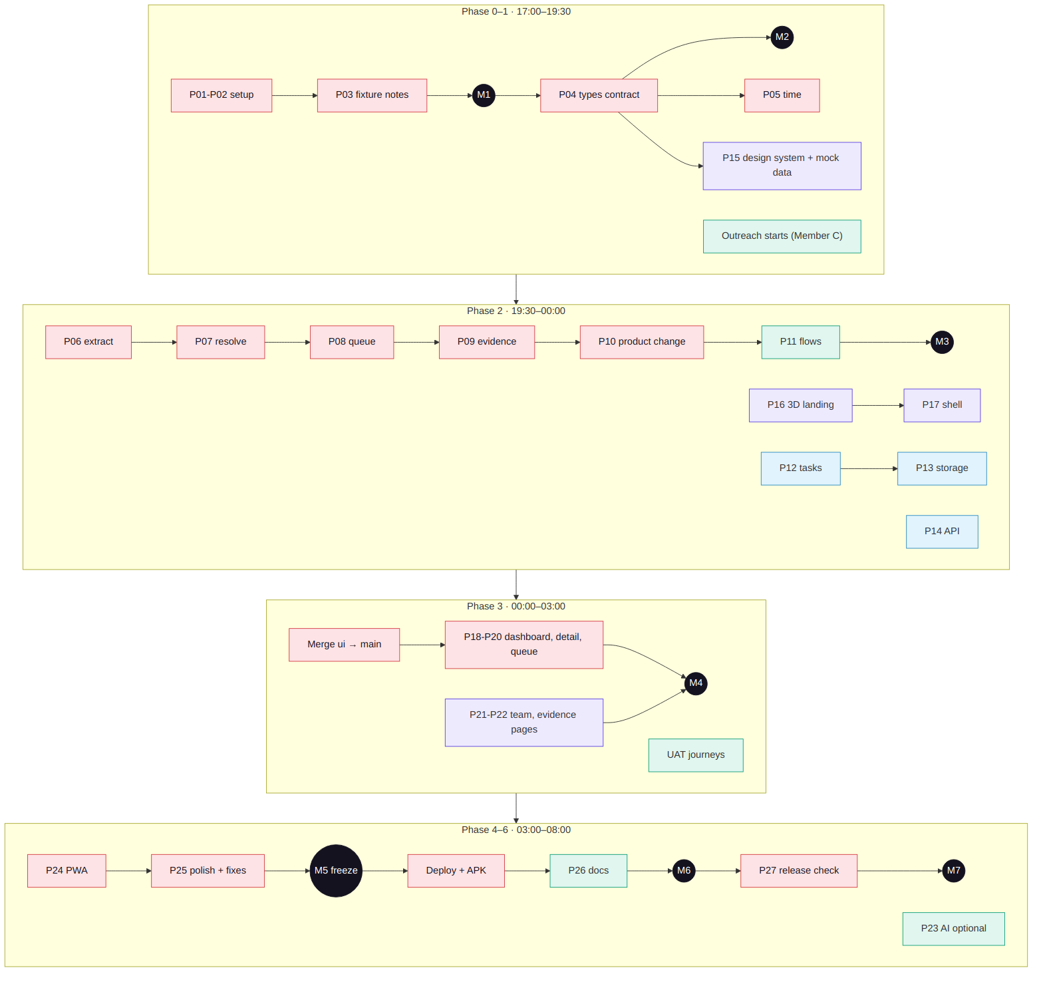
Figure 1 — Dependencies by phase (red = critical path)
View | Tasks
Can start immediately | 0.01 brief, 0.07 Laptop B setup, 0.08 moodboard, 0.09 outreach
Blocked by architecture / contract | 1.02–1.04 and everything in Phase 2 wait for 1.01 (types contract)
Blocked by engine | 2.11 tasks and 2.08 API need the resolver/queue; 3.02–3.04 need merge 3.01
Sequential by nature | P05 → P06 → P07 → P08 → P09 → P10 (each uses the previous output)
Parallel opportunities | Laptop B builds UI on mock data (1.03–2.10) while Laptop A builds the engine; Member C interviews throughout Phase 2
Integration checkpoints | IC1 22:30 scorecard (2.05) · Merge 00:00 (3.01) · IC2 02:00 journeys (3.07) · Live check 05:15 (5.01)
High-risk dependencies | Fixture format (0.06), resolver correctness (2.02), merge (3.01), deploy (5.01)

5.1 Critical path
0.04 → 0.05 → 0.06 → 1.01 → 1.02 → 2.01 → 2.02 → 2.03 → 2.04 → 2.06 → 3.01 → 3.02 → 3.04 → 4.01 → 4.02 → 5.01 → 6.01 → 6.05. Any slip here moves submission; every other task has float and is the first candidate for cutting.

6. Time and Effort Planning
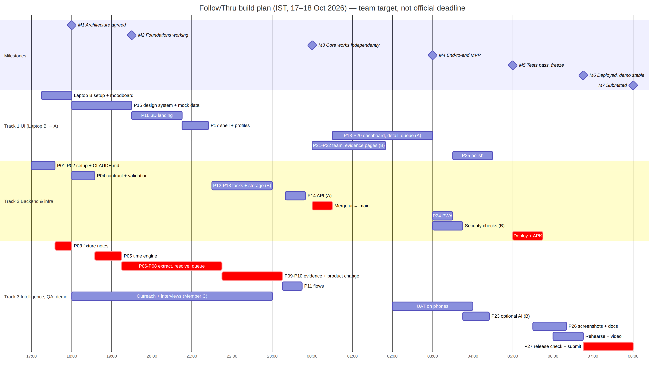
Figure 2 — Gantt chart (estimates; red = critical)
Track | Estimated effort (h) | Notes
T1 | 8.9 | Mostly Claude execution on Laptop B, then A
T2 | 6.1 | Split across A and B
T3 | 16.0 | Includes Member C's elapsed interview time (3 h)
All | 0.0 | Freeze marker
Buffer | Where | Size
Integration buffer | 00:00–00:30 merge window | 30 min
Engine contingency | Float between P11 and merge if IC1 needs fixes (P11 can be cut) | ~30 min
Testing buffer | Phase 4 is fix-only after 4.03 | 2 h
Presentation buffer | Phase 6 | 75 min
Rest | Members B and C sleep 01:00–02:00 or 03:00–04:00 in turns | 1 h each

7. Milestones and Gates
Milestone | Time | Completion criteria | Evidence | Owner | Go / no-go | Recovery if missed
M1 Requirements and architecture approved | 18:00 | Deadline confirmed; CLAUDE.md pushed; fixture notes list labels and edge cases | CLAUDE.md, docs/fixture-notes.md | Shiva | Go if labels found | If labels missing, ask organisers; evaluate on edge-case tests only
M2 Each track has a working foundation | 19:30 | Contract + validation tests pass; style guide renders; mock data typechecks; outreach sent | Test output; /styleguide screenshot | Shiva | Go if contract is on main | Laptop B continues on mock data; A finishes 1.01 first
M3 Core features work independently | 00:00 | Scorecard generated with product change; landing + shell on B; storage + tasks tests pass | evidence/latest, evidence/final | Shiva | Go if scoring checks PASS or failures understood | Cut P11 flows UI and P16 extras; spend time on engine
M4 End-to-end MVP works | 03:00 | Merged main; dashboard, detail, queue on real data; journeys pass | uat-log, screenshots | Shiva + Member C | Go if Must journeys pass | Drop P21/P22 extras; keep dashboard + queue + evidence
M5 Critical tests pass | 05:00 | All P1 tests, typecheck, build; PWA works; freeze | Test report | Shiva | Go if build is green | Revert last risky commit; skip P23 and polish
M6 Deployment and demo stable | 06:45 | Live link, APK, screenshots, README, two rehearsals | Live URL, release, video | Shiva + Member C | Go if live link works on phone | Present from local preview + labelled video
M7 Submission complete | 08:00 | Release check, claims audit, submission confirmation | Confirmation screenshot | Shiva | – | Submit whatever is verified; never claim unverified features

8. Roadmap Risk Management
Risk | Affects | Early sign | Mitigation | Backup
Fixture surprises | T3 critical path | 0.06 summary shows unexpected structure | Adapt types in 1.01 before logic | Ask organisers; document assumption
Engine accuracy below 10/10 | Score | IC1 failures | FIX prompt per failing case | Route ambiguous cases to review and explain honestly
Claude usage limit | All | Limit warning | New chat per prompt; Sonnet for simple tasks | Other laptop + CONTINUE prompt
Merge conflicts | T1/T2 | Both touched package.json/CLAUDE.md | Folder ownership; pull main into ui at 2.11 | MERGE prompt; keep both
3D performance | T1 | Phone stutter in 2.14 | Instancing, DPR cap | Hero-only 3D, 2D fallback
Deploy failure | T2 | Vercel build red | Build locally before push | Local preview + video
Interviews not done | T3 business | < 4 rows by 23:00 | Start at 18:00; widen to student project leads | Honest smaller n, labelled
Fatigue | All | Errors after 03:00 | Freeze at 05:00; rest rotation | Cut list below

8.1 Escalation rules
- Any task 30 min over its estimate → stop, run the FIX prompt once, then decide with Shiva: fix or cut.
- Any red build on main → all feature work pauses until green.
- Any change to types.ts → announce to both laptops before pushing.

8.2 Scope-cut order (remove from the top)
- P23 optional AI mode.
- Flow editor UI (keep default flows in the engine).
- Time-travel 'play' animation and command palette.
- 3D status ring (use the 2D version).
- Blockers board and celebration animations in team pages.
- 3D landing reduced to hero + one transition.
- /api/evidence endpoint (keep health and process).
Never cut: validation, extraction, linking, resolver, idempotent queue, suppression, evidence script, stale suppression, recipient review, dashboard, queue UI, evidence page, honest docs.

9. Team Workflow (Hackathon Cadence)
Practice | How
Kickoff | 17:00 — 10-minute call: read Roadmap §3 and §7, confirm owners
Progress updates | On the hour, one WhatsApp line per person: done / doing / blocked
Task ownership | Owner column is final; reassign only via Shiva
Branches | Laptop A on main; Laptop B on ui until 00:00 merge; afterwards both on main in separate folders
Pull requests / review | Merge via MERGE prompt; review = 'You check' line + npm test output
API contract management | types.ts changes first, announced, pulled by both
Integration frequency | B pulls main at 1.04 and 2.11; full merge at 3.01; then every prompt starts with git pull --rebase
Blockers | Escalate after 30 minutes (§8.1)
Definition of done | Implemented, tested, typechecked, built, committed (human-style message), pushed, visible in UI or evidence
Checkpoints | IC1 22:30, merge 00:00, IC2 02:00, freeze 05:00, live check 05:15

10. Final Roadmap Views

10.1 Phase-by-track responsibility matrix
Phase | T1 Frontend/UI | T2 Backend/infra | T3 Intelligence/QA/demo
0 | Laptop B setup; moodboard | Repo, scaffold, CLAUDE.md | Brief/deadline, fixture notes, outreach
1 | Design system, mock data | Contract, validation, CSV, integration rules | Time engine, interview script
2 | 3D landing, shell, device test | Tasks, storage/audit, API | Extraction → product change, flows, IC1, interviews
3 | Dashboard, detail, queue, team, evidence pages | Merge | Scorecard re-run, IC2 journeys, log summary
4 | Polish | PWA, security | Fixes, optional AI, UAT, final log
5 | Live visual pass | Deploy, APK | Screenshots/docs, deck numbers, rehearsal
6 | – | Repo hygiene, submit | Release check, claims audit, rehearsal

10.2 Milestone summary
M1 18:00 | M2 19:30 | M3 00:00 | M4 03:00 | M5 05:00 | M6 06:45 | M7 08:00
Architecture agreed | Foundations | Core independent | E2E MVP | Tests + freeze | Live + rehearsed | Submitted

10.3 Dependency and critical-path summary
Contract (1.01) unlocks parallel work; the engine chain 1.02 → 2.06 is the longest path; merge 3.01 joins the tracks; deploy 5.01 is the last high-risk dependency.

10.4 Risk and contingency summary
Top three: fixture surprises (act at 0.06), engine accuracy (act at IC1), missing real interviews (act at 0.09). Contingency for all: scope-cut list §8.2 and labelled fallbacks.

10.5 Final-day checklist
- Live link opens on a phone in incognito; /api/health OK.
- APK installs; iPhone 'Add to Home Screen' works.
- Scorecard PASS values copied exactly into the deck.
- Starting state, negotiated scope, final evidence present.
- Growth log rows real and summarised; business numbers labelled.
- README: live link, APK link, limitations, team.
- Backup video labelled 'recorded'; laptops charged; phone hotspot ready.

10.6 Task completion checklist
Phase | Task IDs (tick when done)
0 | ☐ 0.01 ☐ 0.02 ☐ 0.03 ☐ 0.04 ☐ 0.05 ☐ 0.06 ☐ 0.07 ☐ 0.08 ☐ 0.09
1 | ☐ 1.01 ☐ 1.02 ☐ 1.03 ☐ 1.04 ☐ 1.05 ☐ 1.06
2 | ☐ 2.01 ☐ 2.02 ☐ 2.03 ☐ 2.04 ☐ 2.05 ☐ 2.06 ☐ 2.07 ☐ 2.08 ☐ 2.09 ☐ 2.10 ☐ 2.11 ☐ 2.12 ☐ 2.13 ☐ 2.14
3 | ☐ 3.01 ☐ 3.02 ☐ 3.03 ☐ 3.04 ☐ 3.05 ☐ 3.06 ☐ 3.07 ☐ 3.08 ☐ 3.09
4 | ☐ 4.01 ☐ 4.02 ☐ 4.03 ☐ 4.04 ☐ 4.05 ☐ 4.06 ☐ 4.07 ☐ 4.08
5 | ☐ 5.01 ☐ 5.02 ☐ 5.03 ☐ 5.04 ☐ 5.05 ☐ 5.06
6 | ☐ 6.01 ☐ 6.02 ☐ 6.03 ☐ 6.04 ☐ 6.05

10.7 How the three tracks work together
T2 publishes the contract first, so T1 can build screens on typed mock data while T3 builds the engine against the same types. T3's evidence script proves correctness independently of the UI. At midnight the merge swaps mock data for the real engine and store, and from then on all three tracks converge on one demo path: dashboard → detail → queue → evidence. T3 owns the final word on claims, so the demo only shows what the evidence supports.

11. Consistency Review
Question | Answer
Does the solution directly address C14? | Yes — every scored check and edge case maps to tasks 2.01–2.06 and tests T1–T13 in the Blueprint
Is the innovation meaningful and feasible? | Yes — history replay, freshness check and evidence pack fit the time with free tools
Are architecture and stack justified? | Yes — Blueprint §6–7
Security, privacy, risks, failures addressed? | Yes — Blueprint §13–14; task 4.04; §8 here
Does the roadmap cover every essential blueprint feature? | Yes — Must features: 1.01, 1.02, 2.01–2.06, 2.12, 3.02, 3.04, 3.06, 5.03; Should: 2.07–2.11, 3.03, 3.05, 4.01, 5.02; Could: 4.05
Exactly three tracks? | Yes — T1, T2, T3 (plus an 'All' freeze marker)
Dependencies and integration points clear? | Yes — §5, IC1, merge, IC2
MVP realistic in the assumed time? | Yes if the critical path holds; cut list protects it
Demo proves actual functionality? | Yes — live app + generated evidence; recorded video only as labelled fallback
Claims vs assumptions distinguished? | Yes — assumptions table §1, claims audit 6.03

