FYND × NMIMS HYDERABAD · CHALLENGE C14
Hackathon Complete Solution Blueprint
FollowThru — Automated Chaser Draft Queue
Team repo: github.com/shivv-14/followthru
Stream: Engineering (with MBA business assignment)
Version: 1.0 — 17 Oct 2026
Companion documents: Three-Track Roadmap · Prompt Playbook · About the Project · Business Case · Pitch Deck

FollowThru — Chase what's late. Never what's done.

Contents

If the contents list is empty, right-click it in Word and choose Update Field.

1. Executive Summary
Item | Summary
Project name | FollowThru
Tagline | Chase what's late. Never what's done.
Event | Fynd × NMIMS Hyderabad — Product and business simulation, Challenge C14: Automated Chaser Draft Queue (engineering stream)
Problem | Project coordinators lose track of commitments made in conversations. Deadlines move, owners change and work is completed in other threads, so coordinators either chase finished work or miss real overdue work.
Solution | A PWA that reads conversations, extracts commitments, replays the full history of each one to keep owner, deadline and status correct, and drafts exactly one reminder per genuinely overdue commitment. A coordinator reviews every draft and recipient. Nothing is sent automatically (shadow mode).
Target users | Primary: project coordinator / delivery manager in a professional-services firm. Secondary: team members who own commitments.
Main innovation | History-replay engine with evidence for every decision: cross-thread completion linking, silence-is-not-status rule, idempotent draft queue with in-place versioning, and a pre-approval freshness check. Every result cites message ids and can be replayed with a time-travel slider.
Expected impact (targets) | 10/10 labelled commitments correct; 0 reminders for completed, cancelled or deferred work; 1 draft per action. Business hypothesis: ~6.5 coordinator hours saved per month (to be tested).
Key technologies | React + TypeScript, Tailwind, Framer Motion, react-three-fiber (3D), Zod, Dexie (IndexedDB), Vitest, Playwright, Vercel serverless functions, vite-plugin-pwa, PWABuilder (APK). Optional Gemini with labelled rules fallback.
Why it can win | It targets the official 25 engineering points directly, proves them with a generated scorecard, treats the hard edge cases as first-class rules, separates evidence from assumptions in the business case, and delivers a memorable 3D experience on phone and laptop.

Source of truth: the C14 brief (Fynd × NMIMS Hyderabad). The only official scoring given is the 25-point engineering outcome check. Any other evaluation framework in this document is a provisional estimate, labelled as such.

2. Problem Analysis

2.1 The brief, decomposed
Brief element | What it actually requires | Required or optional
User and end goal | Identify overdue commitments and prepare relevant reminders without chasing completed work | Required
Engineering build | Extract actions from synthetic conversations; maintain owner, deadline, status; draft reminders; suppress after completion | Required
Starter data | Use Starter_Data/C14/fixture.json: message ids, thread ids, timestamps/timezone, owners, commitments, due dates, later changes and completions | Required input
Outcome checks (25 pts) | 10: owner/deadline/status for ten labelled commitments with evidence · 10: zero reminders for completed/cancelled/deferred · 5: one action one draft; deadline update changes the queue without duplicates | Required, scored
Edge cases | 'Maybe Friday', timezone, delegated owner, completion in another thread, no response vs not completed | Required
Product change | Stale-message suppression + recipient review; save starting state, negotiated scope, final evidence | Required
Capabilities | UI and state; data validation; tested business rules; CSV or JSON handling; readable evidence and a saved result | Required
AI | Language/image/speech model with a labelled fallback | Optional
MBA assignment | Professional-services delivery manager; team subscription; price, cost-to-serve, first-customer path; common MBA deliverables; project operations, stakeholder communication, adoption | Required (business track)
Growth experiment | Observe ten overdue commitments; record who was approached, the response and what counts as useful | Required
Pilot path | Shadow a coordinator; measure false reminders, overdue-action coverage, approval rate before controlled sends | Required (plan)
Business proof | Separate observed evidence from assumptions; customer value; contribution or WTP hypothesis; negotiated change; next 30-day test; no claim of live revenue or production readiness | Required

2.2 Root causes
- Commitments are unstructured. They are made in natural language inside threads, not as task records.
- State is spread over time and space. The truth about a commitment is the sum of many later messages, often in other threads.
- Silence is ambiguous. 'No reply' looks like 'not done' to a naive system, which causes wrong status changes.
- Time is relative and local. 'Friday' or 'EOD' depends on who said it and in which timezone.
- Ownership moves. Hand-offs ('Priya, can you take this?') change who should be reminded.
- Drafts age. A reminder written an hour ago can be wrong by the time it is approved.

2.3 User pain points
Pain | Consequence
Manually scanning threads for promises | Coordinator time lost every day (size of loss: assumption to test)
Chasing work that was already delivered | Embarrassment, eroded trust, reminder fatigue
Missing work that is truly late | Client deadlines slip
Reminding the wrong person after a hand-off | Confusion, delay
Unclear deadlines ('maybe Friday') | Either premature nagging or no follow-up

2.4 Limitations of existing approaches (category level)
Approach | Limitation for this problem
Spreadsheets / notes | Manual, quickly stale, no history
Task tools with due-date reminders | Only see tasks typed into the tool; blind to commitments made in conversation
Chat reminder commands | No owner/deadline/status model; never suppress when work completes
AI meeting-note action items | Typically stop at extraction; weak on later changes, cross-thread completion and approval
These are general category observations, not tested product comparisons; verify before external claims.

2.5 Stakeholders
Stakeholder | Interest | Influence
Project coordinator / delivery manager | Accurate list, fewer manual chases, control | High (user and buyer)
Team members (owners) | No spam, no reminders for finished work, respect for timezone | Medium (adoption)
Firm leadership / client | Commitments kept; proof for status updates | Medium
IT / security | Privacy of conversation data | Medium (gatekeeper in pilot)
Hackathon judges (Fynd × NMIMS) | Correctness, evidence, honesty, product thinking | High (now)

2.6 Scope and boundaries
In scope (hackathon) | Out of scope (documented future)
Process fixture JSON and CSV conversations | Live Slack/Teams/email ingestion
Commitment extraction, linking, history resolution | Real reminder sending
Draft queue, suppression, flows, recipient review, freshness check | Company SSO and multi-device sync
Coordinator and member workflows on local demo profiles | Payments, multi-tenant admin
Evidence generation, REST API, PWA + APK | ML model training

2.7 Assumptions and how to validate them
ID | Assumption | Validation
A1 | fixture.json contains labelled expected answers for ten commitments | Prompt P03 inspects the file and documents label location and format
A2 | The fixture contains a usable reference time (or the latest message time is a fair 'now') | P03 documents the evaluation clock; confirm with organisers if unclear
A3 | Judges accept a browser-hosted app with serverless API (no separate DB server) | Brief scores behaviour and evidence, not infrastructure; mention in demo
A4 | Team target: submission by 08:00 IST, 18 Oct 2026 (stated by the team, not an official deadline in the brief) | Confirm the official deadline with organisers at kickoff
A5 | Coordinators spend ~3 h/week chasing commitments | Growth-experiment interviews
A6 | US$39 (₹2,999) per team per month is acceptable | Price question in interviews; pilot conversion

2.8 Problem statement
Project coordinators need a reliable way to know which commitments made in team conversations are genuinely overdue right now, and to prepare the right reminder for the right person, without ever chasing work that has been completed, cancelled or deferred, even when that change happened later or in a different thread.

3. Proposed Solution and Innovation

3.1 How FollowThru works
FollowThru treats a commitment as a story told across many messages. It first finds the opening line of the story (a commitment, or a request that someone accepts). It then replays every later message in time order, across all threads, and updates the story: the deadline moved, the owner changed, the work was finished, the request was cancelled. Only at the end does it decide whether a reminder is appropriate.
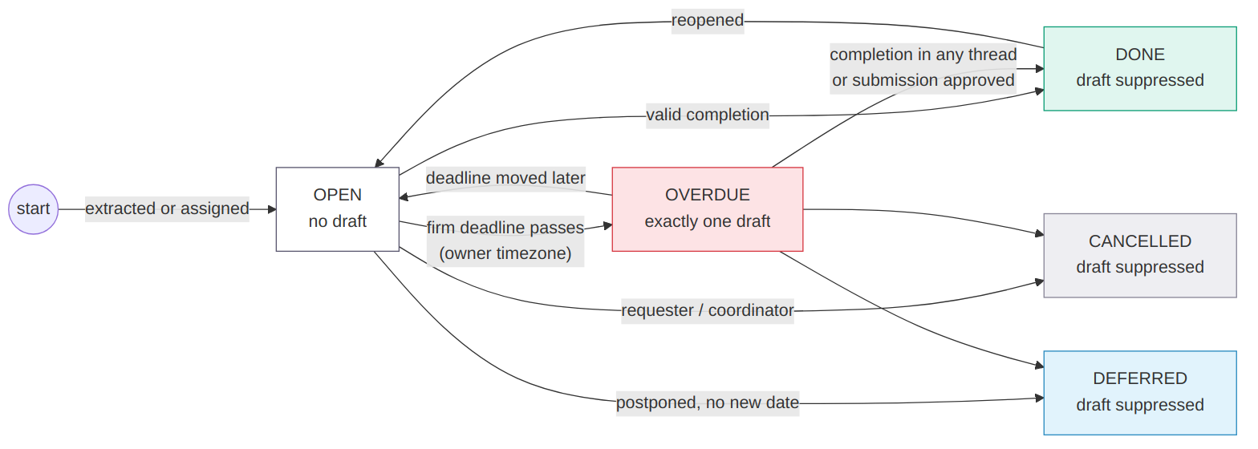
Figure 1 — Commitment lifecycle and draft behaviour

3.2 Operating principles (the engine's rules)
- Silence never changes status. No reply means responseState 'pending', shown as 'Response pending'.
- Only reliable evidence changes status: a message from the owner, requester or coordinator, or an authorised human decision in the app.
- Ambiguity goes to a human. A possible completion elsewhere sets needsReview and blocks chasing; it never silently completes the task.
- Time is read where it was said. Relative phrases are interpreted in the speaker's timezone, stored as UTC, displayed in owner and viewer time.
- One commitment, at most one draft. Idempotency key = commitment id; changes create a new version of the same draft.
- Fresh before approval. Every draft is re-checked against newer messages before it can be approved.
- Every decision is explainable. Each change stores message id, thread id, time, quote and rule name.
- The engine is pure. Same input + same 'now' = same output. No clock inside the engine.

3.3 Differentiators
Differentiator | Why it matters to judges
History replay across threads with evidence | Directly earns the 10-point owner/deadline/status check and handles completion elsewhere
Suppression ledger with reasons | Makes 'zero reminders for completed/cancelled/deferred' visible and auditable
Idempotent, versioned drafts | Proves 'one action, one draft' including deadline updates
Clarify drafts for tentative deadlines | Turns 'maybe Friday' into a useful action instead of a wrong chase
Freshness check + recipient review | Implements the negotiated product change as testable rules with before/after evidence
Time-travel slider + Why? panel | Judges can watch the status change and see the exact message that caused it
Generated evidence pack | Readable scorecard, CSV/JSON, test report, hashes and timestamped screenshots in one command
Cinematic 3D PWA + APK | Memorable demo that works on any phone, installable and offline

3.4 Why this approach and not simpler ones
A keyword search for 'I'll' plus a due date would create reminders from the first message only, which is exactly what the brief warns against. A pure LLM approach would be hard to test deterministically, costly, and could hallucinate completions. A deterministic rule engine with an optional, labelled AI assist gives testable correctness, explainability and zero cost, while still allowing better language coverage when a key is available.

3.5 Feasibility in the hackathon window
The build is decomposed into 27 Claude Code prompts executed on two laptops (see the Prompt Playbook and the Three-Track Roadmap). The scored engine work sits on the critical path and is scheduled first; 3D and polish are parallel and can be cut back without affecting scoring.

4. User Personas and Use Cases

4.1 Personas
 | Ananya — Delivery Manager (primary) | Rahul — Team Member (secondary)
Context | Runs 3–5 client projects at a ~60-person agency; team in IST, client in GMT/PT | Developer on two projects; works in IST
Goal | Every promise kept without becoming the team's nag | Clear priorities; no pointless reminders
Frustrations | Scrolling threads; chasing finished work; hand-offs lost | Being chased for work already submitted; reminders at night
Uses FollowThru to | Monitor, assign, design flows, approve drafts, approve submissions, export evidence | See my tasks in my time, update status, report blockers, submit work

4.2 Key user journeys
- First run: open link → 3D landing → Open app → setup (name, timezone) → load Fynd data → validation summary → choose profile → dashboard.
- Daily triage (coordinator): dashboard → Needs your attention → open a commitment → read Why? panel → Queue → confirm recipient → approve (shadow).
- Tentative deadline: 'maybe Friday' item shows ~ deadline → after Friday a clarify draft appears → coordinator approves → member proposes a date.
- Completion elsewhere: item overdue with draft → message 'report submitted' in another thread → freshness check suppresses the draft → card moves to Suppressed with evidence.
- Assign and approve work: coordinator assigns to a team → each member gets a task → member submits files → coordinator approves → status done, draft suppressed.
- Evidence: Evidence page → scorecard → download CSV/JSON → upload a screenshot → audit shows the upload with timestamp and hash.

4.3 Functional requirements
ID | Requirement
FR1 | Import fixture JSON (bundled) and CSV; validate with readable issues
FR2 | Extract commitments with owner, requester, deadline phrase, certainty, evidence
FR3 | Link later messages across threads; resolve owner, deadline, status, responseState
FR4 | Create at most one draft per commitment; update in place on change; suppress on terminal events
FR5 | Clarify drafts for passed tentative deadlines
FR6 | Freshness check before approval; stale drafts suppressed or updated with reason
FR7 | Recipient review; approval blocked until recipient confirmed (flag on)
FR8 | Follow-up flows with defaults; stage changes update the same draft
FR9 | Coordinator: assign tasks to person/team, change deadline/owner, approve submissions
FR10 | Member: update status, report blocker, request more time, submit work with files
FR11 | Audit log of every change with actor and timestamp; evidence uploads with SHA-256
FR12 | Export commitments, drafts, suppressions, audit as CSV/JSON; evidence script; REST API
FR13 | Optional AI extraction, clearly labelled, with rules fallback

4.4 Non-functional, accessibility and usability requirements
Area | Requirement (target)
Determinism | Same input and 'now' produce identical output (tested)
Performance | Engine run on fixture < 200 ms on a laptop (target, to measure); app shell main chunk < ~250 KB gzip; 3D lazy-loaded
Availability | Works offline after first load; no server dependency for core flows
Devices | 360 px phones to 1920 px desktops; touch targets ≥ 44 px
Accessibility | Text contrast ≥ 4.5:1; status never by colour alone; keyboard operable; visible focus; reduced-motion respected; canvas aria-hidden
Privacy | Data stays on device; AI key never leaves the device except to the provider; no message text in API logs
Honesty | Shadow mode labelled; AI mode labelled; limitations in README

5. Feature Breakdown and Prioritisation
Priorities use MoSCoW for the hackathon. 'Prompt' refers to the Prompt Playbook step that builds the feature.
Feature | Problem solved / user | Priority | Size | Depends on | Implementation | Acceptance criteria | Demo
Fixture validation & import | Bad data / coordinator | Must | M | Types | Zod schema, issue list (P04) | Real fixture: 0 errors; broken copies give correct codes | Setup screen summary
Deadline & timezone parser | 'Maybe Friday', TZ / both | Must | M | Types | date-fns-tz rules (P05) | 25+ tests incl. IST vs PT, DST | Owner time + my time
Signal extraction | Unstructured promises | Must | M | Parser | Rule signals (P06) | One test per signal; deterministic ids | Why? panel rule names
Cross-thread linking & history resolver | Completion elsewhere, delegation | Must | H | Extraction | Scored linking + replay (P07) | All edge-case tests pass | Time-travel slider
Idempotent draft queue + suppression | No duplicates, no wrong chases | Must | M | Resolver | Key = commitment id (P08) | Scoring B and C tests pass | Suppressed lane, version history
Evidence script & scorecard | Proof for judges | Must | M | Queue | tsx script (P09) | Scorecard written with timestamps + hashes | Evidence page
Stale suppression + recipient review | Negotiated change | Must | M | Queue | Flags, freshness, gate (P10) | Acceptance criteria AC1–AC5 | Rahul example; locked approve
Coordinator dashboard & queue UI | Monitoring, review | Must | M | Store | React pages (P18, P20) | Numbers match scorecard | Live walkthrough
Storage + audit | State, traceability | Must | M | Engine | Dexie repos (P13) | Refresh keeps data; audit for every action | Audit page
Follow-up flows | Coordinator automation | Should | M | Queue | Flow steps (P11) | Stage change keeps one draft | Flow editor preview
Task assignment & member workspace | Assign, submit, approve | Should | M | Store | Task actions (P12, P21) | Member cannot approve own work | Profile switch demo
REST API | Integration / 'backend' | Should | L | Engine | Vercel functions (P14) | 200 / 422 / 405 tests | /api/health live
3D landing story | First impression | Should | H | Design system | r3f + Lenis (P16) | Smooth on mid phone; fallback works | Opening hook
PWA + APK | Use on any phone | Should | L | Build | vite-plugin-pwa, PWABuilder (P24) | Installable; offline reload works | Phone install
Time-travel slider & Why? panel | Explainability | Should | M | Resolver | Re-run pure engine (P19) | Slider shows status changes | Most impressive moment
Optional AI extraction | Messy language | Could | M | Extractor interface | Gemini, Zod output (P23) | No key → 'Rules (fallback)' | Mode chip
Real sending, Slack/email, SSO, ML training | Production | Won't (now) | – | – | Documented future | – | Roadmap slide

5.1 MVP vs advanced
MVP (must work end-to-end by M4) | Advanced (add if on schedule) | Future (post-hackathon)
Validation, parser, extraction, linking, resolver, queue, suppression, evidence script, product change, storage, dashboard, commitment detail, queue UI | Flows editor, team/member workspace, API, 3D landing, time travel, PWA/APK, AI mode, screenshots script | Integrations, real sends, SSO, sync, analytics, ML-assisted ranking

5.2 Features deliberately avoided
- Real email/Slack sending — risky, out of brief scope, and contradicts shadow-mode pilot path.
- Real authentication and cloud database — adds failure points without scoring value.
- Training an ML model — no labelled dataset beyond the fixture; rules are testable.
- Chat-bot interface — distracts from the queue workflow the brief describes.

5.3 How we prove it works
npm run evidence produces scorecard.md with the three official checks as PASS/FAIL, a labelled-commitment table (expected vs actual with message ids), the suppression list and edge-case coverage; the Vitest report proves each rule; Playwright screenshots show the UI states with timestamps. Starting-state and final runs prove the product change.

6. System Architecture
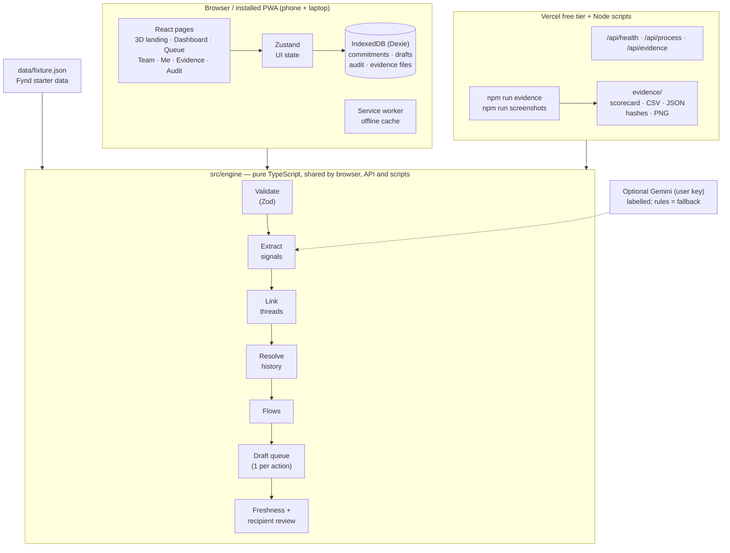
Figure 2 — System architecture
Component | Responsibility | Talks to | Alternatives considered
React PWA | All screens, interaction, state display | Store hooks, engine (pure calls) | Next.js (heavier SSR not needed), plain HTML (too slow to build)
Zustand | Ephemeral UI state (filters, slider, profile) | Components | Redux (boilerplate)
Dexie / IndexedDB | Persistent data, audit, evidence blobs | Repositories | MongoDB/Firebase (network dependency, setup time)
Engine (src/engine) | All business logic as pure functions | Store, API, scripts | Server-only logic (would break offline use)
Vercel functions | REST API reusing engine | Engine | Express server on Render (cold starts, sleeps)
Service worker | Offline cache, installability | Browser | None (would lose PWA)
Evidence & screenshot scripts | Generate proof artefacts | Engine, Playwright | Manual screenshots (no timestamps/hashes)
Gemini (optional) | Extra extraction signals | Extractor interface | OpenAI/Anthropic APIs (paid keys)

6.1 Authentication and authorisation
Hackathon: local demo profiles with optional 4-digit PIN (hashed). Role checks are enforced in engine actions (members cannot approve, cancel or reassign) and in route guards. This is not security against a malicious user on the same device and is labelled as a demo feature; company SSO is a pilot item.

6.2 Logging, monitoring, error handling
Audit log for every domain action (in-app). Route-level error boundaries with 'Reload' and 'Reset demo data'. API returns a consistent error shape and never logs message text. Vercel's built-in function logs for API errors.

7. Technology Stack and Tool Selection
Layer | Choice | Why | Limitations | Cost | Alternatives
Language | TypeScript (strict) | One language for UI, engine, API, scripts; types = contract between laptops | Compile errors slow beginners | Free | JavaScript
Frontend | React 18 + Vite | Fast dev server, huge ecosystem, Claude Code fluent | SPA only | Free | Next.js, SvelteKit
Styling / motion | Tailwind v4, Framer Motion, Lenis | Rapid premium UI, spring animations, smooth scroll | Animation can hurt low-end phones | Free | CSS modules, GSAP
3D | three.js via @react-three/fiber, drei, postprocessing | Cinematic scroll story with bloom; declarative | Bundle size; WebGL support | Free | Spline (hosted assets), plain CSS 3D
Validation | Zod | Readable errors, types from schemas | – | Free | Yup, AJV
Storage | Dexie (IndexedDB) | Offline, persistent, zero setup | Single device | Free | Firebase, Supabase, MongoDB Atlas
Backend | Vercel serverless functions | Free REST API reusing engine; deploys with frontend | Cold starts small; limits on free tier | Free (Hobby) | Express on Render/Railway
CSV | PapaParse | Robust parsing both ways | – | Free | csv-parse
Tests | Vitest, Testing Library, fake-indexeddb, Playwright | Fast unit tests; automated screenshots | Playwright browser download (~150 MB) | Free | Jest, Cypress
PWA / APK | vite-plugin-pwa, PWABuilder | Installable, offline; APK without Android Studio | TWA needs assetlinks for full screen | Free | Capacitor
AI (optional) | Gemini API free tier, user key | Labelled extra signals; zero cost | Rate limits, terms may change; verify current docs | Free tier | None (rules only)
Version control | Git + GitHub (public), feature branch ui | Collaboration, Vercel auto-deploy | Merge conflicts | Free | –
AI coding | Claude Code in VS Code (2 Pro accounts) | Executes the prompt playbook, commits, pushes | Usage limits | Existing subscriptions | Manual coding

8. Database and Data Design

8.1 Data sources
Only Starter_Data/C14/fixture.json (provided by Fynd) and user imports (JSON/CSV) or app actions. No other dataset is assumed. The fixture's exact fields are documented by prompt P03 in docs/fixture-notes.md before any logic is written.

8.2 Validation and preprocessing
- Required fields: message id, thread id, author, timestamp with offset/timezone, text.
- Errors: duplicate ids, unparsable dates, unknown IANA timezone, manual task without owner or with due date before creation.
- Warnings: unknown author/mention, missing thread, empty text, due date < 2 h away.
- Normalisation: all times to UTC ISO; people and threads indexed; messages stable-sorted by time then id.

8.3 Schema and relationships
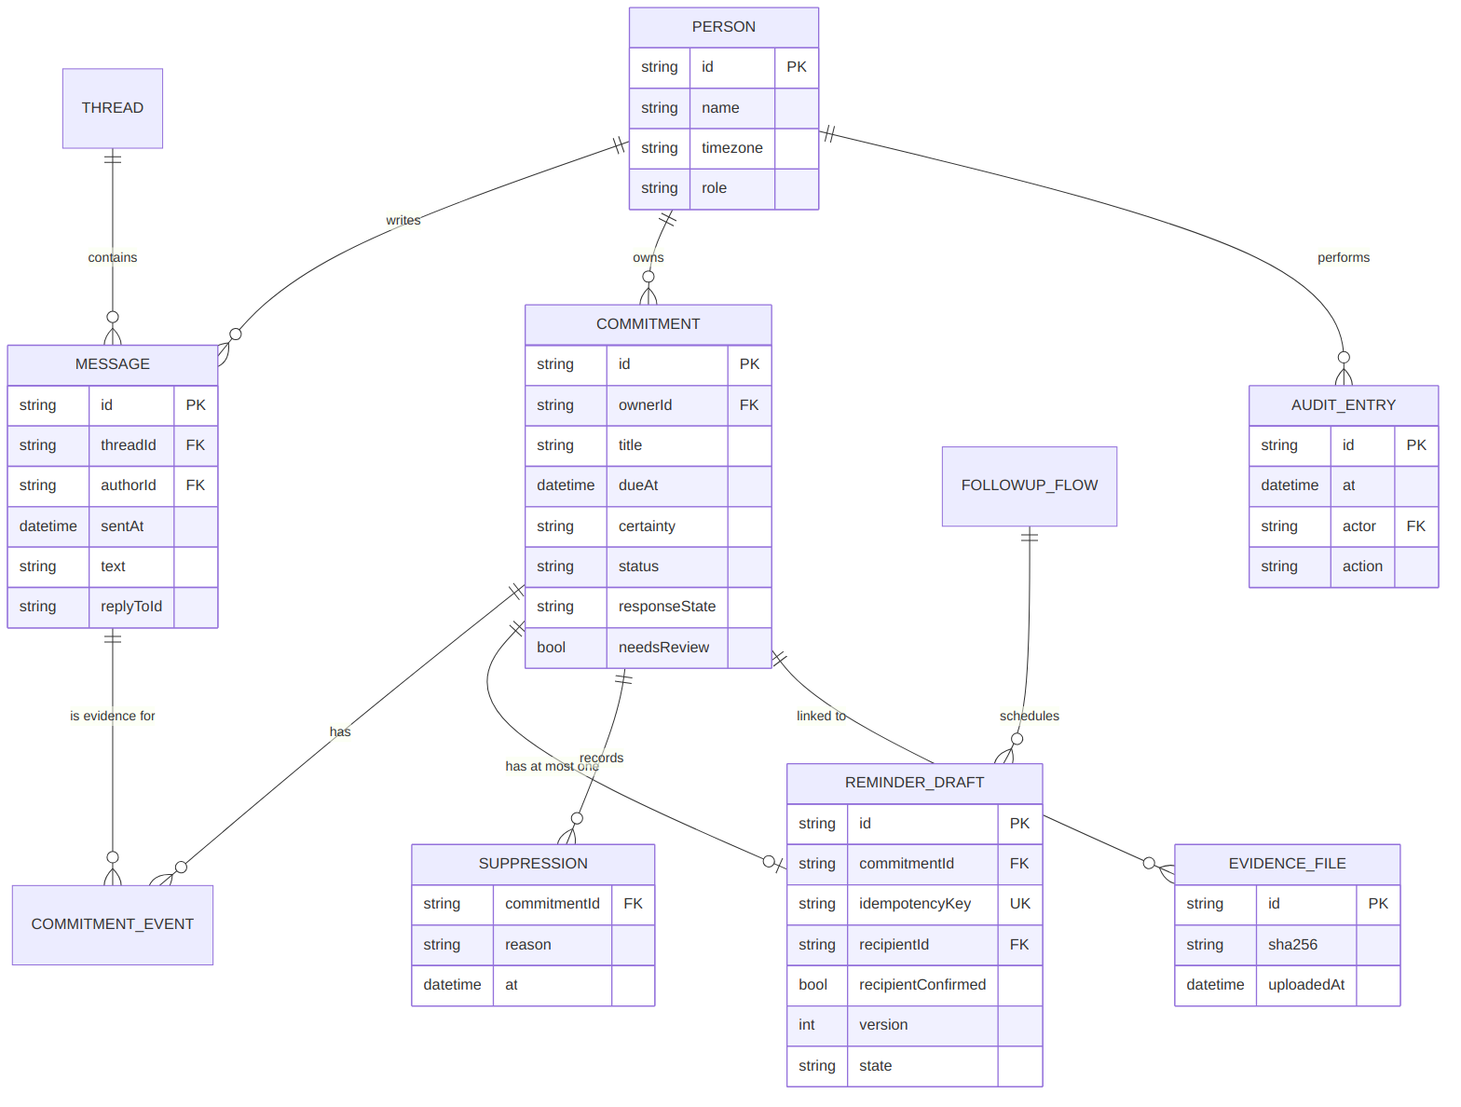
Figure 3 — Entity relationships (IndexedDB tables)
Table | Key fields and constraints
people | id (PK), name, timezone (IANA, required), role, teamId
threads | id (PK), title, participantIds[]
messages | id (PK, unique), threadId (FK), authorId (FK), sentAt (UTC), text, replyToId
commitments | id (PK = 'c_' + source message id), ownerId, deadline{dueAt, certainty, phrase, evidence}, status, responseState, needsReview, events[]
drafts | id (PK), commitmentId (FK, unique via idempotencyKey), recipientId, recipientConfirmed, state, version, history[]
suppressions | commitmentId, reason, evidence[], at
flows | id, isDefault, appliesTo, steps[] (afterHours ascending), quietHours, skipWeekends
audit | id, at, actor, action, entity, entityId, before, after (append-only)
evidenceFiles | id, name, mime, size, sha256, uploadedAt, uploadedBy, linkedTo, blob
runs, settings | saved engine runs; profile, flags, AI key (local only)

8.4 Example records
commitment {
"id": "c_m_12", "title": "Send revised deck to client", "ownerId": "p_priya",
"deadline": { "dueAt": "2026-10-16T12:30:00Z", "certainty": "firm", "phrase": "Friday 6pm",
"interpretedTz": "Asia/Kolkata", "evidence": { "messageId": "m_12", "rule": "COMMIT" } },
"status": "done", "responseState": "responded", "needsReview": false,
"events": [ { "type": "delegated", "by": "p_arjun", "evidence": { "messageId": "m_18" } },
{ "type": "completed", "by": "p_priya", "evidence": { "messageId": "m_31", "threadId": "t_4",
"quote": "deck sent to client", "rule": "DONE+LINK_SIMILARITY" } } ] }
draft { "id": "d_c_m_12", "idempotencyKey": "c_m_12", "state": "suppressed", "version": 2 }
Ids and names above are illustrative; real values come from the fixture.

8.5 Retention, backup, privacy
- Data stays in the browser; 'Reset demo data' clears it after confirmation (audit-logged).
- Backup = Export all (JSON); restore = Import backup with validation.
- Evidence runs are committed to Git (synthetic data only), giving versioned backup.
- No personal data beyond the synthetic fixture; uploads stay local.

9. Backend and API Design

9.1 Modules
Module | Responsibility
schema/validate | Zod parsing, issue codes, CSV parsing/export
engine/time | parseDeadline, isOverdue, formatting across timezones
engine/signals + extract | Message signals, commitment creation, extractor interface
engine/link + resolve | Cross-thread linking, event replay, status and responseState
engine/flows + queue + templates | Flow stages, idempotent drafts, suppression, wording
engine/stale + recipient | Freshness check, recipient warnings, canApprove
engine/tasks | Manual task actions and role permissions
engine/evaluate | Label comparison and the three scoring checks
store/* | Dexie repositories, recompute that preserves human decisions, audit
api/* | Serverless endpoints

9.2 Endpoints
Method & route | Purpose | Auth | Request | Response | Errors
GET /api/health | Liveness + engine version | None | – | { ok, engineVersion, time } | 500
POST /api/process | Run engine on supplied data | None (no secrets; size-limited) | { fixture | csv, config?: { now, flags } } ≤ 2 MB JSON | EngineResult { commitments, drafts, suppressions, validation, meta } | 405 wrong method · 413 too large · 415 type · 422 validation issues
GET /api/evidence | Download results of bundled fixture | None | ?format=json|csv&kind=commitments|drafts|suppressions | File (attachment, timestamped name) | 400 bad params
Error shape: { "error": { "code": "VALIDATION_FAILED", "message": "...", "issues": [ ... ] } }. No database operations: the API is stateless and reuses the engine.
curl -X POST https://LIVE_URL/api/process \
-H "Content-Type: application/json" \
-d '{"fixture": { ... }, "config": { "flags": { "staleSuppression": true, "recipientReview": true } }}'
→ 200 { "meta": { "commitmentCount": 14, "extractor": "rules", ... }, "drafts": [ ... ] } (counts illustrative)

9.3 Core business logic summary
Rule | Behaviour
Commitment creation | COMMIT by speaker, or REQUEST + ACCEPT by acceptor; deterministic id
Delegation | Owner changes on acceptance or coordinator/requester assignment; else needsReview
Completion | Valid if by owner, requester or coordinator; cross-thread via explicit link or similarity above threshold; ambiguous → review
Cancel / defer | Cancel by requester/coordinator; defer = postponed without concrete date
Deadline change | New deadline; old kept in events; draft updated (version + 1)
Overdue | certainty firm and now > dueAt; tentative past due → clarify draft + review
responseState | 'responded' if owner wrote after deadline/last reminder; else 'pending'
Queue | ≤ 1 draft per commitment; terminal → suppressed with reason; re-run is idempotent
Freshness | Newer terminal event → suppress; owner/deadline change → update; > 24 h unapproved → stale
Recipient review | Warnings for delegation, not in thread, quiet hours, ambiguity; approve needs confirmation

10. Frontend and UI/UX Blueprint

10.1 Design system 'Nocturne'
Dark background #07060D, glass surfaces, violet accent #7C5CFF and one colour per status (done mint #3EE6B0, overdue coral #FF5D6C, tentative amber #FFB547, deferred sky #5CC8FF, cancelled grey #8A8799). Space Grotesk for display, Inter for body (self-hosted for offline). Spring animations, Lenis smooth scrolling on the landing page, full reduced-motion support. The feel is inspired by scrolltide.co and threeui.com; all code and assets are original.

10.2 Screens
Screen | Purpose | Key elements | States
Landing (/) | Explain value in 30 s | 3D scroll story: chaos → scan → sort by status → queue; live counts; CTA | WebGL fallback, reduced motion
Setup | First run | Name, timezone, load Fynd data, validation summary | Errors block import
Profile picker | Choose role | Coordinator and member cards, optional PIN | –
Dashboard | What needs attention now | KPIs, attention list, 3D status ring, 7-day deadline strip, team health, engine chip | Loading skeletons, empty
Commitments | All items | Table/cards, filters in URL, bulk export | No results
Commitment detail | Explain and decide | Why? panel, evidence timeline, time-travel slider, draft card, actions | needsReview banner
Queue | Review drafts | Lanes, recipient review, freshness chip, keyboard, before/after toggle | Approve disabled with reason
Flows | Automation | Step builder, live preview, validation | Defaults locked
Team / Me | Assign and do work | Assign sheet, submissions inbox, blockers; my tasks, submit with files | Celebration on approval
Evidence / Data / Audit | Proof and control | Scorecard, runs, uploads with hashes; import/export; audit diff | Validation table

10.3 Navigation and responsiveness
Desktop: collapsible glass sidebar + top bar (search, evaluation-clock chip, mode chip, profile). Mobile: bottom tab bar, cards instead of tables, bottom sheets instead of modals, safe-area insets. Command palette (Ctrl/Cmd+K).

10.4 How the UI communicates value fast
- The suppressed-lane header states live: '0 reminders for completed, cancelled or deferred work'.
- Every status shows its reason in one click (Why?).
- Deadlines always show both the owner's time and the viewer's time.
- Mode chip always says Rules or AI, so the fallback is visible.

11. Intelligent System Design

11.1 Is AI justified?
The core is a deterministic rule engine because the scoring requires exact, explainable, repeatable answers on a fixed synthetic dataset, and rules can be unit-tested message by message. AI is useful only as an optional assistant for messy phrasing beyond the fixture. The brief explicitly allows a model 'with a labelled fallback'.
Aspect | Design
Model | Google Gemini free-tier 'flash' model (name configurable; verify current model id in docs)
Input | One thread at a time; message ids preserved
Output | JSON array of signals validated by Zod: messageId, kind, owner, task, deadlinePhrase, hedged, refersToMessageId, confidence
Integration | AI signals feed the same linker/resolver; deadlines still parsed by parseDeadline
Trust rule | Conflict with rules or confidence < 0.7 → needsReview; AI alone never changes status
Fallback | No key, offline, 8 s timeout, rate limit, invalid JSON → rules; UI shows 'Mode: Rules (fallback) – reason'
Evaluation | Same scorecard run with AI on/off; report both (only if time allows)
Risks | Hallucinated completions (blocked by trust rule), cost (free tier), key leakage (local storage only), latency
Training | None. No dataset beyond the fixture is assumed.

12. End-to-End Workflow
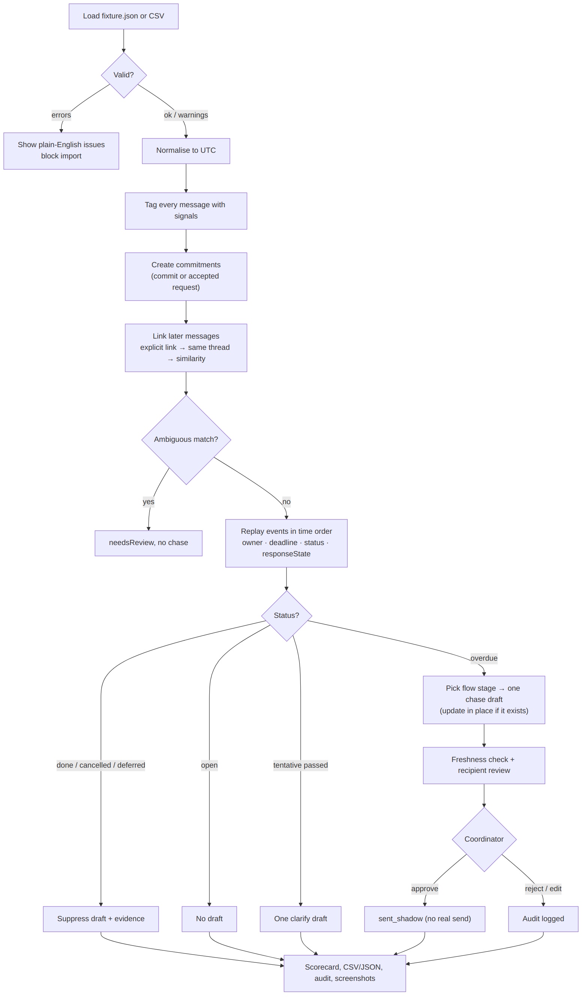
Figure 4 — Processing workflow
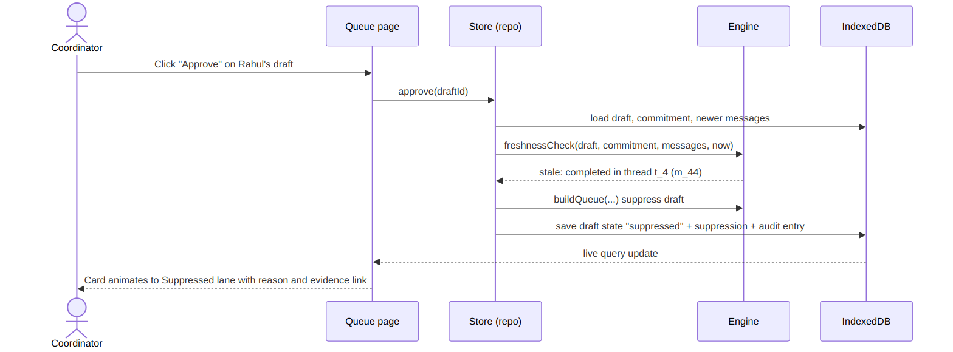
Figure 5 — Sequence: approving a draft that has become stale

12.1 Worked example
Time (IST) | Message | Engine result
Mon 10:00 | Arjun (t_1): "Can someone send the revised deck by Friday?" | REQUEST, no commitment yet
Mon 10:05 | Priya: "Sure, I'll do it by Friday 6pm" | Commitment c_m_2, owner Priya, due Fri 18:00 IST (12:30 UTC), firm
Wed 15:00 | Arjun: "Rahul, can you take the deck? Priya is on leave" · Rahul: "ok" | Delegated → owner Rahul (accepted)
Fri 18:01 | (silence) | Overdue, responseState pending → one gentle draft to Rahul, recipient warning 'owner changed'
Fri 19:30 | Rahul (t_4, other thread): "deck sent to client ✅" | Linked (similarity), status done
Fri 19:31 | Coordinator opens queue | Freshness check → draft suppressed, reason stale source – completed (m_44)
Example is illustrative to explain behaviour; the scored cases come from the fixture.

13. Security, Privacy and Responsible Design
Threat | Where | Mitigation (in scope) | Verification
XSS via message text | Rendering chat quotes | React escaping only; no dangerouslySetInnerHTML; quotes trimmed to 140 chars | Test with <script> in a fixture copy
CSV formula injection | Exports opened in Excel | Prefix cells starting with = + - @ with an apostrophe | Unit test on toCsv
Malicious upload | Evidence files | Allow-list (png, jpg, webp, pdf, csv, json); 10 MB limit; SVG blocked; files never executed; previews via object URLs | Upload tests
Oversized / malformed API input | /api/process | 2 MB limit, content-type check, Zod validation, 422 with issues | API tests
API key leakage | Optional Gemini key | Stored only in IndexedDB on the device; never in code, Git, logs or our API; .env ignored | git grep for keys before release (P27)
Weak local auth | Demo profiles | Labelled 'demo profiles'; PIN hashed; role checks in engine actions | Role tests; honest label
Abuse of API | Public endpoints | Stateless, no secrets, size limits; Vercel platform limits | Manual check
Dependency vulnerabilities | npm packages | npm audit before release; pinned lockfile | Release check
Privacy of conversations | Pilot | Shadow mode, anonymised exports, consent, local storage, no sending | Pilot data note
Surveillance perception / fairness | Team members | Only explicit commitments tracked; members see their own data; reminders respect quiet hours | Stakeholder FAQ
Security headers | Hosting | vercel.json: CSP (self + fonts + Gemini endpoint), X-Content-Type-Options, Referrer-Policy | Response header check
We do not claim the application is secure. These are mitigations appropriate to a hackathon prototype on synthetic data; a pilot would require a proper security review.

14. Risk Register and Mitigation Plan
ID | Risk | Category | L | I | Sev. | Early warning | Prevention | Contingency | Track | Residual
R1 | Fixture format differs from assumptions (labels missing, odd timezones) | Data | M | H | High | P03 notes show surprises | Read fixture first (P03); adapt types | Adjust schema; ask organisers | T3 | Low
R2 | Scorecard < 10/10 on labelled commitments | Technical | M | H | High | Evaluation failures in P09 | Rule per edge case + tests | FIX prompt; review lane for ambiguous cases | T3 | Med
R3 | Claude usage limit hit mid-build | Schedule | H | M | High | Usage warnings | New chat per prompt; Sonnet for simple tasks | Switch laptop (CONTINUE prompt) | All | Low
R4 | Merge conflicts between ui and main | Integration | M | M | Med | Both edit package.json | Separate folders; types contract first | MERGE prompt; keep both sides | T1/T2 | Low
R5 | 3D landing laggy on phones | Product | M | M | Med | FPS drops on test phone | Instancing, DPR caps, lazy load | Reduce chips; 2D fallback | T1 | Low
R6 | Deploy fails or live link breaks | Deployment | L | H | Med | Build errors on Vercel | npm run build before each push | Local vite preview + screenshots + video | T2 | Low
R7 | Co-author lines expose AI tooling in commits | Process | L | M | Low | git log shows Co-Authored-By | settings.json flag; check after first commit | Amend before further pushes | T2 | Low
R8 | Growth experiment not done (no real responses) | Business | M | H | High | Empty log at 04:00 | Start outreach at 18:00 | Smaller sample, clearly labelled | T3 | Med
R9 | Over-claiming results in pitch | Presentation | M | H | High | Deck numbers ≠ scorecard | Update slide 10 from scorecard | Remove unverified numbers | T3 | Low
R10 | Optional AI distracts or breaks | AI | M | L | Low | Time slipping before P23 | Mark optional; flag off by default | Skip P23 | T3 | None
R11 | Team fatigue overnight | Teamwork | H | M | Med | Errors increase after 03:00 | Feature freeze 04:30; 1–2 h sleep buffer | Cut Could-haves | All | Med
R12 | Storage blocked (private mode / quota) | Technical | L | M | Low | Dexie errors | Feature-detect; in-memory fallback message | Use normal window | T2 | Low

14.1 Most dangerous risks — act first
- R1/R2: run P03 immediately after setup; do not write logic before fixture notes exist; check the scorecard at P09 before building UI-heavy features on Laptop A.
- R8: send outreach messages tonight (18:00) so answers arrive before morning.
- R3: keep one Claude session per laptop and a new chat per prompt from P03.

15. Testing and Quality Assurance
Level | Tooling | Scope
Unit | Vitest | time, signals, extract, link, resolve, queue, flows, stale, recipient, tasks, schema, csv
API | Vitest with mocked req/res | /api/health, /api/process, /api/evidence
Integration | Vitest + fake-indexeddb | store recompute preserves human decisions; audit; import/export
Frontend | Testing Library (key components) + manual device pass | Queue approve gate, filters, forms
End-to-end evidence | scripts/evidence.ts, Playwright screenshots | Scorecard and visual proof
Security | Targeted unit tests + npm audit | XSS string, CSV injection, upload allow-list, size limits
Performance | Build chunk report, manual FPS check on phone | 3D and engine timing
UAT | Member C runs scripted journeys on two phones | Section 4.2 journeys

15.1 Test matrix
ID | Scenario | Input | Expected | Priority | Pass criterion
T1 | Maybe Friday | Hedged deadline message from fixture | certainty tentative; not overdue; clarify draft after date | P1 | Assertion passes
T2 | Timezone | Same phrase by IST vs PT speaker | Different UTC dueAt; overdue at exact instant | P1 | Assertion passes
T3 | Delegation | Request + acceptance by new owner | Owner changes; draft recipient = new owner + warning | P1 | Assertion passes
T4 | Completion elsewhere | DONE in other thread | Linked; status done; draft suppressed | P1 | Assertion passes
T5 | Ambiguous completion | Two similar candidates | needsReview; no chase; status unchanged | P1 | Assertion passes
T6 | No reply vs not done | Silence vs 'still working' | Both overdue; pending vs responded; different wording | P1 | Assertion passes
T7 | Scoring A | Fixture labels | 10/10 owner, deadline, status | P1 | Scorecard PASS
T8 | Scoring B | Fixture | 0 active drafts for done/cancelled/deferred | P1 | Scorecard PASS
T9 | Scoring C | Fixture before/after deadline change | Same draft id, version 2, count unchanged | P1 | Scorecard PASS
T10 | Stale draft | Draft then completion message | Suppressed before approve, reason stale_source | P1 | Assertion passes
T11 | Recipient gate | Delegated draft, unconfirmed | canApprove false; UI button disabled | P1 | Test + screenshot
T12 | Validation | Broken fixture copies | Correct issue codes, no crash | P1 | Assertion passes
T13 | Determinism | Run engine twice | Identical output | P1 | Deep-equal
T14 | Member permissions | Member approves own work | Rejected with reason | P2 | Assertion passes
T15 | Offline | Reload with network off | App opens with data | P2 | Manual check
T16 | API errors | Wrong method / broken body | 405 / 422 shape | P2 | Assertion passes
T17 | AI fallback | No key / invalid output | Rules mode labelled | P3 | Assertion passes

15.2 Demo-ready definition
- npm test, npm run typecheck, npm run build pass on main.
- Scorecard shows the three official checks PASS (or the deck states the real result honestly).
- Live link and /api/health work in an incognito phone browser.
- The critical demo path (section 18) runs twice in a row without errors.
- Starting state, negotiated scope and final evidence files exist.

16. Evaluation Metrics and Success Criteria
Metric | Definition | Target (proposed) | Measured?
Labelled accuracy | Owner, deadline, status correct for labelled commitments | 10/10 | By scorecard (to be filled)
Wrong reminders | Active drafts for done/cancelled/deferred | 0 | By scorecard
Duplicate drafts | Commitments with > 1 draft | 0 | By scorecard
Edge-case coverage | Edge cases with passing tests | 5/5 + deadline change | By test report
Engine latency | Run on fixture in browser | < 200 ms | To measure
Growth experiment usefulness | Useful reminders / 10 | ≥ 7/10 | Real interviews (to be filled)
Pilot: false reminder rate | Rejected as wrong / all drafts | < 5% | Pilot only
Pilot: overdue coverage | Overdue with correct draft / truly overdue | ≥ 90% | Pilot only
Pilot: approval rate | Approved with no/minor edit / reviewed | ≥ 80% | Pilot only
Coordinator time saved | Hours/week before vs after | ≥ 1.5 h/week | Pilot only (hypothesis)
All targets are proposed. Only values written by npm run evidence or recorded in the growth log may be presented as measured.

17. Deployment and Infrastructure
Item | Plan
Dev environment | Windows, Node LTS, Git, VS Code + Claude Code; project in C:\Users\shiva\projects\followthru (outside OneDrive); PowerShell execution policy RemoteSigned
Secrets | None required. Optional Gemini key entered at runtime in Settings (device only). .env* git-ignored.
Database deployment | None: IndexedDB in each browser
Backend + frontend hosting | Vercel Hobby: imports GitHub repo, Vite preset, npm run build, output dist, functions in /api, SPA rewrite in vercel.json
CI/CD | Vercel auto-deploys every push to main; optional GitHub Action running npm test on push (free minutes)
Monitoring | Vercel deployment and function logs; /api/health
Mobile | PWABuilder → Android package (APK) → GitHub Release v1.0.0; assetlinks.json for full-screen TWA; keystore kept out of Git
Backup if internet fails | npm run preview locally; offline PWA; evidence folder and screenshots in repo; recorded demo video clearly labelled as recorded

17.1 Deployment checklist
- npm test, npm run typecheck, npm run build pass locally.
- git grep -i "api_key\|secret\|AIza" returns nothing sensitive.
- Push to main → Vercel build green → open live link in incognito on phone.
- Check /api/health, install PWA, reload offline.
- PWABuilder score passes; APK installs on an Android phone.
- README live link and APK link updated.

18. Hackathon Demo Strategy
Time | Beat | What to show / say
0:00–0:30 | Hook | 3D landing: message chips in chaos. 'Every coordinator has chased someone who already finished. We built the tool that never does.'
0:30–1:00 | Relatable problem | Arjun asks, Priya promises, Rahul takes over, the deck is sent in another thread.
1:00–1:40 | Dashboard | Load Fynd data → validation summary → KPIs, attention list with owner time and my time.
1:40–2:40 | Most impressive feature | Commitment detail: drag the time-travel slider — overdue → draft → suppressed; Why? panel cites message ids. Then the 'maybe Friday' clarify draft.
2:40–3:20 | Product change | Queue: approve locked until recipient confirmed; stale draft suppressed live; before/after toggle.
3:20–4:00 | Evidence | Scorecard (real numbers), test report, timestamped screenshots, CSV export, /api/health.
4:00–4:30 | Business | Delivery-manager persona, team plan, contribution assumption, growth-experiment results (real), 30-day shadow pilot.
4:30–5:00 | Close | Phone: installed app offline. 'Chase what's late. Never what's done.' Limits: synthetic data, shadow mode.

18.1 Critical path and fallbacks
Failure | Fallback
Wi-Fi down | Installed PWA works offline; local vite preview
Vercel down | Local preview + evidence folder on GitHub (cached) or local files
3D lags on projector laptop | Reduced-motion toggle → 2D fallback
AI provider fails | Rules mode is default; nothing to fix
Data corrupted during demo | Settings → Reset demo data
Total failure | Recorded demo video, labelled 'recorded'

19. Judge-Oriented Competitive Strategy
Official rubric available: only the 25-point engineering outcome checks. The framework below is a provisional estimate of what judges in a product-and-business simulation are likely to value.
Dimension (provisional) | How FollowThru shows it | Hard question → answer
Problem relevance | Built exactly around C14 wording and edge cases | 'Why not a task tool?' → commitments live in conversation; tools only see typed tasks
Technical depth | History replay, linking, idempotency, freshness check, pure engine | 'How do you link completion elsewhere?' → explicit links first, similarity second, ambiguous → review
Correctness & evidence | Generated scorecard, tests, hashes | 'How do we know it's not hard-coded?' → labels only used in evaluate.ts; rules tested on broken copies
Completeness | End-to-end coordinator + member flows, API, PWA | 'Does it send?' → shadow mode by design, per the pilot path
UX | 3D landing, Why? panel, time travel, phone-first | 'Is 3D necessary?' → it's the hook; app works without it (fallback)
Business thinking | Persona, price, cost-to-serve, WTP hypothesis, 30-day test | 'Is anyone paying?' → no; we state the hypothesis and test
Responsible design | Silence rule, human approval, labelled AI, privacy notes | 'What if AI hallucinates?' → AI cannot change status alone

20. Alternatives and Trade-Offs
Approach | Effort | Cost | Reliability | Innovation | Demo readiness | Verdict
A. Rule engine + labelled optional AI, browser-first PWA, serverless API (chosen) | Medium | Free | High, deterministic | High (history replay, evidence) | High (offline) | Best balance
B. LLM-only extraction and status with server DB | Medium | API costs | Variable, hard to test | Medium | Network dependent | Risky for scored exactness
C. Full-stack Node + MongoDB/Firebase + auth | High | Free tiers | Medium (more moving parts) | Low (infrastructure, not logic) | Medium | Time spent on non-scored parts
D. Spreadsheet-style manual tracker | Low | Free | High | Low | High | Does not meet extraction requirement

21. Team Roles and Ownership
Staffing reality (assumption confirmed by the team): one developer (Shiva) drives the code using two Claude Code sessions on two laptops; two teammates take non-coding ownership (device testing, research, demo). Tracks are therefore assigned to both a laptop and a human owner.
Track | Human owner | Executes on | Responsibilities
Track 1 — Frontend, UI/UX | Shiva (driver) · Member B (reviewer) | Laptop B (branch ui), later Laptop A | Design system, 3D landing, shell, dashboard, detail, queue, team/member pages, polish; Member B tests on phones and reports UI bugs
Track 2 — Backend, data, APIs, infra | Shiva | Laptop A | Repo, CLAUDE.md, types contract, validation, CSV/JSON, task actions & permissions, storage + audit, API, PWA, deploy, APK, security
Track 3 — Intelligence, testing, demo | Shiva (engine) · Member C (QA, research, demo) | Laptop A + Member C's phone/laptop | Fixture analysis, parser, extraction, linking, resolver, queue, flows, product change, evaluation & evidence, optional AI; Member C runs growth experiment, UAT, demo script, deck

21.1 Collaboration rules
- src/engine/types.ts is the contract; changes to it are announced and merged first.
- Laptop B works only in src/pages, src/components, src/three, src/styles until the merge.
- Every prompt starts with git pull --rebase; small commits pushed immediately.
- Merge ui into main at ~00:00–00:30 with the MERGE prompt; afterwards both laptops work on main in different folders.
- Code review = human checks the 'You check' line of each prompt plus npm test output.

22. Cost, Resources and Dependencies
Resource | Cost | Notes
Claude Pro (2 accounts) | Existing subscriptions | Usage limits are the main constraint
GitHub public repo | Free | –
Vercel Hobby | Free | GitHub sign-in; no card
PWABuilder | Free | Generates APK/AAB and signing key
Fonts, libraries | Free (open source) | Self-hosted fonts via @fontsource
Gemini API | Free tier (optional) | Requires a Google account and key; limits and terms may change — verify
Playwright browser | Free | ~150 MB download
Play Store listing | Paid one-time developer fee (not needed) | Out of scope; APK via GitHub Release

23. Limitations and Future Scope
Limitation now | Future step
Evaluated only on synthetic fixture | Shadow pilot on anonymised real threads
Rules cover known phrasing; unusual language goes to review | AI-assisted signals measured against rules; active learning from coordinator decisions
Single-device data, demo profiles | Cloud sync (e.g. Postgres) + Google/Microsoft SSO + roles
No real sending | Controlled sends via Slack/Teams/email after pilot thresholds
No integrations | Slack/Teams/Gmail connectors with consent
Manual pricing hypothesis | Pilot conversion data; pricing page; billing

24. Final Implementation Specification
Item | Specification
Final feature list | Must: validation, parser, extraction, linking, resolver, idempotent queue, suppression, evidence script, stale suppression, recipient review, storage+audit, dashboard, detail, queue UI. Should: flows, team/member, API, 3D landing, time travel, PWA/APK. Could: AI mode.
Stack | React+TS+Vite, Tailwind, Framer Motion, r3f, Zustand, Dexie, Zod, PapaParse, Vitest, Playwright, Vercel functions, vite-plugin-pwa
Architecture | Pure engine shared by browser, API and scripts; IndexedDB persistence; stateless API
Data | Tables in section 8.3; idempotency key = commitment id; append-only audit
APIs | /api/health, /api/process, /api/evidence
Critical dependencies | fixture.json format (P03), types contract (P04), resolver (P07) before UI integration
Acceptance | Test matrix T1–T13 pass; scorecard PASS on the three checks; AC1–AC5 of the product change
Definition of done (per feature) | Implemented, tested, typechecked, built, committed with human-style message, pushed, visible in UI or evidence

24.1 Final demo checklist
- Live link + APK + repo links in README and deck.
- Deck slide 10 numbers match evidence/latest/scorecard.md.
- Growth log has real rows and a summary marked Observed.
- Demo path rehearsed twice with timing; fallback video ready and labelled.
- Limitations stated: synthetic data, shadow mode, not production-ready, no revenue.

