**\*'TV-PG': PARENTAL GUIDANCE SUGGESTED This program contains material that parents may find unsuitable for younger children. Many parents may want to watch it with their younger children. The theme itself may call for parental guidance and/or the program may contain one or more of the following: some suggestive dialogue (D), infrequent coarse language (L), some sexual situations (S), or moderate violence (V)**

**\*'TV-MA': MATURE AUDIENCES ONLY**

**This program is specifically designed to be viewed by adults and therefore may be unsuitable for children under 17. This program may contain one or more of the following: crude indecent language (L), explicit sexual activity (S), or graphic violence (V**

**\*'TV-Y7-FV': DIRECTED TO OLDER CHILDREN - FANTASY VIOLENCE**

**Programs where fantasy violence may be more intense or more combative than other programs in this category will be designated TV-Y7-FV.**

**\*'TV-Y7': PARENTS STRONGLY CAUTIONED**

**This program contains some material that many parents would find unsuitable for children under 14 years of age. Parents are strongly urged to exercise greater care in monitoring this program and are cautioned against letting children under the age of 14 watch unattended. This program may contain one or more of the following: intensely suggestive dialogue (D), strong coarse language (L), intense sexual situations (S), or intense violence (V)**

**\*****'TV-14': PARENTS STRONGLY CAUTIONED**

**This program contains some material that many parents would find unsuitable for children under 14 years of age. Parents are strongly urged to exercise greater care in monitoring this program and are cautioned against letting children under the age of 14 watch unattended. This program may contain one or more of the following: intensely suggestive dialogue (D), strong coarse language (L), intense sexual situations (S), or intense violence (V)**

**\*'R': UNDER 17 REQUIRES ACCOMPANYING PARENTS OR ADULT GUARDIAN. Restricted(R) , Under 17 requires accompanying parent or adult guardian. Contains some adult material. Parents are urged to learn more about the film before taking young children with them.**

**\*'TV-Y': ALL CHILDREN**

**This program is designed to be appropriate for all children. Whether animated or live-action, the themes and elements in this program are specifically designed for a very young audience, including children from ages 2-6. This program is not expected to frighten younger children.**

**\*'NR': The content od this film has not been Evaluated. I a film has not been submitted for a rating or is an uncut version of a film that was submitted, the labels Not Rated(NR) or Unrated(UR) are often used. Uncut/Extended versions of films that are labeelef "Unrated also contain warnings saying thaat the uncut version of the film contains content that differs from the theatrical release and might not be suitable for minors.**

**\*'PG-13': Parental Strongly cautioned, some material may be inappropriate for children under 13.**

**Parents are urged to be cautions. Some material may not be appropriate for pre-teenagers.**

**\*'TV-G': General Audience, Most parents would find this program suitable for all ages.Although this rating does not signify a program designed specifically for children,most parents may let younger children watch this program unattended. It contains little or no violence, no strong language and little or no sexual dialogue or situations.**

**\*\*'PG': Parental Guidence Suggested, Some material may not be suitable for children. Parents urged to give parental guidance. May contain some material parents might not like for their young children.**

**“G”: General audience. All ages admitted. Nothing that would offend parents for viewing by children**

**nan**

**\*'UR'**

*'NC-17' : An NC-17 rating means the content isn't suitable for children under 17 and younger.

**According to the Motion Picture Association of America, or the MPAA, a NC-17 rated movie is defined as, "No one under 17 and under admitted." This rating is based on several factors, including violence, language, drug use, and sexual content.**

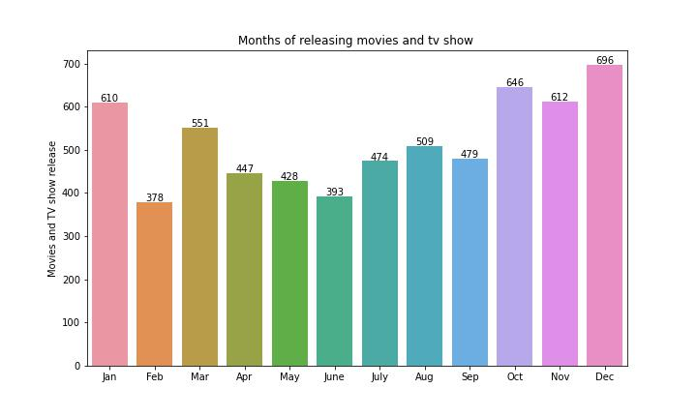

Here we see that maximum movies and TV show releases after October. Because most of the holiday present in December month so this month is also helpful for the producer to earn a lot of profit also.

**WORD CLOUD OF DESCRIPTION COLUMN**

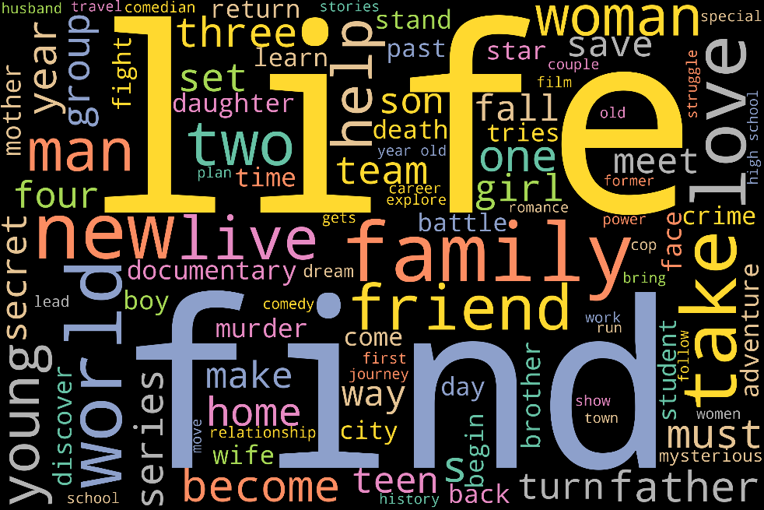

In this figure, we see that **LIFE, FIND,FAMILY, WORLD,WOMEN,LOVE** are bigger in size. Wordcloud shows the frequency of the words. These words more frequently occur in the dataset.

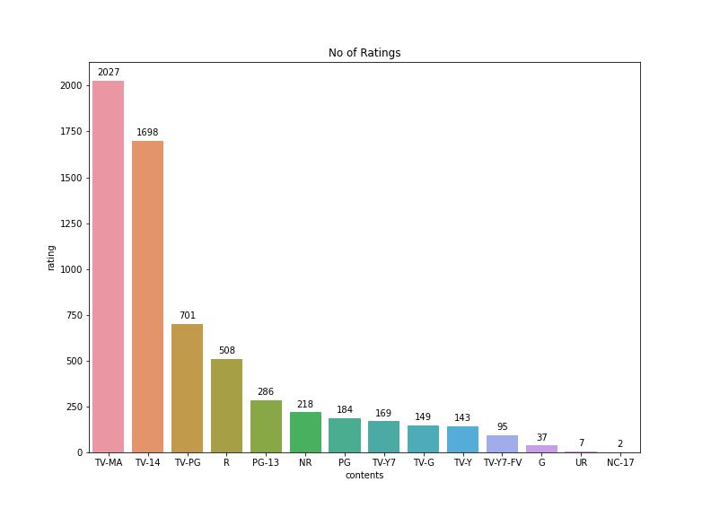

Figure shows that TV-MA and TV-14 have highest rating that means audience give more preference to it and NC-17 have lowest rating .

**'TV-MA': MATURE AUDIENCES ONLY,This program is specifically designed to be viewed by adults and therefore may be unsuitable for children under 17.But it basically include bo**

**'TV-14': PARENTS STRONGLY CAUTIONEDThis program contains some material that many parents would find unsuitable for children under 14 years of age. Parents are strongly urged to exercise greater care in monitoring this program and are cautioned against letting children under the age of 14 watch unattended.**

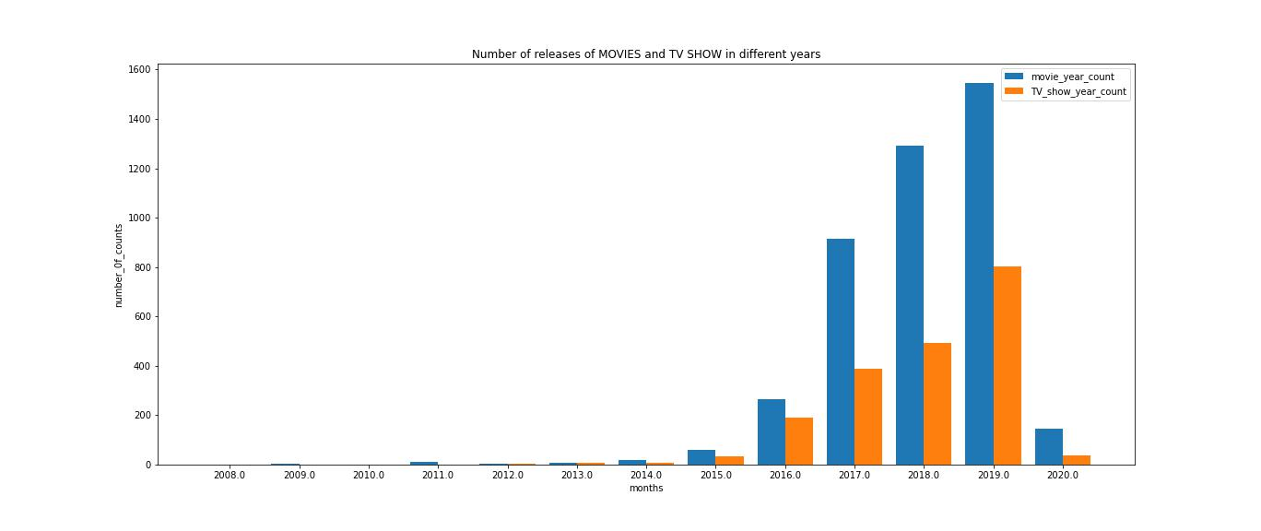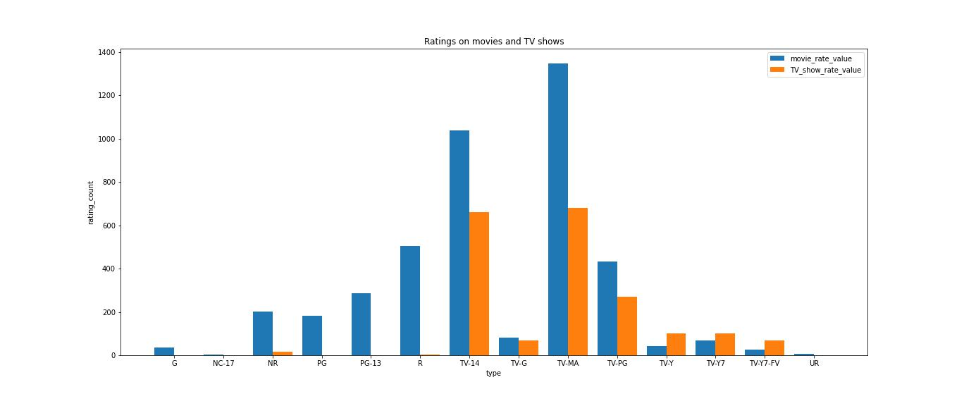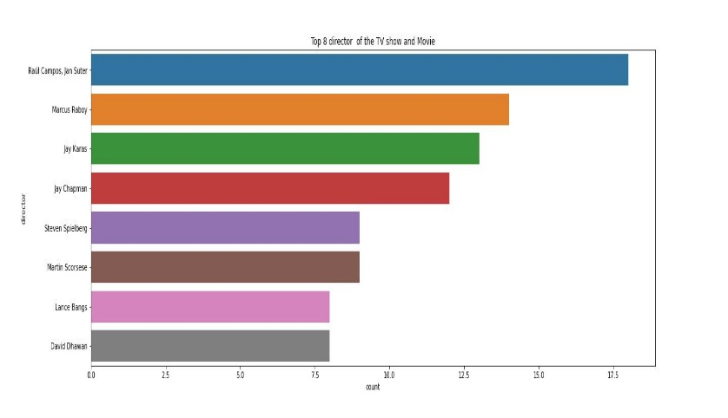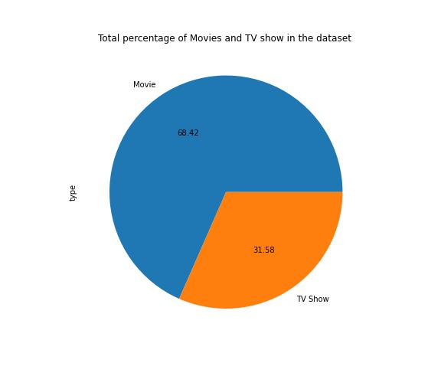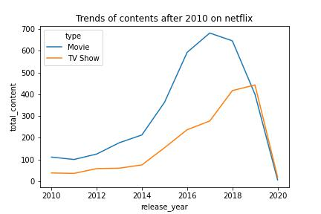

Figure shows the maximum person want to see the movie whose director is (**Raul Campos;Jan Suter), Macros Raboy, Jay Karas, Jay chapman.**

Figure shows the comparison between the (TV-shows and Movies) vs Ratings. Blue bar shows the movies and orange bar **shows the TV show**.

* Maximum people prefer movies over tv-shows on Netflix.
* Large number of people watch TV-MA rating movies and tv shows which are for mature audience.

Highest number of movies and TVshows released on 2019 and 2018, and due to covid reason it drasctically decreases.

68.42% audience like to watch movies over TV show in Netflix.

This is the trend of content(movie, tv show) after 2010 on Netflix, here we see both content exponential growth but after 2019 covid came then it is going downward. After 2019, it badly affects the Netflix for producing contents.