PROJECT BASED LEARNING RECORD
On
UCS4001
DATABASE MANAGEMENT SYSTEM



SCHOOL OF COMPUTER SCIENCE AND ENGINERING
IILM UNIVERSITY
JANUARY 2026 – MAY 2026

Submitted By:
Tanush Bhargava – 2410030192
Ekansh Seth - 2410030477
Abhinav Sharma - 2410030292
Shiwam Bora – 2410030246
Hariom Srivastava – 2410030378

SECTION: - 2CSE10

REAL ESTATE PORTAL
Entity Relationship (ER) Model
Introduction

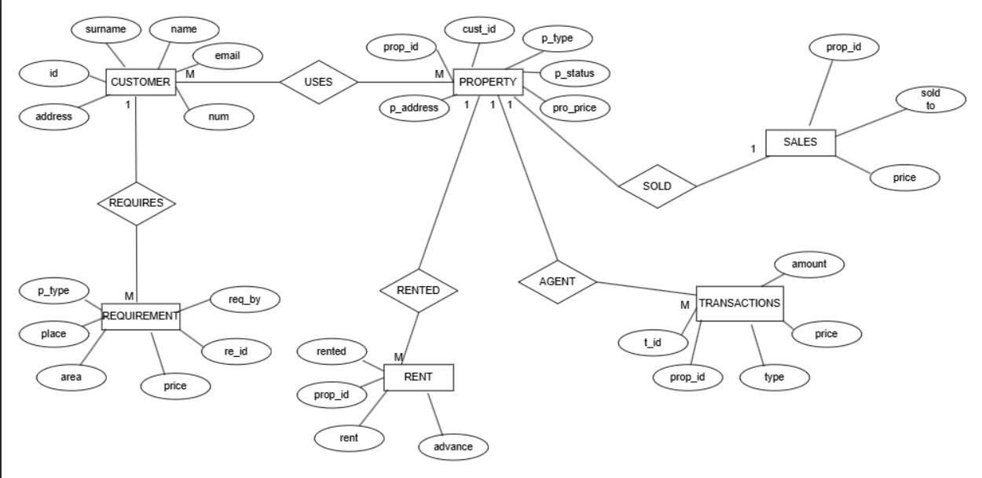
The Real Estate Portal is a database system designed to manage property listings, customer requirements, sales, rentals, and financial transactions.
The ER model represents the logical structure of the database including entities, attributes, and relationships.

List of Entities:
- CUSTOMER
- PROPERTY
- REQUIREMENT
- RENT
- SALES
- TRANSACTIONS

Entity Description with Attributes

CUSTOMER
Represents users of the portal (buyers/sellers).
Attributes:
- id (Primary Key)
- name
- surname
- email
- num (contact number)
- address

PROPERTY
Represents properties listed on the portal.
Attributes:
- prop_id (Primary Key)
- cust_id (Foreign Key → CUSTOMER.id)
- p_type (flat, villa, plot, etc.)
- p_status (available/sold/rented)
- pro_price
- p_address

REQUIREMENT
Represents customer property requirements.
Attributes:
- re_id (Primary Key)
- req_by (Foreign Key → CUSTOMER.id)
- p_type
- place
- area
- price

RENT
Represents rental details of a property.
Attributes:
- rent_id (Primary Key – assumed)
- prop_id (Foreign Key → PROPERTY.prop_id)
- rent
- advance
- rented (status/date)

SALES
Represents sales details of properties.
Attributes:
- sale_id (Primary Key – assumed)
- prop_id (Foreign Key → PROPERTY.prop_id)
- sold_to (Customer ID)
- price

TRANSACTIONS
Represents financial transactions related to property deals.
Attributes:
- t_id (Primary Key)
- prop_id (Foreign Key → PROPERTY.prop_id)
- type (sale/rent)
- amount
- price

Relationships

4.1 USES
Between: CUSTOMER and PROPERTY
Type: Many-to-Many (M:N)
Explanation:
- One customer can view/use many properties.
- One property can be viewed by many customers.

4.2 REQUIRES
Between: CUSTOMER and REQUIREMENT
Type: One-to-Many (1:M)
Explanation:
- One customer can create multiple requirements.
- Each requirement belongs to one customer.

4.3 RENTED
Between: PROPERTY and RENT
Type: One-to-Many (1:M)
Explanation:
- One property can have multiple rental records (over time).
- Each rent record belongs to one property.

4.4 SOLD
Between: PROPERTY and SALES
Type: One-to-Many (1:M)
Explanation:
- One property can have one or more sale records (history).
- Each sale record belongs to one property.

4.5 AGENT (via Transactions)
Between: PROPERTY and TRANSACTIONS
Type: One-to-Many (1:M)
Explanation:
- One property can have multiple transactions.
- Each transaction is related to one property.

Primary Keys and Foreign Keys
Primary Keys:
- CUSTOMER → id
- PROPERTY → prop_id
- REQUIREMENT → re_id
- RENT → rent_id
- SALES → sale_id
- TRANSACTIONS → t_id

Foreign Keys:
- PROPERTY.cust_id → CUSTOMER.id
- REQUIREMENT.req_by → CUSTOMER.id
- RENT.prop_id → PROPERTY.prop_id
- SALES.prop_id → PROPERTY.prop_id
- TRANSACTIONS.prop_id → PROPERTY.prop_id

