Open cmd promt
Step1: windows + r , type : cmd, there type ipconfig
Switch : responsible to handle local area network using lan wire. Responsible to provide ip addresses to each and every computer
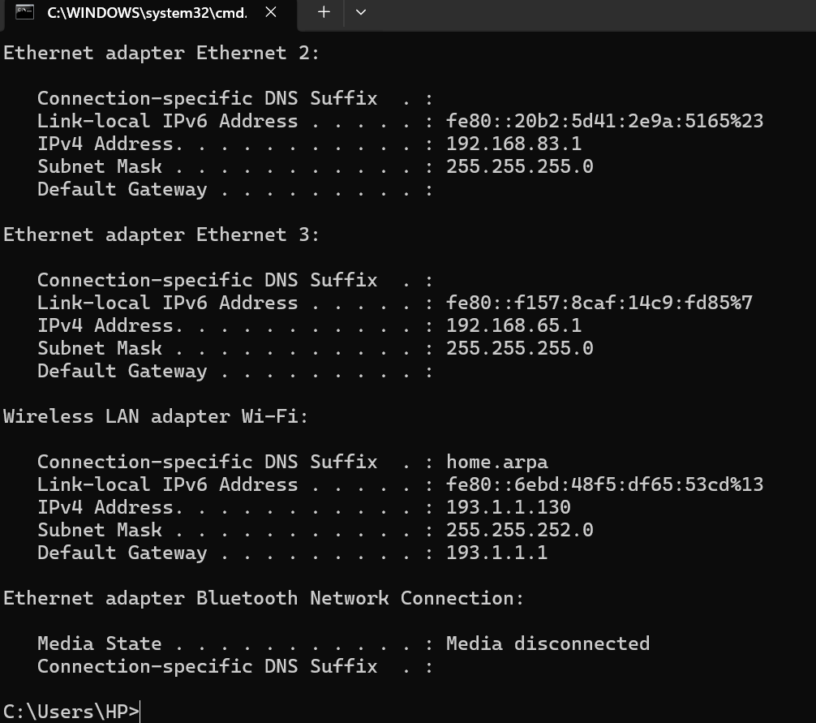

OF OPTIC FIBER-Black box - modem - router---switch
Router will have mmmultiple ports that are used for use for computer at home . it also has blue wan.
Black box - OF:optic fibre passes the electic energy
Modem: it is a combination of 2 words i.e. modulator and demodulator information comes from black box in the form of modulation and converts it into demodulation so that it can be used by the router….
Switch : takes information from router and helps communicate between local area computers or netwrks through lan, manages the ip address
IPV4 has 32 bits
A ip address has 4 parts:
193:1:1:1
N:h:h:h
Class a N:H:H:H
Class b N:N:H:H
Class c N:N:N:H
Class d N:N:N:N

Subnets tells us which class of networks are we using
Mac address: 12 bits long :1st 6 bits are manufacturer and next 6 are unique id
Media access control address : MAC
ARP : ADDRESS RESOLUTION PROTOCOL
Public id :
Personel ip : secured type
Static and dynamic ip
DHCP :

