Wipro-Salesforce Class 2

- Basics Data type primitive [Integer , string , float]
- Collections [List , Set , Map]
- sObject
- Enums

Data type:-

Integer x=100;
Decimal d=10.20;
Long l=123456789l;
Double db=112.123;
Date dt=system.today();
DateTime dtime=system.now();
String s='Shivam';
Boolean flag=true;
Id y='a00fj00002Un6OYAAZ';

system.debug('Integer='+x);
system.debug('Decimal='+d);
system.debug('Long='+l);
system.debug('Cuurent Date='+dt);
system.debug('Current date and time='+dtime);
system.debug('String='+s);
system.debug('Boolean='+flag);
system.debug('Salesforce Id='+y);
output:-

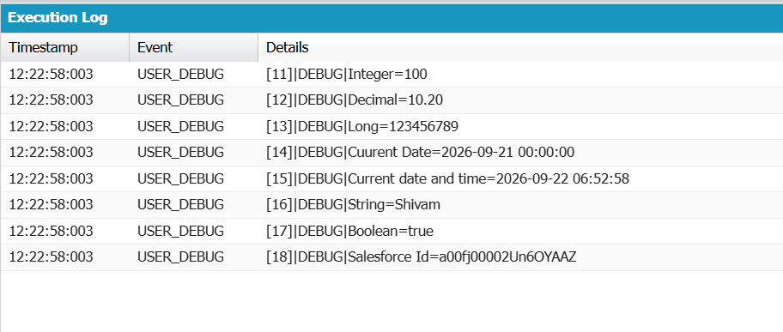

Conditional Statements:-
If Condition :-

- Simple If
Integer x=200;
if(x==100){
system.debug('value of x='+x);
}
- If-Else

Integer x=200;
if(x==100){
system.debug('value of x='+x);
}
else{
system.debug('Wrong Data');
}

- Nested If

Integer Age=30;
String Gender='Female';

if(Age>18){
if(Gender=='Male'){
system.debug('you are eligible');

}
else{
system.debug('Females are not eligible');
}
}
else{
system.debug('less then 18 not allow');
}
- Ladder If
Integer Age=30;
String Gender='T';

if(Age>18){
if(Gender=='Male'){
system.debug('you are eligible');

}
else{
if(Gender=='Female'){
system.debug('you are not eligible');

}
else{
system.debug('transgender are not allowed');
}

}
}
else{
system.debug('less then 18 not allow');
}

Not :-
Boolean flag=false;
if(!flag){
system.debug(flag);
}
else{
system.debug('true');
}

Looping:-
For
for(integer i=0;i<=510;i++){
if(i>310 && i<410){
continue;
}
system.debug('value='+i);
}
For iteration:-

List<Applicant__c> listApp=[select Id,First_Name__c,Last_Name__c,Gender__c,Age__c from Applicant__c];
for(Applicant__c objApp:listApp){
system.debug('First Name='+objApp.First_Name__c+'Last Name='+objApp.Last_Name__c+'Gender='+objApp.Gender__c+'Age='+objApp.Age__c);
}

While
Do-while

