Wipro-Salesforce Class 1

- What is salesforce
- What app object ,field , relationship
- Validation rules
- Opps concepts

App
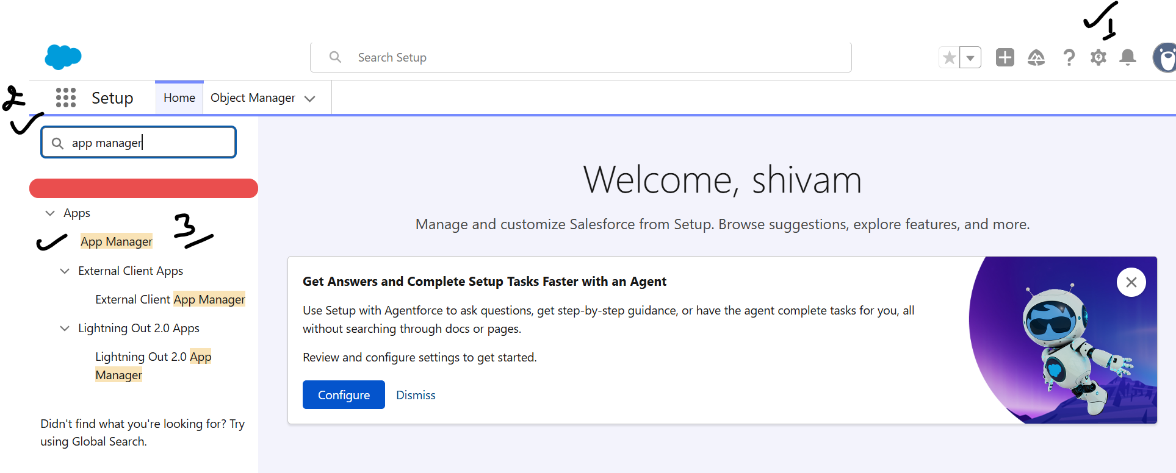
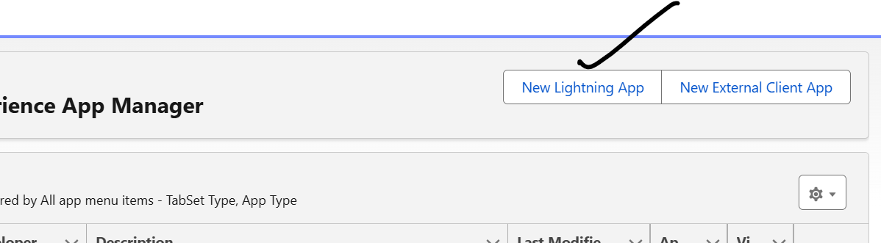

Object :-

User Story 1] if age is <18 and gender Male or Female and name starts with s then error should be “wrong data”

