Assignment No.: 1
5 August, 2026
1] Prevent Applicant If, He is Eligible for Police Verification and Gender is “Male” or “Female”.
Prevention Formula-
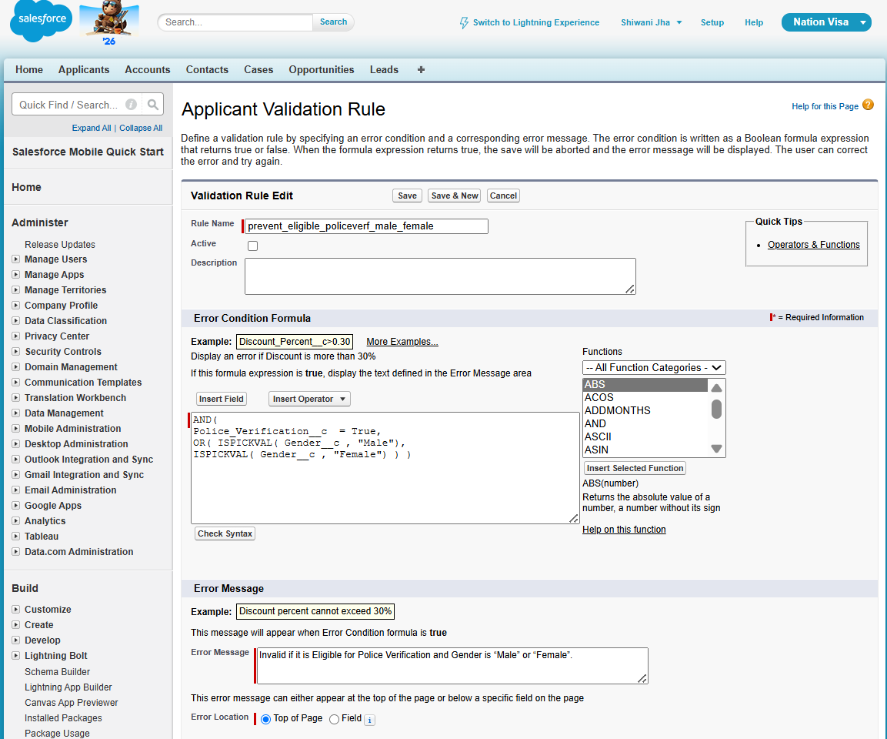

Unit Testing-
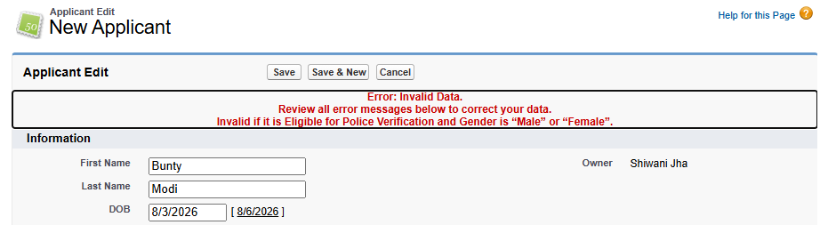

2] Prevent Applicant If, He is Eligible for Police Verification and Gender is “Male” or “Transgender” and DOB Year is before 2000.
Prevention Formula-
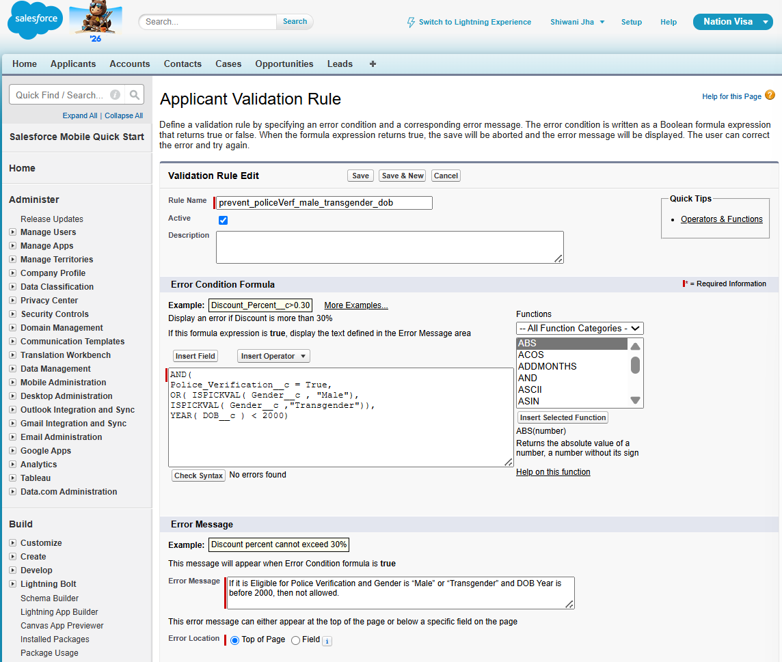

Unit Testing-
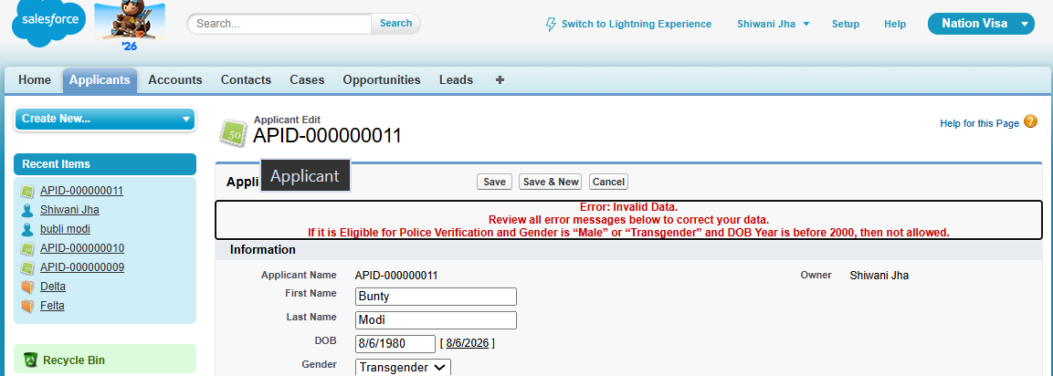

3] Prevent Account is Rating is “Hot” OR “Cold” and SLA is “Gold” or “Platinum” and SIC Code is Blank.
Prevention Formula-
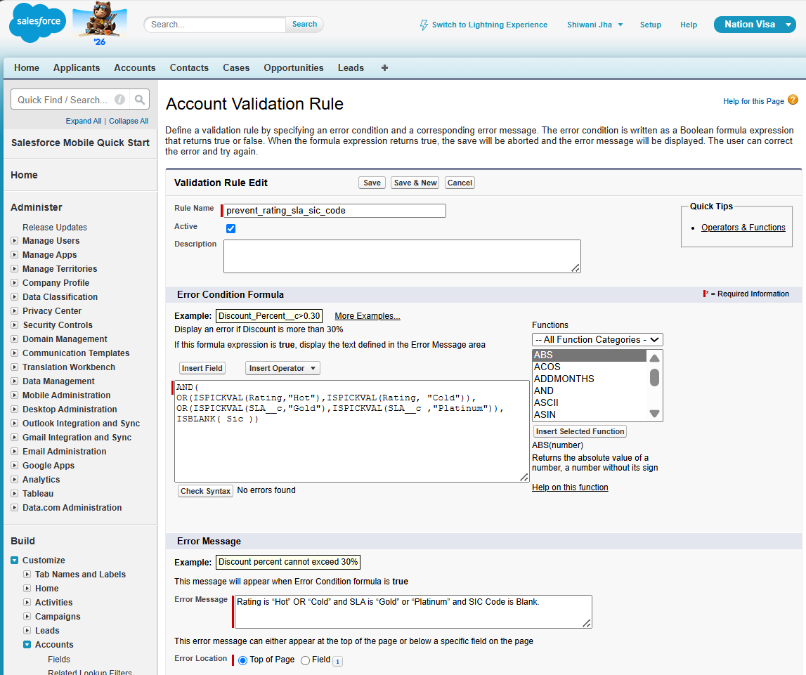
Unit Testing-
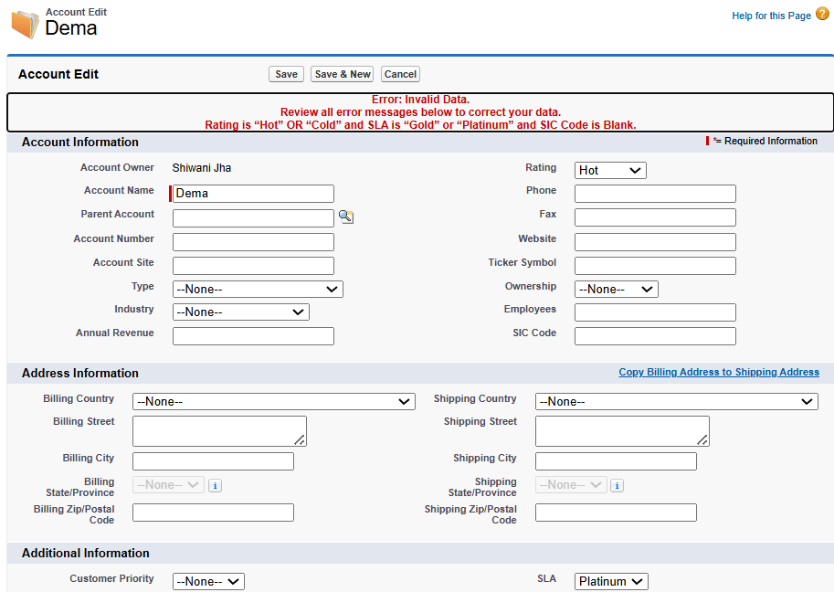
4] Prevent if Contact Email id is Blank and Contact First Name is starting with “A”.
Prevention Formula-
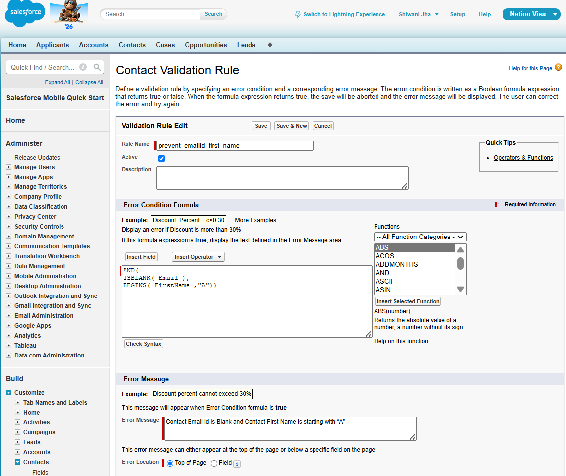

Unit Testing-
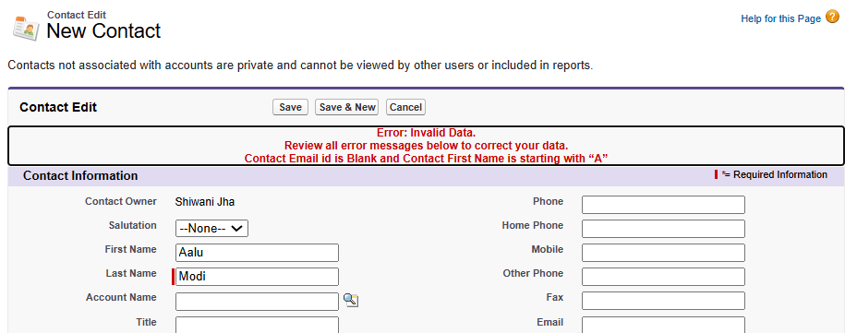

5] Prevent IF Account Type is “Prospect” OR “Customer - Direct” and Rating is “Hot” or “Warm”
And Account Name starts with “A”.
Prevention Formula-
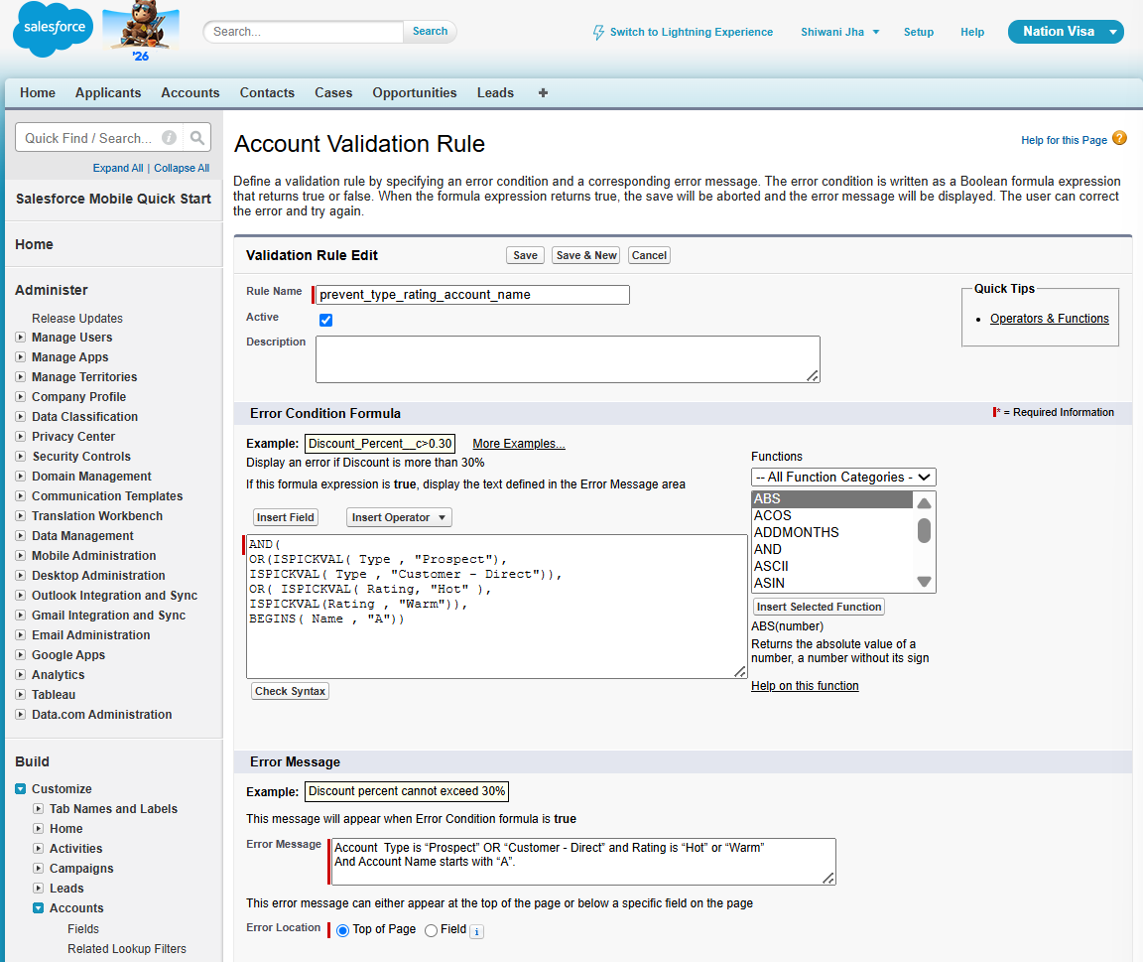

Unit Testing-
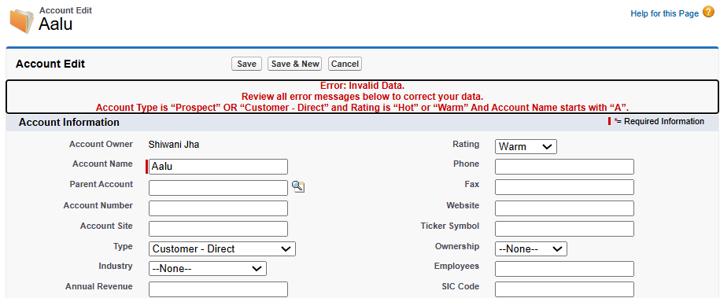
6] Prevent Record If,
1] Age < 18 and Gender is “Female”
Or
2 ] Age =30 and Gender is “Male”
Prevention Formula-
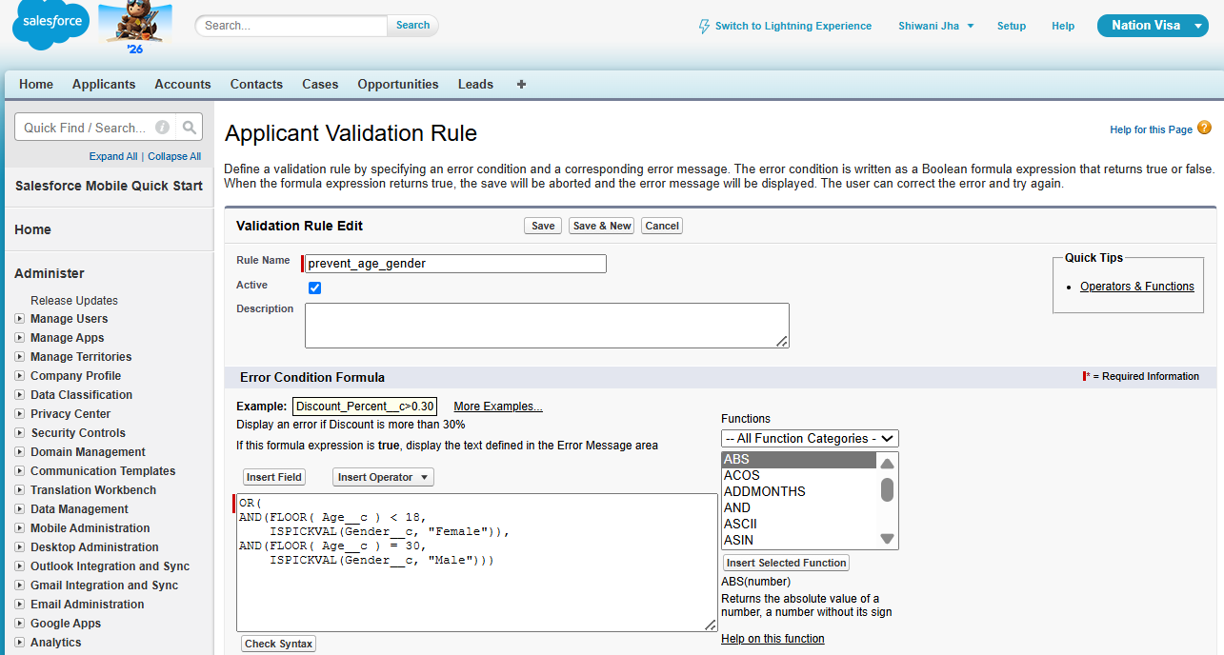

Unit Testing-
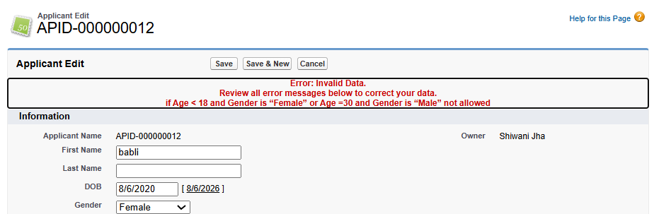
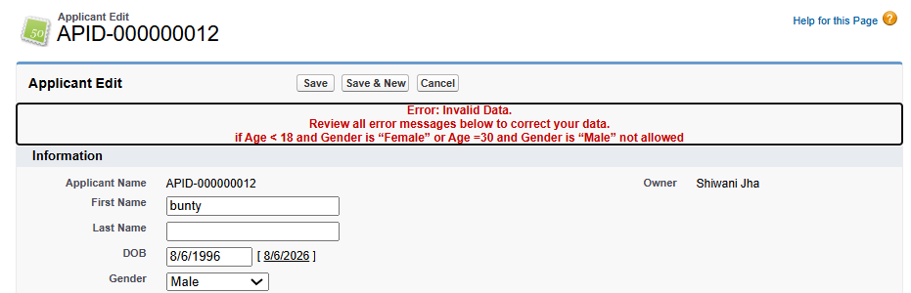
7] Prevent Applicant If, He is Eligible for Police Verification and Gender is “Male” or “Transgender” and DOB Year is before 2000.
Prevention Formula-
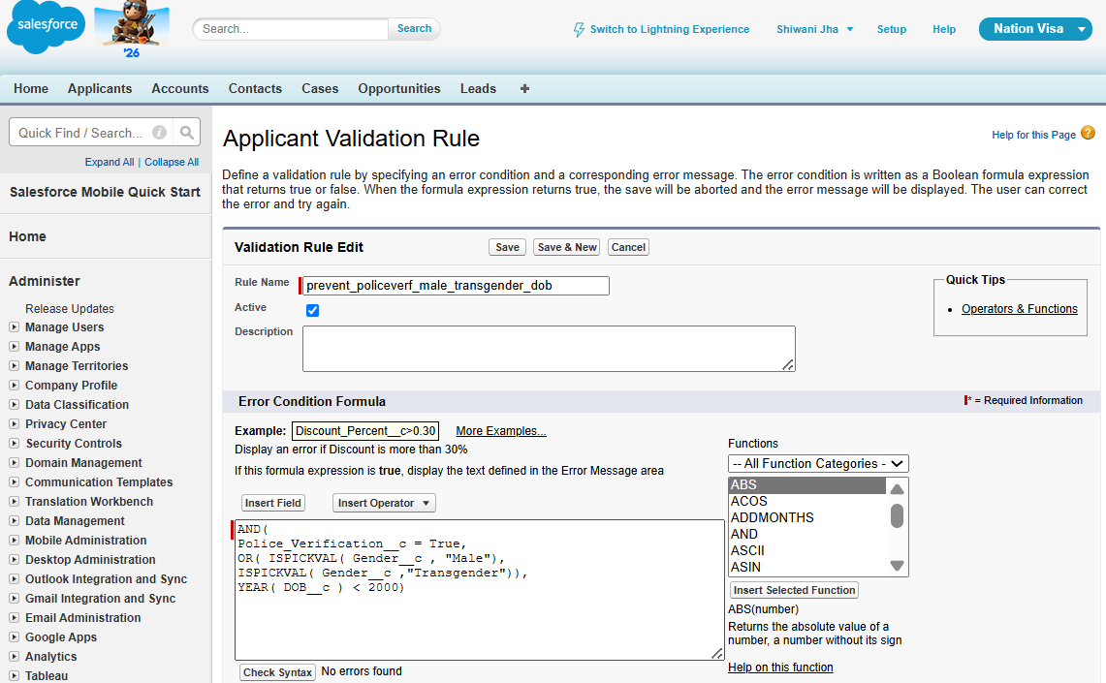

Unit Testing-
