Manuscript for MADA Project

Trend in mammogram screening for breast cancer and socio-economic status of hispanic and non-hispanic women during 2000, 2005, 2010, and 2015

Shiwani Sapkota

4/24/23

# 1. Summary/Abstract

There exists racial differences in mammography screening and breast cancer incidence rates. Hispanic and Black women mostly have later stage cancer diagnosis and lower survival rates compared to White women. Mammography screening could be of great importance in reducing such later stage breast cancer diagnosis among minority women. In that case, it is essential to understand the association between breast cancer screening (mammogram) and socio-economic status of Hispanic and non-Hispanic women. This study was conducted to fill up that knowledge gap with the aim of exploring the relationship trend among socioeconomic status and other predictive factors influencing the likelihood of using mammography screening services within Hispanic and non-Hispanic women.

This study used the publicly available self-reported data from the National Health Interview Survey (NHIS). The study was limited to 40-74 years Hispanic and non-Hispanic women with no report of cancer during the years 2000, 2005, 2010, and 2015. After data cleaning, 24,848 subjects were used for subsequent data analysis.

Women aged 40-74 years were reported having mammogram as 84.5%, 85.3%, 87.8%, and 87.5% during years’ 2000, 2005, 2010, and 2015 respectively. Hispanic women were found having lower mammogram screening rates (80.0%) compared to non-Hispanic women (87.5%). All bivariate and multivariate relationships between mammogram status and hypothesized predictors (year, hispanic status, age, income, education, marital status, region of residence, insurance status, health status, usual medical care status, smoking status, alcohol status, and diabetes status) were found to be significantly associated with mammogram screening. There was a higher log odds of having mammogram among women with income at or above the poverty threshold as opposed to those below the poverty threshold. Alcohol and smoke users were found having low log odds of having mammograms compared to never alcohol and smoke users.

This study findings could be of great importance as health practitioners could identify high risk behavior individuals and recommend appropriate cancer screening services. Given the lower overall breast cancer screening rates among Hispanic women, increased education and awareness should be among top priorities for developing appropriate population-based interventions for increasing the use of mammography screening. Furthermore, intervention programs should emphasize on educating women and on making uneducated women aware of such cancer screening services.

# 2. Introduction

Breast cancer is one of the most common cancers and the second leading cause of cancer death among women in the US. Mammography screening is a screening process where an x-ray image of the breast is taken to detect irregularities in breast tissue which could be the sign of cancer (1). Mammography screening can help detect and treat breast cancer at early stages reducing the mortality rate (2,3,4,5). Hence, mammography screening can play a great role in early breast cancer detection and treatment, and in reduction in the number of deaths related to breast cancer. The U.S. Preventive Services Task Force (USPSTF) recommends a biennial (every other year) mammography screening for women aged 50 to 74 years and advises to determine the need for mammography screening on an individual basis for women aged 40 to 49 years (6).

There are well established racial differences in breast cancer incidence and mortality rates (7,8). The rate of breast cancer is higher among White women compared to Black and Hispanic women. But Black and Hispanic women are often diagnosed at later stages of the cancer and have lower survival rates compared to White women (7). Apart from the racial differences, there are some consistent findings regarding the positive association between breast cancer screening and SES factors such as income and having a usual/regular source of medical care but there are some conflicting results regarding the effects of SES factors such as education, age, and marital status on breast cancer screening (9).

Little is known about the predictors of using cancer screening services among minority women, particularly Hispanics. Very few studies have studied the influence of socioeconomic status (SES) and sociodemographic factors on utilizing mammography screening services among Hispanic/non-Hispanic groups of women (7). It is important to understand the influence of women’s SES and race/ethnicity on the use of available health care services for improving knowledge about service utilization pattern in women population and for designing appropriate interventions accordingly (10). Hence, for developing appropriate population-based interventions for increasing the use of mammography screening, it is essential to first identify and understand the association and interaction between the use of mammography screening and demographic/socio-economic characteristics of women (7).

This study aims to explore the relationship trend among socioeconomic status and other predictive factors influencing the likelihood of using mammography screening services within Hispanic and non-Hispanic women aged 40 to 74 years during 2000, 2005, 2010, and 2015.

# 3. Methods

The study used the data from the National Health Interview Survey (NHIS). The NHIS survey collects information related to health, health care access, health behaviors of the civilian and non-institutionalized US population and makes digital data files available for years 1963 to present (11). Users can create their own costumed NHIS data extracts for analysis from the NHIS website. For this study, data with the variables of interest for years: 2000, 2005, 2010, and 2015 were directly extracted from the NHIS website. Those specific 4 years were selected for the study as there were most data points available for those years and 5-years difference comparison could give great insights at the trends of mammogram screening over years. The study was restricted among Hispanic and non-Hispanic women aged 40-74 years as per the mammography screening recommendation by USPSTF and those age groups women fall under high-risk groups for developing breast cancer. Hence, the study was limited within 40-74 years Hispanic and non-Hispanic women with no report of cancer during the years 2000, 2005, 2010, and 2015. Exclusion of missing data points in 1 or more predictor variables yielded a final sample of 24,848 subjects.

Mammography screening status (yes or no) was defined as outcome variable of interest for the study. Similarly, the following variables were assessed as predictors of mammogram screening: (1) age (40-44, 45-49, 50-54, 55-59, 60-64, 65-69, or 70-74), (2) income (at or above poverty threshold, or below poverty threshold), (3) education (never attended/kindergarten only, less than high school, high school, some college or associate’s degree, or bachelor’s degree and higher), (4) marital status (never married, married, or single (separated/widowed/divorced)), (5) region of residence (Northeast, North Central/Midwest, South, or West), (6) insurance status (no coverage or coverage), (7) self-reported health status (excellent/very good/good or fair/poor), (8) having a usual place of medical care (no place or have usual place), (9) smoking status (never, current, or former), (10) alcohol status (never, current, or former), and (11) diabetic status (yes or no).

The univariate relationship between the mammogram screening and each hypothesized predictors was assessed using logistic regression. Multiple logistic regression was also performed for determining the multivariate effect on mammogram screening. Model selection process was performed and the final model model was selected based on ROC AUC (Area under the Receiver Operating Characteristic curve) value. The model evaluation was performed using 5-fold cross-validation process repeated for 5 times. All analysis were performed using R (version 4.2.1) and cross-validation was performed using the tidymodels package. The code and data for reproducing results are available on [Github](https://github.com/shiwanisapkota/shiwanisapkota-MADA-project).

# 4. Results

## 4.1 Exploratory/Descriptive analysis

Table 1 shows the demographic characteristics of the study population on the basis of mammogram screening status (Yes/No). Out of 24,848 subjects, there were 21,466 (86.4%) women doing mammogram screening while there were 3,382 (13.6%) women who did not do mammogram screening. Similarly, there were 21,056 (84.7%) non-Hispanic women and 3,792 (15.3%) Hispanic women. Larger proportion of women aged 40-44 years did not go for mammogram screening compared to other aged women. Similarly, women with education level of some college or associate degree had higher proportion of mammogram screening. Majority of our participants (58.7%) were never smokers. Out of 21,056 non-Hispanic women, 18,432 (87.6%) had mammogram screening while out of 3,792 Hispanic women, 3,034 (80%) had mammogram screening. Figure 1 shows increasing trend in mammogram screening among women going through 2000 to 2015.

**Table 1: Demographic characteristics of study population by mammogram screening status**

|  | **No** | **Yes** |
| --- | --- | --- |
| **Characteristic** | **N = 3,382**1 | **N = 21,466**1 |
| hispanic_status |  |  |
| NH | 2,624 (78%) | 18,432 (86%) |
| H | 758 (22%) | 3,034 (14%) |
| year |  |  |
| 2000 | 885 (26%) | 4,837 (23%) |
| 2005 | 848 (25%) | 4,924 (23%) |
| 2010 | 706 (21%) | 5,092 (24%) |
| 2015 | 943 (28%) | 6,613 (31%) |
| age |  |  |
| 40-44 years | 1,420 (42%) | 3,244 (15%) |
| 45-49 years | 639 (19%) | 3,852 (18%) |
| 50-54 years | 402 (12%) | 3,731 (17%) |
| 55-59 years | 304 (9.0%) | 3,364 (16%) |
| 60-64 years | 225 (6.7%) | 2,919 (14%) |
| 65-69 years | 209 (6.2%) | 2,380 (11%) |
| 70-74 years | 183 (5.4%) | 1,976 (9.2%) |
| income |  |  |
| At or above poverty threshold | 2,575 (76%) | 18,720 (87%) |
| Below poverty threshold | 807 (24%) | 2,746 (13%) |
| education |  |  |
| Never attended/kindergarten only | 46 (1.4%) | 80 (0.4%) |
| Less than high school | 737 (22%) | 2,691 (13%) |
| High school | 1,121 (33%) | 6,129 (29%) |
| Some college or Associate degree | 847 (25%) | 6,553 (31%) |
| Bachelor degree and higher | 631 (19%) | 6,013 (28%) |
| marital_status |  |  |
| Never married | 571 (17%) | 2,111 (9.8%) |
| Married | 1,485 (44%) | 10,741 (50%) |
| Single (separated/widowed/divorced) | 1,170 (35%) | 7,933 (37%) |
| Living with partner | 156 (4.6%) | 681 (3.2%) |
| region_residence |  |  |
| Northeast | 477 (14%) | 3,884 (18%) |
| North Central/Midwest | 678 (20%) | 4,716 (22%) |
| South | 1,355 (40%) | 7,748 (36%) |
| West | 872 (26%) | 5,118 (24%) |
| insurance_status |  |  |
| No Coverage | 2,409 (71%) | 19,425 (90%) |
| Coverage | 973 (29%) | 2,041 (9.5%) |
| health_status |  |  |
| Excellent/very good/good | 2,787 (82%) | 17,806 (83%) |
| Fair/poor | 595 (18%) | 3,660 (17%) |
| usual_medicalcare_status |  |  |
| No place | 752 (22%) | 1,327 (6.2%) |
| Usual place | 2,630 (78%) | 20,139 (94%) |
| smoking_status |  |  |
| Never | 1,974 (58%) | 12,608 (59%) |
| Current | 896 (26%) | 3,729 (17%) |
| Former | 512 (15%) | 5,129 (24%) |
| alcohol_status |  |  |
| Never | 1,183 (35%) | 5,223 (24%) |
| Current | 1,673 (49%) | 12,602 (59%) |
| Former | 526 (16%) | 3,641 (17%) |
| diabetes_status | 336 (9.9%) | 2,985 (14%) |
| 1n (%) | | |

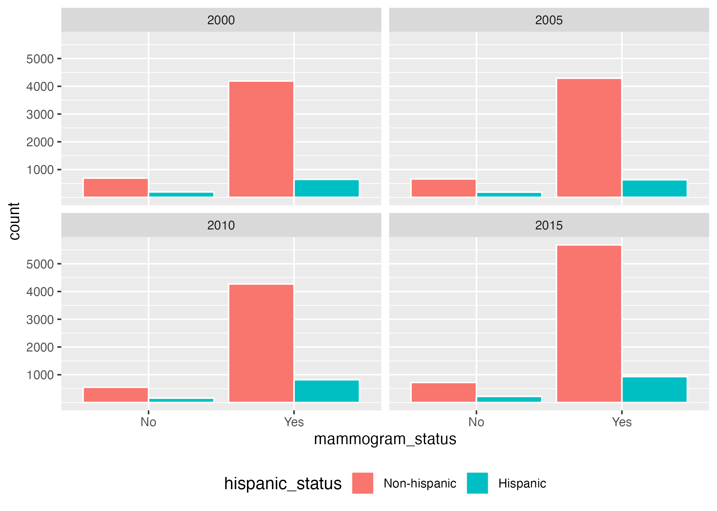

**Figure 1: Summary of mammography screening status and the Hispanic status of study population in 2000, 2005, 2010, and 2015.**

## 4.2 Statistical Analysis

### 4.2.1 Model Fitting

We aimed to explore the bivariate and multivariate relationship between mammogram screening and other hypothesized predictors i.e., year, hispanic status, age, income, education, marital status, region of residence, insurance status, health status, usual medical care status, smoking status, alcohol status, and diabetes status. Logistic regression was used for examining such relationships. In bivariate relationship (Supplementary Tables 3-12), we found statistically significant relationship between mammogram screening and hispanic status of women and found the log odds of having mammogram screening for Hispanic women as -0.56 compared to non-Hispanic women. The log odds of having mammogram was found as 0.25 in year 2015 compared to that of 2000. We also found that the log odds of having mammogram increased with age, and education. We found the log odds of having mammogram screening for women with income below the poverty threshold as -0.76 compared to women with income at or above the poverty threshold. The log odds of having mammogram for married was 0.67 compared to never married women. Women having the usual medical place had the log odds of having mammogram of 1.47 compared to those having no usual medical place. Similarly, Table 2 shows the multivariate relationship between mammogram screening and all other predictors of interests. All predictors of interests were found to be significant predictors of mammogram.

Table 3 shows the model performance comparison which compared the models’ performance including various numbers of predictors. The best model performance was found for the full model including all predictors of interests (AIC: 16981 and RMSE: 0.32). Similarly, based on model performance comparison, second best model was identified as the model including demographic predictors (age, hispanic status, income, education, marital status, and region of residence) that had AIC of 17764.1 and RMSE of 0.33.

**Table 2: Full model fitting using mammogram_status as outcome variable and other variables as predictor variables.**

| term | estimate | std.error | statistic | p.value |
| --- | --- | --- | --- | --- |
| (Intercept) | -1.5443 | 0.2316 | -6.669 | 0.00e+00 |
| (year)2005 | -0.0216 | 0.0565 | -0.383 | 7.01e-01 |
| (year)2010 | 0.2212 | 0.0594 | 3.722 | 1.98e-04 |
| (year)2015 | -0.0620 | 0.0556 | -1.115 | 2.65e-01 |
| (age)45-49 years | 1.0472 | 0.0567 | 18.474 | 0.00e+00 |
| (age)50-54 years | 1.4752 | 0.0652 | 22.640 | 0.00e+00 |
| (age)55-59 years | 1.6388 | 0.0723 | 22.674 | 0.00e+00 |
| (age)60-64 years | 1.7749 | 0.0810 | 21.922 | 0.00e+00 |
| (age)65-69 years | 1.5231 | 0.0848 | 17.963 | 0.00e+00 |
| (age)70-74 years | 1.4977 | 0.0906 | 16.539 | 0.00e+00 |
| (hispanic_status)Hispanic | 0.1025 | 0.0578 | 1.775 | 7.59e-02 |
| (income)Below poverty threshold | -0.2723 | 0.0555 | -4.903 | 9.00e-07 |
| (education)Less than high school | 0.7649 | 0.2071 | 3.693 | 2.21e-04 |
| (education)High school | 0.9931 | 0.2077 | 4.782 | 1.70e-06 |
| (education)Some college or Associate degree | 1.3474 | 0.2093 | 6.436 | 0.00e+00 |
| (education)Bachelor degree and higher | 1.4689 | 0.2118 | 6.936 | 0.00e+00 |
| (marital_status)Married | 0.4842 | 0.0610 | 7.938 | 0.00e+00 |
| (marital_status)Single (separated/widowed/divorced) | 0.3620 | 0.0630 | 5.747 | 0.00e+00 |
| (marital_status)Living with partner | 0.2742 | 0.1120 | 2.448 | 1.44e-02 |
| (region_residence)North Central/Midwest | -0.2085 | 0.0681 | -3.061 | 2.21e-03 |
| (region_residence)South | -0.1806 | 0.0613 | -2.945 | 3.23e-03 |
| (region_residence)West | -0.2559 | 0.0660 | -3.877 | 1.06e-04 |
| (insurance_status)Coverage | -0.7057 | 0.0560 | -12.591 | 0.00e+00 |
| (health_status)Fair/poor | 0.1054 | 0.0578 | 1.825 | 6.80e-02 |
| (usual_medicalcare_status)Usual place | 0.9063 | 0.0604 | 15.011 | 0.00e+00 |
| (smoking_status)Current | -0.3440 | 0.0521 | -6.604 | 0.00e+00 |
| (smoking_status)Former | 0.1173 | 0.0575 | 2.041 | 4.12e-02 |
| (alcohol_status)Current | 0.5173 | 0.0496 | 10.430 | 0.00e+00 |
| (alcohol_status)Former | 0.3845 | 0.0635 | 6.059 | 0.00e+00 |
| (diabetes_status)Yes | 0.1729 | 0.0677 | 2.554 | 1.07e-02 |

**Table 3: Model Performance Comparisons.**

| Name | AIC | BIC | RMSE |
| --- | --- | --- | --- |
| log_fit_year | 19738 | 19771 | 0.343 |
| log_fit_hispanicstatus | 19633 | 19650 | 0.342 |
| log_fit_age | 18481 | 18538 | 0.332 |
| log_fit_income | 19517 | 19533 | 0.341 |
| log_fit_education | 19424 | 19465 | 0.340 |
| log_fit_maritalstatus | 19617 | 19649 | 0.342 |
| log_fit_regionresidence | 19729 | 19761 | 0.343 |
| log_fit_insurancestatus | 18957 | 18974 | 0.336 |
| log_fit_healthstatus | 19774 | 19790 | 0.343 |
| log_fit_usualmedicalcarestatus | 19022 | 19038 | 0.336 |
| log_fit_smokingstatus | 19549 | 19573 | 0.341 |
| log_fit_alcoholstatus | 19610 | 19635 | 0.342 |
| log_fit_diabetesstatus | 19732 | 19748 | 0.343 |
| log_fit_fullmodel | 16981 | 17225 | 0.320 |
| log_fit_year_age_hispanic | 18385 | 18474 | 0.332 |
| log_fit_demographic | 17764 | 17918 | 0.327 |
| log_fit_medical | 18639 | 18680 | 0.333 |
| log_fit_smoking_alcohol | 19381 | 19422 | 0.340 |

### 4.2.2 Model Evaluation

Model evaluation was performed for the full model including all predictors of interest and the alternative model including only hispanic status of women as the main predictor for mammogram. Data splitting was done by putting 3/4 of the data into the training set and recipe was created accordingly for fitting the full and alternative logistic models. Figure 2 shows the ROC curve for the full model (using mammogram status as the main outcome of interest and other variables as predictors) having ROC-AUC as 0.76 and the ROC curve for the alternative model (using mammogram status as the main outcome of interest and hispanic status as the main predictor) having ROC-AUC as 0.54. The larger the area under the curve, better the model is at distinguishing those with the outcomes from those without the outcomes. Hence, from the given figure, we can say that for mammogram status, the full model with all the predictors of interest is better than the alternative model having only Hispanic status as the main predictor.

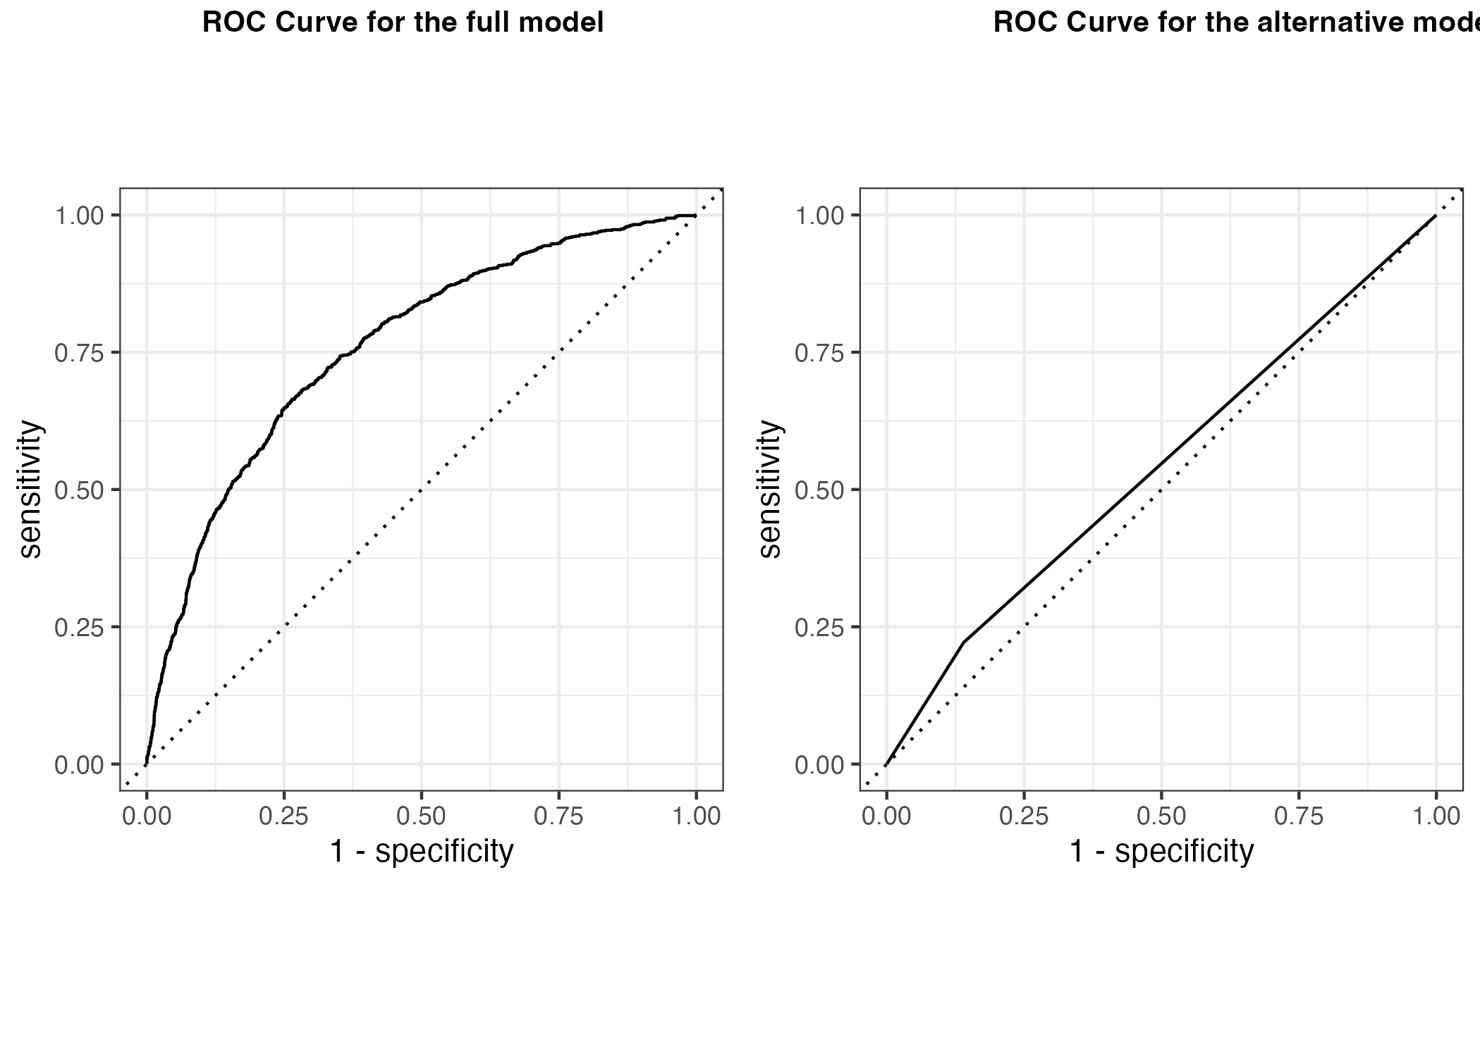

**Figure 3: ROC Curve for the full model and alternative model.**

### 4.2.3 Machine Learning

Different modeling techniques were performed for multivariate analysis using Decision-tree method and Lasso method. The data was split into 70% training and 30% testing using mammogram status (outcome) as stratification. Five-fold cross-validation was also performed which was repeated for 5 times. A null model was used for comparing the model performance and for interpreting the predictors’ importance. The ROC_AUC value for null model was found as 0.5 and this value was used as a basis for comparing Decision tree and Lasso models. The Decision tree model had the ROC_AUC value of 0.7 while Lasso model had the ROC_AUC value of 0.8. Both models performed better than the null model. But out of all the models, Lasso model performed the best and hence, Lasso model was chosen as the best performing model.

**Table 4: Model Selection using Null method, Decision tree method, and Lasso method.**

| Model | ROC_AUC |
| --- | --- |
| Null | 0.5 |
| Decision Tree | 0.7 |
| Lasso | 0.8 |

# 5. Discussion

This study aimed to explore the relationship trend among socioeconomic status and other predictive factors influencing the likelihood of using mammography screening services within Hispanic and non-Hispanic women aged 40 to 74 years during 2000, 2005, 2010, and 2015. There are very few studies relating to ethnicity and socio-economic characteristics of women for mammogram screening so this study helps to identify and understand the association and interaction between the use of mammography screening and demographic/socio-economic characteristics of women.

In this study, we examined the mammography screening status of women aged 40 to 74 years and their relationship with the hypothesized predictors: year, hispanic status, age, income, education, marital status, region of residence, insurance status, health status, usual medical care status, smoking status, alcohol status, and diabetes status. During years 2000, 2005, 2010, and 2015, 84.5%, 85.3%, 87.8%, and 87.5% of women aged 40-74 years reported having mammogram. Though there was not much increment in mammography rate from 2010 to 2015 but there was some mammography rate increment compared to 2000 and 2005. Such increment in mammography rate could be due to people’s increased awareness and education, improved access to healthcare, advanced in technology, and changing mammography recommendation guidelines. Our findings support previous research as Hispanic women having lower mammogram screening rates (80.0%) compared to non-Hispanic women (87.5%) (12). All bivariate and multivariate relationships between mammogram status and predictors were found to be significant hence, all hypothesized predictors were found to have strong association with mammogram screening. As suggested in previous studies (13), we found higher log odds of having mammogram among women with income at or above the poverty threshold as opposed to those below the poverty threshold. Alcohol and smoke users were found having low log odds of having mammograms compared to never alcohol and smoke users. Previous studies have also suggested that people engaging in high risk behaviors are less likely to comply with cancer screening guidelines (14). This finding could be of great importance as health practitioners could identify such individuals and recommend appropriate cancer screening services. In full model, we found education and age as the predictors having highest significant association with mammogram screening. In that case, intervention programs should emphasize on educating women and make uneducated women aware of such cancer screening services.

This study has several strengths, including the large national women sample size which contributes to the generalizability of this study’s findings. The publicly available dataset from NHIS makes the study easily accessible and feasible for this study’s reproducibility. Furthermore, this study includes women of minority groups especially Hispanic women, who are largely excluded from breast cancer screening studies.

Nevertheless, there are some limitations of the study. There could be some form of bias resulting from the use of self-reported data. The study was limited to only 4 years study (2000, 2005, 2010, and 2015) as most of the data points for other years were missing so this study might not have captured the potential confounding variables that might have changed over time.

# 6. Conclusions

This study confirms that there exists some association between mammogram screening and socio-economic status of Hispanic/non-Hispanic women during different years as all the hypothesized predictors were found to be significantly associated with mammogram status. We found age, education, income, and smoking/alcohol behavior as the great predictors for having mammogram screening. Further research needs to be done to dive more into these hypothesized predictors to see their absolute and relative effects on mammogram screening. Furthermore, given the lower overall breast cancer screening rates among Hispanic women, increased education and awareness should be among top priorities for developing appropriate population-based interventions for increasing the use of mammography screening.

# 7. References

1. Gorina Y, Elgaddal N. [Patterns of Mammography, Pap Smear, and Colorectal Cancer Screening Services Among Women Aged 45 and Over](https://www.ncbi.nlm.nih.gov/pubmed/34181518). *National Health Statistics Reports*. 2021;(157):1-18.

2. Tabár L, Gad A, Holmberg LH, et al. REDUCTION IN MORTALITY FROM BREAST CANCER AFTER MASS SCREENING WITH MAMMOGRAPHY. *The Lancet*. 1985;325(8433):829-832. doi:[10.1016/S0140-6736(85)92204-4](https://doi.org/10.1016/S0140-6736(85)92204-4)

3. Kerlikowske K, Grady D, Rubin SM, Sandrock C, Ernster VL. [Efficacy of screening mammography. A meta-analysis](https://www.ncbi.nlm.nih.gov/pubmed/7799496). *JAMA*. 1995;273(2):149-154.

4. Shapiro S, Venet W, Strax P, Venet L, Roeser R. [Ten- to fourteen-year effect of screening on breast cancer mortality](https://www.ncbi.nlm.nih.gov/pubmed/6955542). *Journal of the National Cancer Institute*. 1982;69(2):349-355.

5. Lăără E, Day NicholasE, Hakama M. TRENDS IN MORTALITY FROM CERVICAL CANCER IN THE NORDIC COUNTRIES: ASSOCIATION WITH ORGANISED SCREENING PROGRAMMES. *The Lancet*. 1987;329(8544):1247-1249. doi:[10.1016/S0140-6736(87)92695-X](https://doi.org/10.1016/S0140-6736(87)92695-X)

6. Siu AL, on behalf of the U.S. Preventive Services Task Force. Screening for Breast Cancer: U.S. Preventive Services Task Force Recommendation Statement. *Annals of Internal Medicine*. 2016;164(4):279. doi:[10.7326/M15-2886](https://doi.org/10.7326/M15-2886)

7. Selvin E, Brett KM. Breast and cervical cancer screening: Sociodemographic predictors among White, Black, and Hispanic women. *American Journal of Public Health*. 2003;93(4):618-623. doi:[10.2105/ajph.93.4.618](https://doi.org/10.2105/ajph.93.4.618)

8. Aftab IB, Ahmed A, Mumu SK, Mouly TF, Commar DS. Trends and Disparities in Breast Cancer Incidence-Mortality Rates of Black-White Women in the U.S.: 2000-2016. *Advances in Breast Cancer Research*. 2021;10(04):200-217. doi:[10.4236/abcr.2021.104017](https://doi.org/10.4236/abcr.2021.104017)

9. Achat H, Close G, Taylor R. Who has regular mammograms? Effects of knowledge, beliefs, socioeconomic status, and health-related factors. *Preventive Medicine*. 2005;41(1):312-320. doi:[10.1016/j.ypmed.2004.11.016](https://doi.org/10.1016/j.ypmed.2004.11.016)

10. Monnat SM. Race/Ethnicity and the Socioeconomic Status Gradient in Women’s Cancer Screening Utilization: A Case of Diminishing Returns? *Journal of Health Care for the Poor and Underserved*. 2014;25(1):332-356. doi:[10.1353/hpu.2014.0050](https://doi.org/10.1353/hpu.2014.0050)

11. Blewett, Lynn A., Drew, Julia A. Rivera, Griffin, Risa, King, Miriam L., Williams, Kari C.W. IPUMS Health Surveys: National Health Interview Survey, Version 6.2. Published online 2016. doi:[10.18128/D070.V6.2](https://doi.org/10.18128/D070.V6.2)

12. Selvin E, Brett KM. Breast and Cervical Cancer Screening: Sociodemographic Predictors Among White, Black, and Hispanic Women. *American Journal of Public Health*. 2003;93(4):618-623. doi:[10.2105/AJPH.93.4.618](https://doi.org/10.2105/AJPH.93.4.618)

13. Katz SJ, Zemencuk JK, Hofer TP. Breast cancer screening in the United States and Canada, 1994: Socioeconomic gradients persist. *American Journal of Public Health*. 2000;90(5):799-803. doi:[10.2105/ajph.90.5.799](https://doi.org/10.2105/ajph.90.5.799)

14. Holm CJ, Frank DI, Curtin J. Health beliefs, health locus of control, and women’s mammography behavior: *Cancer Nursing*. 1999;22(2):149-156. doi:[10.1097/00002820-199904000-00007](https://doi.org/10.1097/00002820-199904000-00007)