NAME : SHIWANSHU KUMAR JHA
MOBILE_NUMBER : 7979756698
EMAIL_ID : shiwanshukumarjha7@gmail.com
GIT_REPO : https://github.com/shiwanshu97/GIT_Assessment.git

Question 1: Project Initialisation & First Push
Objective : Set up a new Git project and push it to a remote repository.

- Tasks :-

- Create a new folder for your project
Git Assessment is a new folder
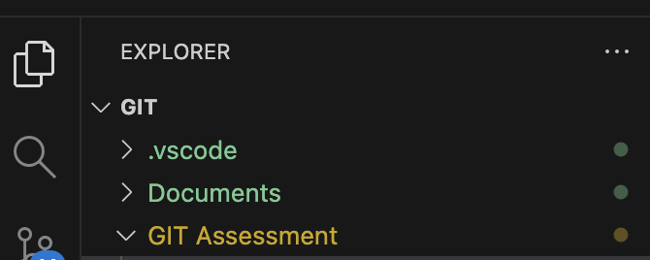

- Initialise Git repository
Initialised git repository using git init command
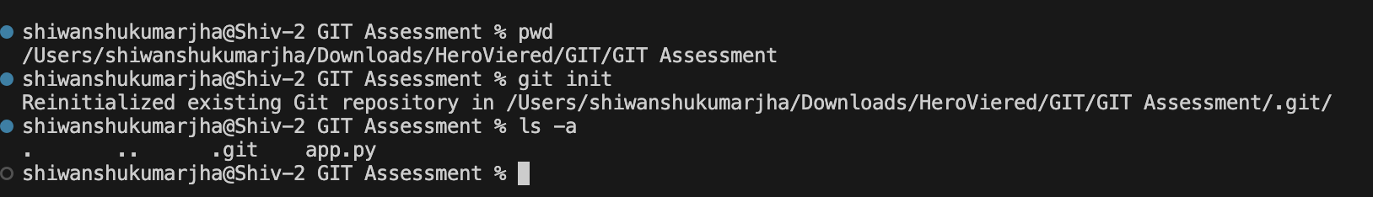

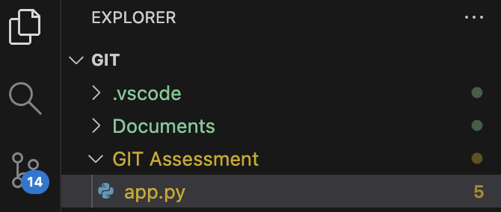
3. Create a file named app.py and add some Python code

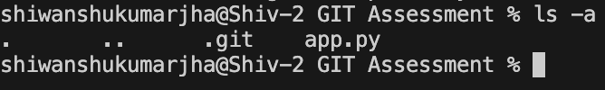

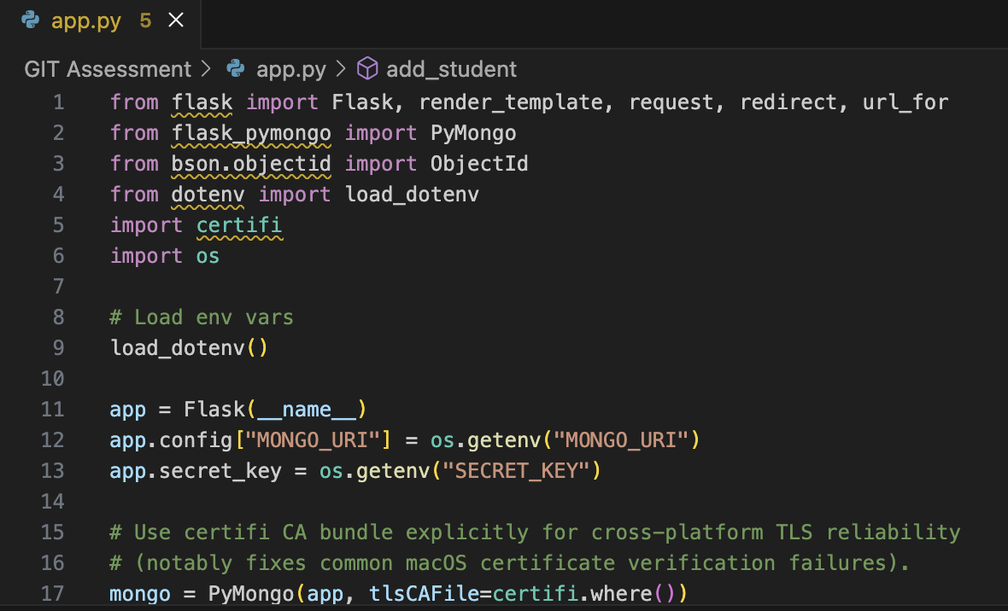

4. Check the current Git status
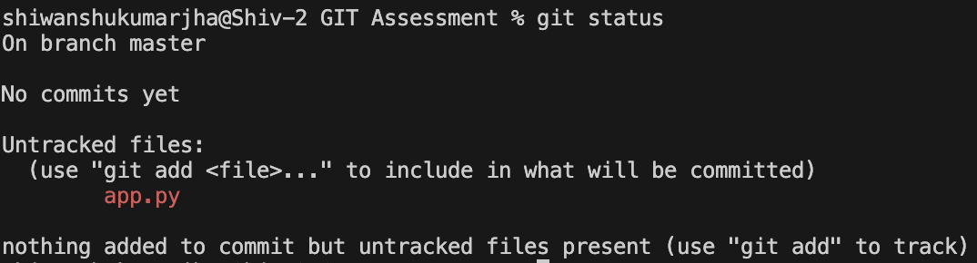

5. Stage the file
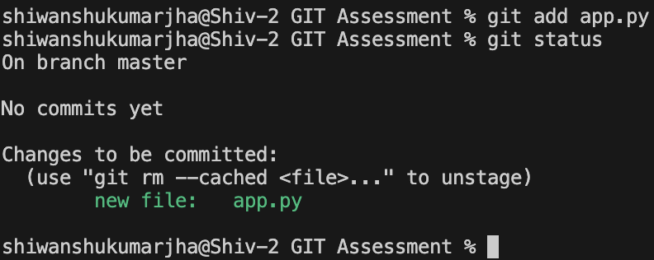

6. Commit with a meaningful message
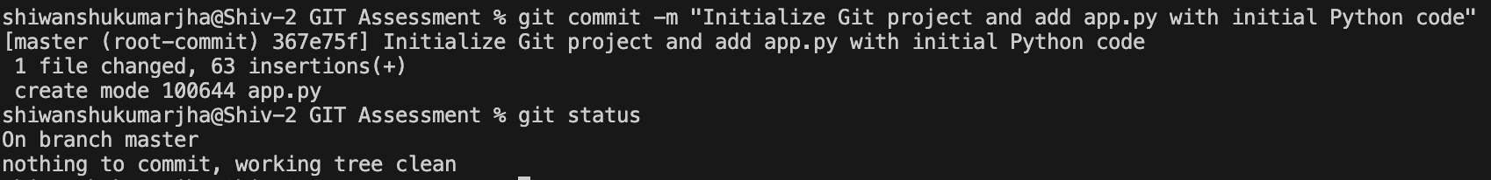

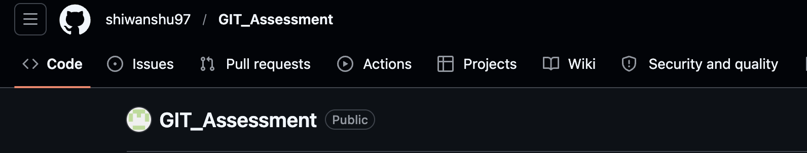
7. Create a remote repository (GitHub or similar)

8. Add the remote (origin) to your local repo

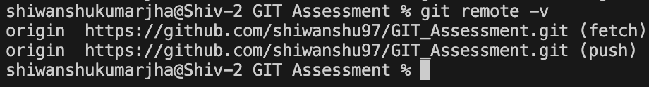
9. Verify the remote configuration

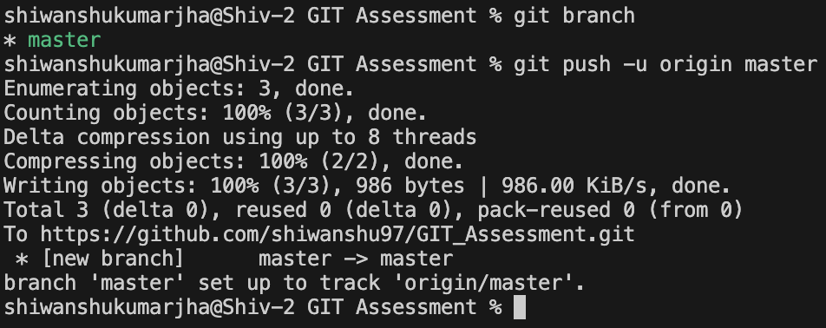
10. Push your code to the remote repository

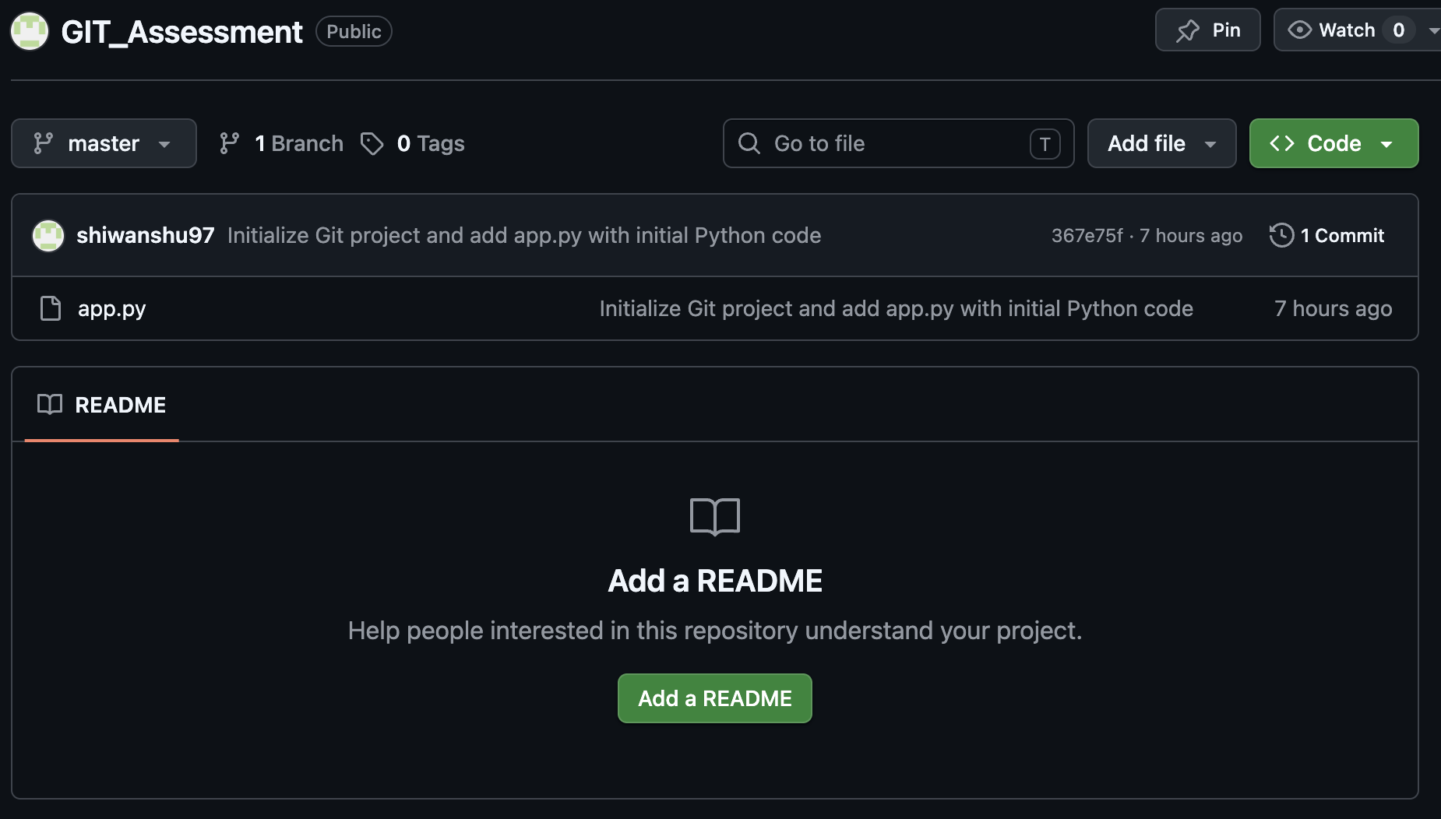

Question 2: Working with Changes & History
Objective : Track code changes and manage commit history properly.

- Tasks :-

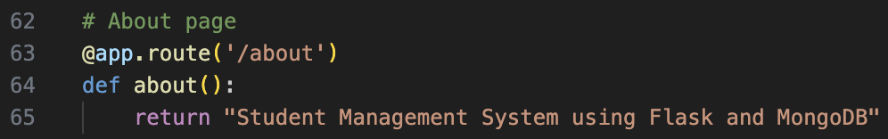
- Modify app.py by adding new functionality.

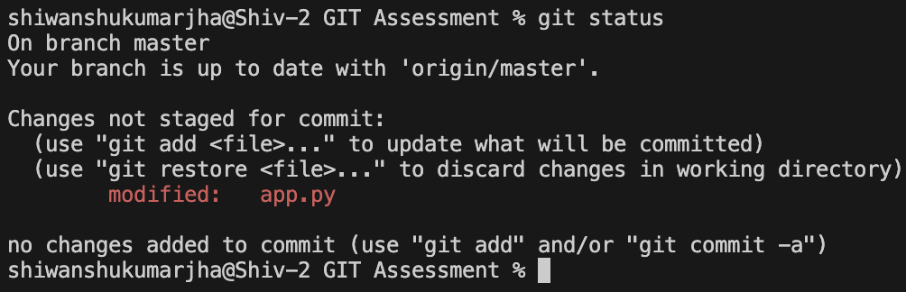
2. Check what changes are made before staging.

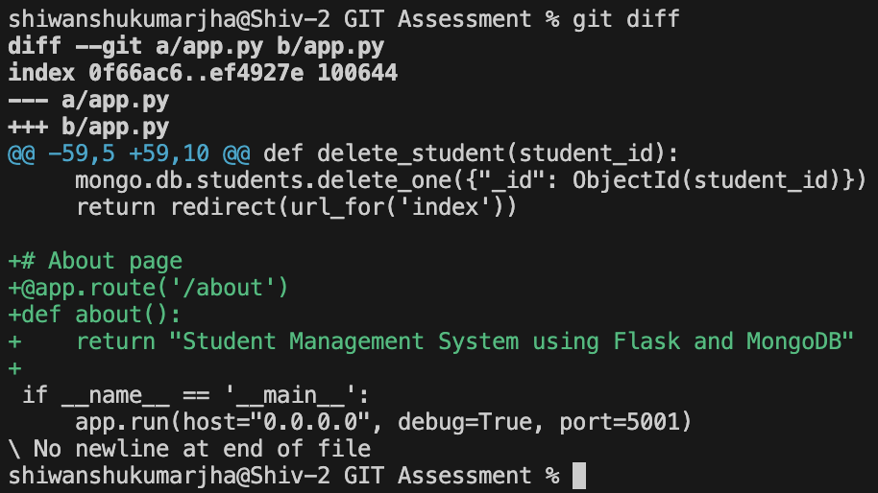
3. View differences in the file.

4. Stage only specific changes (if possible)
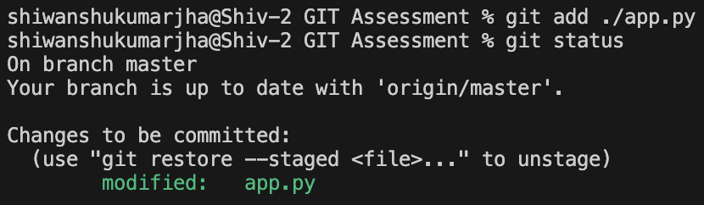

5. Commit with a clear message.

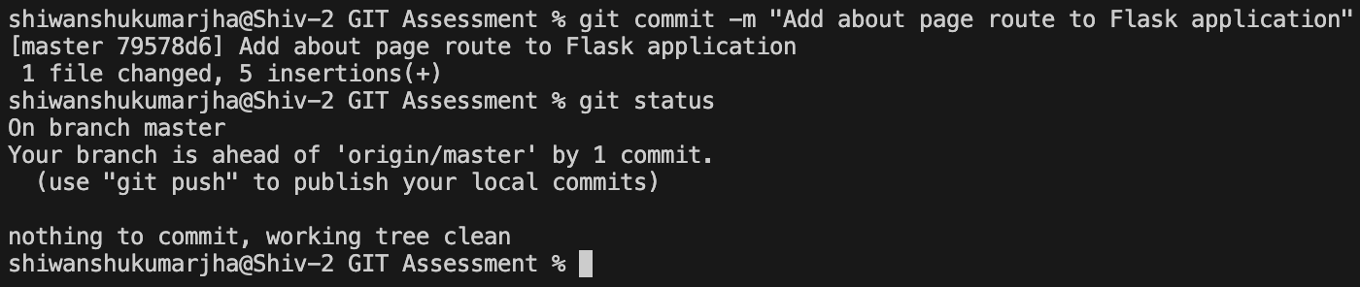

6. Make another change in app.py

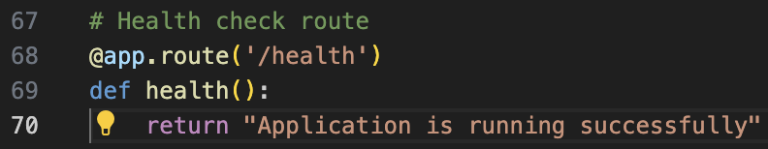

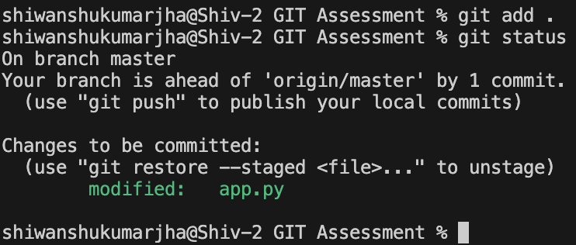
7. Stage all changes

8. Commit again

9. View full commit history
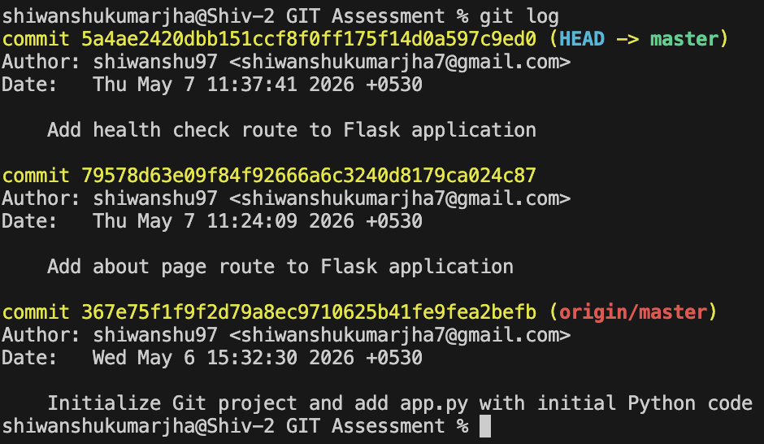

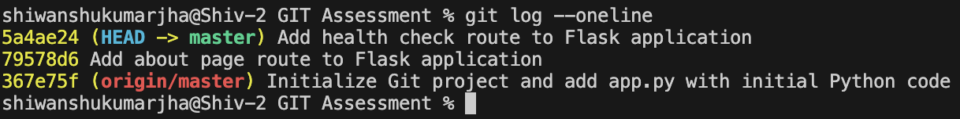
10. View compact (one-line) history

Question 3: Branching & Feature Development
Objective : You are developing a new feature separately to avoid affecting the main code.

- Tasks :-

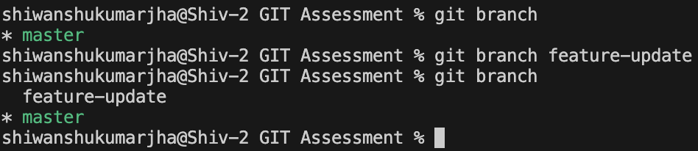
- Create a new branch (e.g., feature-update)
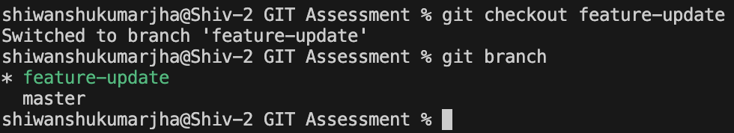
- Switch to the new branch
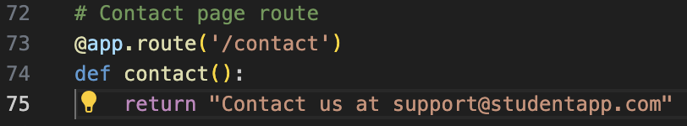
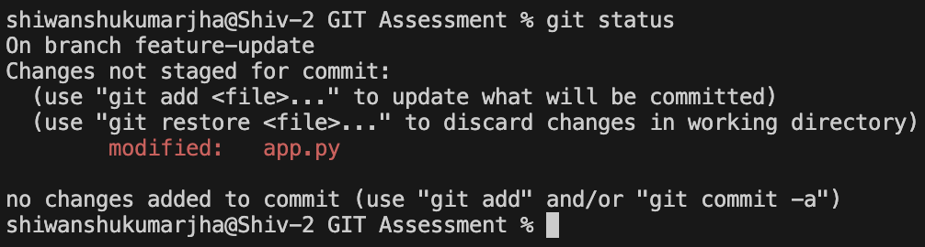
- Modify app.py with new feature logic

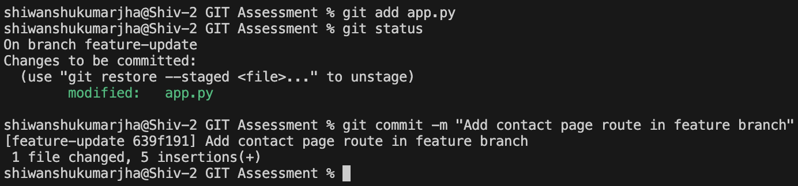
- Stage and commit the changes
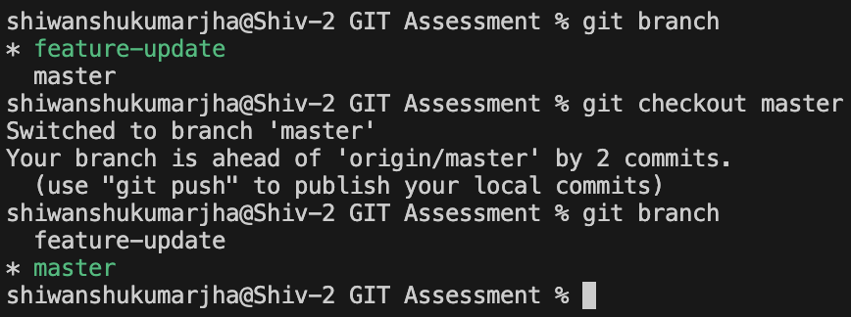
- Switch back to the main branch
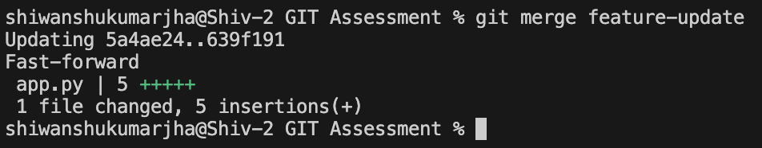
- Merge the feature branch into main
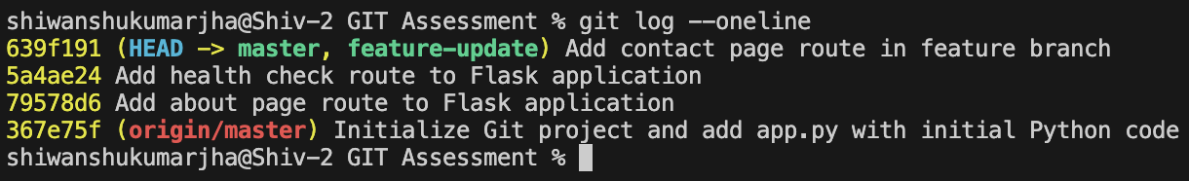
- Verify changes are merged
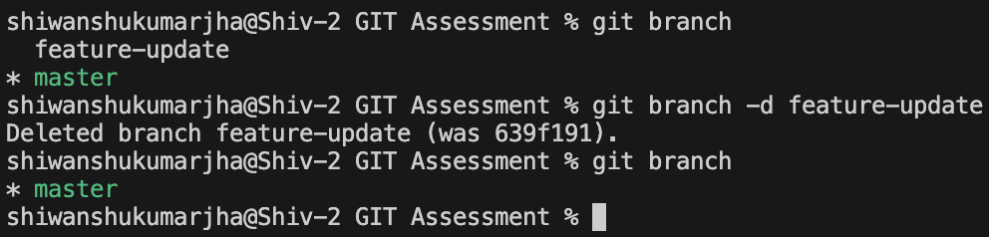
- Delete the branch safely
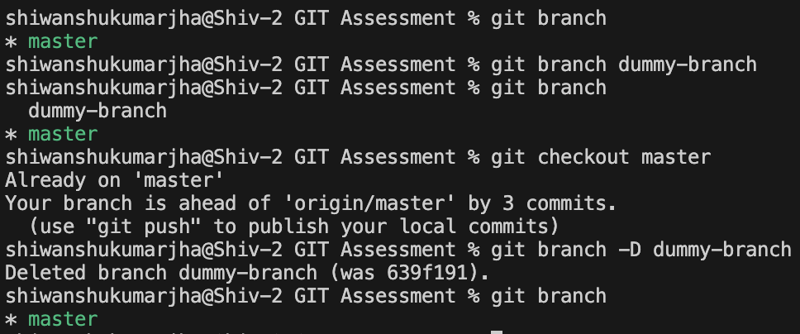
- Try force deleting a branch (create a dummy branch for this)

Question 4: Handling Errors (Stash, Reset, Revert)
Objective : Learn how to manage mistakes and unfinished work.

- Tasks :-

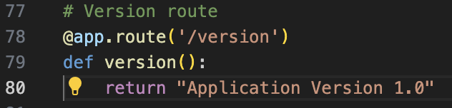
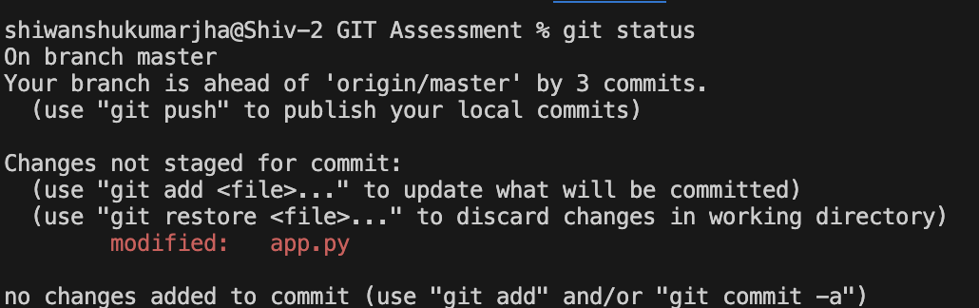
- Make changes to app.py but do NOT commit
- Stash the changes (include untracked files)
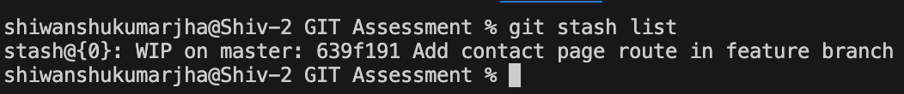
- Check the stash list
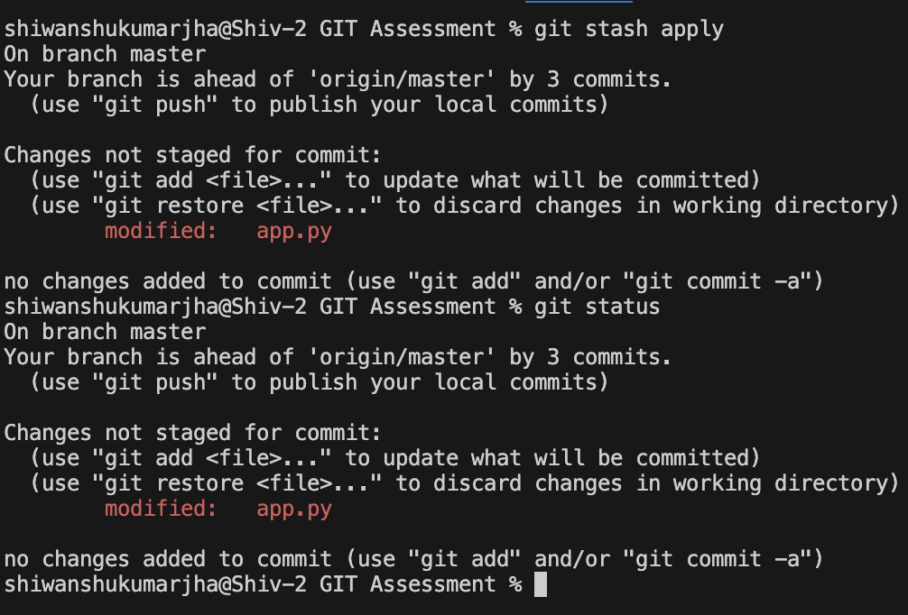
- Apply the stashed changes back
- Commit the changes
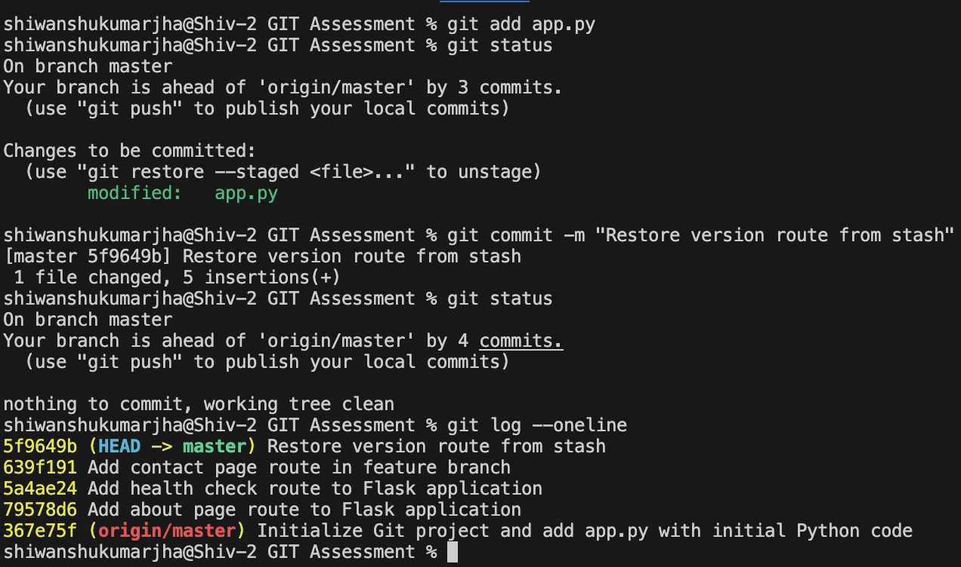
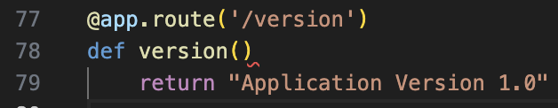
- Make another commit with incorrect code
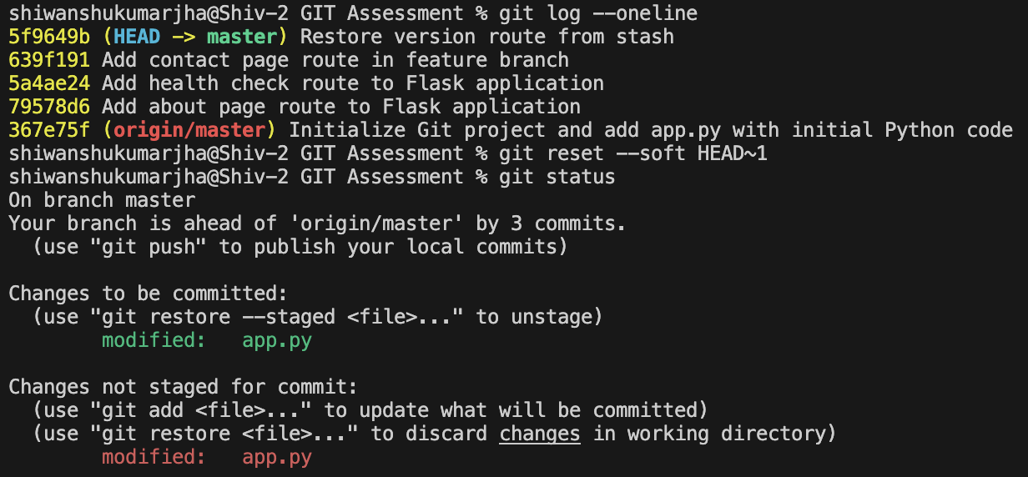
- Undo the last commit using reset
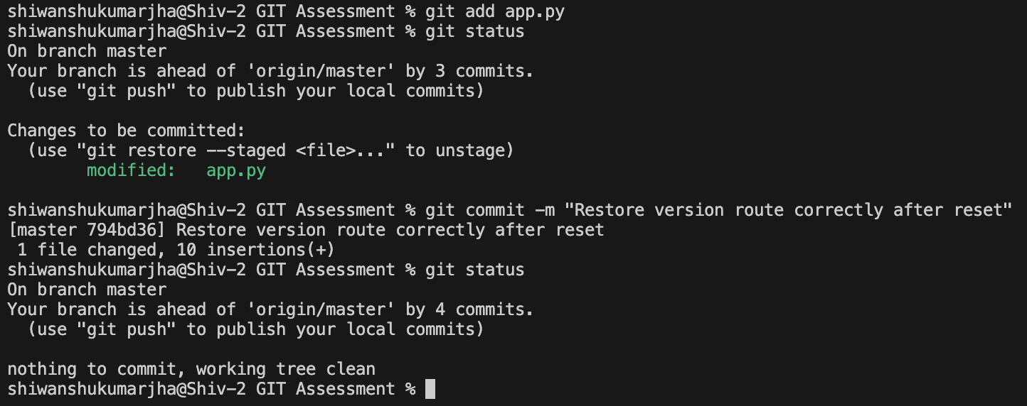
- Make another commit
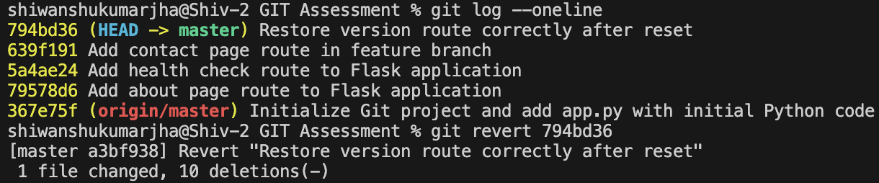
- Undo a commit using revert (create a new reversing commit)
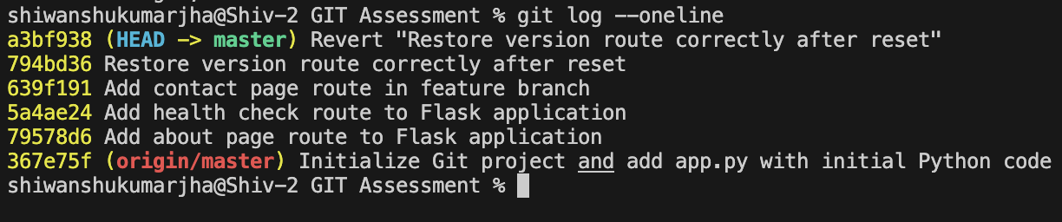
- Verify the commit history

