NAME : SHIWANSHU KUMAR JHA
MOBILE_NUMBER : 7979756698
EMAIL_ID : shiwanshukumarjha7@gmail.com
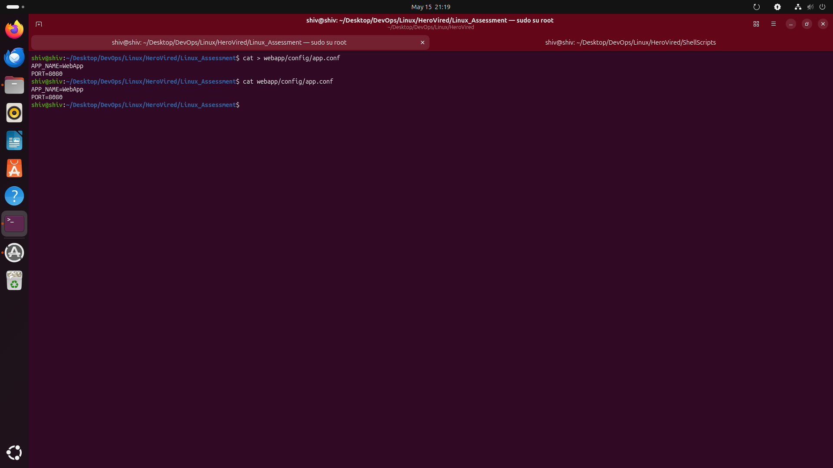
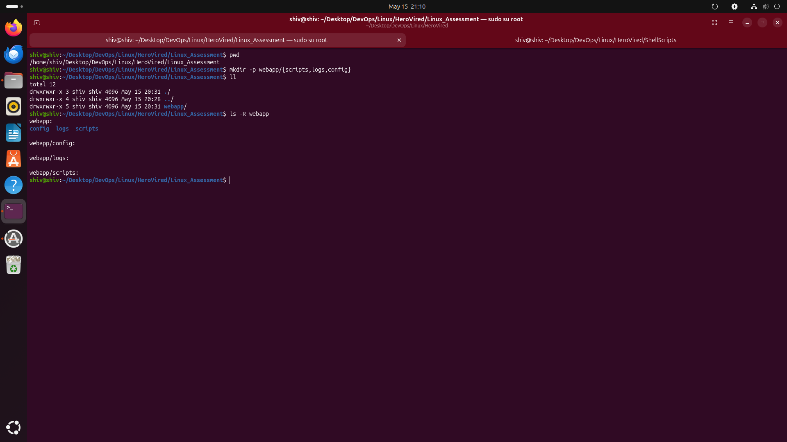
GIT_REPO : https://github.com/shiwanshu97/Linux_Assessment.git
Question 1: Set Up Your DevOps Project Structure
Objective: Create a complete project directory from scratch, apply correct permissions, and set ownership. The structure you build here will be used directly by your script in Question 2.
* Tasks :-
1. Create the directory /home/ec2-user/webapp/ with three subdirectories inside it: scripts/, logs/, and config/ using a single mkdir -p command.
=>Used mkdir -p to create the webapp directory with scripts, logs, and config subdirectories in a single command.
2. Use cat > to create config/app.conf with two lines of content: APP_NAME=WebApp and PORT=8080. Save using Ctrl+D.
=>Used cat > to create app.conf and added application settings (APP_NAME and PORT) inside the file.

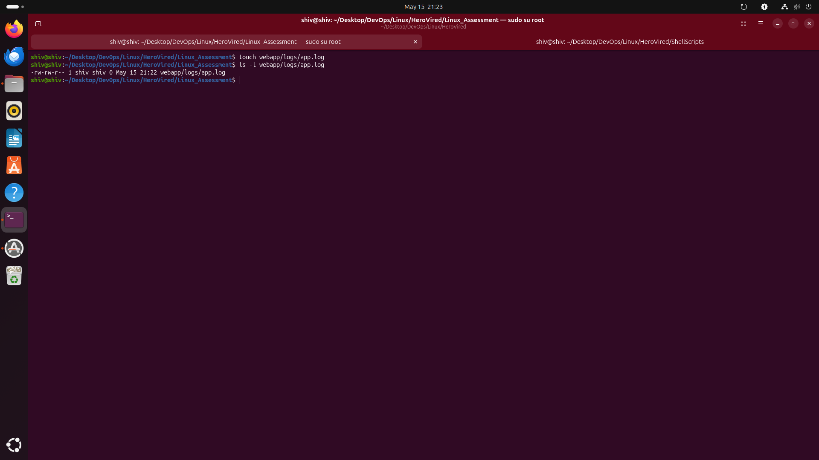
3. Use touch to create an empty file at logs/app.log. Confirm it is 0 bytes using ls -l.
=> Used touch to create an empty app.log file and verified it was 0 bytes using ls -l.
4. Set permissions: chmod 755 scripts/ and chmod 644 config/app.conf. Explain in your own words what 755 and 644 mean for owner, group, and others.
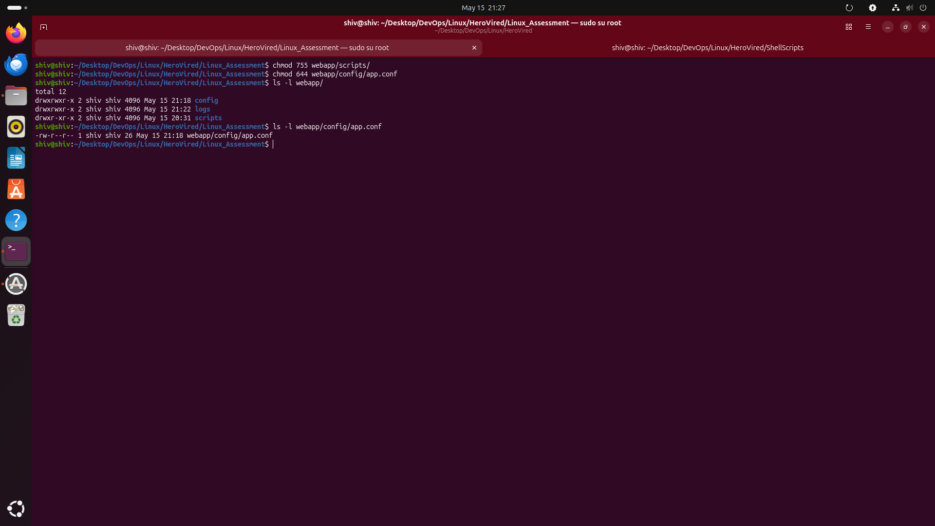
=> Applied chmod 755 to the scripts directory and chmod 644 to app.conf to control access for owner, group, and others.
Explanation of 755

7 = rwx → Owner can Read, Write, Execute
5 = r-x → Group can Read and Execute
5 = r-x → Others can Read and Execute

So:

Owner has full access
Group can only view and access
Others can only view and access

755 is commonly used for directories and executable files.

Explanation of 644
6 = rw- → Owner can Read and Write
4 = r-- → Group can only Read
4 = r-- → Others can only Read

So:

Owner can modify the file
Group can only view it
Others can only view it

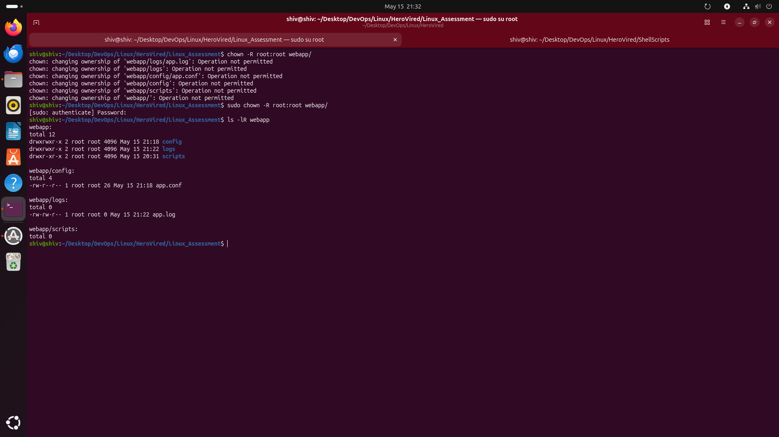
644 is commonly used for configuration and text files.
5. Recursively change ownership of the entire webapp/ directory to root:root using chown -R. Then run ls -lR /home/ec2-user/webapp/ and share the output to confirm every file and folder shows root root as owner.
=>Used sudo chown -R root:root to recursively change ownership of the entire webapp directory and verified it using ls -lR.
Question 2: Write an Interactive Log Script
Objective: Using the webapp/ structure from Question 1, write a bash script that takes user input, reads a config file, and writes timestamped log entries. The log entries you create here will be the input for Question 3.

- Tasks :-
1. Create a new script file at /home/ec2-user/webapp/scripts/log_user.sh using vim. Start with the correct shebang line
=> Used Vim to create log_user.sh and added the shebang line #!/bin/bash to specify the Bash interpreter.
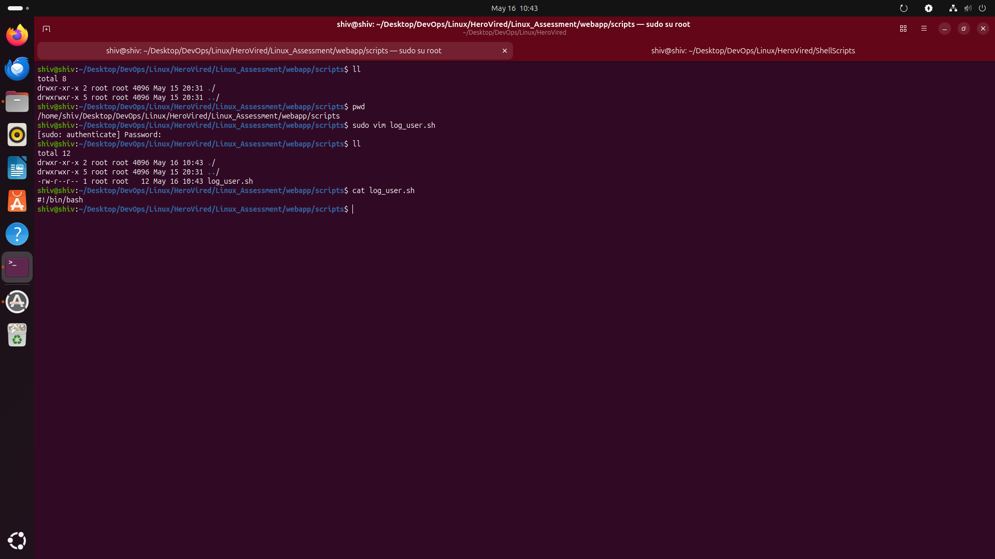
2. Use read -p to prompt the user to enter their name and store it in a variable called username.
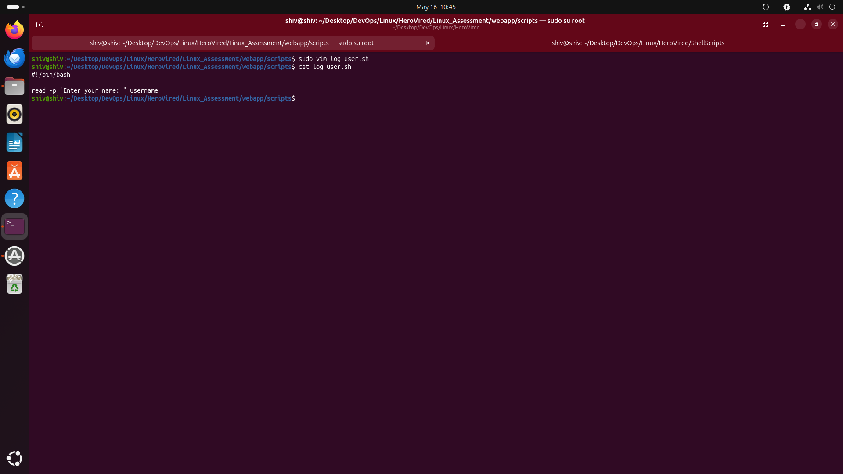
=> Used read -p to prompt the user for their name and stored the input in the username variable.

3. Use cat with the absolute path to display the contents of config/app.conf to the screen.

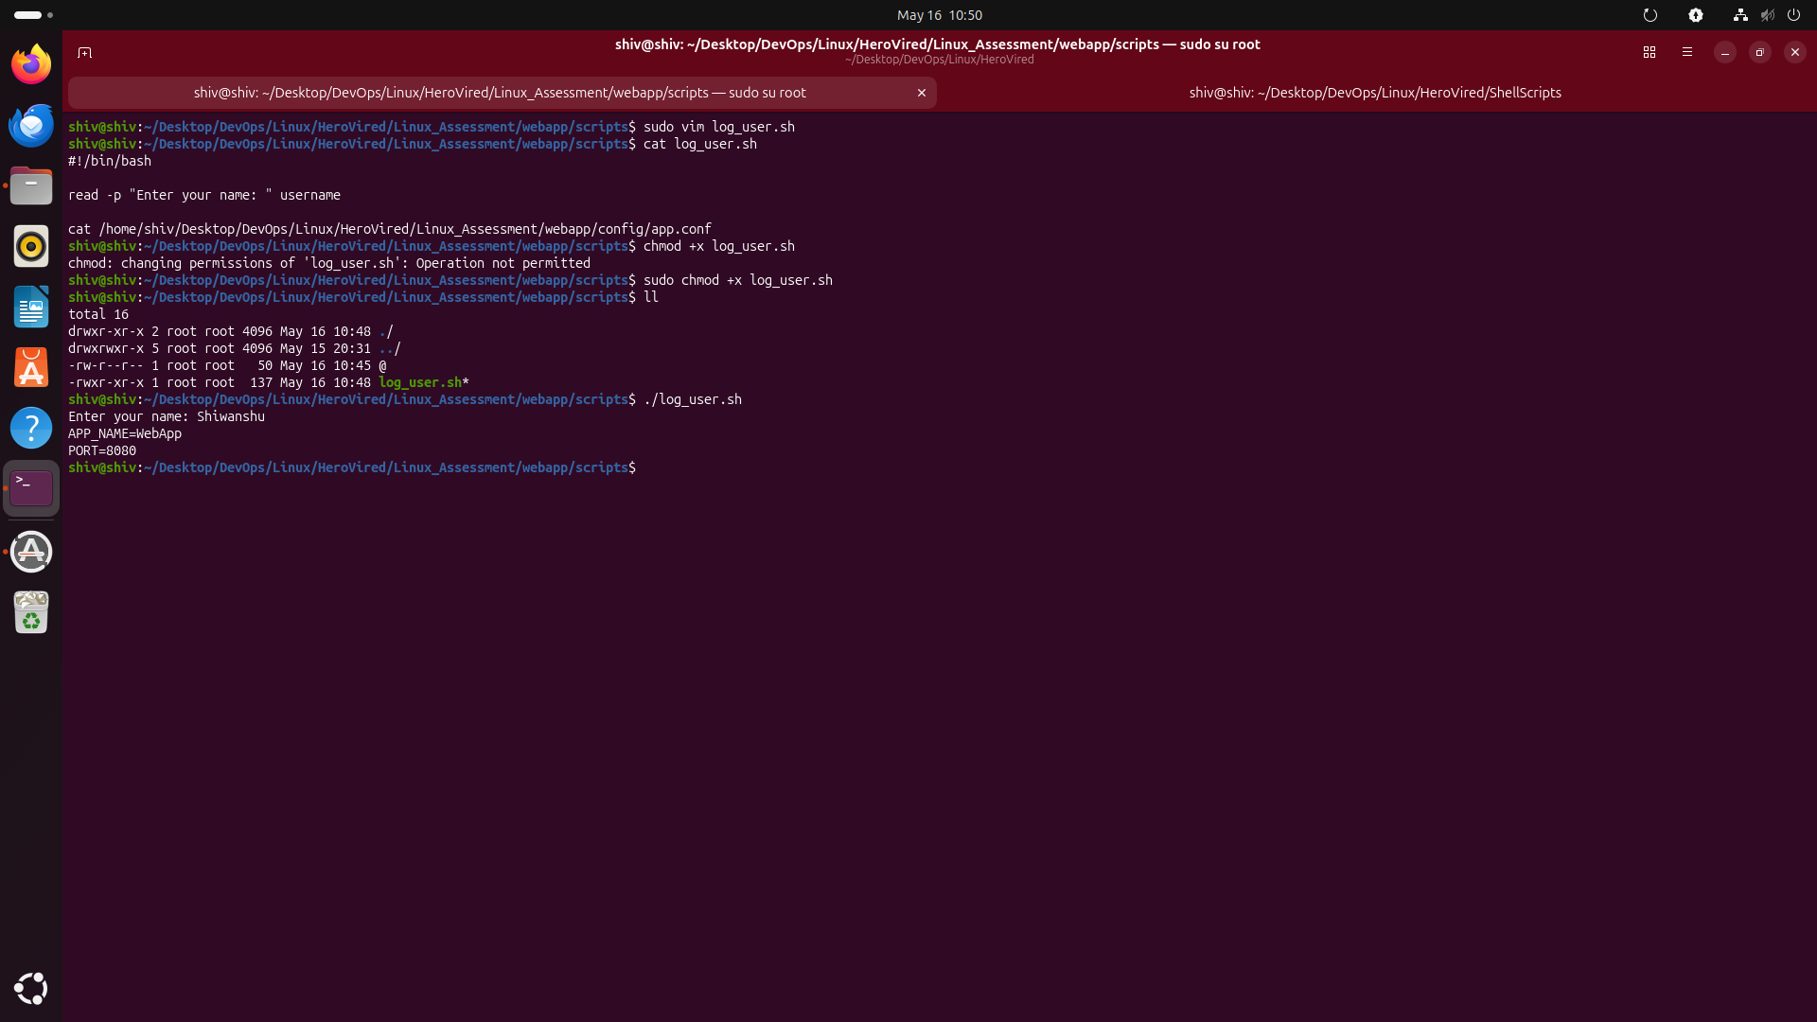
=> Used cat with the absolute path to display the contents of app.conf on the terminal.

4. Append a log entry to logs/app.log using echo >> in this exact format: Login: $username Date: $(date). Then display the full log file contents.

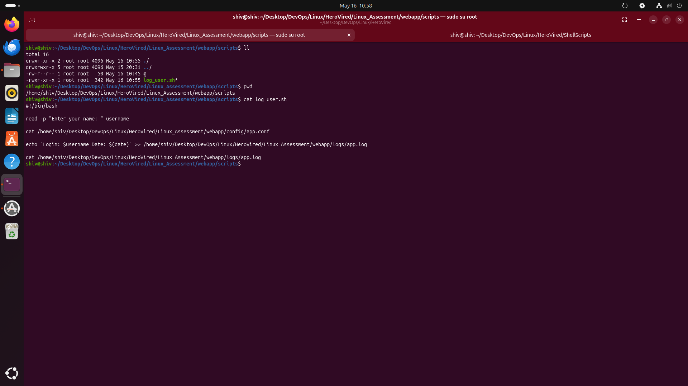
=> Used echo >> to append login details with the current date and time into app.log.
5. Give the script execute permission with chmod +x and run it at least 3 times using different names (e.g., Chirag, Priya, Ravi) so the log file has multiple entries for Question 3.

=> Used chmod +x to give execute permission to the script and ran it multiple times with different usernames to generate multiple log entries.
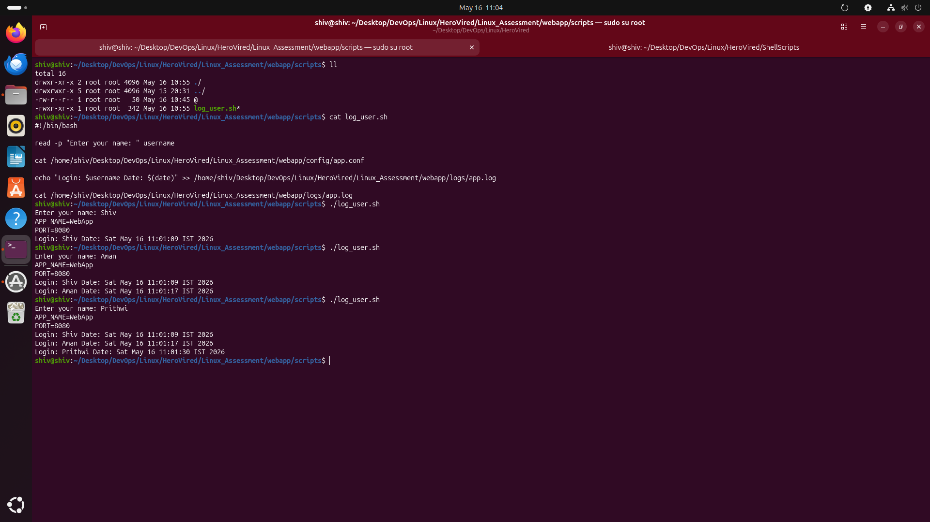
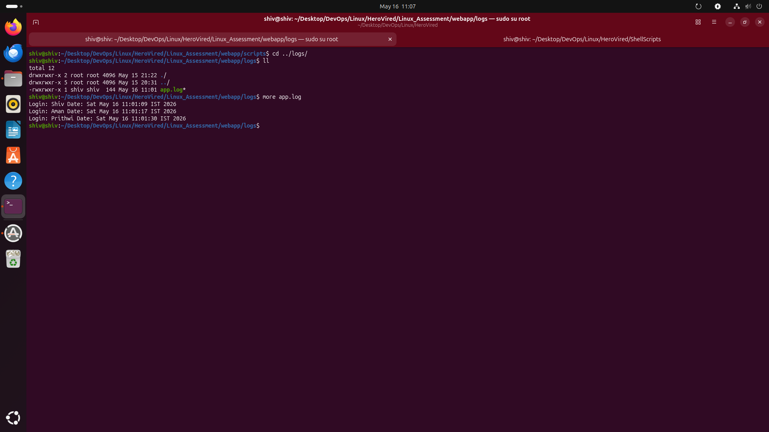
Question 3: User Management and File Permission Control

Objective: Create 4 Linux users. Two of them must have write access to the log_user.sh script created in Question 2, and the other two must have read-only access. Use Linux groups and chmod to control this.

- Tasks :-

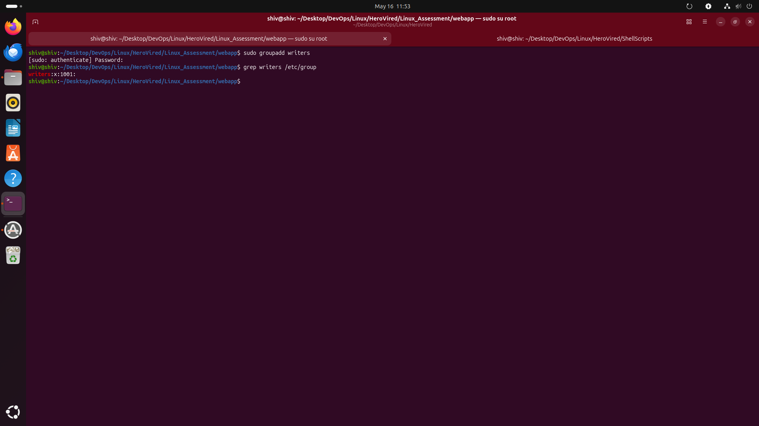
- Create a group called writers
=> Created a new group named writers using groupadd to manage shared file access and permissions for multiple users.

2. Create 4 users with home directories:

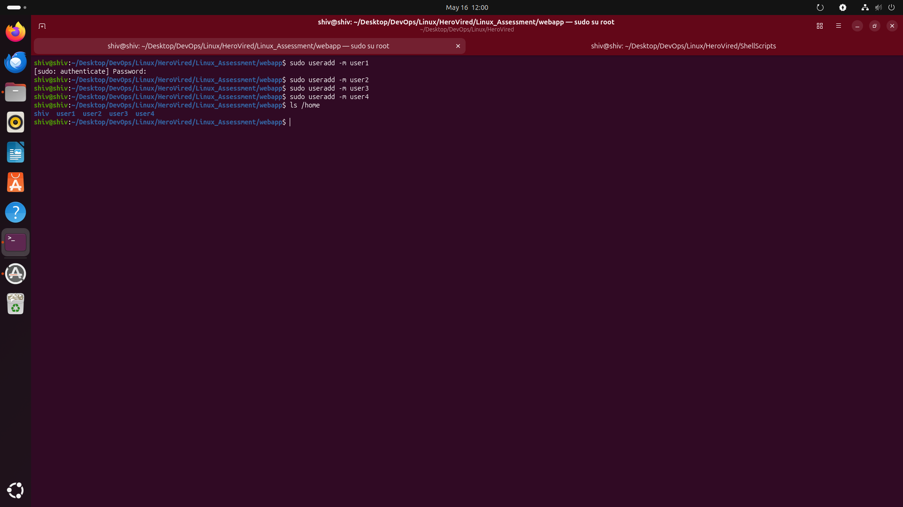
=> Created four users with the useradd -m command, which also automatically generated separate home directories for each user under /home.

3. Add the two write-access users to the writers group:

=> Added the write-access users to the writers group using usermod -aG so they can share group-based permissions and access files collaboratively.
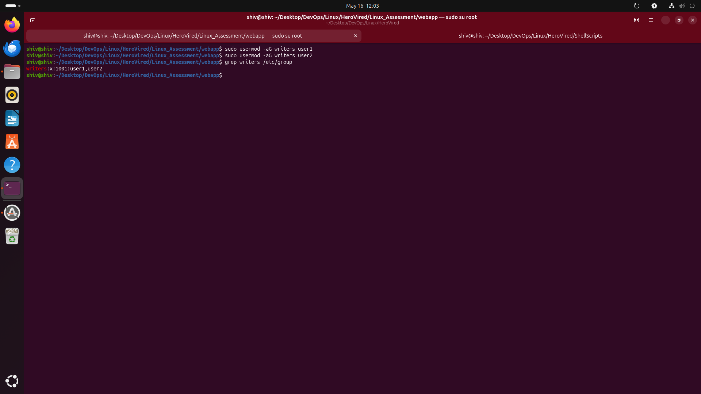

4. Change the group ownership of log_user.sh to writers: sudo chown root:writers /home/ec2-user/webapp/scripts/log_user.sh

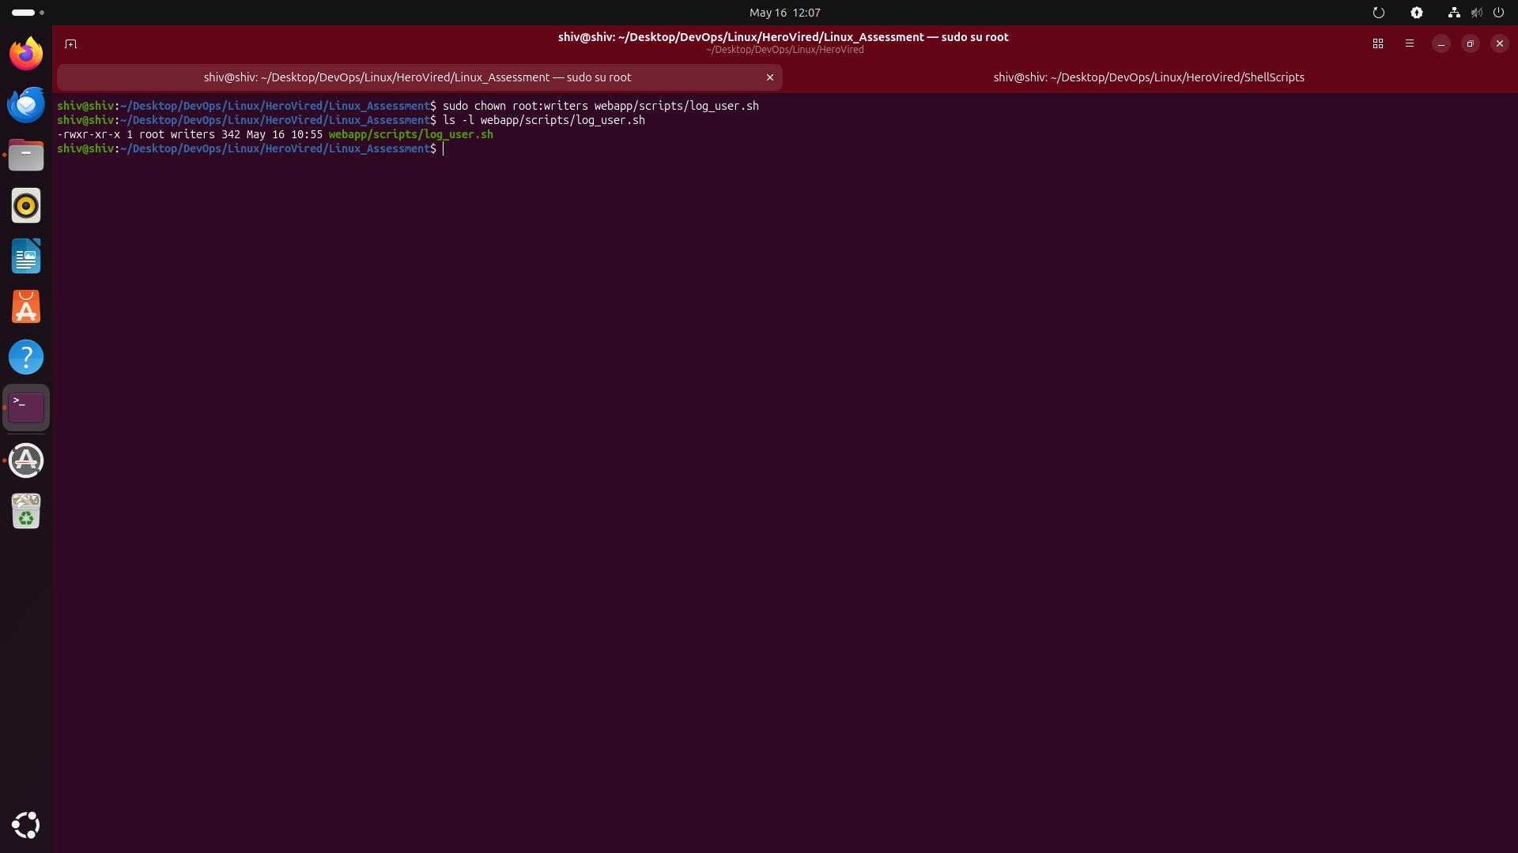
=> Changed the group ownership of log_user.sh to writers using chown so users in the writers group can access the script through group permissions.

5. Set permissions to 664 so writers group gets rw and others get r only: sudo chmod 664 /home/ec2-user/webapp/scripts/log_user.sh

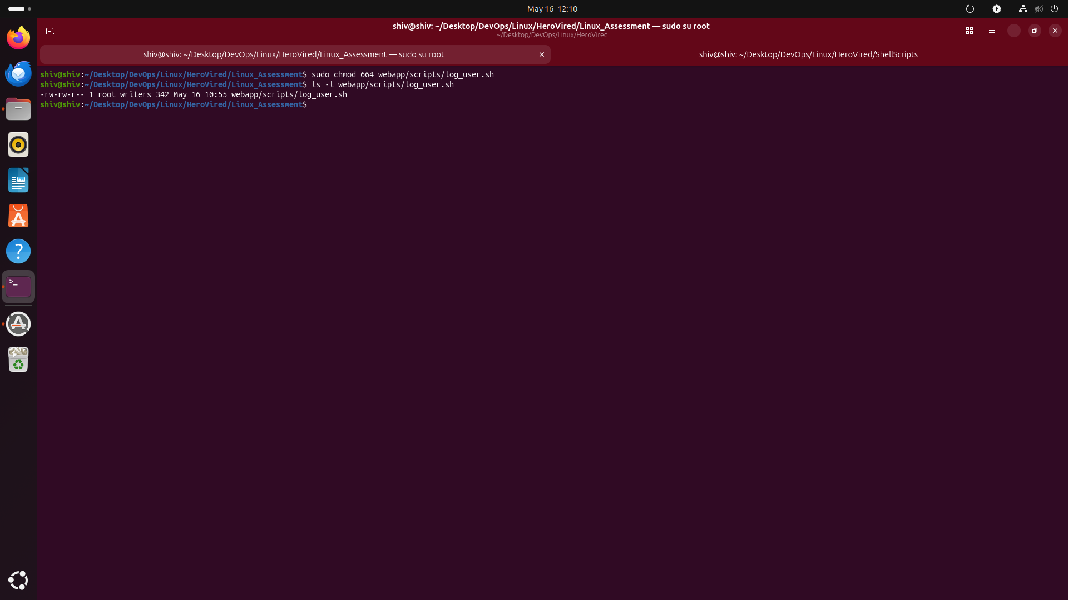
=> Set the script permissions to 664 using chmod so the owner and writers group can read and modify the file, while others only have read access.


6. Verify the permission output shows: -rw-rw-r-- root writers log_user.sh
=> Verified the final ownership and permissions of log_user.sh using ls -l, confirming the file belongs to root:writers with 664 access rights.

7. Switch to each user and test access to confirm it is working correctly:
Permission Layout (chmod 664):
chmod 664 log_user.sh
6 6 4
Owner(rw) Group(rw) Others(r)
root writers devuser3, devuser4

=> Tested file access by switching between users to confirm that members of the writers group had read/write access while other users had read-only access according to the 664 permission layout.
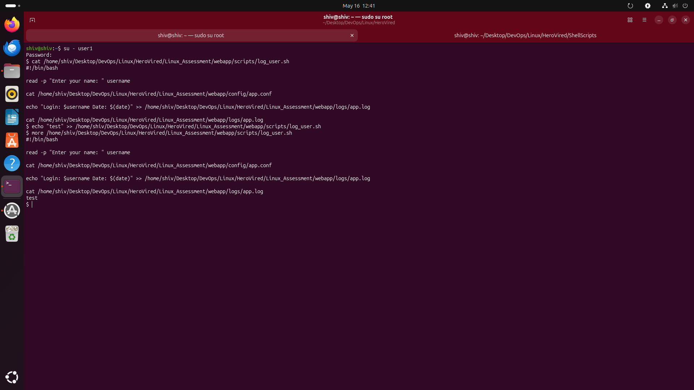
User 1—> su - user1

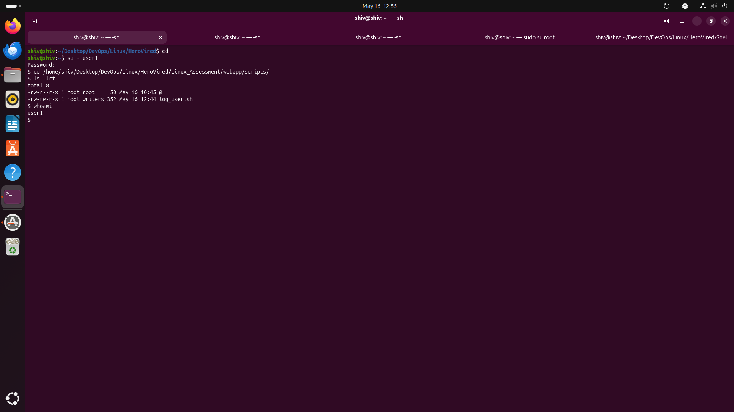
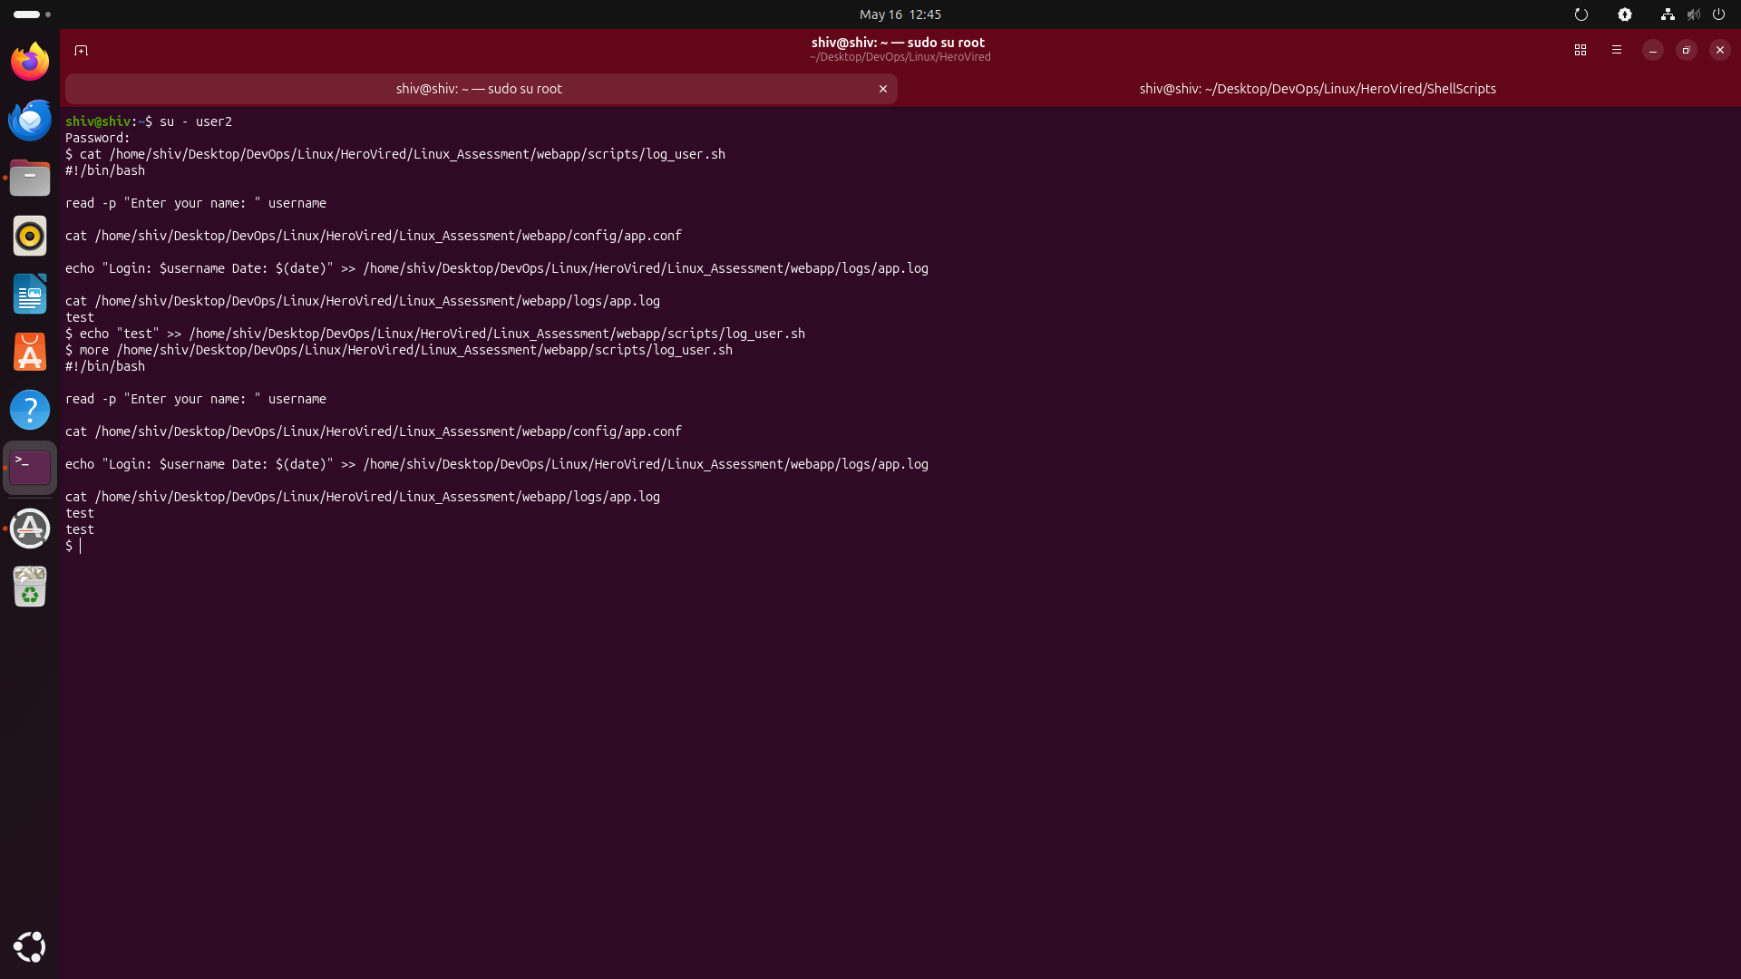
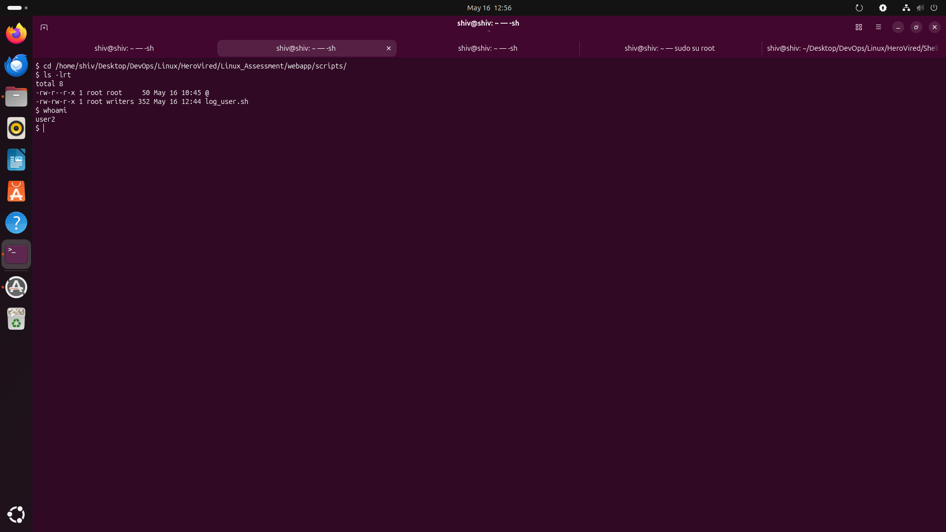
User 2—> su - user2
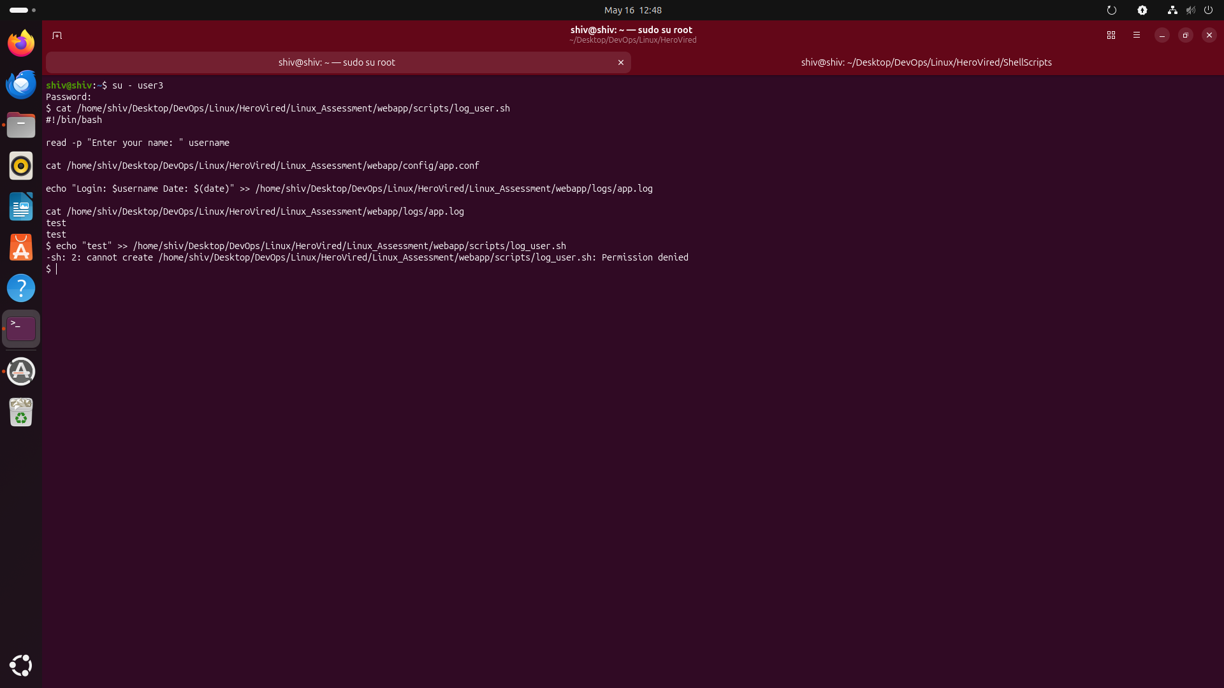
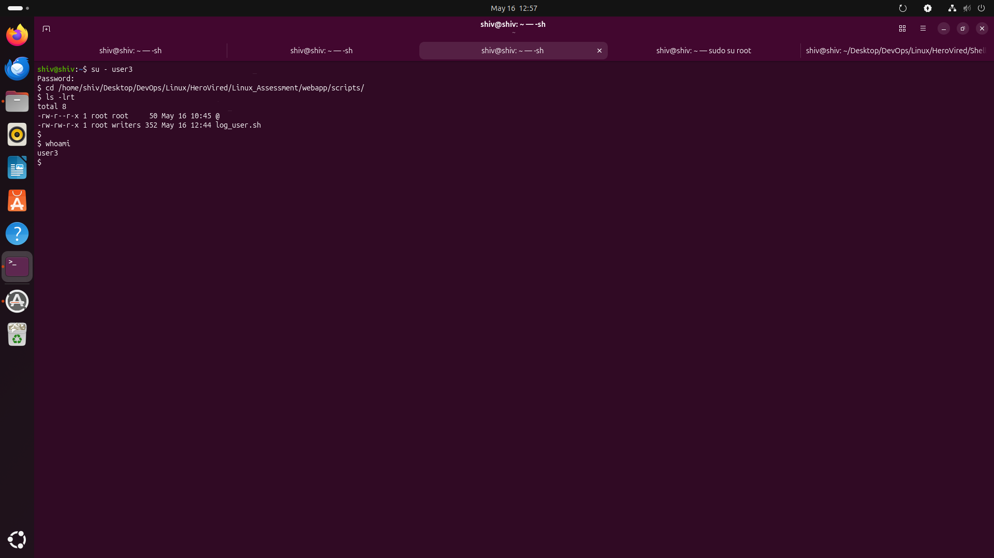
User 3—> su - user3
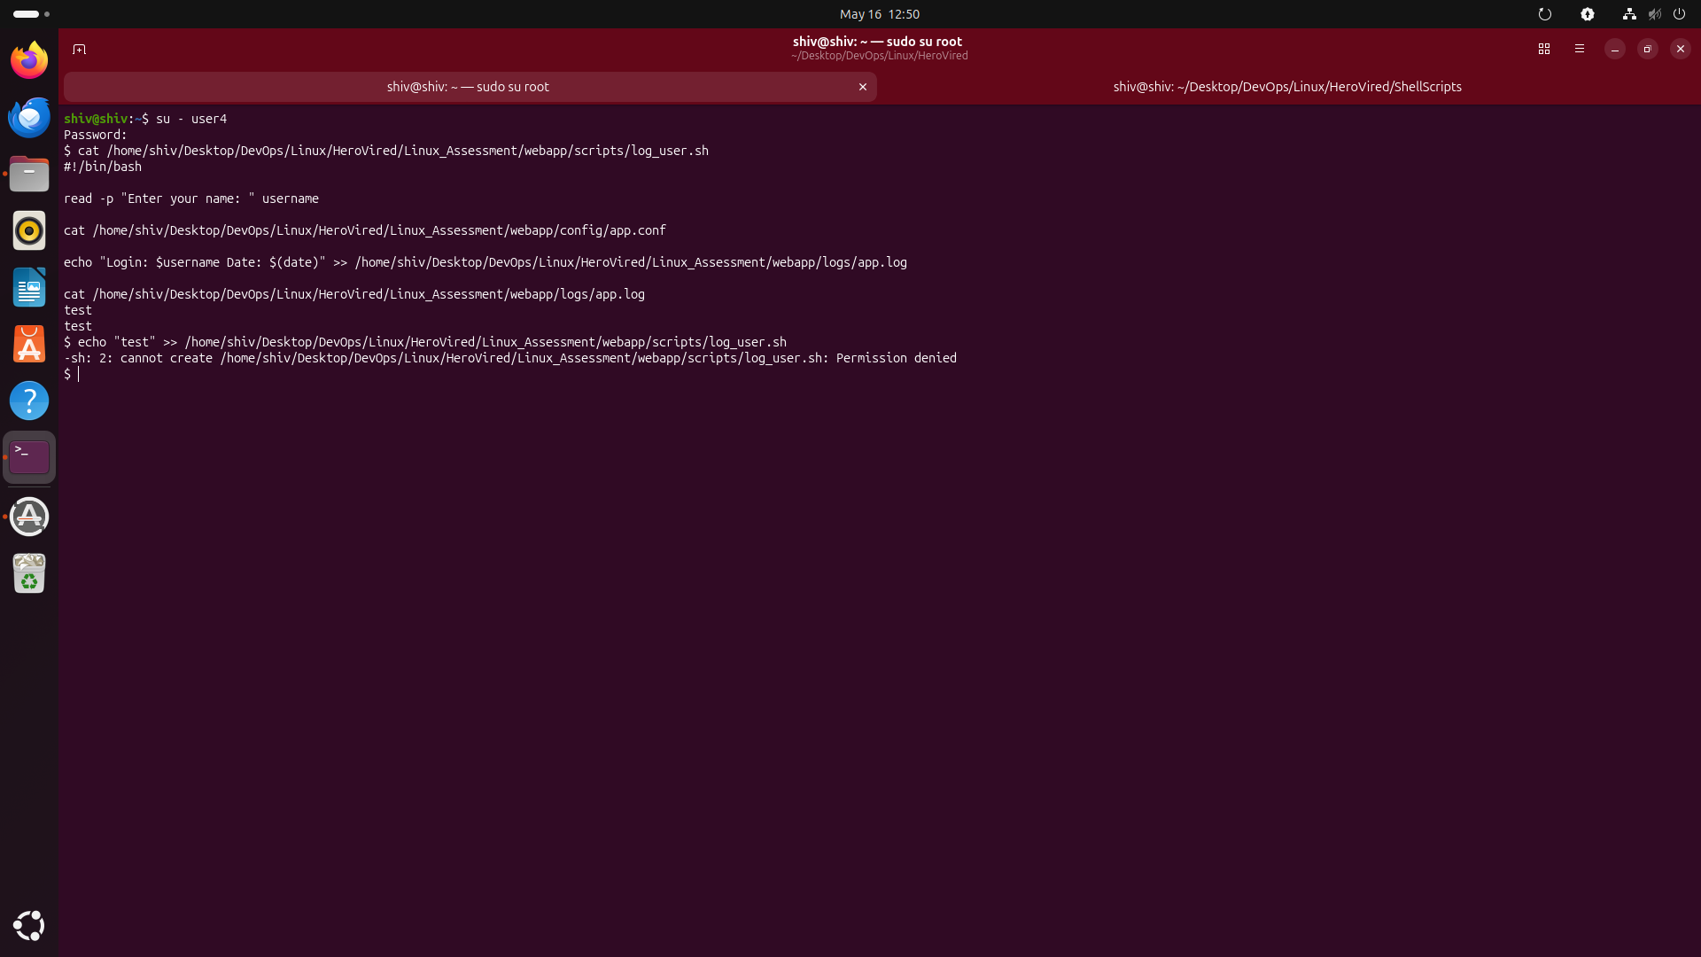
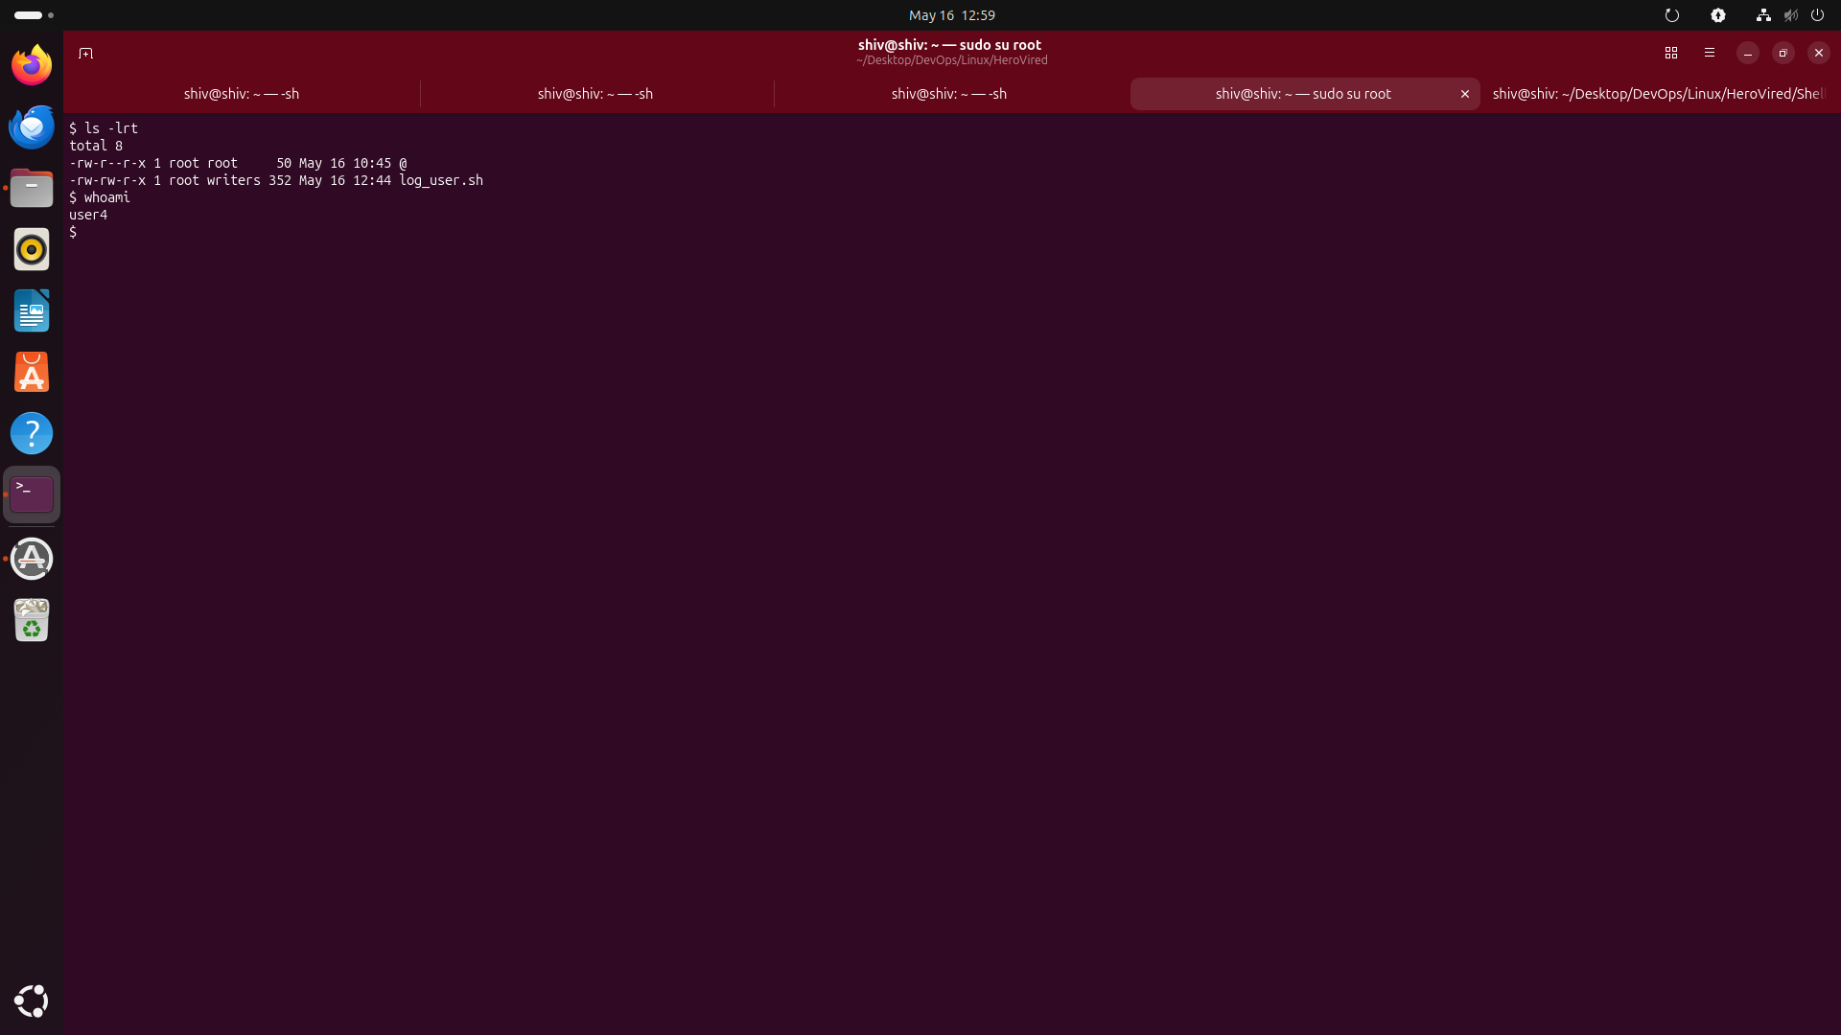
User 4—> su - user4

