**Hibernate**

Struts : 架子 Spring : 春天

Hibernate 冬眠: 把对象冬眠一样持久的保存到数据库中.

核心想法: java程序员按照面向对象的方式操作数据库, 不再需要使用SQL.

Hibernate 的问题

1. 不用写SQL, 但是要重新学习 HQL
2. 会生成不理想的SQL, 影响数据库性能
3. 特殊操作, 无法实现!

解决了 ORM 问题: 对象关系映射问题

**Hibernate 结构**

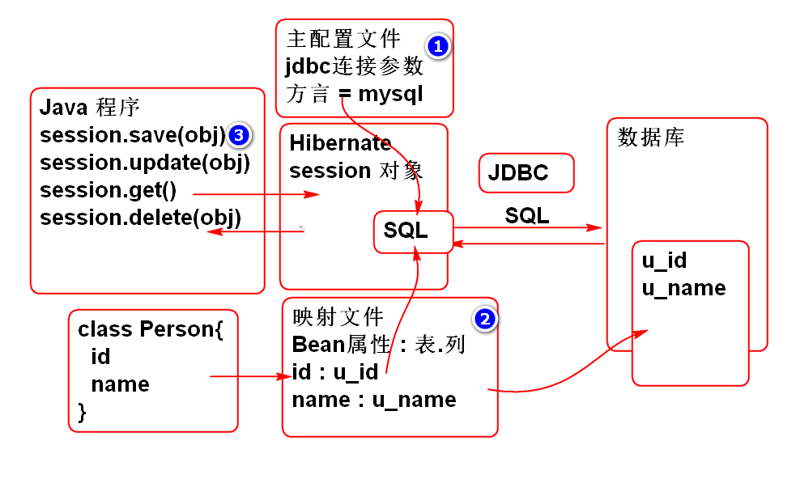

**使用Hibernate**

1. 导入包:

<dependency> <groupId>org.hibernate</groupId> <artifactId>hibernate-core</artifactId> <version>3.6.9.Final</version> </dependency> <dependency> <groupId>mysql</groupId> <artifactId>mysql-connector-java</artifactId> <version>5.1.6</version> </dependency>

1. 配置Hibernate主配置文件 hibernate.cfg.xml:

<?xml version='1.0' encoding='UTF-8'?> <!DOCTYPE hibernate-configuration PUBLIC "-//Hibernate/Hibernate Configuration DTD 3.0//EN" "http://www.hibernate.org/dtd/hibernate-configuration-3.0.dtd"> <hibernate-configuration> <session-factory> <property name="dialect"> org.hibernate.dialect.MySQLDialect </property> <property name="connection.username">root</property> <property name="connection.password">root</property> <property name="connection.url"> jdbc:mysql://localhost:3306/cloud_note </property> <property name="connection.driver_class"> com.mysql.jdbc.Driver </property> <property name="show_sql">true</property> <property name="format_sql">true</property> <mapping resource="Person.hbm.xml"/> </session-factory> </hibernate-configuration>

主配置文件主要是提供 数据库 连接参数和MySQL方言

注意: 面试时候经常有人问方言!!!

show*sql 和 format*sql 属性用于调试阶段, 在控制台显示Hibernate生成并且执行的SQL语句.

1. 创建表:

create table p_person( id int not null AUTO_INCREMENT, name varchar(100), primary key(id) ); insert into p_person (name) values ('李老师'); insert into p_person (id, name) values (null,'李老师');

1. 创建实体类 Person

public class Person implements Serializable{ private Integer id; private String name; public Person() { } public Person(Integer id, String name) { super(); this.id = id; this.name = name; } public Integer getId() { return id; } public void setId(Integer id) { this.id = id; } public String getName() { return name; } public void setName(String name) { this.name = name; } @Override public String toString() { return "Person [id=" + id + ", name=" + name + "]"; } @Override public int hashCode() { final int prime = 31; int result = 1; result = prime * result + ((id == null) ? 0 : id.hashCode()); return result; } @Override public boolean equals(Object obj) { if (this == obj) return true; if (obj == null) return false; if (getClass() != obj.getClass()) return false; Person other = (Person) obj; if (id == null) { if (other.id != null) return false; } else if (!id.equals(other.id)) return false; return true; } }

1. 编写映射文件

<?xml version="1.0" encoding="utf-8"?> <!DOCTYPE hibernate-mapping PUBLIC "-//Hibernate/Hibernate Mapping DTD 3.0//EN" "http://www.hibernate.org/dtd/hibernate-mapping-3.0.dtd"> <!-- Hibernate 映射文件负责: 映射 实体和表的对应关系, 映射实体属性和列的对应关系 Class Person{ p_person( id id name name } ) --> <hibernate-mapping> <class name="cn.tedu.entity.Person" table="p_person"> <!-- id 属性是主键, 使用id标签映射 --> <id name="id" column="id"> <!-- class=identity 用于处理自增类型 --> <generator class="identity"/> </id> <!-- 映射普通属性 Person.name -> p_person.name --> <property name="name" column="name"/> </class> </hibernate-mapping>

Hibernate 映射文件负责: 映射 实体和表的对应关系, 映射实体属性和列的对应关系

1. 编写测试案例:

public class HibernateTest { @Test public void testSavePerson(){ //参考: Hibernate 官方手册! //读取配置文件 Configuration cfg=new Configuration(); cfg.configure("hibernate.cfg.xml"); //创建Session工厂 SessionFactory factory = cfg.buildSessionFactory(); //利用Session工厂创建Session Session session=factory.openSession(); //session 自动提供了对象的 CRUD 操作方法 //从数据库中查询id为1的person对象 Person p = (Person)session.get(Person.class,1); System.out.println(p); //最后务必关闭 session session.close(); } }

1. 测试...

**Hibernate 可以自动的完成CRUD方法:**

重构测试案例:

public class HibernateTest { SessionFactory factory; Session session; @Before public void init(){ Configuration cfg=new Configuration(); cfg.configure("hibernate.cfg.xml"); factory = cfg.buildSessionFactory(); session = factory.openSession(); } @After public void destory(){ session.close(); factory.close(); } @Test public void testGet(){ Person p = (Person)session.get( Person.class, 7); System.out.println(p); } @Test public void testAdd(){ //将新对象保存到数据库中, 需要开启事务 Transaction tx=session.beginTransaction(); Person one = new Person(null, "熊大"); session.save(one); tx.commit();//提交事务 System.out.println(one); } @Test public void testUpdate(){ //更新数据 Transaction tx = session.beginTransaction(); Person p = (Person)session.get( Person.class, 7); p.setName("范传奇"); session.update(p); tx.commit(); } @Test public void testDelete(){ //更新数据 Transaction tx = session.beginTransaction(); Person p = (Person)session.get( Person.class, 7); session.delete(p); tx.commit(); } @Test public void testSavePerson(){ //参考: Hibernate 官方手册! //读取配置文件 Configuration cfg=new Configuration(); cfg.configure("hibernate.cfg.xml"); //创建Session工厂 SessionFactory factory = cfg.buildSessionFactory(); //利用Session工厂创建Session Session session=factory.openSession(); //session 自动提供了对象的 CRUD 操作方法 //从数据库中查询id为1的person对象 Person p = (Person)session.get(Person.class,1); System.out.println(p); //最后务必关闭 session session.close(); } }

测试

**整合 Spring 和 Hibernate**

Spring 提供了整合Hibernate功能, 使Hibernate的使用更加简洁方便:

1. 提供了 LocalSessionFactoryBean 简化 Configuration 和 SessionFactory
2. 提供了 HibernateTempalte 简化 session 的使用.

配置使用:

1. 导入包:

<dependency> <groupId>org.springframework</groupId> <artifactId>spring-orm</artifactId> <version>3.0.5.RELEASE</version> </dependency> <dependency> <groupId>commons-dbcp</groupId> <artifactId>commons-dbcp</artifactId> <version>1.4</version> </dependency>

1. 添加Spring配置文件 spring-orm.xml
2. 配置数据源, 用于连接数据库:

<!-- 1. 配置数据库连接池 --> <bean id="dataSource" class="org.apache.commons.dbcp.BasicDataSource"> <property name="driverClassName" value="com.mysql.jdbc.Driver"/> <property name="url" value="jdbc:mysql://localhost:3306/cloud_note"/> <property name="username" value="root"/> <property name="password" value="root"/> </bean>

1. 配置SessionFactory

<!-- 2. 配置Session工厂--> <!-- Spring orm提供了一个工厂Bean, 用于管理Hibernate 的 Session 工厂 --> <bean id="sessionFactory" class="org.springframework.orm.hibernate3.LocalSessionFactoryBean"> <property name="dataSource" ref="dataSource"/> <property name="hibernateProperties"> <props> <prop key="hibernate.dialect"> org.hibernate.dialect.MySQLDialect </prop> <prop key="hibernate.show_sql">true</prop> <prop key="hibernate.format_sql">true</prop> </props> </property> <property name="mappingLocations"> <list> <value>classpath:Person.hbm.xml</value> </list> </property> </bean>

1. 配置 HibernateTemplate

<!-- 3. 配置HibernateTemplate --> <bean id="hibernateTemplate" class="org.springframework.orm.hibernate3.HibernateTemplate"> <property name="sessionFactory" ref="sessionFactory"/> </bean>

1. 测试:

public class SpringHibernateTest { ClassPathXmlApplicationContext ctx; HibernateTemplate temp; @Before public void init(){ ctx = new ClassPathXmlApplicationContext( "spring-orm.xml"); temp = ctx.getBean( "hibernateTemplate", HibernateTemplate.class); } @After public void destroy(){ ctx.close(); } @Test public void testGet(){ //HibernateTemplate 可以替代 session //并且使用更加简便(可以不用管理事务,等) Person p = temp.get(Person.class, 1); System.out.println(p); } }

**作业**

1. 测试 Hibernate的 CRUD 功能
2. 实现 Spring Hibernate 整合, 测试整合后的 CRUD 功能

**SSH**

**SSH 整合应用**

重构云笔记项目, 将Spring MVC 替换为 Struts2, 将MyBatis替换为Hibernate.

**1. 创建项目 搭建 SSH 架构**

1. 创建项目, 导入SSH包:

<dependency> <groupId>org.apache.struts</groupId> <artifactId>struts2-core</artifactId> <version>2.3.8</version> </dependency> <dependency> <groupId>org.apache.struts</groupId> <artifactId>struts2-spring-plugin</artifactId> <version>2.3.8</version> </dependency> <dependency> <groupId>jstl</groupId> <artifactId>jstl</artifactId> <version>1.2</version> </dependency> <dependency> <groupId>org.hibernate</groupId> <artifactId>hibernate-core</artifactId> <version>3.6.9.Final</version> </dependency> <dependency> <groupId>mysql</groupId> <artifactId>mysql-connector-java</artifactId> <version>5.1.6</version> </dependency> <dependency> <groupId>junit</groupId> <artifactId>junit</artifactId> <version>4.12</version> </dependency> <dependency> <groupId>org.springframework</groupId> <artifactId>spring-orm</artifactId> <version>3.0.5.RELEASE</version> </dependency> <dependency> <groupId>commons-dbcp</groupId> <artifactId>commons-dbcp</artifactId> <version>1.4</version> </dependency> <dependency> <groupId>org.apache.struts</groupId> <artifactId>struts2-json-plugin</artifactId> <version>2.3.8</version> </dependency> <dependency> <groupId>aspectj</groupId> <artifactId>aspectjweaver</artifactId> <version>1.5.3</version> </dependency> <dependency> <groupId>commons-codec</groupId> <artifactId>commons-codec</artifactId> <version>1.10</version> </dependency>

还需要导入目标运行环境为: Tomcat Runtime

1. 添加配置 Struts2 和 Spring 的配置 web.xml

<filter> <display-name>StrutsPrepareAndExecuteFilter</display-name> <filter-name>StrutsPrepareAndExecuteFilter</filter-name> <filter-class>org.apache.struts2.dispatcher.ng.filter.StrutsPrepareAndExecuteFilter</filter-class> </filter> <filter-mapping> <filter-name>StrutsPrepareAndExecuteFilter</filter-name> <url-pattern>/*</url-pattern> </filter-mapping> <listener> <listener-class>org.springframework.web.context.ContextLoaderListener</listener-class> </listener> <context-param> <param-name>contextConfigLocation</param-name> <param-value>classpath:conf/spring-*.xml</param-value> </context-param>

1. 添加Struts2 配置文件 struts.xml

<?xml version="1.0" encoding="UTF-8"?> <!DOCTYPE struts PUBLIC "-//Apache Software Foundation//DTD Struts Configuration 2.3//EN" "http://struts.apache.org/dtds/struts-2.3.dtd"> <struts> </struts>

1. 添加Spring配置文件:

spring-aop.xml

<?xml version="1.0" encoding="UTF-8"?> <beans xmlns="http://www.springframework.org/schema/beans" xmlns:xsi="http://www.w3.org/2001/XMLSchema-instance" xmlns:context="http://www.springframework.org/schema/context" xmlns:jdbc="http://www.springframework.org/schema/jdbc" xmlns:jee="http://www.springframework.org/schema/jee" xmlns:tx="http://www.springframework.org/schema/tx" xmlns:aop="http://www.springframework.org/schema/aop" xmlns:mvc="http://www.springframework.org/schema/mvc" xmlns:util="http://www.springframework.org/schema/util" xmlns:jpa="http://www.springframework.org/schema/data/jpa" xsi:schemaLocation=" http://www.springframework.org/schema/beans http://www.springframework.org/schema/beans/spring-beans-3.0.xsd http://www.springframework.org/schema/context http://www.springframework.org/schema/context/spring-context-3.0.xsd http://www.springframework.org/schema/jdbc http://www.springframework.org/schema/jdbc/spring-jdbc-3.0.xsd http://www.springframework.org/schema/jee http://www.springframework.org/schema/jee/spring-jee-3.0.xsd http://www.springframework.org/schema/tx http://www.springframework.org/schema/tx/spring-tx-3.0.xsd http://www.springframework.org/schema/data/jpa http://www.springframework.org/schema/data/jpa/spring-jpa-1.3.xsd http://www.springframework.org/schema/aop http://www.springframework.org/schema/aop/spring-aop-3.0.xsd http://www.springframework.org/schema/mvc http://www.springframework.org/schema/mvc/spring-mvc-3.0.xsd http://www.springframework.org/schema/util http://www.springframework.org/schema/util/spring-util-3.0.xsd"> <!-- 配置组件扫描 --> <context:component-scan base-package="cn.tedu.note.aop"/> <!-- 使 @Aspect 注解生效 --> <aop:aspectj-autoproxy/> </beans>

spring-service.xml

<?xml version="1.0" encoding="UTF-8"?> <beans xmlns="http://www.springframework.org/schema/beans" xmlns:xsi="http://www.w3.org/2001/XMLSchema-instance" xmlns:context="http://www.springframework.org/schema/context" xmlns:jdbc="http://www.springframework.org/schema/jdbc" xmlns:jee="http://www.springframework.org/schema/jee" xmlns:tx="http://www.springframework.org/schema/tx" xmlns:aop="http://www.springframework.org/schema/aop" xmlns:mvc="http://www.springframework.org/schema/mvc" xmlns:util="http://www.springframework.org/schema/util" xmlns:jpa="http://www.springframework.org/schema/data/jpa" xsi:schemaLocation=" http://www.springframework.org/schema/beans http://www.springframework.org/schema/beans/spring-beans-3.0.xsd http://www.springframework.org/schema/context http://www.springframework.org/schema/context/spring-context-3.0.xsd http://www.springframework.org/schema/jdbc http://www.springframework.org/schema/jdbc/spring-jdbc-3.0.xsd http://www.springframework.org/schema/jee http://www.springframework.org/schema/jee/spring-jee-3.0.xsd http://www.springframework.org/schema/tx http://www.springframework.org/schema/tx/spring-tx-3.0.xsd http://www.springframework.org/schema/data/jpa http://www.springframework.org/schema/data/jpa/spring-jpa-1.3.xsd http://www.springframework.org/schema/aop http://www.springframework.org/schema/aop/spring-aop-3.0.xsd http://www.springframework.org/schema/mvc http://www.springframework.org/schema/mvc/spring-mvc-3.0.xsd http://www.springframework.org/schema/util http://www.springframework.org/schema/util/spring-util-3.0.xsd"> <context:component-scan base-package="cn.tedu.note.service"/> </beans>

1. 添加Spring Hibernate 配置文件:

数据库连接参数文件: conf/jdbc.properties

driver=com.mysql.jdbc.Driver url=jdbc:mysql://localhost:3306/cloud_note user=root password=root maxActive=20 salt=\u4ECA\u5929\u4F60\u5403\u4E86\u5417? pageSize=4

spring-hbm.xml

<?xml version="1.0" encoding="UTF-8"?> <beans xmlns="http://www.springframework.org/schema/beans" xmlns:xsi="http://www.w3.org/2001/XMLSchema-instance" xmlns:context="http://www.springframework.org/schema/context" xmlns:jdbc="http://www.springframework.org/schema/jdbc" xmlns:jee="http://www.springframework.org/schema/jee" xmlns:tx="http://www.springframework.org/schema/tx" xmlns:aop="http://www.springframework.org/schema/aop" xmlns:mvc="http://www.springframework.org/schema/mvc" xmlns:util="http://www.springframework.org/schema/util" xmlns:jpa="http://www.springframework.org/schema/data/jpa" xsi:schemaLocation=" http://www.springframework.org/schema/beans http://www.springframework.org/schema/beans/spring-beans-3.0.xsd http://www.springframework.org/schema/context http://www.springframework.org/schema/context/spring-context-3.0.xsd http://www.springframework.org/schema/jdbc http://www.springframework.org/schema/jdbc/spring-jdbc-3.0.xsd http://www.springframework.org/schema/jee http://www.springframework.org/schema/jee/spring-jee-3.0.xsd http://www.springframework.org/schema/tx http://www.springframework.org/schema/tx/spring-tx-3.0.xsd http://www.springframework.org/schema/data/jpa http://www.springframework.org/schema/data/jpa/spring-jpa-1.3.xsd http://www.springframework.org/schema/aop http://www.springframework.org/schema/aop/spring-aop-3.0.xsd http://www.springframework.org/schema/mvc http://www.springframework.org/schema/mvc/spring-mvc-3.0.xsd http://www.springframework.org/schema/util http://www.springframework.org/schema/util/spring-util-3.0.xsd"> <!-- 配置 spring-mybatis.xml --> <!-- 读取配置文件 --> <util:properties id="jdbc" location="classpath:conf/jdbc.properties"/> <!-- 配置数据库连接池 --> <bean id="dataSource" class="org.apache.commons.dbcp.BasicDataSource" destroy-method="close"> <property name="driverClassName" value="#{jdbc.driver}"/> <property name="url" value="#{jdbc.url}"/> <property name="username" value="#{jdbc.user}"/> <property name="password" value="#{jdbc.password}"/> <property name="maxActive" value="#{jdbc.maxActive}"></property> </bean> <bean id="sessionFactory" class="org.springframework.orm.hibernate3.LocalSessionFactoryBean"> <property name="dataSource" ref="dataSource"/> <property name="hibernateProperties"> <props> <prop key="hibernate.dialect"> org.hibernate.dialect.MySQLDialect </prop> <prop key="hibernate.show_sql">true</prop> <prop key="hibernate.format_sql">true</prop> </props> </property> <property name="mappingLocations"> <list> <!-- <value>classpath:hbm/User.hbm.xml</value> --> </list> </property> </bean> <bean id="hibernateTemplate" class="org.springframework.orm.hibernate3.HibernateTemplate"> <property name="sessionFactory" ref="sessionFactory"/> </bean> <!-- spring-mybatis.xml --> <bean id="txManager" class="org.springframework.orm.hibernate3.HibernateTransactionManager"> <property name="sessionFactory" ref="sessionFactory"/> </bean> <!-- 设置 注解驱动的事务管理 --> <tx:annotation-driven transaction-manager="txManager"/> </beans>

1. 部署测试

...

**2. 移植云笔记界面组件**

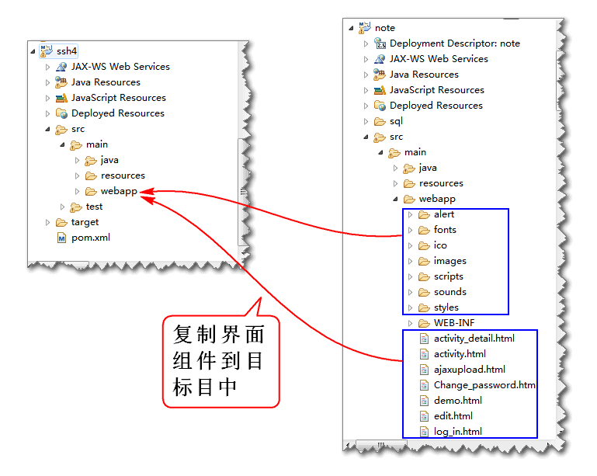

**3. 移植云笔业务层, 持久层和测试组件**

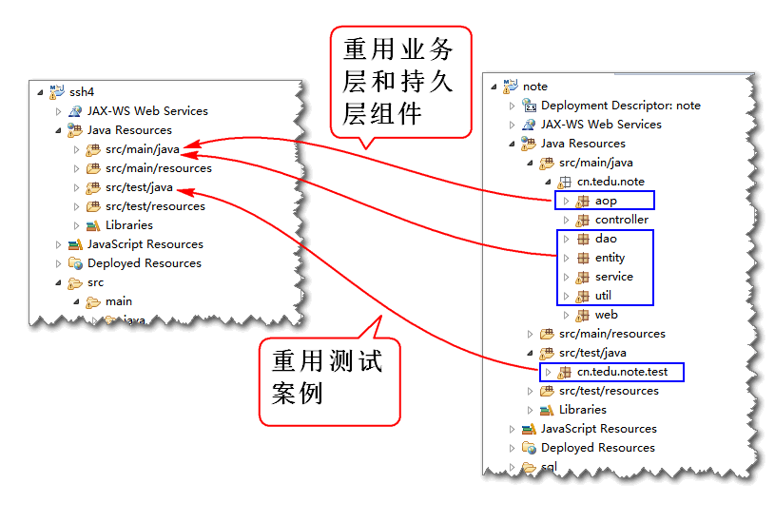

测试组件的作用: 如果能够通过测试组件的回归测试, 则说明持久层和业务层重构成功!

重构 NoteDao, NotebookDao, 删除MyBatis注解 @Param

public interface NoteDao { List<Map<String,Object>> findNotesByNotebookId( String notebookId); Note findNoteById(String noteId); int updateNote(Note note); int addNote(Note note); List<Map<String, Object>> findDeleteNotesByUserId(String userId); int deleteNoteById(String noteId); int deleteNotes( String... ids); List<Map<String, Object>> findNotes( String userId, String notebookId, String statusId); } public interface NotebookDao { List<Map<String, Object>> findNotebooksByUserId( String userId); int countNotebookById(String notebookId); List<Map<String, Object>> findNotebooksByPage( String userId, int start, int pageSize, String table); }

**4. 实现User的映射**

1. 添加映射文件 hbm/User.hbm.xml:

<?xml version="1.0" encoding="utf-8"?> <!DOCTYPE hibernate-mapping PUBLIC "-//Hibernate/Hibernate Mapping DTD 3.0//EN" "http://www.hibernate.org/dtd/hibernate-mapping-3.0.dtd"> <hibernate-mapping> <class name="cn.tedu.note.entity.User" table="cn_user"> <id name="id" column="cn_user_id"></id> <property name="name" column="cn_user_name" type="string"/> <property name="password" column="cn_user_password" /> <property name="token" column="cn_user_token" /> <property name="nick" column="cn_user_nick" /> </class> </hibernate-mapping>

将实体User映射到表 cn_user

1. 实现 UserDao

@Repository("userDao") public class UserDaoImpl implements UserDao { @Resource private HibernateTemplate hibernateTemplate; public User findUserByName(String name) { //HQL Hibernate Query Language // sql: // select * from cn_note // where cn_user_name = #{name} // HQL: // from User // where name = ? String hql = "from User where name = ?"; List<User> list= hibernateTemplate.find(hql, name); return list.isEmpty()?null:list.get(0); } public int addUser(User user) { Serializable id= hibernateTemplate.save(user); return id==null ? 0 : 1; } public User findUserById(String userId) { return hibernateTemplate.get(User.class, userId); } }

1. 重构 spring-hbm.xml

配置hbm/User.hbm.xml

<property name="mappingLocations"> <list> <value>classpath:hbm/User.hbm.xml</value> </list> </property>

打开组件扫描

<context:component-scan base-package="cn.tedu.note.dao"/>

1. 重构 测试案例 基类 BaseTest

@Before public void initCtx() { ctx = new ClassPathXmlApplicationContext( "conf/spring-hbm.xml", "conf/spring-service.xml"); }

1. 执行测试案例 UserDaoTest, 进行回归性测试:

...

**5. 测试 Login 功能**

由于Spring容器初始化期间会扫描创建全部的Bean, 并且注入全部属性, 如果不将dao接口全部实现就会造成Spring容器初始化异常, 故将dao接口全部空实现, 在具体方法的功能实现在日后逐一添加.

1. 实现NoteDao

@Repository("noteDao") public class NoteDaoImpl implements NoteDao { public List<Map<String, Object>> findNotesByNotebookId(String notebookId) { // TODO Auto-generated method stub return null; } public Note findNoteById(String noteId) { // TODO Auto-generated method stub return null; } public int updateNote(Note note) { // TODO Auto-generated method stub return 0; } public int addNote(Note note) { // TODO Auto-generated method stub return 0; } public List<Map<String, Object>> findDeleteNotesByUserId(String userId) { // TODO Auto-generated method stub return null; } public int deleteNoteById(String noteId) { // TODO Auto-generated method stub return 0; } public int deleteNotes(String... ids) { // TODO Auto-generated method stub return 0; } public List<Map<String, Object>> findNotes(String userId, String notebookId, String statusId) { // TODO Auto-generated method stub return null; } }

1. 实现NotebookDao

@Repository("notebookDao") public class NotebookDaoImpl implements NotebookDao { public List<Map<String, Object>> findNotebooksByUserId(String userId) { // TODO Auto-generated method stub return null; } public int countNotebookById(String notebookId) { // TODO Auto-generated method stub return 0; } public List<Map<String, Object>> findNotebooksByPage(String userId, int start, int pageSize, String table) { // TODO Auto-generated method stub return null; } }

1. 实现StarsDao

@Repository("starsDao") public class StarsDaoImpl implements StarsDao { public Stars findStarsByUserId(String userId) { // TODO Auto-generated method stub return null; } public int insertStars(Stars stars) { // TODO Auto-generated method stub return 0; } public int updateStars(Stars stars) { // TODO Auto-generated method stub return 0; } }

1. 测试 UserService 的 Login 方法

...

**6. 实现Login功能的控制器**

1. 创建控制器的抽象父类, 封装控制器的公共属性和方法:

public abstract class AbstractAction extends ActionSupport implements SessionAware, RequestAware, ApplicationAware{ protected static final String JSON="json"; protected Map<String, Object> request; protected Map<String, Object> session; protected Map<String, Object> application; //Json返回值 protected JsonResult jsonResult; public JsonResult getJsonResult() { return jsonResult; } public void setJsonResult(JsonResult jsonResult) { this.jsonResult = jsonResult; } public void setSession( Map<String, Object> session) { this.session=session; } public void setRequest( Map<String, Object> request) { this.request=request; } public void setApplication( Map<String, Object> application) { this.application=application; } }

声明常量 JSON 用于配合JSON返回结果

1. 创建UserAction

@Controller @Scope("prototype") public class UserAction extends AbstractAction{ @Resource private UserService userService; private String name; private String password; public String getName() { return name; } public void setName(String name) { this.name = name; } public String getPassword() { return password; } public void setPassword(String password) { this.password = password; } public String login(){ User user = userService.login(name, password); session.put("loginUser", user); jsonResult=new JsonResult(user); return JSON; } }

其中 name, password 来时用户界面提交的参数, jsonResult 是JSON返回值.

1. 添加配置文件 spring-struts.xml 初始化 Struts 控制器Bean

<?xml version="1.0" encoding="UTF-8"?> <beans xmlns="http://www.springframework.org/schema/beans" xmlns:xsi="http://www.w3.org/2001/XMLSchema-instance" xmlns:context="http://www.springframework.org/schema/context" xmlns:jdbc="http://www.springframework.org/schema/jdbc" xmlns:jee="http://www.springframework.org/schema/jee" xmlns:tx="http://www.springframework.org/schema/tx" xmlns:aop="http://www.springframework.org/schema/aop" xmlns:mvc="http://www.springframework.org/schema/mvc" xmlns:util="http://www.springframework.org/schema/util" xmlns:jpa="http://www.springframework.org/schema/data/jpa" xsi:schemaLocation=" http://www.springframework.org/schema/beans http://www.springframework.org/schema/beans/spring-beans-3.0.xsd http://www.springframework.org/schema/context http://www.springframework.org/schema/context/spring-context-3.0.xsd http://www.springframework.org/schema/jdbc http://www.springframework.org/schema/jdbc/spring-jdbc-3.0.xsd http://www.springframework.org/schema/jee http://www.springframework.org/schema/jee/spring-jee-3.0.xsd http://www.springframework.org/schema/tx http://www.springframework.org/schema/tx/spring-tx-3.0.xsd http://www.springframework.org/schema/data/jpa http://www.springframework.org/schema/data/jpa/spring-jpa-1.3.xsd http://www.springframework.org/schema/aop http://www.springframework.org/schema/aop/spring-aop-3.0.xsd http://www.springframework.org/schema/mvc http://www.springframework.org/schema/mvc/spring-mvc-3.0.xsd http://www.springframework.org/schema/util http://www.springframework.org/schema/util/spring-util-3.0.xsd"> <context:component-scan base-package="cn.tedu.note.action"/> </beans>

1. 在 struts.xml 中配置控制器

<!-- 修改请求扩展名 action改为do --> <constant name="struts.action.extension" value="do"></constant> <package name="user" namespace="/user" extends="json-default"> <global-results> <result name="json" type="json"> <param name="root">jsonResult</param> </result> </global-results> <action name="login" class="userAction" method="login"/> </package>

1. 测试:

http://localhost:8080/ssh4/user/login.do?name=demo&password=123456

1. 在用户界面中整合测试登录功能.

**7. 实现注册功能**

1. 重构控制器 UserAction, 添加控制器方法:

private String nick; private String confirm; public String getNick() { return nick; } public void setNick(String nick) { this.nick = nick; } public String getConfirm() { return confirm; } public void setConfirm(String confirm) { this.confirm = confirm; } public String regist(){ User user = userService.regist( name, nick, password, confirm); jsonResult = new JsonResult(user); return JSON; }

其中扩展了两个表单参数 nick 和 conform

1. 配置 struts.xml:

<action name="regist" class="userAction" method="regist"/>

1. 测试

...

**Struts 拦截器**

Struts 提供了默认的异常拦截功能, 但是不适合将异常转换为JSON, 可以利用拦截器处理Struts2 异常, 转换为JSON消息.

Struts2 拦截器工作原理:

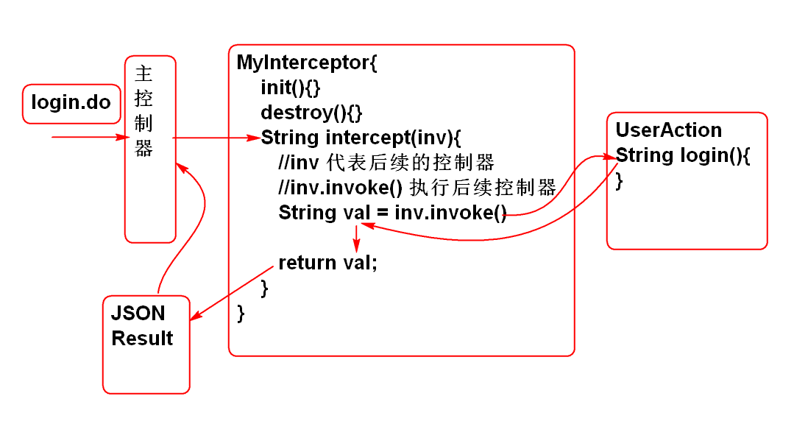

**编写简单的拦截器**

1. 编写拦截器类:

@Component public class MyInterceptor implements Interceptor { public void destroy() {} public void init() {} public String intercept( ActionInvocation invocation) throws Exception { System.out.println("控制器之前"); String val = invocation.invoke(); System.out.println("控制器之后"); return val; } }

1. 设置组件扫描 spring-struts.xml

<context:component-scan base-package="cn.tedu.note.web"/>

1. 配置拦截器:

<interceptors> <interceptor name="demo" class="myInterceptor"/> <interceptor-stack name="demoStack"> <interceptor-ref name="defaultStack"/> <interceptor-ref name="demo"></interceptor-ref> </interceptor-stack> </interceptors> <action name="login" class="userAction" method="login"> <interceptor-ref name="demoStack"></interceptor-ref> </action>

必须将用户拦截器demo和系统拦截器栈defaultStack组合为一个新的拦截器栈 demoStack, 这样才能保留系统提供的功能!!

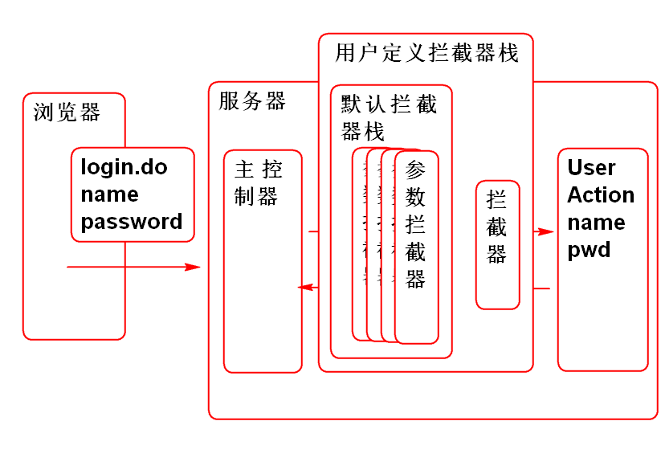

1. 测试: 在登录时候输出拦截器的内容

**利用拦截器处理 异常**

异常原因分析:

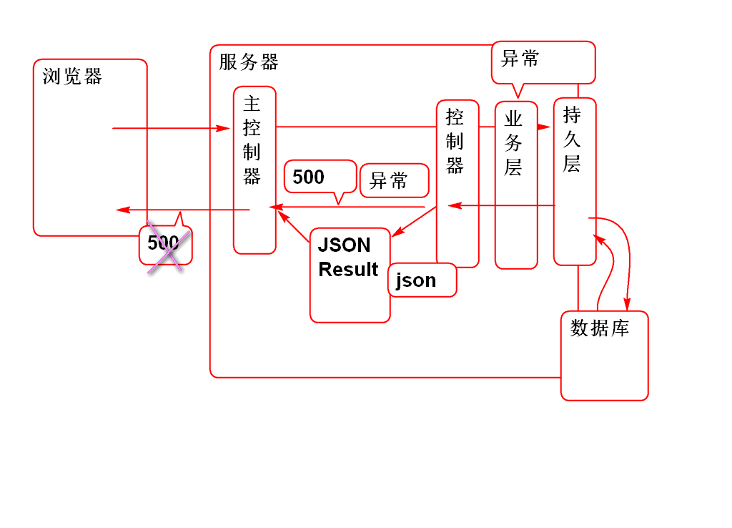

原理:

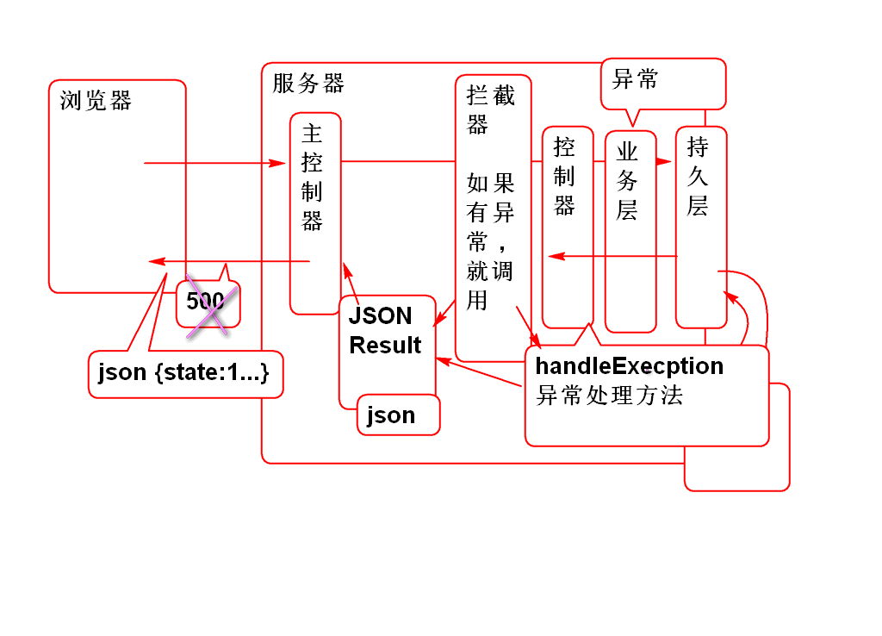

1. 重构 AbstractAction 添加异常处理方法

//AbstractAction 中约定控制器处理异的方法 public String handleException(Exception e) { e.printStackTrace(); jsonResult = new JsonResult(e); return JSON; }

这样全部的控制器都有异常处理方法了.

1. 添加拦截器拦截异常:

@Component public class ExceptionInterceptor implements Interceptor { public void destroy() { } public void init() { } public String intercept( ActionInvocation invocation) throws Exception { //得到目标控制器 AbstractAction action = (AbstractAction)invocation.getAction(); //调用目标控制器的方法 String val = null; try { val = invocation.invoke(); } catch (Exception e) { val = action.handleException(e); } if(val == null){ throw new NullPointerException(); } return val; } }

1. 配置异常拦截器 struts.xml

<interceptors> <interceptor name="execInte" class="exceptionInterceptor"/> <interceptor-stack name="noteStack"> <interceptor-ref name="defaultStack"/> <interceptor-ref name="execInte"></interceptor-ref> </interceptor-stack> </interceptors> <default-interceptor-ref name="noteStack"/>

配置 default-interceptor-ref 元素以后, 所有控制器就都被异常处理拦截器拦截了!

1. 测试...

**作业**

1. 构建SSH项目
   * 重构登录功能
   * 重构注册功能
2. 实现拦截器异常处理