**SSH**

**整合开发**

**自定义异常处理**

重新异常处理方法即可实现自定义异常处理:

1. 重写异常处理方法 UserAction

@Override public String handleException(Exception e) { if(e instanceof UserNotFoundException){ jsonResult = new JsonResult(2, e); }else if(e instanceof PasswordException){ jsonResult = new JsonResult(3, e); }else if(e instanceof UserNameException){ jsonResult = new JsonResult(4, e); }else { jsonResult = new JsonResult(e); } return JSON; }

**笔记本列表功能**

1. 映射笔记本实体到数据库表 Notebook.hbm.xml

<?xml version="1.0" encoding="utf-8"?> <!DOCTYPE hibernate-mapping PUBLIC "-//Hibernate/Hibernate Mapping DTD 3.0//EN" "http://www.hibernate.org/dtd/hibernate-mapping-3.0.dtd"> <hibernate-mapping> <class name="cn.tedu.note.entity.Notebook" table="cn_notebook"> <id name="id" column="cn_notebook_id"></id> <property name="name" column="cn_notebook_name"></property> <property name="typeId" column="cn_notebook_type_id"></property> <property name="userId" column="cn_user_id"></property> <property name="desc" column="cn_notebook_desc"></property> <property name="createtime" column="cn_notebook_createtime" type="java.sql.Timestamp"></property> </class> </hibernate-mapping>

1. 更新配置文件 spring-hbm.xml:

<property name="mappingLocations"> <list> <value>classpath:hbm/User.hbm.xml</value> <value>classpath:hbm/Notebook.hbm.xml</value> </list> </property>

1. 实现 NotebookDaoImpl

@Repository("notebookDao") public class NotebookDaoImpl implements NotebookDao { @Resource private HibernateTemplate hibernateTemplate; public List<Map<String, Object>> findNotebooksByUserId(String userId) { final String hql= "select new map(id as id, name as name) "+ "from Notebook "+ "where userId=? "+ "order by createtime desc"; List<Map<String, Object>> list= hibernateTemplate.find( hql, userId); return list; } public int countNotebookById( String notebookId) { //sql: // select count(*) // from cn_notebook // where cn_notebook_id=? //hql: // select count(*) // from Notebook // where id=? String hql = "select count(*) " + "from Notebook where id=?"; List<Number> list=hibernateTemplate.find(hql, notebookId); return list.isEmpty()? 0: list.get(0).intValue(); } public List<Map<String, Object>> findNotebooksByPage( final String userId, final int start, final int pageSize, final String table) { //sql: select cn_notebook_id, cn_notebook_name // from cn_notebook // where cn_user_id=? // order by cn_notebook_createtime desc //HQL: // select new map(id as id, name as name) // from Notebook // where userId=? // order by createtime desc final String hql="select new map(id as id, name as name) "+ "from Notebook "+ "where userId=? "+ "order by createtime desc"; List<Map<String, Object>> list=hibernateTemplate.execute(new HibernateCallback<List<Map<String, Object>>>() { public List<Map<String, Object>> doInHibernate(Session session) throws HibernateException, SQLException { //利用session创建查询对象 Query query=session.createQuery(hql); //绑定 查询参数 query.setString(0, userId); //绑定分页参数: query.setFirstResult(start); query.setMaxResults(pageSize); //query.list() 执行查询 //返回查询结果 return query.list(); } }); return list; } }

1. 单元测试: 对持久层和业务层进行回归性测试

...

1. 创建控制器 NotebookAction

@Controller @Scope("prototype") public class NotebookAction extends AbstractAction { @Resource private NotebookService notebookService; private String userId; private Integer page; public String getUserId() { return userId; } public void setUserId(String userId) { this.userId = userId; } public Integer getPage() { return page; } public void setPage(Integer page) { this.page = page; } public String page(){ List<Map<String, Object>> list= notebookService.listNotebooks(userId, page); jsonResult = new JsonResult(list); return JSON; } public String list(){ List<Map<String, Object>> list= notebookService.listNotebooks(userId); jsonResult = new JsonResult(list); return JSON; } }

1. 配置控制器:

配置文件结构:

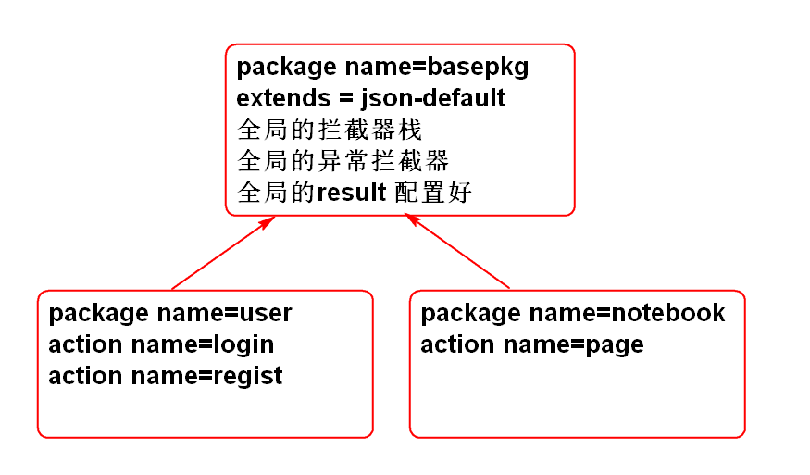

配置文件内容重构: struts.xml

<?xml version="1.0" encoding="UTF-8"?> <!DOCTYPE struts PUBLIC "-//Apache Software Foundation//DTD Struts Configuration 2.3//EN" "http://struts.apache.org/dtds/struts-2.3.dtd"> <struts> <!-- 修改请求扩展名 action改为do --> <constant name="struts.action.extension" value="do"></constant> <package name="basepkg" extends="json-default"> <interceptors> <interceptor name="demo" class="myInterceptor"/> <interceptor name="execInte" class="exceptionInterceptor"/> <interceptor-stack name="noteStack"> <interceptor-ref name="defaultStack"/> <interceptor-ref name="execInte"></interceptor-ref> </interceptor-stack> <interceptor-stack name="demoStack"> <interceptor-ref name="defaultStack"/> <interceptor-ref name="demo"></interceptor-ref> </interceptor-stack> </interceptors> <default-interceptor-ref name="noteStack"/> <global-results> <result name="json" type="json"> <param name="root">jsonResult</param> </result> </global-results> </package> <package name="user" namespace="/user" extends="basepkg"> <action name="login" class="userAction" method="login"/> <action name="regist" class="userAction" method="regist"/> </package> <package name="notebook" extends="basepkg" namespace="/notebook"> <action name="page" class="notebookAction" method="page"/> <action name="list" class="notebookAction" method="list"/> </package> </struts>

1. 对控制器进行测试, 对页面功能进行测试

**Hibernate**

Hibernate的结构:

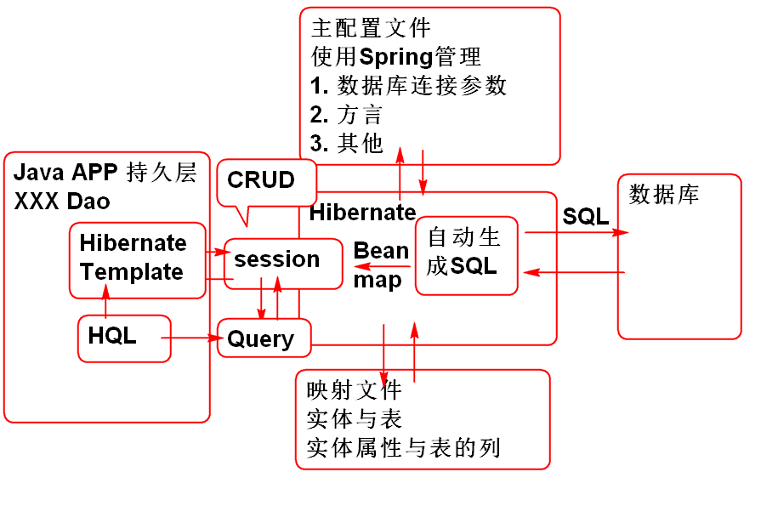

Session 提供了CRUD 功能

* Sesison.get(id)
  + 根据ID从数据库中获取对象, 如果找不到返回null
* Session.load(id)
  + 根据ID从数据库中获取对象, 如果找不到抛异常
* Session.save()
  + 将新对象添加到数据库
* Session.update()
  + 将对象信息保存到数据库
* Session.delete()
  + 将对象的信息从数据库中删除
* Session.clear()
  + 清空Session一级缓存
* Session.evict(对象)
  + 将一个对象从Session缓存中清除

Hibernate 持久化对象生存周期状态管理

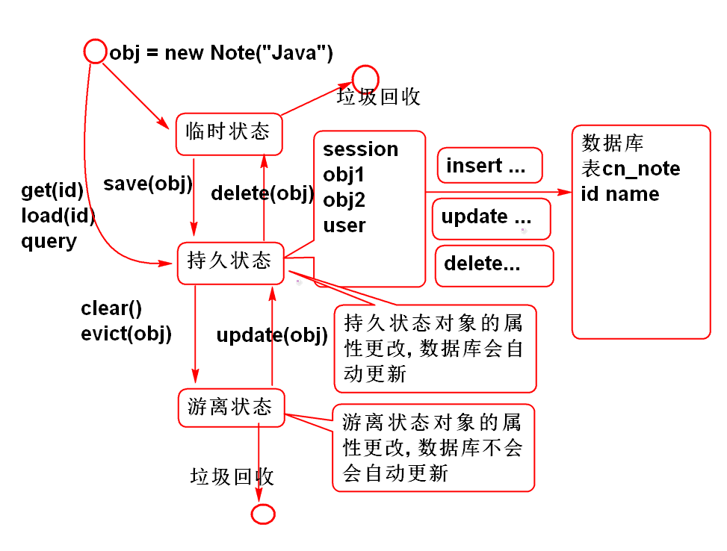

Java Bean == POJO

案例:

public class HibernateTest extends BaseTest { SessionFactory factory; Session session; @Before public void initSession(){ factory = ctx.getBean("sessionFactory", SessionFactory.class); session = factory.openSession(); } @After public void destory(){ session.close(); factory.close(); } @Test public void testSessionFactory(){ //Spring 简化了 Session Factory 的关联 SessionFactory factory = ctx.getBean("sessionFactory", SessionFactory.class); //利用SessionFactory创建Session Session session = factory.openSession(); System.out.println(session); session.close(); System.out.println(factory); } @Test public void testSave(){ Transaction tx=session.beginTransaction(); //持久状态下,更改属性影响到数据库 //user 对象 是临时状态的 User user = new User( "1234567", "熊大", "1234", "", ""); //user成为持久状态 session.save(user); user.setName("范传奇"); user.setPassword("abcde"); tx.commit(); } @Test public void testGet(){ Transaction tx=session.beginTransaction(); //get返回对象是持久状态的 User user = (User)session.get( User.class, "1234567"); System.out.println(user); //更改持久创建对象的属性影响数据库 user.setName("李洪鹤"); tx.commit(); } @Test public void testEvict(){ Transaction tx = session.beginTransaction(); //get返回的对象是持久状态 User user = (User)session.get( User.class, "1234567"); System.out.println(user); //evict将对象清除 sessin缓存, 变成游离状态 session.evict(user); //session.clear(); user.setName("光头强"); tx.commit(); } @Test public void testUpdate(){ Transaction tx = session.beginTransaction(); //get返回的对象是持久状态 User user = (User)session.get( User.class, "1234567"); System.out.println(user); //evict将对象清除 sessin缓存, 变成游离状态 session.evict(user); //session.clear(); user.setName("光头强"); //update 方法 将对象从游离状态改为持久状态 session.update(user); tx.commit(); } @Test public void testDelete(){ Transaction tx = session.beginTransaction(); //get返回的对象是持久状态 User user = (User)session.get( User.class, "1234567"); System.out.println(user); //delete方法将数据从数据库删除, // 对象user在内存中还有数据 // 此时对象是临时状态的! session.delete(user); System.out.println(user); tx.commit(); } @Test public void testLoad(){ //get方法在没有数据时候, 返回null User user = (User)session.get( User.class, "1234567"); System.out.println(user); //null //load方法在没有数据时候, 抛出异常 User u = (User) session.load( User.class, "1234567"); System.out.println(u); } @Test public void testQuery(){ //执行HQL查询 Transaction tx=session.beginTransaction(); //sql: select * from cn_user String hql = "from User"; Query query=session.createQuery(hql); //list 执行返回一组数据的查询 List<User> list = query.list(); for (User user : list) { System.out.println(user); } tx.commit(); } @Test public void testQuery2(){ //执行带参数的SQL //sql: select * from cn_user // where cn_user_name like ? String hql = "from User " + "where name like ?"; Transaction tx = session.beginTransaction(); Query query=session.createQuery(hql); //绑定查询参数 query.setString(0, "%o%"); //执行查询 List<User> list=query.list(); for (User user : list) { System.out.println(user); } tx.commit(); } @Test public void testQuery3(){ //按照名字绑定参数 String hql = "from User " + "where name like :name"; Transaction tx = session.beginTransaction(); Query query=session.createQuery(hql); //绑定查询参数 query.setString("name", "%o%"); //执行查询 List<User> list=query.list(); for (User user : list) { System.out.println(user); } tx.commit(); } @Test public void testQuery4(){ //query 支持唯一结果查询 Transaction tx = session.beginTransaction(); String hql = "from User where name=?"; Query query = session.createQuery(hql); query.setString(0, "demo"); //uniqueResult 用于查找返回唯一的结果 User user = (User)query.uniqueResult(); System.out.println(user); user.setToken("123456"); tx.commit(); } @Test public void testFindPerson(){ String hql = "from Person"; Query query = session.createQuery(hql); List<Person> list = query.list(); for (Person person : list) { System.out.println(person); } } @Test public void testAddPerson(){ Person person = new Person(null, "Wang"); System.out.println(person); Transaction tx = session.beginTransaction(); session.save(person); System.out.println(person); tx.commit(); } @Test public void testFindComment(){ String hql = "from Comment"; Query query = session.createQuery(hql); List<Comment> list = query.list(); for (Comment comment : list) { System.out.println(comment); } } @Test public void testFindPost(){ String hql = "from Post"; Query query = session.createQuery(hql); List<Post> list = query.list(); for (Post p : list) { System.out.println(p); } } }

映射文件:

Person.hbm.xml

<?xml version="1.0" encoding="utf-8"?> <!DOCTYPE hibernate-mapping PUBLIC "-//Hibernate/Hibernate Mapping DTD 3.0//EN" "http://www.hibernate.org/dtd/hibernate-mapping-3.0.dtd"> <hibernate-mapping> <class name="cn.tedu.note.entity.Person" table="p_person"> <id name="id" column="id"> <!-- 使用自增类型的主键生成器 --> <generator class="identity"/> </id> <property name="name" column="name"/> </class> </hibernate-mapping>

Comment.hbm.xml

<?xml version="1.0" encoding="utf-8"?> <!DOCTYPE hibernate-mapping PUBLIC "-//Hibernate/Hibernate Mapping DTD 3.0//EN" "http://www.hibernate.org/dtd/hibernate-mapping-3.0.dtd"> <hibernate-mapping> <class name="cn.tedu.note.entity.Comment" table="p_comment"> <id name="id" column="id"> <!-- 使用自增类型的主键生成器 --> <generator class="identity"/> </id> <property name="title" column="title"/> </class> </hibernate-mapping>

Post.hbm.xml

<?xml version="1.0" encoding="utf-8"?> <!DOCTYPE hibernate-mapping PUBLIC "-//Hibernate/Hibernate Mapping DTD 3.0//EN" "http://www.hibernate.org/dtd/hibernate-mapping-3.0.dtd"> <hibernate-mapping> <class name="cn.tedu.note.entity.Post" table="p_post"> <id name="id" column="id"> <!-- 使用自增类型的主键生成器 --> <generator class="identity"/> </id> <property name="title" column="title"/> <!-- 多个post对应一个person --> <!-- 其中: 属性是person, 属性的类型是Person 属性对应的表格列是 person_id --> <many-to-one name="person" class="cn.tedu.note.entity.Person" column="person_id" > </many-to-one> <set name="comments" > <!-- p_comment 表中的 外键列 post_id--> <key column="post_id"></key> <!-- 当前一个(one)帖子对应多个(many)回复 --> <one-to-many class="cn.tedu.note.entity.Comment"/> </set> </class> </hibernate-mapping>

**单例模式**

模式: 解决问题的固定套路

单例: 在软件中永远唯一的对象个体.

单例模式: 解决 在软件中永远唯一的对象个体 固定套路

注意: Spring 中的Bean默认情况下是 "单例"的, 但是不能称为单例模式!!

**饿汉式:**

//"饿汉式" 立即加载模式 class Girl{ private static Girl instance = new Girl(); private Girl(){ } public static Girl getInstance() { return instance; } }

**懒汉式**

//"懒汉式" 按需加载 class Boy{ private static Boy instance; private Boy(){ } public synchronized static Boy getInstance() { if(instance == null){ instance = new Boy(); } return instance; } }