Minneapolis Case Study

Jamaal Green

February 23, 2018

## Introduction

In order to make their cities more livable, policymakers and planning departments are improving streets and upgrading transportation infrastructure in order to improve access and mobility for pedestrians and bicyclists through the reduction of on-street parking or traffic lanes. While studies have shows how such upgrades improve safety the question remains whether such infrastructure improvements also improve the economic outcomes of improved corridors. This study will attempt to answer to what extent these types of corridor-level street improvements impact economic activity and business vitality for the city of Minneapolis.

Minneapolis is frequently mentioned as one of the best bike cities in the nation and since the passage of the 2011 Bicycle Master Plan the city has focused on continuing to improve on and off-street bicycle facilities. Additionally, the city is in the process of identifying corridors for new protected bicycle lanes in addition to expanding bicycle infrastructure throughout the city. Given the city’s stated goal of continuing bicycle lane, particularly protected lane, expansion the economic impacts of such policies will be of increasing concern for the public.

## Data Sources/Methodology

For this study we used the Longitudinal Employment Household Dynamics Dataset (LEHD). It integrates existing data from state-supplied administrative records on workers and employers with existing census, surveys, and other administrative records to create a longitudinal data system on U.S employment. This dataset tracks Workplace Area Characteristics (WAC), census blocks where people work as opposed to where workers live, for all the census blocks between 2002 and 2015 for most of the states in the US. As such, LEHD provides geographically granular detail about American’s jobs, workers and local economies, allowing us to examine employment by broad industry sector, wage and educational attainment.

### Methodology

We have applied three methods in order to isolate the impact of street improvements while controlling for other economic and regional factors. The methods are an integrated trend analysis (following the NY DOT study), a difference-in-difference approach, and an interrupted time series analysis.

#### Corridor Comparison Selection

In order to properly isolate the effect of the street improvements we must identify treatment corridors (corridors that actually were improved) and control corridors (corridors that are similar to the treatment corridors except they remain unimproved). Treatment corridors are corridors where new bike or pedestrian related improvements were installed. Ideally, these corridors are made up of a minimum of 10 adjacent, or intersecting, census blocks with a minimal number of retail and accommodations related jobs. Additionally, we will only use corridors where street improvements were installed between 2008 and 2013 in order to guarantee with have sufficient data to track pre and post-treatment employment trends.

Once corridors are selected based on these criteria we require further testing in order to discern how similar the proposed treatment and control corridors. Finding corridors that are as similar as possible to each other except for the construction of new bicycle/pedestrian infrastructure allows us to approximate true experimental conditions. We will use a combination of descriptive statistics- comparing corridor employment figures to city employment quantiles- and statistical tests- t-tests in order to determine if the average employment, by block, for each corridor is similar to the other.

#### Aggregated Trend Comparison

This first method follows the previous NYCDOT study (NYCDOT, 2013), aiming to examine whether the treatment corridors tend to have better business performance than comparison corridors after street improvements. The approach compares the trends of treatment and control corridors in addition to city-wide trends over the full time period we have data for. If treatment corridors show greater increases in employment or sales tax receipts that would represent a positive impact of street improvement on business activities. This method is easy to follow and represents the aggregated trend of business activities. However, it lacks the rigor of econometric estimates and statistical tests that explicitly test whether or not the street improvement caused the change in trend.

#### Difference-in-Difference

The second method aims to estimate the difference in business vitality of pre- and post-improvement periods between improved and comparison corridors within the same time period. This is known as a difference-in-difference (DID) approach. It is a designed to answer the “but for” question of what a corridor’s economic trajectory would look like had it streets not been improved. It requires data from pre/post intervention such as panel data (individual level data overtime) or cross-sectional data (individual or group level). The approach looks at the change in the variable of interest in the treatment group before and after it is treated. In this case this means looking at some time period before and after a street improvement. Meanwhile, the control group has not been treated in either time period. The difference in growth trajectories between the two periods will give an unbiased estimate of the effect of the treatment. DID is a useful technique when randomization on the individual level is not possible. This approach removes biases in the second period comparisons between the treatment group and control group that could be result from permanent differences between those groups, as well as biases from comparisons over time in the treatment group that could be the result of trends. A key assumption of DID estimate is that the differences between control group and treatment group would have remained constant in the absence of treatment.

DID is a linear modeling approach and its basic formula is expressed as:

is the observed outcome in groups i and t (in this case chang eine employment or sales tax revenue) is a dummy variable set to 1 if the observation is from the treatment group is a dummy variable set to 1 if the observation is from the post treatment period i either groups is the DID estimate of the treatment effect

If the DID estimate is significant and positive, then that indicates a positive effect of the street improvement. Conversely if the estimate is significant and negative that indicates a negative effect of the improvement. Finally, a non-significant result indicates the improvement had no statistically discernible effect.

#### Interrupted Time Series

Interrupted time series is an econometric technique that estimates how street improvements impact corridor economic vitality from a longitudinal perspective. This approach tracks the treatment corridor over time and estimates the impact by the treatment by looking at the change of the corridor growth trend after the treatment. If the treatment has a causal impact, the post-intervention series will have a different level or slope than the pre-intervention series. In our research, interrupted-time series will be used to distinguish differences in growth before and after a specific time break point where an intervention, such as installation of new bicycled facility happens.

One advantage of ITS is that it allows for the statistical investigation of potential biases in the estimate of the effect of the intervention. Given the longitudinal nature of the test ITS requires a significantly larger amount of data in order to accurately estimate a real effect on the growth trend.

The interrupted time-series analysis equation can be expressed as:

is the observed business outcome in time period t indicates the number of quarters from start to finish of the series is the treatment dummy variable taking values of 0 in the pre-intervention period and 1 in the post-intervention period is the model intercept or baseline level at T = 0 represents the change in the outcome with a time unit increase (the pre-intervention trend) is the level change following the intervention indicates the slope change following the intervention

## Corridor Comparisons

Our first test in corridor comparability is comparing the count of the total number, retail, and accommodation jobs within the corridors compared to block figures for the city of Minneapolis as a whole. This is allows us to have a broad understanding of the relative job density of the corridors. This serves two purposes: first, it gives us a quick estimate of the range of jobs the corridors have; and second, it shows how similar the corridors are to each other in terms of the number of jobs in each. Finally, we perform a t-test, a statisical test designed to measure if the means of two different groups are statistically similar. This final test offers us a more rigorous test of the comparability of the corridors. All of these figures use 2007 employment numbers from the LEHD as that is the earliest year before the first improvement project.

### Riverside Ave.

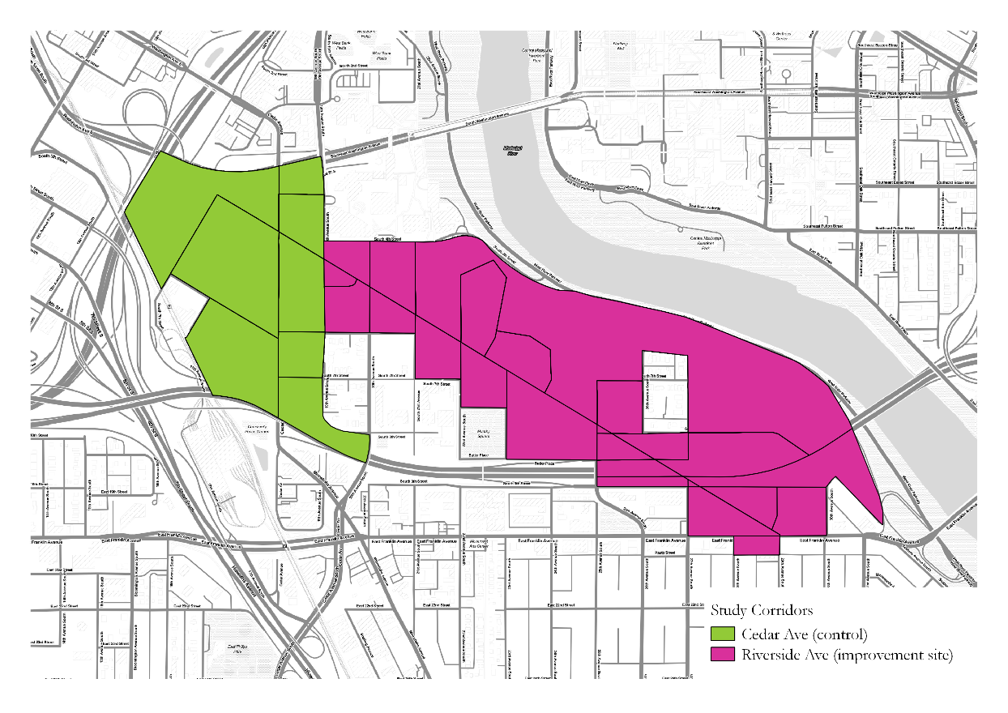

Our first corridor group consists of the Riverside and Cedar Ave corridors. The Cedar Ave comparison corridor is only 2,000 feet and covers three census blocks and is too small for meaningful comparison, but we shall continue forward with the analysis.

The corridor is a vibrant commercial strip with a healthy mix of different retail uses and services a variety of institutions including, but not limited to, the University of Minnesota Medical Center and Augsburg College. Improvements to the corridor were installed in 2009. These improvements included the addition of bicycle lanes traveling in both directions as well as the removal parking spaces and some travel lanes on Riverside. The bicycle lanes are not protected but they do have bright signal paint and are clearly demarcated on the corridor.

The following table shows total, retail, and accomodations employment for Riverside and Cedar and the city-based percentile rank of the corridors. Both corridors are in the top 5% of the city in terms of the number of total and retail. Neither corridor has any accommodations employment.

|  |  |  |  |  |  |  |
| --- | --- | --- | --- | --- | --- | --- |
| Corridor | Tot Emp | Retail Emp | Accom Emp | Tot (%) | Retail (%) | Accom (%) |
| Riverside Ave. | 5341 | 199 | 102 | 95 | 95 | 95 |
| Cedar Ave. | 672 | 97 | 0 | 95 | 95 | N/A |

Table 1: Riverside and Cedar Avenue Employment Percentiles

We performed t-tests on three metrics at the census block level: “business” employment, the sum of retail and accomodations employment; a “business share” metric that is the share of employment in a census block of business employment over the sum of other services industries such as professional/scientific services, public administration and educational services; finally, a second business share metric on a smaller share of services employment including professional/scientific services, administrative/waste management services and arts/accommodation services (check appendix for variable definitions).

On all three metrics the t-test returned non-significant results meaning that there is not a statistically significant difference in the mean employment levels between the two corridors. This means that the corridors are comparable and are appropriate for continued testing.

### Franklin Ave

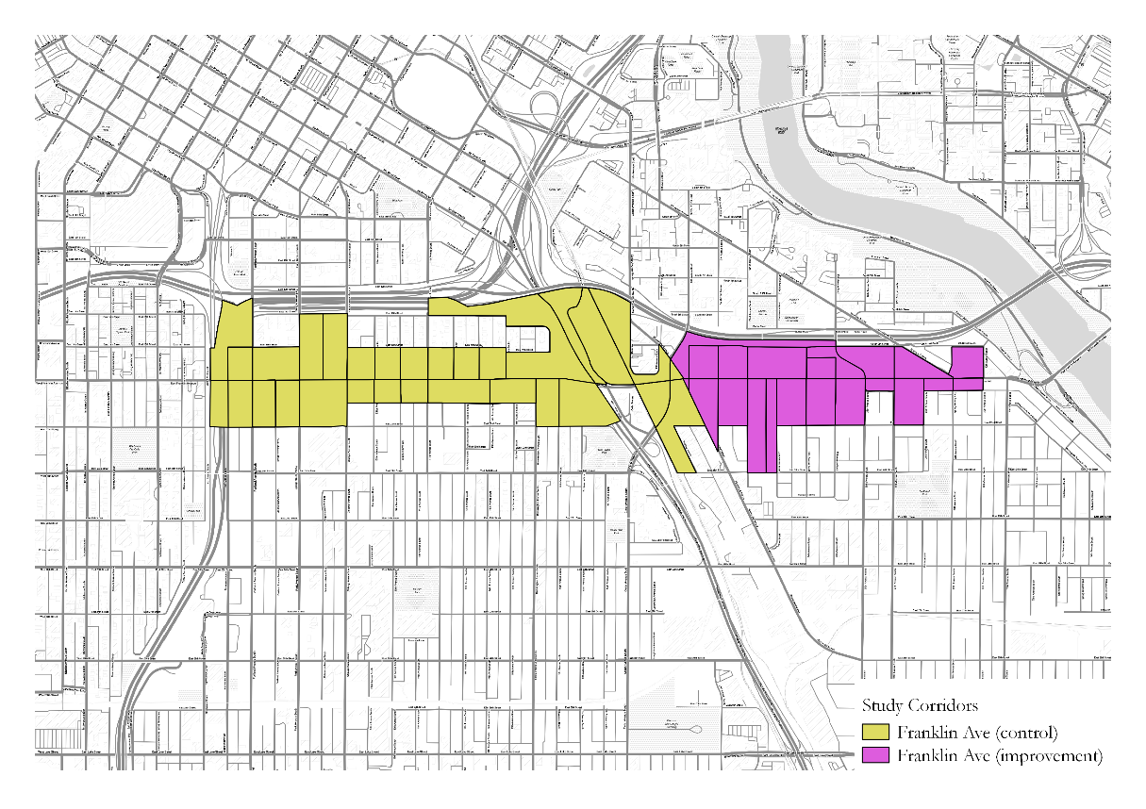

The Franklin Avenue corridors are older, though healthy, low rise commercial corridors with a mix of smaller restaurants, retailers and a mix of residences. It is a frequently traveled corridor with newer bicycle infrastructure as well as a docked bike share station. The bike lanes were installed in 2011 and required the removal of parking spaces but no changes to existing travel lanes.

The Franklin Avenue corridors are both within the top 10% of areas in the city with respect total and retail employment, though the Franklin treatment corridor is in the 90th percentile of total employment compared to the 95th percentile of the Franklin control corridor. The Franklin Avenue control corridor is also in the top 5% of areas of the city in accommodations employment while the improvement corridor has no accomodations employment.

|  |  |  |  |  |  |  |
| --- | --- | --- | --- | --- | --- | --- |
| Corridor | Tot Emp | Retail Emp | Accom Emp | Tot (%) | Retail (%) | Accom (%) |
| Franklin/Riverside | 340 | 39 | 0 | 90 | 95 | N/A |
| Franklin/Minnehaha | 1366 | 19 | 187 | 95 | 95 | 95 |

Table 2: Franklin Ave. Corridors Employment Percentiles

In terms of the t-tests both corridors have statistically non-significant differences in “business” employment and their business employment share categories. Thus these corridors are appropriate comparators for further study.

### Central Avenue

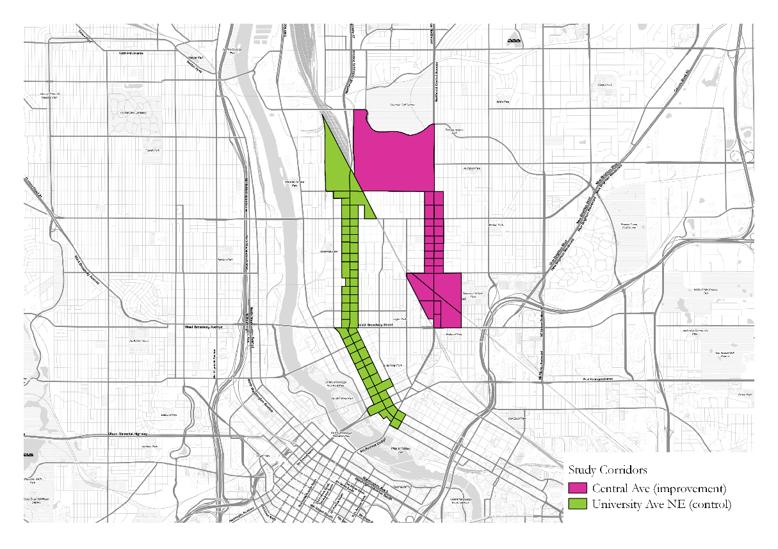

The Central Avenue corridor is a major four-lane thoroughfare and holds a mix of commercial and industrial establishments. Bike lanes were installed in 2012 and required the reduction in lane width, but no removal of lanes or on-street parking was required.

Both the Central and University Avenue corridors have total and retail employment in the top 5% of blocks in the city. Central Avenue also has accommodations employment equal to the top 5% of blocks in the city.

|  |  |  |  |  |  |  |
| --- | --- | --- | --- | --- | --- | --- |
| Corridor | Tot Emp | Retail Emp | Accom Emp | Tot (%) | Retail (%) | Accom (%) |
| Central Ave | 572 | 97 | 16 | 95 | 95 | 95 |
| University Ave | 1182 | 164 | 0 | 95 | 95 | N/A |

Table 3: Central and University Avenue Corridors Employment Percentiles

All t-tests came back non-significant at the .05 level meaning that the two corridors are apprrpaite comparators.

### Lyndale Avenue South

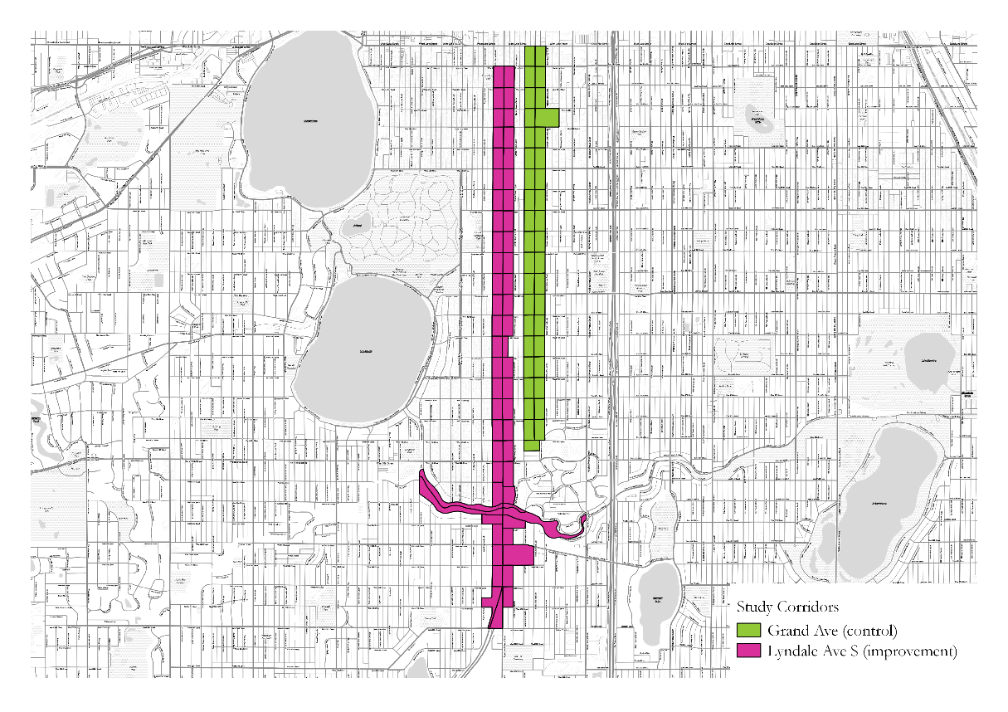

The Lyndale Avenue corridor covers quiet residential streets to busy commercial corridors. While the corridor improvement did not include new bicycle lanes, it was the site of a dramatic road diet from 2008-2009 removing a travel lane in each direction and the addition of a landscaped median strip. The lack of bike lanes should disqualify it from our study but for the sake of consistency we finished the corridor comparison.

Lyndale and Grand Avenue diverge in terms of their total employment numbers but are both in the 95th percentile of retail employment when compared to the rest of the city.

|  |  |  |  |  |  |  |
| --- | --- | --- | --- | --- | --- | --- |
| Corridor | Tot Emp | Retail Emp | Accom Emp | Tot (%) | Retail (%) | Accom (%) |
| Lyndale | 412 | 106 | 0 | 95 | 95 | N/A |
| Grand | 76 | 19 | 0 | 80 | 95 | N/A |

Table 4: Lyndale and Grand Avenue Corridors Employment Percentiles

All t-tests came back non-significant emaning that the corridors are acceptable comparators.

### North 2nd Street

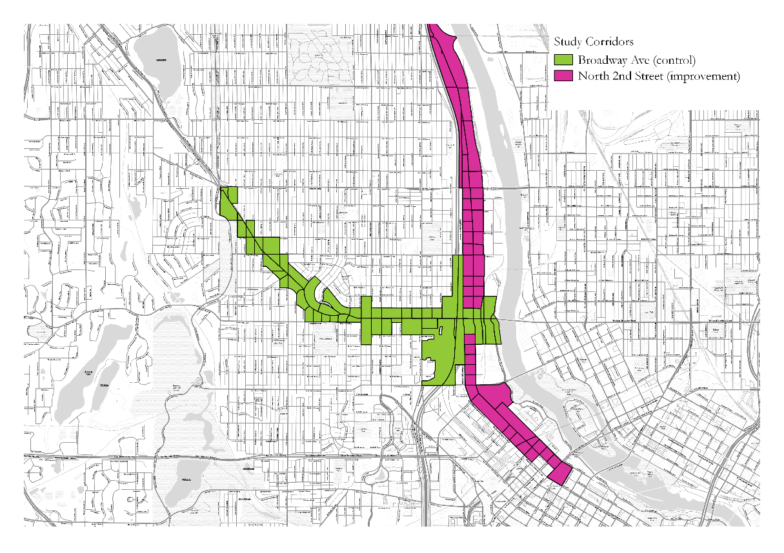

The North 2nd Street corridor is a busy midrise residential and commercial corridor and a major thoroughfare for the city. In 2011, the city installed new bicycle lanes, removing some available parking for them, but keeping existing travel lanes.

North 2nd Street and Broadway Avenue both have total and retail employment in the 95th percentile while Broadway also is in the 95th percentile for the city in accomodations employment, though that translates to only 2 accommodations jobs for the corridor.

|  |  |  |  |  |  |  |
| --- | --- | --- | --- | --- | --- | --- |
| Corridor | Tot Emp | Retail Emp | Accom Emp | Tot (%) | Retail (%) | Accom (%) |
| Second St. | 2570 | 42 | 0 | 95 | 95 | N/A |
| Broadway | 734 | 36 | 2 | 95 | 95 | 95 |

Table 5: North 2nd Street and Broadway Corridors Employment Profile

All t-tests came back non-significant emaning that the corridors are acceptable comparators.