Project Proposal

TCSS 445 Database Systems Development Petter Website Team 18 Vinh Vien Weiwei Shi

Contents

1. Introduction 2
2. Users 3

Family pet owners

Pet trainer

Pet adoption centers

Pet lovers without pets

1. User and System Requirements 3
2. Implementation 4

V. Data Requirements 4

VI. Prototypes 5

# Introduction

Facebook, gives people the power to share and make the world more open and connected. People use Facebook to stay connected with friends and family, to discover what’s going on in the world, and to share and express what matters to them. Tinder, establishes a romantic connections starts from “It’s a match”. Among those tons of social networking sites or apps, they forget one of the most important part of our lives – our pets! Pets need friends too! In this text, we would like to propose a website: Petter, it will provide a platform to make genuine friendships with pets they share common interests with. On the website, the users are able to view other people pets’ information, create pets’ and leave comments on the “Pets Wall” information after they sign-in.

Our target users will be pet owners, pet trainers, staff of pet adoption centers and pet lovers without pets. On the main page, the users will see a search menu, user can search the pets they want by pet-type, sex, city, state and zip code. And also, they could do advanced search. The users are able to search the pets by more catalogs, such as age, color and size. After that, they can start to look for the pets they think their pets might be interested, or find the pets their pets share common interests with. If the users sign-up an account with us, they can create a page for their own pets. And also, they can write comments to other users’ pets. Then the connections start. Additionally, our website will have an “adoption information” section. It will give the pet lovers who have not have a pet yet to look it up. The staff of pet adoption will be able to add the adoption information after they sign-in.

So while the main goal of the website is to help pets connect offline and do activities they enjoy together, there is a strong possibility pets who meet through Petter will really like each other and begin to develop closer relationships from there.

# Users

Our target is anyone that is a pet lover; people with no pets to pet trainers. This is a list of expected users:

1. Family pet owners
   1. Family that own pets would want to let their pet get friends.
   2. It is healthy for pets to play with each other and develop social skills.
2. Pet trainer

Training pets to be friendly with other pets can be challenging and finding people who have pets that are willing to help you train are even more difficult. This website provide a variety of pets that trainers can use to meet other pets, since other owners also want growth for their pets.

1. Pet adoption centers

They can use this website to promote pets for adoption, and let their pets gain some outside world exposure.

1. Pet lovers without pets

People who want to meet pets; for adoption or for fun.

# User and System Requirements

The list of requirements to complete this project:

* User - Will be able to log-in and interact with other accounts; liking, commenting, and see other accounts.
* Pet Account - Users will be able to create pet accounts. This user will be the admin of this pet account. The account will contain basic information about the pet.
* Pet information - The website need to provide information about pets, there will be a minimum requirement of information for certain pets. i.e. breed, age, color and etc.
* Pet wall - A wall that pet can post messages for other users to see.
* Search menu - A table/map menu that allows user to check boxes to find perfect pet they are looking for.
* Tags - An element of the search menu for advance search.
* Search bar - Allows user to search pet and users by their names.
* Rating - A rating system to see if the pet meet up was good.
* User-Create-Direction - Provides step-by-step instruction to create a new user.
* Pet-Create-Direction - Provides step-by-step instruction to create a pet account.

In order to make a user friendly website, the website will focus mostly on the user. The user are the contributor to the site. User will be able to post pets, comments, and rate other pets. The main goal for this project is to construct a fast way to connect with other pets in the community.

|  |  |  |  |  |
| --- | --- | --- | --- | --- |
|  | Create | Read | Update/Review | Delete |
| User | x | x | x | (limited) |
| Pet account |  | x | x |  |
| Moderator | x | x | x | x |
| Anonymous |  | x |  |  |

# Implementation

* Secure user login
* Users can create, update and delete their pet and own accounts
* Allow users to personalize pet account
* Advance search using menu and tags
* Users can submit review about pets
* Pets account can add friends (other pets)

# Data Requirement

* User: first name, last name, password, email, list of pet accounts and user id.
  + User need to be able to store their name, pet accounts, password, email, and account id.
  + User need to store past meet up with pets and history with pets.
  + User need to store pets they are interested in.
* Pet Account: first name, last name, pet id, user id color, age, hobbies, favorite toy, sex, and extra info.
  + Pet account will need to show name, pet id, color, age, and hobbies.
  + Pet account can comments, rate, and befriend other pet accounts.
* Type of pets: type of animals, pet id, and user id.
  + Different table of pet accounts depending on the pet. Example: Snake will have a length category, birds will have a wingspan, and bugs will have a leg count.

# Prototype

Main page:

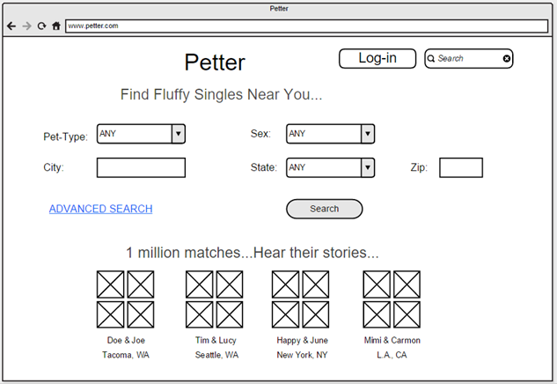

Advanced search page (after the user clicks “ADVANCED SEARCH” and pet-type selects “Dogs”):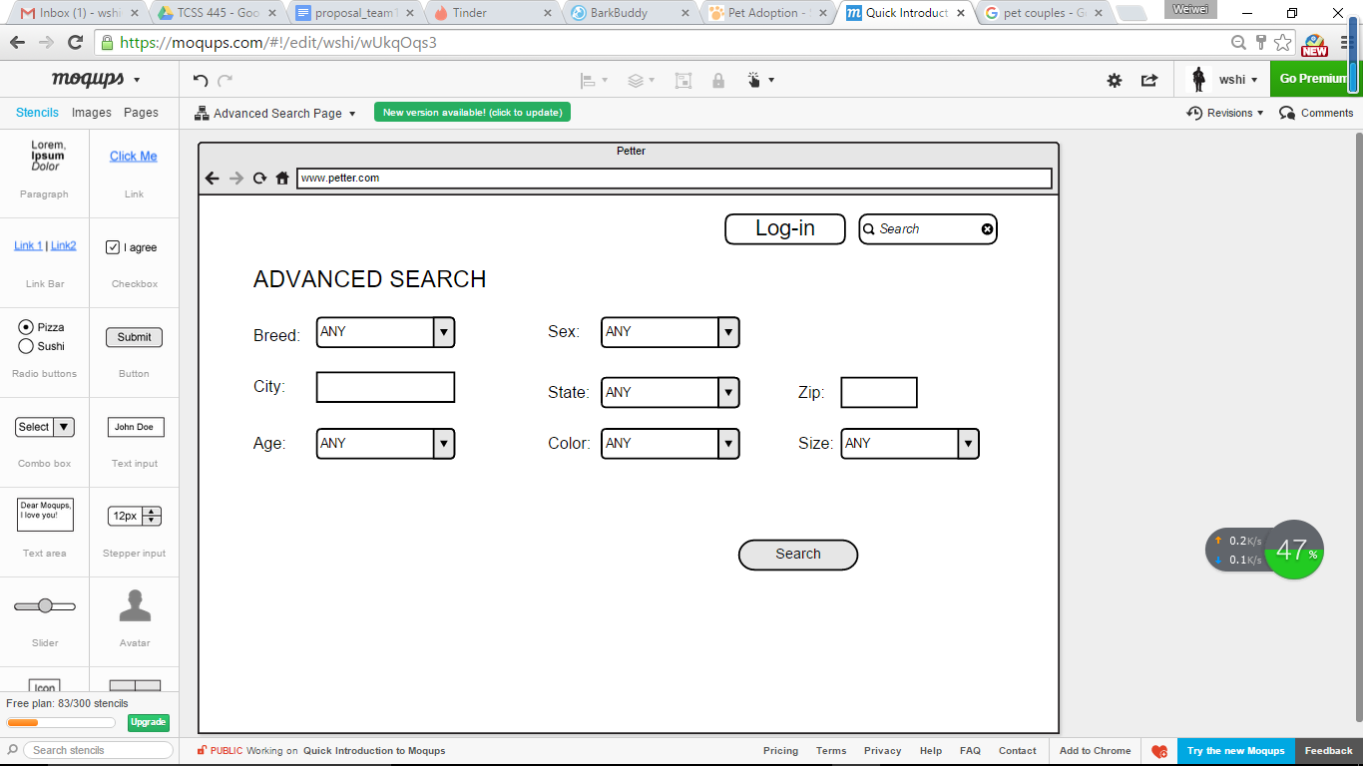

Log-in Page:

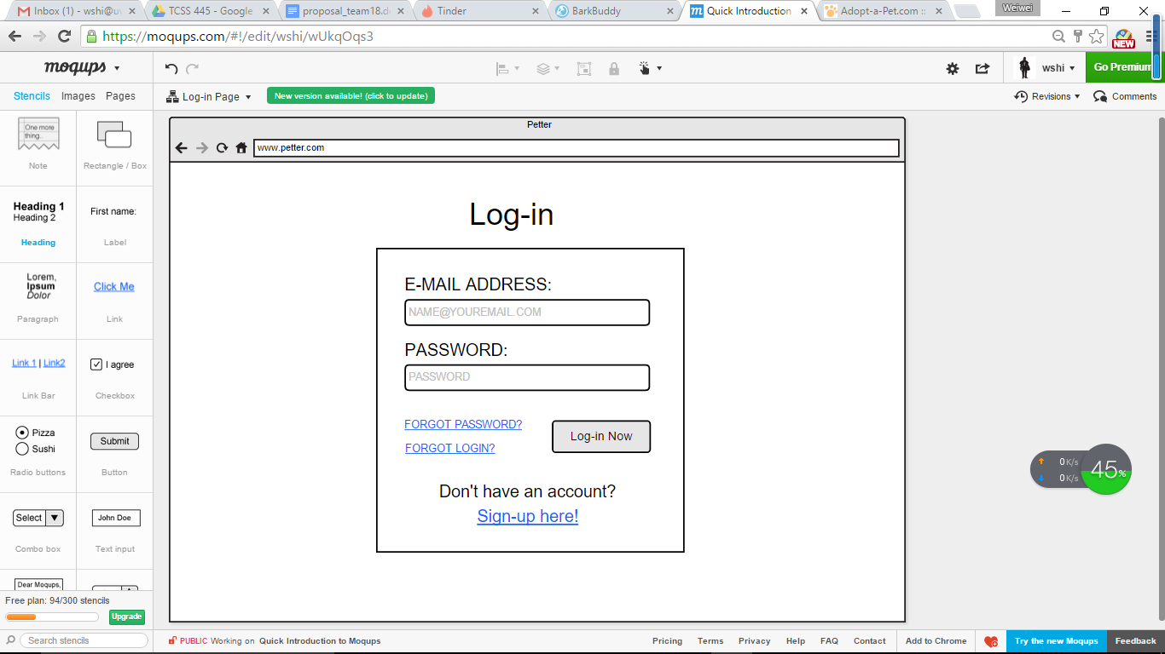

Create an account (Sign-up):

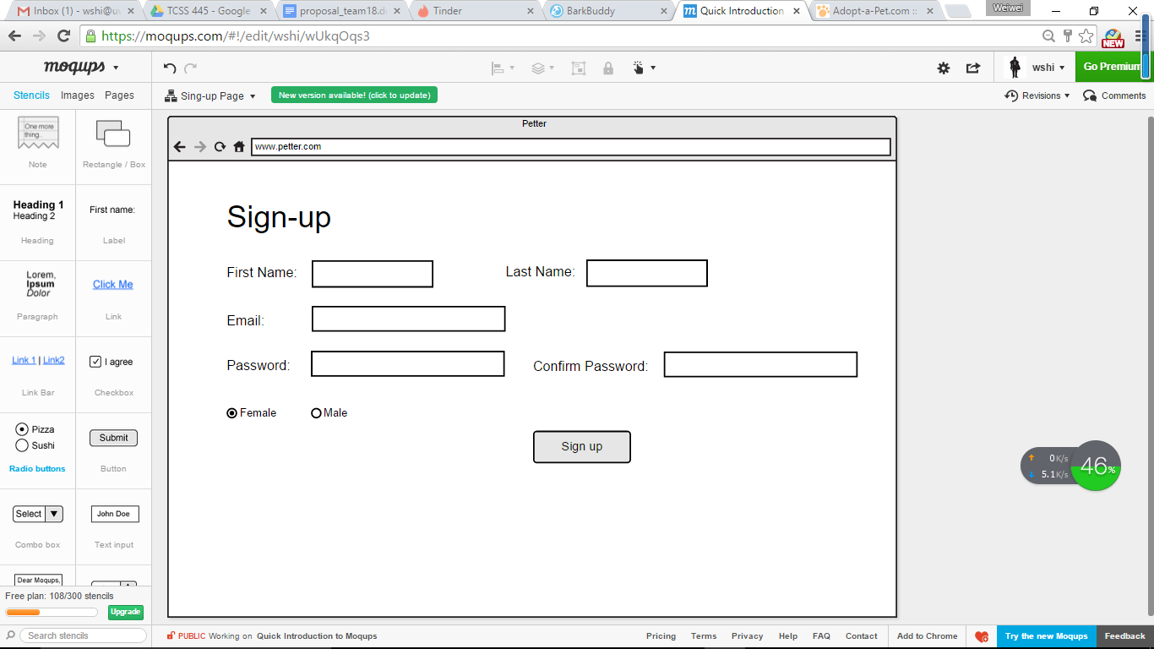

User after log-in, create information for his/her pet:

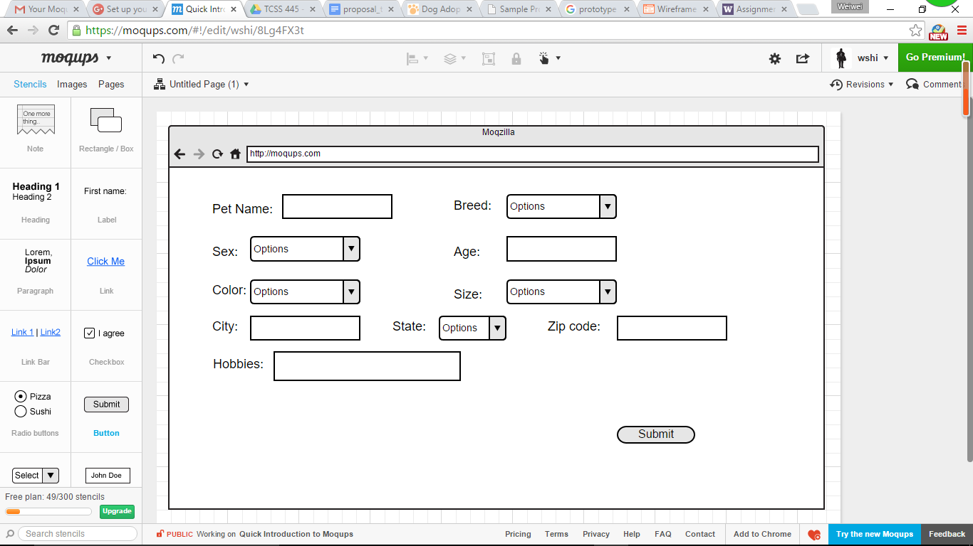

Pet information and leave comments if the user wants to.

