**1.下载源代码<https://github.com/shiwen1997/gxu_ar>  ，在AS中打开:**

打开运行可能会报错。

一般是gradle的错误，确保翻墙（有些google的依赖下载不来），并且把app的gradle依赖版本改成最新的

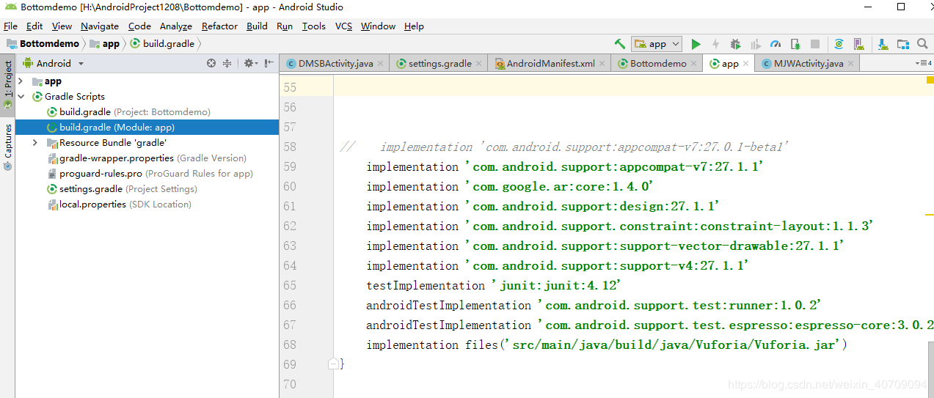​

implementation 'com.android.support:appcompat-v7:27.1.1'

implementation 'com.google.ar:core:1.4.0'

implementation 'com.android.support:design:27.1.1'

implementation 'com.android.support.constraint:constraint-layout:1.1.3'

implementation 'com.android.support:support-vector-drawable:27.1.1'

implementation 'com.android.support:support-v4:27.1.1'

testImplementation 'junit:junit:4.12'

androidTestImplementation 'com.android.support.test:runner:1.0.2'

androidTestImplementation 'com.android.support.test.espresso:espresso-core:3.0.2'

implementation files('src/main/java/build/java/Vuforia/Vuforia.jar')

**2.服务器下载模型文件接口：**

①新建IDEA项目file1223，新建DownloadController.java、application.yml两个文件

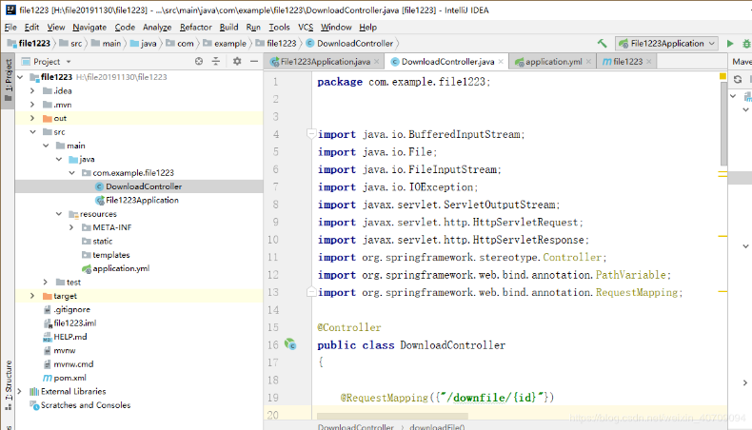​

package com.example.file1223;

import java.io.BufferedInputStream;

import java.io.File;

import java.io.FileInputStream;

import java.io.IOException;

import javax.servlet.ServletOutputStream;

import javax.servlet.http.HttpServletRequest;

import javax.servlet.http.HttpServletResponse;

import org.springframework.stereotype.Controller;

import org.springframework.web.bind.annotation.PathVariable;

import org.springframework.web.bind.annotation.RequestMapping;

@Controller

public class DownloadController

{

@RequestMapping({"/downfile/{id}"})

public String downloadFile(HttpServletRequest request, HttpServletResponse response, @PathVariable String id) throws Exception {

String fileName = id;

if (fileName != null) {

String realPath = "/var/files/modelsfile/";

// String realPath = "H:/modelsfile";

File file = new File(realPath, fileName);

if (file.exists()) {

response.setContentType("application/force-download");

response.setHeader("Content-Length", file.length() + "");

response.setHeader("Content-Disposition", "attachment;fileName=" + new String(fileName.getBytes("GB2312"), "ISO-8859-1"));

byte[] buffer = new byte[1024];

FileInputStream fis = null;

BufferedInputStream bis = null;

try {

fis = new FileInputStream(file);

bis = new BufferedInputStream(fis);

ServletOutputStream servletOutputStream = response.getOutputStream();

int i = bis.read(buffer);

while (i != -1) {

servletOutputStream.write(buffer, 0, i);

i = bis.read(buffer);

}

System.out.println("");

} catch (Exception e) {

e.printStackTrace();

} finally {

if (bis != null) {

try {

bis.close();

} catch (IOException e) {

e.printStackTrace();

}

}

if (fis != null) {

try {

fis.close();

} catch (IOException e) {

e.printStackTrace();

}

}

}

}

}

return null;

}

}

 yml文件设置端口

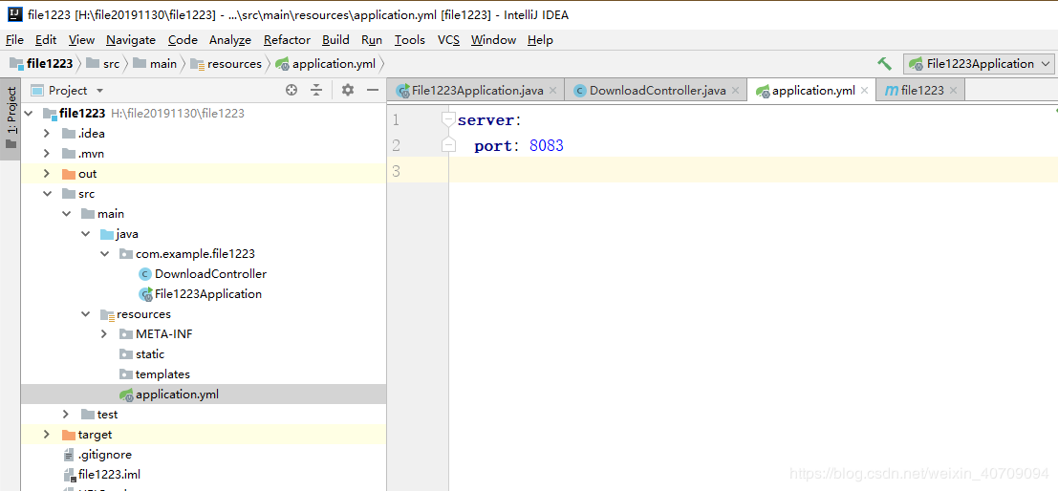​

②打包部署：点击右边Maven projects 的package生成jar文件

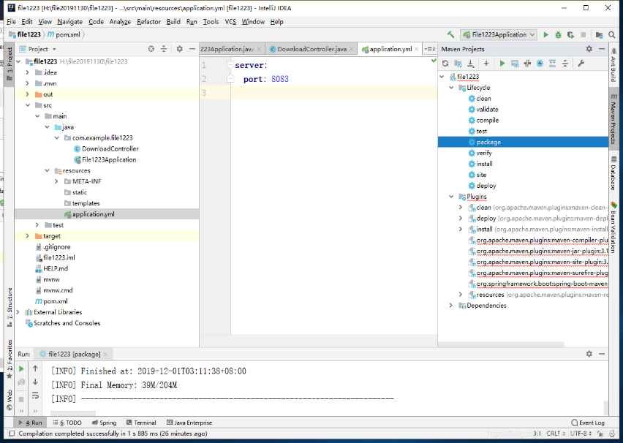​

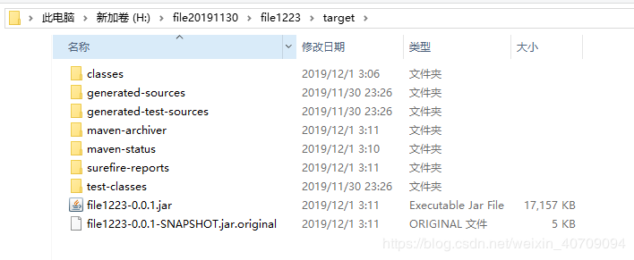​

**③.将资源文件（AR模型文件）放在服务器上：一定要放对目录**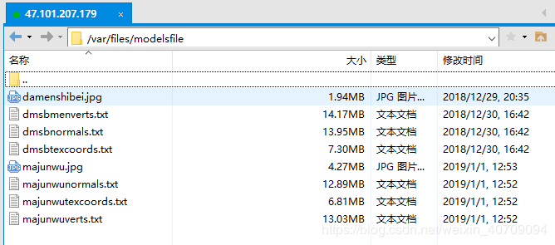​

**④.运行jar包**

nohup java -jar file1223-0.0.1.jar >myfile20191201.out &

file1223-0.0.1.jar是jar包的名字

检测：浏览器输入47.101.207.179:8083/downfile/dmsbtexcoords.txt测试：能下载文件就行。

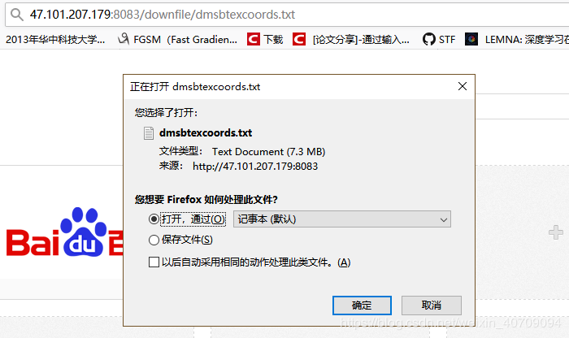​

**⑤修改AS工程内部代码：**

在DMSBActivity.java文件、MJWActivity.java文件里使用了两个模型文件下载接口：只用将47.101.207.179:8084改成服务器的IP就可以了

