Building a Structured Prompting and Streamlit Prototype for Interpreting Bio-Behavioral Team Dynamics Analytics
Shiwen Zhou
Human Systems Engineering, Arizona State University
TMC 498 / TEM 598: Prompt Engineering for Data Analysis
Spring 2026
Option 7: Doctoral Literature Review + AI-Assisted Prototype

Overview
This paper presents a Streamlit-based AI-assisted prototype supplement for the dissertation research question focused on interpretation of bio-behavioral team dynamics analytics. The relevant dissertation question asks whether a customized AI bot can help non-experts understand and interpret dynamic team metrics, including how the metrics are derived and how they lead to reported results. The course project does not test dissertation hypotheses. Instead, it builds a public, synthetic-data scaffold for the future interpretation bot.
The prototype is designed around three constructs from the updated dissertation proposal: interdependence, adaptation, and influence distribution. The public version uses only synthetic data. It generates a 1 Hz multimodal time series for five Fire Support Team roles, computes moving-window Shannon entropy, categorical sample entropy and inverse sample entropy, lag-averaged role-level average mutual information (AMI), AMI influence share, and HHI-style influence concentration. It then displays the outputs in Streamlit and prepares a Gemini prompt payload for a chatbot response. The Jupyter notebook contains the equations and synthetic analysis steps; it does not request or store an API key.

Introduction
High-stakes teams often need feedback while coordination is still unfolding, not only after a scenario has ended. Fire support, aviation, emergency response, and healthcare teams must coordinate specialized roles, adapt to changing task demands, and redistribute influence as conditions shift. Traditional assessment approaches, including surveys and labor-intensive behavioral coding, remain valuable, but they can be too slow or too episodic to support timely interpretation in dynamic training environments.
The broader dissertation addresses this measurement problem by examining objective, time-varying indicators of team interdependence, adaptation, and influence distribution and by developing a customized AI bot that can help stakeholders interpret those indicators. The course project focuses on the second part: the interpretation bot. Practically, the goal is to build a chatbot that can communicate with users about concepts and outputs. A user should be able to ask what an entropy peak means, how inverse sample entropy is derived, why an AMI profile is concentrated in one role, whether a pattern should be interpreted as good or bad, and what additional evidence is needed before drawing conclusions.
Because the dissertation data are restricted, the course prototype uses synthetic demonstration data. This makes it possible to test the data pipeline, visualization logic, prompt structure, and Streamlit interface without exposing raw physiological records, raw audio, identifiable trainee information, or protected project materials. The eventual dissertation implementation can replace the synthetic packet with approved de-identified summaries while preserving the same identity file, prompt structure, visual explanation logic, and conversational interaction pattern.

Literature Review
Teams are commonly understood as groups of two or more members who interact dynamically, interdependently, and adaptively toward shared goals while holding differentiated roles (Salas et al., 1992). Temporally based models of teamwork emphasize that team processes shift across episodes of transition, action, and interpersonal regulation (Marks et al., 2001). For dynamic operational teams, this temporal perspective is essential because a single post-task score can describe an outcome but cannot show when coordination changed, when adaptation occurred, or which role patterns were most coupled with the team system.
Interactive team cognition provides a theoretical foundation for measuring teams through interaction rather than only through aggregated individual mental states. Cooke, Gorman, Myers, and Duran (2013) argued that team cognition can be observed in interaction, communication, and coordination dynamics. This perspective supports the dissertation emphasis on dynamic, interaction-based indicators of interdependence, adaptation, and influence distribution. The present prototype translates that measurement logic into an explanation interface: instead of treating a metric as self-explanatory, the chatbot explains the metric-to-result chain in plain language.
Dynamic measurement supports this theoretical direction. Coordination in teams can be treated as a nonlinear, time-varying process in which patterns stabilize, destabilize, and reorganize around task demands (Gorman et al., 2010). Entropy-based measures are useful because they summarize predictability, irregularity, or variability in a sequence. Sample entropy was developed to address limitations of approximate entropy and is commonly used to characterize regularity in noisy time-series data (Richman & Moorman, 2000). Strang et al. (2012) demonstrated that sample entropy can also be applied to categorically coded team communication sequences, which is relevant for the symbolic-state design used in the current synthetic prototype.
These metrics require cautious interpretation. An increase in entropy may reflect adaptive reorganization after a perturbation, inefficient instability, or a normal transition between task phases. A decrease in sample entropy may reflect more regular temporal structure, but regularity is not automatically desirable. Likewise, AMI can describe statistical coupling between role-state sequences and a team-state sequence, but it should not be interpreted as causal influence or individual competence. This is why the prototype identity file instructs the chatbot to describe patterns neutrally, connect them to constructs cautiously, and state what cannot be concluded from the available information.
Explainable AI provides the second part of the literature foundation. In human-centered XAI, explanation quality is judged not only by technical completeness but also by whether users understand the explanation, calibrate trust appropriately, and can use the information for their task (Hoffman et al., 2023; Lee & See, 2004). Human-AI interaction guidelines similarly emphasize that systems should make their capabilities clear and help users understand when and how to rely on outputs (Amershi et al., 2019). For this project, the chatbot is therefore not merely a text generator. It is an interpretation interface intended to help instructors, analysts, or researchers understand unfamiliar analytics without over-trusting them.
Prompt engineering is part of the methodology. Mollick (2023) distinguishes conversational prompting, in which users iteratively provide context and refine outputs, from structured prompting, in which a reusable prompt specifies role, context, task, constraints, and output format. The current prototype uses both paths. The Streamlit chat interface supports conversational follow-up questions, but the chatbot behavior is bounded by a structured identity file and a JSON explanation packet. Mollick and Mollick (2023) also emphasize that AI output should be actively supervised because LLMs can produce plausible but incorrect responses. The prototype incorporates this principle through human validation checks, privacy boundaries, and explicit statements about uncertainty.

Prototype Method
The prototype uses synthetic demonstration data to represent the structure of future de-identified team dynamics summaries. Each row represents one second in a scenario-like sequence. For five Fire Support Team roles, the generated variables include placeholder heart rate, respiration rate, EEG alpha power, gaze-task focus, communication activity, and a symbolic role state. The script also creates a synthetic team state, phase labels, and a synthetic task-change event marker. These values are not BioTDMS outputs and should not be interpreted as dissertation findings. They are used only to test whether the code, visualizations, structured prompt, and Streamlit interface can work together before restricted dissertation data are introduced.
The analytic workflow includes three metric families. First, moving-window Shannon entropy summarizes adaptation or reorganization in the symbolic team-state sequence. Second, categorical sample entropy and inverse sample entropy summarize temporal regularity in the team-state sequence, which is used as an interdependence-related temporal-structure indicator. Third, lag-averaged AMI estimates descriptive coupling between each role-state sequence and the team-state sequence. The role-level AMI values are normalized into AMI shares, and an HHI-style concentration index summarizes whether coupling is relatively distributed or concentrated across roles.
The Streamlit app is the interactive interface for the prototype. After the user installs the requirements and launches the app, the synthetic analysis can run immediately without a Gemini key. The dashboard tab displays figures and tables, the synthetic-data tab previews the generated 1 Hz time series, and the equations tab summarizes the formulas with a pointer to the notebook. The chatbot tab uses Gemini only when an API key is configured through Streamlit secrets or environment variables. If no key is configured, the app still runs the analyses and figures but does not create a fake offline LLM response.

Prototype components
Component | Purpose in the prototype
Synthetic time-series generator | Creates a public 1 Hz multimodal demonstration dataset for five Fire Support Team roles.
Metric functions | Compute Shannon entropy, sample entropy, inverse sample entropy, lag-averaged AMI, AMI share, and HHI concentration.
Visualizations | Show the symbolic team-state trajectory, entropy trajectory, inverse sample entropy trajectory, AMI summary, and AMI heatmap.
Identity file | Defines the chatbot role, tone, boundaries, privacy rules, and explanation structure.
Gemini prompt payload | Combines the identity file, user question, and JSON explanation packet for API-based chatbot responses.
Streamlit app | Provides the interactive dashboard, data preview, chat interface, equations tab, and generated-file list.
Jupyter notebook | Documents the equations and runs the synthetic analysis without requiring an API key.

Prototype Outputs
The current prototype generates a synthetic time-series CSV file, a symbolic-state CSV file, moving-window entropy and inverse sample entropy tables, role-level AMI tables, labeled PNG figures, a JSON explanation packet, a Gemini prompt payload, and an API status file. The figures are designed for explanation testing rather than empirical interpretation. They are labeled as synthetic so that a GitHub viewer does not mistake them for dissertation results.
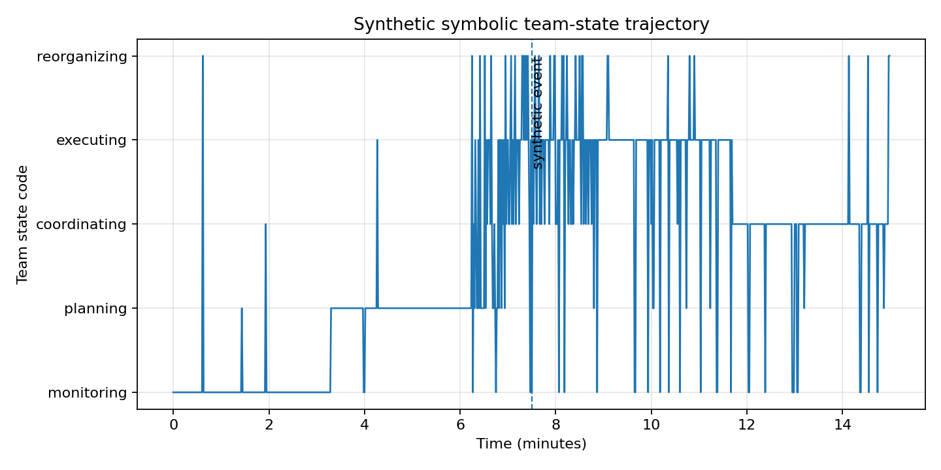
Figure 1. Synthetic symbolic team-state trajectory generated by the prototype.
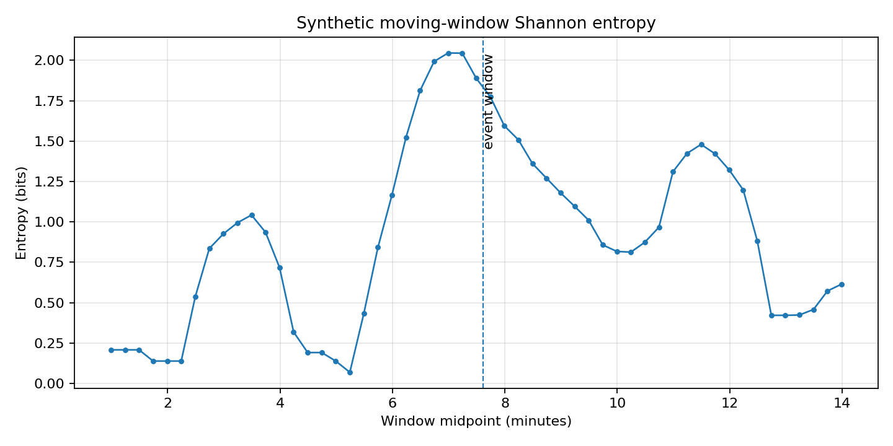
Figure 2. Synthetic moving-window Shannon entropy trajectory for adaptation/reorganization explanation.
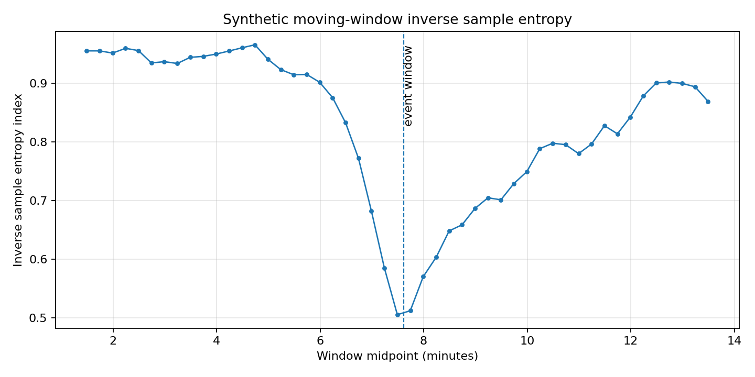
Figure 3. Synthetic moving-window inverse sample entropy trajectory for temporal-structure explanation.
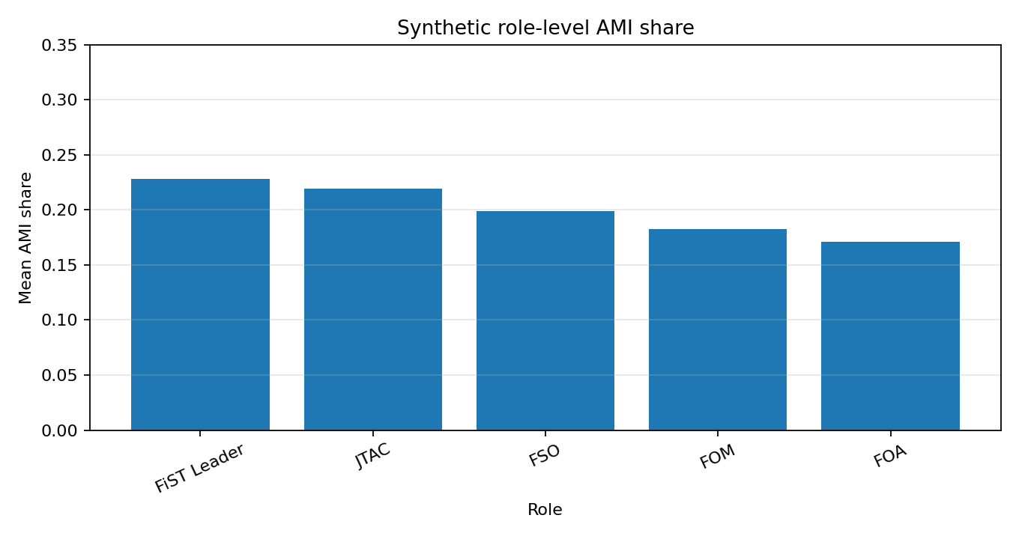
Figure 4. Synthetic role-level AMI share profile for influence-distribution explanation.
In Figure 2, the entropy trajectory increases around the synthetic event window, which gives the chatbot an opportunity to explain possible reorganization or higher variability. In Figure 3, inverse sample entropy decreases near the same period, which gives the chatbot an opportunity to explain reduced regularity in the symbolic sequence. In Figure 4, AMI share is moderately concentrated in the FiST Leader and JTAC roles in this synthetic run, which gives the chatbot an opportunity to explain influence distribution while avoiding individual ranking or causal claims.

Prompting Workflow and AI-Assisted Transparency
The prompt log is included as a separate project artifact and summarized here. The prompts were generated for development tasks rather than copied from an informal chat. They include prompts for reframing the prototype around bio-behavioral team dynamics analytics, reviewing chatbot safeguards, generating the synthetic time series, implementing entropy and AMI functions, debugging the Streamlit app, constructing the Gemini prompt payload, auditing API-key handling, adding equations to the notebook, generating stakeholder-style test questions, and reviewing GitHub readiness.
This workflow follows Mollick's (2023) structured prompting path: the prompts specify role, context, task, constraints, and output format. It also follows Mollick and Mollick's (2023) emphasis on human-in-the-loop supervision. AI assistance was used to support code organization, explanation design, and documentation; it was not treated as an authority. Validation remained a human responsibility. For this prototype, validation included running the synthetic pipeline from a clean shell, checking that CSV and PNG outputs were created, verifying that generated data are synthetic, confirming that AMI shares sum to 1 within windows, and reviewing the identity file for safeguards against over-interpretation.

GitHub and Streamlit Readiness
The final prototype is organized as a GitHub-ready folder. The repository includes the Streamlit app, a metrics module, an executed notebook with equations, the identity file, the prompt log, generated synthetic outputs, a README, requirements file, .gitignore, and a Streamlit secrets example. The real secrets file is excluded from Git. This arrangement separates public demonstration artifacts from restricted dissertation data and allows the technical component to be submitted with the final paper.
The app can be used immediately for synthetic data generation, metric computation, visualization, table preview, and prompt-payload construction after installing the Python requirements. The Gemini chatbot response requires a key configured through Streamlit secrets or environment variables. This design avoids placing an API key in the notebook and supports later deployment through Streamlit Community Cloud or another GitHub-linked hosting workflow.

Limitations and Future Dissertation Connection
The main limitation is that the prototype is not a validated explanation system. It uses synthetic data, a preliminary identity file, and a developing interface. The figures are demonstration artifacts. No dissertation hypothesis is tested, and no conclusion is drawn about real Fire Support Team performance. The generated values are useful only for checking whether the analysis, visualization, and prompt workflow operate correctly.
The next dissertation step is schema testing with approved de-identified BioTDMS summaries. The code will need to handle real column names, missingness, phase markers, event labels, modality-specific quality indicators, and metric ranges. The prompt structure will also need stress testing with flat entropy trajectories, multiple event markers, concentrated and distributed AMI profiles, missing inputs, and user questions that invite unsupported inference. The future RQ2 evaluation can then compare a standard statistical-report condition with a customized AI-bot interpretation condition on understanding, confidence, and interpretation accuracy.

Conclusion
This project produces a reproducible Streamlit prototype for explaining synthetic bio-behavioral team dynamics analytics. It is aligned with the dissertation's applied RQ2 goal while remaining appropriate for a public course submission because it uses synthetic data only. The final artifact includes an interactive app, an equation-centered Jupyter notebook, an identity file, a prompt log, and generated outputs. Together, these components demonstrate how structured prompting and Python-based analysis can support a future chatbot that helps non-experts understand dynamic team metrics without over-interpreting them.

References
Amershi, S., Weld, D., Vorvoreanu, M., Fourney, A., Nushi, B., Collisson, P., Suh, J., Iqbal, S., Bennett, P. N., Inkpen, K., Teevan, J., Kikin-Gil, R., & Horvitz, E. (2019). Guidelines for human-AI interaction. Proceedings of the 2019 CHI Conference on Human Factors in Computing Systems, 1-13. https://doi.org/10.1145/3290605.3300233
Cooke, N. J., Gorman, J. C., Myers, C. W., & Duran, J. L. (2013). Interactive team cognition. Cognitive Science, 37(2), 255-285. https://doi.org/10.1111/cogs.12009
Google AI for Developers. (n.d.). Using Gemini API keys. Retrieved May 9, 2026, from https://ai.google.dev/gemini-api/docs/api-key
Gorman, J. C., Amazeen, P. G., & Cooke, N. J. (2010). Team coordination dynamics. Nonlinear Dynamics, Psychology, and Life Sciences, 14(3), 265-289.
Hoffman, R. R., Mueller, S. T., Klein, G., & Litman, J. (2023). Measures for explainable AI: Explanation goodness, user satisfaction, mental models, curiosity, trust, and human-AI performance. Frontiers in Computer Science, 5, Article 1096257. https://doi.org/10.3389/fcomp.2023.1096257
Lee, J. D., & See, K. A. (2004). Trust in automation: Designing for appropriate reliance. Human Factors, 46(1), 50-80. https://doi.org/10.1518/hfes.46.1.50_30392
Marks, M. A., Mathieu, J. E., & Zaccaro, S. J. (2001). A temporally based framework and taxonomy of team processes. Academy of Management Review, 26(3), 356-376. https://doi.org/10.5465/amr.2001.4845785
Mollick, E. (2023, November 1). Working with AI: Two paths to prompting. One Useful Thing. https://www.oneusefulthing.org/p/working-with-ai-two-paths-to-prompting
Mollick, E. R., & Mollick, L. (2023). Assigning AI: Seven approaches for students with prompts. SSRN. https://ssrn.com/abstract=4475995
Richman, J. S., & Moorman, J. R. (2000). Physiological time-series analysis using approximate entropy and sample entropy. American Journal of Physiology-Heart and Circulatory Physiology, 278(6), H2039-H2049. https://doi.org/10.1152/ajpheart.2000.278.6.H2039
Salas, E., Dickinson, T. L., Converse, S. A., & Tannenbaum, S. I. (1992). Toward an understanding of team performance and training. In R. W. Swezey & E. Salas (Eds.), Teams: Their training and performance (pp. 3-29). Ablex.
Strang, A. J., Horwood, S., Best, C., Funke, G. J., Knott, B. A., & Russell, S. M. (2012). Examining temporal regularity in categorical team communication using sample entropy. Proceedings of the Human Factors and Ergonomics Society Annual Meeting, 56(1), 473-477. https://doi.org/10.1177/1071181312561047
Streamlit. (n.d.). Secrets management. Retrieved May 9, 2026, from https://docs.streamlit.io/develop/concepts/connections/secrets-management

Appendix A. Submitted Technical Component
The technical component is submitted as a GitHub-ready project package rather than pasted into this paper. The package includes streamlit_app.py, src/team_dynamics_metrics.py, notebooks/team_dynamics_chatbot_equations.ipynb, docs/team_dynamics_chatbot_identity.md, docs/team_dynamics_prompt_log.md, requirements.txt, .streamlit/secrets.toml.example, generated synthetic CSV files, metric tables, figures, JSON explanation packet, and Gemini prompt payload.
The notebook includes the equations and reruns the synthetic analysis. The Streamlit app provides the interactive interface and is the only component that calls Gemini after a key is configured through secrets or environment variables.

Appendix B. Prompt Log Summary
The complete prompt log is included as docs/team_dynamics_prompt_log.md. The ten logged prompts cover: reframing the prototype around the updated dissertation proposal; reviewing chatbot identity safeguards; generating the synthetic 1 Hz multimodal time series; implementing entropy, inverse sample entropy, and AMI functions; debugging Streamlit organization; constructing the Gemini prompt payload; auditing API-key handling; adding equations to the notebook; generating stakeholder test questions; and reviewing GitHub readiness.

