实验四使用EJBean访问数据库的应用
实验目的：
掌握EJBean的开发方法

实验要求：
采用EJBean技术，设计通过下列JSP页面访问数据库(如表5-1)，具体要求如下：
1．添加用户页面(AddUser.jsp),如图4-1所示；
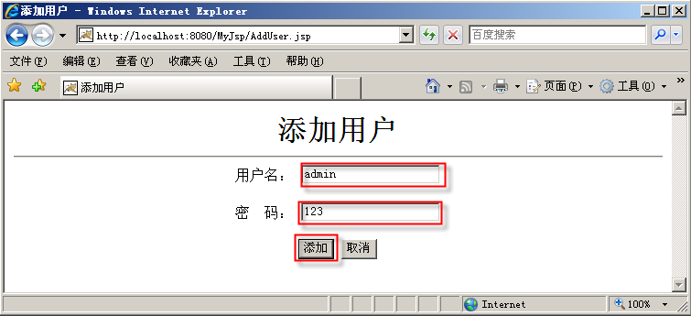
图4-1 添加用户页面

AddUserServlet
Userinfo
DB

AddUser.jsp
DAOUserinfo

图4-2程序框架

实验步骤：
1．准备需要访问的数据库
下载并安装MySQL5.0
Copy MySQL5.0驱动mysql-connector-java-5.0.8-bin.jar到%TOMCAT%\lib文件夹下创建数据库及表：
数据库的设计如下表：
数据库采用MySQL5.0，数据库名：db，表名：user（用户表）
表5-1 数据库的用户表
序号 | 列名 | 数据类型 | 长度 | 主键 | 允许空 | 默认值 | 说明
1 | username | varchar | 40 | 是 | 否 |  | 用户名
2 | password | varchar | 40 |  | 是 |  | 口令
创建过程如下：(可选择使用MySQL的数据库管理和开发工具Navicat 和 MySQL-Front等)
Step1:进入MySQL程序的MySQL Command Line Client界面，如下图所示
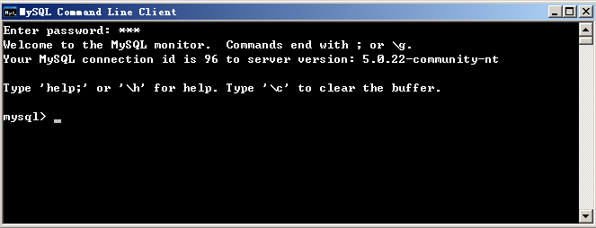
Step2:分别执行下列命令：//支持中文
- 创建数据库：
CREATE DATABASE `mydb`
CHARACTER SET 'utf8'
COLLATE 'utf8_general_ci';
USE DB;
- 建表:
CREATE TABLE `userinfo` (
`username` varchar(20) NOT NULL PRIMARY KEY,
`password` varchar(20)
) ENGINE=InnoDB DEFAULT CHARSET=utf8;

2、开发过程如下：
Step1：EJBean实验
（1）首先进行环境配置，将JBoss5.1.0压缩包拷贝到计算机上，并解压，记住解压的路径，然后在MyEclipse中进行配置。
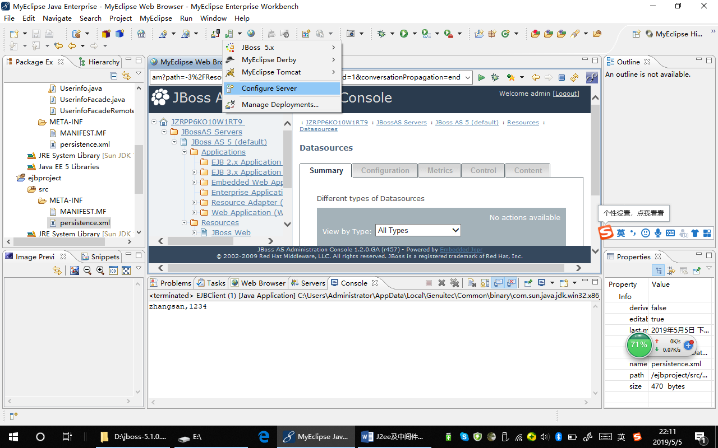
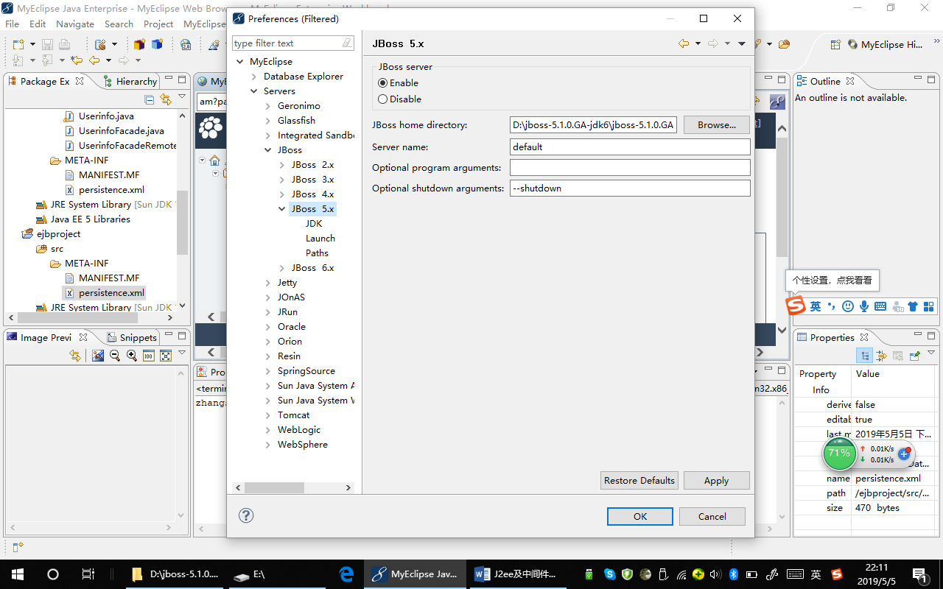
在上述图中，找到JBoss5.x，然后配置JBoss home directory为JBoss解压的目录。如：D:\jboss-5.1.0.GA-jdk6\jboss-5.1.0.GA，另外选择上面的JBoss server为Enable。
此时在Myeclipse中的Server图标处，会出现JBoss 5.，选择Start进行启动。
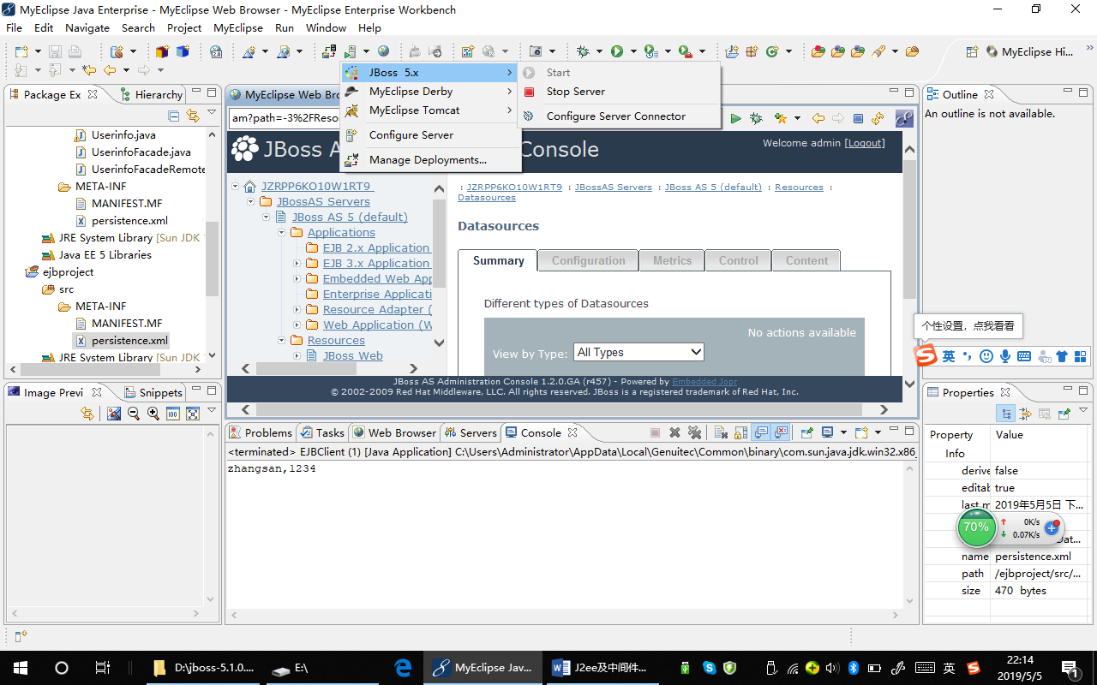
此时可以测试该服务器是否正常工作，新建web工程如myweb，将此工程发布到JBoss服务器下，然后在浏览器上进行测试，在地址栏中输入http://localhost:8080，然后出现JBoss的管理页面。
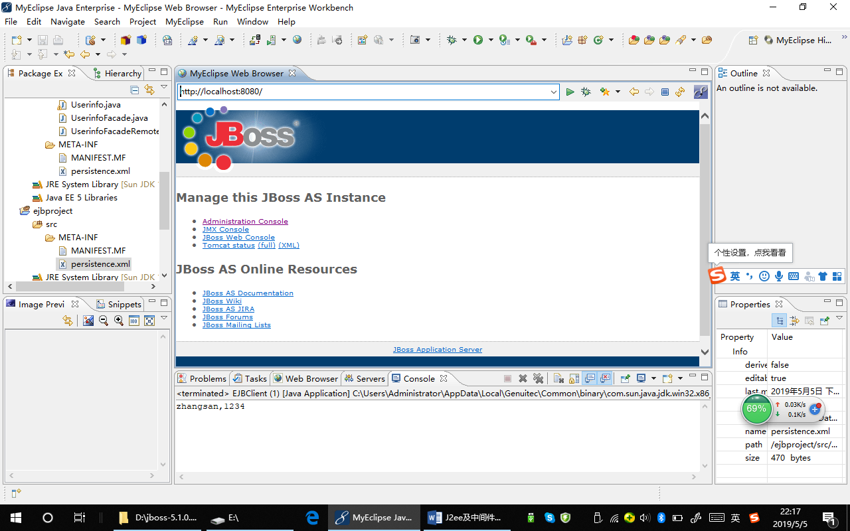

（2）在MyEclipse中，新建EJB Project.
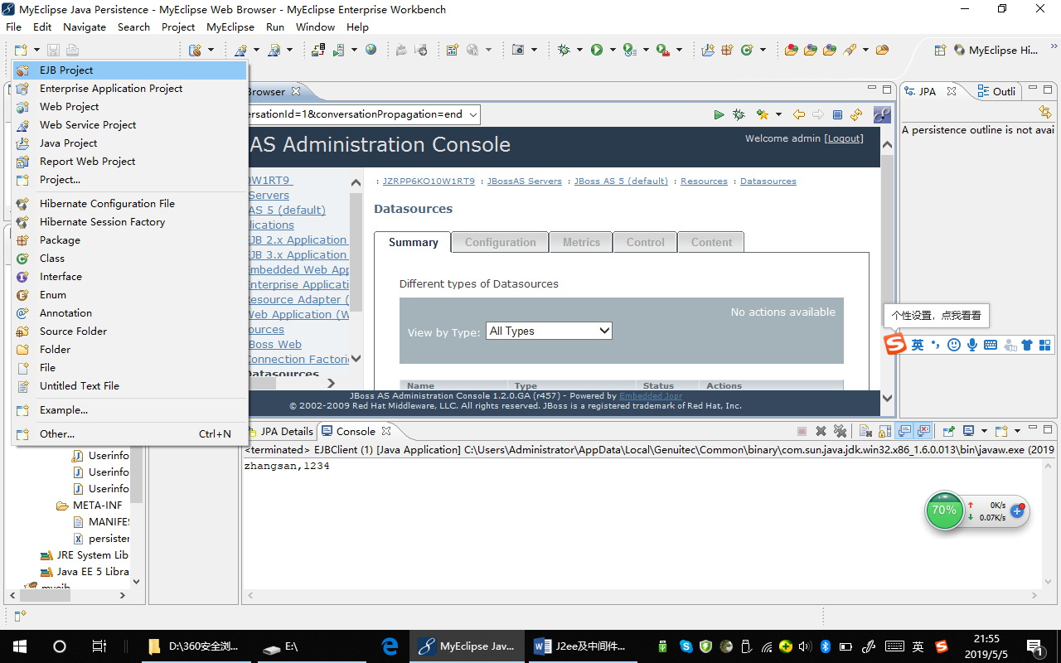
输入EJBean project name:ejbproject
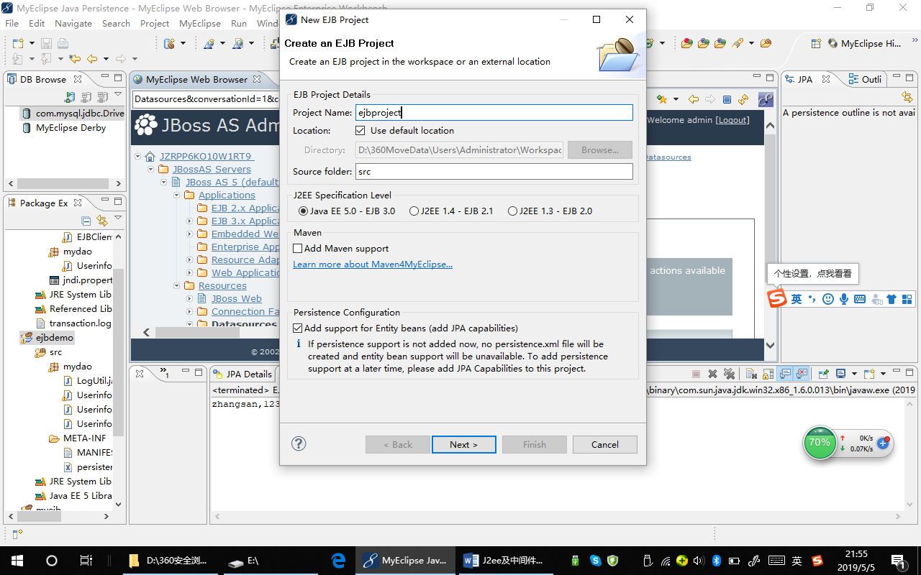
点击下一步，输入数据源JNDI Data Source，该数据源后面介绍如何配置。
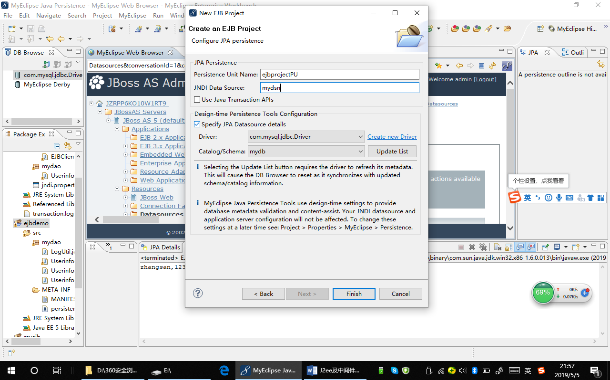
点击finish，可以发现在src->META-INF下面出现一个persistence.xml，这一点和引入JPA框架有点类似，因为EJBean中的实体Bean本身用的也是JPA。
Step2：将具有如下内容的mysql-ds.xml文件拷贝到jboss的-server-default-deploy-下面。D:\jboss-5.1.0.GA-jdk6\jboss-5.1.0.GA\server\default\deploy
文件名：mysql-ds.xml
<?xml version="1.0" encoding="UTF-8"?>

<!-- See http://www.jboss.org/community/wiki/Multiple1PC for information about local-tx-datasource -->
<!-- $Id: mysql-ds.xml 97536 2009-12-08 14:05:07Z jesper.pedersen $ -->
<!-- Datasource config for MySQL using 3.0.9 available from:
http://www.mysql.com/downloads/api-jdbc-stable.html
-->

<datasources>
<local-tx-datasource>
<jndi-name>DefaultMySqlDS</jndi-name>
<use-java-context>false</use-java-context>
<connection-url>jdbc:mysql://localhost:3306/mydb</connection-url>
<driver-class>com.mysql.jdbc.Driver</driver-class>
<user-name>root</user-name>
<password>12345678</password>
<exception-sorter-class-name>org.jboss.resource.adapter.jdbc.vendor.MySQLExceptionSorter</exception-sorter-class-name>
<!-- should only be used on drivers after 3.22.1 with "ping" support
<valid-connection-checker-class-name>org.jboss.resource.adapter.jdbc.vendor.MySQLValidConnectionChecker</valid-connection-checker-class-name>
-->
<!-- sql to call when connection is created
<new-connection-sql>some arbitrary sql</new-connection-sql>
-->
<!-- sql to call on an existing pooled connection when it is obtained from pool - MySQLValidConnectionChecker is preferred for newer drivers
<check-valid-connection-sql>some arbitrary sql</check-valid-connection-sql>
-->

<!-- corresponding type-mapping in the standardjbosscmp-jdbc.xml (optional) -->
<metadata>
<type-mapping>mySQL</type-mapping>
</metadata>
</local-tx-datasource>
</datasources>

注意:如果要连接derby,只要将上面的内容修改为连接derby的驱动、url,用户，密码，另外存为：derby-ds.xml文件即可。

Step2：创建Stateless Session Bean进行测试
在MyEclipse中，找到创建bean的图表，选择session bean
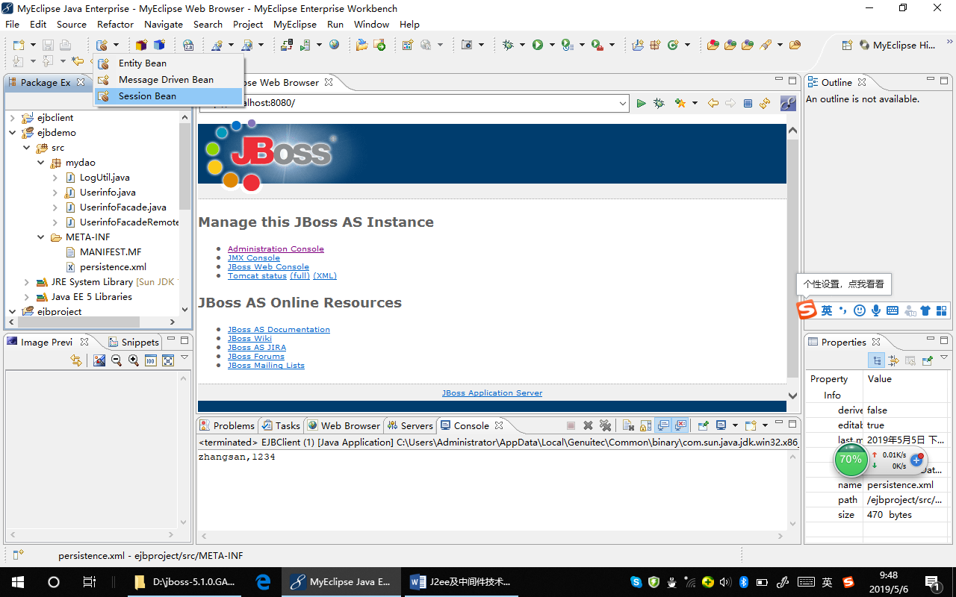
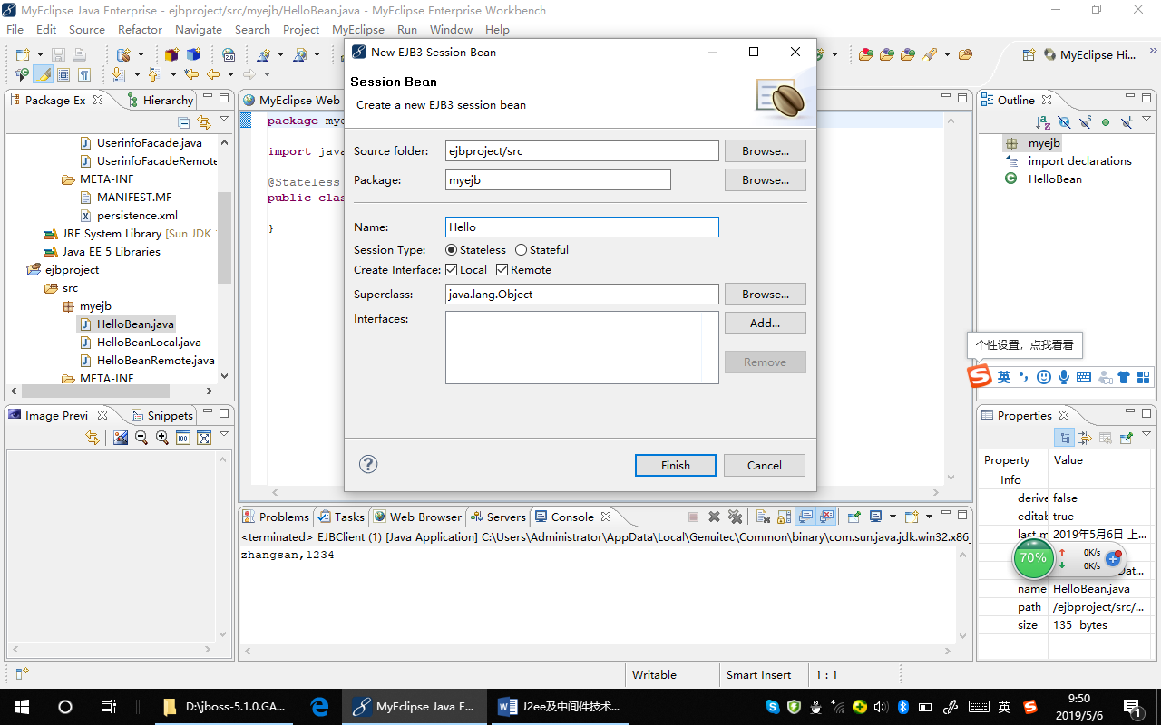
勾选Local,Rmoete选择finish后，在myejb包下，创建了如下接口和类：
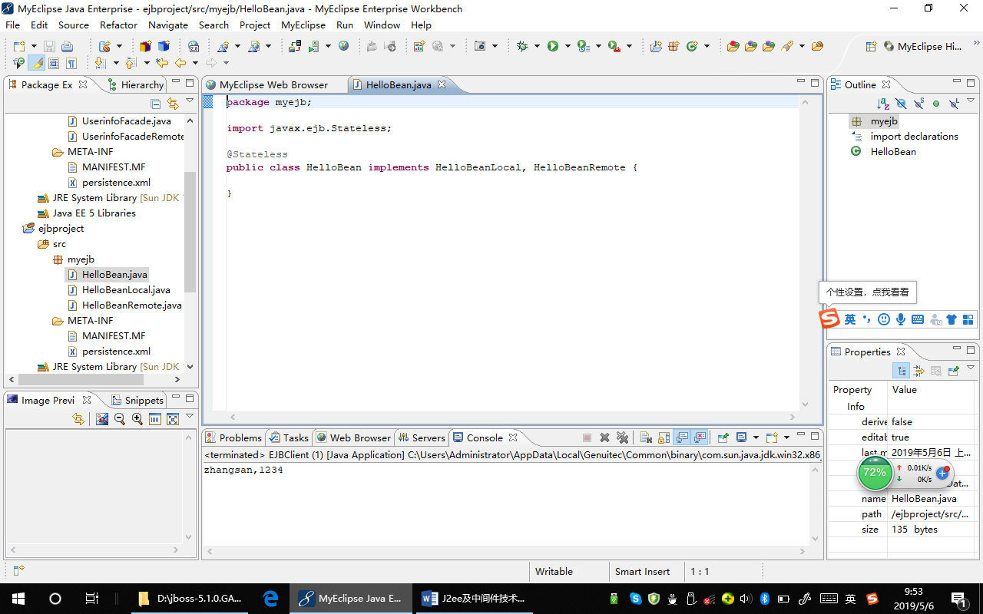
HelloBean,HelloBeanRmote,HelloBeanLocal
下面增加一个业务接口，Hello，其中增加一个方法sayHello().
public interface Hello {
public String sayHello(String name)；
}
然后让HelloBeanRmote,HelloBeanLocal都继承自Hello。
package myejb;

import javax.ejb.Local;

@Local
publicinterface HelloBeanLocal extendsHello {

}
package myejb;

import javax.ejb.Remote;

@Remote
publicinterface HelloBeanRemote extendsHello {

}
在HelloBean下面，实现该方法。
package myejb;
import javax.ejb.Stateless;
@Stateless
publicclass HelloBean implements HelloBeanLocal, HelloBeanRemote {
public String sayHello(String name){
return “Hello,”+name;
}
}
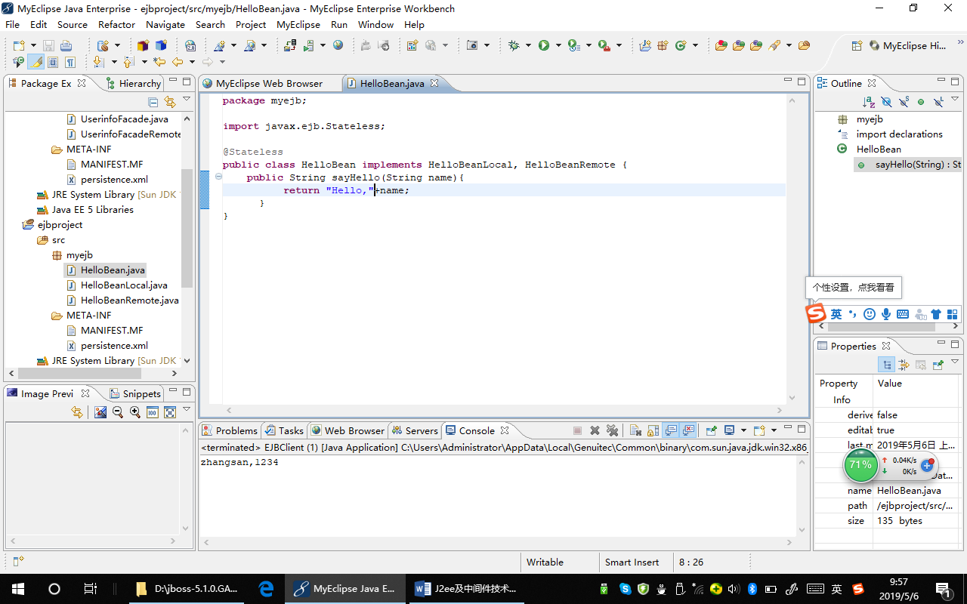
发布该工程。
下面创建客户端进行测试。
创建两个工程：Java Project和Web Project分别来测试EJBean的远程和本地接口。
在此之前，首先要把HelloBean的远程和本地接口及其相关接口如业务接口导出，从而在其他工程中使用该接口。
在Myeclipse下面，选择File-Export，找到Java-Jar File如下图所示：
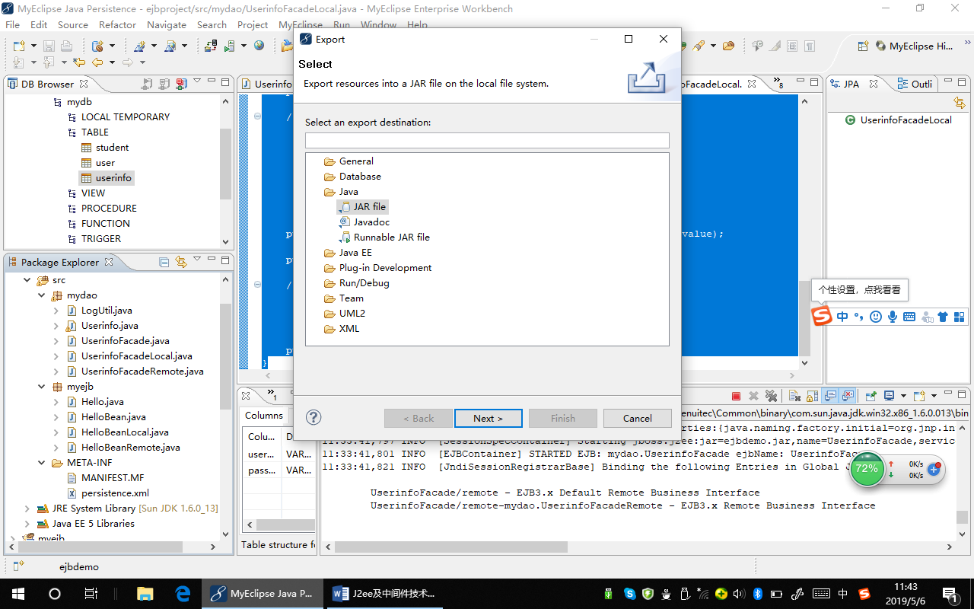
点击Next，找到需要导出的类，在下面选择或输入要保存的jar文件的位置及文件名，然后点击Finish。
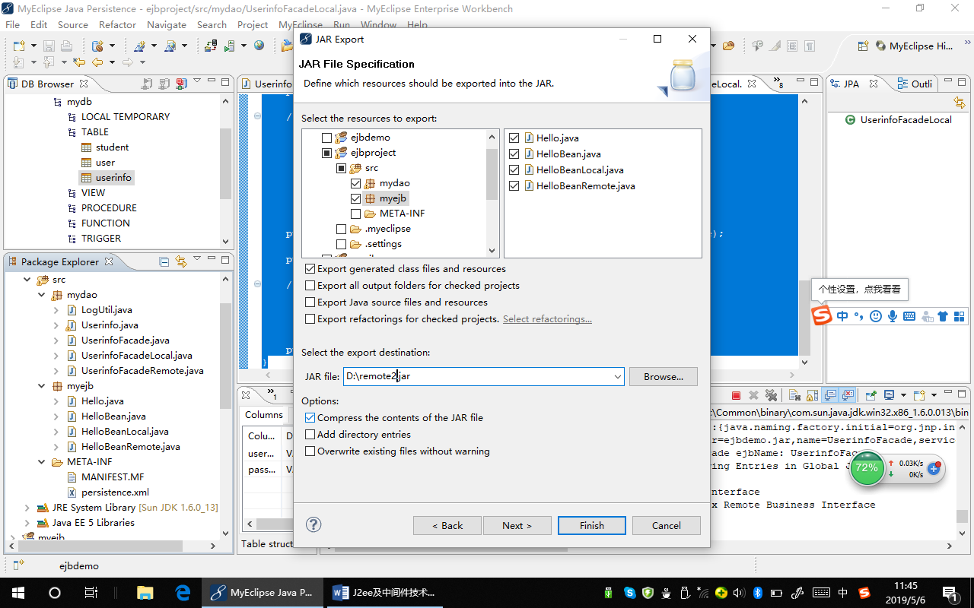
新建Java工程，然后新建一个Java类，包含main方法，在其中输入如下代码：
import java.util.Properties;

import javax.naming.Context;
import javax.naming.InitialContext;
import javax.naming.NamingException;

import myejb.HelloBeanRemote;

publicclass ejbclient {

/**
* @param args
*/
publicstaticvoid main(String[] args) {
// TODO Auto-generated method stub
Properties p = new Properties();
p.put("java.naming.factory.initial", "org.jnp.interfaces.NamingContextFactory");
p.put("java.naming.factory.url.pkgs", "org.jboss.naming:org.jnp.interfaces");
p.put("java.naming.provider.url", "localhost");
try {
Context ctx = new InitialContext(p);
HelloBeanRemote h = (HelloBeanRemote)ctx.lookup("HelloBean/remote");
System.out.println(h.sayHello("zhangsan"));
} catch (NamingException e) {
// TODO Auto-generated catch block
e.printStackTrace();
}
}
}
将上面导出的接口类包和JBoss的Client-jar文件导入到工程中。
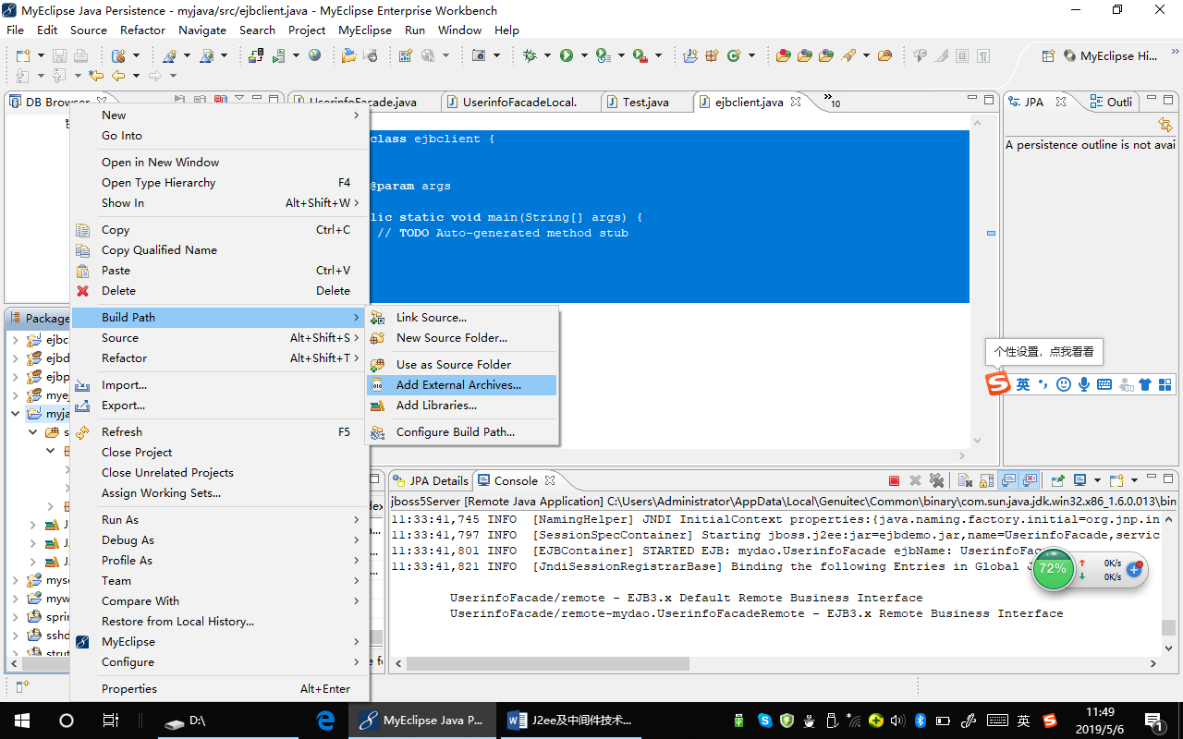
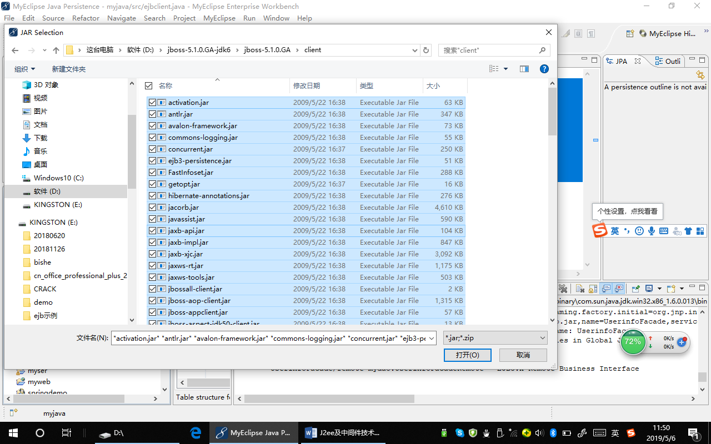

Step3：使用数据库的逆向工具EJB3 Reverse Engineering导出Façade类，类似于JPA和Hibernate中的实体类和DAO类。从而在Servlet中进行访问。
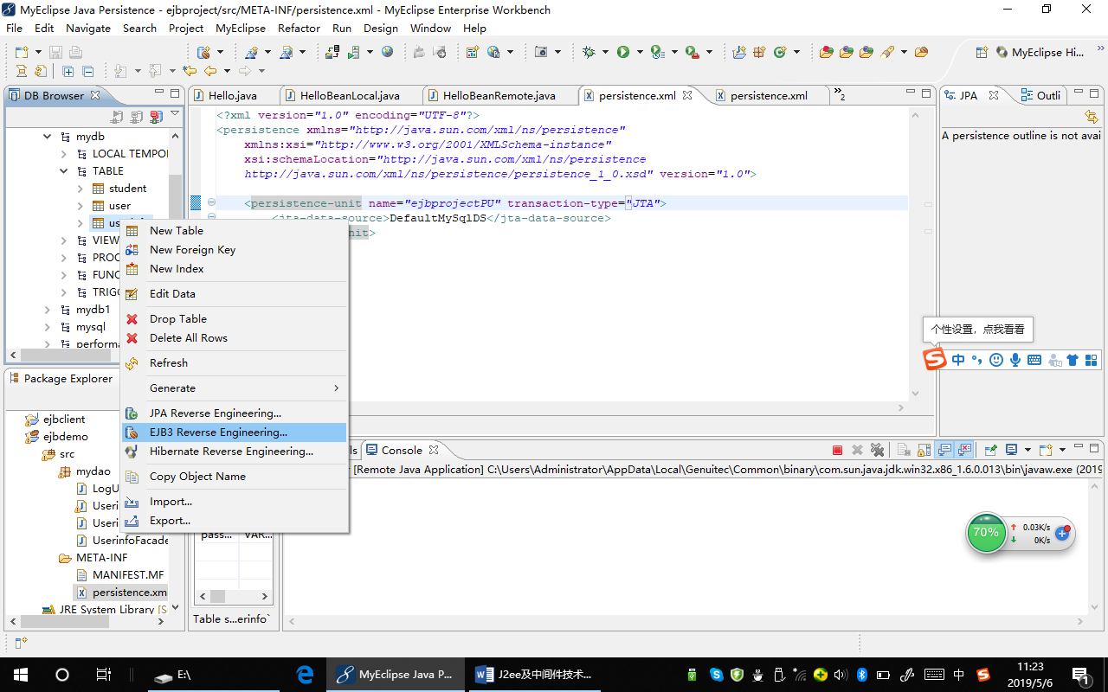
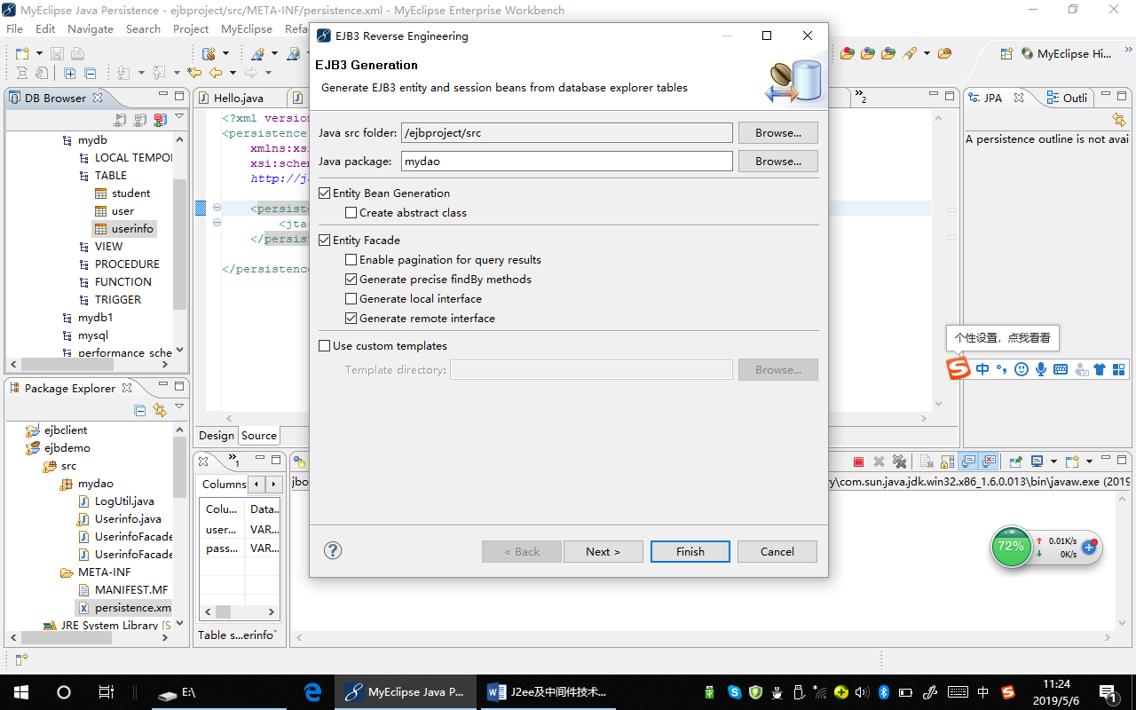
注意勾选上面Entity Façade下面的Remote和Local接口。
产生的Userinfo类和前面JPA产生的一样，这里就不在展示代码了。
产生的UserinfoFacade相当于JPA中产生的DAO，代码如下：
package mydao;

import java.util.List;
import java.util.logging.Level;
import javax.ejb.Stateless;
import javax.persistence.EntityManager;
import javax.persistence.PersistenceContext;
import javax.persistence.Query;

/**
* Facade for entity Userinfo.
*
* @see mydao.Userinfo
* @author MyEclipse Persistence Tools
*/
@Stateless
public class UserinfoFacade implements UserinfoFacadeLocal,
UserinfoFacadeRemote {
// property constants
public static final String PASSWORD = "password";

@PersistenceContext
private EntityManager entityManager;

/**
* Perform an initial save of a previously unsaved Userinfo entity. All
* subsequent persist actions of this entity should use the #update()
* method.
*
* @param entity
* Userinfo entity to persist
* @throws RuntimeException
* when the operation fails
*/
public void save(Userinfo entity) {
LogUtil.log("saving Userinfo instance", Level.INFO, null);
try {
entityManager.persist(entity);
LogUtil.log("save successful", Level.INFO, null);
} catch (RuntimeException re) {
LogUtil.log("save failed", Level.SEVERE, re);
throw re;
}
}

/**
* Delete a persistent Userinfo entity.
*
* @param entity
* Userinfo entity to delete
* @throws RuntimeException
* when the operation fails
*/
public void delete(Userinfo entity) {
LogUtil.log("deleting Userinfo instance", Level.INFO, null);
try {
entity = entityManager.getReference(Userinfo.class, entity
.getUsername());
entityManager.remove(entity);
LogUtil.log("delete successful", Level.INFO, null);
} catch (RuntimeException re) {
LogUtil.log("delete failed", Level.SEVERE, re);
throw re;
}
}

/**
* Persist a previously saved Userinfo entity and return it or a copy of it
* to the sender. A copy of the Userinfo entity parameter is returned when
* the JPA persistence mechanism has not previously been tracking the
* updated entity.
*
* @param entity
* Userinfo entity to update
* @return Userinfo the persisted Userinfo entity instance, may not be the
* same
* @throws RuntimeException
* if the operation fails
*/
public Userinfo update(Userinfo entity) {
LogUtil.log("updating Userinfo instance", Level.INFO, null);
try {
Userinfo result = entityManager.merge(entity);
LogUtil.log("update successful", Level.INFO, null);
return result;
} catch (RuntimeException re) {
LogUtil.log("update failed", Level.SEVERE, re);
throw re;
}
}

public Userinfo findById(String id) {
LogUtil.log("finding Userinfo instance with id: " + id, Level.INFO,
null);
try {
Userinfo instance = entityManager.find(Userinfo.class, id);
return instance;
} catch (RuntimeException re) {
LogUtil.log("find failed", Level.SEVERE, re);
throw re;
}
}

/**
* Find all Userinfo entities with a specific property value.
*
* @param propertyName
* the name of the Userinfo property to query
* @param value
* the property value to match
* @return List<Userinfo> found by query
*/
@SuppressWarnings("unchecked")
public List<Userinfo> findByProperty(String propertyName, final Object value) {
LogUtil.log("finding Userinfo instance with property: " + propertyName
+ ", value: " + value, Level.INFO, null);
try {
final String queryString = "select model from Userinfo model where model."
+ propertyName + "= :propertyValue";
Query query = entityManager.createQuery(queryString);
query.setParameter("propertyValue", value);
return query.getResultList();
} catch (RuntimeException re) {
LogUtil.log("find by property name failed", Level.SEVERE, re);
throw re;
}
}

public List<Userinfo> findByPassword(Object password) {
return findByProperty(PASSWORD, password);
}

/**
* Find all Userinfo entities.
*
* @return List<Userinfo> all Userinfo entities
*/
@SuppressWarnings("unchecked")
public List<Userinfo> findAll() {
LogUtil.log("finding all Userinfo instances", Level.INFO, null);
try {
final String queryString = "select model from Userinfo model";
Query query = entityManager.createQuery(queryString);
return query.getResultList();
} catch (RuntimeException re) {
LogUtil.log("find all failed", Level.SEVERE, re);
throw re;
}
}

}
基本和JPA产生的DAO类似，不同的是，这里将Façade类定义成了Stateless Session Bean，另外还产生了DAO的远程和本地接口，供远程和本地访问。
package mydao;

import java.util.List;
import javax.ejb.Local;

/**
* Local interface for UserinfoFacade.
*
* @author MyEclipse Persistence Tools
*/
@Local
public interface UserinfoFacadeLocal {
/**
* Perform an initial save of a previously unsaved Userinfo entity. All
* subsequent persist actions of this entity should use the #update()
* method.
*
* @param entity
* Userinfo entity to persist
* @throws RuntimeException
* when the operation fails
*/
public void save(Userinfo entity);

/**
* Delete a persistent Userinfo entity.
*
* @param entity
* Userinfo entity to delete
* @throws RuntimeException
* when the operation fails
*/
public void delete(Userinfo entity);

/**
* Persist a previously saved Userinfo entity and return it or a copy of it
* to the sender. A copy of the Userinfo entity parameter is returned when
* the JPA persistence mechanism has not previously been tracking the
* updated entity.
*
* @param entity
* Userinfo entity to update
* @return Userinfo the persisted Userinfo entity instance, may not be the
* same
* @throws RuntimeException
* if the operation fails
*/
public Userinfo update(Userinfo entity);

public Userinfo findById(String id);

/**
* Find all Userinfo entities with a specific property value.
*
* @param propertyName
* the name of the Userinfo property to query
* @param value
* the property value to match
* @return List<Userinfo> found by query
*/
public List<Userinfo> findByProperty(String propertyName, Object value);

public List<Userinfo> findByPassword(Object password);

/**
* Find all Userinfo entities.
*
* @return List<Userinfo> all Userinfo entities
*/
public List<Userinfo> findAll();
}
远程接口类似，只是把@Local改成了@Remote而已。
我们可以在前面创建的客户端工程和Web工程中访问该Façade，从而访问数据库。
例如：
import myejb.HelloBeanRemote;

publicclass ejbclient {

/**
* @param args
*/
publicstaticvoid main(String[] args) {
// TODO Auto-generated method stub
Properties p = new Properties();
p.put("java.naming.factory.initial", "org.jnp.interfaces.NamingContextFactory");
p.put("java.naming.factory.url.pkgs", "org.jboss.naming:org.jnp.interfaces");
p.put("java.naming.provider.url", "localhost");
try {
Context ctx = new InitialContext(p);
UserinfoFacadeRemote h = (UserinfoFacadeRemote)ctx.lookup("HelloBean/remote");
List<Userinfo> users = h.findAll();
for(Userinfo user:users)
System.out.println(user.getUsername()+”,”+user.getPassword());
} catch (NamingException e) {
// TODO Auto-generated catch block
e.printStackTrace();
}
}
}
注意：EJBean是由JavaEE服务器中的EJBean的容器进行管理的，所以不能交由Spring来同时管理。

Step4: 创建JSP网页和相应的Servlet
创建添加用户页面—AddUser.jsp,代码如下：
<%@ page contentType="text/html; charset=gb2312" language="java" import="java.sql.*" errorPage="" %>
<%@ taglib uri=”/strut-tags” prefix=”s”/>
<form method="post" action="AddUserServlet">
<div align="center"><font face="宋体" size="6"><strong>
添加用户</strong></font><br/><hr/>
<input name="username" label="用户名："/>
<br/>
<br/>
<input type=”password” name="password" label="密码："/>
<br />
<br />
<input type="submit" value="添加" />
<input type="reset" value="取消" />
</div>
</form>
利用向导创建success.jsp和error.jsp
其内容分别显示success和register error!
相应的添加用户Servlet(AddUserServlet.java),代码如下：
package servlet.user;
import java.io.IOException;
import java.io.PrintWriter;
import java.sql.SQLException;
import javax.servlet.ServletException;
import javax.servlet.http.HttpServlet;
import javax.servlet.http.HttpServletRequest;
import javax.servlet.http.HttpServletResponse;
import toolBean.db.AccessUserFromDB;
import valueBean.User;
public class AddUserServlet extends HttpServlet {
public void doPost(HttpServletRequest request, HttpServletResponse response)
throws ServletException, IOException {
//返回上页
String goBack="<br><a href='javascript:window.history.go(-1);'>返回上页</a>";
response.setContentType("text/html;charset=gb2312");
PrintWriter out = response.getWriter();

String username=request.getParameter("username");
if(username==null||username.equals(""))
{
out.print("用户名不能为空！");
out.print(goBack);
}
String password=request.getParameter("password");
User user=new User();
user.setUsername(username);
user.setPassword(password);//注入属性
try {
Context ctx = new InitialContext();
UserinfoFacadeLocal h = (UserinfoFacadeLocal)ctx.lookup("HelloBean/local");
h.save(user);
response.sendRedirect(“success.jsp”);
} catch (NamingException e) {
// TODO Auto-generated catch block
e.printStackTrace();
response.sendRedirect(“error.jsp”);
}

UserDAO userDAO=new UserDAO();
if(userDAO.exists(user.getUsername()))
{
out.print("用户名已存在！");
out.print(goBack);
return;
}
try {
userDAO.Add(user);
} catch (SQLException e) {
e.printStackTrace();
out.print("添加失败:"+e.getLocalizedMessage());
out.print(goBack);
return;
}
out.print("添加成功！");
out.print(goBack);
out.close();
}
}

