程序说明
本程序用于完成布匹表面缺陷检测任务，采用 Python 和 OpenCV 实现传统机器视觉检测，不使用神经网络方法。程序固定读取工作区中的正常样图 original.jpg 和待检测图 defect.jpg，对图像进行预处理、缺陷候选提取、区域筛选和结果绘制，最终输出检测结果图 result.jpg。
本程序的核心思想是利用正常样图作为参考，对缺陷图中的异常亮区域进行突出显示。主方法为“基于白帽变换的参考图差分法”：先分别对正常样图和缺陷样图进行灰度化、高斯滤波和白帽变换，以增强局部亮小目标；再将缺陷图的增强结果减去正常图的增强结果，从而抑制布匹重复纹理背景，突出划痕或破损等亮异常区域。之后通过阈值分割、形态学开闭运算、膨胀和去除贴边连通域等步骤，得到候选缺陷区域。
为了提高作业完成度，程序还实现了两种备选方法，分别是自适应阈值法和 Canny 边缘聚合法。当主方法未检测到可信缺陷时，程序会自动按顺序回退到备选方法继续检测，从而增强程序的鲁棒性和完整性。
在候选区域筛选阶段，程序使用连通域分析提取所有可能的缺陷区域，并综合区域面积、平均响应强度、最大响应强度以及长宽比进行评分，最终选择最符合缺陷特征的区域作为检测结果。这种方式可以减少噪声干扰，避免将普通纹理误判为缺陷。
程序最后会将检测到的缺陷区域以绿色框标出，并在结果图中标注所采用的方法名称，生成最终输出图 result.jpg。如果没有检测到可信缺陷，程序也会给出对应提示，保证运行过程完整且结果清晰。

流程图
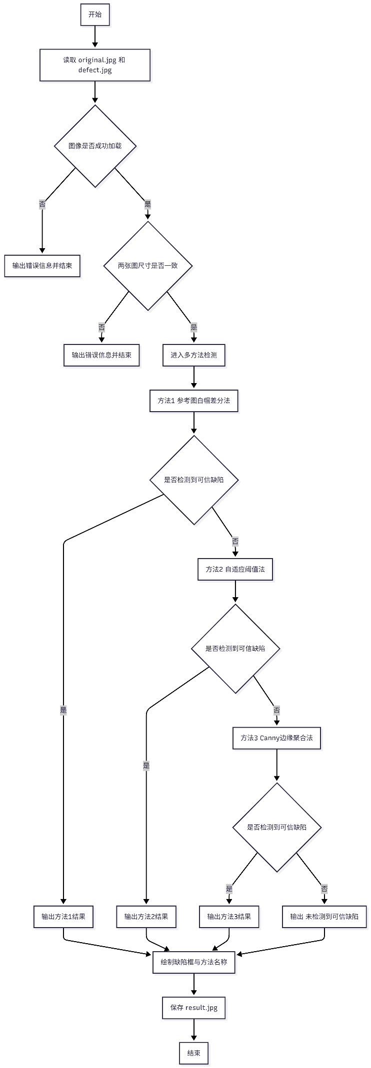
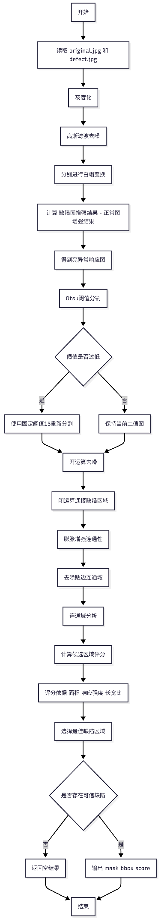
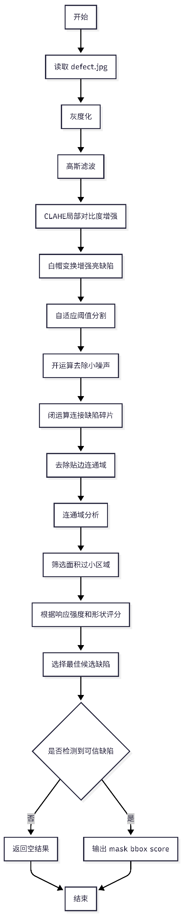
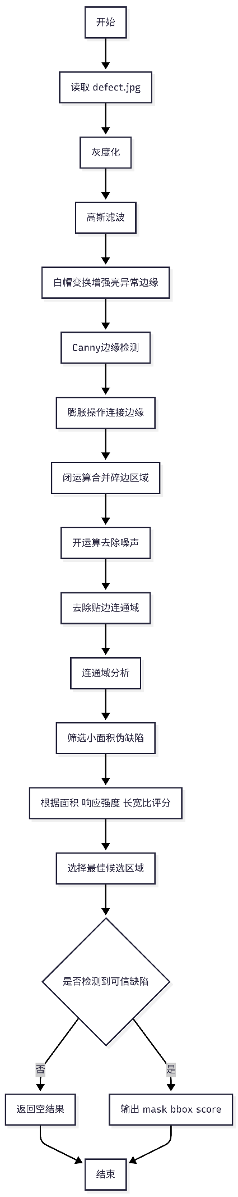
结果图
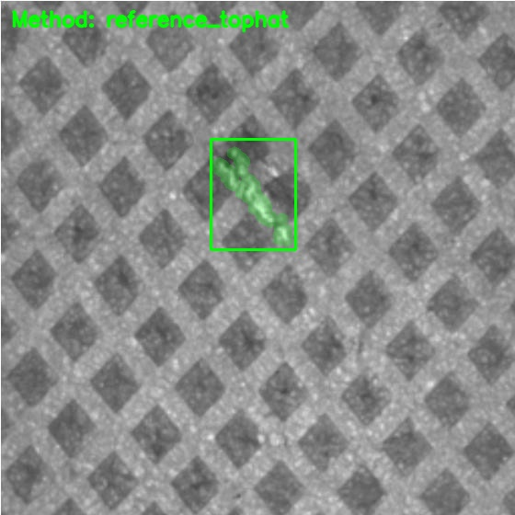
思考题
思考题参考答案
1. 为什么本作业不能使用神经网络方法？
本作业要求使用传统机器视觉方法，主要有以下原因。首先，在工业检测场景中，很多任务的缺陷类型比较明确、成像条件相对固定，使用阈值分割、形态学处理、边缘检测等传统方法就可以较好地完成检测，没有必要引入训练成本更高的神经网络。其次，神经网络通常需要大量带标注的数据，而实际生产中缺陷样本往往较少，采集和标注成本较高。就算使用少量的带标注数据样本，也会导致检测出现严重的漏检，误检等问题。再次，传统方法计算量小、运行速度快、部署简单、结果更容易解释，更适合教学实验以及一些实时性要求较高的工业场景。因此，本作业限制不用神经网络，是为了训练对基础图像处理方法的理解和应用能力，和模拟真实工业应用环境
2. 你使用的检测方法有什么局限性？在什么情况下可能失效？
本程序采用的是“基于白帽变换的参考图差分法”，并辅以自适应阈值和 Canny 边缘检测作为备选方法。这类方法的局限性主要体现在以下几个方面。第一，它对成像条件较敏感，如果光照变化较大、相机位置偏移明显、图像发生旋转或缩放，正常样图和缺陷样图之间的差异会被放大，从而影响检测结果。第二，该方法更适合检测亮色、小尺度、局部突变型缺陷，如果缺陷是暗斑、低对比度磨损，或者与背景纹理非常相似，则可能漏检。第三，阈值和形态学参数依赖当前样图特征，当布匹纹理发生明显变化时，参数可能需要重新调整。第四，若正常样图本身存在噪声或污染，也可能导致误检。因此，该方法更适合成像环境稳定、缺陷类型相对固定的情况。
3. 如果要将算法部署到生产线，还需考虑哪些因素？
如果将该算法真正部署到生产线，还需要综合考虑工程上的多个因素。首先是成像稳定性，包括光源亮度、拍摄角度、相机位置、镜头参数和传送带速度等，这些因素直接影响检测效果。其次是实时性，需要保证算法能够在生产节拍内完成图像处理和结果输出。第三是鲁棒性，算法应尽量适应轻微的光照波动、布料抖动和纹理变化，减少误检和漏检。第四是系统集成问题，例如如何与 PLC、MES 或报警剔除系统联动。第五是维护和标定，包括定期清洁镜头、重新标定相机、更新阈值参数等。除此之外，还应考虑结果存档、缺陷统计、误报追踪和人工复核机制，便于后期质量管理和系统优化。
4. 传统机器视觉与深度学习各有什么优缺点？
传统机器视觉的优点是实现简单、运行速度快、对硬件要求较低、可解释性强，特别适合规则明确、背景稳定、缺陷特征清晰的场景。其缺点是对环境变化较敏感，泛化能力较弱，当缺陷类型复杂或样本变化较大时，往往需要人工调整参数。深度学习的优点是特征提取能力强，适合复杂背景、多类型缺陷和非规则目标检测，在大规模数据支持下通常能获得更高的准确率和更强的泛化能力。其缺点是需要大量训练数据和较高算力，训练与部署成本较高，可解释性相对较差。总体来看，传统机器视觉更适合小样本、规则明确、实时性要求高的任务；深度学习更适合复杂场景和大规模工业应用。

程序
如果可以请使用github，方便查看和拉取
本次作业项目地址: https://github.com/shixin08052/opencv-learing
detect.py
from __future__ import annotations
from pathlib import Path
from typing import Optional, Tuple
import cv2
import numpy as np
BBox = Tuple[int, int, int, int]
def load_images(base_dir: Path) -> Tuple[np.ndarray, np.ndarray]:
original_path = base_dir / "original.jpg"
defect_path = base_dir / "defect.jpg"
original = cv2.imread(str(original_path), cv2.IMREAD_COLOR)
defect = cv2.imread(str(defect_path), cv2.IMREAD_COLOR)
if original is None:
raise FileNotFoundError(f"Failed to read reference image: {original_path}")
if defect is None:
raise FileNotFoundError(f"Failed to read defect image: {defect_path}")
if original.shape[:2] != defect.shape[:2]:
raise ValueError(
"Input images must have the same size, "
f"got {original.shape[:2]} and {defect.shape[:2]}"
)
return original, defect
def preprocess_gray(image: np.ndarray) -> np.ndarray:
gray = cv2.cvtColor(image, cv2.COLOR_BGR2GRAY)
return cv2.GaussianBlur(gray, (5, 5), 0)
def remove_border_components(mask: np.ndarray) -> np.ndarray:
num_labels, labels, stats, _ = cv2.connectedComponentsWithStats(mask, connectivity=8)
cleaned = np.zeros_like(mask)
height, width = mask.shape
for label in range(1, num_labels):
x, y, w, h, _ = stats[label]
if x <= 0 or y <= 0 or x + w >= width or y + h >= height:
continue
cleaned[labels == label] = 255
return cleaned
def component_score(
area: int,
aspect_ratio: float,
mean_response: float,
max_response: float,
) -> float:
elongated_bonus = max(aspect_ratio - 1.2, 0.0) * 20.0
return mean_response * 4.0 + area * 0.03 + max_response * 0.2 + elongated_bonus
def expand_bbox(
bbox: BBox,
image_shape: Tuple[int, int],
pad_left: int = 0,
pad_top: int = 0,
pad_right: int = 0,
pad_bottom: int = 0,
) -> BBox:
x, y, w, h = bbox
height, width = image_shape
x1 = max(0, x - pad_left)
y1 = max(0, y - pad_top)
x2 = min(width, x + w + pad_right)
y2 = min(height, y + h + pad_bottom)
return x1, y1, x2 - x1, y2 - y1
def extract_best_component(
mask: np.ndarray,
score_map: Optional[np.ndarray] = None,
min_area: int = 120,
) -> Tuple[np.ndarray, Optional[BBox], float]:
binary = (mask > 0).astype(np.uint8) * 255
num_labels, labels, stats, _ = cv2.connectedComponentsWithStats(binary, connectivity=8)
best_mask = np.zeros_like(binary)
best_bbox: Optional[BBox] = None
best_score = 0.0
for label in range(1, num_labels):
x, y, w, h, area = stats[label]
if area < min_area:
continue
component = (labels == label).astype(np.uint8) * 255
contours, _ = cv2.findContours(component, cv2.RETR_EXTERNAL, cv2.CHAIN_APPROX_SIMPLE)
if not contours:
continue
rect = cv2.minAreaRect(max(contours, key=cv2.contourArea))
size_a, size_b = rect[1]
short_side = max(min(size_a, size_b), 1.0)
long_side = max(size_a, size_b)
aspect_ratio = long_side / short_side
if score_map is None:
mean_response = float(area)
max_response = float(area)
else:
values = score_map[labels == label]
mean_response = float(values.mean())
max_response = float(values.max())
score = component_score(area, aspect_ratio, mean_response, max_response)
if score <= best_score:
continue
best_score = score
best_bbox = (int(x), int(y), int(w), int(h))
best_mask = component
return best_mask, best_bbox, best_score
def detect_by_reference_tophat(
original: np.ndarray,
defect: np.ndarray,
) -> Tuple[np.ndarray, Optional[BBox], float]:
original_gray = preprocess_gray(original)
defect_gray = preprocess_gray(defect)
kernel = cv2.getStructuringElement(cv2.MORPH_ELLIPSE, (19, 19))
original_tophat = cv2.morphologyEx(original_gray, cv2.MORPH_TOPHAT, kernel)
defect_tophat = cv2.morphologyEx(defect_gray, cv2.MORPH_TOPHAT, kernel)
score_map = cv2.subtract(defect_tophat, original_tophat)
score_map = cv2.GaussianBlur(score_map, (5, 5), 0)
threshold_value, binary = cv2.threshold(
score_map, 0, 255, cv2.THRESH_BINARY + cv2.THRESH_OTSU
)
if threshold_value < 13:
_, binary = cv2.threshold(score_map, 13, 255, cv2.THRESH_BINARY)
open_kernel = cv2.getStructuringElement(cv2.MORPH_ELLIPSE, (5, 5))
close_kernel = cv2.getStructuringElement(cv2.MORPH_ELLIPSE, (7, 7))
binary = cv2.morphologyEx(binary, cv2.MORPH_OPEN, open_kernel)
binary = cv2.morphologyEx(binary, cv2.MORPH_CLOSE, close_kernel)
binary = cv2.dilate(binary, open_kernel, iterations=1)
binary = remove_border_components(binary)
return extract_best_component(binary, score_map=score_map, min_area=150)
def detect_by_adaptive(defect: np.ndarray) -> Tuple[np.ndarray, Optional[BBox], float]:
gray = preprocess_gray(defect)
clahe = cv2.createCLAHE(clipLimit=2.0, tileGridSize=(8, 8))
enhanced = clahe.apply(gray)
score_map = cv2.morphologyEx(
enhanced,
cv2.MORPH_TOPHAT,
cv2.getStructuringElement(cv2.MORPH_ELLIPSE, (15, 15)),
)
binary = cv2.adaptiveThreshold(
score_map,
255,
cv2.ADAPTIVE_THRESH_GAUSSIAN_C,
cv2.THRESH_BINARY,
35,
-4,
)
binary = cv2.morphologyEx(
binary,
cv2.MORPH_OPEN,
cv2.getStructuringElement(cv2.MORPH_ELLIPSE, (3, 3)),
)
binary = cv2.morphologyEx(
binary,
cv2.MORPH_CLOSE,
cv2.getStructuringElement(cv2.MORPH_ELLIPSE, (5, 5)),
)
binary = remove_border_components(binary)
return extract_best_component(binary, score_map=score_map, min_area=120)
def detect_by_canny(defect: np.ndarray) -> Tuple[np.ndarray, Optional[BBox], float]:
gray = preprocess_gray(defect)
score_map = cv2.morphologyEx(
gray,
cv2.MORPH_TOPHAT,
cv2.getStructuringElement(cv2.MORPH_ELLIPSE, (15, 15)),
)
edges = cv2.Canny(score_map, 40, 120)
link_kernel = cv2.getStructuringElement(cv2.MORPH_RECT, (3, 3))
edges = cv2.dilate(edges, link_kernel, iterations=1)
edges = cv2.morphologyEx(edges, cv2.MORPH_CLOSE, link_kernel, iterations=2)
binary = cv2.morphologyEx(
edges,
cv2.MORPH_OPEN,
cv2.getStructuringElement(cv2.MORPH_ELLIPSE, (3, 3)),
)
binary = remove_border_components(binary)
return extract_best_component(binary, score_map=score_map, min_area=120)
def draw_detection(
defect_bgr: np.ndarray,
mask: np.ndarray,
bbox: Optional[BBox],
method_name: str,
) -> np.ndarray:
result = defect_bgr.copy()
overlay = result.copy()
display_mask = cv2.dilate(
mask,
cv2.getStructuringElement(cv2.MORPH_ELLIPSE, (5, 5)),
iterations=1,
)
overlay[display_mask > 0] = (0, 255, 0)
result = cv2.addWeighted(overlay, 0.25, result, 0.75, 0)
if bbox is not None:
x, y, w, h = expand_bbox(
bbox,
defect_bgr.shape[:2],
pad_left=4,
pad_top=10,
pad_right=4,
pad_bottom=4,
)
cv2.rectangle(result, (x, y), (x + w, y + h), (0, 255, 0), 2)
cv2.putText(
result,
f"Method: {method_name}",
(12, 28),
cv2.FONT_HERSHEY_SIMPLEX,
0.75,
(0, 255, 0),
2,
cv2.LINE_AA,
)
return result
def select_detection(original: np.ndarray, defect: np.ndarray) -> Tuple[np.ndarray, Optional[BBox], str]:
methods = [
("reference_tophat", lambda: detect_by_reference_tophat(original, defect)),
("adaptive_threshold", lambda: detect_by_adaptive(defect)),
("canny_merge", lambda: detect_by_canny(defect)),
]
for method_name, method in methods:
mask, bbox, score = method()
if bbox is not None and score > 0:
return mask, bbox, method_name
empty_mask = np.zeros(defect.shape[:2], dtype=np.uint8)
return empty_mask, None, "none"
def main() -> None:
base_dir = Path(__file__).resolve().parent
output_path = base_dir / "result.jpg"
original, defect = load_images(base_dir)
mask, bbox, method_name = select_detection(original, defect)
result = draw_detection(defect, mask, bbox, method_name)
if bbox is None:
cv2.putText(
result,
"No confident defect found",
(12, 56),
cv2.FONT_HERSHEY_SIMPLEX,
0.7,
(0, 255, 255),
2,
cv2.LINE_AA,
)
if not cv2.imwrite(str(output_path), result):
raise IOError(f"Failed to save result image: {output_path}")
if bbox is None:
print(f"Saved result to: {output_path}")
print("No confident defect was detected.")
return
x, y, w, h = bbox
print(f"Saved result to: {output_path}")
print(f"Selected method: {method_name}")
print(f"Defect bbox: x={x}, y={y}, w={w}, h={h}")
if __name__ == "__main__":
main()

