第一题：
public class Exam1 {
public static void main(String[] args) {
A a1 = new A();
A a2 = new B();
B b = new B();
C c = new C();
D d = new D();
System.out.println("(1)" + a1.show(b));//(1) A and A//优先父类
System.out.println("(2)" + a2.show(d));//(2) A and D
System.out.println("(3)" + b.show(c));//（3）B and B//父类无，找子类
System.out.println("(4)" + b.show(d));//（4）A and D//
}
}
class A{
public String show(D obj){
return ("A and D");
}
public String show(A obj){
return "A and A";
}
}
class B extends A{
public String show(B obj){
return "B and B";
}
public String show(A obj){
return "B and A";
}
}
class C extends B{

}
class D extends B{

}

第二题：
public class Exam2 {
public static void main(String[] args) {
Base b = new Sub();//多态引用
System.out.println(b.x);//父类无法直接调用子类重写的属性和方法
}
}
class Base{
int x = 1;
}
class Sub extends Base{
int x = 2;
}

第三题：
public class Father{
private String name = "atguigu";
int age = 0;
}
public class Child extends Father{
public String grade;

public static void main(String[] args)
Father f = new Child();
System.out.println(f.name);
}
}

第四题：
public class Person{//父类
public Person(){//构造器
System.out.println("this is a Person.");//不继承
}
}
public class Teacher extends Person{
private String name = "tom";
public Teacher(){//子类无参构造器
System.out.println("this is a teacher.");
super();//空参
}
public static void main(String[] args){
Teacher tea = new Teacher();//本态
System.out.println(this.name);this is a teacher.Tom
}
}

第五题：
public class Test {

public static void main(String[] args) {
Base b1 = new Base();//100
Base b2 = new Sub();//100，70 先执行父类，再执行子类
}
}
class Base{
Base(){
method(100);
}//无参
public void method(int i){
System.out.println("base : " + i);
}//有参
}
class Sub extends Base{
Sub(){
super.method(70);
}//无参
public void method(int j){
System.out.println("sub : " + j);
}//有参
}

第六题：
package com.atguigu.exam1;

class HelloA{
public HelloA(){
System.out.println("HelloA");
}
{
System.out.println("I'm A Class");
}
static{
System.out.println("static A");//静态
}
}

public class HelloB extends HelloA{
public HelloB(){
System.out.println("HelloB");
}
{
System.out.println("I'm B Class");
}
static{
System.out.println("static B");//静态
}

public static void main(String[] args) {
new HelloB();
}

}
static A
static B
I'm A Class
HelloA
I'm B Class
HelloB

第七题：
package com.atguigu.exam2;

public class TestChild {
public static void main(String[] args) {
new Child("mike");
}
}
class People{
private String name;
public People(){
System.out.print("1");
}
public People(String name){
System.out.print("2");
this.name = name;
}
}
class Child extends People{
People father;

public Child(String name){
System.out.print("3");
father = new People(name +" F");
}
public Child(){
System.out.print("4");
}
}

第八题：
package com.atguigu.exam3;

public class Exam3 {
public static void main(String[] args) {
Father f = new Son();//父类编译，执行子类重写的方法
System.out.println(f.x);
}
}
class Father{
int x = 10;
public Father(){
this.print();
x = 20;
}
public void print(){
System.out.println("Father.x = " + x);
}
}
class Son extends Father{
int x = 30;
public Son(){
this.print();
x = 40;
}
public void print(){
System.out.println("Son.x = " + x);//30
}
}

第九题：
package com.atguigu.exam4;

public class Father {
public Father(){
System.out.println("father create");
}
}

package com.atguigu.exam4;

public class Child extends Father{
public Child(){
System.out.println("child create");
}

public static void main(String[] args) {
Father f = new Father();
Child c = new Child();
}
}

第十题：
package com.atguigu.exam5;

public class Father {
private String name = "father";

public String getName() {
return name;
}

}

package com.atguigu.exam5;

public class Test extends Father{
private String name = "test";

public static void main(String[] args) {
Test test = new Test();
System.out.println(test.getName());
}
}

第十一题：
package com.atguigu.exam6;

public class Something {
public static void main(String[] args) {
Other o = new Other();
new Something().addOne(o);
System.out.println(o.i);
}

public void addOne(final Other o){
o.i++;
}
}
class Other{
public int i;
}

第十二题：
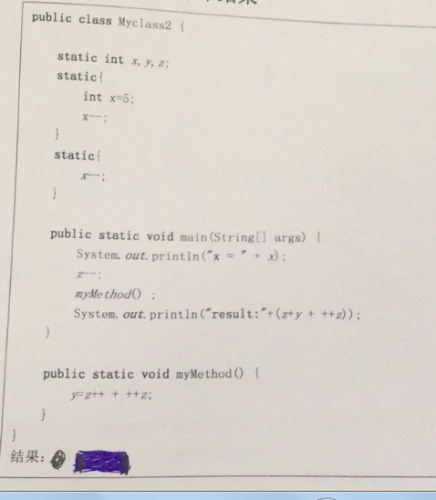

第十三题：
==和equals()的区别
==，基本数据类型：比较类型值
引用数据类型：比较地址值
未重写equals()方法前，两者一样，重写后equals()成为类型比较及内容

第十四题：
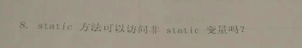可以
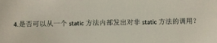不可以

第十五题：


第十六题：

