create table Customer(Custid int not null identity(1001,1), constraint pk_custid primary key(Custid), Custname varchar(20), Age int, phone bigint)

create table Loan(Loanid int not null identity(101,1), constraint pk_Loanid primary key(Loanid), Amount int, Custid int, constraint fk_custid_loan foreign key(Custid) references Customer(Custid), EMI int)

create table Account(Acno int not null identity(1,1), constraint pk_Acno primary key(Acno), Custid int, constraint fk_custid_Account foreign key(Custid) references Customer(Custid), Balance int)

INSERT INTO Customer ( custname, age, phone) VALUES

( 'John', 30, 123-456-7890),

( 'Jane', 25, 987-654-3210),

( 'Janes', 25, 987-6505-710),

( 'smith', 40, 555-555-5555);

INSERT INTO Loan ( amount, custid, emi) VALUES

(286760,1004,50000),

( 100000, 1001, 500),

( 5000, 1002, 250),

( 15000, 1003, 750);

INSERT INTO Account (custid, balance) VALUES

(1001, 10000),

(1002, 5000),

(1003, 5000),

(1004, 20000);

select * from Customer

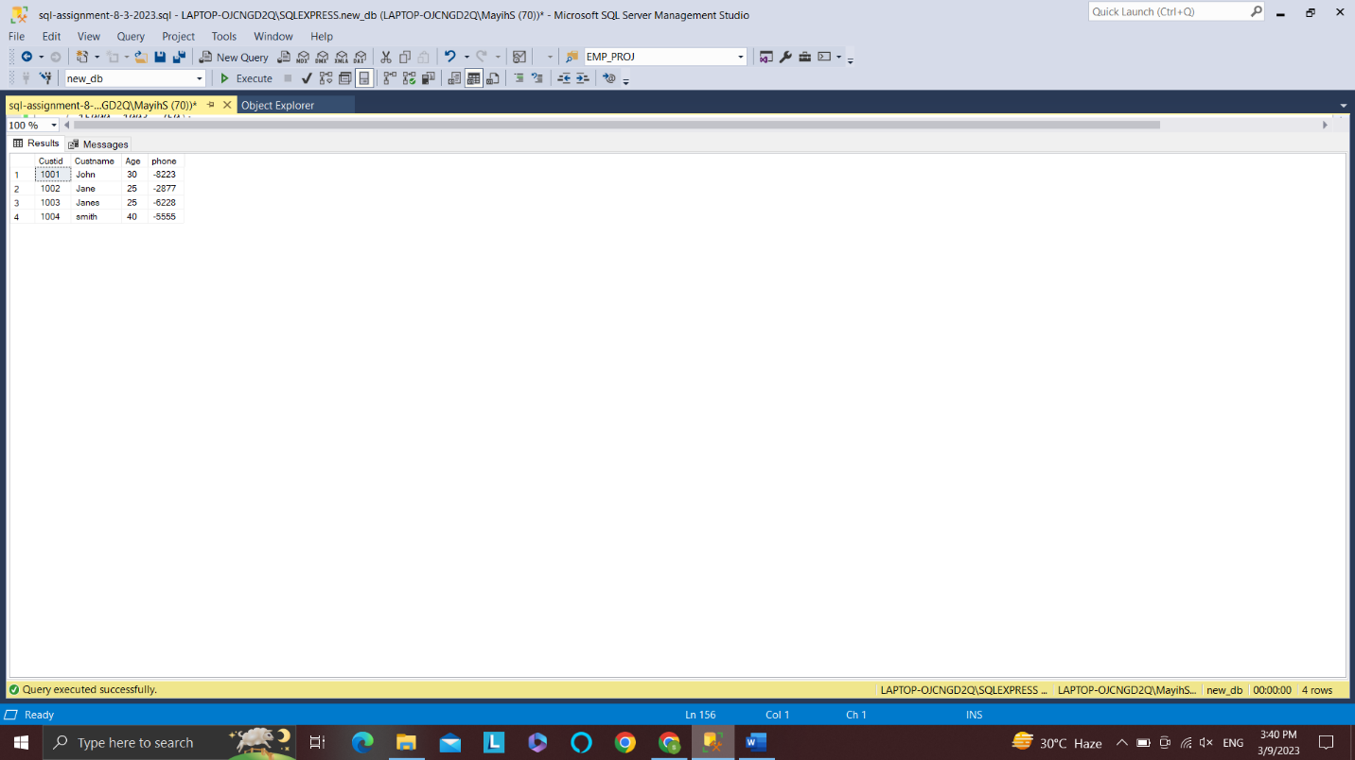

select * from Loan

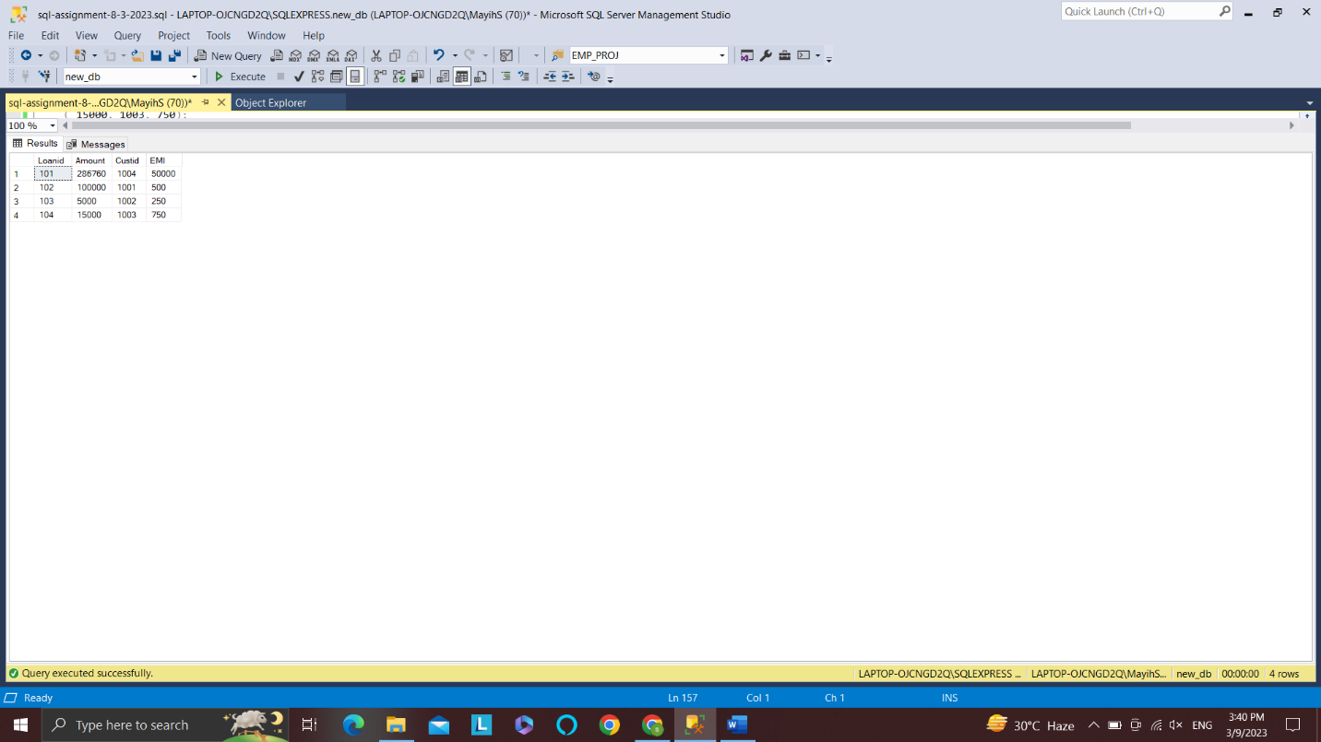

select * from Account

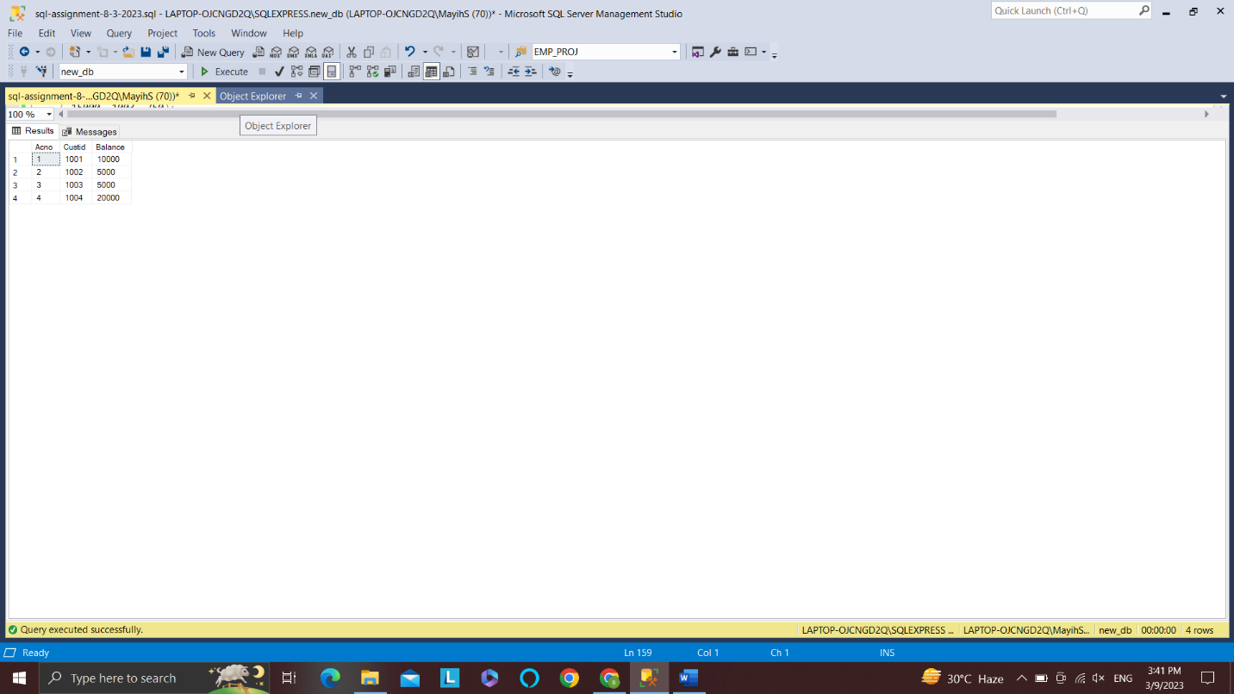

/*a) List the Loanid of Loans with EMI more than Rs.50,000.*/

select Loanid from Loan where Amount > 50000

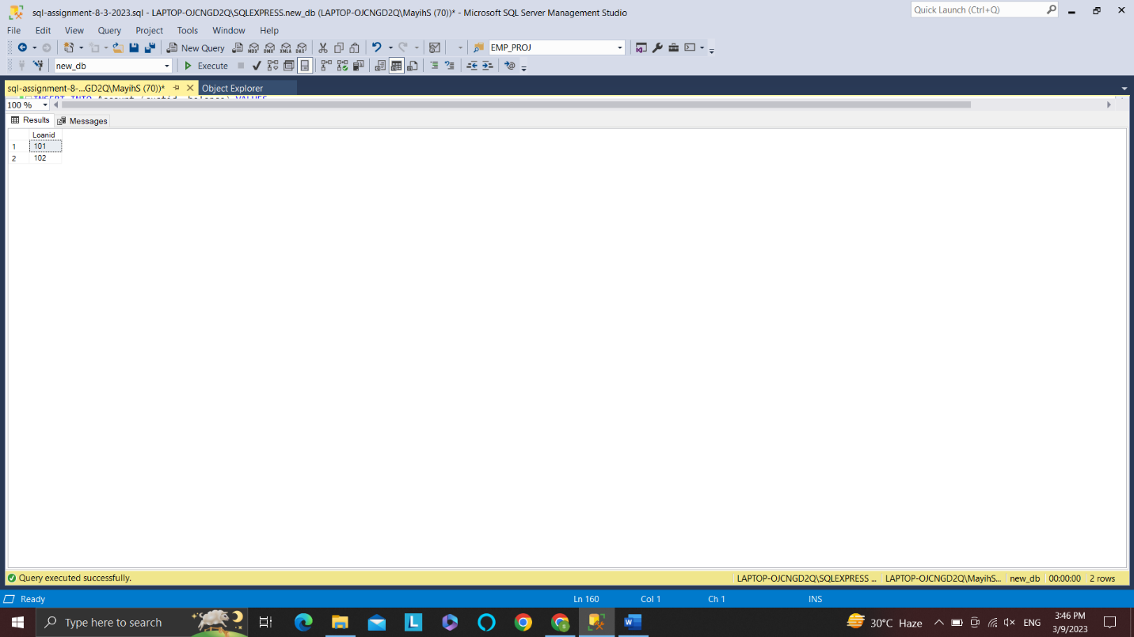

/*b) List the EMI and number of loans with that loan amount.*/

select EMI, count(*) as num_loans from loan group by EMI

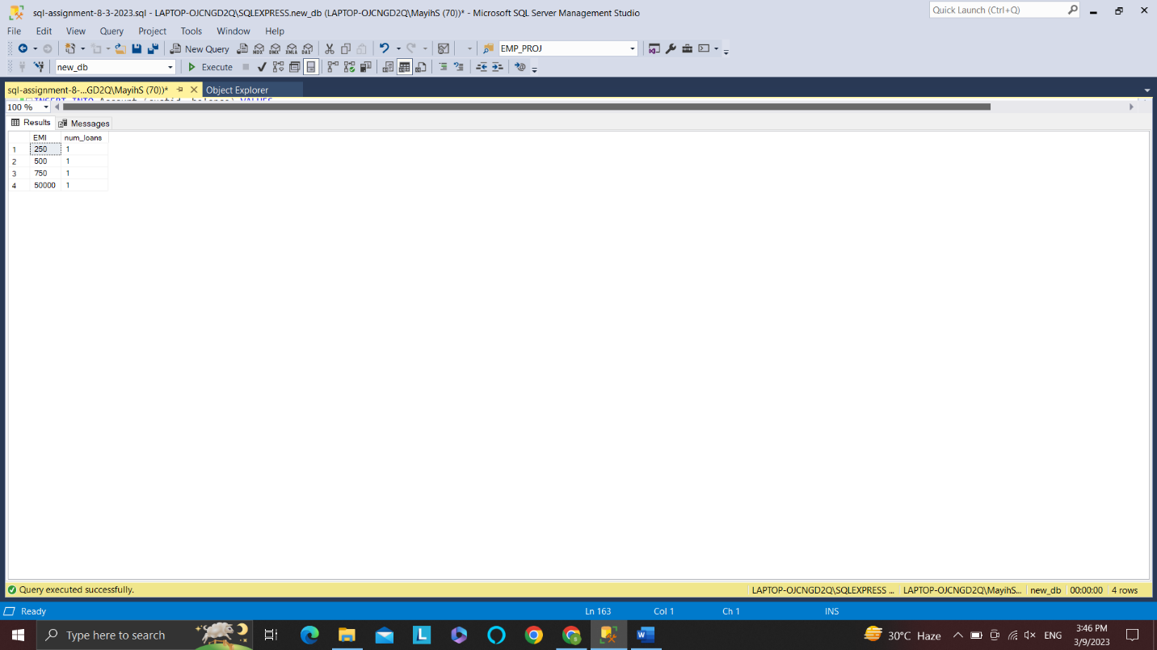

/*c) Create a view to list the total number of loans availed.*/

select count(*) as total_no_of_loans from loan

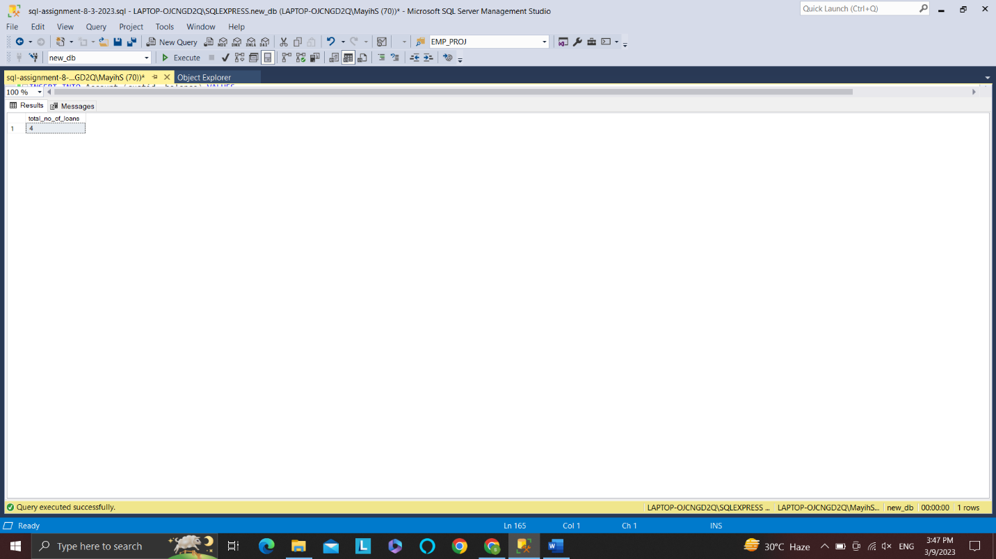

/*d) Display the EMI amount of Customer "Smith".*/

select EMI from Loan inner join Customer on Loan.Custid = Customer.Custid where Custname = 'smith'

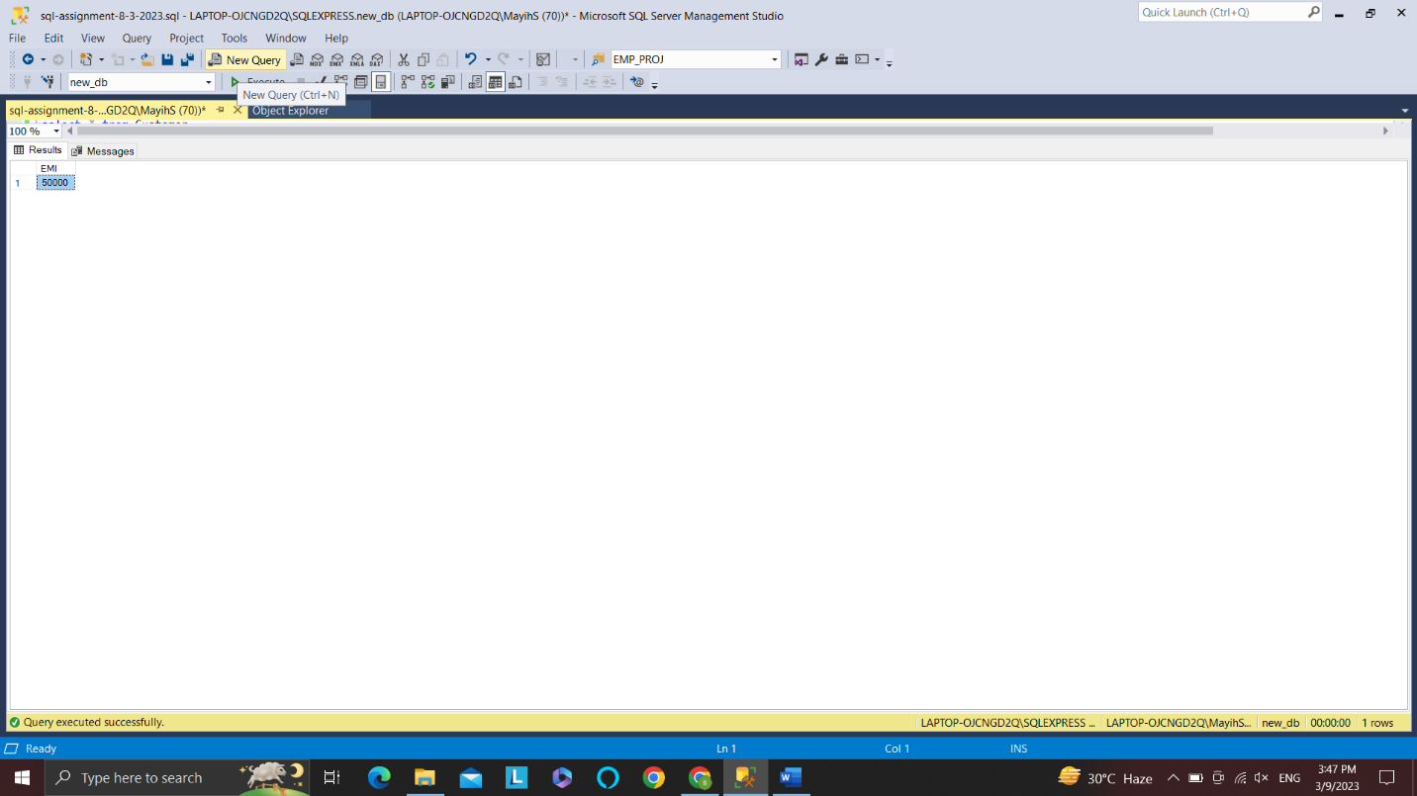

/*e) Create a procedure to print the Amount and Custid of Loanid 1001.*/

create proc print_A_C_L

as

begin

declare @a int, @c int;

set @a = (select Amount from Loan where Loanid = 101)

set @c = (select Custid from Loan where Loanid = 101)

print 'Loan Amount ' + str(@a) + ' '+'Custid '+ str(@c)

end

exec print_A_C_L

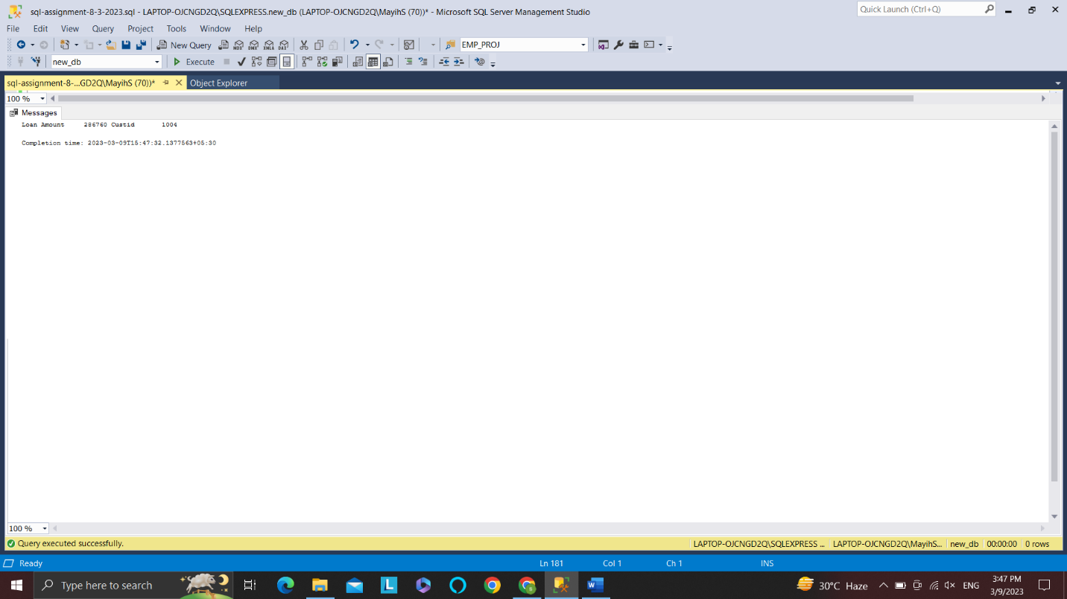

/*f) Create a function to display the loan amount of customer with customerid 100.*/

create function get_loan_amount (@custid int)

returns int

as

begin

declare @loan_amount int;

set @loan_amount = (select Amount

from Loan

where Custid = @custid)

return @loan_amount;

end

select dbo.get_loan_amount(1001) as get_loan_amt

