Assignment(23-03-2023)

# Program – 1

public void Program_1(){

int n = GetOneInput();

for(int i =0; i<n; i++)

{

for(int j = 0; j<i+1; j++)

{

Console.Write("*");

}

Console.WriteLine();

}

}

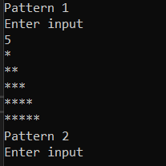

# Program – 2

public void Program_2()

{

int n = GetOneInput();

for (int x = 1; x <= n; x++)

{

for (int y = x; y < n; y++)

{

Console.Write(" ");

}

for (int z = 1; z < (x * 2); z++)

{

Console.Write("*");

}

Console.WriteLine();

}

}

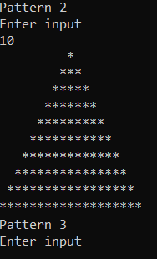

# Program – 3

public void Program_3(){

int n = GetOneInput();

int count = n-1;

for (int i =0; i<n; i++)

{

for(int j = 0; j<n; j++)

{

if(j >= count)

{

Console.Write("*") ;

count--;

}

else

{

Console.Write(" ");

}

}

Console.WriteLine();

}

}

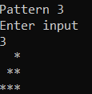

# Program – 4

public void Program_4()

{

int n = GetOneInput(); int res = 1;

while(n > 0)

{

res *= n; n--;

}

Console.WriteLine(res);

}

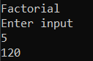

# Program – 5

# public void Program_5()

# {

# int n = GetOneInput();

# int t = n;

# int res = 0;

# while(t > 0)

# {

# res +=(int) Math.Pow((t % 10),3);

# t /= 10;

# }

# if(res == n)

# {

# Console.WriteLine("{0} is Amstrong Number", res);

# }

# else

# {

# Console.WriteLine("{0} is not Amstrong Number", res);

# }

# }

# 

# Program – 6

public void Program_6(/*int n*/)

{

//Console.WriteLine(6 % 3);

int n = GetOneInput();

int res = 0;

for(int i = 1; i<= n/2; i++)

{

if(n % i == 0)

{

//Console.WriteLine(i);

res += i;

}

}

//Console.WriteLine(res);

if(res == n)

{

Console.WriteLine("{0} Perfect {1}",n, res);

}

else

{

Console.WriteLine("{0} ImPerfect {1}", n, res);

}

}

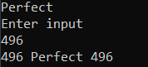

# Program – 7

public void Program_7()

{

int n = GetOneInput();

Console.WriteLine("Click 1 for C to F");

Console.WriteLine("Click 2 for F to C");

int a = GetOneInput();

float res = 0;

if(a == 1)

{

res = (n * 1.8f) + 32;

}

else if(a == 2)

{

res = (n - 32 ) * (float)(5/9);

}

else

{

Console.WriteLine("Enter a choose a valid option");

}

Console.WriteLine(res);

}

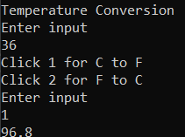

# Program – 8

public void Program_8()

{

int p = GetOneInput();

int n = GetOneInput();

int r = GetOneInput();

Console.WriteLine("Simple Interest{0}", (p * n * r) / 100);

}

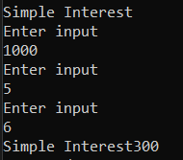

# Program – 9

public void Program_9()

{

double p = Convert.ToDouble(GetOneInput());

double r = Convert.ToDouble(GetOneInput());

Console.Write(r);

double m = Convert.ToDouble(GetOneInput());

Console.Write(m);

int compound = (int)(p * Math.Pow(1 + (r / 100*m),m));

Console.WriteLine("Compound Interest is " + compound);

}

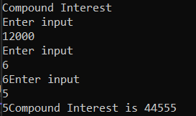

# Program - 10

public void Program_1(){

int n = GetOneInput();

for(int i =0; i<n; i++)

{

for(int j = 0; j<i+1; j++)

{

Console.Write("*");

}

Console.WriteLine();

}

}

