St Joesph college of engineering,Chennai.
HACKATHON(Runner).
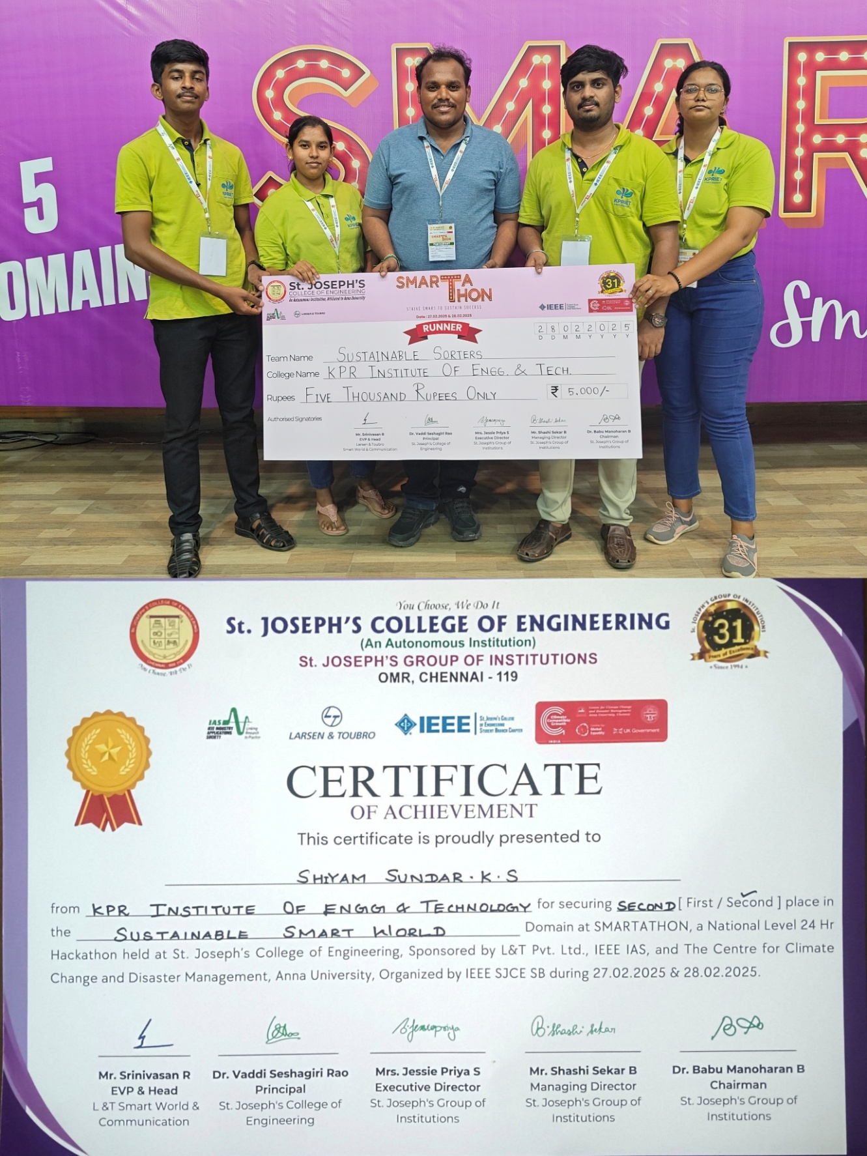
Microsoft(MLSA x GLA Univertisity), Gurugram , Haryana.
Hackathon (Special Prize: “BEST IOT PROJECT”)

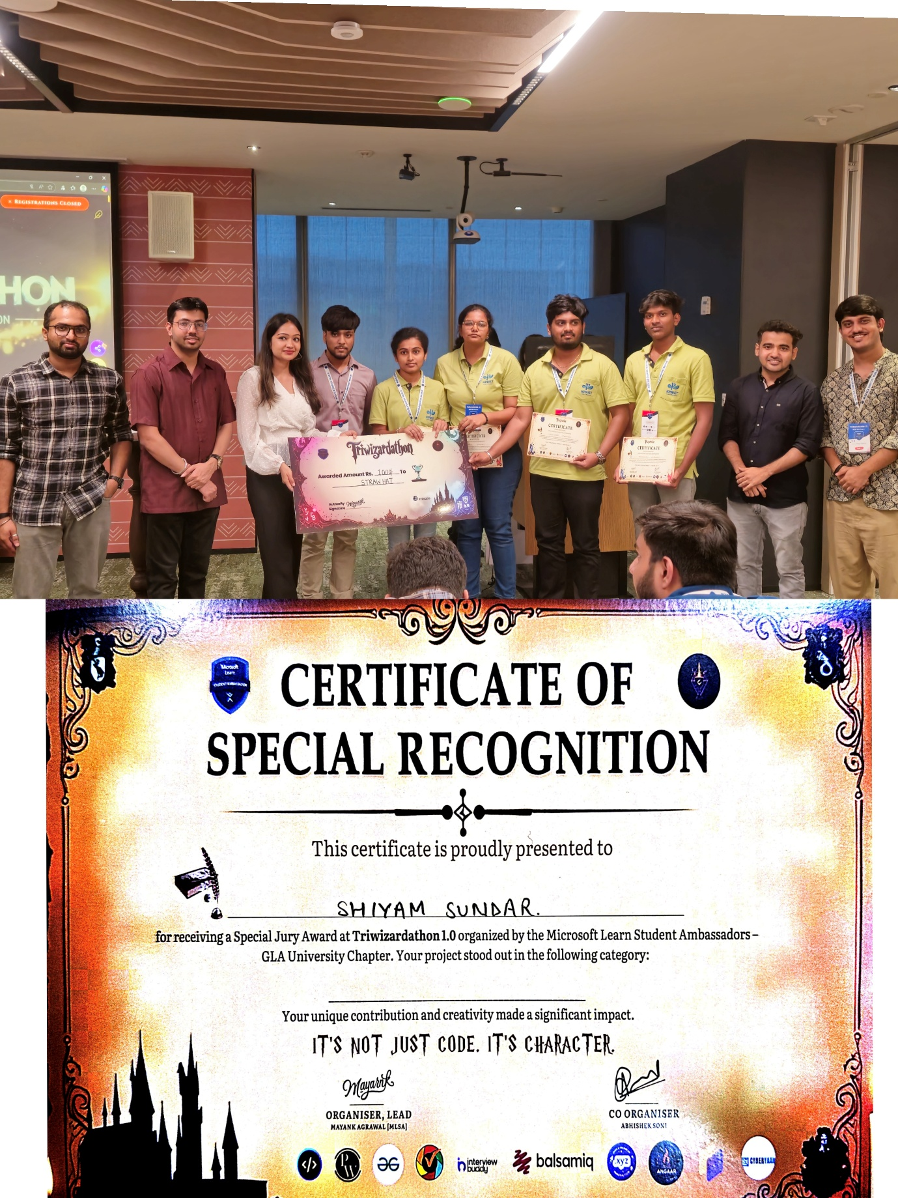
SNS college of engineering, Coimbatore.
Hackathon (Winner)
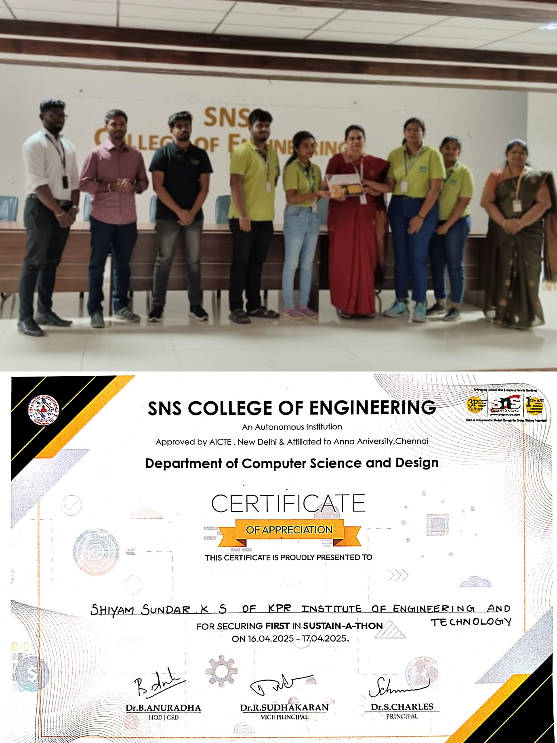
SRM IST, Tiruchi.
Hackathon(Winner).
