**Strategic Insights into Costco's Revenue Growth:**

**Membership Fees, Market Expansion, and Forecasting**

**Section 0: Duties and Contribution**

|  |  |  |  |
| --- | --- | --- | --- |
| Ma Xinai | 3036348018 | Constructing the Endogenous Revenue Drivers Analysis (rmd) & Clearing up data & PPT Modification | 16.6% |
| Chen Siqi | 3036347284 | Constructing the Endogenous Revenue Drivers Analysis (rmd) & Data Collection & PPT Modification | 16.6% |
| Feng Jiayi | 3036347234 | Writing the Executive Summary, Introduction, and Data Section (report) & Data Collection & PPT Modification | 16.6% |
| Huang Haowen | 3036345298 | Constructing the time series model (rmd) & Writing Analysis and Data section (report) | 16.6% |
| Chau Man Lung | 3036431528 | Organizing report and manuscript & Creating powerpoint | 16.6% |
| Wu Zhuoya | 3036345834 | Organizing report and manuscript & Creating powerpoint & Data Collection | 16.6% |

**Section 1: Executive Summary**

**1.1 Problem Description and Significance**

Costco, the largest membership-based warehouse retailer in the United States, derives a significant portion of its revenue from membership fees. On September 1, 2024, Costco announced an increase in the annual membership fees for its Gold Star membership in the U.S. and Canada, from $60 to $65, and for its Executive membership, from $120 to $130. This is the first adjustment to membership fees since 2017. In recent years, with increasing market competition and adjustments to membership fees, Costco has faced the challenge of balancing the growth of membership fees with customer demand. An in-depth analysis of the relationships between endogenous variables such as membership fees, cardholder numbers, gross margin, and warehouse count can provide data-driven insights for Costco, enabling the company to make more informed decisions when optimizing pricing strategies and expanding its market. Additionally, this study will build a time series model to forecast future revenue, which will allow Costco to better handle future uncertainties and make proactive adjustments in advance.

* 1. **Research Process**

1. **Data Collection**: The report utilized Python to scrape quarterly data from Costco's official financial reports and the Wind database, covering the period from 2009 to 2024, which includes quarterly revenue, membership fees, gross margin, cardholder numbers, warehouse count, and the revenue share.
2. **Endogenous Revenue Drivers Analysis**: The report first analyzed the correlations between membership fees, gross margin, cardholder numbers, and warehouse count with revenue. A multiple regression model was then built. To ensure accuracy, we refined the analysis by removing factors that showed excessive overlap, ensuring a more reliable understanding of which elements truly drive revenue growth.
3. **Time Series Model Construction**: To predict future revenue trends, we analyzed historical patterns, identifying growth trends and seasonal fluctuations. The best-performing model was selected based on its ability to provide accurate forecasts and ensure reliable decision-making. This model effectively captures Costco’s business cycles and provides a strong foundation for strategic planning.
   1. **Key Findings and Business Impact**

Our research shows that membership fees and warehouse expansion are the two most important drivers of revenue growth. Raising membership fees increases revenue, but retaining and expanding the customer base is crucial for long-term financial success. Warehouse expansion plays a key role in revenue growth, with Costco's store count rising from 400 in 2009 to 850 in 2024, allowing the company to serve more customers.

Looking ahead, our forecasting model indicates that Costco's revenue will follow a seasonal pattern in 2025. The third quarter (Q3) is expected to generate the highest revenue, making it a prime opportunity to increase inventory and marketing efforts. The first quarter (Q1) is projected to be the lowest revenue period, suggesting the need for strategic promotions to drive sales during this time.

**Section 2: Introduction**

**2.1 Summarize literature**

Xu’s[1] study on membership programs highlight their impact on customer loyalty, repeat purchases, and corporate cash flow. In order to satisfy the condition, retailers should take such measures: making the diﬀerence between service level and membership card price bigger and reducing consumers’ estimated default risk and retailers’ service adjustment factors. Research on Costco and similar retailers indicates that membership fees and the number of cardholders are key drivers of revenue. Allaway et al. [2] used membership data to explore customer segmentation behavior. Leenheer et al. [3] studied the impact of membership program on customer loyalty and estimated models both for the membership decision and for the eﬀect of membership on share-of-wallet. The relationship between membership and revenue is also a very popular research topic.

**2.2 Outline**

The rest of this report is organized as follows. In Section 3, we describe the data used in this analysis, including the sources of the data, the period covered, and the preprocessing steps involved in preparing the data for time series modeling. We also present key summary statistics and visualizations, such as trends, seasonal patterns, and correlations between variables. In Section 4, we provide a detailed analysis, where we explain the steps taken to build the forecasting models, including the selection of the SARIMA model, model evaluation metrics, and the interpretation of results. This section also includes a discussion on the seasonal variations and growth trends predicted for 2025 based on the models. In Section 5, we summarize our findings and give specific strategies for membership growth, warehouse expansion, and other actionable insights, offering feasible suggestions and predictions for the company's future development.

**Section 3: Data**

**3.1 Data description**

In the Endogenous Variable analysis part, the key data we collected include quarterly revenue, membership fees, gross margin, cardholder numbers, warehouse count, and the revenue share from different regions. In the time series model part, the dataset used for this analysis consists of quarterly revenue figures for Costco spanning from the first quarter of 2009 to the fourth quarter of 2024. The dataset includes two primary attributes: the quarter identifier (e.g., Q1-2009) and the corresponding revenue for that quarter, measured in millions of dollars. The data was originally provided in CSV format, which was preprocessed to make it suitable for time series analysis. Specifically, the quarter information was converted into a date format compatible with R’s time series functions, ensuring accurate trend and seasonality modeling.

The data collection process involved compiling historical revenue records from Costco’s financial reports and publicly available databases. Using both Python and R for data scraping and cleaning helps optimize the efficiency of data processing.

**3.2 Summary statistics**

During 2009 to 2024, Costco’s membership fees steadily rose, highlighting the growing membership base and pricing strategy. The number of cardholders increased from 50 million to 100 million, demonstrating Costco’s market penetration and customer loyalty. Warehouse count expanded significantly, with the number of warehouses rising from 400 to 850, supporting Costco’s strategic market expansion. While gross margin fluctuated between 11.2% and 16.4%, it suggests adjustments in product mix or pricing strategies over time. The average quarterly revenue over the observed period was approximately $36649 million, with a minimum of $15,806 million recorded in Q2-2009 and a maximum of $79697 million in Q3-2024. The increasing trend in revenue highlights Costco’s growth over time. To further explore the data, a time series plot of quarterly revenue was created.

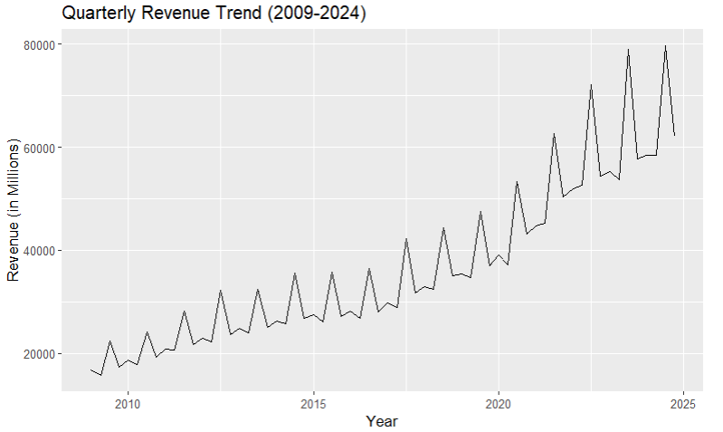

This comprehensive approach to the data, combined with the generated visualizations and statistical analysis, provides a solid basis for forecasting Costco’s future revenue.

**Section 4: Analysis**

The primary goal of this analysis is to forecast Costco's revenue for 2025 and provide actionable business insights. To achieve this, a systematic approach was adopted, involving the evaluation of various time series models and the selection of the best-performing model based on key performance metrics.

**4.1 ACF and PACF Analysis**

1. **Purpose**: The Autocorrelation Function (ACF) and Partial Autocorrelation Function (PACF) plots were generated to analyze the revenue time series for trends, seasonality, and potential model structures. This step was critical for identifying the appropriate parameters for the SARIMA model.
2. **Interpretation**: The ACF plot revealed slow decay in autocorrelations and periodic spikes every four lags, indicating the presence of both trend and quarterly seasonality. The PACF plot showed a sharp decline after a significant spike at lag 1, suggesting that a low-order autoregressive model (e.g., AR(1)) could adequately capture the short-term dependencies.
3. **Insights**: The observations confirmed that the revenue data is non-stationary, requiring first-order differencing to achieve stationarity. Additionally, the seasonal peaks validated the need for seasonal differencing and the inclusion of seasonal components in the model.

**4.2 Model Selection**

1. **Purpose**: Multiple time series models were tested to determine the most suitable one for forecasting quarterly revenue. Key performance metrics, including Root Mean Square Error (RMSE) and Mean Absolute Percentage Error (MAPE), were used to evaluate model accuracy.
2. **Comparison of Models**:

* SARIMA(1,1,0)(1,1,1)[4]: RMSE = 3585.766, MAPE = 5.53%
* SARIMA(1,1,1)(1,1,0)[4]: RMSE = 4005.115, MAPE = 6.14%
* Auto ARIMA: RMSE = 4073.59, MAPE = 6.24%
* Two-Level Model: RMSE = 4073.586, MAPE = 6.24%

1. **Interpretation:** Among the models, SARIMA(1,1,0)(1,1,1)[4] outperformed others, achieving the lowest RMSE and MAPE. Its seasonal differencing and seasonal AR(1) and MA(1) terms effectively captured the recurring quarterly revenue peaks, aligning well with the observed data patterns.
2. **Insights**: This analysis confirmed that SARIMA models incorporating seasonal terms are more effective for capturing Costco’s quarterly revenue fluctuations than non-seasonal models like Auto ARIMA or the Two-Level Model.

**4.3 Forecast Results**

1. **Purpose:** The selected model was used to forecast Costco’s revenue for 2025, providing a detailed view of quarterly performance and seasonal trends.
2. **Interpretation:** The forecast highlights significant seasonal variation, with revenue peaking in Q3 and dipping in Q1. This pattern aligns with historical trends, where Q3 consistently demonstrates strong performance due to increased consumer spending. The 95% confidence intervals indicate high reliability, though the wider range in Q3 reflects greater uncertainty in predicting the peak value. This could be attributed to the inherent variability of seasonal demand during that quarter.
3. **Insights**: The Q3 peak underscores the importance of strategic inventory planning and supply chain optimization to meet heightened demand. The relatively low revenue in Q1 suggests an opportunity for targeted promotional campaigns to mitigate seasonal dips and boost sales. The forecast provides a reliable basis for financial planning, enabling Costco’s management to allocate resources effectively and align budgets with expected seasonal fluctuations.

**Section 5: Conclusion**

**5.1 Research Conclusions**

Based on the analysis results, we have summarized the following strategies.

Firstly, membership fees and the number of cardholders have a significant positive impact on revenue. Increasing membership fees and expanding the member base are important strategies for driving revenue growth. There is also a significant positive correlation between the number of warehouses and revenue, indicating that increasing the number of warehouses helps the company expand its market share and boost revenue. By expanding its warehouse network, Costco has enhanced market coverage and customer loyalty.

Secondly, the gross margin of Costco exhibits a weak negative correlation with revenue, suggesting that although increasing the gross margin may lead to higher profits, it could negatively affect sales volume, thereby impacting total revenue. Costco's business model tends to focus on low gross margins and high sales volume, which helps attract more customers and increase revenue.

Thirdly, according to the forecasting model, revenue projections for 2025 show seasonal variations, with the third quarter expected to generate the highest revenue, while the first quarter is anticipated to have relatively lower revenue. Based on this, it is recommended that Costco intensify promotional activities during high-revenue periods like Q3, while implementing targeted customer engagement strategies during lower-revenue periods like Q1. Additionally, inventory, supply chain, and human resources should be accurately planned to ensure adequate preparation for the peak revenue season in Q3.

**5.2 Future Work and Value Proposition**

In the future, out team will explore several key areas to enhance Costco's strategic capabilities.

1. **Customer Segmentation Analysis:** A deeper dive into customer segmentation based on membership type, purchasing behavior, and regional differences could provide more granular insights into customer loyalty and retention strategies. This would enable Costco to tailor membership benefits and promotions more effectively.
2. **Optimization of Membership Benefits:** Investigating the optimal balance between membership fees and benefits could identify opportunities to enhance perceived value for members, thereby increasing retention rates and attracting new customers.

In conclusion, the findings of the study provide actionable insights that can significantly benefit Costco's financial performance and strategic direction. With further investment in data analytics and research, our team can unlock even greater potential for growth and customer satisfaction for Costco.

**References**

1. Xu, Lina, Meng, Zhiqing, Dynamic Analysis of Retailers’ Paid Membership Strategy, Discrete Dynamics in Nature and Society, 2021, 6412614, 9 pages, 2021. <https://doi.org/10.1155/2021/6412614>
2. A. W. Allaway, R. M. Gooner, D. Berkowitz, and L. Davis, “Deriving and exploring behavior behavior segments within aretail loyalty card program,” European Journal of Marketing, vol. 40, no. 11-12, pp. 1317–1339, 2006.
3. J. Leenheer, H. J. van Heerde, T. H. A. Bijmolt, and A. Smidts,“Do loyalty programs really enhance behavioral loyalty? An empirical analysis accounting for self-selecting members” International Journal of Research in Marketing, vol. 24, no. 1,pp. 31–47, 2007

**Appendix**

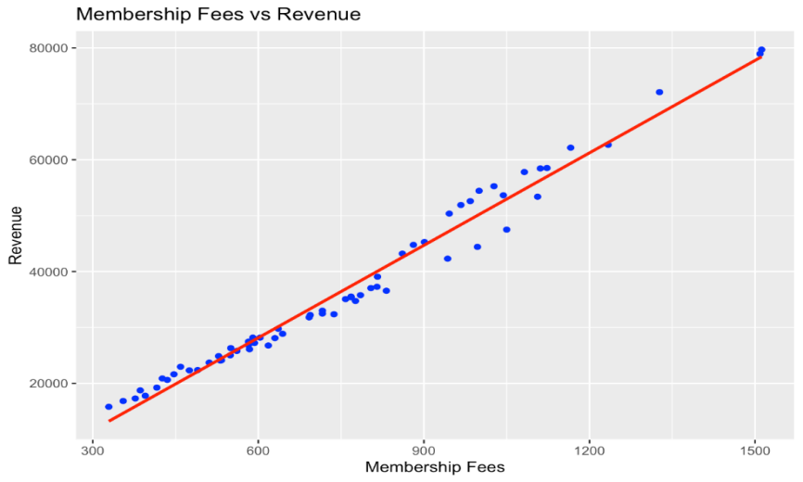

Figure 1 Correlation Between Revenue and Membership Fees

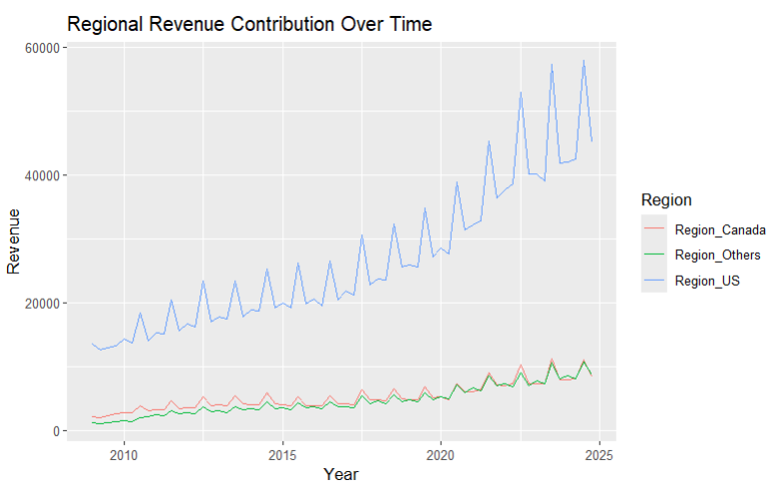

Figure 2 Regional revenue contribution over time

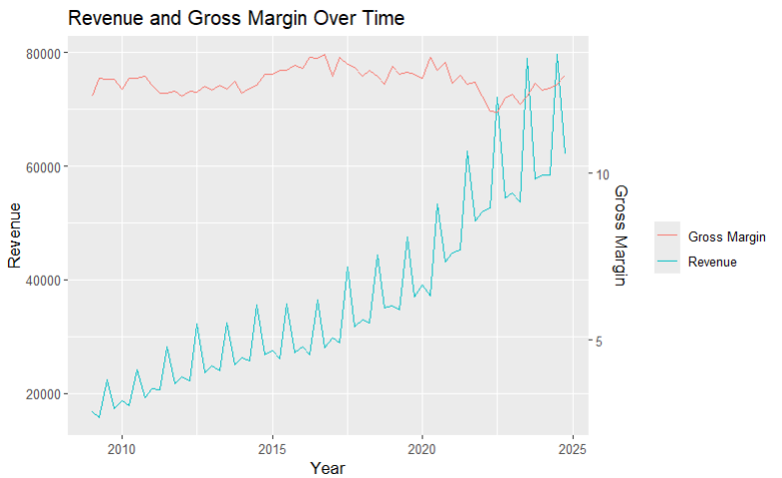

Figure 3 Relationship Between Gross Margin and Revenue

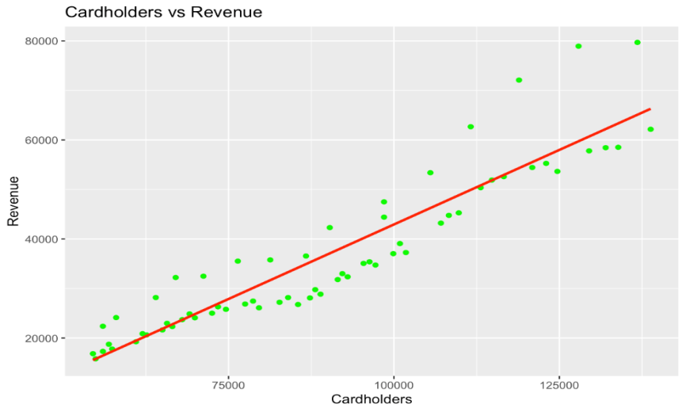

Figure 4 Relationship Between Number of Cardholders and Revenue

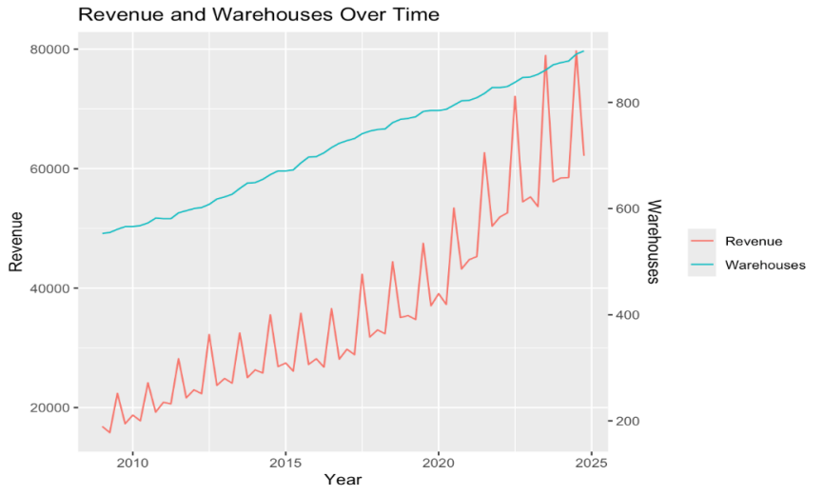

Figure 5 Relationship Between the Number of Warehouses and Revenue

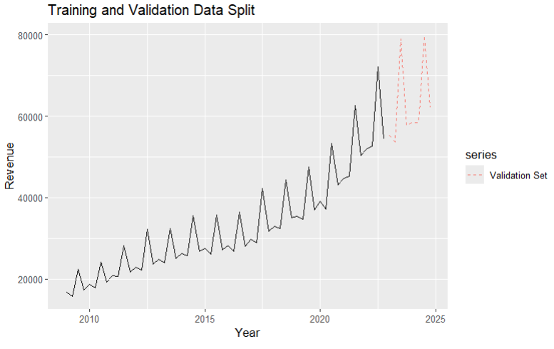

Figure 6 Split the data into training and validation sets

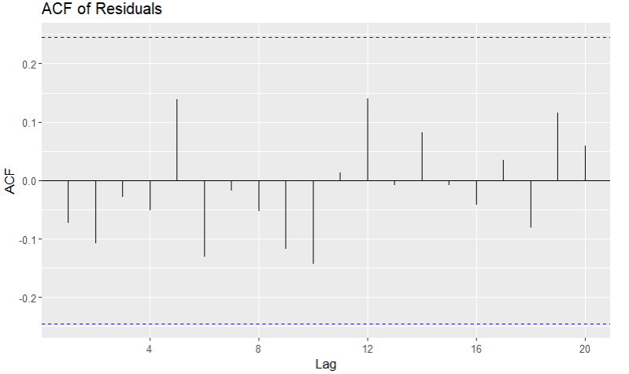

Figure 7 ACF of Residuals

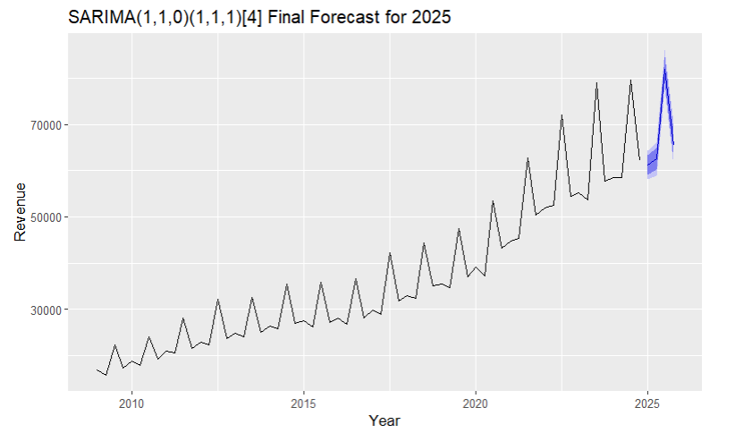

Figure 8 SARIMA(1,1,0)(1,1,1)[4] Final Forecast for 2025

|  |  |  |  |
| --- | --- | --- | --- |
| Quarter | Predicted Revenue | Lower_95_CI | Upper_95_CI |
| Q1-2025 | 61227.51 | 58063.75 | 64391.28 |
| Q2-2025 | 62531.72 | 58964.92 | 66098.52 |
| Q3-2025 | 81878.96 | 77594.37 | 86163.55 |
| Q4-2025 | 65484.18 | 60744.93 | 70223.43 |

Table 1 Forecast result