Inverse Usercf (论文有区别)
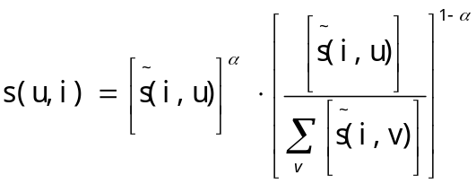
movielens，L=20，knn=20
 | rs | gini | epc | intrasimilarity
usercf | 0.0913 | 0.1034 | 0.7774 | 0.2045
Reverse usercf(a=0) | 0.1604 | 0.4227 | 0.9818 | 0.0521
Reverse usercf(a=0.1) | 0.1458 | 0.48 | 0.9751 | 0.0594
Reverse usercf(a=0.2) | 0.1312 | 0.5514 | 0.9627 | 0.0713
Reverse usercf(a=0.3) | 0.1181 | 0.5791 | 0.9431 | 0.0896
Reverse usercf(a=0.4) | 0.1076 | 0.5057 | 0.9178 | 0.1113
Reverse usercf(a=0.5) | 0.1001 | 0.3899 | 0.89 | 0.1347
Reverse usercf(a=0.6) | 0.0953 | 0.2921 | 0.8648 | 0.1544
Reverse usercf(a=0.7) | 0.0924 | 0.2247 | 0.8441 | 0.1697
Reverse usercf(a=0.8) | 0.0909 | 0.1833 | 0.8289 | 0.1803
Reverse usercf(a=0.9) | 0.0904 | 0.1568 | 0.817 | 0.1883
Reverse usercf(a=1) | 0.0904 | 0.1388 | 0.8076 | 0.1944

netflix | RS | Gini | Intrasimilarity | EPC
User cf | 0.0699 | 0.0254 |  | 0.7853
Reverse usercf(a=0) | 0.0907 | 0.614 | 0.0351 | 0.988
Reverse usercf(a=0.1) | 0.0846 | 0.63 | 0.041 | 0.983
Reverse usercf(a=0.2) | 0.0785 | 0.633 | 0.049 | 0.975
Reverse usercf(a=0.3) | 0.0729 | 0.605 | 0.0605 | 0.964
Reverse usercf(a=0.4) | 0.0678 | 0.53 | 0.0755 | 0.947
Reverse usercf(a=0.5) | 0.0638 | 0.406 | 0.096 | 0.923
Reverse usercf(a=0.6) | 0.061 | 0.261 | 0.1214 | 0.89
Reverse usercf(a=0.7) | 0.0594 | 0.148 | 0.146 | 0.858
Reverse usercf(a=0.8) | 0.0587 | 0.081 | 0.1655 | 0.833
Reverse usercf(a=0.9) | 0.0585 | 0.05 | 0.1786 | 0.816
Reverse usercf(a=1) | 0.0587 | 0.037 | 0.1867 | 0.805

Inverse Itemcf
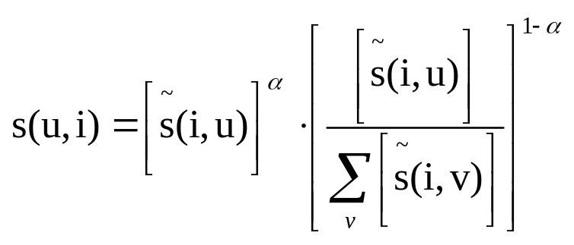
MovieLens | RS | Gini | EPC | Intrasimilarity
itemcf | 0.127 | 0.0584 | 0.7427 | 0.2351
Reverse itemcf(a=0) | 0.1317 | 0.4878 | 0.9411 | 0.0785
Reverse itemcf(a=0.1) | 0.1314 | 0.4934 | 0.9315 | 0.0838
Reverse itemcf(a=0.2) | 0.1311 | 0.4837 | 0.9191 | 0.0922
Reverse itemcf(a=0.3) | 0.1308 | 0.4631 | 0.9055 | 0.1009
Reverse itemcf(a=0.4) | 0.1305 | 0.4282 | 0.8911 | 0.1107
Reverse itemcf(a=0.5) | 0.1303 | 0.3795 | 0.8757 | 0.1203
Reverse itemcf(a=0.6) | 0.13 | 0.3306 | 0.8615 | 0.1303
Reverse itemcf(a=0.7) | 0.1299 | 0.2841 | 0.8488 | 0.1389
Reverse itemcf(a=0.8) | 0.1298 | 0.246 | 0.8390 | 0.1458
Reverse itemcf(a=0.9) | 0.1299 | 0.2194 | 0.8315 | 0.1503
Reverse itemcf(a=1) | 0.1312 | 0.1674 | 0.8168 | 0.1596

Netflix | rs | gini | epc | intrasimilarity
itemcf | 0.0708 | 0.015 | 0.769
Reverse itemcf(a=0) | 0.08956 | 0.5583 | 0.9877 | 0.0323
Reverse itemcf(a=0.1) | 0.08952 | 0.5573 | 0.9869 | 0.0323
Reverse itemcf(a=0.2) | 0.08949 | 0.5533 | 0.9851 | 0.0327
Reverse itemcf(a=0.3) | 0.08945 | 0.5408 | 0.9809 | 0.0341
Reverse itemcf(a=0.4) | 0.08942 | 0.5085 | 0.9725 | 0.0376
Reverse itemcf(a=0.5) | 0.08939 | 0.4516 | 0.9591 | 0.0451
Reverse itemcf(a=0.6) | 0.08937 | 0.3746 | 0.9419 | 0.057
Reverse itemcf(a=0.7) | 0.08937 | 0.2892 | 0.9232 | 0.0726
Reverse itemcf(a=0.8) | 0.08941 | 0.2070 | 0.9054 | 0.0895
Reverse itemcf(a=0.9) | 0.08954 | 0.1455 | 0.8917 | 0.1033
Reverse itemcf(a=1) | 0.0901 | 0.0817 | 0.8747 | 0.1179

