

Course Title: MSc Data Science and AI

Project Title: An End-to-End Data Engineering and Predictive Framework for Demand Forecasting and Inventory Optimization in Pharmaceutical Distribution

Student Name: Shiyas Rasi
Student ID: M01087756

Supervisor: Submitted By:
Sudhakar Camilos Fernando Shiyas Rasi Pandarakkal

ABSTRACT
This research focuses on the real-time prediction of upcoming product demand and automated inventory replenishment triggers within the pharmaceutical distribution sector. The research domain is the wholesale healthcare supply chain, where logistical planners and retail pharmacy clients can obtain data-driven predictions on future medicine purchase quantities and determine optimal stock levels. The data for the prediction is sourced from a multi-year historical B2B order ledger from a wholesale distributor, containing line-item transaction ledgers, order quantities, client tiers, product categories, and transaction timestamps.
The raw transactional data undergoes a robust data engineering pipeline (ETL/ELT) to resolve missing entries, normalize drug classification names, eliminate duplicates, and construct temporal lag vectors and rolling statistical features. To address the challenge of demand heterogeneity, products are categorized into fast-moving SKUs and intermittent or lumpy demand items. The research attempts to predict demand using both classical statistical techniques and modern supervised machine learning algorithms, specifically Seasonal ARIMA (SARIMA), Random Forest, and Gradient Boosted Decision Trees (XGBoost).
The model outputs feed directly into a mathematical inventory optimization engine that dynamically computes Safety Stock ($SS$) and automated Reorder Points ($ROP$) using lead-time variance and service-level parameters. The expected end product of this research is a dashboard interface that displays SKU-level monthly purchase predictions for retail clients and generates proactive "Stock-Up" alerts when current stock drops below calculated safety thresholds. The primary outcome expected from this research is the reliable forecasting of multi-level demand and the operationalization of machine learning into actionable logistics workflows.
This research would be beneficial for wholesale pharmaceutical distributors, supply chain managers, and retail pharmacies. It enables them to maintain a continuous, uninterrupted supply of essential medicines so that sales operations avoid costly stockouts during sudden epidemiological spikes, while simultaneously mitigating financial capital traps and waste arising from expired drug inventories.

TABLE OF CONTENTS

ABSTRACT ................................................................................................................................................ 1
List of Figures: ........................................................................................................................................ 3
ACKNOWLEDGEMENT ............................................................................................................................. 6
1: INTRODUCTION ................................................................................................................................... 7
1.1 BACKGROUND: ........................................................................................................................ 8
1.2.1 Terminology Used: ..................................................................................................................... 8
1.2 PROBLEM STATEMENT ................................................................................................................ 10
1.3 AIMS & OBJECTIVES: ................................................................................................................... 10
1.4 DISSERTATION ORGANISATION: ................................................................................................. 11
2: LITERATURE REVIEW ......................................................................................................................... 12
2.1 INTRODUCTION: .......................................................................................................................... 12
2.2 RESEARCH TIMELINE: .................................................................................................................. 12
2.3 METHODOLOGY .......................................................................................................................... 13
2.4 REVIEW ........................................................................................................................................ 16
2.4.1 Level 1: ................................................................................................................................. 16
2.4.2 Level 2 : ................................................................................................................................ 17
2.4.3 Level 3 : ................................................................................................................................ 19
2.4.4 Level 4 : ................................................................................................................................ 20
2.5 OUTPUT OF THE REVIEW ............................................................................................................ 22
3: METHODOLOGY ................................................................................................................................ 24
3.1 DATA EXTRACTION : ............................................................................................................. 24
3.1.1 DATA PLATFORM .................................................................................................................. 25
3.2 DATA : ....................................................................................................................................... 25
3.3 DATA PREPARATION ............................................................................................................. 26
3.3.1 Data Cleaning: ..................................................................................................................... 26
3.3.2 Data Pre-processing: ............................................................................................................ 27
3.4 DATA ANALYTICS PIPELINE ................................................................................................ 27
3.4.1 VISUALIZATION..................................................................................................................... 28
3.4.2 MODELLING .......................................................................................................................... 34
3.4.3 Hyper Parameter Tuning of Model: ..................................................................................... 38
3.5 PROTOTYPE OF THE END PRODUCT: ........................................................................................... 38
4: RESULTS & FINDINGS ....................................................................................................................... 40
4.1 PRE-PROCESSING: ....................................................................................................................... 40
4.2 MODELING: ................................................................................................................................. 41
4.2.1 Linear Regression .................................................................................................................41
4.2.2 Gradient Boosting: ............................................................................................................... 45
4.2.3 RANDOM FOREST ................................................................................................................. 48
4.3 HYPER PARAMETER TUNING: ...................................................................................................... 49
4.3.1 Random Forest: .................................................................................................................... 49
4.3.2 Gradient Boosting Model: .................................................................................................... 50
4.4 RESULT OBTAINED FROM RAPIDMINER: .................................................................................... 52
4.5 FINAL PRODUCT .......................................................................................................................... 53
5: DISCUSSIONS ..................................................................................................................................... 56
5.1 DATA ........................................................................................................................................... 56
5.2 MODELING .................................................................................................................................. 57
5.2.1 Linear Regression ................................................................................................................. 57
5.2.2 Gradient Boosting Model: .................................................................................................... 58
5.2.3 Random Forest: .................................................................................................................... 59
5.3 SUMMARISING COMPARISON OF MODELS: ............................................................................... 59
5.4 HYPER PARAMETER TUNING ....................................................................................................... 60
5.4 OPTIMIZATION: ........................................................................................................................... 60
5.5 RESEARCH PRODUCT: .................................................................................................................. 60
6: CONCLUSION ..................................................................................................................................... 61
6.1 SUMMARY OF THE THESIS MODULES: ........................................................................................ 61
6.1.1 Data Extraction: ................................................................................................................... 61
6.1.2 Predictive Model Selection: ................................................................................................. 61
6.1.3 Optimization: ....................................................................................................................... 62
6.2 MANAGERIAL IMPLICATION ........................................................................................................ 62
6.3 THEORETICAL IMPLICATIONS ...................................................................................................... 63
6.4 LIMITATIONS: .............................................................................................................................. 63
6.5 FUTURE WORK: ........................................................................................................................... 65
6.5.1 Feature Level Work: ............................................................................................................. 65
6.5.2 Model Level Work: ............................................................................................................... 65 7 : BIBLIOGRAPHY ................................................................................................................................. 66
8.APPENDICES ....................................................................................................................................... 70

List of Figures:

Figure 1:Used Car Vs. New Car Sales ...................................................................................................... 7
Figure 2:Used Car value index UAE ......................................................................................................... 7 Figure 3:Dissertation Organization .......................................................................................................11
Figure 4-Chapter Format ....................................................................................................................... 12
Figure 5-Number of Papers reviewed ................................................................................................... 13
Figure 6-Predictive analytics status (a) 2006 & (b) 2020 ..................................................................... 13
Figure 7-Final Set of Publication .......................................................................................................... 14
Figure 8-Classification of the Papers .................................................................................................... 15
Figure 9-Hierarchical Paradigm for Review ......................................................................................... 15 Figure 10-Classification of the papers based on levels ......................................................................... 15
Figure 11-Distribution of data .............................................................................................................. 16 Figure 12-Business Value of Predictive Analytics ............................................................................... 17 Figure 13-Output of review .................................................................................................................. 22
Figure 14:PIPELINE ................................................................................................................................ 28
Figure 15: Data Structures .................................................................................................................... 28
Figure 16:Correlation Plot ..................................................................................................................... 29
Figure 17:Missingness ........................................................................................................................... 29
Figure 18:Percentil 95 ........................................................................................................................... 30
Figure 19:Sum(Price) vs. Variables ........................................................................................................ 32
Figure 20:Median(Price) vs. Variables .................................................................................................. 33
Figure 21:SUM(Price) Vs. SUM( Mileage ) ............................................................................................ 33
Figure 22:Median(Price)vs Median(Mileage) ....................................................................................... 34
Figure 23:Correlation value .................................................................................................................. 34
Figure 24:Regression Curve of Price vs. Year ........................................................................................ 35
Figure 25:Regression Plot Year and Mileage Vs. Price .......................................................................... 35
Figure 26:Regression Plot Year and Mileage Vs. log10(Price) .............................................................. 35
Figure 27:Inc MSE and Inc Node Purity Plot ........................................................................................ 36
Figure 28:Gradient Boost Model........................................................................................................... 37
Figure 29:Removing Outlier .................................................................................................................. 40
Figure 30:Null Check ............................................................................................................................. 40
Figure 31:Price value Distribution graph .............................................................................................. 41
Figure 32:Structure of Linear Model ..................................................................................................... 42
Figure 33:Regression Prediction Plot .................................................................................................... 42
Figure 34:LR with Normal Split and Original Price Value ...................................................................... 43
Figure 35:Structure of LR with log10(Price) .......................................................................................... 43
Figure 36:LR With normal split and log10(Price) .................................................................................. 44
Figure 37:Random Splitting of data ...................................................................................................... 44
Figure 38:LR with Random split and Price ............................................................................................ 44
Figure 39:LR with Random Split and log10(Prices) ............................................................................... 45
Figure 40:LR with CV ............................................................................................................................. 45
Figure 41:Relative Influence Graph ...................................................................................................... 45
Figure 42:GBM Normal Split ................................................................................................................. 46
Figure 43:GBM Normal split with relative influenced variable............................................................. 46
Figure 44:GBM with log10(Price) and relative influenced values ......................................................... 46
Figure 45:GBM with Random Split ........................................................................................................ 47
Figure 46:Plotting Optimum Tree graph ............................................................................................... 47
Figure 47:GBM with optimum tree value result ................................................................................... 47
Figure 48:Random Forest Normal Split ................................................................................................. 48
Figure 49:Random Forest with log10(Price) ......................................................................................... 48
Figure 50:Random Forest with Random Split ....................................................................................... 48 Figure 51:Comparison of Models ..........................................................................................................49
Figure 52:Random Forest with Normal split Hyperparameter Tuning ................................................. 49
Figure 53:Random Forest with Log split Hyperparameter Tuning ........................................................ 50
Figure 54:Random Forest with Normal split and Log split Hyperparameter Tuning Graph ................. 50
Figure 55:Hyper Parameter Tuning of GBM ......................................................................................... 51
Figure 56:Application of Hyper Parameter Tuned Result ..................................................................... 51
Figure 57: Variable Statistics ................................................................................................................. 52
Figure 58:Ensemble tree in GBM ......................................................................................................... 52
Figure 59:(a)SVM (b)Decision Tree .................................................................................................... 52
Figure 60:Deep Learning and Linear Regression ................................................................................. 52
Figure 61:GBM and Random Forest ..................................................................................................... 53 Figure 62:Comparison of Result based on RapidMiner ........................................................................ 53
Figure 63:UI of the product ................................................................................................................... 54
Figure 64:The UI send data request in backend and scraping .............................................................. 55
Figure 65:Output from the prediction .................................................................................................. 55
Figure 66:Final Output .......................................................................................................................... 55

ACKNOWLEDGEMENT
In the successful accomplishment and completion of this project, many thanks to the almighty God. I would like to extend my gratitude to many people who have best owned upon me their blessings and heart pledged support and to everyone who has directly or indirectly been part of this journey of completion of the project.
Firstly, I would like to extend my sincere thanks of gratitude to my Professor and Mentor, Sudhakar Camilos Fernando who has guided and supported me throughout the course to complete this project on this amazing topic, “Demand Forecasting and Inventory Optimization in Pharmaceutical Distribution”. This topic's choice resulted from one of the activities initiated by Sudhakar Camilos Fernando, where we were asked to choose a topic and find the relevant datasets from the open sources and related hashtags. I was keen to explore this topic further and decided to choose this to complete my thesis.
I would also like to extend my gratitude to my parents, peers and friends who have helped me and encouraged me throughout the year of my study at Middlesex University. Special mention to my parents who supported me and encouraged me to believe in myself. I am grateful to the faculties and professors who are always ready to help me and share their knowledge and experience. I have learned so much from my professors and classmates based on their experience and knowledge. I am lucky to have the best mentor and advisor which resulted in successfully completing the project, without whom I could not have done this any better.

1: INTRODUCTION
Pharmaceutical distribution operates within an intricate and highly sensitive supply chain environment where demand forecasting and inventory management present unique operational challenges. Unlike fast-moving consumer goods, pharmaceutical demand is frequently non-stationary, seasonal, intermittent, and highly sensitive to external epidemiological events, local healthcare dynamics, and regional population shifts. On the supply side, inventory policy is heavily constrained by strict product expiration dates, stringent regulatory requirements, high holding costs, and near-zero tolerance for stockouts on critical life-saving medications. Consequently, sub-optimal forecasting directly translates into severe double-ended operational risks: stockouts that endanger patient care and supply shortages, or excess stock accumulation that leads to costly expiration-related waste. The central problem is thus twofold: improving predictive precision under irregular demand conditions and systematically translating those predictive outputs into reliable, risk-aware inventory replenishment decisions.
To address these challenges, the forecasting literature has progressed from classical time-series techniques—such as exponential smoothing and Auto-Regressive Integrated Moving Average (ARIMA) variations—toward modern machine learning (ML) and deep learning (DL) architectures. Modern non-linear and sequence-based models, including gradient-boosted decision trees and Long Short-Term Memory (LSTM) networks, offer the capacity to ingest complex feature spaces, capturing non-linear relationships, multi-seasonal patterns, and exogenous variables. Simultaneously, specialized methods within the broader intermittent-demand literature demonstrate that sparse and lumpish demand profiles require cautious model selection, custom loss functions, and domain-appropriate, inventory-aware evaluation metrics.
However, superior predictive accuracy in isolation does not guarantee supply chain efficiency. A forecasting model is only as effective as the upstream data engineering pipeline that feeds it, requiring high-quality, continuous, and timely data ingestion. Furthermore, the downstream utility of predictive modeling relies entirely on its seamless integration into concrete inventory control heuristics—such as dynamically adjusted reorder points, economic order quantities, and optimized safety stock thresholds.
To address these interconnected challenges, this literature review evaluates four critical, converging themes:
- Pharmaceutical Demand Dynamics: Identifying the specific statistical characteristics and drivers of pharmaceutical demand, including intermittency and seasonality.
- Classical Forecasting Paradigms: Reviewing traditional statistical and time-series models, their baseline performance, and their mathematical limitations.
- Advanced Machine Learning & Deep Learning Approaches: Assessing non-linear and neural network architectures, multi-horizon capabilities, and feature engineering practices.
- End-to-End Operational Integration: Examining the bridge between data pipelines (ETL/MLOps), predictive modelling, and downstream inventory control algorithms.
By critically synthesizing these domain areas, this review establishes the conceptual, methodological, and architectural foundations for the proposed Pharma-Flow framework. In doing so, it highlights a distinct research gap: the lack of end-to-end, operationalized systems that directly synthesize robust data engineering pipelines, advanced non-linear forecasting models, and inventory-aware decision logic within the pharmaceutical distribution sector.

1.1 BACKGROUND:
The Complexity of Pharmaceutical Supply Chains
Pharmaceutical supply chains are among the most strictly regulated and complex logistics networks globally. Unlike traditional retail or consumer packaged goods (CPG) supply chains, pharmaceutical distribution deals directly with public health outcomes. The primary objective is to maintain uninterrupted availability of life-saving medications across diverse clinical settings—ranging from large urban hospital networks to remote rural pharmacies.
The structure of pharmaceutical distribution involves multiple tiers: primary manufacturing facilities, active pharmaceutical ingredient (API) suppliers, national or regional wholesalers, third-party logistics (3PL) providers, and end-point dispensers (hospitals, clinics, and retail pharmacies). Operational friction, information distortion (such as the "bullwhip effect"), or delays at any tier immediately jeopardize downstream patient access.
Statistical Nature of Drug Demand
Managing inventory within this network is challenging because pharmaceutical demand profiles do not adhere to standard normal distributions. Instead, demand is characterized by:
- High Intermittency and Sparsity: Many specialized drugs, rare disease treatments, and high-cost medications exhibit sporadic sales patterns with frequent zero-demand periods punctuated by large, sudden orders.
- Epidemiological and Seasonal Sensitivity: Demand for respiratory medications, antibiotics, and vaccines fluctuates sharply based on seasonal climate changes, disease outbreaks, and regional health trends.
- Exogenous Disruptions: Policy shifts, changes in national healthcare coverage, patent expirations, drug recalls, and global supply chain disruptions introduce non-stationary variance into historical time-series data.
The Operational Dilemma: Holding Costs vs. Expiry & Shortages
Inventory management in pharmaceutical distribution requires balancing two costly failure states:
- Stockouts and Service Failure: Running out of critical pharmaceuticals leads to delayed treatments, compromised patient safety, regulatory penalties, and significant loss of institutional trust. To prevent stockouts, planners often maintain high buffer stock.
- Overstocking and Expiration Waste: Maintaining excessive inventory incurs high financial holding costs and strains cold-chain storage facilities. Because pharmaceuticals have strict, legally mandated shelf lives, holding excess inventory leads directly to product expiration, requiring hazardous waste disposal and causing substantial financial loss.
The Need for Systemic Integration
Historically, pharmaceutical companies relied on siloed, classical time-series techniques (such as moving averages or basic exponential smoothing) paired with static rule-of-thumb safety stock formulas. These legacy approaches fail when confronted with intermittent, non-linear demand patterns and fail to dynamically incorporate real-time external data.
While recent advances in artificial intelligence and machine learning provide tools to better capture complex demand dynamics, high-accuracy predictive models remain ineffective if they operate in isolation. Realizing the full operational value of advanced analytics requires a unified architecture—one that seamlessly links automated data engineering pipelines (ETL/MLOps) to ingest clean data, advanced predictive models to capture demand patterns, and dynamic inventory optimization logic (such as automated reorder points and variable safety stock) to guide real-world replenishment decisions.

1.2.1 Terminology Used:
- Intermittent Demand: A demand pattern characterized by sparse historical occurrences—frequent time periods with zero demand interspersed with occasional non-zero demand pulses of varying magnitude.
- Safety Stock ($SS$): The buffer inventory held to mitigate the risks of stockouts caused by uncertainties in demand spikes or lead-time delays.
- Reorder Point ($ROP$): A predefined inventory threshold that triggers a purchase order. Calculated as the sum of expected demand during lead time and safety stock:
$$\text{ROP}=\left(\text{Average Daily Demand}×\text{Lead Time}\right)+\text{Safety Stock}$$
- Stockout: An operational failure state occurring when unfulfilled demand exceeds available inventory, leading to missed sales or compromised patient care.
- Shelf Life & Expiry Risk: The legally mandated period during which a pharmaceutical product remains safe and effective. Holding stock past this duration results in unsellable waste requiring specialized hazardous disposal.
- Service Level (Cycle Service Level / Fill Rate): The target probability or percentage of customer/patient demand that is satisfied directly from available inventory without incurring a stockout.

1.2 PROBLEM STATEMENT
This research's background studies prove that the sale of the used car is higher in UAE, but customers' sale to customer share is very less. The dealer's sale share is very much high compared to others due to the offers they apply to the customers, Which means the dealers buy the car from the user at a lower price and resell it at a higher price showing the discount. The sales of the user, in turn, result in loss due to the poor knowledge of the market value. The dealers also charge an amount of commission from the user; hence is it essential to promote the customer to customer sale which is very less due to the user fear of fraudulent activities of loss they might incur from an unknown person which might be a higher value than compared to the registered dealers. There can be a chance that user sales get delayed due to the higher demand of the sales value.
The intended research helps predict the value of the car that the user wants to sell, which would promote the customer to customer sale, which in turn helps the user to sell the car value by demanding the market price without causing any delay in the sales. This research would have a high demand in this time as the car sales have increased widely through the internet sources, which could help users fall prey for fraudulent acts of the dealers. This research would speed up the process of sales, helping the seller and buyer get the value predicted and hence to decide the final sale price so that it would end up in a loss for both.
The research opportunity lies in the time of higher sales time where the market of the sales is very less, and the urgency of the sale to happen is very high.
1.3 AIMS & OBJECTIVES:
The aims and objectives of this research would help in building an effective solution for the problem statement.
AIM
Identify and predict the car price with the variables such as mileage, year of production, color, cylinder number, and other given specification.
The research aims to predict the value of the used car depending on the given specification of the car that they want to sell.
OBJECTIVE:
The objective of this research would help in fulfilling the aim that is mentioned.
- O1: Interface for the user to input the description of the car to be sold is to be Generated
O1 deals with the generation of the interface for the user to enter the specification of the car that they want to sell. It acts like a webpage for the user.
- O2: The Data set will be lively scraped from the internet using the input from the user
The second objective is the real-time value collection of the data. This is done by scraping the data from dubbizle.com by taking the input from the user. The scraped data will have the data of all the cars of the same model in sale for the current time.
- O3: The Data analysis of the scraped data using multiple algorithms for the prediction
This objective is the analysis of the data that is scraped for the analysis. This uses multiple algorithms for the predive analysis for the prediction of the final value.

- O4: The selection of the model that gave the accurate output for building the product
The research uses multiple algorithms for the prediction to find the algorithm that produces the best accuracy with less error rate—the real deals with the selection of the final model.

- O5: Optimization of the predicted value
The predicted value may not be optimized. It is to be optimized to give the final result to the user depending on the sale time demand of the customer.

1.4 DISSERTATION ORGANISATION:
The proposed research lies on the importance of the prediction of used car value. The dissertation consist of study and development of a product based on the multiple analysis of the model conducted. The structure of the dissertation are as follows
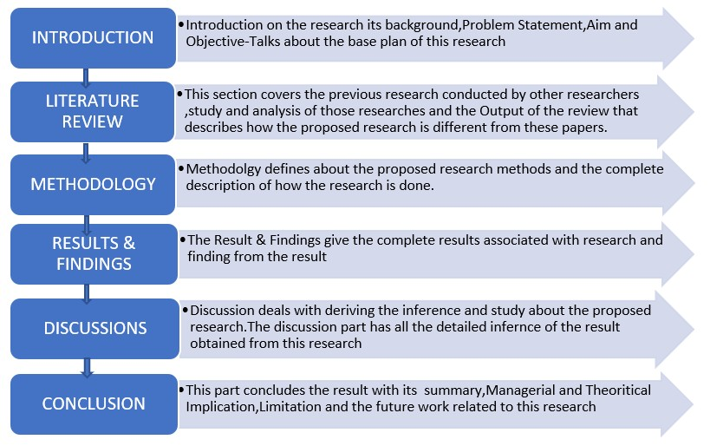
Figure 3:Dissertation Organization

2: LITERATURE REVIEW

2.1 INTRODUCTION:
Machine learning and predictive analytics have been in playing the market for a decade. It has been used widely for the prediction of many business values. There has been tremendous growth in the insights derived through predictive analytics—the number of research and study conducted in this area. The study related to this field is so massive that it proves the power of the prediction, which would strengthen any research conducted in the field.
The structure of the chapter follows the below structure.
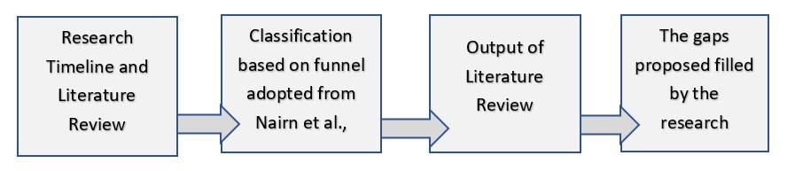 Figure 4-Chapter Format
The chapter begins with the research time of the literature review, which defines how machine learning has shaped up over the years. It specifies how machine learning has been changing over the years, and similar researches related to this proposed research has been conducted in these years. The next section covers the methodology of the research. It covers how this review has been structured and how different researches have been collected to study the same. It is followed by the classification of our research based on the architecture of Nairn et al. It defines a funnel structure with four levels, which helps in differentiating the heterogenous papers used in this review.
The output of the literature review gives us the idea of the algorithms used in different researches. This would help the intended research to understand the working of different algorithms in similar researches and select multiple algorithms for the proposed research and choosing the best algorithm with the best accuracy and less error rate. This is followed by the mentioning of the gaps in the reviewed researches and studies with the intended research. This section describes the change that is being made in the proposed research from other researches that would help in solving the problem statement much efficiently.
2.2 RESEARCH TIMELINE:
Machine learning came into existence from 1952, where the computer was able to learn using neural networks and perceptron. The kind of research at the time was pattern and shape recognition. The times till now, it has marked importance and the need for machine learning. With certain practices, machine learning did not have any progress since 1970 due to the argument of Neumann architecture being more accessible than a neural network.1982 again marked rise in interest for this neural network. It then got developed with backpropagation, which is a critical content in a neural network. Then again, the study went into a black box.
The graph marks a timely research journal article that was published related to the proposed research. From the graph, it is observed that there is a sudden surge in the number of studies conducted between 2010 and 2020. It is because the 21st century marked a significant difference in machine learning. There have been several algorithms developed in machine learning for prediction and analysis. 2009 marked the beginning of the new deep learning. It leads machine learning to be used widely in services and applications; hence many studies and projects were conducted after 2010, which lead to a peak in the number of publications in Figure 2. The 21st century led to many achievements in machine learning, such as ImageNet, Googles AphaGo. The preceding time of machine learning had its discovery and application.
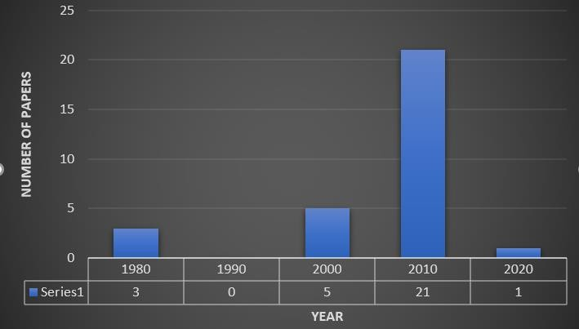
Figure 5-Number of Papers reviewed
Predictive Analytics and machine learning growth have tremendously increased. Figure 3a shows the status of the predictive analytics in 2006 were the predictive analytics was in 45 % exploration stage. The Figure 3b shows the growth of business market value in billions. These two figures widely explain the growth of predictive analytics and machine learning in the market.
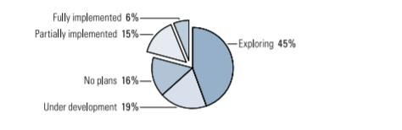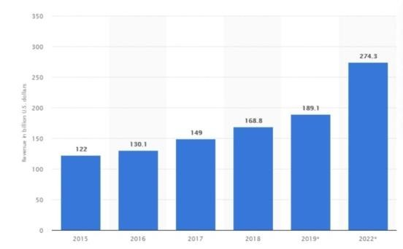
Figure 6-Predictive analytics status (a) 2006 & (b) 2020
Multiple numbers of people studied the proposed research on car value prediction. Multiple numbers of similar researches were conduction for the similar topic of prediction since 2011.
2.3 METHODOLOGY
The search for the articles and publications started with the databases: Google Scholar and Unihub Library Search. The publication article and journals were taken for the proceedings. There were multiple keywords used for the research of the papers. Data Science, Predictive Analytics, Used car sales in the automotive industry, Used car sales value prediction, Machine learning for Prediction, Algorithms in machine learning for continuous value prediction. Out of this research keyword the Used car value prediction, Machine learning for continuous value prediction, Predictive analytics gave the maximum number of papers. There were more than 50 results were obtained, and the final 30 papers were selected by excluding those that had the least significance.

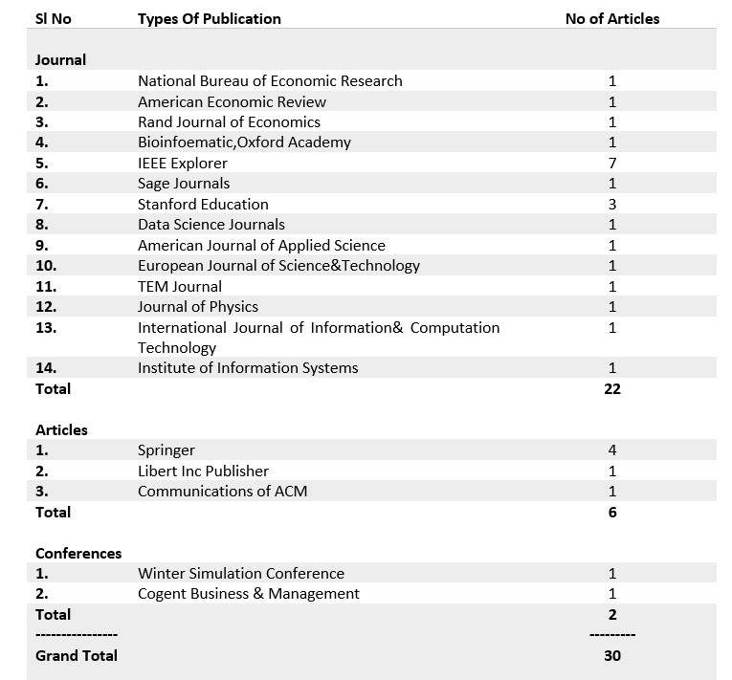
Figure 7-Final Set of Publication
The 30 papers selected has 22 papers in journal six as articles and two from conferences.

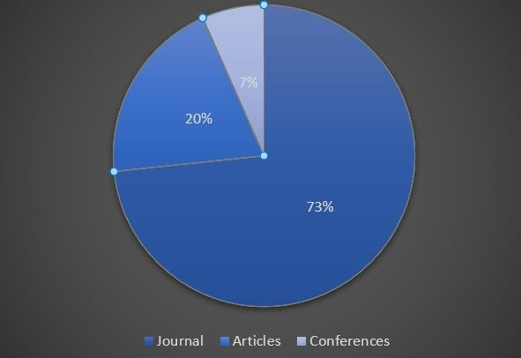
Figure 8-Classification of the Papers The Hierarchical paradigm was chosen for the research review.
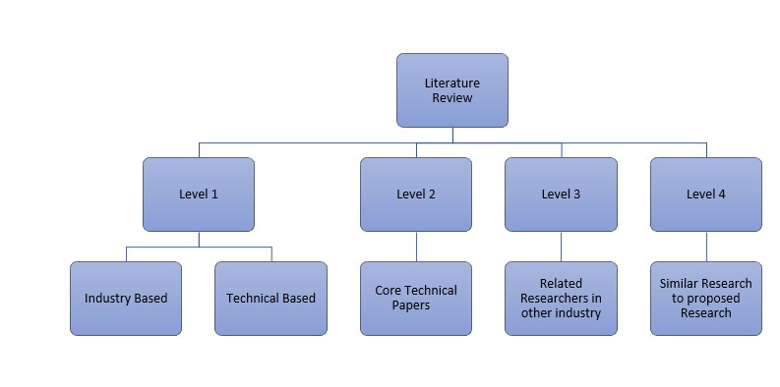
Figure 9-Hierarchical Paradigm for Review
The first level deals with the papers that are related to industry and the general technical idea about machine learning—the Level 2 deals with the study of predictive analytics. Level 3 speaks of the papers of similar researches in continuous value prediction, and level 4 dealt with all the similar works conducted.
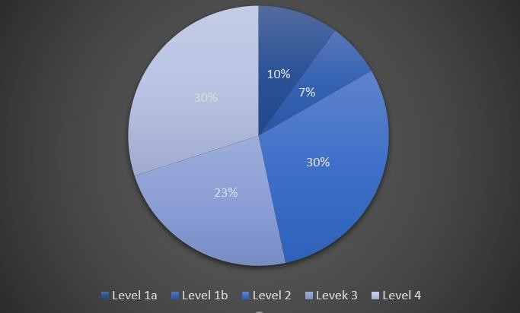
Figure 10-Classification of the papers based on levels
2.4 REVIEW
2.4.1 Level 1:
This level deal with the papers, researches, article, and books related to the industry and the Machine learning and data science. Most of the work in level 1is based on gaining the general idea in the automotive industry and the subject study of Machine learning and data science.
A total of 5 papers at this level constitute the general study. Out of the five papers, the 3 constitutes the journal papers, and two are contributed articles published. This level has the least number of papers associated.
This level dealt with the Level 1a industry study and the Level 1b technical study of the machine learning and data science. The primary issue that speaks in the industry study is the issue of equilibrium in the market in sales of the primary and secondary(Berkovec 1985) and any heuristic thinking in the market(Lacetera et al. 2012). The observation of the study also says about the differences between the past decade and the current trend.
The importance of the data used for the study is being described by Dhar(2013). There was a huge increase in the amount of data generated in recent times. Figure 8 shows the surge in data generation. The past decade study methods did not have any subtle method for modeling and did not have any assumptions about any features of the data such linearity, monotonicity, which lead to a downside in picking up the noise in the data. The distinguishing of signal and noise will be less if the features of the data are not considered. The observation of research led to an idea of the importance of feature management and the biased nature of the industry.
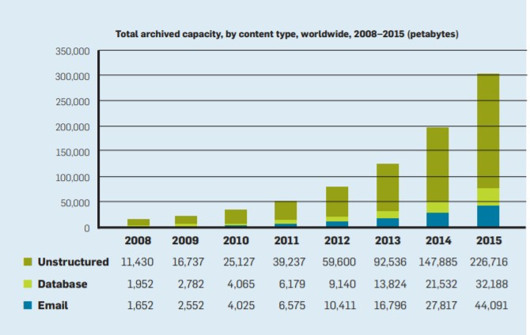
Figure 11-Distribution of data
The observation from the research of Lacetera et al. (2012) is that the value of the car is highly dependent on the value of odometer, out of which the left four-digit value of it profoundly affects the sales.

Papers | Description
Foster and Tom(2013) | The paper talks about how data science helps in making data-driven decisions and the fundamental concept of data science.
Dhar(2013) The implication of data science from the research and
business stand point. General analysis of the data science of predictive analysis with earlier years and current situation.

Gillingham et. al(2019) | This describes about the trade between the used car and the new car and modelling the equilibrium in the automobile market.
Lacetera et.al(2012) | Aim to study how the left four digit bias of the odometer value affect the affects the sale.
Berkovec(1985) | Presents the model of demand, supply , scrappage and hence to combine it to an equilibrium to understand the future trend in the market.

2.4.2 Level 2 :
This is an essential section that talks about the technical description of the predictive analytics and models that are being used in multiple types of research. This method constitutes 30% of papers of the research. This method deals with the idea of predicting its applications in areas. The core area of this level is the accuracy, sampling methods, error rate that can be used in predictive analytics and different models in predictive analytics.
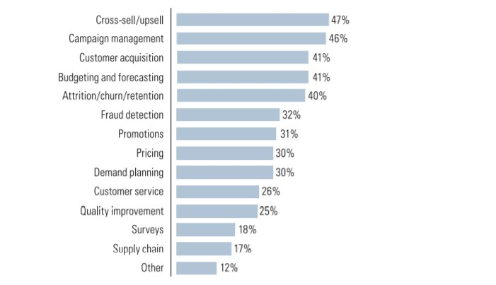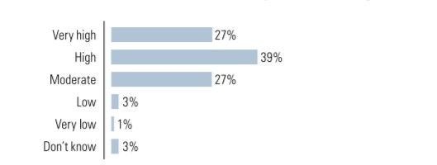
Figure 12-Business Value of Predictive Analytics
The papers of this level are highly speaking about the issue that is faced during the predictive analysis methods such as the sampling, accuracy improvement, and decreasing the error rates. The major part of predictive analytics is dependent on the mentioned methods to derive the best outcome.(Hastie.et.al,2003) states that misspecification of the model, randomness in the model even after the model is specified accurately, and sample size that is being used constitutes the bias measure.
It is observed that feature selection plays a very crucial step while developing a predictor. As the noise in the variable increases, the accuracy decreases, and it may lead to overfitting. It is challenging to select an accurate model from numerous available models. It is also essential to assess the error rate of the chosen model(Molinaro,2005). It is also observed in the paper that the ratio of the sample size and noise ratio profoundly influences the resampling methods. The sample size and difference among the resampling methods are inversely proportional.
Knofczynski & Mundfrom(2008) papers dealt with the issue of the sample size. It tried to figure out the minimum sample size that is required for the model with multiple scenarios by varying the correlation between the predictor variable and the criterion variable. It is observed that there is a relationship that exists between the size of the sample and the squared multiple correlation coefficient.

Papers |  | Description
Boonsiritomachai.et.al (2016) |  | Paper describes the predictive analytics. Its definition, applications, and business values trends and the process of predictive analytics.
Hastie.et.al(2003) |  | The description of the predictive analysis of how accuracy can be increased, and an error rate can be decreased.
Molinaro(2005) |  | The study was on the feature selection; the model is selected and its predictive assessment. It also estimates the error rate when a feature is selected.
Ljung(2002) |  | Paper aims at the study of fundamental properties of Prediction Error Methods, which is highly applicable for the wide variety of structuring a model.
Knofczynski  Mundfrom(2008) | & | Describe the relationships that exist between sample size and the correlation coefficient.
Rodrı´guez.et.al(2010) |  | This aims to look at the variance of how the K crossvalidation is sensitive to the training set.
Adra(2016) |  | Extensibility and reusability of the model being used when the predictive analysis is being done with real-time data
Burman(1989) |  | Study of the concept of the v-fold cross-validation and the repeated learning and the testing method.
Breiman(1984) |  | It is the analysis of the classification and regression models and their accuracy.

The error rate analysis is vital for model selection. Rodrı´guez.et.al(2010) dealt with analysis in bias, variance, and statistical properties of the K-fold Cross-validation. It is observed that it would be good to use a less biased error estimator for measuring the least error rate. Breiman(1984) talks about the issue of pruning a tree and getting an accurate estimation of the misclassifications. Cross-validation is very expensive in practical problems(Burman,1989), from his study, it is observed that the v-fold cross-validation reduces the cost issue of cross-validation. It is observed that the bias and variance value get decreased when the value of 'v' increases; the bias of the model depends on the ratio of the test set and the learning set.
It is essential to understand the issue that comes with real-time data. The real-time data is taken such that it should not affect the validity of the model that is used(Adra,2016). It has been observed from his research that real-time data will maximize the effectiveness of the operation and even improves the delivery time of the organization.
The observations of this level include how the accuracy of the model is to be increased, and the error rate is to be decreased with the model on a selection of the methods.
2.4.3 Level 3 :
This section deals with papers that have researched a prediction of discrete or continuous values. This section has the least number of papers associated with it. The level generally looked at the issue of the prediction of the value of an item for sale. The eight papers referred to different types of predictions and multiple ways to approach the problem statement they mentioned.
Geng.et.al (2011) tried to address the car sale prediction with the idea of Particle Swarm Optimization. The method proposed helped in finding the optimal values for the parameters in SVM. It is observed that the model solved the problem of the overfitting and gave the least Mean Absolute percentage error.
The e-commerce norm had a high effect on the image of the sales(Chen.et.al,2018).The prediction of the sale using the product image of the study performed. The feature visualization, a seller, can determine which of the feature is correlated to the higher price.
Limsombunchai(2004)researched on the prediction of the house prices with the Neural network and hedonic price models. The comparison of the model proved that the Neural network gave a more accurate result over the other model. It is observed from the study that the lack of real-time data was an issue of the result. The real-time data will perform differently compared to the pre-recorded data.
Internet Word of mouth is a factor that severely affects the sales in e-commerce(Chiu and Shu,2017). It gave the idea that sales are also affected by eWOM. Kejela.et.al(2014) studied with real-time data; it is observed that the gradient boost model(GBM) outperformed the general linear model(GLM). The error distribution in GBM is very less compared to GLM.

Papers | Description
Geng.et.al (2011) | The paper describes the car sale prediction with the particle swarm optimization and how it helps in prediction.
chen et.al(2018) | The paper describes the prediction with the help of product Images and how it affects sales.
Limsombunchai(2004) The research aimed to predict the house prices with multiple algorithms and to compare the results of the multiple models

Chiu and Shu(2017) | This shows the customer behavior in e-commerce sales with the internet word of mouth and how it affects sales.
Kejela.et.al(2014) | The study shows how a machine learning algorithm would give an accurate prediction for both continuous and categorical variables with the help of real-time data.
Markou.et.al(2018) | The demand prediction of taxis with multiple models with the data from the web at regular traffic hours.
Huang.et.al(2015) | The study done with the trigger model over a single model in ecommerce. It focusses on forecasting a sales with high effectiveness and high accuracy.

2.4.4 Level 4 :
The level contains the papers of similar research conducted by other researchers. All the paper contributes to the details of the researches conducted with multiple models. This level gives an in-depth idea about the prediction of the used car values. The primary issue that researchers dealt with at this level was data availability. The researchers used data from multiple online sources and the paper which was already existing.
The objective of the research conducted by each contributes to the automotive industry for predicting the nominal value of the used car, which would help the customers. Voß and Lessmann (2013) in the research discussed the increasing competition in the market, which led to a decrease in sales. They proposed a well-versed prediction of sale value with the car functions and other values. There were 18 models used by them for the prediction and got a result with the linear model that has less significance than a random forest and ES model. The study conducted by Ozer and Omer(2019) made predictions with normality test, analysis on correlation, and linear regression. The data was taken from a different period, and it is observed that the value change in the variable had a significant effect on the sale value. Thus we can conclude from his observation that the variables had a significant effect on the models.
Khitij.et.al(2019) used six algorithms for the prediction. The tree model chosen for the prediction did not perform well due to the linearity in the dataset. The concluded with the result of overfitting in tree and outperformance of the ensemble model used. Puteri and Safitri(2020) made a prediction with the linear regression. They made changes in the values of the price and tried different predictions. There were significant changes observed when the value of the car was predicted. It can be observed that the logarithmic value or any other processed values can give a better accurate result than the normal price value in the data set.
Papers | Description
Voß and Lessmann (2013) | Study based on the competition in the market that reduced the marginal car sale. Used 18 models for the prediction.
Pudaruth(2014) | Prediction of the used car after the lease period. The methods used were Multiple linear regression, KNN, Decision Tree, and Naïve Bayes. Data was collected from a daily newspaper.
Ozer and Omer(2019) | The prediction of the used car was made with linear regression on ikinciyeni.com data.
Gegic, E .et.al(2019) | Prediction with Neural network, support vector machine, and random forest model. The data was taken from autopijaca.ba
Puteri and Safitri(2020) Prediction of used car value in Indonesia. Uses Multiple linear regression—obtained data from www.mobil123.com.

Khitij.et.al(2019) The used car worthiness depending on factors such as make, model, year. The study used Linear Regression, Gradient Boost, Random Forest, XGBoost, KMeans + Linear Regression Ensemble, Light GBM. Data obtained from Kaggle.
Ho and Wo(2012). | The aim was to make a prediction based on the price as a categorical value. Used Support Vector Machine and logistic regression for prediction.Obtained data from Kaggle.
Pal(2018) | The prediction with a random forest tree was made on the data from the Kaggle.
Gongqi.et.al(2011) | The research aimed to predict the residual value of var with various conditions using BP Neural network and non-linear curve

There exist a trend of selling the car after the lease period. Pudaruth(2014) tried to predict the values of the cars after the lease period. The research was done with Naïve Bayes, Decision tree, KNN, and multiple linear regression. He derives that the correlation between the price and mileage is high. The high correlation between price *year and a very weak positive correlation between the cylinder value * price.The price as categorical value prediction was done by (Albert Ho and Alice Wo,2012). The result obtained by their study was in contrast to the machine learning output; the balanced data set did not perform well. It is observed from his prediction that the data normalization, using of F1 score, Auc, and boosting was beneficial for prediction. Gegic E.et.al(2019)used Artificial Neural Network, SVM, and Random Forest, model. The research applied on three categories of data as cheap, moderate, and expensive data. The study draws a conclusion of the consumption of more computational resource for the method used than a single algorithm in Machine Learning.
Gongqi.et.al(2011) researched the residual value prediction with the BP neural network and non-linear curve. The result of the research was obtained as a curve. The proposed model by the researcher could obtain an accurate and convenient model with a residual value of the used car in various conditions. The prediction with the random forest was used by Pal.et.al(). The research could produce an outcome with good accuracy compared to the related works that used the same data sets. The common problem of overfitting in the tree was overcome in this study by averaging the predictions of each tree and hence reduced the variance and product consistency.
2.5 OUTPUT OF THE REVIEW
The used car value prediction is a complex process as the value of the car may not be fixed as any other product. It may vary from a country to another country, a region to another region. The result obtained may depend only on the limited data that is used during the prediction time. The use of the different variables, methods, and periods mat result in differences in the analysis result. The outcome of the review includes challenges in the Prediction, Business values of the predictive analysis.
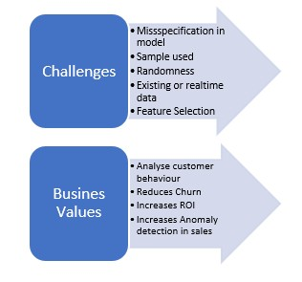
Figure 13-Output of review
The challenges in the prediction include the misspecification in the model due to any bias. The sample size is another criterion that profoundly affects the prediction. As the size of the sample is smaller, the bias will be higher. Randomness in the model can affect the error in the Prediction (Hastie,2003). The data selection for the prediction profoundly affects the prediction. The existing data prediction gives the prediction based on the data that is prerecorded the real-time data has the current market data, which is more tend to give the accurate result, but there are chances that real-time data can disturb the validity of the model(Adra,2016). Feature selection is a crucial step in the development of class prediction. It should be chosen such that the variables are not noisy, affecting the accuracy and leading to overfitting(Ransohoff, 2004).
The business values produced by predictive analytics using machine learning is very high. The specific case includes customer behavior prediction. This would help to understand the behavior and improve the sale. The reduction in the churn rate is highly improved by the prediction. The ROI of the company with prediction has a higher ROI. It also helps to increase the prediction of the sales anomaly rate helps in the improvement of the sales.
Multiple types of research were conducted in the case of the prediction of used car values. The reviewed researches used the pre-existing data from multiple sources. The price of the car is highly dependent on the time and the variables used for the prediction. The pre-existing data that is available for the prediction may not give good results for the research as they are prerecorded and may not be related to the current situation in the market. It would not give the best result and affect the computation. The proposed study and the research of the real-time prediction of the used car values use the current data that is web scraped from dubizzle, which has the current value of a car in the market. The data is chosen such that it takes the brand name and model and model name and scrapes the data depending on the data given by the user. The research would bring in good results in the pricing of the car for sale to the end-user.

3: METHODOLOGY
The Proposed Research of prediction of used car values mainly focuses on predicting the values based on the predictive algorithm. The research intends to focus on the aim and objectives described. The aim primarily intends to predict the value, and the objective revolves around the successive application to complete the aim. The objective of the research raises the research question of how data dependency is associated with the outcome. The core of the research is based on predictive analytics with multiple algorithms to model. The model is hence compared to choose one that has less error and best accurate to build the product.
The research started with data extraction using R codes. The research uses multiple tools such as rapid miner, Jupiter Notebook, Tableau. It was followed by an understanding of researches conducted by other researchers. A deep understanding of the methodology that other researches had used was studied, and the methods were selected. Post selection of the method followed the study regarding data. Comparing different papers regarding the data used for the modeling was taken, and could see that all of the researchers conducted the studies based on the pre-existing data. The proposed research was not based on heuristic thinking of pre-existing data instead considered it the black space between the existing research and proposed research. The proposed research is based on the live data depending on the input. Data extraction was followed by the data understanding using Tableau and then modeled using R codes and packages. The rapid miner tool was used to make an auto model for multiple models to see the error rates and accuracy developed by multiple models.
3.1 DATA EXTRACTION :
Data, a critical element of Machine Learning, plays a vital role in the modeling. The data selection and extraction is very crucial. The dependency of each variable and its correlation is vital to the predicted value price; hence the proposed research uses live data rather than previously recorded data.
The data extraction is done on live scrapping based on user input. The data was scraped from dubizzle.com. The data scraping was done using the RVEST package in R. The rvest package helps extract the text data from the HTML page using the HTML tag and HTML nodes. The HTML page consists of multiple pages with multiple brand and model car details. In order to extract data from multiple pages, we use the package called PURRR. For an accurate prediction, the data set should be scrapped so that scraped data only has the data of the same brand and model that the user has input. The steps followed for the scraping include:
1.Getting the generalized URL for the page with the same modeled car The data is scraped from the particular page with multiple cars.

2.Get the HTML for the webpage that is needed to be scrapped.
The scraped landing webpage has limited availability of the data. The central data is available on the landing page; hence to get the detailed data of the particular car, it is needed to redirect to the detailed page of each car and get the details. Hence from the landing page, all the reference links are scraped using the HTML NODE class name and stored in a data frame for the mentioned number of pages.

3.The extracted links of all cars stored in the data frame are taken one by one and select the HTML tag and HTML Node to be scraped and stored back in the data frame.
The 'mapdf' function of the PURRR package helps in parsing the multiple pages and hence scraping the data from multiple pages.
3.1.1 DATA PLATFORM
The proposed research chooses dubizzle.com as the data platform. The scraping mentioned is done in the dubizzle data, and it is stored for the modeling. There are multiple other data platforms available such as Yalla motors, sellanycar.com.The data can also be extracted from that site.As the data platform changes, the data format changes; Hence only one source can be used at a time. The proposed research has chosen the mentioned data platform because, in comparison with multiple other sources, the data available of this source was high, and the meaningful data for the prediction with more data variables were available here.
The HTML Extraction code attached in Annexure 2
3.2 DATA :
The scraped data consist of 14 variables Description, data types, and possible value of the data as mentioned below:
VARIABLE NAME | DESCRIPTION | POSSIBLE VALUE | TYPE
Lr | The web scraped links from the model car's landing pages, and the link is used for scraping the details.
year | Model Year of Car | 1990+ | int
mileage | Kilometers Driven by the car | 0+ | int
color | Colour of the car | Any color | Char
transmission | Transmission Type of the car  (Manual, Automatic) | Automatic or Petrol | Char
spec The country of GCC, European, Char
Manufacture Japanese, American,

Others
bodycond | The interior and external Body condition of the car | Perfect inside and out, Normal wear & tear a few issues, No accidents, very few faults, A bit of wear & tear, all repaired, Lots of wear & tear to the body | Char
mechcond | The mechanical condition of the car. Mention if any mechanical issue associated with the car | Perfect inside and out, Minor faults, all fixed, Major faults, all fixed, Major faults fixed, small remain, Ongoing minor  & major faults | Char
body | The type of car | Coupe, Crossover, Hard  Top Convertible,  Hatchback, Sedan, Soft Top Convertible, Sports | Char
 |  | Car, SUV, Van, Wagon, Other
warranty | If there exists any warranty for the car | Yes, No, Does not Apply | Char
trim | Mentions the number of the door | 2,3,4,5 | int
cylinder | Number of Cylinders | 3,4,5,6,8,10,12,Unknown | Char
fuel | Fuel type of car | Gasoline, Petrol, Hybrid, Electric | Char
seller type | Type of user who posted the advertisement if an owner or a dealer | Owner, Dealer,  Dealership/Certified PreOwned, Unknown | Char
price | Price of the car | 0+ | int

The data variables type and the possible value taken by them are shown. All the possible values expected are mentioned. The values are given a list of drop-down for the users. The list of data scraped from the dubbizle has mentioned has only these values.
3.3 DATA PREPARATION
3.3.1 Data Cleaning:
The data cleaning is essential because it identifies and removes the errors and duplicate in the data to get reliable data. The cleaning method would improve the quality of the data to be trained and enable us to get accuracy in decision making.
The data extracted shown above listed. The user is expected to input all the variables as user input. The user selects the value from the drop-down list. Since the user is given the option to select from the drop-down, the possibility of the data entered by the user to be wrong does not exist. Since the scraped data has only given values available rate of error possible to happen is significantly less.
The extraction of data was not post stored and processed since the data extraction and modeling takes place simultaneously. Hence the cleaning was done simultaneously along with the extraction and then stored to the data frame. Since the data extracted only has a fixed value, the possibilities that can happen is the error in the text extraction of the HTML. Possible data cleaning ways are as follows:
1.The error in the scraped data during text extraction
VARIABLE NAME | Scraped Value | Cleaned Value
mileage | “\n \n \n 66,000 \n” | 66000
colour | “\n \n Black \n” | Black
bodycond | “\n \n No accidents” | No accidents
mechcond | “\n \n Minor faults\n” | Minor faults
trim | “\n \n 4+ door \n” | 5
cylinder | “\n \n \n 2 \n” | 2
fuel | “\n \n Gasoline \n ” | Gasoline
seller type | “\n \n Owner \n” | Owner
price | “\n \n AED 99,000\n” | 99000

2.There can be chances that certain values in the html page can be unfilled.
If the html accessed is null it can lead to break of scraping due to the empty value. It is cleaned by forced adding 'NA' Value to empty column.
3.The 'NA' accessed from page.
It can be removed by removing those rows with empty rows using
4.subseting the data set to remove lr from the data set, which is of no use.
3.3.2 Data Pre-processing:
Data needs to be pre-processed to get accurate type of data. The extracted data, in default, have the data type depending on the type it was extracted. The default data type may not give the exact meaning and value to it as it is intended; hence the variable has to be changed to the exact data type it is intended to be. The exact data type improves the accuracy of prediction.
VARIABLE NAME | Old Type | New Type
year | Int | Numeric
mileage | Int | Numeric
color | Char | Factor
transmission | Char | Factor
spec | Char | Factor
bodycond | Char | Factor
mechcond | Char | Factor
body | Char | Factor
warranty | Char | Factor
trim | Int | Factor
cylinder | Int | Factor
fuel | Char | Factor
seller type | Char | Factor
price Int Numeric

3.4 DATA ANALYTICS PIPELINE
The pipeline will automate the workflow.
Advantages:
Flexibility: Computation is made easy by each module. Change to one module can be made without affecting the other module
Extensibility: Easy to make new functionality
Scalability: If any part occurs in any issue, it can be possible to scale them separately.

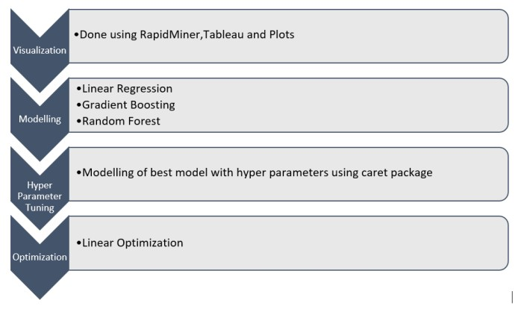
Figure 14:PIPELINE
3.4.1 VISUALIZATION
The research models with three algorithms. The algorithms are chosen depending on the performance marked by the others in the literature review conducted. The research is based on the prediction of used car value. Hence the dependent variable is the price, and independent variables are year, mileage, color, specs, warranty, body, bodycond, mechcond, fuel, trim, cylinder, seller_type, and transmission. Hence there are one dependent and 13 independent variables. The study for the variable is based on data input given FORD EXPLORER. The data structure is as follows.
3.4.1.1 Data Visualization:
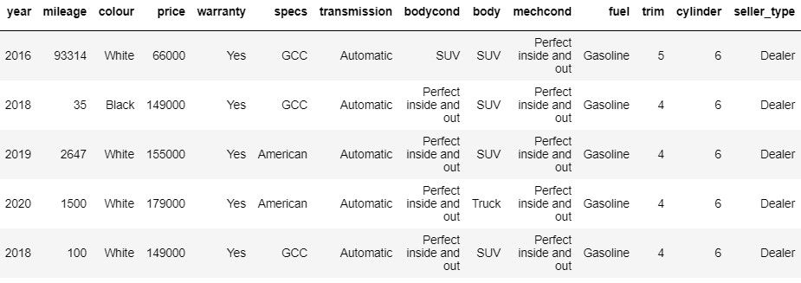
Figure 15: Data Structures

Correlation factors help us to analyze the dependency relation of variables with each other. The variables are converted to numeric to graph the relationship with other using fit_transform in python.
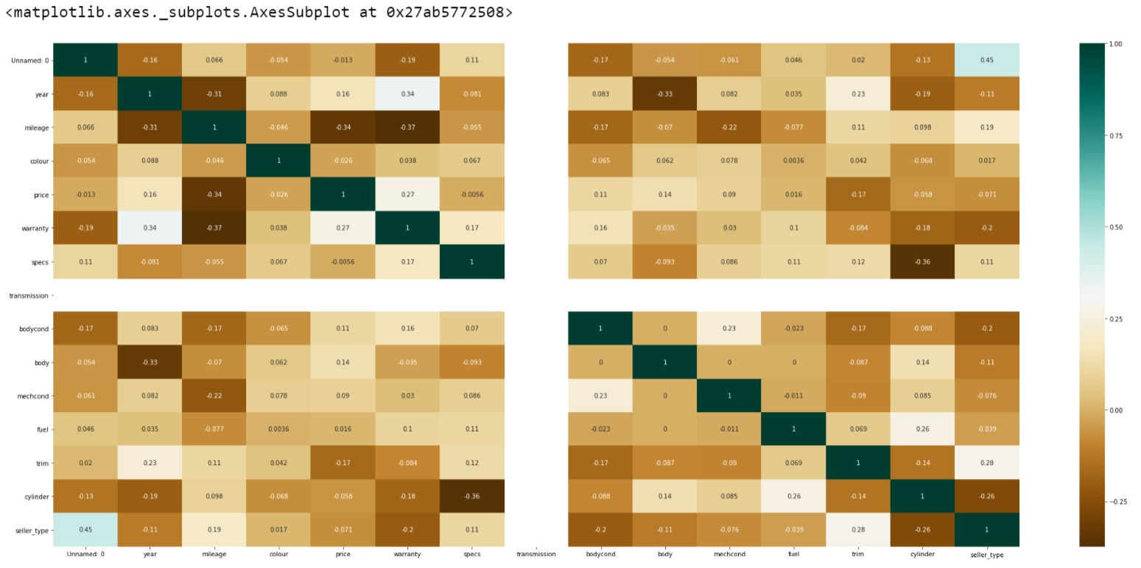
Figure 16:Correlation Plot
From the plot, we can gain information such as
- Variables are not very highly correlated; hence it is suitable for using the modeling.
- Highest correlation variable with the price is mileage(-0.34).There exists a negative correlation with mileage; hence, as the mileage increases, price decreases. 3. There exist a small negative correlation(-0.37) between warranty and mileage.
4.Correlation of 0.34 exist between warranty and year. It implies that the older the car, the warranty does not apply.
5.Warranty and price have a positive correlation. The cars with a warranty have a higher price.
6.Year and mileage are positively correlated. Newer the car Mileage is less .There can be a case of vice versa; hence the correlation value is less.

The below image is extracted using the missingno package in python and helps locate any missing values in data, and hence it is clear that the data set does not have any null values. This helps us to confirm that the pre-processing step has removed any null values if it existed.
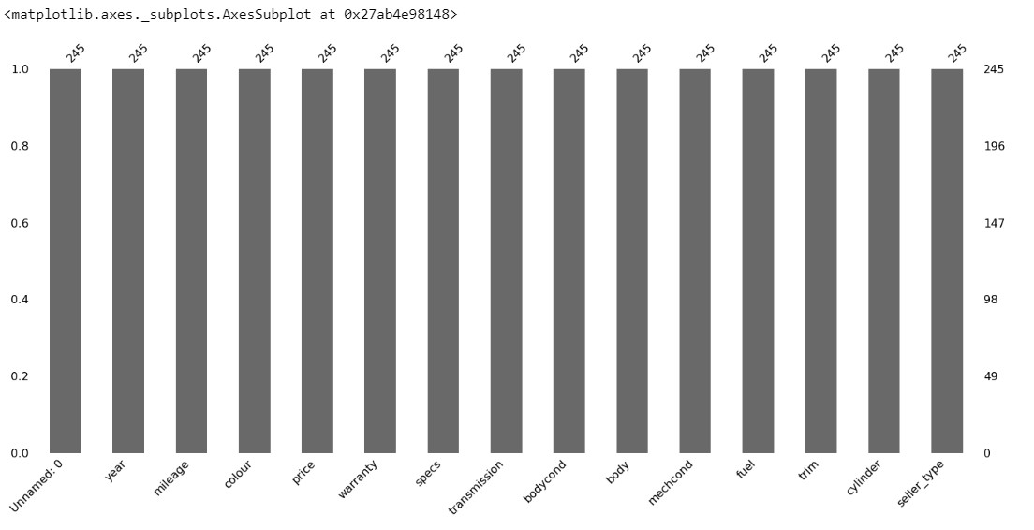
Figure 17:Missingness
Let us look at the variables to see how the values are distributed in the data.
Dependent Variable:
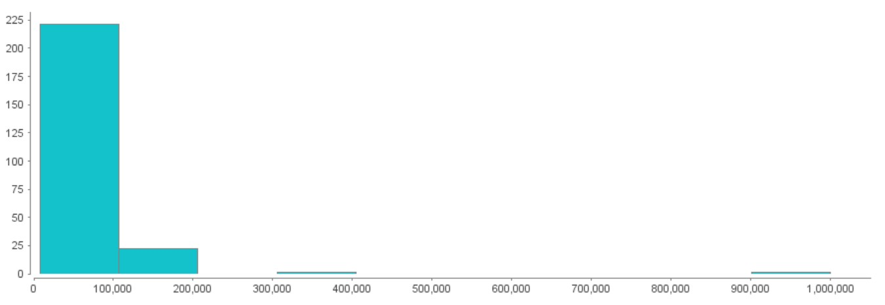
Price

The dependent variable price is distributed, as shown. We can see that there exists 1 data value of price 1,000,000 AED, and it cannot be an outlier. The data input value of 1,000,000 to be bid for ford vehicles is very rare, and hence it can be considered false data. The value range of the particular car lies between 0-200000 AED. The data of 3,00000 can also be false data.
Figure 18:Percentil 95
The percentile graph of the price variable proves the mentioned data are false data. The 95 percentile value of the price is 149000. There can be a possible chance of rare higher prices; hence any prices above percentile 95 + 25000 AED can be considered false data and can be removed.
Independent Variables:
The independent variable distribution graph helps us understand how the independent values are done by transforming the categorical data into categorical values.
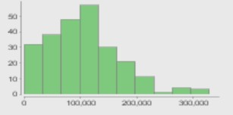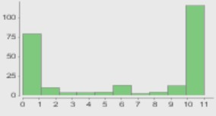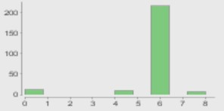

  Mileage
  Colour |  | Cylinder

1.Mileage distribution shows that most of the selling cars are in the range of 100000.
2.Colour distribution shows that specific colors are prominent in cars
3.Ford explorer mostly comes in 6 cylinders. Similarly the distribution will be different brands.

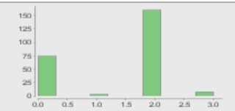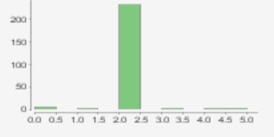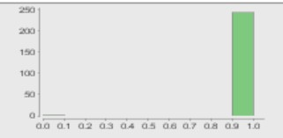

Seller Type |  | Body |  | Fuel

4.The owner and dealer based sell more.
5.Most of the Ford explorer comes in SUV type.
6.The Fuel is Gasoline

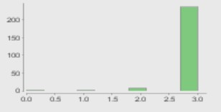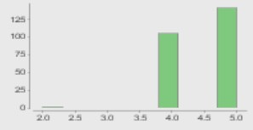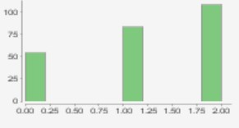

Mech Condition |  | Trim |  | Warranty

7.Most of the cars are of good mechanical condition
8.Most of the Ford explorers are 5 or 4 doors.
9.There can be cars with warranty and without equally available in the market

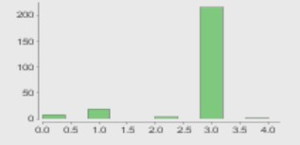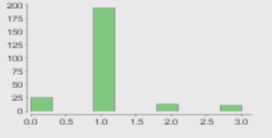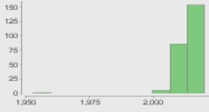

Body Condition |  | Spec |  | Mech Condition

10.The perfect body condition cars are more in the sales for the market. However, mechanical condition distribution shows that there can be a variable kind of mechanical condition. It implies that the car comes to sale with an excellent outer appearance but may have some mechanical issues.
11.GCC vehicles are more in the market.

The relation between Dependent and Independent Variables:
The below images depicts the relation between the
(a)certain variables with sum(price)
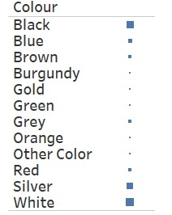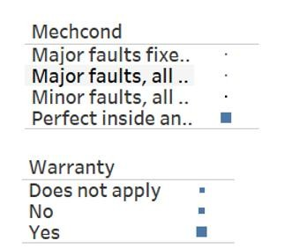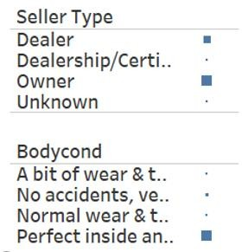
Figure 19:Sum(Price) vs. Variables
1.The visualization between variables and sum (price) .This helps us understand which variables are more prominent in sales of the car.
2.The color variable shows that White, Black followed by the silver colors are the color of the car that are mostly available sales. It proves one of the assumptions of the car sale that we have.
3.Perfect mechanical and body condition cars are the highest in the sales market. 4The sale type of car usually comes by owner and dealers. A high percentage of cars have a warranty

(b)certain variables with Median(price)
Let us now draw the inference on the price with regards to a few variables. For drawing inference, we use the median of the price so that we can see how variable types are affecting the price
1.The sales market has more cars of color White, black, and silver, but the price of rare colors such as burgundy has more median (price).This is because the prominent colors have the price value spread on the range whereas rare colors come with more price and few numbers.
2. Price concerning the body and mechanical condition is evident that vehicle with nofault and minor faults has a higher price; hence the assumptions come true.
3.Price of a car with a warranty is more.
4.Seller type with owner and dealer has higher sales, whereas Dealership/Certified was less compared, but the price of Dealership and Certified is more. It can be because of the varied price range in a car similar to the color, and the dealership charges the seller more cost for the profit and charges more. Hence the sale price is higher.
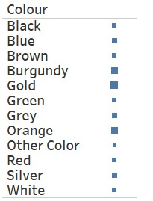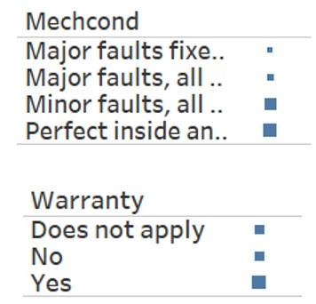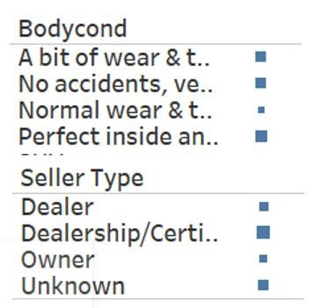

Figure 20:Median(Price) vs. Variables
(c)The relation with sum(mileage) and sum(price)
Most of the graph and assumption talks about the correlation between mileage and the price. The correlation index of the negative value indicated an inverse relation between Mileage and Price.
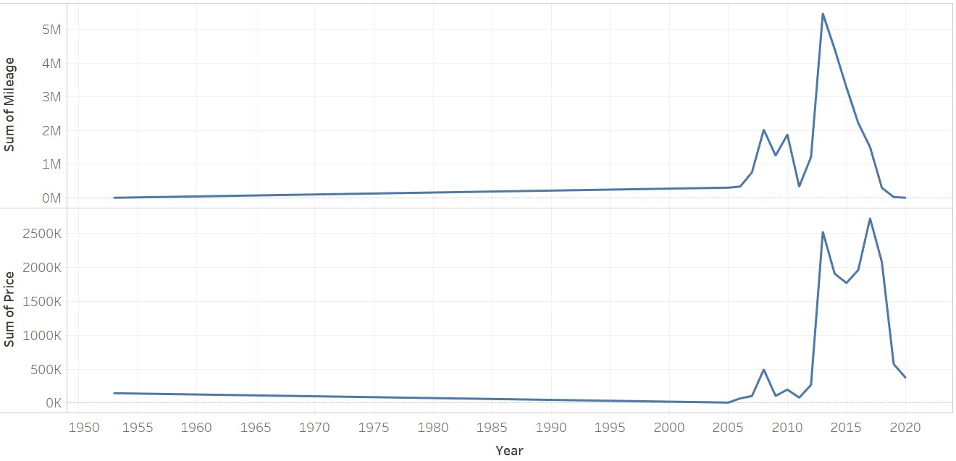
Figure 21:SUM(Price) Vs. SUM( Mileage )
The sum of the mileage and price graph shos the same rice pattern as it is the calculated sum. There was a fall in price post-2014 due to oil price reduction.It severely affected the market, which led to a drop in the graph of mileage from 2014. If we consider the median price and median mileage, we can see that the inverse relationship between the mileage and price is apparent, and they inversely draw a similar pattern. Hence it is visible the relationship of price to mileage.
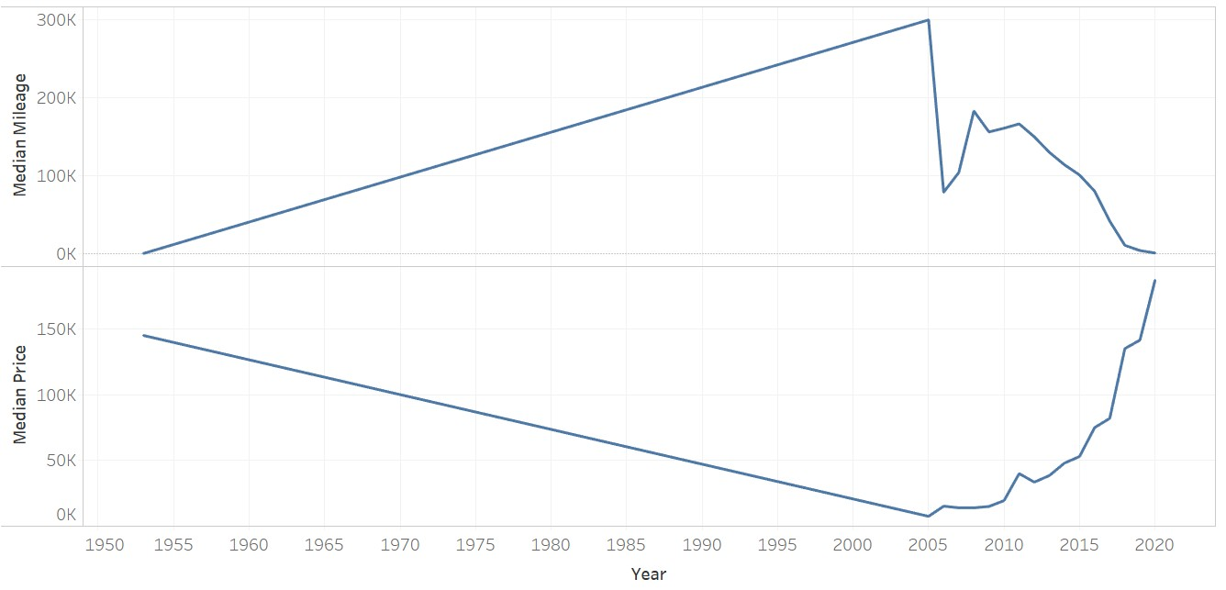
Figure 22:Median(Price)vs Median(Mileage)
Let us look at different models expected to perform well-chosen through many studies conducted.
3.4.2 MODELLING
3.4.2.1 Linear Regression:
Linear Regression(LR) is one of the most accessible models that takes the least time to execute the models. It can be used as a baseline model for comparison with the other models. Linear regression is models with all the data variables to obtain the summary to see which variables fit best for the model. The linear regression's primary aim is to estimate the values of the parameter based on the data.
LR is applied to the data set in three types of data split for test and train.
The data found as false data was removed in the data cleaning, and it and other pre-processing parts are done so that it is good enough to be used for modeling.
The initial modeling started with inserting all 13 independent variables and price as the dependent variable. The correlation coefficient computed has shown that the variables do not have a strong relationship with the price, and mileage and year are inversely related.
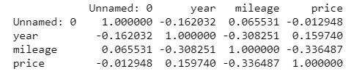
Figure 23:Correlation value
The below graphs show the data distribution of price vs. year—this graphical representation has false data.
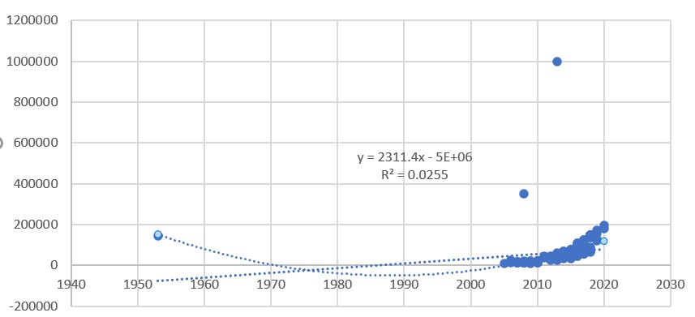
Figure 24:Regression Curve of Price vs. Year
The below graph depicts the relation between the independent variable mileage and year with the dependent variable price. The plotted graph shows that they do not have an entirely linear relationship. The false data in graph1 was removed and obtained a new graph to obtain consistency and more linearity. We can see that the R2 value changed from 0.02 to 0.66.

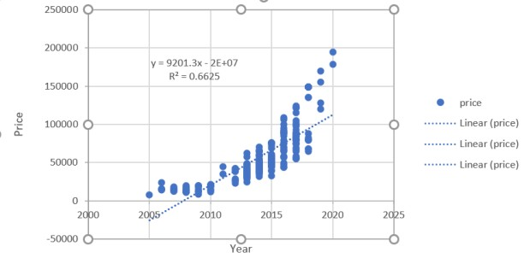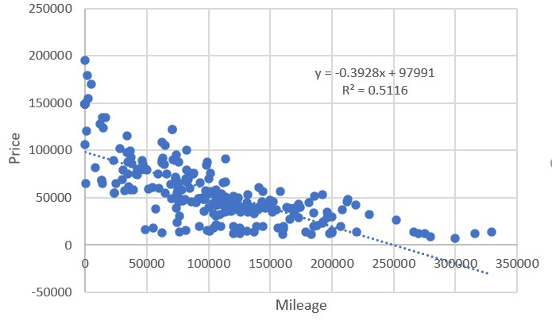

Figure 25:Regression Plot Year and Mileage Vs. Price
The logarithmic value of the price is considered to increase the linearity and R2 value. The result was studied.
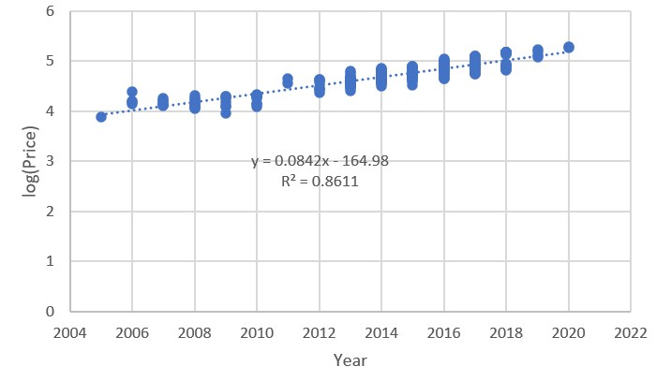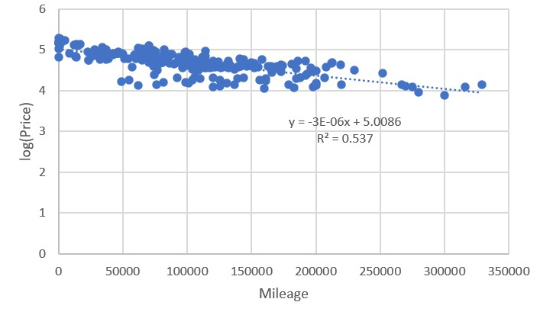
Figure 26:Regression Plot Year and Mileage Vs. log10(Price)
There was a massive changed result obtained. The year vs. price graph turned to be linear, with an increase of r2 value from 0.66 to 0.86. The mileage vs. price graph had an increase in the value of r2 from 0.53 from 0.51. The distribution got narrowed and got more linear.
After removing an outlier, the model can be considered a base model; the logarithmic value of the price is taken to be the dependent variable. The model is built on three variants of data set to see the performance
Let us now remove the particular variable with the least importance and do the modeling to see the modeling's characteristics. The variables such as mileage, year, trim, warranty, mechcond, bodycond, body, and seller_type are used for modeling.
The result is obtained based on the actual and predicted Mix Max Accuracy, MAPE(Mean Average Percentage Error), and AIC(Akaike's Information Criterion), which define the fitness of our model from the data it was generated. A comparison of actuals and predicted are made based on the standard deviation of predicted and actuals. MAPE is expected to be the least possible, and AIC should lie between 2K – 2(log-likelihood); hence value should be as least to 2k.
The result obtained was compared with the baseline model and the model with logarithmic price values. The result of all the three models has been analyzed and studies. The results are now stored to compare with the other models. 3.4.2.2Random Forest:
The random forest model, also called a Random decision forest, belongs to an ensemble method. It can be used for both regressions as well as classification problems. This method was developed for the problem of overfitting. This model was applied with data as in linear regression to test the accuracy of the prediction. The random forest model is one of the meta estimators that can fit multiple decision trees on the samples and uses the averaging to control overfitting and improve the accuracy. The random forest model has the main advantage of improving the bagging as it can correlate the tree by introducing the splitting based on a random subset of the variables.
The variable's importance is one of the significant factors in random forest modeling. Let us look at the variable importance of random forest modeling. Hence compare the feature importance to see the index value of feature importance with node purity and MSE.
The node purity, which is calculated base on the Gini index impurity, is a measure of the probability that a variable wrongly classified when chosen. The higher the node purity value, it decreases the Gini score, and the higher would be the variable importance. Hence we can see the essential features that can be used. The features that can be used in primary are mileage, warranty, color, trim, fuel, specs, body, cylinder.
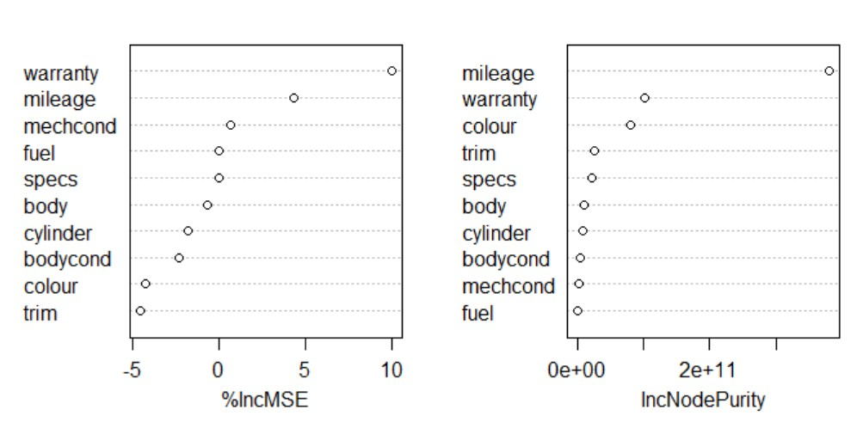
Figure 27:Inc MSE and Inc Node Purity Plot
The features are now given the model based on the three splits as similar in linear regression. Unlike the linear regression, the random forest differs in the way of creating model and prediction. The random forest runs multiple trees that are independent of each other tree. The random forest is run with tuning based on the three splits mentioned and tries to get the best possible 'mtry' parameter value possible. It is the number of the variables that are available for splitting at the node. The fitting tris to run for multiple trees and tries to get the best mtry parameter available, and hence it is fed to run the prediction model.
The evaluation factors for the random forest tells if the value of the model fit the prediction. The model given is evaluated using the MAPE, AIC score, Min-max accuracy, comparison of the actuals and predicted, and the RMSE value. The random forest is run on the R with the package called 'RandomForest.' 3.4.2.3 Gradient Boosting Model:
Gradient Boost model(gbm) is being used in the proposed research to gradually and sequentially train the data.The customization depending on the needs of the application, can be done with the loss function. This model will continuously work on the error fitting and allow the user to experiment with multiple models. The implementation comparing to the other model is easy, and the training time is less for gbm.
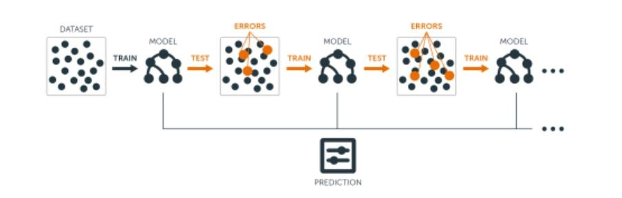
Figure 28:Gradient Boost Model
The modeling is done based on the data set with three splits as similar in other models. The package required for the gradient boosting model to run is gbm.T he gbm model feds the parameters such as
n.trees: the number of trees to be fit interaction. Depth: Control the complexity in the boosted ensemble.
Shrinkage: reduces the learning speed to reduce the impact of any unstable regression coefficients.
distribution: distribution of the variable
The gbm model requires the gbm library. Initially, the formula which specifies the dependent and independent variables are given. The distribution for the response variable is given. Here we consider the Gaussian model to get the squared error. The data specification then follows it, and other parameters such as n.tree, default value considered is 100. ntree value is tested for various values to find fitting of each tree and best is selected. We also provide the interaction depth to specify the depth of tree and shrinkage for the learning rate as it can reduce any impact of additionally fitted learners. It reduces the size of incremental steps, and hence penalizing the vitality of every consecutive iteration.cv folds criterion is added to remove the early stopping in gbm. Method argument specifies the technique that is used for deciding the optimum number of trees. The method used here is cv.

The gbm model is evaluated using the error rate. The gbm package, which has default gbm.perf(), is used in evaluation in finding the optimum numbers in the iterations. The accuracy measure, error rate(MAPE, MAE, RMSE), and actual and predicted comparison are also used to evaluate the model.

3.4.3 Hyper Parameter Tuning of Model:
The research now ran by changing multiple parameters with different datasets and different models. With the evaluation criteria, the models are compared with the baseline model and other models to see each's performance. Out of all the models, we can see that gbm with regular split gave the best accuracy and least error and gave good values for the other criterion. Hence, we perform the hyperparameter tuning on gbm to see the performance and choose the best possible values for which our model is entirely fitting.
The hyperparameter started with the tuning of the n_estimators and the learning rate. The n_Estimators were capturing the tree. It is tuned to reduce the computing expense and to increase accuracy. The R uses the trainControl function of the caret package for tuning the parameters. The train control output is given to the model as the argument for training—the hyperparameter tuning. The fitcontrol function has parameters such as method, which takes the method for tuning the optimum number of trees. The method used is repeatedcv as it can repeat the random sampling validation. The method argument gives the number of resampling iterations to be done. Repeats are used, as our method is repeatedcv. It says the number of the complete set of the folds. The classProbs is a boolean mentioning if the class probability is computed with predicted value in every sample. The traincontrol output is fed to train (), which does the hyperparameter tuning as the parameter to trControl.The other parameters for the train function are a method that describes which model is to be done. The gbm is our expected model, and we feed gbm to the method, and tune length is set for the number of levels for trying different parameter combinations. The higher the tunelength, the more combination is applied. We apply1, 5, and 10 as to compare the performance of tuned parameters.
3.5 PROTOTYPE OF THE END PRODUCT:
The research product is a web page that can be filled with the data as per the requirement. The user entry fields are given appropriate value for the selection depending on the data similar in the data plat form.When the user submits the data it is send as a request to the backend (Rcode).The backend code that we have generated is exposed as an API using plumber package which is then consumed by the UI and hence getting the output of prediction as a response.The response will be shown as the output in UI.
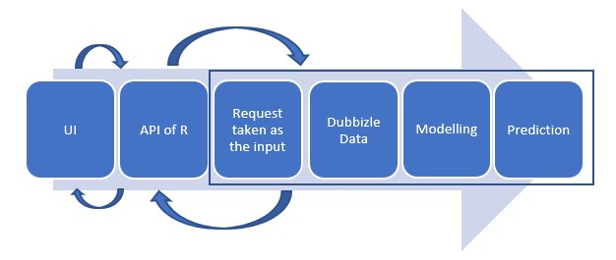
1.The user inputs the data sent to the backend (R Code) as a request through the API Exposed.
2.The request from the UI is taken as the input and fed the code the brand and model for scraping from dubizzle.
3.The scraped data is given for modeling using gbm model.
4.The prediction is done and result is send back to the UI as a response to the UI through the API exposed which will be displayed as the output.

4: RESULTS & FINDINGS
The predicted research was modeled on multiple algorithms to find the best model that can fit the data. The research looks at a good value for the results that are to be obtained from the models. Let us now look at the results obtained from different models.
4.1 PRE-PROCESSING:
One of the significant parts is that data processing is to find if any false data or outlier can happen in data. The real-time data can be very challenging. When considering data from a data source for car sales, it can be twice the error rate than other data as customers tend to bid any value for sale. Here we use the quantile function, which gives the percentile value of the cars. 95% of the price gives the value that the model can bid. However, there can be a chance that a particular buffer value more than the maximum value can happen. Hence we add 50000 along with the percentile value to make the range as the maximum. We can find two outlier values of 1000000 and 350000, which is a cost even higher than the new owner car.so we remove it as false data.
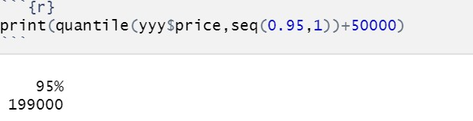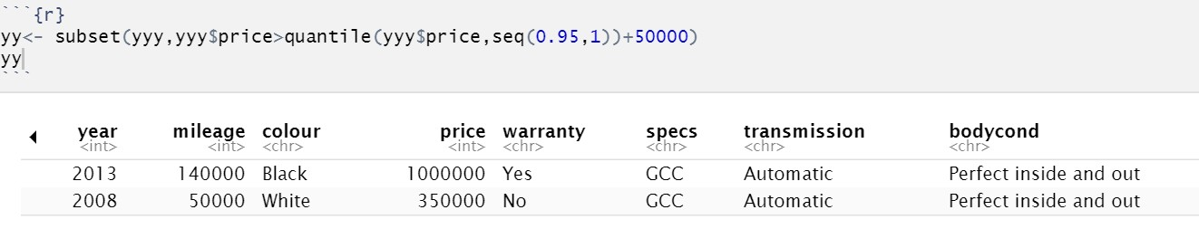

Figure 29:Removing Outlier
The Null values of the data are tested with complete.cases(). Our data proves to be complete without any null values.
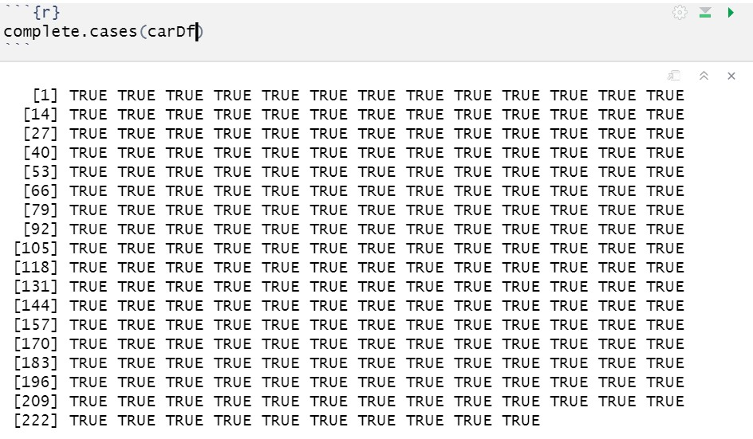
Figure 30:Null Check
The price value is distributed along with a long-range. The distribution of the variable is normalized. The logarithmic value is applied to the price variable. The regression graph in the above methodology firmly proves that price logarithmic value gives a more accurate prediction. The distribution of the price is shown below.
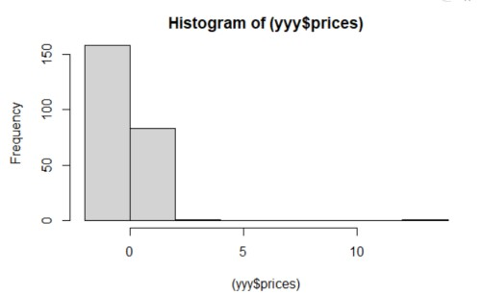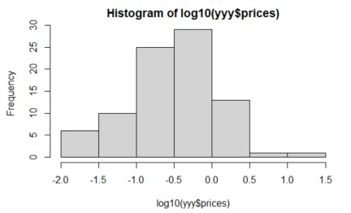

Figure 31:Price value Distribution graph

4.2 MODELING:
4.2.1 Linear Regression
The linear regression is the most accessible model in terms of runtime. Let us consider the normal data split value as the baseline model.
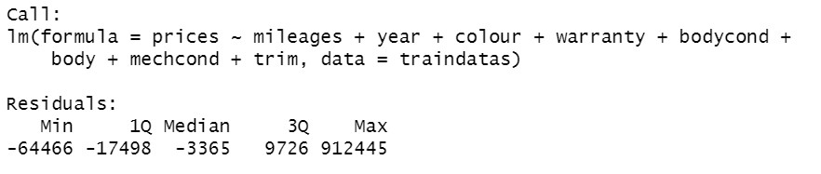

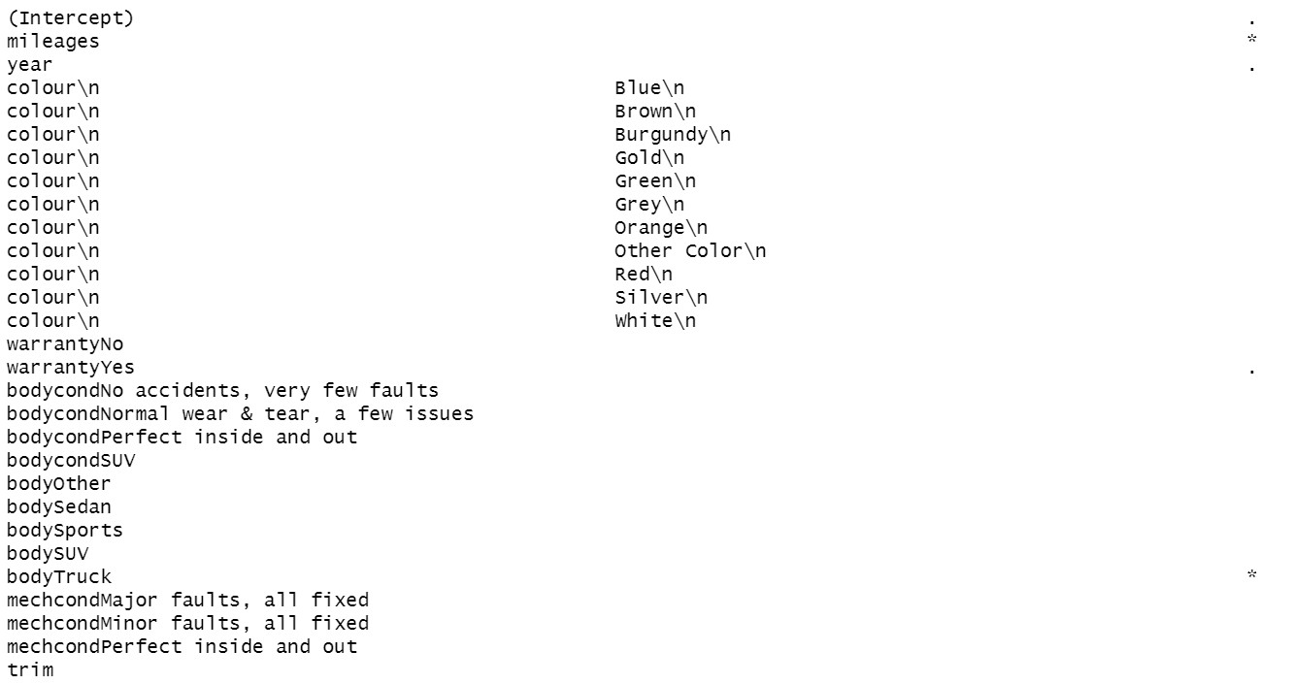

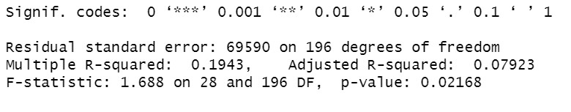
Figure 32:Structure of Linear Model
The linear regression baseline model ran with the data such as mileages, year, color, warranty, bodycond, mechcond, body, and trim. The model ran with all possible data variables. The variable transmission and seller_types are omitted as the transmission had only one value and seller_type had the value dealership/certified in very few numbers, resulting in an error of new testing variables. The residual error is the average distance that the value can have from the regression line. The value is 69590, which is very high. It is to keep to low as possible on 196 degrees of freedom. i.e, on 196 varying independent values, the residual error is 69590. The multiple R2 shows the correlation of the dependent variable with the independent variable. The value is expected to be more than 0.50. Fstatistic also compares the correlation of price with other independent variables.
The regression-based on the graph is shown below the year and mileage, two significant variables for the prediction. The above pictures depict the linear regression result over normal price values, and below depicts the variation over logarithmic. The year variation of the regression graph performs well with the log value of the price.The variation is still high
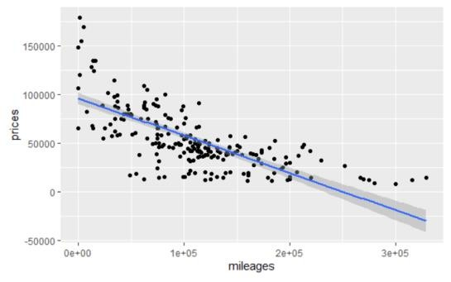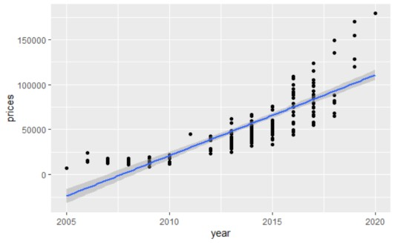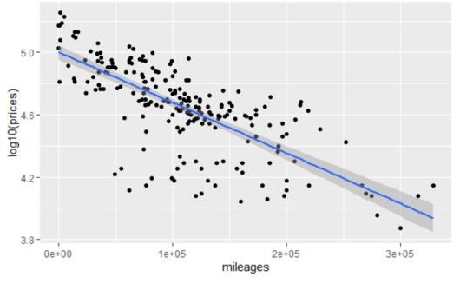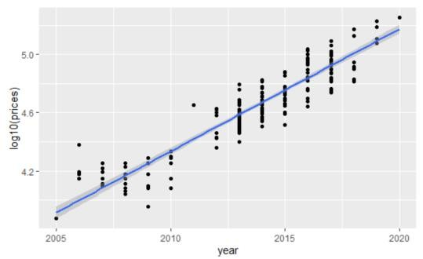

Figure 33:Regression Prediction Plot
The prediction with normal value varies as follows.
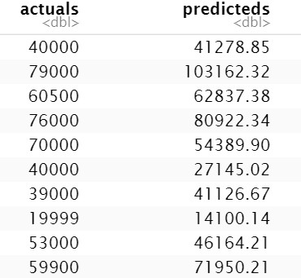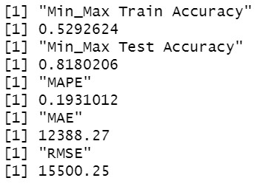
Figure 34:LR with Normal Split and Original Price Value
The values on the modeling of the linear regression are shown. It is seen that with normal values of prices, the test accuracy is much higher than train accuracy. When the price is standardized using the log values, the results vary from the previous result. The significance of the variable changes very much when the value of the price is changed. The accuracy value increases, and train test accuracy variation and the Average error rates get lowered. The results with the log values are shown below.

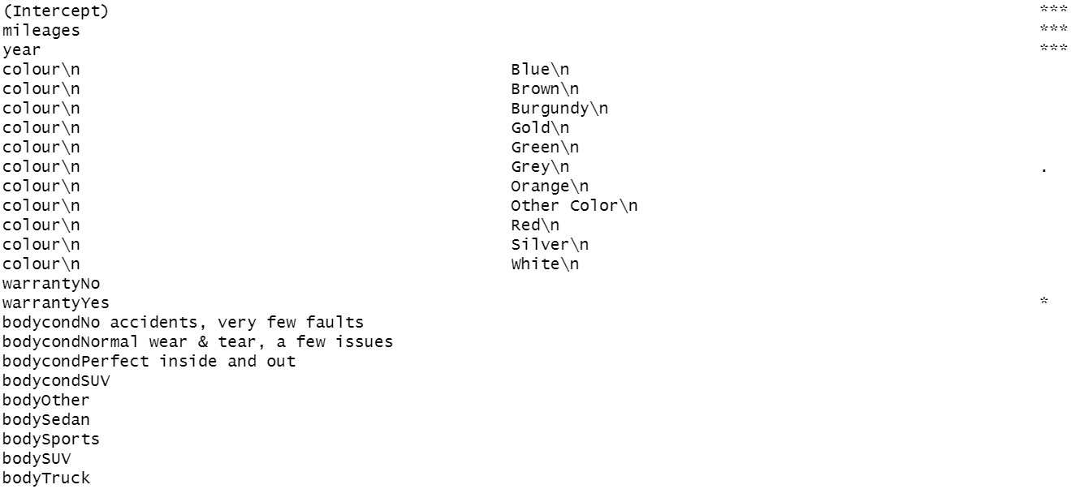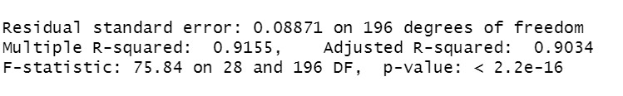

Figure 35:Structure of LR with log10(Price)
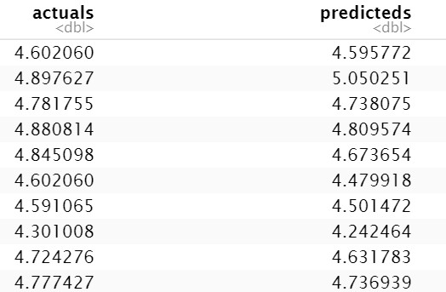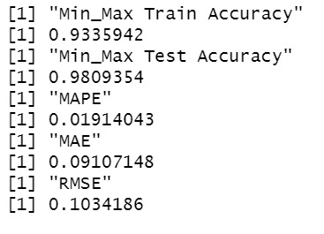
Figure 36:LR With normal split and log10(Price)
Random Split
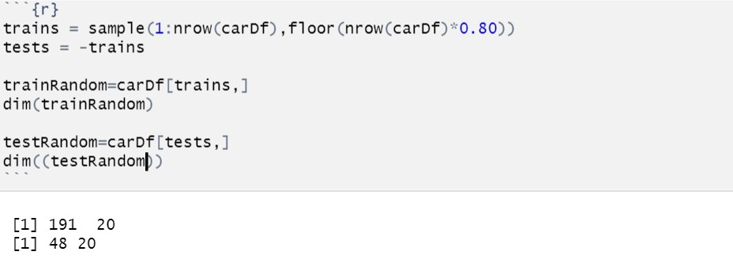
Figure 37:Random Splitting of data
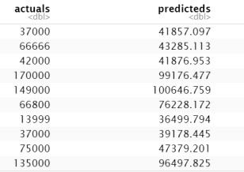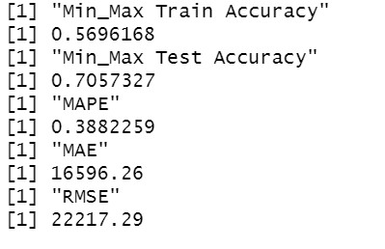
Figure 38:LR with Random split and Price
The values of the random split are very less compared to a normal split. The logarithmic value of the price is added to the variable pricelog.
s 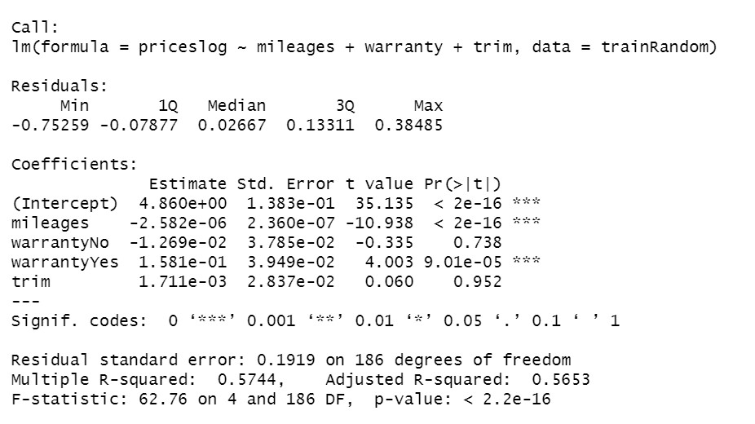
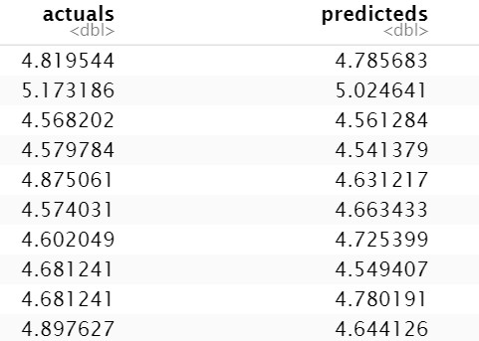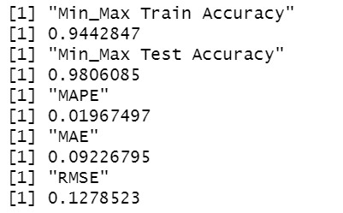
Figure 39:LR with Random Split and log10(Prices)
The performance of the random split is slightly better than the normal split. The crossvalidation result is shown below, and the cross-validation results are not that promising.
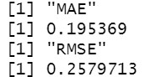
Figure 40:LR with CV
4.2.2 Gradient Boosting:
Gradient Boosting is the other model used for prediction.GB is the easiest and fast learning
model. Let us look at the results of the model.
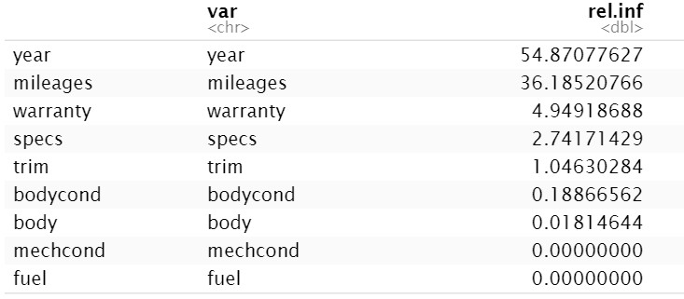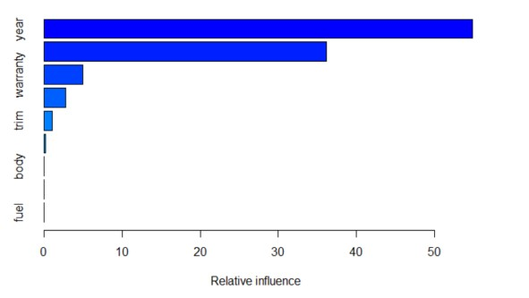

Figure 41:Relative Influence Graph
The relative influence index in the gbm model fitting summary gives the variable influence of the data to the dependent variable in the gbm model fitting. The model is run for all the 3 data splits. The normal fit does not perform as expected. The min-max accuracy of train and test had a large variation. The error rate for the gbm with the normal split is very less compared to linear regression. In the Relative influence graph, the variable with the least influence and 0 value can be removed to see how the accuracy and error value gets affected for the normal value of the price.
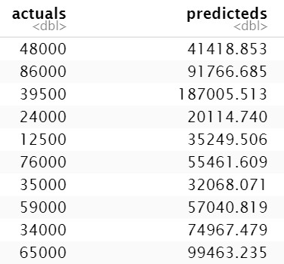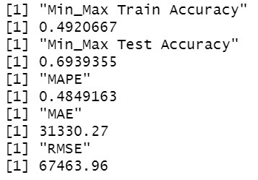
Figure 42:GBM Normal Split
The value with the least relative index was removed, and the other variables were used for the valuation. The accuracy and error rates were better compared to the previous model. Let us now look at how the performance will be when the value of the price is standardized to the log value. The log valued performed very well with high accuracy of 0.999. The variation from the training data is also no that large. The high accuracy can be overfitting, but the MAPE, MAE, and RMSE values are very least show that the model performance is good.
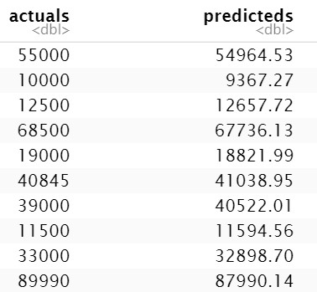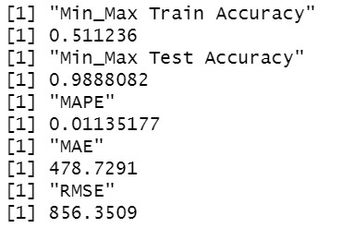
Figure 43:GBM Normal split with relative influenced variable

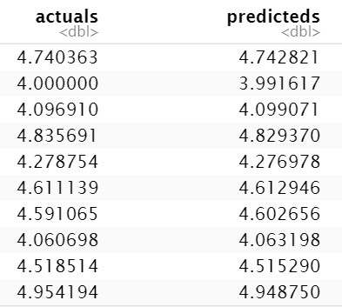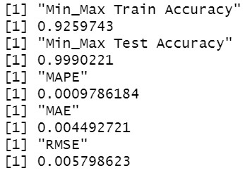
Figure 44:GBM with log10(Price) and relative influenced values
The Raandom split value's performance sheet with least variables also performs well, but the error rate compared to the normal split is higher. Hence, the gbm with a normal split of log value of price gives the best result.
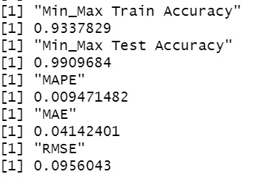
Figure 45:GBM with Random Split
Let us select the optimum number of the tree using the perf() of gbm and another plot to indicate the tree's optimum number on this technique.
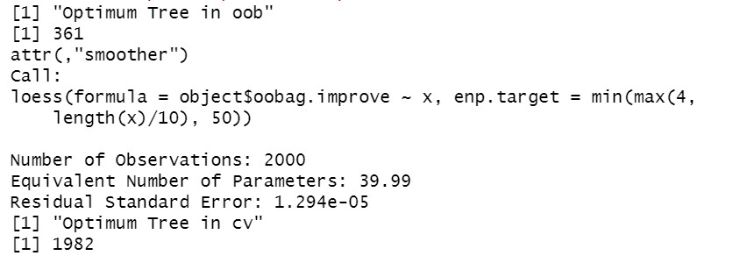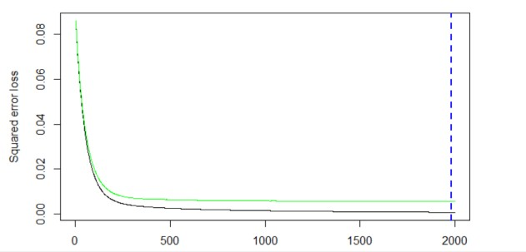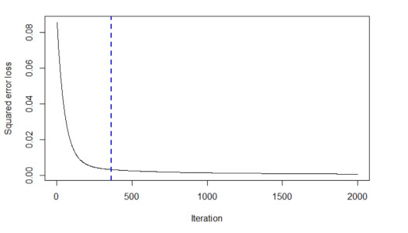

Figure 46:Plotting Optimum Tree graph
The graph indicates the test's error marked in green line and the error in train marked in black line. The blue line indicates the optimum number of iterations. Beyond that value, the train test accuracy may increase; hence the training stops at the optimum number. The result with optimum value gave a good result and slightly more train accuracy than normal split and less deviation from train and test accuracy.

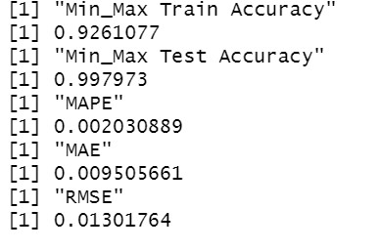
Figure 47:GBM with optimum tree value result
4.2.3 RANDOM FOREST
The random forest is yet another model that was used for the valuation of the car. The random forest result depends on the variable and creates several decision trees to fit the model. The data split is similar to another model with another performance-related modeling.
The random forest model started modeling with a normal value of the price. Like other models, the random forest also outperformed.It has a high value of error rate. Where as the modeling was done on the logarithmic value performed well and produced a result of good accuracy and less error rate. The result of random forest compared to gbm, the random forest did not perform well. Similary, the modeling was done the random splitting with the log value of the price. The model performed well. The result of accuracy was slightly higher than the normal split with the least error.
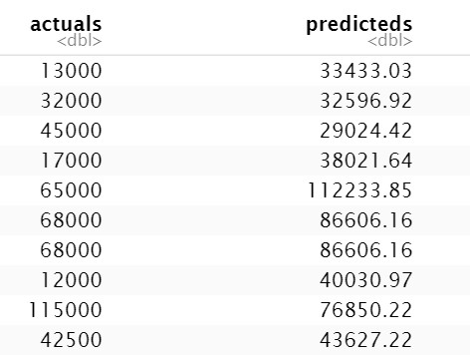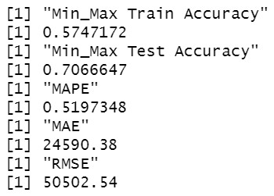
Figure 48:Random Forest Normal Split
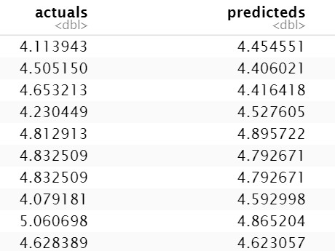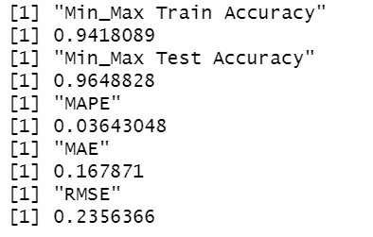
Figure 49:Random Forest with log10(Price)

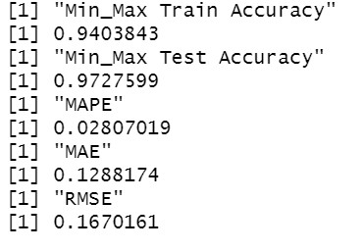
Figure 50:Random Forest with Random Split
Let us compare the models with the evaluation matrix of min-max accuracy of train and test data, Mean average percentage error(MAPE), Mean Average Error(MAE), Root Mean Square Error(RMSE).
Linear Regression -LR, Cross-Validation -CV | Gradient Boosting-GBM, Random Forest-RF,
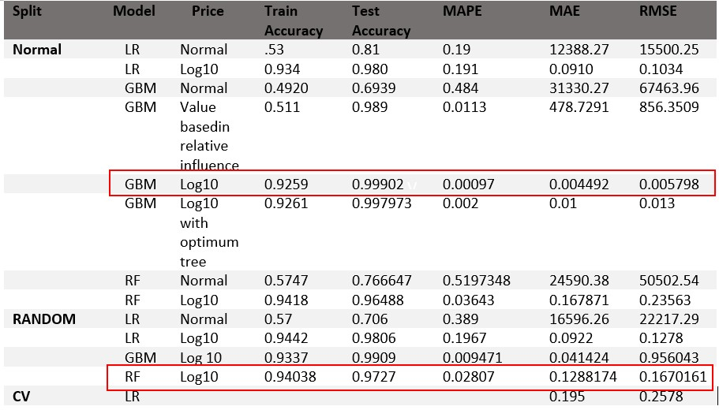
Figure 51:Comparison of Models
The three models performed better than others; let us Hyperparameter these models to get the best value for the parameters.
4.3 HYPER PARAMETER TUNING:
4.3.1 Random Forest:
Let us compare the tuning results of the random forest with normal price value and log10 Price Value.
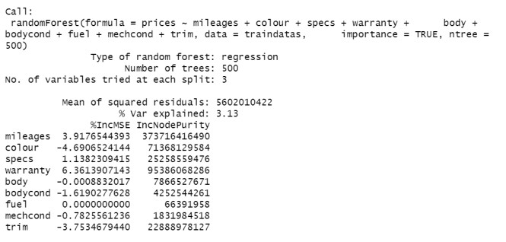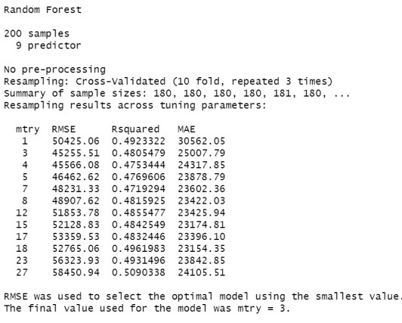

Figure 52:Random Forest with Normal split Hyperparameter Tuning
The log10 value of the price gave a better output. The normal value of price gave an optimal model at mtry three, where the RMSE value is 45255.51, R2 value of 0.4805479, and MAE is 25007.79.The log10 value of price gave an optimum value with mtry 14 with RMSE = 0.1843,R2 value = 0.6336,MAE=0.1291.The RF hyperparameter tuned model does not give that good value.
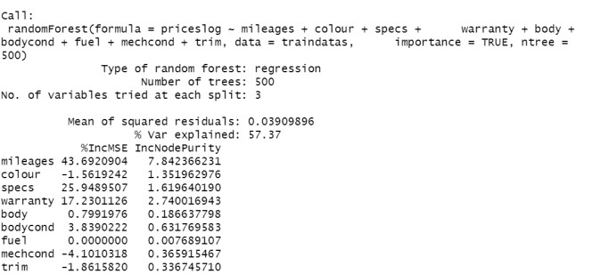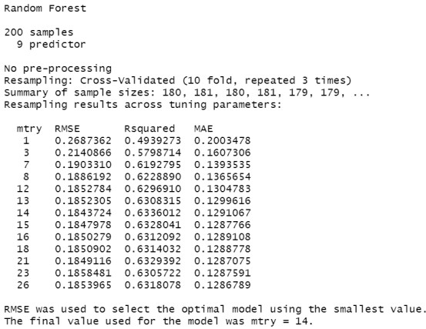

Figure 53:Random Forest with Log split Hyperparameter Tuning

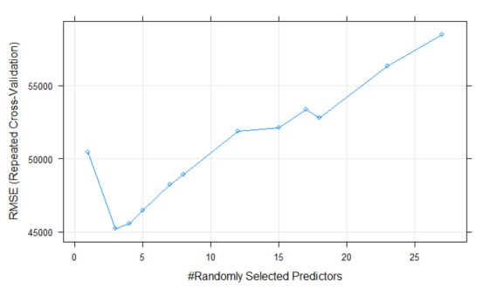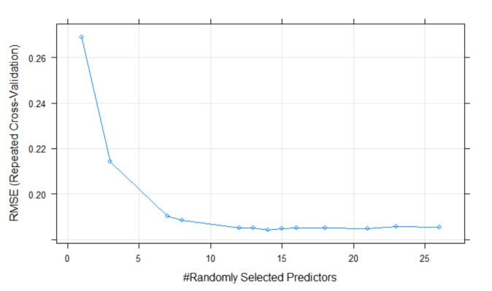
Figure 54:Random Forest with Normal split and Log split Hyperparameter Tuning Graph
4.3.2 Gradient Boosting Model:
Gradient Boosting hyperparameter tuning was done using trainControl, which is fed to train function with a tunelength of 50 on the cv method. The result of the train function.
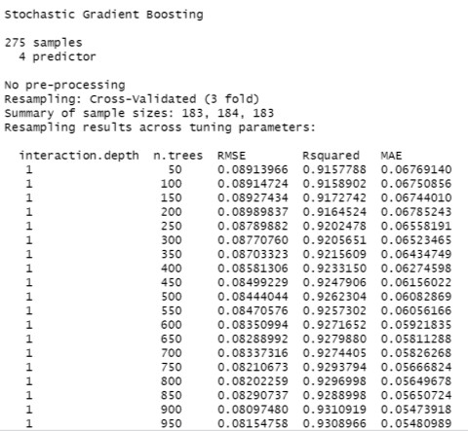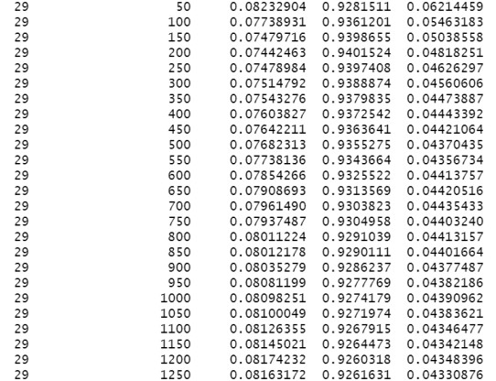

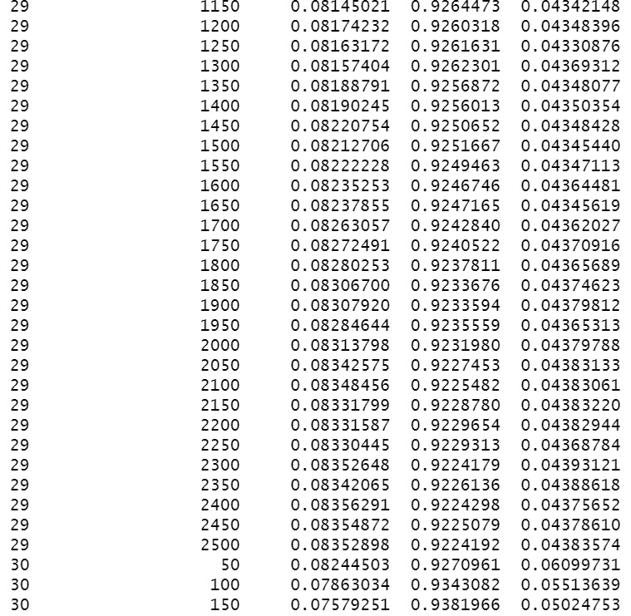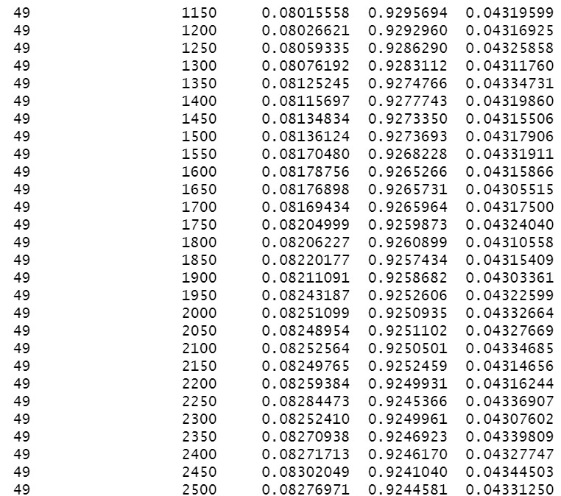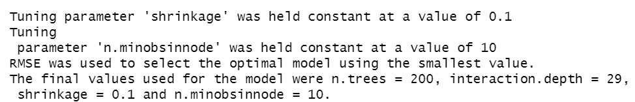

Figure 55:Hyper Parameter Tuning of GBM
The model obtains the best fitting at interaction.depth = 29, shrinkage =0.1, n.trees=200 with the
RMSE = 0.07442, R2 Accuracy of 0.94015, MAE =0.0481825
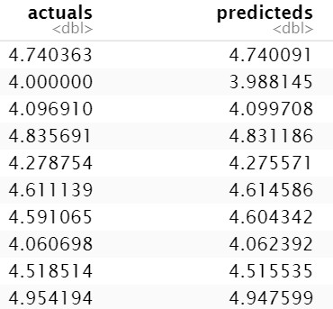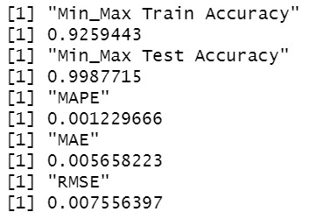
Figure 56:Application of Hyper Parameter Tuned Result
The result obtained from the train() is fed to the gbm model and saw the accuracy and accuracy of good values of accuracy and the least error.
Comparing all the models, we can see that gbm is the best model fit for the final product. The gbm model will be given to the final product with parameter values as shown
interaction.depth = 29 |  | shrinkage =0.1 |  | n.trees=200
4.4 RESULT OBTAINED FROM RAPIDMINER:
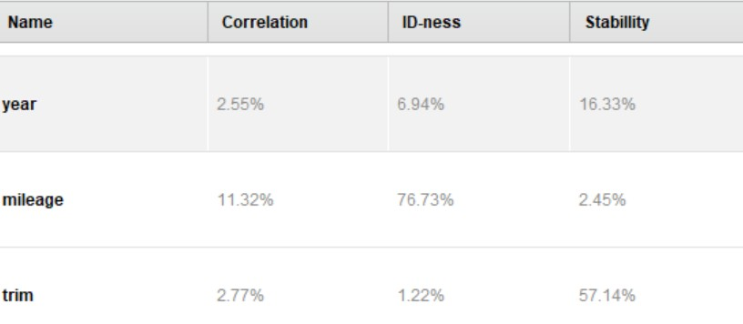
Figure 57: Variable Statistics
The data ran on the rapid miner shows the major three significant variables that we ontained from plots and modelling results.
The gbm ensemble tree produced by the performance in the rapid miner is shown below.
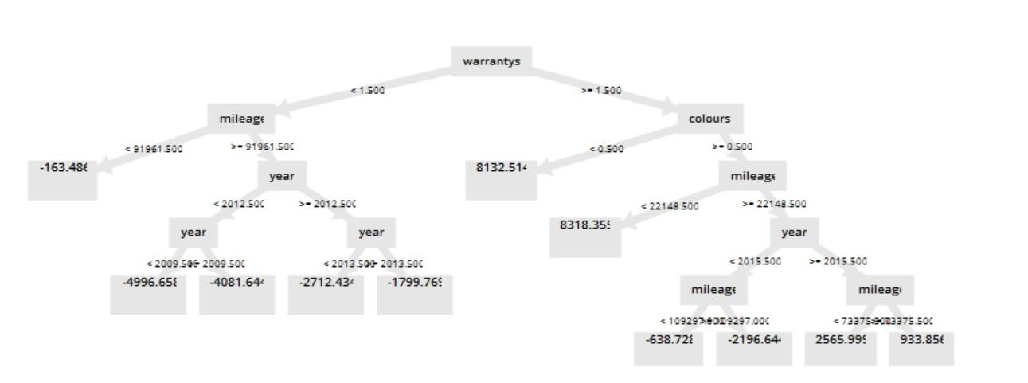
Figure 58:Ensemble tree in GBM
The data was modeled on others to see the performance. The SVM results prove that it does not provide a good result as expected.
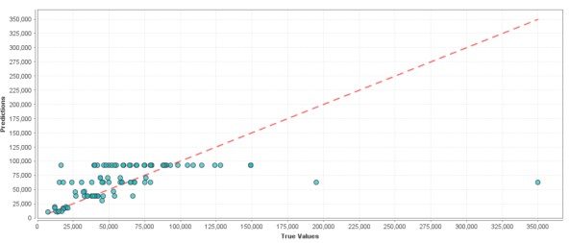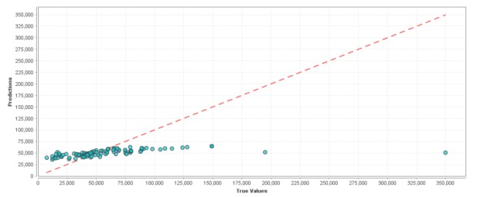
Figure 59:(a)SVM (b)Decision Tree
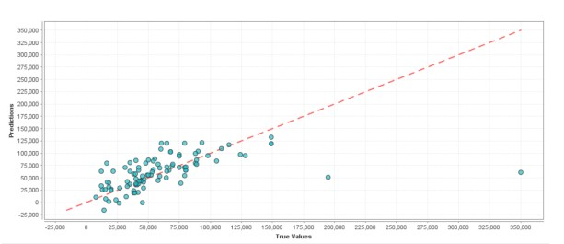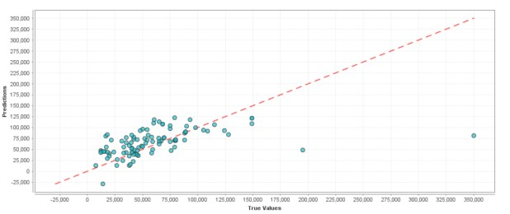
Figure 60:Deep Learning and Linear Regression
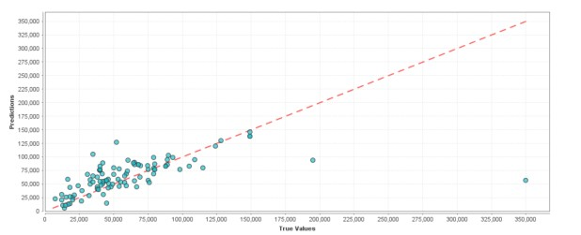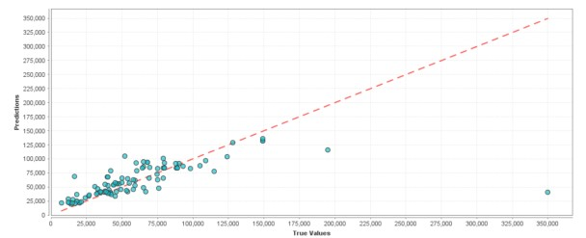
Figure 61:GBM and Random Forest

Model | Relative Error | Standard Deviation | Total Time | Training Time (1,000 Rows) | Scoring Time (1,000 Rows)
Generalized Linear Model | 0.3 | 0.0 | 2232.0 | 522.4 | 132.7
Deep Learning | 0.3 | 0.0 | 2290.0 | 1689.8 | 122.4
Decision Tree | 0.2 | 0.1 | 377.0 | 24.5 | 61.2
Random Forest | 0.2 | 0.0 | 9044.0 | 4604.1 | 154030.6
Gradient Boosted Trees | 0.2 | 0.0 | 18271.0 | 273.5 | 1000.0
Support Vector Machine | 0.3 | 0.0 | 1175.0 | 57.1 | 71.4
Figure 62:Comparison of Result based on RapidMiner
On comparing the model results in the rapid miner with the proposed research model, the RF and GBM perform the best. RF has the least variation from the regression line but the training time taken for the RF is 20 times higher than gbm. Similarly, the Deep learning model also performed well compared to other models, but the relative error is higher than other models.

4.5
FINAL PRODUCT

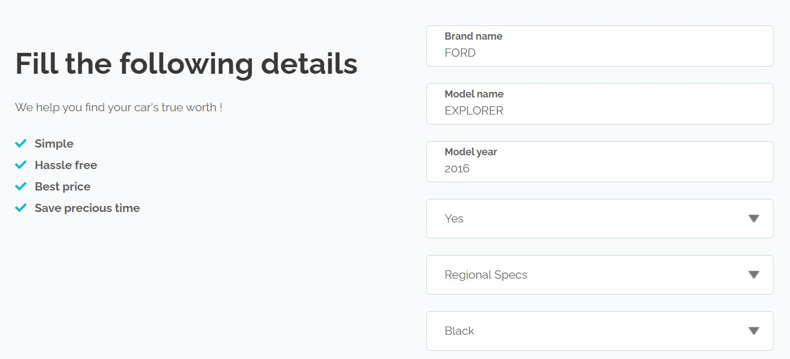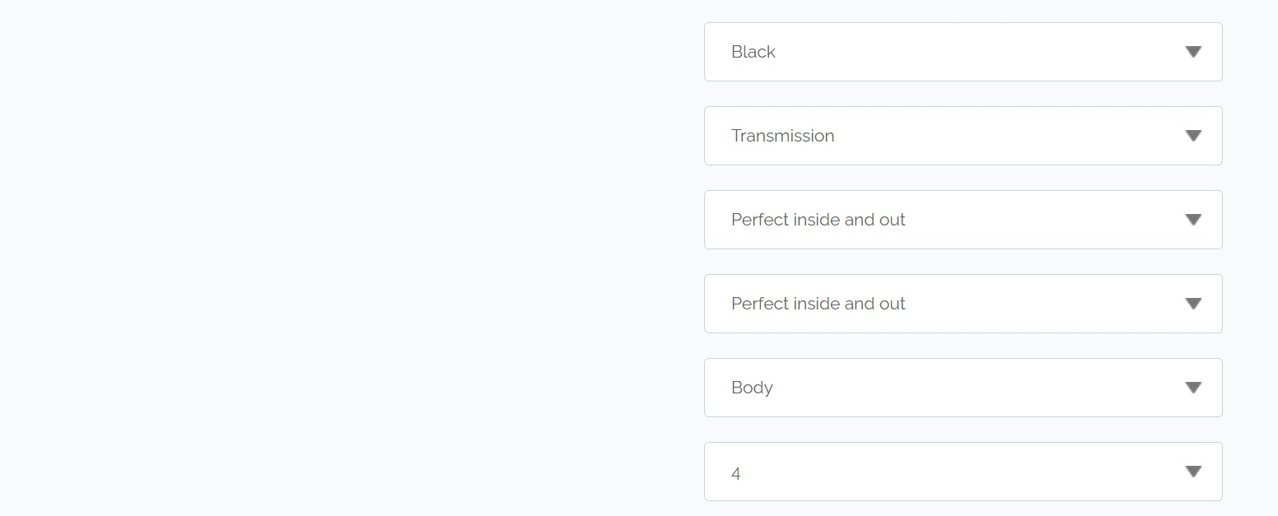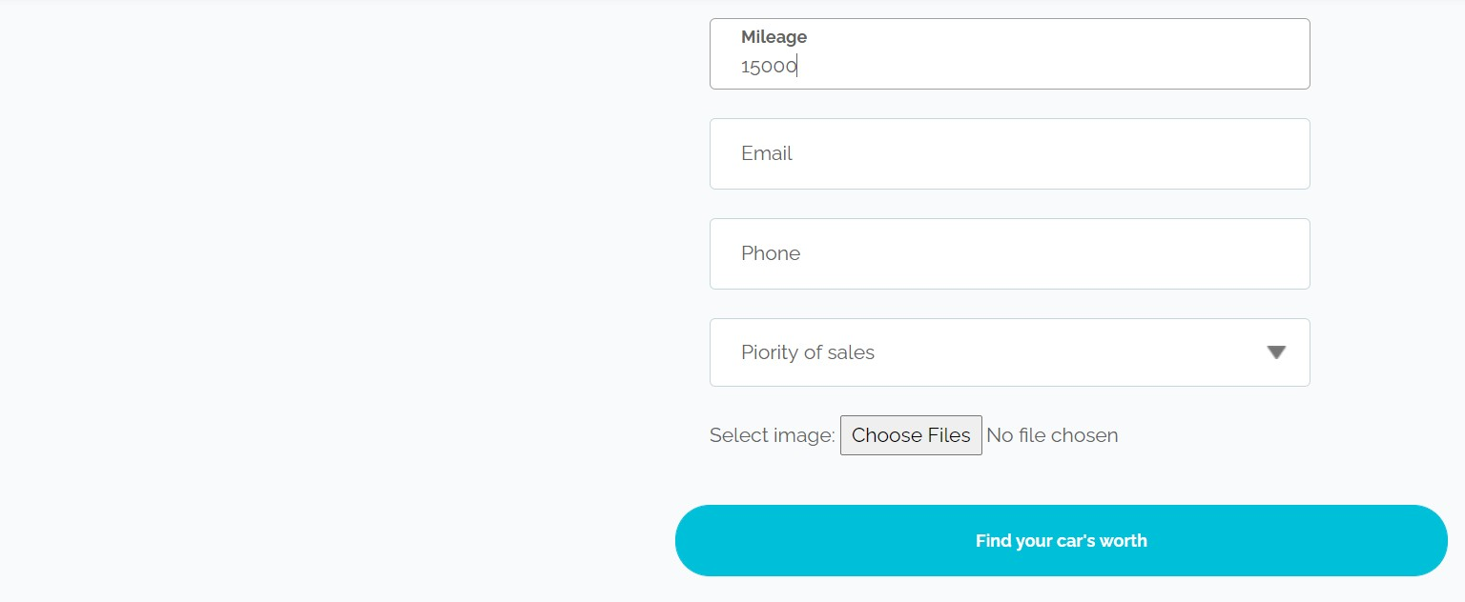
Figure 63:UI of the product

The UI has the request the and once the find your car’s worth button is clicked. The API is started as shown in the below figure, and scraping starts followed by the prediction, and the result is sent back to the UI, as shown in the figures below.
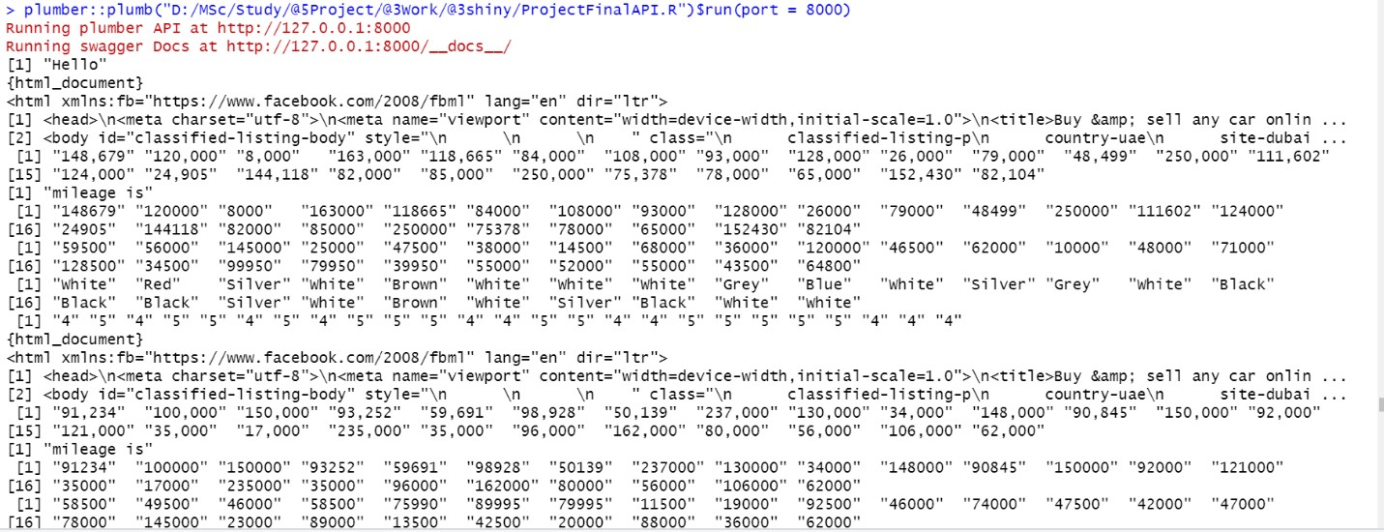
Figure 64:The UI send data request in backend and scraping
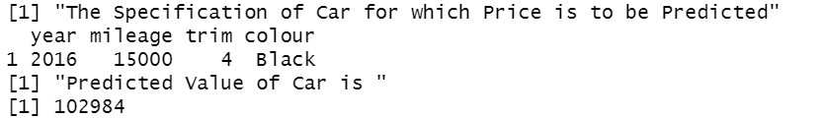
Figure 65:Output from the prediction
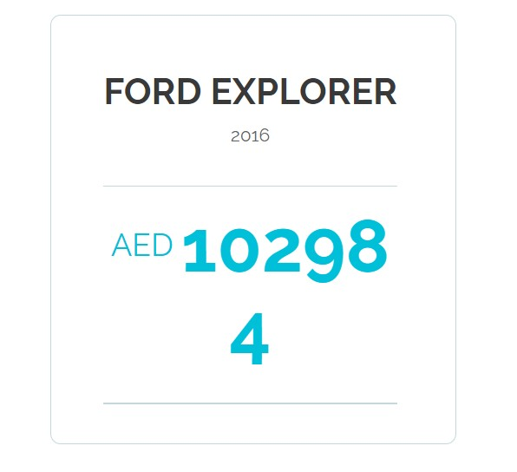
Figure 66:Final Output

5: DISCUSSIONS
Proposed research depends on the output obtained from different models—the research of car value done modeling with three algorithms.The research was based on real-time data. The evaluation of the classification tasks can be done using multiple evaluation factors such as recall, sensitivity,f1 score. The regression evaluation can be done on RMSE, MAE, MAPE, and Accuracy score. The proposed research depending factor is the price; hence we use supervised learning. The best model selection done by modeling three algorithms was made a data scraped out of a brand. The model used is Linear Regression, Gradient Boost Model, and Random Forest supervised learning. The dependent variable of the data is the price, which is a continuous data. Hence the evaluation factors that can be used are RMSE, Min-Max Accuracy, MAE & MAPE. The result obtained from algorithms and its comparisons have been shown in Figure 51
5.1 DATA
The result obtained from different models says that the prediction accuracy varies in different ranges. The data we obtained through scraping is very dynamic that price range and mileage may not be of a fixed range. It can vary from 0 to any value. There can be possible chances that data entered in the site to be inaccurate by the customer. There can be chances to bid the higher prices knowingly or unknowingly. Hence it can highly affect the data modeling. The data consist of 1 dependent 13 independent variables. The multiple correlation graphs and models are shown in Figure 27 show that the highest correlated variables are mileage ,year, warranty, and color. If we look at each variable one by one, let us see how the variables' relation is dependent on the dependent variable.
Mileage - Figure 22 shows that the mileage is inversely related to price. As the car's mileage increases, the value of car-driven increases, and the price decreases.
Year - Year is one of the other factors that is highly affecting the value of the car. It is also inversely related to the price. It implies that as the car gets older, the price gets lowered.
Colour - Colour is a factor depending on the price, but it is not relative to the year and mileage. The relation of color over price is shown in Figure 19 & 20. It is clear that certain color is more in markets, and similarly, those colors that are least in the market has more price.
Warranty - Warranty relation with price can be seen it the Gini index impurity graph of the RF Model. It means that the probability of the impurity in the variable. The warranty has the least impurity and more variable importance. Those cars that come in the market with a warranty will cost a higher price than those that are not.
Trim & body- Trim value, which tells about the number of doors and body, has less influence than the factors mentioned above.
bodycond & mechcond - The body condition and mech condition have less influence on price than the other factors. They are based on the market price. If a customer applies to get the car for lower prices, the heuristic thinking that profit on the price can replace the body and mech condition issue as per the buyer's wish. Hence they have the least relation with the price.
Seller_type, Cylinder, Specs-These variables influence the price and are shown in Figures 19 & 20, but in this use case, since the data contains the least number of factor levels, they cannot be used to train the model. Hence they are the least significant.
Transmission & fuel – Transmission & fuel are a variable affecting the sale, but in the particular use case, the data set is related to a particular brand hence the variation of transmission would be less due to which it is not used in the modeling.
Value of Price:
The modeling was done over two types of value of prices. Normal Value in the data extracted and log10 value of the price. It was done as the value of the price was distributed along with the range. The performance of the log value price was more evident than the normal value. As the price's value is applied with log10, the variable range decreases, and values become close.
The variation of the value in the prediction gets lowered, hence the error rate.
Data Platform:
The proposed research was done with the live data scraped from the dubbizle.com. The research is highly dependent on data that is being scraped; hence, it is very important to get the data from a reliable source with full data content. The dubizzle.com website is a good source and a market player that can be relied on. Multiple other platforms are available for the scraping. It is important is to understand how the data source platform can change the data available for scraping, which is further used in the modeling.
The different platform provides different data available. Certain data that are available from one source may not be available in another. The basic data for sales may be available in all. We can see that warranty and door were one of the factors that were shown to be influencing. Compared with other data sources such as sellanycar.com and yallamotors, these details were not available; hence, the data prediction is affected by it. There can be chances that prediction may vary highly. It is important that scraping and data training are to be changed widely to apply the data source. A few variables can also be added, which can create value for the data.
Hence the data source is one important factor.
Advantage:
The advantage of using log value is that error rates get decreased, and accuracy increases.
Disadvantage:
The reverse conversion leads to the normal value, and prediction accuracy decreases.

5.2 MODELING
The modeling of this research is done on three supervised learning algorithms.
5.2.1 Linear Regression
The linear regression is the easiest model for training and least tun time. The variables such as mileages, year, color, warranty, bodycond, mechcond, warranty,bodycond, body, mechcond, trim are used. Only these variables are considered for the modeling as other variables are least significant to the modeling and did not have multiple levels for training. The significant variables are mileages, year, body, and bodycond. The F-statistic in Figure 32 is to be as low as possible from 0. The p-value tells about the relation of the model with the hypothesis. The 0.02 displays that there is a small evident relation with the other variables. However, it is no that closely related to the variable relations that are not high.
The modeling was done on both the value of prices as mentioned and studied the result. Figure 33 shows the linearity of the model prediction after the price was converted to the log values. The log value was applied to the mileages, but the mileage variation was not that promising similar to price; hence, we keep the normal value for the prediction. We can see that the price's normal value gave a bad performance with less accuracy rate and higher error rates in Figure 34. The value in the actual and predicted column is an evident result variation of the result.
The values of the logged value prediction show that the model is a good fit for the prediction. The MAPE, MAE, and RMSE are less as the price's log value has the least variation, but there is a slight variation in train accuracy and test accuracy. This can be because of the chance of overfitting the model, but the possibility of linear regression to overfit is least.
The test result of the random split was done. It was done to see how random splitting effects modeling. The random splitting helps in the shuffling of the data. The result produced from the random split is less compared to the normal split. It has less accuracy and more error rate. The less result of the random split can be of the shuffling result where the variation in train data was higher compared to normal split. The cross-validation method also produced a result that was not much promising. The cross-validation method expects to perform well in all models as they are trying for all data combinations, but this user case outperformed as the variation was increasing in the different split. The normal split expects the data scraped of similar data, and variation is least.
5.2.2 Gradient Boosting Model:
The gradient boosting model is the model that is easy to implement and fast learning model. The Gradient Boosting Model. The relative influence graph (Figure 41) shows the more relative variables to the dependent variable used in the prediction. The graph shows that the year has the strongest influence on modeling. It proves the heuristic assumption of the car sale depending on the year, followed by the mileage. The modeling was done on the normal and random split with the original value and the price's log10 value. The normal split accuracy of the gbm was very less compared to the linear baseline model and higher error rate, but the variation of the train and test accuracy is less compared to the linear model. It proves the tend of this model to fit better than the linear model. The gbm model produced the evident good result with a log price. The test accuracy was around 0.9990. The value of accuracy can lead to thinking of the overfitting, and the variation of test and train accuracy variation also says a slight chance of overfitting, but the error rates of the modeling can be considered for thinking the model to be a good fit.
The modeling was on the random split similar to the linear regression with log values. The similarity was similar to the normal split value. The train and test accuracy variation were slightly less as the model tend to fit all the possible values. However, the error rate is slightly higher than the normal split, as it can be caused by the variation in data due to the shuffling.
The model's performance was analyzed using gbm.perf()to see the optimum number of the needed tree. It was done using both the cv method and OOB (out of the bag). These optimum values produced were 361 and 1982, respectively. The value helps to understand the variation of test train accuracy. The value is such that any value beyond produces a variation in test and train accuracy; hence the model training stops at that optimum number. The performance graph value of optimum cv value is given to find the model fitting with it and produce a more positive result than other models. The test train variation was the least, and error rates were less compared to other models.
The rapid miner study on the gbm also proves to have a higher performance of gbm over other models. The log value selection creates and ambiguity on the model's selection though the value of performance was best in the log value of price, the use case request to reverse the value back to normal, and hence the normal value tends to have the variation of old accuracy. Though the variation is expected in the ambiguity, the log value is chosen to produce less variation than the normal value.
5.2.3 Random Forest:
The random forest model is another model that was used for our prediction. The random forest model build tree and its advantage of tree generation with the least error are very evident. Hence this model is highly dependent on the variables. The Figure 27 with the IncMSE and IncNodePurity prove the variable importance. The variable's Gini score is to be kept as low as possible to get a pure variable. The least value of Inc Node purity shows that the fuel, body cond, and mechcond are least significant to the modeling.
The random forest was done on a normal split with normal values of the price and log10 value of price and the random split on log10m value of the price. The Normal value gave an accuracy similar to gbm. The overlook of the result was done for the log10 price of the normal split model. The result was much promising, with the least train test variation. The random forest tends to build a tree with the best fir; hence, this model produced the least variation and training and test results. The error rates were least that, but we are not that promising compared to the gbm model. The random split was done on the log10 value prediction. This time prediction was very promising, with the least variation in test train accuracy and the least error rate compared to the normal split.
5.3 SUMMARISING COMPARISON OF MODELS:
- On comparison of all models with the accuracy and the error rates, as shown in Figure 51. When we compare the accuracy, we can see that all models ran with the original price's original value outperformed. They gave the least accuracy and higher error rates. It was because of the variation in the price. The price value varied in the higher range and hence giving the least accuracy and higher error rates.
- Those models with the log value of high price prediction as the price variation got reduced in the log value and decreased the error.
- The linear model performs least compared to other models as gbm, and the random forest is build to fit the most with trees.
- Random model performance was least compared to the Normal split as the data variation increases when the data get shuffled.
- The gbm and Rf model of log10 price performed well compared to all other models as the models tend to fit the maximum using decision trees and ensemble method hence producing better results.
- The gbm has less error rate, and RF has the least train and test accuracy variation. Their characteristic of the RF model tends to fit multiple decision trees and reduce overfitting, and the gbm ensemble method continuous and sequential work for error fitting.
- The chosen model shown in Figure 51 marked is the best, and it is tuned to get the best parameter producing accurate results.

5.4 HYPER PARAMETER TUNING
The hyperparameter tuning is done on the random forest model. With the hyperparameter tuning, we compare the normal value of price and log10 value of the price. The hyperparameter tuning was done on traincontrol() with repeatedcv and repeat. The value from the traincontrol is fed to the train(), producing results in multiple mtry to the best result produced. The same method was applied to the log10 values. The optimized result will be produced on the fitcontrol, but the results produced are not promising.
The tuning was done on GBM. The fitcontrol function was applied with the cv method of fold value -3. The output fed to the train produced the best result at the interaction.depth value=29 and tree =200.It produced good accuracy, and the result is fed to model to the best fit model. The gbm model produced the best accurate result with error compared to all.
The Gradient Boost model (price-log) at interaction.Depth = 29, shrinkage =0.1, n.trees=200 is chosen to be the final model as it produces the best result compared to all other.

  - OPTIMIZATION:
The optimization works to optimize the result, depending on the sales' user priority, but the optimization result was not obtained for the proposed research as the data have the least number of a continuous variable. The data had only mileage as the best continuous variable; hence, running an optimization for that regression equation depends on other categorical variables. So, this is not a good candidate for our linear optimization
  - RESEARCH PRODUCT:
The research product is fed with the mentioned gradient boosting model with the mentioned feature values. The product produces a dynamic value for each input given. The variations of each scraped data can vary depending on the input. The model was chosen based on the results of the selected data. It may outperform in certain cases. The UI's input is passed to the code's API to scrap and model and return the UI results.

6: CONCLUSION
The Research, Demand Forecasting and Inventory Optimization in Pharmaceutical Distributions are based on the user's input, and the prediction based on the data extracted depending on the user input. This research showed that predictive analytics is an excellent tool in delivering the prediction value for the problem statement—the research intended to predict the live data extraction. The data is the central part that plays a role in the prediction, positively influencing the outcome. The chapter summarizes the approach, Managerial and Theoretical Implications, Limitations of the Research, and The future applied to it. The research aimed to get multiple perspectives of the model and eventually compare the performance of the models.
The research aimed to Predict the value of the used car with real-time data. The research primarily focussed on modules such as data extraction, prediction. The research's predictive analytics was initiated with real data collection, which was done by the scraping method. The scraped data is trained with multiple models to see how different prediction works for the aim and how it results with the best accuracy and least error rate. This research helps to understand how a prediction works effectively with real-time data rather than pre-existing data recorded a while back.
The Prediction algorithms that have been used differed each other in the characteristics with the prediction power and accuracy. The result of a different model that has been used for the model selected given out a result that has a considerable variation in the result from good accuracy- the least error rate to feasible model accuracy and large error rate. The limitations in the model limited the research from bringing out a much better and accurate result. The scraped data has the least error rate as the data from the website was specific, and the pre-processing part was worked to find the empty content in the scraped data, and finally, the variable type was changed to numeric and factors accordingly. This final data was used for modeling.
6.1 SUMMARY OF THE THESIS MODULES:
6.1.1 Data Extraction:
Data extraction played a vital role in the research. The live data extraction depends on the user input, which has to scrape when the user enters his data. The data was scrapped based on the brand and model of the car entered by the user. The pre-existing data, which consists of the car and its details, will intend to have all types of a car with less data, which can critically affect the prediction. The research has shown that the data extraction part can get any data extracted depending on the user input, which is good enough for the prediction part to work, bringing out the best accurate result than training on a pre-existing data. The dependency of the data in the model is highly visible and marked this research. The module played an essential role in the intended research to achieve the best result to attain the aim.
6.1.2 Predictive Model Selection:
This module intended to select a model from multiple models depending on the user Input. The scraped data used for the modeling shows how machine learning is influencing the prediction. The model selection done after multiple model training on the data helped understand how each model is working on training data. Another result drawn from the multiple models for selection is how they positively influence the feature selection in understanding how certain variables are affected in the modeling. Hyperparameter tuning helped to find the model with high accuracy and the least error rate. The data and its type play an essential role in modeling.
Modeling based on tuning the parameter helped find a parameter that could bring out the least error rate.
6.1.3 Optimization:
The optimization was focusing on the sales priority, but as the data has the least number of continuous variables, running optimization is not feasible, and the result was not that meaningful.
6.2 MANAGERIAL IMPLICATION
The outcome of the research to take place is a managerial Implication of the research. The Car value is the price that gets dropped from the moment the car is bought. As each year passes on, the depreciation of the car gets continued. The features of the cars are very much affecting factors for the valuation of the car. Multiple levels of sectors can use this research. The proposed research aimed to help the users in predicting the value of their used car. The research mainly focuses on users such as customers to draw a market idea about the price for them to bid for the sale. Though it is intended mainly for the individual customer, the research is highly useful for Cooperate users who are in the automobile market for the sales and buy out of the used car. The automotive industry and user car sales are one of the growing sectors. The sales of the used cars have been increased from day today. The research product is the car's valuation, which plays a vital role in the sales market. It can also be used by banks, NBFCs, and even by the motor insurers.
The Dealers, Organizations, and web portals that deal with car sales can use this product for the valuation. This product plays a key to customer interaction for any organization and deals with them in clearing the car's value. This research product can also work with buying users who intend to a used car. Users can use this product for valuing the car that they are planning to buy. The car valuation of the used car helps the user in the hassle-free assessment of the car they will sell or buy. It would help the organization reduce the time for sales with proven value for the seller rather than procrastinate the sale on the means of sales value.
The growing market of used car sales calls for the importance of such products, which could improve the market growth and sales without much loss in the sales for both ends. The usage of the product would improve the credibility of the value that the dealer or organization bid. A negative impact raised in users' minds is valuing the car by a seller is instead a figure raised by them rather than based on the market value. It can indeed be overruled with the product's usage, which would make the customer understand how the market value can be applied to their car. Rather than an automotive industry, it is useful for the NBFCs and banks for valuing the car the approval of the loan amount for the user. It can also be used as the motor insurers, which would help them calculate the motor insurances' Premiums.
Research product plays a major role in all sectors and organizations that deal with the used car sales. The product helps calculate the loan amount to be approved, the Sale amount that would not incur a loss, and premium calculation of the insurance. If someone underprices the value, it highly affects sales. In the buyer case, if a motor insurer underprices the value, It will affect the customer when they are trying for the next sale for the car. It can cause a lower value claim payout in the policy, which would lead to a loss when any theft happens. Hence it very important to value the car where the product plays a significant role, which would help in an accurate value of the car depending on the Market value that would affect neither the customer nor the seller. It could improve the credibility of the user organization's valuation of the car between the customers overwriting all the pre-existing negative impacts on users.
6.3 THEORETICAL IMPLICATIONS
All the research intends to bring out the best accuracy and least error rate prediction. The proposed research would bring out the best outcome for the users and the intended customers. The integration of multiple researches for a worthy product is highly appreciated for market benefit. It brings an outcome to improve the area of study and to improvise the scope of research. The theoretical implication of the research always lies in the understanding of the theory of the research. It involves the application of the research beyond any set of conditions that the research initially built.
The research key role in the day to day life is highly important. At the same phase, the intended research could be used by much other research in the work for the development of much other valuable work that could benefit the users in a much better and best way. The automotive industry is one of the major industries where several studies and computer vision projects have been carried for better outcomes and predictions. A broad set of projects are carried with the automotive industry, which could use this intended research, and to integrate it, bring out the best outcome for society.
The intended research value is based on the features of the cars. Some projects have been carried with image processing on the identification of the damages in the car. The researchers used an image data set to train the model and evaluate the user input car-based as the test to predict the car's damages. It would help identify the dents, scratches, repainting, or any kind of changes that were made. Other researches are carried out with any kind of loan prediction and insurance premium predictor.
The proposed research can be integrated with the mentioned researches in bringing out a much better model. The research can integrate to make project outcomes to get the user's data input, such as the brand model year and other features along with multiple image input of the car. The model will run the algorithm to identify the severity of the damages in the car. It then evaluates an index value of the damage severity and then uses that index value as a variable for the model that predicts the car's value. The integrated research would bring out an outcome that could be developed as a product that would be beneficial for multiple users and customers.
The proposed research is an outcome that could bring out a base project, which, in turn, integrated with many other modules research could develop research of greater scope giving an outcome to the society. Another possibility of integrating the proposed research includes the proposed research to predict Loan Value for a car, Prediction of Motor Insurance. The Loan value prediction, motor insurance premium value prediction is sensitive such that the error rate would highly influence the outcome. The mentioned sensitive predictions are highly correlated to the variable values that are used for the modeling. The better the data higher would be the accuracy and least error rates. Hence the proposed research would positively contribute and can be integrated into such projects for best accuracy prediction.
6.4 LIMITATIONS:
The research outcome expects a model that predicts the value of the used car with real-time data with the user input—each research focus to provide the best outcome with the least error rate. Though the research is diverged to produces the best out, multiple limitations limited the study that could be applied to prediction. Limitations are crucial factors that influence the thesis. A few Major limitations to the predicted researches are mentioned below
1.Availability of the data:
The data required for the research is used by scrapping from the internet rather than pre-existing data. Hence the availability of the data is least. As mentioned in the previous section of the research. The data is crucial for prediction, and the number of data of similar car models was significantly less (¬300). As the number of data increases, the variability of the factors can be increased in the prediction, bringing out much better results than available. The more the data number more robust, the prediction to be.
2.The Scraping Issues:
The proposed research uses web scraping for extracting the data depending on the user input. There were multiple issues associated with the scraping, which limited the research. Few of them are :
1.The unavailability of whole data in the vehicle mentioned.
2. Any changes in the structure of the source from where we scrape the data would highly limit the computation
3.Difficulty in the structure of the textual data from scrape.
4.The saving of data to the data frame gets distracted with any error that occurs. The scraping was a multiple number of od issues, and limitation is considered to improve the research.
3.Feature Availability:
The features of the car are significant factors that are critical in modeling. The more the number of features available more good would be the prediction. The features with good correlation were significantly less. There was more number of features that are least correlated to price than highly correlated ones. The features such as service availability, damage rating, and expected mileage would add more value to the prediction.
4.Data cleaning:
Data cleaning is another area that is to be done rigorously. The 'NAs' were handly removed those rows filled with NAs, which reduced the data availability further. The data cleaning lies with the modeling part; hence, the scraped beauty depends on the source. The Unwanted formatting of the text and inclusion of text to the data when scraping could cause an error in the prediction, which must be handled carefully.
5.Data Preprocessing:
Data Preprocessing and data cleaning would result in making the data more rigorous for use and prediction. The data format change depending on the source, and changing the type of data from numeric to factor is to be done carefully, which highly affects the accuracy.
6.Computation time:
One of the significant factors that each research would look at is the computation time required for the product's performance. The research computation time is highly dependent on the number of variables and scraping. There was a recorded time of 3min required for computation and prediction for a model with five variables, and it then increased to 25 minutes for the computation of 14 variables.
The limitations are another milestone for future work. Every limitation is expected to be overwritten and improved in future work.
6.5 FUTURE WORK:
The future work for this research would aim to improvise at the modeling level and the feature level. The future work majorly aims at the development of the project, along with image processing. Feature level looks at the user's basic features of prediction depending on the user. The model-level looks at the research's improvisation, technically overcoming the limitations of the current product and adding more functionality and hence improving the prediction.
6.5.1 Feature Level Work:
1.The proposed research majorly focuses on the seller level. Future work expects to cover the buyer level aspect. Its focus on prediction and optimization difference depending on the user type of seller and buyer.
2.The future work expects to attach images to the variable. It can be used for computer vision for detecting the severity of the damages and hence calculate the damage severity index. The damage severity index calculation with computer vision studies would highly benefit the prediction in giving the best outcome. The index predicted by the computer vision algorithms can be used as another variable for predicting the values.
6.5.2 Model Level Work:
1.A better data platform is to find that the source's data is very accurate, depending on the market value.
2.The currently proposed research uses the method such as linear regression, GBM, Random Forest, and Light GBM for the modeling and the future work plan to use Neural Network to see how the performance accuracy and error rate are changed produces the best model.
3.Addition of the computer vision and image processing for the damage severity index prediction.
4.A new optimization method to improve the prediction and final result.

: BIBLIOGRAPHY

Alpaydin,Ethem(2014),Introduction to Machine learning.United States:MIT Press, 2014
Bercovec,James(1985),' New car sales and used car stocks: a model of the automobile market',The RAND Journal of Economics, Vol. 16, No. 2 (Summer, 1985), pp. 195-214
Boonsiritomachai, W., McGrath, G. M., & Burgess, S. (2016). Exploring business intelligence and its depth of maturity in Thai SMEs. Cogent Business & Management, 3(1), 1220663. https://doi.org/10.1080/23311975.2016.1220663
Breiman,L. and Spector,P. (1992) Submodel selection and evaluation in regression. The Xrandom case. Int. Stat. Rev., 60, 291–319.
Breiman,L., Friedman,J.H., Olshen,R.A. and Stone,C.J. (1984) Classification and Regression Trees. Wadsworth and Brooks/Cole, Monterey, CA.
Burman,P. (1989) A comparative study of ordinary cross-validation, v-fold cross-validation and the repeated learning-testing methods. Biometrika, 76, 503–514.
C. Chiu and C. Shu, "Monthly car sales prediction using Internet Word-of-Mouth (eWOM)," (2017),IEEE International Conference on Innovations in Intelligent SysTems and Applications (INISTA), Gdynia, 2017, pp. 345-348, doi: 10.1109/INISTA.2017.8001183.
Chen, S., Chou, E., & Yang, R.R. (2018). The Price is Right: Predicting Prices with Product Images. ArXiv, abs/1803.11227.
Dhar,Vasant(2013),' Data Science and Prediction',DOI:10.1145/2500499
G. Kejela, R. M. Esteves and C. Rong, "Predictive Analytics of Sensor Data Using Distributed Machine Learning Techniques," (2014) IEEE 6th International Conference on Cloud Computing Technology and Science, Singapore, 2014, pp. 626-631, doi: 10.1109/CloudCom.2014.44.
Gallo,Amy (2015), 'A Refresher on Regression Analysis',Hardvard Business Review,04 November.Available at: https://hbr.org/2015/11/a-refresher-on-regression-analysis (Accessed on 13 July 2020)
Gegic, E. et al. (2019) 'Car Price Prediction using Machine Learning Techniques', TEM Journal, 8(1), p. 113-118,DOI:10.18421/TEM81-16.
Gillingham.et.al(2019),' Equilibrium Trade in Automobile Markets',The national bureau of economic research, (DOI): 10.3386/w25840
Haine, Alice. (2019) 'Nine in 10 UAE car buyers will choose second-hand over new in 2019', The National (Business)18 Feb, Pg 14.
Hastie,T., Tibshirani,R. and Friedman,J. (2003) The Elements of Statistical Learning: Data Mining, Inference, and Prediction. Springer Series in Statistics. Springer, 1st edn, 3rd print. Springer-Verlag, New York.
Huang, W., Zhang, Q., Xu, W., Fu, H., Wang, M. and Liang, X., (2015). A Novel Trigger Model for Sales Prediction with Data Mining Techniques. Data Science Journal, 14, p.15.
DOI: http://doi.org/10.5334/dsj-2015-015
I. Markou, F. Rodrigues and F. C. Pereira, "Real-Time Taxi Demand Prediction using data from the web," (2018), 21st International Conference on Intelligent Transportation Systems (ITSC), Maui, HI, 2018, pp. 1664-1671, doi: 10.1109/ITSC.2018.8569015.
Institute of Information Systems, University of Hamburg(2013), Resale Price Prediction in the
Used Car Market, Available at: https://www.semanticscholar.org/paper/Resale-PricePrediction-in-the-Used-Car-
MarketVo%C3%9F/edd2191dae1b2f10052c51fd61a908e0b91fbb74
Knofczynski & Mundfrom(2008), 'Sample Sizes When Using Multiple Linear Regression for Prediction'Sage Journals, Volume 68 Number 3,Pg:431-442
Lacetera.et.al.( 2012). 'Heuristic Thinking and Limited Attention in the Car Market'. American Economic Review, 102 (5): 2206-36.
Limsombunchai, V. (2010). 'House Price Prediction : Hedonic Price Model vs . Artificial
Neural Network'. American Journal of Applied Sciences 1 (3): 193-201, 2004 ISSN 1546-9239
Ljung, L(2002).' Prediction error estimation methods'. Circuits Systems and Signal Process 21, Pg:11–21
Molinaro.et.al(2005), ‘Prediction error estimation: a comparison of resampling methods’, Bioinformatics, Volume 21, Issue 15, , Pages 3301–3307
Nairn, A., Berthon, P., & Money, A. (2003). THROUGH THE PARADIGM FUNNEL: A CONCEPTUAL TOOL FOR LITERATURE ANALYSIS. International Journal of Market
Research, 49(2), 257–274.
Özer Çelik, Osmanoğlu(2019) ,Prediction of the Prices of Second-Hand Cars, European
Pal, N.et.al. (2017). How much is my car worth? A methodology for predicting used cars prices using Random Forest. ArXiv, abs/1711.06970.
Provost,Foster and Fawcett,Tom(2013) 'DATA SCIENCE AND ITS RELATIONSHIP TO BIG DATA AND DATA-DRIVEN DECISION MAKING', DOI: 10.1089/big.2013.1508
Puteri ,Safitri(2020), Analysis of linear regression on used car sales in Indonesia, Journal of Physics: Conference Series ,1469,doi : 10.1088/1742-6596/1469/1/012143
ResearchAndMarkets (2019) ,UAE Used Car and Auto Classified Market 2018-2022. Newyork: Cision PR Newswire , Available at: https://www.prnewswire.com/newsreleases/uae-used-car-and-auto-classified-market-2018-2022-300840808.html(Accessed:
12.07.2020).
Rodriguez J.D.(2010),' Sensitivity Analysis of k-Fold Cross Validation in Prediction Error Estimation',IEEE Transactions on Pattern Analysis and Machine Intelligence, vol. 32, no. 3, pp. 569-575, doi: 10.1109/TPAMI.2009.187.
Roeder, Theresa M. K. et al. (2016). 'REAL-TIME PREDICTIVE AND PRESCRIPTIVE ANALYTICS WITH REAL-TIME DATA AND SIMULATION'.' Winter Simulation
Conference',Availableat:https://pdfs.semanticscholar.org/af34/ef860bf06cfe2f1338281717b6 a05f1561cc.pdf?_ga=2.153409659.217006139.1595444084-528633918.1595444084
Rouse,Margaret(2015),' ensemble modelling',Tech Target,02 January. Available at: https://searchbusinessanalytics.techtarget.com/definition/Ensemble-modeling (Accessed on 13 July 2020)
- Gongqi, W. Yansong and Z. Qiang, (2011)‘New Model for Residual Value Prediction of the Used Car Based on BP Neural Network and Nonlinear Curve Fit', Third International Conference on Measuring Technology and Mechatronics Automation, Shangshai, 2011, pp. 682-685, doi: 10.1109/ICMTMA.2011.455.
Sameerchand Pudaruth(2014), Predicting the Price of Used Cars using Machine Learning
Techniques , International Journal of Information & Computation Technology. ISSN 09742239 Volume 4, Number 7 (2014), pp. 753-764
Stanford University |(2012), Don't Get Kicked - Machine Learning Predictions for Car
Buying,Available at:
http://cs229.stanford.edu/proj2012/HoRomanoWuKickedCarPrediction.pdf
Stanford University |(2019), Predicting Used Car Prices,Available at:
http://cs229.stanford.edu/proj2019aut/data/assignment_308875_raw/26463410.pdf
- Petereke et.al(2013), "Performance evaluation of Random Forest regression model in tracking Parkinson's disease progress," 13th International Conference on Hybrid Intelligent Systems ,Gammarth, 2013, pp. 83-87, doi: 10.1109/HIS.2013.6920459.
techopedia(2020)Real-TimePredictiveAnalytics. Available at: https://www.techopedia.com/definition/31743/real-timepredictiveanalytics#:~:text=Real%2Dtime%20predictive%20analytics%20is%20based%20on %20a%20predictive%20model,of%20large%20amounts%20of%20data.&text=This%20mod el%20is%20then%20made,data%20is%20fed%20to%20it..
Wayne W. Eckerson(2007) PREDICTIVE ANALYTICS. United States: TDWI
X. Lu and X. Geng, (2011), "Car Sales Volume Prediction Based on Particle Swarm Optimization Algorithm and Support Vector Regression," 2011 Fourth International Conference on Intelligent Computation Technology and Automation, Shenzhen, Guangdong, pp. 71-74, doi: 10.1109/ICICTA.2011.25
Yiu,Tony(2019),' Understanding Random Forest How the Algorithm Works ,towards data science ,12 June. Available at: https://towardsdatascience.com/understanding-random-forest58381e0602d2 (Accessed on 13 July 2020)
Zhang,Zixuan(2019),’Boosting Algorithms Explained Theory, Implementation, and Visualization',towards data science ,26 June. Available at: https://towardsdatascience.com/boosting-algorithms-explained-d38f56ef3f30 (Accessed on 13 July 2020)

8.APPENDICES

1.FINAL PRODUCT
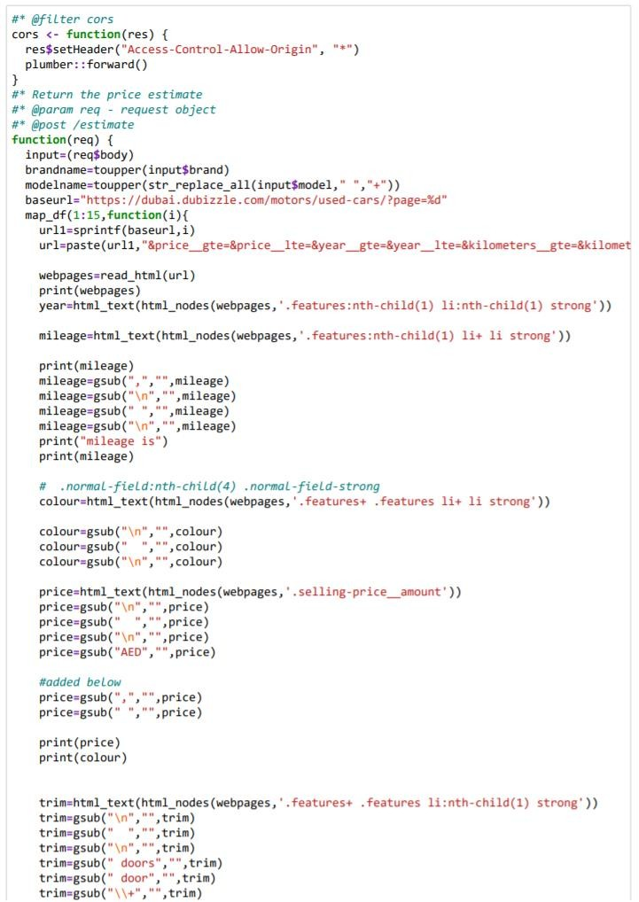

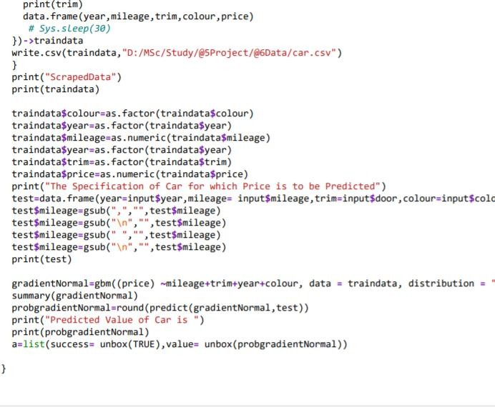

2.SCRAPING CODE
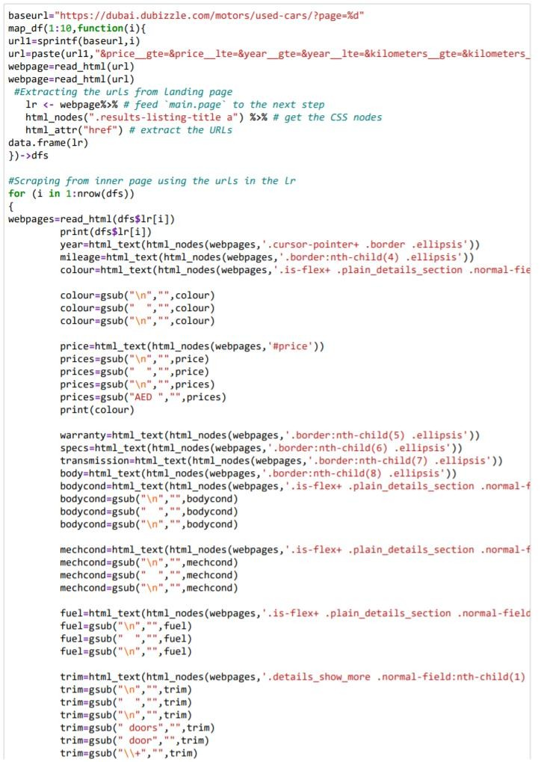

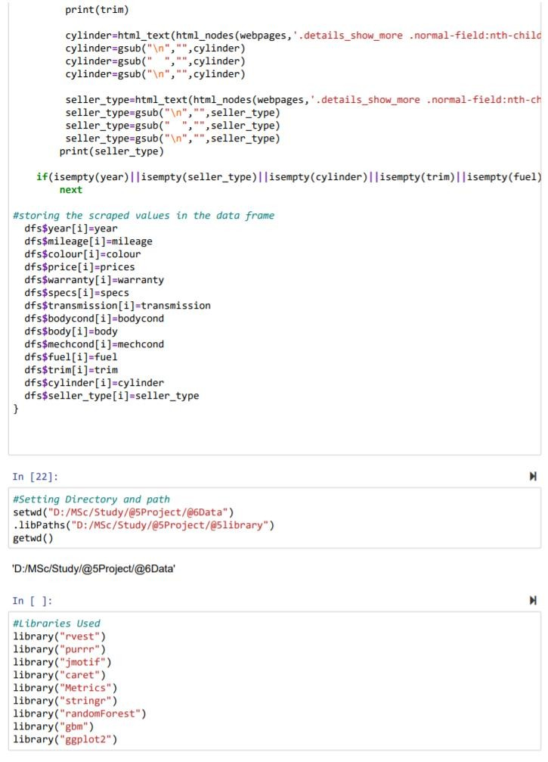

3.MODELING
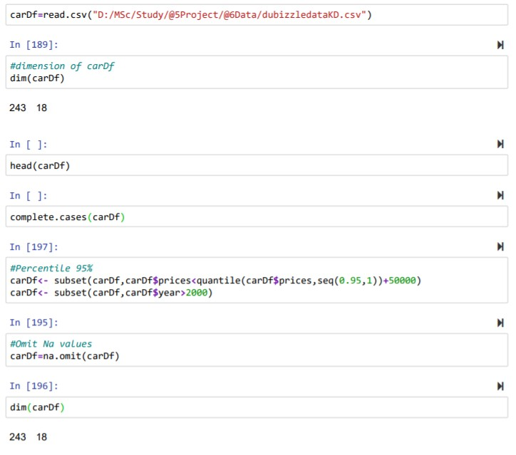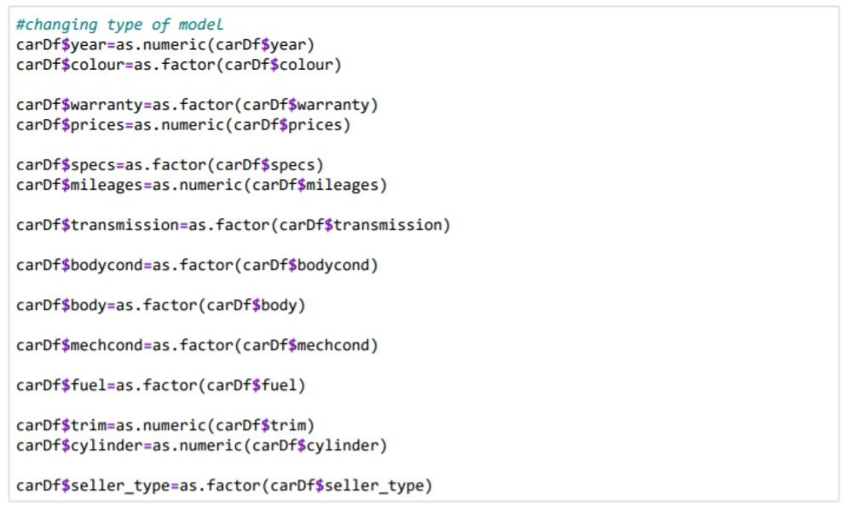
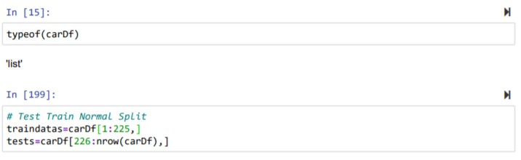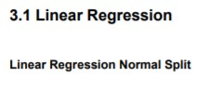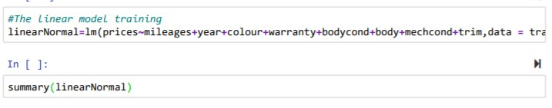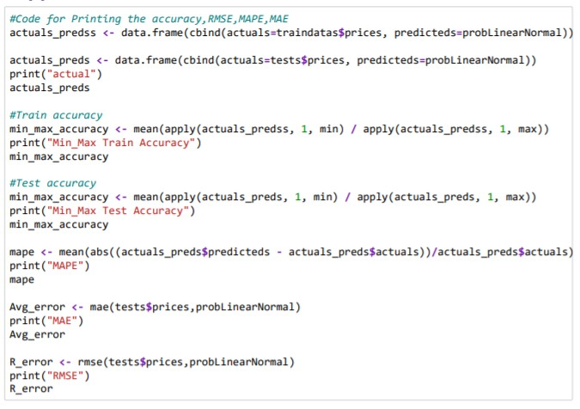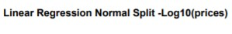

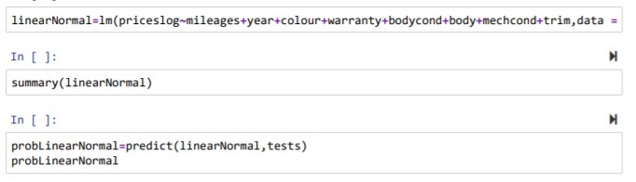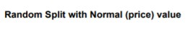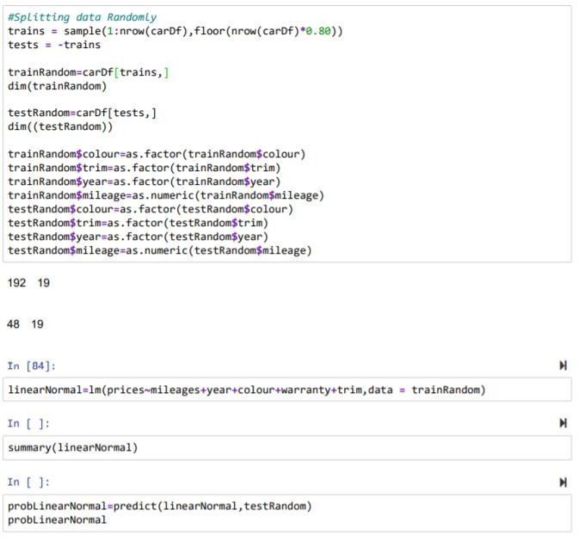

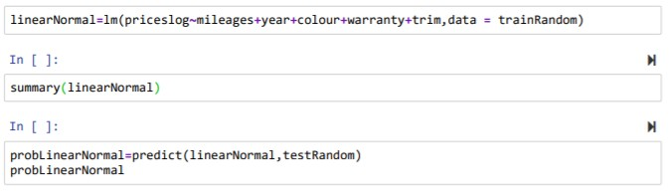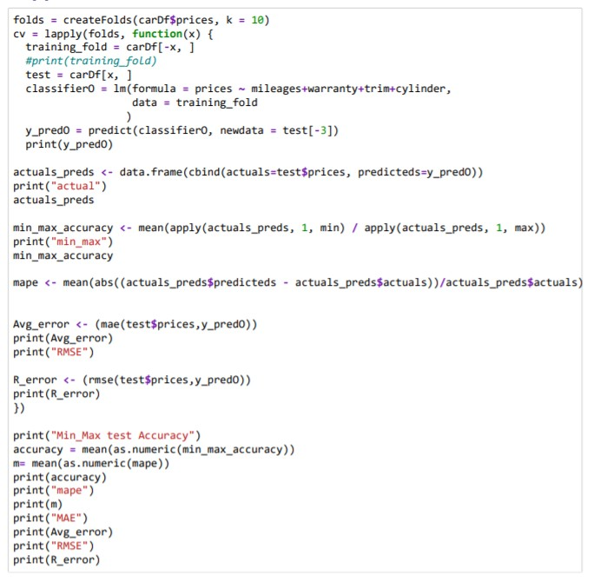

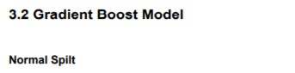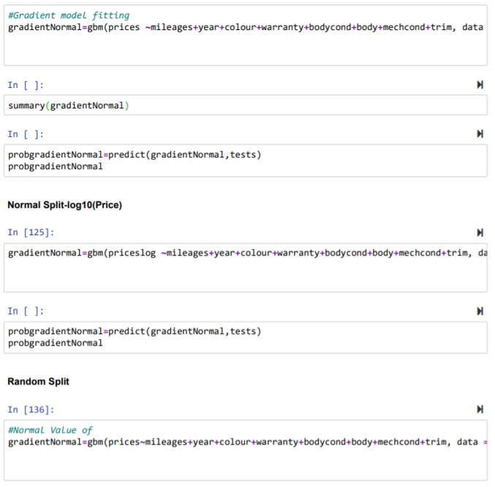

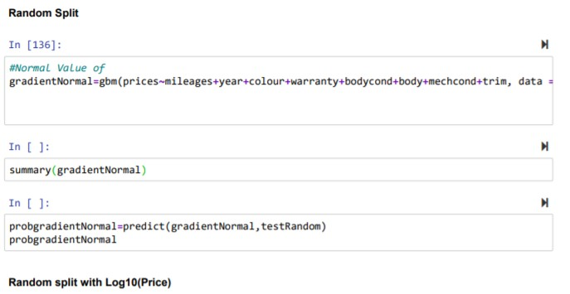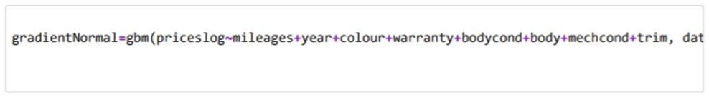

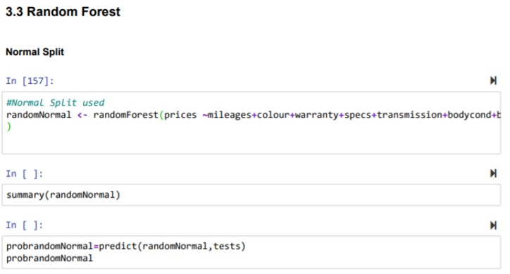
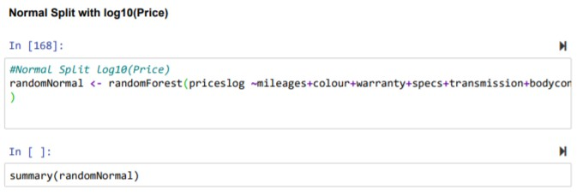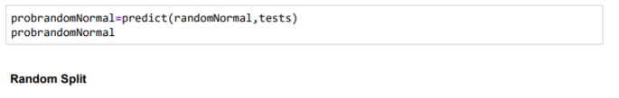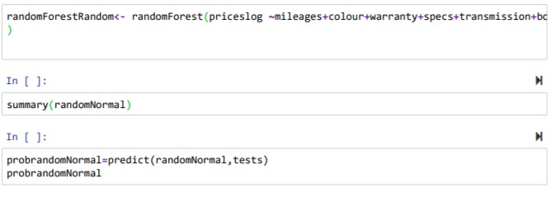

4 HYPERPARAMETER TUNING
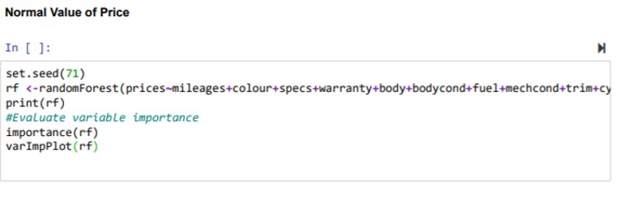
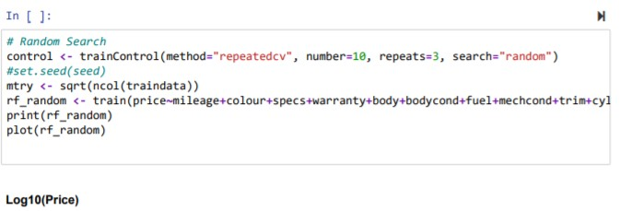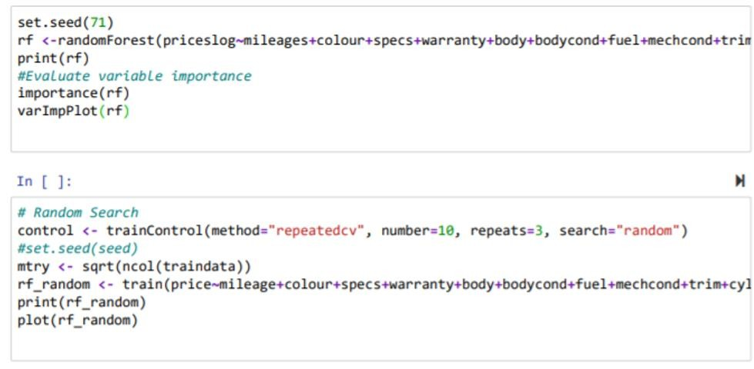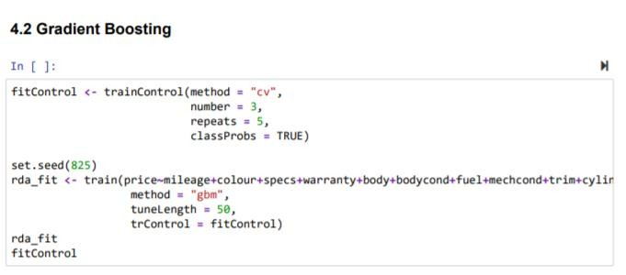
5. FINAL MODEL
