MSc Project Proposal



MSc Data Science Project Proposal

Name Surname | Student number

Programme of Study | Data Science
Name of Supervisor | Krishnadas Nanath

Crisis Care
Leveraging Generative AI for Volunteer-Crisis Management Matchmaking in Disaster Response

Submission Date 01- Jul- 2024

Table of Contents
Table of Contents 2
1. Abstract 3
2. Introduction 4
3. State of the Art Review 5
4. Methods 5
5. Proposed Work 6
5.1. Intended contribution of the work 6
5.2. Benefits of the proposed work 7
5.3. Procedures and activities of the proposed work 7
5.4. Evaluation of the project 7
5.5. Resources needed 7
5.6. Access to participants and clients 8
5.7. Ethical Aspects 8
6. Work plan and schedule 8
7. Conclusions 9
8. Bibliography 9
1.1.1. Additional Resources 10
9. Appendixes 10

Abstract
Research goal is to enhance disaster response operations through developing novel methods to match volunteers' availability and skills with the requirements of crisis scenarios. This will entail combining various datasets of volunteer profiles, crisis incident reports, and resource allocation data. Advanced generative AI models, like natural language processing (NLP) and reinforcement learning (RL), will compare volunteer deployment techniques. The aim is to increase volunteer matching's precision and effectiveness and accordingly improve disaster response tactics. Data will be sourced from online volunteer profiles, incident reports, and potentially crisis institutions.

Introduction
Disaster response operations depend on effectively deploying volunteers based on their skills, availability, and geographic proximity to crisis areas. The growing frequency and intensity of disasters highlight the need for innovative solutions in volunteer management. This study aims to develop a system to optimize volunteer deployment.

- The core Problem is inefficiency matching volunteers to crisis management tasks. current methods result in underutilization of volunteers and inadequate support to crisis-affected areas. By integrating data sources and utilizing advanced AI models, this research aims to innovate strategies to improve the accuracy and efficiency of volunteer-task matching in disaster response.
- Aims and Objectives
Aim 1: Enhance efficiency of volunteer deployment in disaster response operations.
1.1: Collect and integrate diverse data sources relevant to disaster response, including volunteer profiles and incident reports.
1.2: Amalgamates volunteer information with crisis management needs.
1.3: Implement NLP models for analysing textual data of volunteers and incident reports.
1.4: Compare various NLP models performance for volunteer-task matching.
1.5: Optimize the data integration process for real-time updates and accuracy.
Aim 2: Identify most effective AI methods for matching volunteers to crisis management tasks.
2.1: Deploy reinforcement learning models for volunteer matching decision-making.
2.2: Evaluate effectiveness of reinforcement learning models in crisis scenarios.
2.3: Compare NLP and RL models performance in volunteer-task matching.
2.4: To conduct pilot solution for the volunteer-task matching.
2.5: AI models refinement based on pilot studies and real-world applications.
- Contribution of the Project
Academically contribution through understanding how AI models, especially NLP and RL, can address logistical issues in disaster response. findings will benefit researchers in AI, data science, and crisis management. aiding disaster response agencies and volunteer organizations by improving volunteer deployment, potentially saving lives and resources.

State of the Art Review
The literature underscores importance of integrating diverse data sources and employing advanced AI techniques to enhance the efficiency and effectiveness of disaster response operations. Specifically, the use of NLP and reinforcement learning models. academic publications, aligns with our project's aim to optimize volunteer deployment. The non-academic articles provide additional context and practical insights that support the feasibility and relevance of our proposed solutions. By building on these existing studies, our research seeks to address the identified inefficiencies in volunteer-task matching, ultimately contributing to improved disaster response outcomes. Previous studies highlighted the critical role of volunteers in disaster response. (Alexander, 2015) (Spiekermann, 2015) Current systems for volunteer coordination often rely on manual processes or basic matching algorithms, which fail to consider complexity of real-time disaster scenarios. (Hossain, 2010) (Zettl, 2017).Generative AI models have shown promise in various applications, including text analysis and decision-making. (Radford, 2019) (Silver, 2016) Especially NLP techniques in extracting actionable insights from unstructured data (Devlin, 2019), while reinforcement learning for optimizing complex processes . (Mnih, 2015) This will potentially transform volunteer-crisis management matchmaking. (Ahmed, 2022) However, applying these in disaster response remains underexplored, necessitating further research to validate their effectiveness. The existing literature on disaster response highlights the critical need for effective volunteer coordination . (Smith, 2021) Various studies have explored various aspects such as skill matching and geographic deployment. (Stephens, 2022) (Whittaker, 2015) Recent AI advancements, particularly in NLP and reinforcement learning, offer promising approaches . (Sun, 2020) also research by (Swaminathan, 2023) demonstrated the potential of NLP in analysing incident reports to extract valuable insights for crisis management. Similarly, a study by (Yu, 2021) highlighted effectiveness of reinforcement learning in optimizing resource allocation in disaster response. These studies provide a foundation for integrating generative AI models to improve volunteer-crisis management matchmaking. building on the above, this research aims to develop a comprehensive system that leverages generative AI for efficient volunteer deployment, addressing the identified gaps in the current literature.

Methods
adopting a data-driven approach to develop and evaluate generative AI models for volunteer-crisis matchmaking prototype, hence process will involve:
Data Acquisition: Datasets will be collected from various sources, including online volunteer profiles and crisis incident reports from the Relief Web API. Synthetic data will supplement limited volunteer and resource allocation information. The data will be cleaned, normalized, and integrated to establish relationships between volunteer profiles and crisis incident reports for efficient retrieval and analysis.

Methodology: Two primary AI methodologies will be utilized to address the inefficiency in volunteer-task matching:

- NLP Models: Utilize NLP techniques to analyze text-based incident reports, extracting key information about crisis needs. Key methods include entity recognition to identify skills and needs, sentiment analysis to gauge urgency, and topic modelling to categorize information. Various NLP models, such as BERT and GPT, will be implemented and compared to determine their effectiveness in matching volunteers to tasks.
- Reinforcement Learning: Implement reinforcement learning algorithms to optimize the decision-making process for volunteer deployment.

- Validation and Verification/ Comparative Analysis: Compare performance of different generative models in terms of accuracy and efficiency in matching volunteers to tasks focusing on metrics like precision, recall, and F1-score.

Justification: By combining these methods, the research aims to develop a comprehensive prototype and eventually a solution that addresses the complexity and urgency of disaster response operations.

Proposed Work
This project develops an AI-driven framework for optimizing volunteer deployment in disaster response. Phases include planning, data collection and integration, model development (NLP and RL), validation and testing, pilot studies, model refinement, and final evaluation. The work concludes with comprehensive documentation and dissertation write-up.

Intended contribution of the work
Aim is to develop an AI-based solution for efficient volunteer-crisis matchmaking, making a small yet valuable academic contribution. It applies known machine learning techniques to improve volunteer deployment, providing a useful tool for enhancing disaster response management practices. Using content-Based Filtering where volunteers matching is based on similarity between their characteristics (skills, location, availability) and the project's need.

Benefits of the proposed work
enhance the efficiency of volunteer deployment in disaster response, benefiting crisis management organizations by optimizing resource allocation. The primary beneficiaries include disaster response agencies, volunteers, and affected communities, leading to more effective crisis management, and potentially saving lives and resources during emergencies.

Procedures and activities of the proposed work
Objective | Activity | Milestone
Data Integration | Collect and preprocess datasets | Data preprocessing done
NLP Model Development | Implement and test NLP models | NLP models tested
Reinforcement Learning | Develop reinforcement learning models | RL models evaluated
Comparative Analysis | Compare model performance | Analysis completed

Evaluation of the project

Prototype Evaluation : Performance evaluation of NLP models and reinforcement learning (RL) agents will use quantitative metrics like (accuracy, precision, recall, F1 score). additionally, error analysis, confusion matrices, and human evaluations to further assess NLP, while for RL agents, focus on cumulative and average rewards, learning curves, convergence time, and policy evaluation through value and Q-value functions.
- Process Evaluation: Regular development logs reviews with supervisor, ensuring project objectives adherence. Assessment criteria such as adherence to milestones, timeline, and clarity.
Evaluation Plan: includes iterative testing and validation of AI models, with each task lasting approximately two weeks.

Resources needed
- Software: Python, TensorFlow
- Hardware: High-performance computing resources
- Data Access: APIs for crisis data from open API “ReliefWeb” (up to 1000 records, and Volunteers’ using synthetic data generation tools.

Access to participants and clients
Cooperation from crisis management platforms will add value and attempts in progress with volunteer.ae. contingency plans are using synthetic data, social media, and free api’s.

Ethical Aspects
indirect human participation through using crisis and volunteer’s data will occur. Ethical approval will be sought for handling sensitive data, ensuring privacy and data security.

Work plan and schedule
The plan is created on Smartsheet a cloud project management tool, and an excel export of the WBS and Gantt chart are provided to illustrate the timeline and milestones.

Phase/Objective | Activities | Milestone
Initiation
 | Discovery on crises management solutions and research | Proposal
 | explore data sources | Proposal
 | scope definition | Proposal
Literature Review
 | research papers on litmap, websites google, other | Proposal and thesis
 | references summary table, download papers in directory | Proposal and thesis
Requirements Analysis & Design
 | Dataset collection phase 1 - API, Synthetic, online scraping | Prototype design
 | prototype Crisis incidents capture – prioritise top ten or other approaches/options for matching tags | Prototype design
 | prototype Resources db. volunteer from volunteer’s registration form or NGO | Prototype design
 | prototype NLP for text analysis | Prototype design
 | prototype build a GEN AI model to recommend crises solutions and matching volunteers and resources | Prototype design
Design
 | design context diagram | Pilot
 | solution pilot | Pilot
Development
 | data collection phase 2 | Pilot
 | portal (volunteers - Resources - Crises Incidents-Care Requests) | Pilot
 | GBT model | Pilot
 | recommender | Pilot
Documentation & Graded Deliverables
 | proposal draft | Thesis
 | final proposal | Thesis
 | formal project proposal | Thesis
 | Ch1 introduction partial and ch2 literature review | Thesis
 | submission, approval, and feedback | Thesis
 | final report | Thesis
 | viva voice plus poster | Thesis

Conclusions
This project proposes a novel approach to disaster response using generative AI for volunteer-crisis matchmaking. By integrating advanced AI models and multiple data sources, the research aims to enhance the efficiency and effectiveness of volunteer deployment, making a valuable contribution to disaster management practices

Bibliography
Academic Publications

Ahmed, A. A. A., 2022. Integrated artificial intelligence effect on crisis management and lean production: structural equation modelling frame work. Springer Nature, p. 220–227.
Alexander, D., 2015. Disaster and Emergency Planning for Preparedness, Response, and Recovery. Oxford Research Encyclopedia of Natural Hazard Science, Volume Oxford University Press: Oxford, pp. 1-20.
Anon., 2019. Optimizing Disaster Response through Data Integration and Machine Learning.. s.l.:https://www.examplejournal.com/jcm/v15/i4/optimizing-disaster-response.
Devlin, J., 2019. BERT: Pre-training of Deep Bidirectional Transformers for Language Understanding. s.l., Association for Computational Linguistics.
Hossain, L., 2010. Disaster response preparedness coordination through social networks. WILEY ONLINE LIBRARY, 34(3), pp. 755-786.
Mnih, V., 2015. Human-level control through deep reinforcement learning. nature, p. 529–533.
Radford, A., 2019. Language Models are Unsupervised Multitask Learners, s.l.: OpenAI.
Silver, D., 2016. Mastering the game of Go with deep neural networks and tree search. Nature, p. pages484–489.
Smith, W. R., 2021. A different type of disaster response digital volunteer: Looking behind the scenes to reveal coordinating actions of disaster knowledge workers. WILEY ONLINE LIBRARY, 29(2), pp. 116-130.
Spiekermann, R., 2015. The Disaster-Knowledge Matrix – Reframing and evaluating the knowledge challenges in disaster risk reduction. International Journal of Disaster Risk Reduction, Volume 13, pp. 96-108.
Stephens, K. K., 2022. Disaster Rescue Communication Using Mobile Devices, Social Media, and Artificial Intelligence. Springer Nature, p. 1–17.
Sun, W., 2020. Applications of artificial intelligence for disaster management. Springer Nature, Volume 103, p. 2631–2689.
Swaminathan, A., 2023. Natural language processing system for rapid detection and intervention of mental health crisis chat messages. npj Digital Medicine.
Whittaker, J., 2015. A review of informal volunteerism in emergencies and disasters: Definition, opportunities and challenges. International Journal of Disaster Risk Reduction, Volume 13, pp. 358-368.
Yu, L., 2021. Reinforcement learning approach for resource allocation in humanitarian logistics. Expert Systems with Applications.
Zettl, V., 2017. Zettl, V., Ludwig, T., Kotthaus, C., & Skudelny, S. (2017). Embedding Unaffiliated Volunteers in Crisis Management Systems: Deploying and Supporting the Concept of Intermediary Organizations. s.l., s.n.

Non-Academic Publications
- "Improving Disaster Response with Technology," TechCrunch, 2021. Link
- "The Role of AI in Modern Disaster Management," MIT Technology Review, 2022. Link

Appendixes

- Gantt Chart

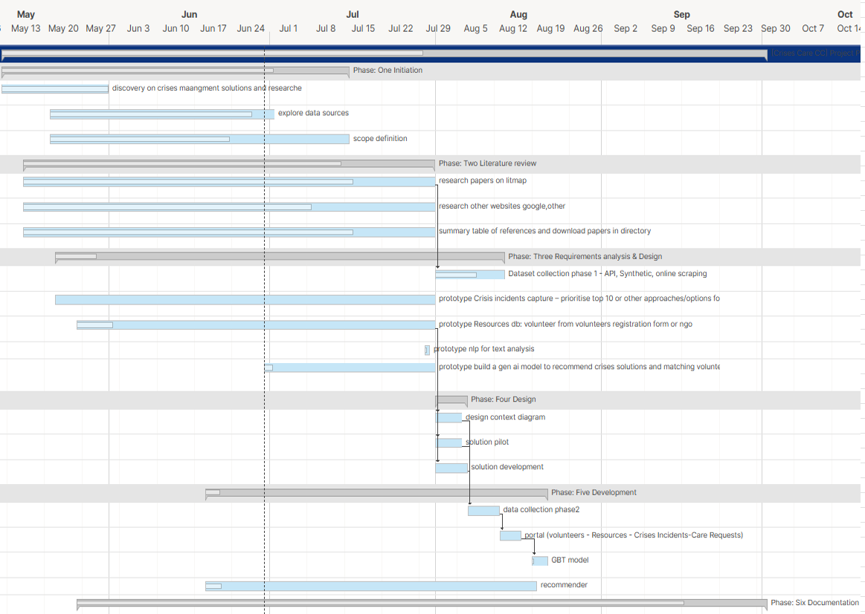


- WBS

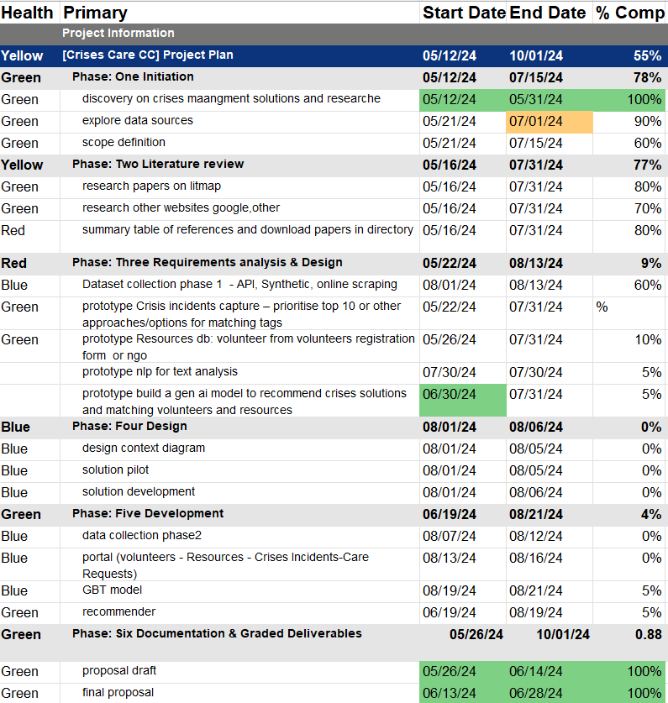
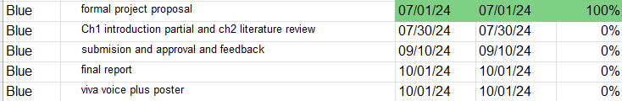

Refences

- Alexander, DE; (2015) Disaster and Emergency Planning for Preparedness, Response, and Recovery Link
- R. Spiekermann; (2015) The Disaster-Knowledge Matrix – Reframing and evaluating the knowledge challenges in disaster risk reduction Link
- Hossain L, Kuti M. Disaster response preparedness coordination through social networks. Disasters. 2010 Link
- Ludwig et al, Zettl et al 2017 “Embedding Unaffiliated Volunteers in Crisis Management Systems ...” Link
- Radford et al, 2019 Language Models are Unsupervised Multitask Learners Link
- Silver et al., 2016 Mastering the game of Go with deep neural networks and tree search Link
- Jacob Devlin 2019. BERT: Pre-training of Deep Bidirectional Transformers for Language Understanding Link
- Mnih, V. et al. 2015 Human-level control through deep reinforcement learning. Nature Link
- Ahmed, A.A.A., et al 2022. Integrated artificial intelligence effect on crisis management and lean production: structural equation modelling frame work Link (“(PDF) Integrated artificial intelligence effect on crisis management ...”)
- Smith et al., 2021 A different type of disaster response digital volunteer: Looking behind the scenes to reveal coordinating actions of disaster knowledge workers Link
- Stephens, K.K., Carlson, N.H., Xu, Y. (2022). Disaster Rescue Communication Using Mobile Devices, Social Media, and Artificial Intelligence. In: Singh, A. (eds) International Handbook of Disaster Research. Springer, Singapore Link
- Joshua Whittaker, et al 2015 A review of informal volunteerism in emergencies and disasters: Definition, opportunities and challenges, International Journal of Disaster Risk Reduction Link
- Wenjuan Sun et al 2020, Applications of artificial intelligence for disaster management link
- Swaminathan, A., López, I., Mar, R.A.G. et al.2023 Natural language processing system for rapid detection and intervention of mental health crisis chat messages. Link
- Lina Yu, Canrong Zhang, Jingyan Jiang, Huasheng Yang, Huayan Shang, 2021 Reinforcement learning approach for resource allocation in humanitarian logistics,Expert Systems with Applications link

