https://www.6wresearch.com/industry-report/saudi-arabia-core-assurance-service-market
Saudi Arabia Core Assurance Service Market Report thoroughly covers the market by Organization Type and by End user. Saudi Arabia Core Assurance Service Market Outlook report provides an unbiased and detailed analysis of the ongoing Saudi Arabia Core Assurance Service Market trends, opportunities/high growth areas, and market drivers. This would help stakeholders devise and align their market strategies according to the current and future market dynamics.
Saudi Arabia Core Assurance Service Market Synopsis
The Saudi Arabia Core Assurance Services Market is witnessing sustained expansion, underpinned by Vision 2030–driven public spending, regulatory tightening, and a sharp rise in the number of regulated operating entities across priority sectors. Saudi Arabia’s annual government budget increased, reflecting continued fiscal commitment to infrastructure, transportation, energy, and industrial development. These investments are directly translating into the formation of new operating companies, SPVs, and government-linked enterprises, all of which are subject to mandatory statutory audits, audited financial statements, and IFRS-aligned reporting. Vision 2030 focus sectors including construction, transportation, healthcare, and renewables are projected to collectively increase in the coming years, structurally expanding the addressable market for core financial and statutory assurance services.
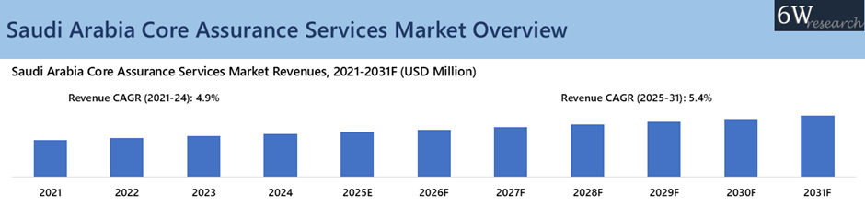
According to 6Wresearch, Saudi Arabia Core Assurance Services Market revenue size is projected to grow at a CAGR of 5.4% during 2025-2031. Supported by tourism expansion which is emerging as a major incremental demand driver for assurance services. In 2024, Saudi Arabia issued hospitality licenses, while accommodation room licenses and travel and tourism service licenses rate increased tremendously, materially expanding the base of regulated hospitality operators requiring audited financial statements. International arrivals are projected to rise in the coming years, reinforced by global events such as the 2026 Spanish Super Cup and the 2034 FIFA World Cup, sustaining long-term statutory audit demand across hotels, entertainment, and supporting infrastructure. Manufacturing expansion is further reinforcing market growth, with the sector’s GDP contribution increasing and industrial establishments rising massively. Saudi Arabia aims to triple industrial production by 2030, supported by billions in planned manufacturing investments across electronics, automotive, steel, food & beverages, and renewable components, increasing statutory audit complexity linked to capital intensity, inventory valuation, and consolidation requirements.
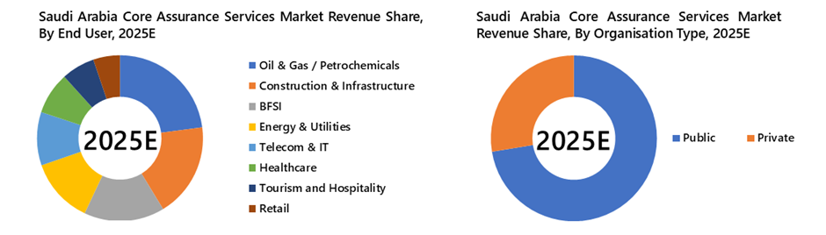
Market Segmentation By Organization Type
The private sector in Saudi Arabia’s Core Assurance Services Market is expected to record the fastest growth from 2025 to 2031, supported by the expanding base of privately owned companies, increased capital market participation, and steady growth in debt-funded expansion and M&A activity. Rising enforcement of financial reporting standards, cross-border investments, and private sector participation in Vision 2030 projects are driving sustained demand for recurring statutory and financial assurance services, accelerating growth ahead of the public sector.”
Market Segmentation By End user
The tourism and hospitality sector in Saudi Arabia’s Core Assurance Services Market is expected to record the fastest growth from 2025 to 2031, supported by rapid capacity additions across hotels, resorts, entertainment destinations, and travel services, alongside accelerating private investment. Increasing capital market participation, asset-heavy expansion, and a steady pipeline of debt-funded development and M&A across operators and developers are intensifying the need for robust financial assurance. Rising enforcement of financial reporting standards, higher volumes of cross-border partnerships and investments, and the sector’s central role in Vision 2030 giga-projects are driving sustained demand for recurring statutory audits, revenue and receivables assurance, internal controls reviews, and compliance assurance, accelerating growth ahead of more mature segments.
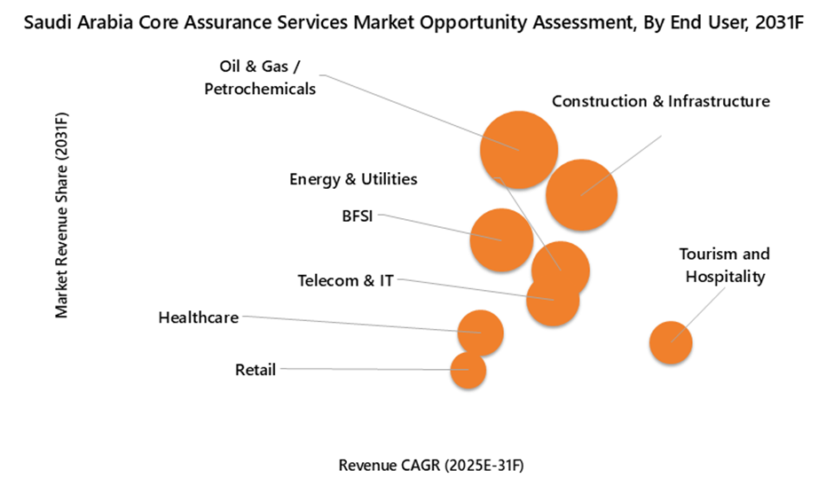
Key Attractiveness of the Report
10 Years Market Numbers.
Historical Data Starting from 2021 to 2024
Base Year: 2024
Forecast Data until 2031
Key Performance Indicators Impacting the Market.
Major Upcoming Developments and Projects.
Key Highlights of the Report:
Global Core Assurance Services Market Overview
Saudi Arabia Core Assurance Services Market Overview
Saudi Arabia Core Assurance Services Market Outlook
Saudi Arabia Core Assurance Services Market Forecast
Historical Data and Forecast of Saudi Arabia Core Assurance Services Market Revenues for the Period 2021-2031F
Historical Data and Forecast of Saudi Arabia Core Assurance Services Market Revenues, By Organization Type, for the Period 2021-2031F
Historical Data and Forecast of Saudi Arabia Core Assurance Services Market Revenues, By End User, for the Period 2021-2031F
Industry Life Cycle
Porter’s Five Force Analysis
Saudi Arabia Core Assurance Services Market Drivers and Restraints
Market Trends & Evolution
Market Opportunity Assessment
Saudi Arabia Core Assurance Services Market Revenues, By Top 4 Companies
Competitive Benchmarking
Company Profiles
Key Strategic Recommendations

https://www.6wresearch.com/industry-report/saudi-arabia-fashion-e-commerce-market
https://www.6wresearch.com/industry-report/saudi-arabia-e-commerce-apparel-market
Saudi Arabia E Commerce Apparel Market Overview
The Saudi Arabia e-commerce apparel market is experiencing rapid growth due to increasing internet penetration, a young population with a high affinity for online shopping, and a growing preference for international and trendy fashion brands. Major players in the market include Namshi, Noon, and Souq, offering a wide range of clothing options for men, women, and children. The market is highly competitive, with players focusing on enhancing customer experience through personalized recommendations, easy payment options, and fast delivery services. The COVID-19 pandemic has further accelerated the shift towards online shopping, leading to increased demand for casual and comfortable clothing. In response, retailers are investing in digital marketing strategies and expanding their product offerings to capitalize on the growing demand for e-commerce apparel in Saudi Arabia.
Saudi Arabia E Commerce Apparel Market Trends
The Saudi Arabia e-commerce apparel market is experiencing significant growth driven by factors such as increasing internet penetration, rising smartphone usage, and a growing young population with high disposable income. Consumers are increasingly turning to online platforms to shop for a wide range of apparel products, including traditional clothing and western wear. Key trends in the market include the rising popularity of fast fashion, the emergence of online marketplaces offering a diverse selection of brands, and the growing demand for modest fashion options catering to the preferences of the local population. E-commerce players are also focusing on enhancing the shopping experience through personalized recommendations, easy payment options, and fast delivery services to capture a larger share of this expanding market.
Saudi Arabia E Commerce Apparel Market Challenges
In the Saudi Arabia e-commerce apparel market, some key challenges include navigating the strict regulations and customs duties imposed on international online purchases, ensuring secure online payment methods to build consumer trust, addressing logistical issues in delivering products efficiently across the vast geographical area of the country, and overcoming the preference for traditional in-store shopping experiences among some consumers. Additionally, competition from established brick-and-mortar retailers and global e-commerce giants entering the market poses a threat to local e-commerce apparel businesses. Adapting to cultural norms and preferences, such as modesty requirements in clothing choices, and providing personalized shopping experiences to meet the diverse needs of consumers in Saudi Arabia are also important challenges that players in the e-commerce apparel market must address.
Saudi Arabia E Commerce Apparel Market Investment Opportunities
The Saudi Arabia e-commerce apparel market presents promising investment opportunities due to the country`s young population, high internet penetration rate, and increasing preference for online shopping. With a rising middle class and growing disposable incomes, consumers in Saudi Arabia are increasingly turning to e-commerce platforms to purchase apparel, creating a lucrative market for investors. Additionally, the government`s Vision 2030 initiative aims to diversify the economy and promote digital transformation, further boosting the e-commerce sector. Investing in e-commerce platforms, logistics and supply chain infrastructure, digital marketing, and technology solutions tailored for the Saudi market can offer substantial returns in this rapidly evolving sector. However, investors should also be mindful of competition, evolving consumer preferences, and regulatory considerations in the Saudi Arabian market.
Saudi Arabia E Commerce Apparel Market Government Policy
In Saudi Arabia, the e-commerce apparel market is regulated by the Ministry of Commerce and Investment, with policies aimed at promoting online consumer protection and fair competition. The government has implemented regulations to ensure transparency in pricing, product quality, and terms of sale for e-commerce platforms operating in the country. Additionally, there are guidelines in place to protect consumer data privacy and prevent fraudulent activities in online transactions. Saudi Arabia has also introduced initiatives to support the growth of the e-commerce sector, such as providing training programs for entrepreneurs and promoting digital payment solutions. Overall, the government`s policies focus on creating a conducive environment for the expansion of the e-commerce apparel market while safeguarding consumer rights and fostering innovation in the industry.
Saudi Arabia E Commerce Apparel Market Future Outlook
The future outlook for the Saudi Arabia e-commerce apparel market is promising as the country`s rapidly growing internet penetration rate and increasing use of smartphones are driving online shopping trends. With a young and tech-savvy population, there is a strong demand for convenient and diverse retail options, including clothing and fashion items. As more international e-commerce platforms expand their presence in Saudi Arabia and local players continue to innovate and improve their services, the market is expected to experience significant growth in the coming years. Additionally, the recent shift towards online shopping due to the COVID-19 pandemic has further accelerated the adoption of e-commerce in the apparel sector, indicating a bright future for the Saudi Arabia e-commerce apparel market.
Key Highlights of the Report:
Saudi Arabia E Commerce Apparel Market Outlook
Market Size of Saudi Arabia E Commerce Apparel Market,2024
Forecast of Saudi Arabia E Commerce Apparel Market, 2031
Historical Data and Forecast of Saudi Arabia E Commerce Apparel Revenues & Volume for the Period 2021-2031
Saudi Arabia E Commerce Apparel Market Trend Evolution
Saudi Arabia E Commerce Apparel Market Drivers and Challenges
Saudi Arabia E Commerce Apparel Price Trends
Saudi Arabia E Commerce Apparel Porter's Five Forces
Saudi Arabia E Commerce Apparel Industry Life Cycle
Historical Data and Forecast of Saudi Arabia E Commerce Apparel Market Revenues & Volume By Product Type for the Period 2021-2031
Historical Data and Forecast of Saudi Arabia E Commerce Apparel Market Revenues & Volume By Men's Apparel for the Period 2021-2031
Historical Data and Forecast of Saudi Arabia E Commerce Apparel Market Revenues & Volume By Women's Apparel for the Period 2021-2031
Historical Data and Forecast of Saudi Arabia E Commerce Apparel Market Revenues & Volume By Kids' Apparel for the Period 2021-2031
Historical Data and Forecast of Saudi Arabia E Commerce Apparel Market Revenues & Volume By Distribution Channel for the Period 2021-2031
Historical Data and Forecast of Saudi Arabia E Commerce Apparel Market Revenues & Volume By Online Marketplaces for the Period 2021-2031
Historical Data and Forecast of Saudi Arabia E Commerce Apparel Market Revenues & Volume By Brand-Owned Websites for the Period 2021-2031
Historical Data and Forecast of Saudi Arabia E Commerce Apparel Market Revenues & Volume By Multi-Brand Retailers for the Period 2021-2031
Saudi Arabia E Commerce Apparel Import Export Trade Statistics
Market Opportunity Assessment By Product Type
Market Opportunity Assessment By Distribution Channel
Saudi Arabia E Commerce Apparel Top Companies Market Share
Saudi Arabia E Commerce Apparel Competitive Benchmarking By Technical and Operational Parameters
Saudi Arabia E Commerce Apparel Company Profiles
Saudi Arabia E Commerce Apparel Key Strategic Recommendations
How much growth is expected in the market?
Saudi Arabia Core Assurance Service Market is projected to grow at a CAGR of 5.4% during 2025-2031F.
How much growth is expected in the market?
Saudi Arabia Core Assurance Service Market is projected to grow at a CAGR of 5.4% during 2025-2031F.
What are the challenges faced by market?
The market faces restraints due to rising technology adoption.

https://www.6wresearch.com/industry-report/saudi-arabia-car-window-tinting-film-paint-protection-film-ppf-and-ceramic-coating-market
Saudi Arabia Car Window Tinting Film, Paint Protection Film (PPF), and Ceramic Coating Market Report thoroughly covers the Market by type, product type, vehicle type, sales channel, and by means of financing. Saudi Arabia Car Window Tinting Film, Paint Protection Film (PPF), and Ceramic Coating Market Outlook report provides an unbiased and detailed analysis of the ongoing Saudi Arabia Car Window Tinting Film, Paint Protection Film (PPF), and Ceramic Coating Market trends, opportunities/high growth areas, and Market drivers. This would help stakeholders devise and align their Market strategies according to the current and future Market dynamics.
Saudi Arabia Car Window Tinting Film, Paint Protection Film (PPF), and Ceramic Coating Market Synopsis
Saudi Arabia Car Window Tinting Film, Paint Protection Film (PPF), and Ceramic Coating Market recorded strong expansion between 2021 and 2024, underpinned by structural growth in the automotive sector, rising vehicle ownership, and increasing preference for premium vehicle protection solutions. Passenger vehicle sales increased massively, reflecting a sustained rise in the active vehicle parc. The passenger car segment accounted for largest units in 2024, significantly outweighing commercial vehicles units, reinforcing the dominance of personal mobility in national transport demand. This growth was further supported by increasing localization ambitions under Vision 2030, with Saudi Arabia targeting production rate of passenger vehicles by 2030. These trends collectively strengthened installation volumes for tinting, PPF, and ceramic coatings across both dealership and professional detailing channels.
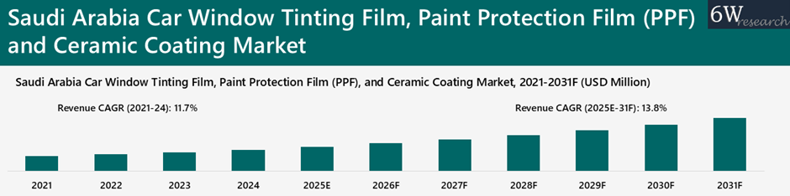
According to 6Wresearch, Saudi Arabia car window tinting film, PPF, and ceramic coating Market is projected to grow at a CAGR of 13.8% during 2025-2031F, driven by continued expansion in vehicle sales, rising urban concentration, and increasing adoption of premium automotive care services. Riyadh, Makkah, and the Eastern Province together account for nearly more than half percent of automotive activity. These regions benefit from higher vehicle utilization, growing premium car penetration, and fleet-driven demand linked to industrial and logistics activity.
Vision 2030 initiatives, including investments in clean mobility, local manufacturing, and infrastructure development, are further accelerating vehicle turnover and customization trends. As consumers increasingly prioritize heat rejection, UV protection, surface preservation, and aesthetic enhancement, demand for window tinting, PPF, and ceramic coatings is expected to scale steadily, reinforcing long-term revenue visibility and expanding commercial opportunities for service providers across Saudi Arabia’s automotive protection ecosystem.
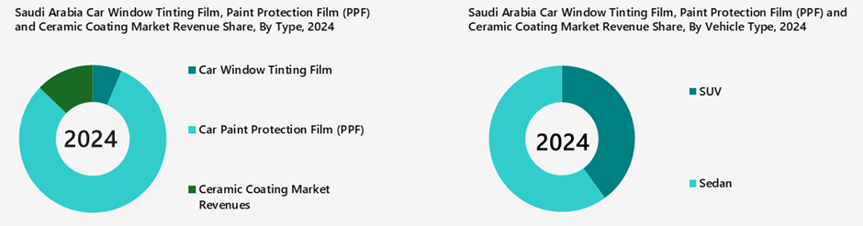
Market Segmentation By Type
Paint Protection Film (PPF) is both the dominant and fastest-growing segment in Saudi Arabia’s car window tinting film, PPF, and ceramic coating market, as it commands the largest revenue share while also exhibiting the highest growth. Its dominance is driven by higher average selling prices, increasing penetration in premium vehicles and SUVs, and strong demand for long-term paint preservation under Saudi Arabia’s extreme heat and sand exposure.
Market Segmentation By Product Type
Carbon Tint remains the dominant product type in Saudi Arabia’s car window tinting film market, as it holds the largest revenue share in 2031F, driven by its strong balance of affordability, effective heat rejection, and wide acceptance across mass-market vehicles and aftermarket installations.
Thermoplastic Polyurethane (TPU) is both the dominant and faster-growing product type in Saudi Arabia’s Paint Protection Film (PPF) market, accounting for the overwhelming majority of revenue in 2031F and registering a higher CAGR than Thermoplastic Hybrid (TPH).
Quartz/Silica-based (SiO₂) coatings are the dominant product type in Saudi Arabia’s ceramic coating market, accounting for the largest revenue share in 2031F, driven by their superior hardness, long-term gloss retention, hydrophobicity, and strong resistance to UV exposure, sand abrasion, and chemical contaminants in harsh desert conditions.
Market Segmentation By Vehicle Type
Sedans remain the dominant vehicle segment in Saudi Arabia’s car window tinting film market, holding the largest revenue share in 2031F, driven by their large installed base, high ownership among private commuters, and widespread adoption of tinting for heat reduction, privacy, and interior protection.
Sedans continue to dominate Saudi Arabia’s Paint Protection Film (PPF) market by vehicle type, accounting for the largest revenue share in 2031F, supported by their extensive on-road base, high usage in daily commuting, and strong adoption of PPF for maintaining resale value and paint condition under harsh climatic exposure.
In Saudi Arabia’s ceramic coating market, SUVs emerge as the dominant vehicle segment, slightly surpassing sedans in 2031F revenue, reflecting the strong preference for larger vehicles and their higher per-vehicle coating requirements due to greater surface area.
Market Segmentation By Sales Channel
Professional detailing centers are the dominant sales channel in Saudi Arabia’s car window tinting film, PPF, and ceramic coating market, accounting for the largest revenue share in 2031F, as protection solutions are increasingly purchased as specialist, service-led upgrades delivered through dedicated application facilities.
Market Segmentation By Means of Financing
Credit cards remain the dominant means of financing in Saudi Arabia’s car window tinting film, PPF, and ceramic coating market, accounting for the largest revenue share in 2031F, driven by widespread card penetration, reward programs, and easy acceptance across dealerships and professional detailing centers for high-value protection services.
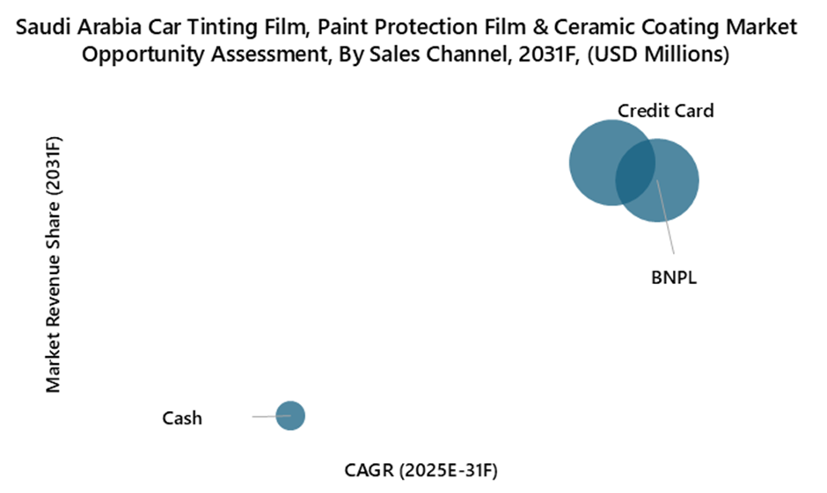
Key Attractiveness of the Report
10 Years Market Numbers.
Historical Data Starting from 2021 to 2024
Base Year: 2024
Forecast Data until 2031
Key Performance Indicators Impacting the Market.
Major Upcoming Developments and Projects.
Key Highlights of the Report:
Saudi Arabia Car Window Tinting Film, Paint Protection Film (PPF), and Ceramic Coating Market Overview
Saudi Arabia Car Window Tinting Film, Paint Protection Film (PPF), and Ceramic Coating Market Forecast
Historical Data and Forecast of Saudi Arabia Car Window Tinting Film, Paint Protection Film (PPF), and Ceramic Coating Market Revenues, By Type for the Period 2021-2031F
Historical Data and Forecast of Saudi Arabia Car Window Tinting Film, Paint Protection Film (PPF), and Ceramic Coating Market Revenues, By Product Type for the Period 2021-2031F
Porter’s Five Force Analysis
Saudi Arabia Car Window Tinting Film, Paint Protection Film (PPF), and Ceramic Coating Market Drivers and Restraints
Saudi Arabia Car Window Tinting Film, Paint Protection Film (PPF), and Ceramic Coating Market Trends
Saudi Arabia Car Window Tinting Film, Paint Protection Film (PPF), and Ceramic Coating Market Opportunity Assessment, By Type
Saudi Arabia Car Window Tinting Film, Paint Protection Film (PPF), and Ceramic Coating Market Opportunity Assessment, By Product Type
Saudi Arabia Car Window Tinting Film, Paint Protection Film (PPF), and Ceramic Coating Market Revenue Share, By Top 3 Companies
Market Competitive Benchmarking
Company Profiles
Key Strategic Recommendations
How much growth is expected in the Market?
Saudi Arabia Car Window Tinting Film, Paint Protection Film (PPF), and Ceramic Coating Market is projected to grow at a CAGR of 13.8% during 2025-2031F.

https://www.researchandmarkets.com/reports/6051407/saudi-arabia-fashion-market-region?utm_source=GNE&utm_medium=PressRelease&utm_code=jffv39&utm_campaign=2040768+-+Saudi+Arabia+Fashion+Market+Report+2025%3a+Cultural+Shifts%2c+Changing+Attitudes%2c+%26+Rise+of+Modest+Fashion+Influence+on+the+%245.7+Billion+Industry+-+Competition%2c+Forecast+%26+Opportunities+to+2030&utm_exec=chdomspi

The Saudi Arabia Fashion Market was valued at USD 4.25 Billion in 2024, and is expected to reach USD 5.70 Billion by 2030, rising at a CAGR of 5.07%. The Saudi Arabian fashion market is witnessing significant growth, fueled by changing consumer preferences and a younger, fashion-conscious population. As the country diversifies its economy through Vision 2030, fashion and retail sectors have become pivotal to its development. International brands are increasingly entering the market, while local designers are gaining recognition. E-commerce is rapidly expanding, offering consumers more convenience and a broader range of choices.
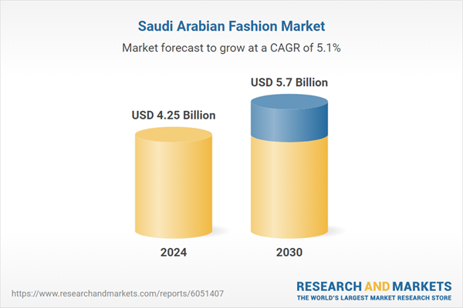
In 2024, a study highlighted that the digital fashion marketplace in Saudi Arabia operates on a robust dual-channel approach. E-tailing platforms, including popular names like Namshi, Shein, Temu, and Ounass, collectively account for 50% of the online fashion market in the Kingdom. On the other hand, omnichannel players such as Amazon, Noon, and Centrepoint contribute to 30% of the market share. These platforms have gained traction by offering extensive product ranges, exclusive deals, and a seamless online shopping experience tailored to local preferences. This dynamic shift promises a vibrant future for the Saudi fashion industry.

Key Market Drivers

Changing Demographics and Growing Youth Population
One of the most significant drivers of the Saudi Arabian fashion market is the country’s youthful population. With over 50% of the population under the age of 30, the demand for trendy, modern, and fashion-forward products is rapidly increasing. Young Saudis, especially millennials and Gen Z, are highly engaged in global fashion trends and are influencing the market with their preferences for modern, stylish apparel. They are more inclined toward international brands, yet also show growing support for local designers, which has led to a vibrant mix of global and homegrown fashion.
This demographic is heavily influenced by social media, where platforms like Instagram, TikTok, and Snapchat are not only popular for entertainment but also as sources of fashion inspiration. These young consumers are increasingly seeking brands and designs that reflect their personal style, preferences, and individuality. This has led to a surge in demand for unique, custom, and designer pieces. Fashion is becoming an integral part of their social identity, and they are more willing to spend on clothing, accessories, and beauty products that resonate with their personality and status.

Economic Transformation and Increasing Disposable Income
The economic reforms outlined under Saudi Arabia’s Vision 2030 are another driving force behind the growth of the fashion market. As the kingdom moves away from oil dependency, there has been a concerted effort to boost the private sector, promote tourism, and enhance the overall standard of living. This economic diversification has contributed to higher disposable incomes, particularly among the younger generation, creating a significant demand for premium and luxury fashion items.
With the rise in disposable income, consumers are increasingly willing to indulge in fashion as a form of self-expression and luxury. As Saudi Arabia’s middle class continues to expand, the demand for both affordable and high-end fashion products is surging. The shift towards an urbanized lifestyle, especially in cities like Riyadh and Jeddah, has encouraged more urban shopping habits, with consumers spending more on clothing, footwear, and accessories. Shopping malls and retail complexes are becoming increasingly sophisticated, and consumers are attracted to the high-end shopping experiences these locations offer.

Cultural Shifts and Changing Attitudes Toward Fashion
In recent years, Saudi Arabia has witnessed substantial cultural shifts, especially with the government’s efforts to modernize and open up society under Vision 2030. Reforms like the easing of restrictions on women’s rights have played a crucial role in reshaping the fashion landscape. Women are now more actively participating in the fashion market, not only in terms of purchasing apparel but also as consumers who are contributing to the design, retail, and entrepreneurial aspects of the industry.
Additionally, cross-border transactions (CBT) in the Saudi Arabian fashion market have experienced a significant surge, with their share rising from 26% in 2022 to 28% in 2023. This growth is primarily driven by the increasing popularity of fast fashion, as international brands like Shein, Temu, and Trendyol continue to dominate consumer preferences. These platforms attract a growing customer base by offering extensive collections of affordable and stylish apparel that meet the rising demand for budget-friendly yet fashionable clothing among Saudi consumers

Key Market Challenges

Cultural Sensitivity and Modesty Regulations
One of the key challenges facing the Saudi Arabian fashion market is navigating the country’s cultural sensitivity and modesty regulations. Saudi Arabia is a conservative society, and while recent reforms have increased personal freedoms, the principles of modesty rooted in Islamic traditions still strongly influence the fashion industry. This affects both domestic and international brands entering the market, as they must adapt their offerings to meet local norms.
For women, modesty is a central consideration in fashion, which has led to a demand for modest yet fashionable clothing, such as abayas and hijabs. However, with growing liberalization and changing social norms, consumers are increasingly seeking more modern styles, often blending traditional modest fashion with contemporary trends. Brands must strike a delicate balance between meeting the demand for modest clothing while also appealing to those desiring more Westernized, trendy styles. This creates a unique challenge for fashion companies that must be both culturally respectful and innovative to succeed in the market.

High Competition and Market Saturation
The Saudi Arabian fashion market is becoming increasingly competitive as both local and international brands vie for consumer attention. The market has seen a surge in the number of global fashion brands entering, including luxury labels, fast fashion giants, and e-commerce platforms. This growing influx of brands has led to market saturation, making it difficult for new entrants to gain a foothold without significant investment in brand recognition and consumer loyalty.
Local designers and homegrown fashion labels also face stiff competition from international brands that are often able to leverage larger budgets, established reputations, and more extensive marketing strategies. As a result, local brands must be highly innovative, offer unique designs, and create a strong emotional connection with consumers to differentiate themselves. This intensifies the need for effective branding and marketing strategies that resonate with the target audience, particularly in a market with diverse tastes and cultural nuances.

Key Market Trends

Rise of Modest Fashion
One of the most significant trends in the Saudi Arabian fashion market is the rise of modest fashion, a movement that aligns with cultural and religious values while embracing modern, stylish designs. Modesty has always been a key aspect of Saudi fashion, especially for women, with traditional garments like the abaya and niqab being widely worn. However, in recent years, there has been a shift towards a more stylish and contemporary interpretation of modest clothing, leading to the emergence of the modest fashion trend.
The demand for modest fashion is not only driven by religious or cultural values but also by a desire for personal expression. Young Saudi women are increasingly looking for stylish yet modest clothing that aligns with their values while allowing them to express their individuality. Local and international designers have recognized this shift and are creating modern abayas, dresses, and separates that combine both modesty and high fashion.

Luxury Fashion and International Brands
Saudi Arabia’s fashion market is increasingly characterized by a growing demand for luxury fashion items. As the country’s wealth continues to rise, especially among the younger, affluent population, luxury goods have become a symbol of status and success. Saudi consumers, particularly those in urban centers like Riyadh and Jeddah, are increasingly seeking high-end fashion products, including luxury clothing, accessories, and footwear.
International luxury brands like Louis Vuitton, Gucci, Prada, and Chanel are expanding their presence in Saudi Arabia, particularly in the kingdom’s major shopping malls and luxury retail outlets. These brands are tailoring their offerings to meet the tastes and preferences of Saudi consumers, with exclusive collections and limited-edition items often being introduced to cater to the country’s growing demand for luxury goods.

Sustainability and Ethical Fashion
Sustainability is an emerging trend that is beginning to take hold in the Saudi Arabian fashion market. As global awareness of environmental issues grows, Saudi consumers, particularly the younger generation, are becoming more conscious of the impact their purchasing decisions have on the planet. This shift towards sustainability is encouraging fashion brands to adopt more eco-friendly and ethical practices, such as using sustainable materials, reducing waste, and ensuring fair labor practices.
Sustainable fashion brands are gaining traction in Saudi Arabia, as consumers are increasingly seeking products that align with their values of environmental stewardship and ethical consumption. Local and international brands are now focusing on creating fashion lines that prioritize eco-friendly materials, such as organic cotton, recycled polyester, and biodegradable fabrics. Additionally, fashion companies are investing in reducing their carbon footprint through more sustainable manufacturing processes.

Segmental Insights

Product Type Insights
Apparel was the dominating segment in the Saudi Arabian fashion market, driven by strong demand for both traditional and modern clothing. The preference for modest fashion, such as *abayas* and modest dresses, alongside the rising trend for contemporary styles, has shaped this segment. Saudi consumers seek a blend of cultural relevance and global fashion trends, with women’s and men’s apparel gaining popularity. Additionally, the increasing influence of younger generations and urbanization has led to a shift toward fashionable yet modest clothing. With an expanding retail and e-commerce sector, the apparel segment continues to lead Saudi Arabia’s fashion market.

Regional Insights
Northern and Central Saudi Arabia, particularly cities like Riyadh and Jeddah, dominate the fashion market due to their economic significance and high population density. Riyadh, the capital, is a key hub for both traditional and modern fashion, attracting major international brands and luxury retailers. Jeddah, known for its cosmopolitan nature, also plays a central role in shaping fashion trends, with a growing demand for global fashion labels and local designs. These regions benefit from a large, affluent population, increasing disposable incomes, and urbanization, making them primary markets for apparel, luxury goods, and online fashion retail in Saudi Arabia.

Key Market Players
- Middle East - Fad International Co. (femi9)
- Majid Al Futtaim Holding LLC
- Apparel Group
- Alyasra Fashion
- Almutlaq Group
- Rubaiyat Modern Luxury Products Company Ltd.
- Nysaa Trading LLC
- AlWahida Equipment Co. Ltd (Zara)
- Sun and Sand Sports LLC (Nike)
- Landmark Arabia Co. (Max Fashion)

