1. The expected lifetime of an industrial fan when operated at the listed temperature is shown in the table that follows. Estimate the lifetime at 70 ◦ C by using all four points with Lagrange interpolation. 小数点后保留1位。

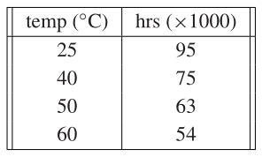

1. The total world oil production in millions of barrels per day is shown in the table that follows. Using Newton method to determine and plot the degree 9 polynomial through the data. Use it to estimate 2010 oil production。（小数点后保留3位）

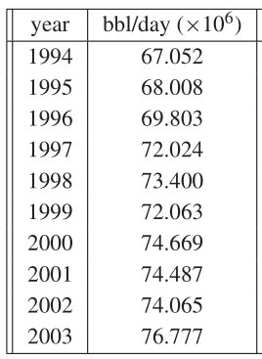

1. Find the equations and plot the natural cubic spline that interpolates the data points (a) (0,3),(1,5),(2,4),(3,1) 自然边界M0=M3=1(b) (−1,3),(0,5),(3,1),(4,1),(5,1).