**写之前记得加上clear;clc; !!!!!!!!!!!!!!!!!!**

二分法：

function res = division_fun(f, a, b, e)

% f:函数指针

% a:区间左端点

% b:区间右端点

% e:精度

while abs(b - a) > e

mid = f((a + b) / 2);

if mid == 0

res = (a + b) / 2;

break

elseif mid * f(a) < 0

b = (a + b) / 2;

elseif mid * f(a) > 0

a = (a + b) / 2;

end

end

res = (a + b) / 2;

end

不动点迭代法：

function res = fix_point_fun(f, x0, e)

% f:函数指针

% x0:迭代初值

% e:精度

x1 = f(x0);

while abs(x1 - x0) >= e

x0 = x1;

x1 = f(x0);

end

res = x1;

end

牛顿迭代法：

function res = newton_fun(f, x0, e)

% f:函数

% x0:初始迭代值

% e:精度

x1 = x0 - f(x0) / dif_fun(f, x0);

while abs(x1 - x0) >= e

x0 = x1;

x1 = x0 - f(x0) / dif_fun(f, x0);

end

res = x1;

end

牛顿下山法：

function res = newton_downhill_fun(f, x0, e)

% f:函数

% x0:初始迭代值

% e:精度

x1 = x0 - f(x0) / dif_fun(f, x0);

while abs(x1 - x0) >= e

lambda = 1;

while abs(f(x1)) >= abs(f(x0))

lambda = lambda / 2;

x1 = x0 - lambda * f(x0) / dif_fun(f, x0);

end

lambda = 1;

x0 = x1;

x1 = x0 - lambda * f(x0) / dif_fun(f, x0);

end

res = x1;

end

牛顿插值：

function res = newton_interpolation_fun(X, Y)

% X:横坐标向量

% Y:纵坐标向量

ps = [];

n = length(X);

for i = 1:n

ps = [ps; poly(X(i))];

end

T = Y;

for i = 1:n-1

ls = zeros(1, n);

for j = i:n-1

ls(j+1) = (T(i, j+1) - T(i, j)) / (X(j+1) - X(j+1-i));

end

T = [T; ls];

end

res = zeros(1, n);

for i = 2:n

xp = 1;

for j = 1:i-1

xp = conv(xp, ps(j, :));

end

xpf = zeros(1, n);

for j = 1:length(xp)

xpf(n-length(xp)+j) = xp(j);

end

res = res + T(i, i) * xpf;

disp(res)

end

res(n) = res(n) + T(1, 1);

res = res';

end

新牛顿插值：

function f = new_newton_interpolation_fun(X, Y)

n=length(X);

T=zeros(n,n);

% 对差商表第一列赋值

for k=1:n

T(k)=Y(k);

end

% 求差商表

for i=2:n

for k=i:n

T(k,i)=(T(k,i-1)-T(k-1,i-1))/(X(k)-X(k+1-i));

end

end

f = @(x)(T(1,1)+0*x);

for i = 2:length(X)

w = @(x)(1+0*x);

for j = 1:i-1

w = @(x)(w(x).*(x-X(j)));

end

f = @(x)(f(x)+T(i, i).*w(x));

end

end

拉格朗日插值：

function res = lagrange_interpolation_fun(X, Y)

% X:横坐标向量

% Y:纵坐标向量

ps = [];

for i = 1:length(X)

ps = [ps; poly(X(i))];

end

ls = [];

for i = 1:length(ps)

ll = 1;

for j = 1:length(ps)

if j == i

continue

end

ll = conv(ll, ps(j, :));

end

div_ll = 1;

for j = 1:length(ps)

if j == i

continue

end

div_ll = div_ll * (X(i) - X(j));

end

ll = ll ./ div_ll;

ls = [ls; ll];

end

res = 0;

for i = 1:length(ls)

res = res + ls(i, :) * Y(i);

end

end

Jacobi迭代：

function x = jacobi_fun(a, b, x0, e)

% a:系数矩阵

% b:右边向量

% x0:初始向量(列向量)

% e:精度

% 最大迭代次数M

n = length(b);

M = 100000;

m = 0;

x = zeros(n, 1);

% 求系数矩阵的对角矩阵

cm_diag = diag(diag(a));

B = cm_diag \ (cm_diag - a);

% 计算谱半径

R = max(abs(eig(B)));

if R >= 1

x = zeros(n, 1);

disp('谱半径不小于1，无法收敛')

return

end

while m <= M

m = m + 1;

for i = 1:n

sum_ax = 0;

for j = 1:n

if j == i

continue

end

sum_ax = sum_ax + a(i, j) * x0(j);

end

x(i) = -(sum_ax - b(i)) / a(i, i);

end

if norm(x - x0, 1) < e

break

end

x0 = x;

end

if m > M

disp('达到最大循环次数')

end

end

G-S迭代：

function x = gauss_seidel_fun(a, b, x0, e)

% a:系数矩阵

% b:右边向量

% x0:初始向量(列向量)

% e:精度

% 最大迭代次数M

n = length(b);

% 求系数矩阵的对角矩阵

cm_diag = diag(diag(a));

B = cm_diag \ (cm_diag - a);

% 计算谱半径

R = max(abs(eig(B)));

if R >= 1

x = zeros(n, 1);

disp('谱半径不小于1，无法收敛')

return

end

M = 100000;

m = 0;

x = zeros(n, 1);

while m <= M

m = m + 1;

for i = 1:n

sum_ax = 0;

for j = 1:i-1

sum_ax = sum_ax + a(i, j) * x(j);

end

for j = i+1:n

sum_ax = sum_ax + a(i, j) * x0(j);

end

x(i) = -(sum_ax - b(i)) / a(i, i);

end

if norm(x - x0, 1) < e

break

end

x0 = x;

end

if m > M

disp('达到最大循环次数')

end

end

高斯消去法：

function x = gauss_elimi_fun(a, b)

% a:系数矩阵

% b：右边向量

% n：方程组的阶数

% x: 求解结果列向量

n = length(b);

m = zeros(n, n);

x = zeros(n, 1);

for k = 1:n-1

if det(a) == 0

disp('第'+str(k)+'次迭代的矩阵a的顺序主子式为0，无法继续运算');

return

end

for i = k+1:n

m(i, k) = a(i, k) / a(k, k);

for j = k+1:n

a(i, j) = a(i, j) - m(i, k) * a(k, j);

end

b(i) = b(i) - m(i, k) * b(k);

end

end

x(n) = b(n) / a(n, n);

for i = n-1:-1:1

sum_of_ax = 0;

for j = i+1:n

sum_of_ax = sum_of_ax + a(i, j) * x(j);

end

disp(sum_of_ax)

x(i) = (b(i) - sum_of_ax) / a(i, i);

end

end

列主元高斯消去法：

function x = col_pivot_gauss_elimi_fun(a, b)

% a:系数矩阵

% b：右边向量

% n：方程组的阶数

% x: 求解结果列向量

n = length(b);

m = zeros(n, n);

x = zeros(n, 1);

for k = 1:n-1

if det(a) == 0

disp('第'+str(k)+'次迭代的矩阵a的顺序主子式为0，无法继续运算');

return

end

max_ai = k;

max_a = a(k, k);

for i = k:n

if a(i, k) > max_a

max_a = a(i, k);

max_ai = i;

end

end

if max_ai ~= k

tmp = a(k, :);

a(k, :) = a(max_ai, :);

a(max_ai, :) = tmp;

end

for i = k+1:n

m(i, k) = a(i, k) / a(k, k);

for j = k+1:n

a(i, j) = a(i, j) - m(i, k) * a(k, j);

end

b(i) = b(i) - m(i, k) * b(k);

end

end

x(n) = b(n) / a(n, n);

for i = n-1:-1:1

sum_of_ax = 0;

for j = i+1:n

sum_of_ax = sum_of_ax + a(i, j) * x(j);

end

x(i) = (b(i) - sum_of_ax) / a(i, i);

end

end

三次样条插值：

function res = cubic_spline_interpolation_fun(X, Y, condi)

% 目前只能设定自然条件

% X:横坐标向量

% Y:纵坐标向量

% condi:边界条件值

n = length(X);

form = zeros(n,n);

form(:,1)=Y;

M0 = condi(1);

Mn = condi(2);

for i=2:n

for j=i:n

form(j,i) = (form(j,i-1)-form(j-1,i-1))/(X(j)-X(j-i+1));

end

end

h = zeros(n-1,1);

for i=1:n-1

h(i)=X(i+1)-X(i);

end

b = zeros(n-2,1);

c = zeros(n-2,n-2);

for i=1:n-2

c(i,i)=2;

if (i==1)

b(i,1)=6 * form(i+2,3)-h(i)/(h(i)+h(i+1))* M0;

elseif (i==(n-2))

b(i,1)=6 * form(i+2,3)-(h(i+1)/(h(i)+h(i+1)))* Mn;

else

b(i,1)=6 * form(i+2,3);

end

end

for i=2:n-2

c(i,i-1)= h(i)/(h(i)+h(i+1));

c(i-1,i)= h(i)/(h(i-1)+h(i));

end

c(1,n-2) = h(1)/(h(1)+h(2));

c(n-2,1) = h(n-1)/(h(n-2)+h(n-1));

M = c\b;

M = [M0; M; Mn];

res = [];

for i = 1:n-1

s1 = conv(conv([-1, X(i+1)], [-1, X(i+1)]), [-1, X(i+1)]);

s1 = s1 * M(i) / (6 * h(i));

s2 = conv(conv([1, -X(i)], [1, -X(i)]), [1, -X(i)]);

s2 = s2 * M(i+1) / (6 * h(i));

s3 = [-1, X(i+1)] * (Y(i) - M(i) * h(i) * h(i) / 6) / h(i);

s4 = [1, -X(i)] * (Y(i+1) - M(i+1) * h(i) * h(i) / 6) / h(i);

ss = zeros(1, 4);

for j = 1:length(s1)

ss(4-length(s1)+j) = ss(4-length(s1)+j) + s1(j);

end

for j = 1:length(s2)

ss(4-length(s2)+j) = ss(4-length(s2)+j) + s2(j);

end

for j = 1:length(s3)

ss(4-length(s3)+j) = ss(4-length(s3)+j) + s3(j);

end

for j = 1:length(s4)

ss(4-length(s4)+j) = ss(4-length(s4)+j) + s4(j);

end

res = [res; ss];

end

end

二阶导：

function res = ddif_fun(f, x)

% 求函数数值二阶导

e = 0.0001;

left = diff([f(x-e), f(x)])/e;

right = diff([f(x), f(x+e)])/e;

res = diff([left, right])/e;

end

一阶导：

function res = dif_fun(f, x)

% 求函数数值一阶导

% f:需要求导的函数

% x:求x处的导数值

e = 0.00000001;

res = diff([f(x), f(x+e)])/e;

end

展示多项式：

function disp_fun(X)

% X:系数矩阵

% 系数个数n

n = length(X);

if n == 1

fprintf('%.2f', X(1))

elseif n > 1

res = '';

for i = 1:n

if i == 1

if X(i) == -1

res = [res, '-'];

elseif X(i) == 1.0

res = res;

else

res = [res, num2str(X(i))];

end

res = [[res, 'x^'], num2str(n-i)];

elseif i < n - 1

if X(i) > 0

res = [[[[res, '+'], num2str(X(i))], 'x^'], num2str(n-i)];

elseif X(i) < 0

res = [[[res, num2str(X(i))], 'x^'], num2str(n-i)];

end

elseif i == n - 1

if X(i) > 0

res = [[[res, '+'], num2str(X(i))], 'x'];

elseif X(i) < 0

res = [[res, num2str(X(i))], 'x'];

end

else

if X(i) > 0

res = [[res, '+'], num2str(X(i))];

elseif X(i) < 0

res = [res, num2str(X(i))];

end

end

end

end

disp(res)

end

句柄函数绘图：

function f_plot_fun(f, X, Y, e, x0, y0)

% f:函数句柄

% X:插值节点横坐标

% Y:插值节点纵坐标

% left:左边界

% right:右边界

% e:绘制图像中的两点间隔

% x:（可选）要预测的点横坐标

% y:（可选）要预测的点纵坐标

if nargin > 4

left = min([x0 - 2 * e, X(1) - 2 * e]);

right = max([x0 + 2 * e, X(length(X)) + 2 * e]);

else

left = X(1) - 2 * e;

right = X(length(X)) + 2 * e;

end

x = left:e:right;

y = zeros(1, length(x));

for i = 1:length(x)

y(i) = f(x(i));

end

plot(x, y, 'b');

hold on

plot(X, Y, 'ro');

if nargin > 4

hold on

plot(x0, y0, '*');

end

end

三次埃尔米特插值：

function res = hermite_fun(X,Y,y0,yn)

% y0:左边界导数值

% yn:右边界导数值

x_input = X;

y_input = Y;

n = length(X);

y_0 = y0;

y_n = yn;

[~,number] = size(x_input);

delta_h = zeros(1,number-1);

delta_f = zeros(1,number-1);

lambda_ = zeros(1,number-2);

miu = zeros(1,number-2);

e = zeros(1,number-2);

for i = 1:(number-1)

delta_h(i) = x_input(i+1) - x_input(i);

delta_f(i) = (y_input(i+1) - y_input(i))/ delta_h(i);

end

for i=1:number-2

lambda_(1,i) = delta_h(1,i+1) / (delta_h(1,i+1) + delta_h(1,i));

miu(1,i) = 1 - lambda_(1,i);

e(1,i) = 3*(lambda_(1,i)*delta_f(1,i) + miu(1,i)*delta_f(1,i+1));

end

A = zeros(number-2,number-2);

B = zeros(number-2,1);

A(1,1) = 2;

A(1,2) = miu(1,1);

B(1,1) = e(1,1) - lambda_(1,1) * y_0;

for i = 2:number-3

B(i,1) = e(1,i);

A(i,i-1) = lambda_(1,i);

A(i,i) = 2;

A(i,i+1) = miu(1,i);

end

A(number-2,number-3) = lambda_(1,number-2);

A(number-2,number-2) = 2;

B(number-2,1) = e(1,number-2) - miu(1,number-2)*y_n;

m_matrix = A\B;

m = zeros(1,number);

m(1) = y_0;

m(number) = y_n;

for i = 2:number-1

m(i) = m_matrix(i-1,1);

end

res = [];

for i = 1:n-1

s1 = conv([1/(X(i)-X(i+1)), -X(i+1)/(X(i)-X(i+1))], [1/(X(i)-X(i+1)), -X(i+1)/(X(i)-X(i+1))]);

s1 = conv(s1, [2/(X(i+1)-X(i)), 1-2*X(i)/(X(i+1)-X(i))]);

s1 = s1 * Y(i);

s2 = conv([1/(X(i+1)-X(i)), -X(i)/(X(i+1)-X(i))], [1/(X(i+1)-X(i)), -X(i)/(X(i+1)-X(i))]);

s2 = conv(s2, [2/(X(i)-X(i+1)), 1-2*X(i+1)/(X(i)-X(i+1))]);

s2 = Y(i+1) * s2;

s3 = conv([1/(X(i)-X(i+1)), -X(i+1)/(X(i)-X(i+1))], [1/(X(i)-X(i+1)), -X(i+1)/(X(i)-X(i+1))]);

s3 = m(i) * conv(s3, [1, -X(i)]);

s4 = conv([1/(X(i+1)-X(i)), -X(i)/(X(i+1)-X(i))], [1/(X(i+1)-X(i)), -X(i)/(X(i+1)-X(i))]);

s4 = m(i+1) * conv(s4, [1, -X(i+1)]);

res = [res; s1+s2+s3+s4];

end

end

分段插值函数绘图：

function multi_poly_plot_fun(param, X, Y, e, x0, y0)

% param:多项式系数向量

% X:插值节点横坐标

% Y:插值节点纵坐标

% left:左边界

% right:右边界

% e:绘制图像中的两点间隔

% x:（可选）要预测的点横坐标

% y:（可选）要预测的点纵坐标

[n, m] = size(param);

for i = 1:n

if i == 1

if nargin > 4

left = min([x0 - 3 * e, X(i) - 3 * e]);

x = left:e:X(i+1);

else

x = (X(i)-3 * e):e:X(i+1);

end

elseif i == n

if nargin > 4

right = max([x0 + 3 * e, X(i+1) + 3 * e]);

x = X(i):e:right;

else

x = X(i):e:X(i+1) + 3 * e;

end

else

x = X(i):e:X(i+1);

end

y = zeros(1, length(x));

for j = 1:m

y = y + param(i, j) * x .^ (m-j);

end

plot(x, y, 'b');

hold on

end

plot(X, Y, 'ro');

if nargin > 6

hold on

plot(x0, y0, '*');

end

end

牛顿前向插值

function [res, param] = newton_forward_interpolation_fun(X, Y, x)

% X:横坐标向量

% Y:纵坐标向量

% x:插值节点

n = length(X);

inter = X(2) - X(1);

dt = Y;

for i = 2:n

dl = zeros(1, n);

for j = i:n

dl(j) = dt(i-1, j) - dt(i-1, j-1);

end

dt = [dt; dl];

end

t = (x - X(1)) / inter;

param = zeros(1, n);

pse = zeros(1, n);

pse(n) = dt(1, 1);

param = param + pse;

ps = 1;

for i = 2:n

ps = conv(ps, [1, 2-i]);

for j = 1:length(ps)

pse(n-length(ps)+j) = ps(j);

end

pse = pse * dt(i, i);

pse = pse ./ factorial(i-1);

param = param + pse;

end

res = 0;

for i = 1:n

res = res + param(i) * t^(n-i);

end

end

已知重根数的牛顿迭代法：

function res = newton_know_root_fun(f, x0, m, e)

% f:函数

% x0:初始迭代值

% m:m重根

% e:精度

x1 = x0 - f(x0) / dif_fun(f, x0);

while abs(x1 - x0) >= e

x0 = x1;

x1 = x0 - m * f(x0) / dif_fun(f, x0);

end

res = x1;

end

未知重根数的牛顿迭代法：

function res = newton_unknow_root_fun(f, x0, e)

% f:函数

% x0:初始迭代值

% e:精度

x1 = x0 - f(x0) / dif_fun(f, x0);

while abs(x1 - x0) >= e

x0 = x1;

x1 = x0 - dif_fun(f, x0) * f(x0) / (dif_fun(f, x0) * dif_fun(f, x0) - f(x0) * ddif_fun(f, x0));

end

res = x1;

end

线性插值：

function res = piecewise_linear_interpolation_fun(X, Y)

% X:横坐标向量

% Y:纵坐标向量

n = length(X);

res = zeros(n-1, 2);

for i = 1:n-1

res(i, 1) = Y(i) / (X(i) - X(i+1)) + Y(i+1) / (X(i+1) - X(i));

res(i, 2) = -X(i+1) * Y(i) / (X(i) - X(i+1)) - X(i) * Y(i+1) / (X(i+1) - X(i));

end

多项式求值：

function y = poly_value_fun(param, x)

y = 0;

for j = 1:length(param)

y = y + param(j) * x ^ (length(param)-j);

end

end

SOR迭代法：

function x = sor_fun(a, b, n, x0, e, w)

% a:系数矩阵

% b:右边向量

% x0:初始向量(列向量)

% e:精度

% w:松弛因子

% 最大迭代次数M

M = 100000;

m = 0;

x = zeros(n, 1);

while m <= M

m = m + 1;

for i = 1:n

sum_ax = 0;

for j = 1:i-1

sum_ax = sum_ax + a(i, j) * x(j);

end

for j = i+1:n

sum_ax = sum_ax + a(i, j) * x0(j);

end

if i == 0

x(i) = -(sum_ax - b(i)) / a(i, i);

elseif i > 0

x(i) = -w * (sum_ax - b(i)) / a(i, i) + (1 - w) * x0(i);

end

end

if norm(x - x0, 1) < e

break

end

x0 = x;

end

if m > M

disp('达到最大循环次数')

end

end

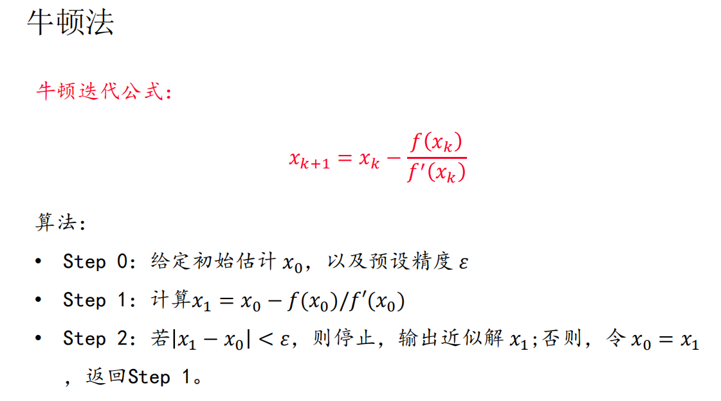

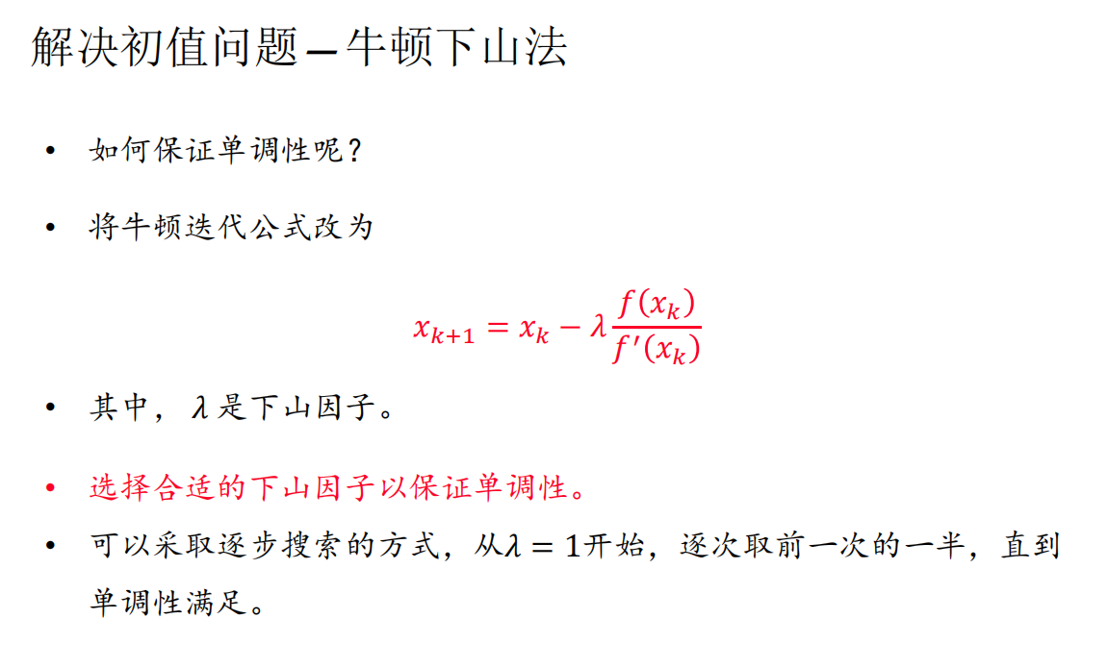

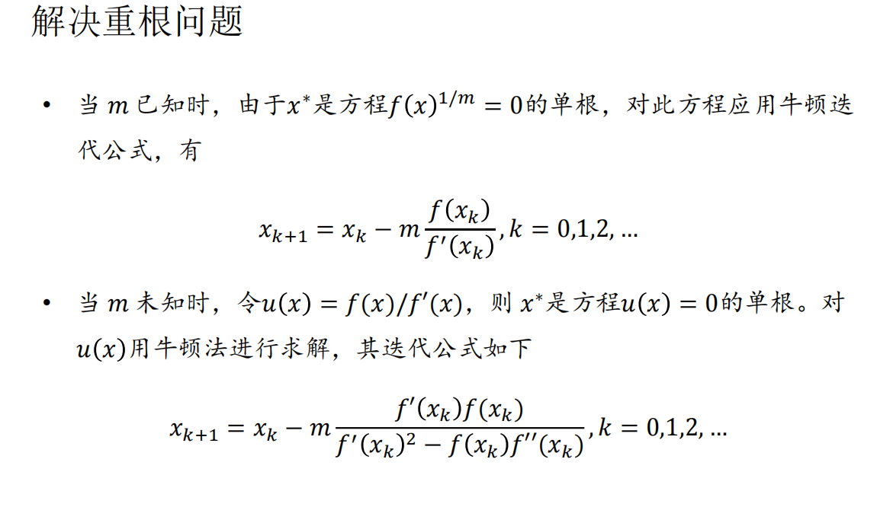

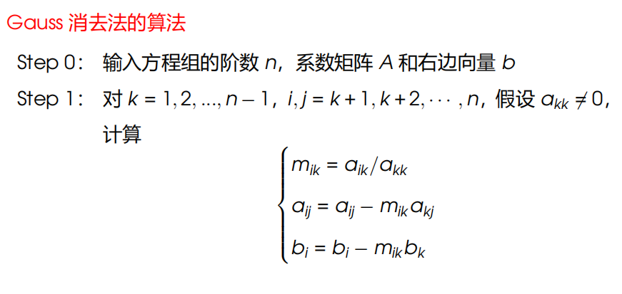

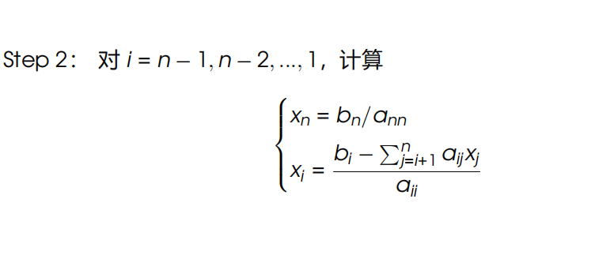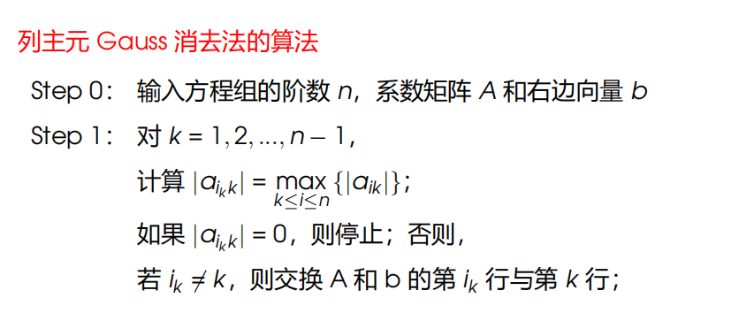

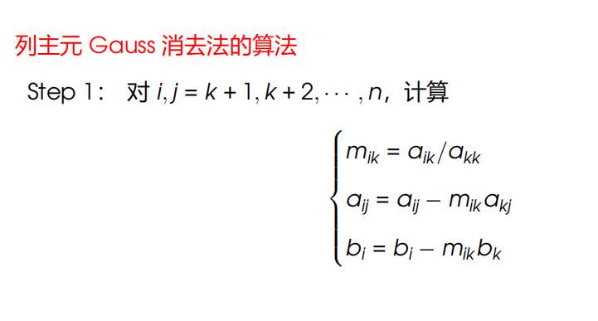

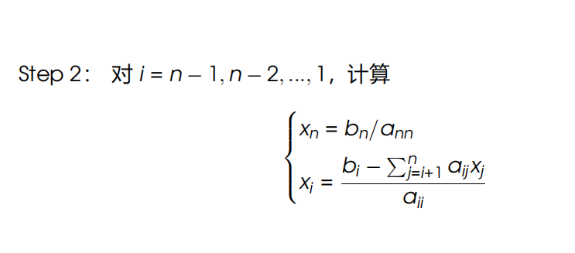

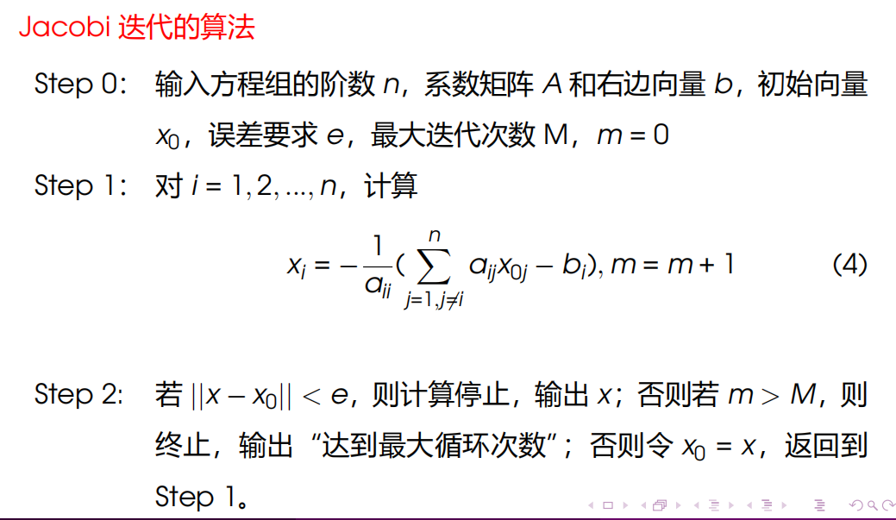

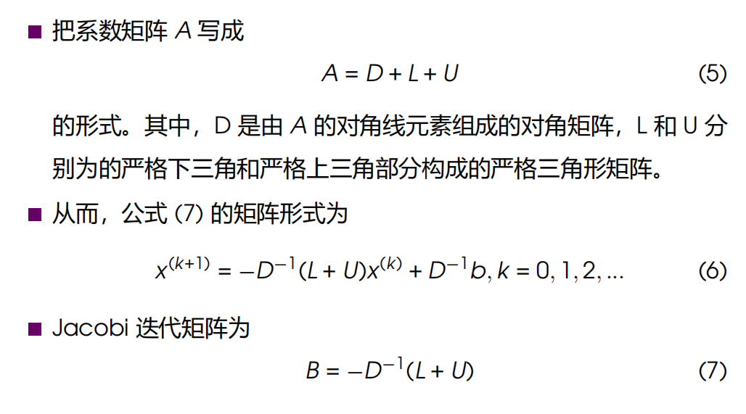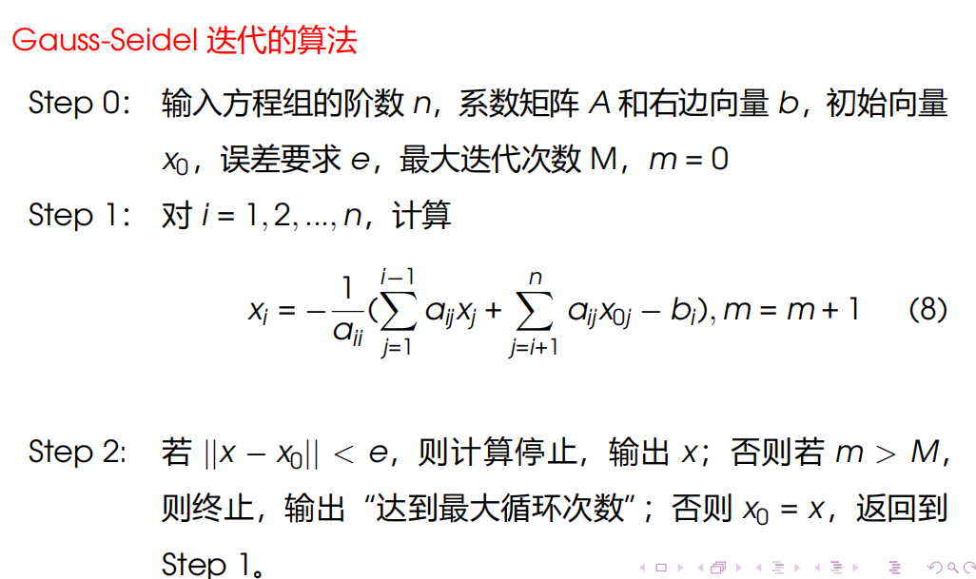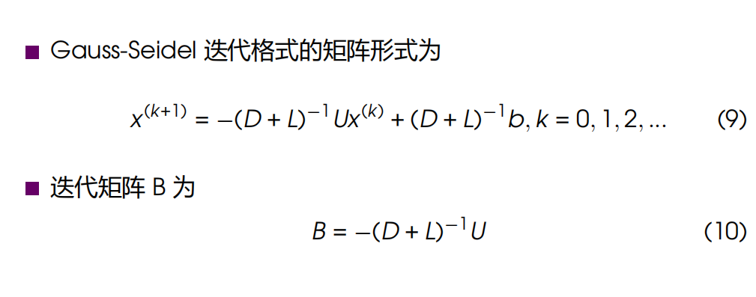

拉格朗日插值：

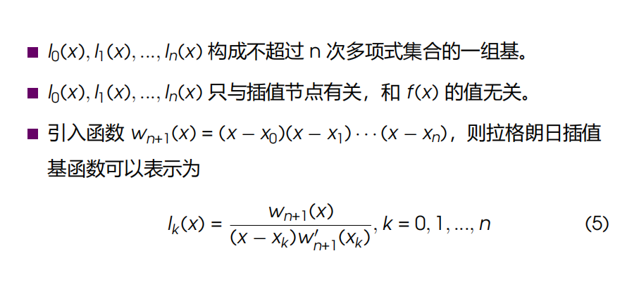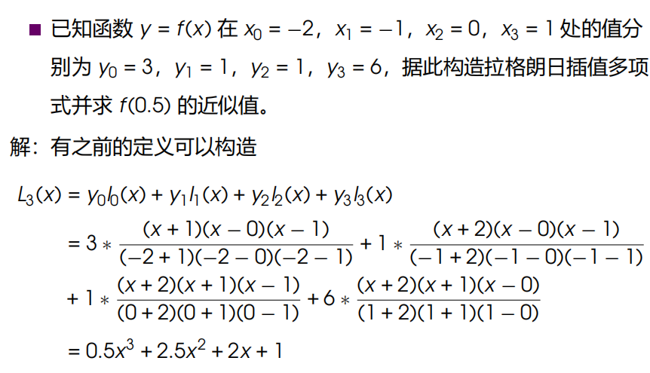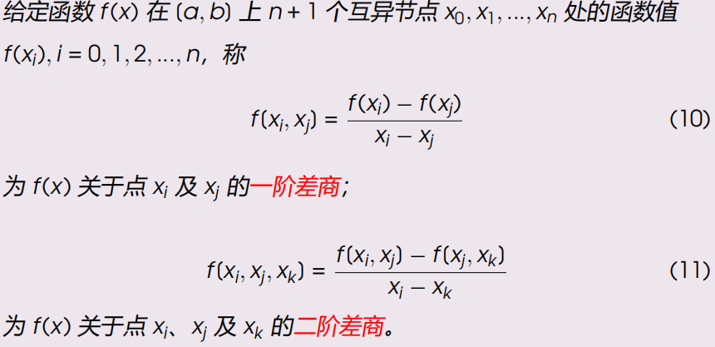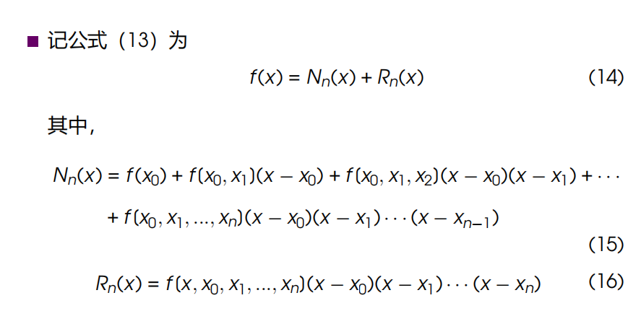

牛顿前插：

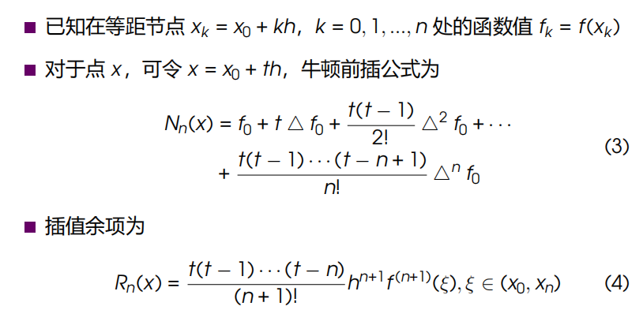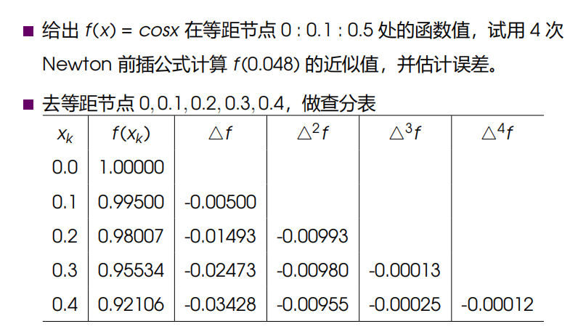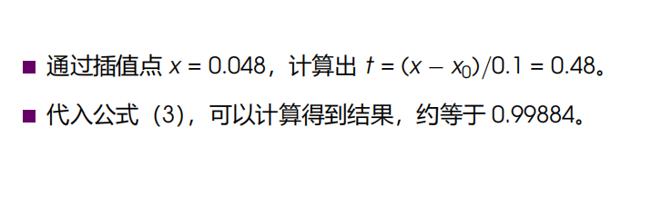

分段线性插值：

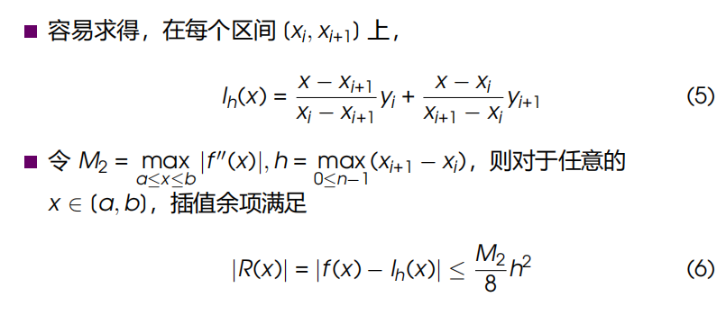

埃尔米特插值：

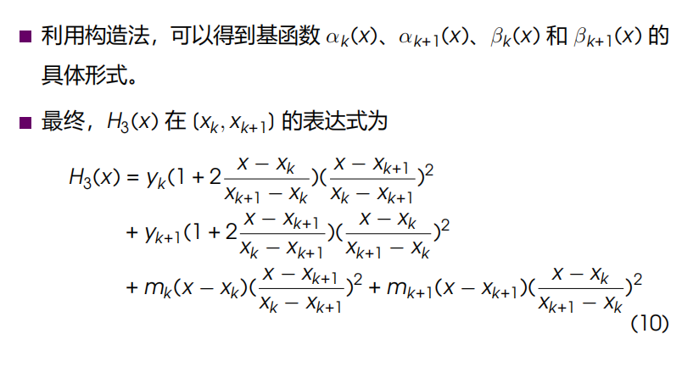

三次样条插值：

