Draft

Prepared for April 29, 2026

Sonoma Water

Lake MEndocino and Lake Sonoma

Reservoir Water Supply Operations Adaptive Management Plan

Draft

Lake MEndocino and Lake Sonoma

Reservoir Water Supply Operations Adaptive Management Plan

Prepared for April 29, 2026

Sonoma Water

775 Baywood Drive
Suite 100
Petaluma, CA 94954
707.795.0900
esassoc.com

Bend  Irvine  Los Angeles  Mobile  Oakland  Orlando  Palm Beach County | Pasadena  Pensacola  Petaluma  Portland  Rancho Cucamonga  Sacramento  San Diego | San Francisco  San Jose  Santa Barbara  Sarasota  Seattle  Tampa  Thousand Oaks

Contents
Lake Mendocino and Lake Sonoma
Reservoir Water Supply Operations Adaptive Management Plan
Page
Acronyms and Other Abbreviations iii
Chapter 1, Introduction and Background 1-1
Chapter 2, Reservoir Operations Workgroup 2-1
2.1 Reservoir Operations Adaptive Management Decision-Making Process 2-1
Chapter 3, Reservoir Operations Forecasting and Communications 3-1
3.1 Ensemble Forecast Operations Modelling 3-1
3.2 Forecasting Communications 3-4
Chapter 4, Reservoir Operations Adaptive Management Action Development and Implementation 4-1
4.1 Lake Mendocino Pulse Flow Adaptive Management 4-1
4.2 Lake Sonoma Blockwater Adaptive Management 4-2
4.2.1 Dry and Critical Year Supplemental Lake Sonoma Fall Release 4-3
4.3 Interagency Coordination 4-3
Chapter 5, Reservoir Operations Adaptive Management Accounting and Reporting 5-1
Chapter 6, References 6-1

Tables
Table 1 Storage thresholds in Lake Mendocino and evaluation dates for the proposed Interim hydrological index (in acre-feet) 1-1

Figures
Figure 1. Timeline of Adaptive Management periods for Lake Mendocino Pulse Releases and Lake Sonoma Blockwater Releases. 2-2
Figure 2. Adaptive Management Decision Tree for Lake Mendocino Pulse Releases. 2-3
Figure 3. Adaptive Management Decision Tree for Lake Sonoma Blockwater Releases. 2-4
Figure 4. Examples of reservoir storage projections used in the EFO model process for a) Lake Mendocino and b) Lake Sonoma showing relevant management storage curves including 10th, 50th, and 90th percentiles, Dry and Critical thresholds (Lake Mendocino), the Guidecurves, the FIRO Pool (Lake Mendocino) and Deviation Pool (Lake Sonoma) curves, and Observed conditions. 3-2
Figure 5. Examples of Russian River instream flow projections used in the EFO model process at three key locations: a) Forks, b) Healdsburg, and c) Hacienda showing hydrograph prediction curves including 10th, 50th, and 90th percentiles, and Observed conditions. 3-3

Acronyms and Other Abbreviations
Abbreviation | Definition
2025 BO | 2025 NMFS Biological Opinion for the Russian River Watershed Water Supply and Channel Maintenance Project
CDFW | California Department of Fish and Wildlife
cfs | cubic feet per second
CNRFC | California-Nevada River Forecast Center
EFO | Ensemble Forecast Operations
ESA | Environmental Science Associates
HEFS | Hydrologic Ensemble Forecast Service
NMFS | National Marine Fisheries Service
Plan | Reservoir Water Supply Operations Adaptive Management Plan
RPM | Reasonable and Prudent Measures
ROW | Reservoir Operations Workgroup
SWRCB | State Water Resources Control Board
USACE | United States Army Corps of Engineers

Introduction and Background
This Reservoir Operations Adaptive Management Plan (Plan) establishes the framework for reservoir water supply pool adaptive management at Lake Mendocino and Lake Sonoma. The Plan addresses Lake Mendocino pulse flow adaptive management and Lake Sonoma blockwater release adaptive management and is intended to support salmonid migration and survival while maintaining water supply reliability and consistency with applicable reservoir operating constraints.
The Plan was developed to comply with a commitment developed by Sonoma County Water Agency (Sonoma Water) (ESA 2024) that is reflected in the 2025 NMFS Biological Opinion for the Russian River Watershed Water Supply and Channel Maintenance Project (2025 BO) (NMFS 2025). Sonoma Water and U.S. Army Corps of Engineers (USACE) anticipate implementation of the Lake Mendocino Water Supply Pool Pulse Flow Adaptive Management action and the Lake Sonoma Water Supply Pool Blockwater Release Adaptive Management action following completion of this Plan, or within 2 years of issuance of the 2025 BO.
The adaptive management actions described here augment the broader reservoir operations outlined in the 2025 BO, and includes ongoing changes in Potter Valley Project transfers and a shift in the Russian River hydrologic index from cumulative inflow into Lake Pillsbury to storage thresholds at Lake Mendocino (Table 1), and conservation measures to include pulse flow releases and management of blockwater intended to improve water supply reliability while remaining consistent with fisheries objectives (see NMFS 2025 for additional information).
Table 1
Storage thresholds in Lake Mendocino and evaluation dates for the proposed Interim hydrological index (in acre-feet)
Jan  1 | Feb  1 | Mar  1 | Mar  16 | Apr  1 | Apr  16 | May  1 | May  16 | Jun  1 | Oct  1 | Nov  1 | Dec  1
Critical
≤42,000 | ≤49,000 | ≤57,000 | ≤67,000 | ≤73,000 | ≤74,000 | ≤75,000 | ≤76,000 | ≤76,000 | ≤46,000 | ≤41,000 | ≤40,000
Dry
≤68,400 | ≤68,400 | ≤68,400 | ≤77,000 | ≤86,000 | ≤91,000 | ≤93,000 | ≤94,000 | ≤94,000 | ≤58,000 | ≤51,000 | ≤49,000
Normal
>68,400 | >68,400 | >68,400 | >77,000 | >86,000 | >91,000 | >93,000 | >94,000 | >94,000 | >58,000 | >51,000 | >49,000
SOURCE: NMFS 2025

Reservoir Operations Workgroup
Sonoma Water, in coordination with the USACE, will convene a Reservoir Operations Workgroup consisting of designated members from Sonoma Water, USACE, National Marine Fisheries Service (NMFS), California Department of Fish and Wildlife (CDFW), and State Water Resources Control Board (SWRCB) (coordinating agencies). The Reservoir Operations Workgroup will include designees from the coordinating agencies with technical expertise from each agency that contributes to the Reservoir Operations Adaptive Management Action. The Reservoir Operations Workgroup (ROW) will develop projections for Lake Mendocino and Lake Sonoma storage and Russian River instream flows to assess fish migration (passage) based on existing conditions and hydrologic forecasts. These projections will be used to assess water supply that could be made available for a pulse release from Lake Mendocino or a blockwater release from Lake Sonoma without leading to a decline in storage conditions at either reservoir resulting in a significant risk to water supply reliability (e.g., substantial decreased storage, depletion of cold water pool, inadequate storage for subsequent year reservoir operations management objectives, including minimum flows for fish habitat).

Reservoir Operations Adaptive Management Decision-Making Process
Sonoma Water will make water supply projections and forecasts monthly during winter/spring (February 15 through May 31) and fall (October through December) adaptive management periods (Figure 1). Fisheries managers may determine that winter/spring management should be extended through June 15 either to meet salmonid outmigration needs or other fisheries objectives. Based on projections and forecasts, the ROW will determine the appropriate target flow/blockwater release strategy and develop an operations plan including flow schedules (specific timing, magnitude, and duration of flows).
In addition to communication during the Adaptive Management periods, the ROW will also meet once in late-spring/early-summer (i.e., June), and once in late-summer/early-fall (i.e., September). These meetings will serve two purposes: 1) further inform future decision-making based on results of implemented actions, and 2) determine the necessity of additional blockwater releases from Lake Sonoma to support fisheries objectives.
During winter/spring and fall Adaptive Management periods, the ROW will communicate via regular conference calls, share current information and forecasts via e-mail and/or an internet website. All adaptive management actions will be recorded and reported on weekly via an accounting webpage, and in annual reports, including information on estimated effectiveness of action implementation at achieving objects (i.e. did the release achieve its’ objectives), consequences to water supply (e.g., impacts on carryover or in-season supplies), and recommendations for consideration in subsequent years.
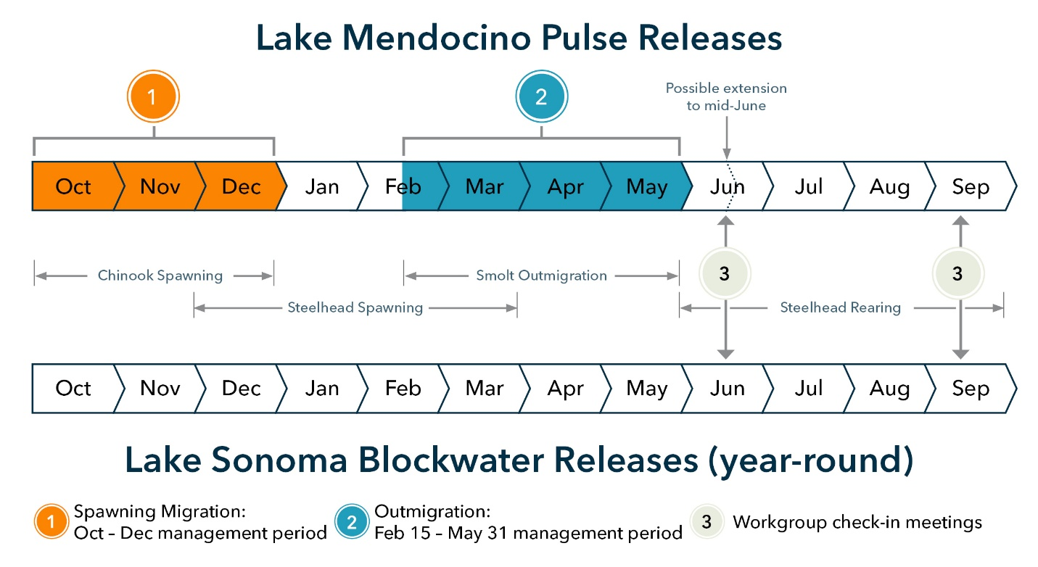
Note: Species timing is for illustrative purposes and does not reflect exact dates of salmonid presence within the Russian River.
Figure 1. Timeline of Adaptive Management periods for Lake Mendocino Pulse Releases and Lake Sonoma Blockwater Releases.
If agreement on the Lake Mendocino Water Supply Pulse Flow Adaptive Management or the Lake Sonoma Water Supply Blockwater Release Adaptive Management actions cannot be reached between all designees from the coordinating agencies (Reservoir Operations Workgroup), Sonoma water will defer to NMFS’s recommendation, in coordination with the SWRCB and CDFW, on blockwater release actions.
The decision-making tree for Lake Mendocino Pulse Flow Actions is provided in Figure 2. The Fall Pulse Release Action decision tree is triggered by the following conditions:
- The mouth of the Russian River Estuary at Jenner is open
- The Water Supply Condition for the Russian River watershed is Dry
- Spawning salmonids are actively migrating
- Russian River flows are forecasted to be impassable by salmonids
The Spring Pulse Release Action decision pathway is triggered by the following conditions:
- The Water Supply Condition is Dry
- Russian River estuary is open
- Russian River flows are forecasted to be impassable by salmonids
When these conditions are met during the respective Adaptive Management periods (winter/spring or fall), Sonoma Water will begin the Adaptive Management process by notifying the Reservoir Operations Workgroup. The Reservoir Operations Workgroup will then follow the decision-making pathway to determine the appropriate action strategy.
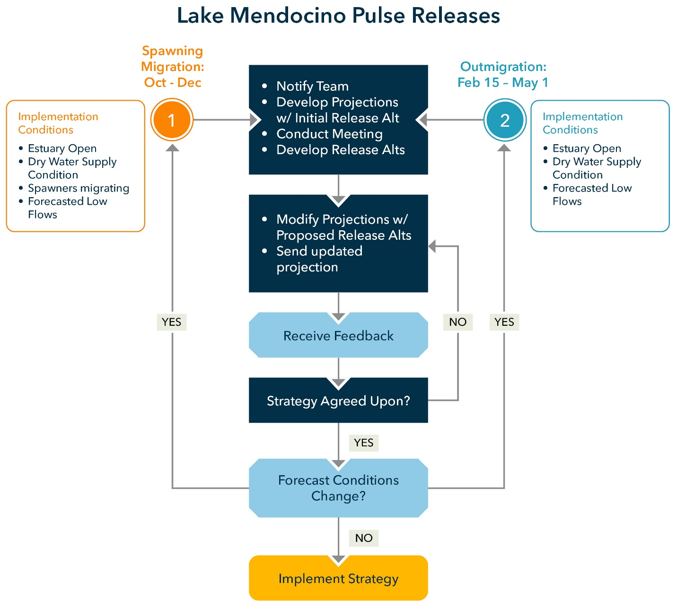
Figure 2. Adaptive Management Decision Tree for Lake Mendocino Pulse Releases.
The decision tree for Lake Sonoma Blockwater Releases will follow the decision tree process provided in Figure 3. This process may be initiated year-round, whenever a need for additional blockwater releases is identified.

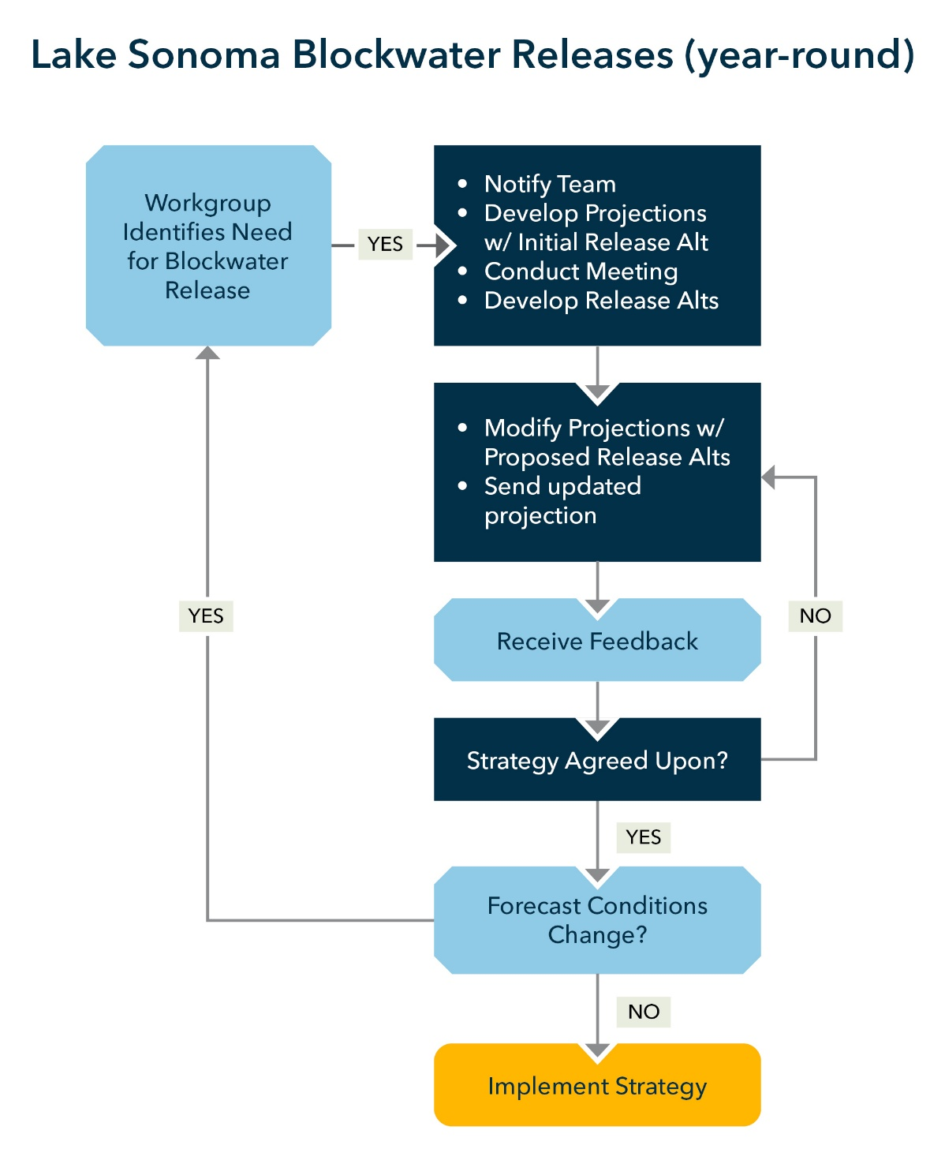
Figure 3. Adaptive Management Decision Tree for Lake Sonoma Blockwater Releases.

Reservoir Operations Forecasting and Communications
Forecasting will be centered on reservoir storage and Russian River flow projections developed from existing conditions and hydrologic forecasts using the Ensemble Forecast Operations (EFO) model. This model is also used to support real time management and implementation of Forecast Informed Reservoir Operations (FIRO) at Lake Mendocino, and implementation of a 2023 Minor Deviation of operations at Lake Sonoma (Jasperse et al. 2020). Forecasts will be made for Lake Mendocino and Lake Sonoma storage, as well as flows at at least three points along the Russian River: the Forks near Ukiah (Forks), Healdsburg, and Hacienda.

Ensemble Forecast Operations Modelling
The EFO model is used to support adaptive reservoir operations at Lake Mendocino and Lake Sonoma by providing probabilistic forecasts of hydrologic conditions. The model incorporates ensemble streamflow predictions derived from the Hydrologic Ensemble Forecast Service (HEFS) developed by the California–Nevada River Forecast Center (CNRFC). These ensemble forecasts represent a range of plausible future hydrologic scenarios based on meteorological inputs and watershed conditions, allowing reservoir operators to evaluate uncertainty in inflows and downstream responses.
EFO simulations are conducted on a weekly basis during the primary adaptive management periods, including fall, winter, and spring (see Figures 1, 2 and 3 above). Each model run provides a 30-day forecast horizon, allowing the Reservoir Operations Workgroup to evaluate intermediate-term and near-term hydrologic conditions when considering pulse flow or blockwater release actions.
Model outputs include guidecurves, projections of reservoir storage conditions at Lake Mendocino and Lake Sonoma (Figure 4), as well as forecasted flows at key downstream locations (Figure 5). These locations include the Forks (upper Russian River), Healdsburg (middle Russian River), and Hacienda Bridge (lower Russian River).
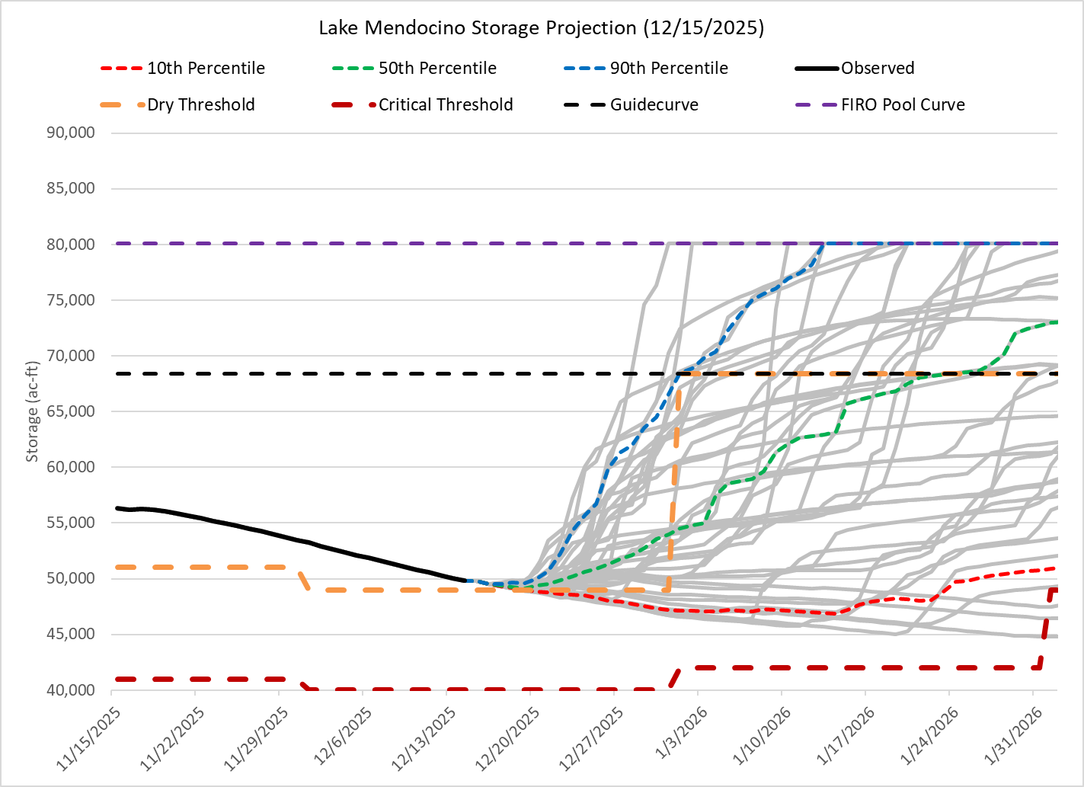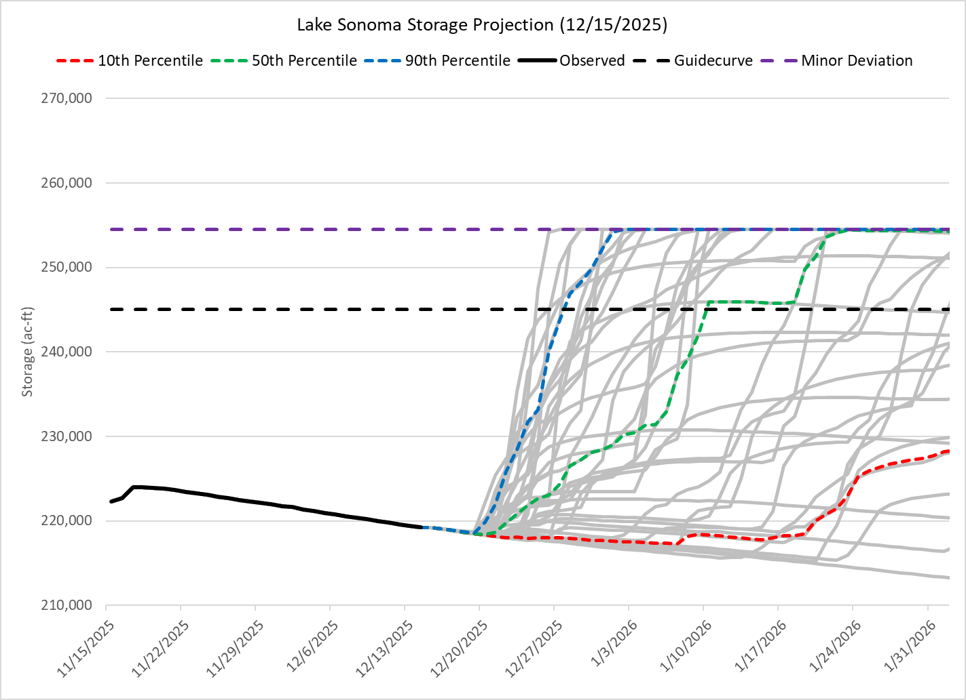
a)
b)
Source: Sonoma Water 2025
Figure 4. Examples of reservoir storage projections used in the EFO model process for a) Lake Mendocino and b) Lake Sonoma showing relevant management storage curves including 10th, 50th, and 90th percentiles, Dry and Critical thresholds (Lake Mendocino), the Guidecurves, the FIRO Pool (Lake Mendocino) and Deviation Pool (Lake Sonoma) curves, and Observed conditions.
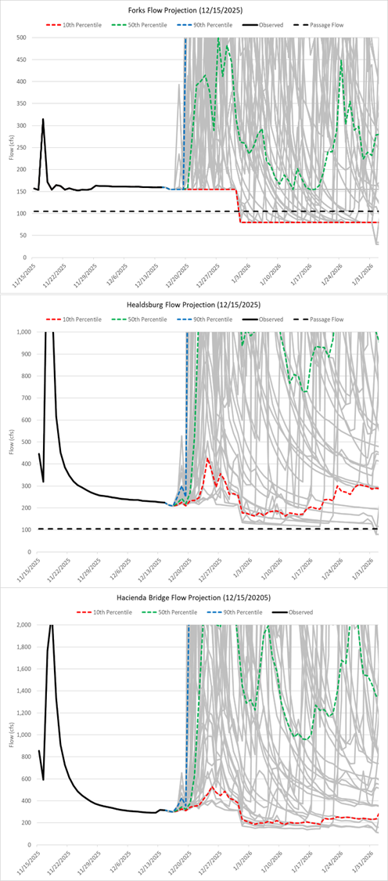
b)
c)
a)
Source: Sonoma Water 2025
Figure 5. Examples of Russian River instream flow projections used in the EFO model process at three key locations: a) Forks, b) Healdsburg, and c) Hacienda showing hydrograph prediction curves including 10th, 50th, and 90th percentiles, and Observed conditions.

Forecasting Communications
Forecast information and current conditions will be shared through regular conference calls, e-mail, and an internet website hosted and maintained by Sonoma Water for interagency coordination. Communications during active adaptive management periods will include, at a minimum, the current reservoir storage, hydrologic forecast information, the proposed flow release window, the candidate release magnitude and duration, and the projected effect on storage and water year classification.
Forecast projections will be posted weekly to the Sonoma Water Reservoir Operations Communications page. This page will contain graphical projections of storage at Lake Mendocino and Lake Sonoma and flows at at least the three identified Russian River locations.

Reservoir Operations Adaptive Management Action Development and Implementation
The following sections provide a more detailed framework and sideboards for developing and implementing pulse/blockwater releases.

Lake Mendocino Pulse Flow Adaptive Management
Lake Mendocino pulse flow adaptive management is contingent on Sonoma Water reservoir storage projections. For each candidate action, Sonoma Water will project Lake Mendocino storage based on existing conditions and hydrologic forecasts to determine whether a pulse release can occur without leading to a significant decline in storage, cold-water pool volume, or triggering a Critical water supply condition. The Reservoir Operations Workgroup will use those projections to determine whether a fall pulse release or a late winter/early spring pulse release may proceed. Pulse flow adaptive management actions would only be implemented during Dry water supply conditions (Table 1). During Dry conditions, minimum instream flow requirements in the Upper River are 75 cfs. In the Lower River, the minimum instream flow during Dry water supply years is 70 cfs. Guidelines for developing Release Alternatives for each Adaptive Management Period are provided below:

Fall Pulse Release
- The Fall Pulse Release can occur one time from October through December for up to 14 days
- The Fall Pulse Release can only occur during Dry water supply conditions
- The Fall Pulse Release increases the minimum instream flow requirement for Upper Russian River from 75 cfs to 105cfs
- The Fall Pulse Release time window of 14 days includes both the ramping period to bring flows up to the 105 cfs minimum instream flow requirement in the Upper Russian River and ramping back down to 75 cfs.

Winter/Spring Pulse Release
- The Winter/Spring Pulse Release can occur one time for up to 14 days
- The Winter/Spring Pulse Release can occur only during Dry water supply condition
- The Winter/Spring Pulse Release increases minimum instream flow requirement on Upper Russian River to 150 cfs
- The Winter/Spring Pulse Release time window of 14 days includes both the ramping period to bring flows up to the 150 cfs minimum instream flow in the Upper Russian River and ramping back down to 75 cfs.

Lake Sonoma Blockwater Adaptive Management
Sonoma Water, in coordination with USACE, will commit up to 2,500 acre-feet of Lake Sonoma storage for blockwater releases on an annual basis, reset each water year, to augment releases from Lake Sonoma into Dry Creek and the Lower River to aid in adult and juvenile salmonid migration and survival. Accounting of blockwater released from Lake Sonoma will include water released during the ramp up and ramp down from the target release. The Reservoir Operations Workgroup will identify the appropriate target blockwater release strategy and develop the corresponding flow schedule (specific timing, magnitude and duration of flows) for implementation. Example justifications for the use of additional blockwater releases might include:
- Blockwater Release could occur during the fall and winter adult salmonid migration season to augment flows in the Lower River and Dry Creek to facilitate upstream migration.
- Blockwater Release could occur during the spring to augment flows in the Lower River and Dry Creek to increase survival of outmigrating salmonids (smolts and kelts).
Examples of different Blockwater Release strategies (totaling 2,500 acre-feet) could include:
- ~315 cfs for 4-day period,
- ~180 cfs for 7-day period,
- ~90 cfs for 14-day period,
- Shaped (variable) release strategy that includes higher and lower variable flows (pulse) across 7-, 14-, or other multi-day period.
Additionally, release ramping (≤ 12 cfs/hour, and ≤ 24 cfs/day) will be implemented as necessary, in accordance with BO Reasonable and Prudent Measure (RPM) 1 to “Ensure measures are undertaken to avoid and minimize take of juvenile salmonids during down-ramping at Warm Springs Dam” and monitoring surveys will be conducted in accordance with RPM 8: “During WSD down-ramping monitoring surveys, Sonoma Water and USACE shall document any instances of salmonid stranding, including mortalities, and relocation efforts.”

Dry and Critical Year Supplemental Lake Sonoma Fall Release
In consultation with NMFS and CDFW, Sonoma Water may release additional water, in addition to the 2,500 acre-feet blockwater release, from Lake Mendocino to achieve minimum adult passage flows (110 cfs) in the lower Russian River if the following conditions are met:
- Dry or Critical water supply conditions,
- Estuary inlet is open, and
- Adult Chinook Salmon presence is documented in the Estuary/lower Russian River.

Interagency Coordination
Adaptive management implementation requires direct coordination between Sonoma Water, USACE, NMFS, CDFW, and the SWRCB. Sonoma Water will coordinate with USACE regarding overlap between water supply adaptive management actions and USACE flood control operations, including FIRO at Lake Mendocino and operational constraints associated with Lake Sonoma including Lake Sonoma Deviations.
Coordination shall also include alignment of Lake Mendocino water supply releases with USACE flow augmentation intended to assist spring outmigration of juvenile and smolt salmonids.
Finally, adaptive management strategies shall consider coordination with CDFW hatchery releases from Coyote Valley Fish Facility and with the Upper and Lower River survival studies conducted by USACE and Sonoma Water to aid in estimating the effectiveness of action implementation in achieving release strategy objectives and informing recommendations for consideration in subsequent years.

Reservoir Operations Adaptive Management Accounting and Reporting
Weekly updated accounting will be posted to the Sonoma Water website. Accounting will include releases to ramp up and down to target release rate. For Lake Mendocino this will include the number of days of release, and for Lake Sonoma these will include the volume of water. This accounting will also provide reasoning for any implemented pulse and blockwater releases.
In addition to the weekly updated accounting, all adaptive management actions will be documented and reported annually. Reporting shall include the action implemented, the timing, magnitude, duration, and ramping approach of the release, as well as the storage projections used to support the decision.
Annual reporting shall also include available information on estimated outcomes of effectiveness, including coordination with hatchery releases and survival studies where relevant, together with a discussion of any observed operational consequences such as reduced carryover storage, changes in water supply condition, depletion of cold-water pool volume, or other constraints identified during implementation.
Recommendations for subsequent years shall be developed through the Reservoir Operations Workgroup based on annual implementation experience, monitoring information, and the evolving understanding of operational effectiveness. Potential updates to this Plan may be developed through the same interagency process used for implementation decisions, including coordination with NMFS and CDFW, in accordance with the BO. Updates to this Plan may be required to comply with implementation of the RPMs summarized below:
RPM-3.2: Sonoma Water will pursue contingency measures to increase juvenile outmigration survival rates.
RPM-3.3: During Critically Dry years, Sonoma Water will monitor pools downstream of the lowest critical riffle from October 15 through December 3 to determine if flow augmentation strategies are necessary to promote upstream migration of adult salmonids.
RPM-8.2: During Warm Springs Dam down-ramping monitoring surveys, Sonoma Water and USACE shall document any instances of salmonid stranding, including mortalities, and relocation efforts.

References
Environmental Science Associates (ESA). 2024. Russian River Biological Assessment (2023) – Reservoir Water Supply Pool Operations Adaptive Management Action Technical Memorandum. Prepared April 15, 2024 (updated May 8, 2024).
Jasperse, J., Ralph, F. M., Anderson, M., Brekke, L., Malasavage, N., Dettinger, M. D., Forbis, J., Fuller, J., Talbot, C., Webb, R., & Haynes, A. 2020. Lake Mendocino Forecast Informed Reservoir Operations Final Viability Assessment. UC San Diego. https://escholarship.org/uc/item/3b63q04n.
National Marine Fisheries Service (NMFS). 2024. Final Environmental Assessment Russian River Steelhead Integrated Harvest Hatchery Program. West Coast Region, California Coastal Office.
National Marine Fisheries Service (NMFS). 2025. Endangered Species Act Section 7(a)(2) Biological Opinion and Magnuson–Stevens Fishery Conservation and Management Act Essential Fish Habitat Response: The Russian River Watershed Water Supply and Channel Maintenance Project. NMFS Consultation Number WCRO-2023-02169. West Coast Region, California Coastal Office.

Guidecurves are seasonal limits on reservoir storage, defined in Water Control Manuals (WCMs) based on historical hydrology and flood risk patterns. They specify the maximum water level allowed in the reservoir at any given time of year to mitigate flood risks while accommodating other uses.
Critical water supply condition is defined by water storage falling below the storage thresholds for Critical water supply identified in Table 1, above, and would set minimum instream flows in the Upper River to 25 cfs and 35 cfs in the Lower River.
The Chinook salmon passage threshold in the Upper River has been determined to be 105 cfs at Healdsburg. This threshold is considered the most conservative, as Chinook salmon are the largest bodied salmonids in the Russian River and require the most flow for upstream passage.
Note: These examples do not consider ramping needed to comply with BO RPM 1.

