**Assignment 4 Report**

# File List and Description

The folder *assign4-5130309117* contains

1. *RDT3.0*

This folder contains the project of my RDT3.0 implementation. It has 3 subfolders

1. JarFiles

This will be the main folder to use for the test. I will introduce it in next section.

1. src

It contains all the source files for the RDT3.0 implementation.

1. bin

Some executable files produced by eclipse. You may ignore it when test using my jar files.

1. *OtherProtocols*

This folder includes 3 projects for protocol implementations other than RDT3.0. They are

1. TCP Using TCP protocol to transfer files.
2. GBN Using GBN to transfer files. This protocol need further enhancement. Currently it only supports sliding window size 1.
3. UDP Using UDP protocol to transfer files.

All three subfolders above have similar structure with *RDT3.0*. Their test methods are also similar.

# Test Method

For every protocol project folder (*RDT3.0, UDP, TCP*), there can will be a *JarFiles* subfolder.

For example, in *RDT3.0/JarFiles* we have

1. *Receiver.jar*

The jar file of the receiver program.

1. *Sender.jar*

The jar file of the sender program.

1. *receive*

The folder of receiver to accept files from the sender side.

1. *sender*

The folder of sender where files that can be transferred to receiver locate.

I already place one file named *hw3.pdf* in this folder for testing use.

To do the test, just follow the following steps

1. Open two terminals, one for receiver, and the other one for sender.
2. Change directory into ***RDT3.0/JarFiles/***
3. To start the receiver, run

../../../Desktop/屏幕快照%202016-04-21%20下午10.31.03.png

Then you will see the receiver window

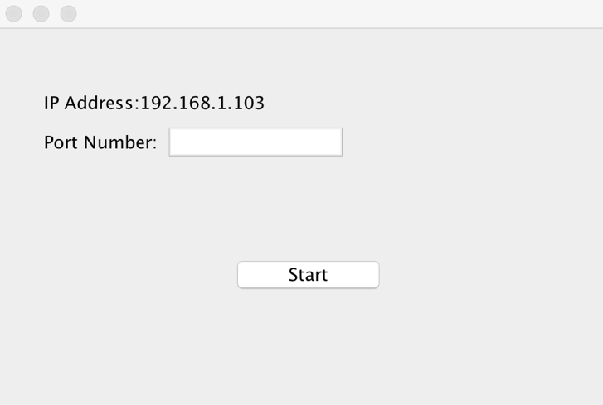

1. Set the Port number of receiver and click ***Start***button. Then you will see

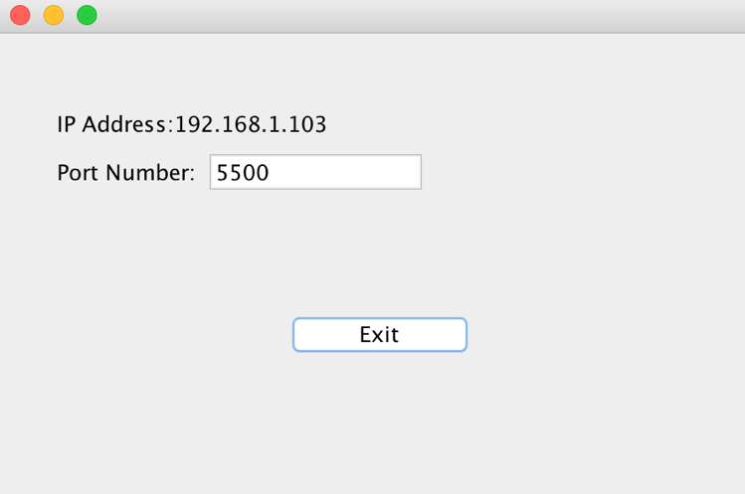

1. To start the sender, run

../../../Desktop/屏幕快照%202016-04-21%20下午10.34.39.png

Now the sender window should appear

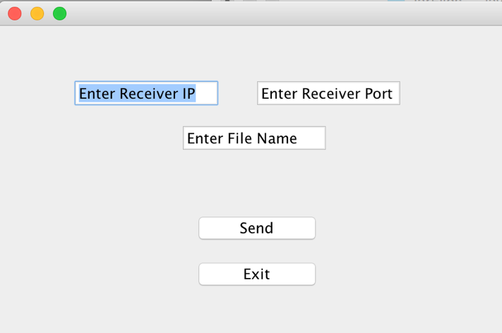

1. Designate the IP and Port number of ***Receiver*** in the above window.

For example, from the receiver window we know the IP and Port number of receiver are 192.168.1.103 and 5500, respectively. So we should fill in the text fields like this

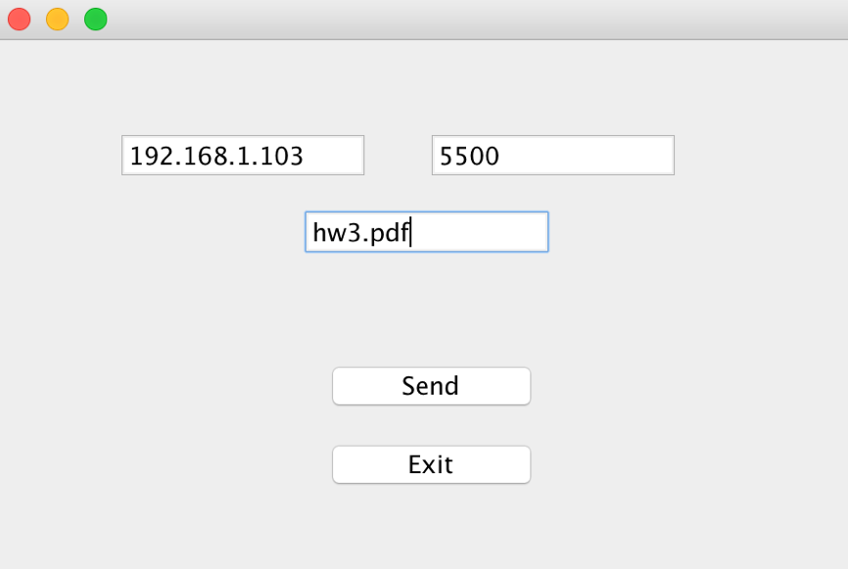

1. Fill in the file name, note that this file must be under the ***send*** directory on the sender side (hw3.pdf, for example).
2. Click send, now the file will emerge under the ***receive*** directory on the receiver side.

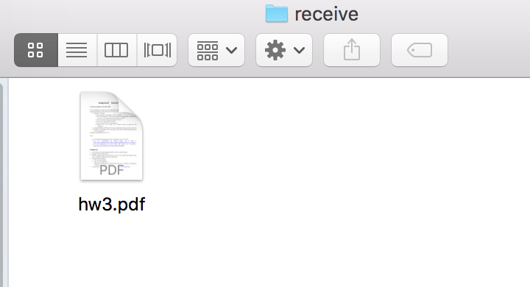

1. After when the transmission is finished, we can see the time when file is sent by sender and the time when receiver receives the whole file in the windows.

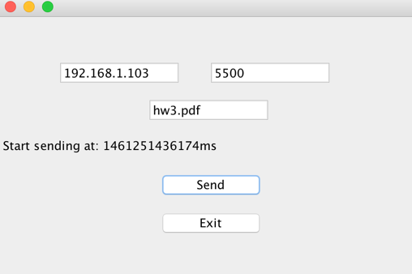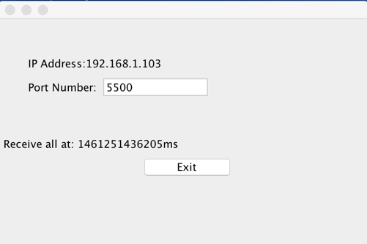

In this way we can calculate the delay.

1. To quit, just click the ***Exit*** buttons on receiver window and sender window.

# Testing results

We can calculate the error bits by copying the original file and transmitted file to one machine. Read them into a program and compare them bit by bit.

Here is the result of error bits and delay of different protocols.

|  |  |  |
| --- | --- | --- |
| Protocol | Error bits  (per 1000 bits) | Delay  (us/byte) |
| RDT3.0 | 0 | 1.135 |
| UDP | 134.371 | 0.108 |
| TCP | 0 | 0.576 |
| GBN | 0 | 0.863 |