Lab Report 0

Group 10

Shiyu Wang

**Lab 0.1 Connecting to ZedBoard**

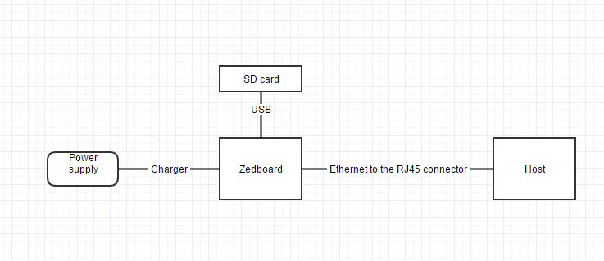

We first connect ZedBoard with the power supply (charger). Then switch on the ZedBoard. (Making sure the green light is on). After that we login in to the PC Host, connect it to ZedBoard with Ethernet to RJ45 connector. Finally, we connect the SD card on ZedBoard and start run mobaxterm program.

**Lab 0.2 Discuss why you should avoid working as root?**

We firstly login as root to create our own group account. We don’t work as root, because root has complete control over all files and directories on the system. And we don’t want to accidently delete or edit any file to break things. Avoiding working as root can help avoid problems.

**Lab 0.3 Hello World on ZedBoard**

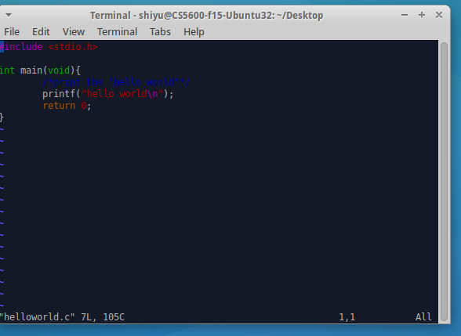

The code for hello world is very basic. It just prints out the string.

**Output:**



**Lab 0.4 Sorting 10 integers**

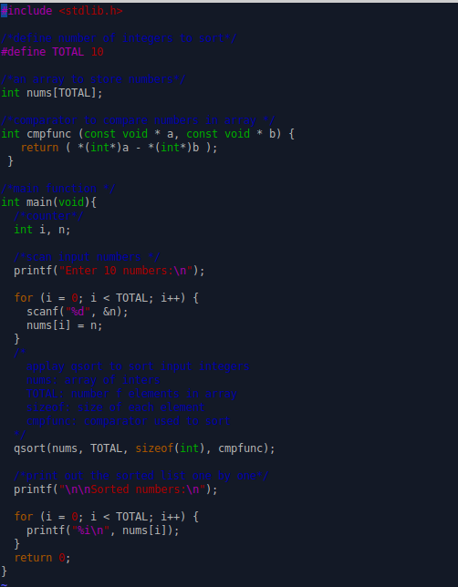

We first create an empty array to store integers. Then we create an easy comparator used to compare integers for sorting. After that, we scan user inputs for 10 integers. (Assuming user always input valid integers.) Then, we apply qsort to sort integers and print the list out.

**Output:**

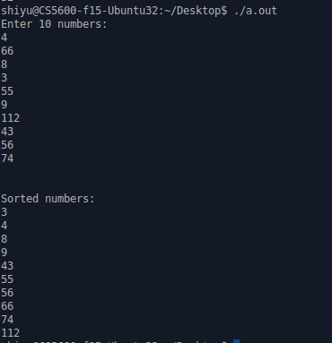

**Extra Credit**

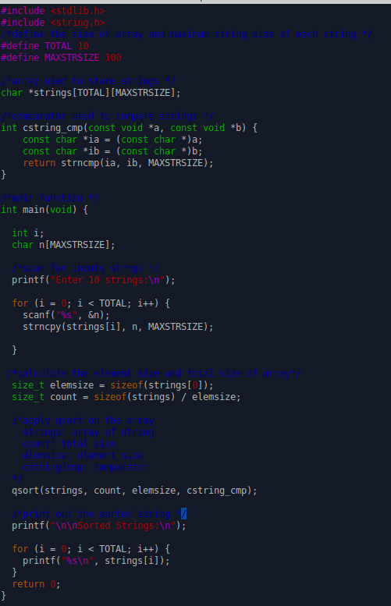

We first create an empty array to store strings. Then we create an easy comparator used to compare strings for sorting. After that, we scan user inputs for 10 strings. (Assuming user always input valid strings.) Then, we apply qsort to sort strings and print the list out.

*The key point here is the size of element and size of whole string. The size of elements are all same, so we pick the first one. The total size is equal to the size of array divided by the string size.

**Output:**

