Homework3

Shiyu Wang

* 1. XOR

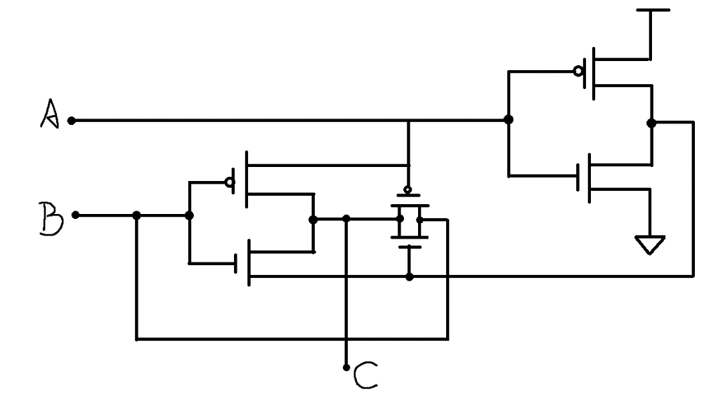

* 1. NAND

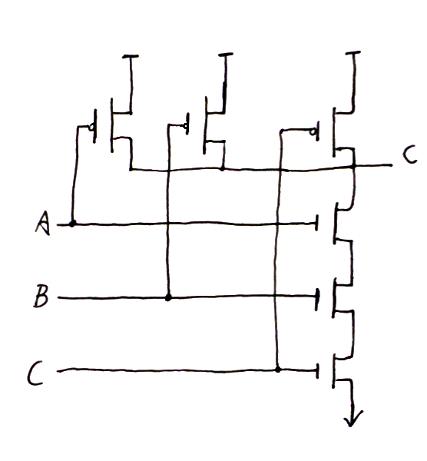

* 1. 𝐹 = (𝐴 ⋅ (𝐵 + 𝐶𝐷))′

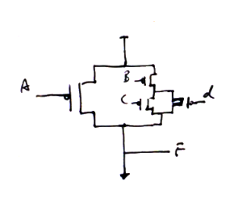



2.

a.

𝑥𝑦𝑧 + 𝑥′𝑦 + 𝑥𝑦𝑧′

= y(xz + x’ + xz’)

= y(x’ + x(z + z’))

= y(x’ + x⋅T)

= y(x’ + x)

= y⋅T

= y

b.

(x + y) ′ ⋅ (x′ + y′)

= (x’ ⋅ y’) ⋅ (x′ + y′)

= (x’ ⋅ y’ ⋅ x’) + (x’ ⋅ y’ ⋅ y’)

= (x’ ⋅ y’) + (x’ ⋅ y’)

= x’ ⋅ y’

c.

A′C′ + ABC + AC′

= (A’C’ + AC’) + ABC

= (C’ ⋅ (A’ + A))+ ABC

= (C’ ⋅ T) + ABC

= C’ + ABC

d.

(A + B)′ ⋅ (𝐴′ + 𝐵′)′

= (A’ ⋅ B’) ⋅ (A ⋅ B)

= F

3.

1) Output:

F = B’C’D’ + A’B’C + AC’D + BC’D’ + A’B’CD’

|  |  |  |  |  |  |
| --- | --- | --- | --- | --- | --- |
| # | A | B | C | D | Output |
| 0 | 0 | 0 | 0 | 0 | 1 |
| 1 | 0 | 0 | 0 | 1 | 0 |
| 2 | 0 | 0 | 1 | 0 | 1 |
| 3 | 0 | 0 | 1 | 1 | 1 |
| 4 | 0 | 1 | 0 | 0 | 1 |
| 5 | 0 | 1 | 0 | 1 | 0 |
| 6 | 0 | 1 | 1 | 0 | 0 |
| 7 | 0 | 1 | 1 | 1 | 0 |
| 8 | 1 | 0 | 0 | 0 | 1 |
| 9 | 1 | 0 | 0 | 1 | 1 |
| 10 | 1 | 0 | 1 | 0 | 0 |
| 11 | 1 | 0 | 1 | 1 | 0 |
| 12 | 1 | 1 | 0 | 0 | 1 |
| 13 | 1 | 1 | 0 | 1 | 1 |
| 14 | 1 | 1 | 1 | 0 | 0 |
| 15 | 1 | 1 | 1 | 1 | 0 |

F (A, B, C, D) = ∑ (0, 2, 3, 4, 8, 9, 12, 13)

2) K-map

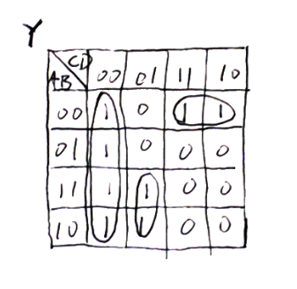

3) Minimized form

Y = C’D’ + AC’D + A’B’C

4) NAND form

Y = ((C’D’)’ (AC’D)’ (A’B’C)’)’

5) Circuit

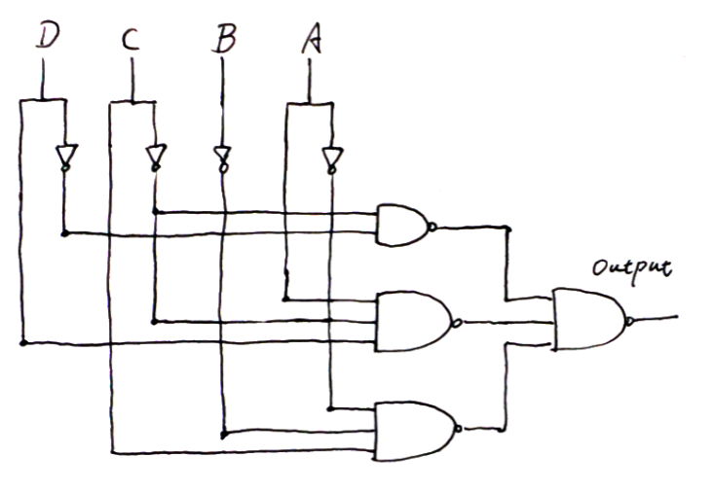

4.

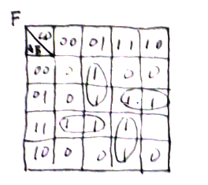

F = A’C’D + A’BC + ABC’ + ACD

5.

A< B

|  |  |  |  |  |
| --- | --- | --- | --- | --- |
| A0A1 \ B0B1 | 00 | 01 | 11 | 10 |
| 00 | 0 | 1 | 1 | 1 |
| 01 | 0 | 0 | 1 | 1 |
| 11 | 0 | 0 | 0 | 0 |
| 10 | 0 | 0 | 1 | 0 |

F1 = A0’B0 + A0’A1’B1 + A1’B0B1

A > B

|  |  |  |  |  |
| --- | --- | --- | --- | --- |
| A0A1 \ B0B1 | 00 | 01 | 11 | 10 |
| 00 | 0 | 0 | 0 | 0 |
| 01 | 1 | 0 | 0 | 0 |
| 11 | 1 | 1 | 0 | 1 |
| 10 | 1 | 1 | 0 | 0 |

F2= A0B0’ + A0A1B1’+ A1B0’B1’

A = B

|  |  |  |  |  |
| --- | --- | --- | --- | --- |
| A0A1 \ B0B1 | 00 | 01 | 11 | 10 |
| 00 | 1 | 0 | 0 | 0 |
| 01 | 0 | 1 | 0 | 0 |
| 11 | 0 | 0 | 1 | 0 |
| 10 | 0 | 0 | 0 | 1 |

F3 = A0’A1’B0’B1’ + A0’A1B0’B1 + A0A1B0B1 + A0A1’B0B1’

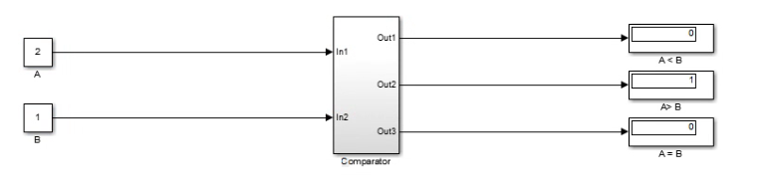

Question_5.slx is fully tested and attached.

6.

a)

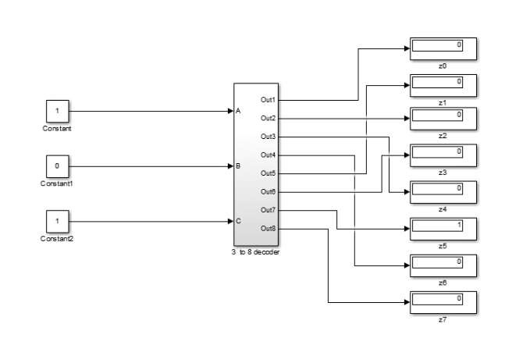

Question_6_a.slx is fully tested and attached.

b)

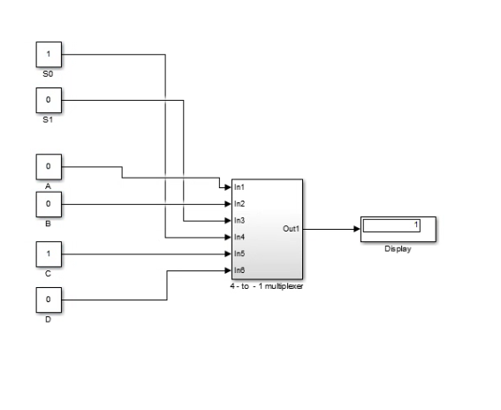

Question_6_b.slx is fully tested and attached.