Homework4

Shiyu Wang

April 15, 2017

#### Problem 1

##### (a)

For x<=ξ, f1(x) has coefficients a1=β0,b1=β1,c1=β2,d1=β3a1=β0,b1=β1,c1=β2,d1=β3.

##### (b)

For x>ξ, f(x) has the form of:  
β0+β1x+β2x^2+β3^3+β4(x−ξ)^3  
=β0+β1x+β2x^2+β3x^3+β4(x^3−3x^2ξ+3xξ^2−ξ^3)  
=(β0−β4ξ^3)+(β1+3β4ξ^2)x+(β2−3β4ξ)x^2+(β3+β4)x^3  
  
So   
a2=β0−β4ξ^3   
b2=β1+3β4ξ^2   
c2=β2−3β4ξ  
d2=β3+β4

##### (c)

f1(ξ)=β0+β1ξ+β2ξ^2+β3ξ3  
f2(ξ)=(β0−β4ξ^3)+(β1+3β4ξ^2)ξ+(β2−3β4ξ)ξ^2+(β3+β4)ξ^3  
=β0−β4ξ3+β1ξ+3β4ξ3+β2ξ2−3β4ξ3+β3ξ3+β4ξ3  
=β0+β1ξ+β2ξ^2+3β4ξ^3−3β4ξ^3+β3ξ^3+β4ξ^3−β4ξ^3  
=β0+β1ξ+β2ξ^2+β3

##### (d)

f′(x)=b1+2c1x+3d1x^2  
f′1(ξ)=β1+2β2ξ+3β3ξ^2  
f′2(ξ)=β1+3β4ξ^2+2(β2−3β4ξ)ξ+3(β3+β4)ξ^2  
=β1+3β4ξ^2+2β2ξ−6β4ξ^2+3β3ξ^2+3β4ξ^2  
=β1+2β2ξ+3β3ξ^2+3β4ξ^2+3β4ξ^2−6β4ξ^2  
=β1+2β2ξ+3β3ξ^2

##### (e)

f′′(x)=2c1+6d1x  
f′′1(ξ)=2β2+6β3ξ  
f′′2(ξ)=2(β2−3β4ξ)+6(β3+β4)ξ  
=2β2+6β3ξ

#### Problem 2

x = -2:2  
y = 1 + x + -2 * (x-1)^2 * I(x>1)  
plot(x, y)

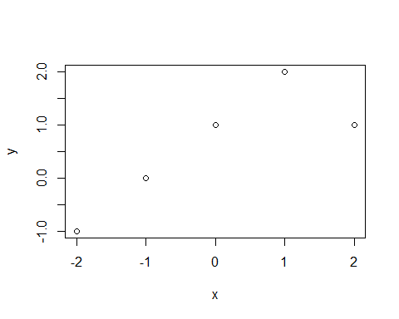

#### Problem 3

##### (a)

Code is provided at the end of the report in appendix with python 2.7

##### (b)

Accuracy = 68.06   
Details of process can be found in appendix code

##### (c)

Accuracy 66.20  
Details of process can be found in appendix code  
LDA and Naive Bayes have similar accuracy because LDA is also based on Naive Bayes to separate

#### problem 4

##### (a)

# read the data  
SAheart <- read.table("http://www-stat.stanford.edu/~tibs/ElemStatLearn/datasets/SAheart.data", sep=",",head=T,row.names=1)  
# set the seed  
set.seed(1)  
  
library(ISLR)

## Warning: package 'ISLR' was built under R version 3.3.3

attach(SAheart)  
Present = ifelse(chd==1, "Yes", "No")  
SAheart = data.frame(SAheart, Present)  
train <- sample(1:462,231)  
valid <- c(1:462)[-train]  
SAheart$famhist <- as.character(SAheart$famhist)  
SAheart$famhist[which(SAheart$famhist=="Present")] <- "1"  
SAheart$famhist[which(SAheart$famhist=="Absent")] <- "0"  
SAheart$famhist <- as.numeric(SAheart$famhist)  
# create training and validation sets  
SAheart_train <- SAheart[train,]  
SAheart_train <- SAheart_train[,-10]  
SAheart_valid <- SAheart[valid,]  
SAheart_valid <- SAheart_valid[,-10]

##### (b)

# fit a tree to the training data  
# building tree model with all predictors  
# It has 24 terminal nodes.  
# Training error is 0.130  
library(tree)

## Warning: package 'tree' was built under R version 3.3.3

treeModel = tree(Present~., SAheart_train)  
summary(treeModel)

##   
## Classification tree:  
## tree(formula = Present ~ ., data = SAheart_train)  
## Number of terminal nodes: 24   
## Residual mean deviance: 0.6281 = 130 / 207   
## Misclassification error rate: 0.1299 = 30 / 231

##### c)

treeModel

## node), split, n, deviance, yval, (yprob)  
## * denotes terminal node  
##   
## 1) root 231 308.000 No ( 0.61472 0.38528 )   
## 2) age < 25.5 32 0.000 No ( 1.00000 0.00000 ) *  
## 3) age > 25.5 199 273.700 No ( 0.55276 0.44724 )   
## 6) ldl < 8.205 182 245.900 No ( 0.59341 0.40659 )   
## 12) tobacco < 8.04 150 193.600 No ( 0.65333 0.34667 )   
## 24) famhist < 0.5 81 88.250 No ( 0.76543 0.23457 )   
## 48) sbp < 147 62 74.700 No ( 0.70968 0.29032 )   
## 96) ldl < 2.805 7 0.000 No ( 1.00000 0.00000 ) *  
## 97) ldl > 2.805 55 69.550 No ( 0.67273 0.32727 )   
## 194) sbp < 141 43 48.900 No ( 0.74419 0.25581 )   
## 388) ldl < 5.475 34 42.810 No ( 0.67647 0.32353 )   
## 776) tobacco < 1.36 14 11.480 No ( 0.85714 0.14286 )   
## 1552) sbp < 123 6 7.638 No ( 0.66667 0.33333 ) *  
## 1553) sbp > 123 8 0.000 No ( 1.00000 0.00000 ) *  
## 777) tobacco > 1.36 20 27.530 No ( 0.55000 0.45000 )   
## 1554) tobacco < 2.37 5 5.004 Yes ( 0.20000 0.80000 ) *  
## 1555) tobacco > 2.37 15 19.100 No ( 0.66667 0.33333 ) *  
## 389) ldl > 5.475 9 0.000 No ( 1.00000 0.00000 ) *  
## 195) sbp > 141 12 16.300 Yes ( 0.41667 0.58333 )   
## 390) tobacco < 2.3 7 5.742 Yes ( 0.14286 0.85714 ) *  
## 391) tobacco > 2.3 5 5.004 No ( 0.80000 0.20000 ) *  
## 49) sbp > 147 19 7.835 No ( 0.94737 0.05263 ) *  
## 25) famhist > 0.5 69 95.520 No ( 0.52174 0.47826 )   
## 50) ldl < 5.17 35 43.570 No ( 0.68571 0.31429 )   
## 100) obesity < 21.895 6 5.407 Yes ( 0.16667 0.83333 ) *  
## 101) obesity > 21.895 29 29.570 No ( 0.79310 0.20690 )   
## 202) age < 48.5 17 7.606 No ( 0.94118 0.05882 ) *  
## 203) age > 48.5 12 16.300 No ( 0.58333 0.41667 )   
## 406) alcohol < 8.075 6 7.638 Yes ( 0.33333 0.66667 ) *  
## 407) alcohol > 8.075 6 5.407 No ( 0.83333 0.16667 ) *  
## 51) ldl > 5.17 34 44.150 Yes ( 0.35294 0.64706 )   
## 102) age < 57 28 38.240 Yes ( 0.42857 0.57143 )   
## 204) typea < 49 5 0.000 Yes ( 0.00000 1.00000 ) *  
## 205) typea > 49 23 31.840 No ( 0.52174 0.47826 )   
## 410) typea < 52.5 5 0.000 No ( 1.00000 0.00000 ) *  
## 411) typea > 52.5 18 24.060 Yes ( 0.38889 0.61111 )   
## 822) adiposity < 31.18 7 5.742 Yes ( 0.14286 0.85714 ) *  
## 823) adiposity > 31.18 11 15.160 No ( 0.54545 0.45455 ) *  
## 103) age > 57 6 0.000 Yes ( 0.00000 1.00000 ) *  
## 13) tobacco > 8.04 32 39.750 Yes ( 0.31250 0.68750 )   
## 26) adiposity < 34.4 26 25.460 Yes ( 0.19231 0.80769 )   
## 52) obesity < 24.495 9 0.000 Yes ( 0.00000 1.00000 ) *  
## 53) obesity > 24.495 17 20.600 Yes ( 0.29412 0.70588 ) *  
## 27) adiposity > 34.4 6 5.407 No ( 0.83333 0.16667 ) *  
## 7) ldl > 8.205 17 12.320 Yes ( 0.11765 0.88235 )   
## 14) alcohol < 15.71 12 0.000 Yes ( 0.00000 1.00000 ) *  
## 15) alcohol > 15.71 5 6.730 Yes ( 0.40000 0.60000 ) *

# Let's pick 822, it means if adiposity is the predictor, and when its value is greater than 31.18,   
# there're 7 data points belongs to this region.   
# The prediction at this node is chd=1, 14.286% of data points have cha value to be 0, and the rest of them are 1.   
# A * in the line denotes that this is in fact a terminal node

##### d)

plot(treeModel)  
text(treeModel, pretty = 0)

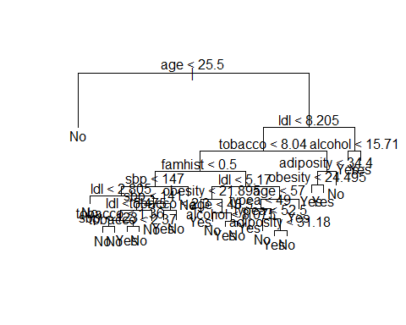

###### e)

treePred = predict(treeModel, SAheart_valid, type="class")  
table(SAheart_valid$Present, treePred)

## treePred  
## No Yes  
## No 121 39  
## Yes 41 30

Error rate is (42+41)/231 = 35.93%

##### f)

treeCV = cv.tree(treeModel, FUN=prune.misclass)  
names(treeCV)

## [1] "size" "dev" "k" "method"

treeCV

## $size  
## [1] 24 21 15 11 8 6 4 1  
##   
## $dev  
## [1] 81 78 82 83 82 78 84 90  
##   
## $k  
## [1] -Inf 0.000000 1.000000 1.250000 1.666667 4.000000 5.000000 8.333333  
##   
## $method  
## [1] "misclass"  
##   
## attr(,"class")  
## [1] "prune" "tree.sequence"

The tree with 6 terminal nodes results in the lowest cross-validation error rate, 78

##### g)

plot(treeCV$size ,treeCV$dev ,type="b", xlab="Tree Size", ylab="CV classification Error Rate")

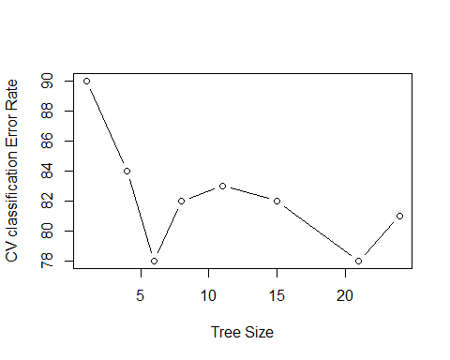

##### h)

When size = 6, result for cross-validation error rate is lowest.

##### i)

treePrune =prune.misclass(treeModel ,best = 6)

##### j)

summary(treePrune)

##   
## Classification tree:  
## snip.tree(tree = treeModel, nodes = c(7L, 24L, 51L, 13L, 50L))  
## Variables actually used in tree construction:  
## [1] "age" "ldl" "tobacco" "famhist"  
## Number of terminal nodes: 6   
## Residual mean deviance: 1.013 = 228 / 225   
## Misclassification error rate: 0.2338 = 54 / 231

Misclassification error rate is 23.38%, which is higher than before.

##### k)

treePrunePred = predict(treePrune, SAheart_valid, type="class")  
table(SAheart_valid$Present, treePrunePred)

## treePrunePred  
## No Yes  
## No 133 27  
## Yes 37 34

Test error rate is now (27+37)231 = 27.71%, which is lower than before.

##### (4b i & ii)

library(randomForest)

## Warning: package 'randomForest' was built under R version 3.3.3

## randomForest 4.6-12

## Type rfNews() to see new features/changes/bug fixes.

library(caret)

## Warning: package 'caret' was built under R version 3.3.3

## Loading required package: lattice

## Loading required package: ggplot2

## Warning: package 'ggplot2' was built under R version 3.3.3

##   
## Attaching package: 'ggplot2'

## The following object is masked from 'package:randomForest':  
##   
## margin

train.errors = rep(0, 100)  
test.errors = rep(0, 100)  
for (i in 1:100) {  
 tree.bag = randomForest(Present~., SAheart_train, mtry=9, ntree=i, importance=TRUE)  
 yhat.bag = predict(tree.bag, SAheart_train)  
 yhat.bag.test = predict(tree.bag, SAheart_valid)  
 train.errors[i] = confusionMatrix(yhat.bag, SAheart_train$Present)$overall[1]  
 test.errors[i] = confusionMatrix(yhat.bag.test, SAheart_valid$Present)$overall[1]  
}  
plot(train.errors, xlab="Number of Trees", ylab="% of correct predictions", main="Bagging on the training set")

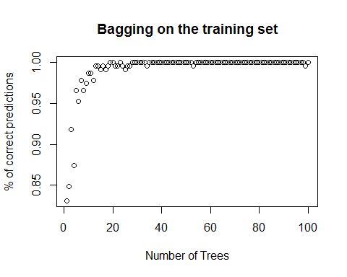

plot(test.errors, xlab="Number of Trees", ylab="% of correct predictions", main="Bagging on the testing set")

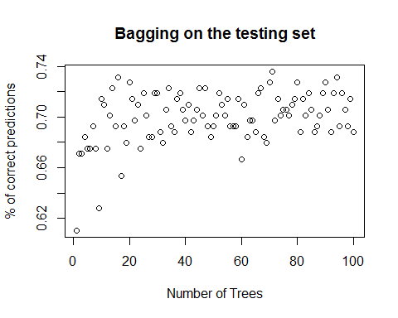

##### (4b iii)

When B increase the accuracy on the training set is keep increasing, but it is not true for valid set. From the plot, we can see it may cause overfit if B is too large. ##### (4c i & ii)

train.errors1 = rep(0, 100)  
train.errors2 = rep(0, 100)  
test.errors1 = rep(0, 100)  
test.errors2 = rep(0, 100)  
for (i in 1:100) {  
 rf1 = randomForest(Present~., SAheart_train, mtry=6, ntree=i, importance = TRUE)  
 rf2 = randomForest(Present~., SAheart_train, mtry=3, ntree=i, importance = TRUE)  
 yhat.rf1 = predict(rf1, SAheart_train)  
 yhat.rf2 = predict(rf2, SAheart_train)  
 yhat.rf1.test = predict(rf1, SAheart_valid)  
 yhat.rf2.test = predict(rf2, SAheart_valid)  
 train.errors1[i] = confusionMatrix(yhat.rf1, SAheart_train$Present)$overall[1]  
 test.errors1[i] = confusionMatrix(yhat.rf1.test, SAheart_valid$Present)$overall[1]  
 train.errors2[i] = confusionMatrix(yhat.rf2, SAheart_train$Present)$overall[1]  
 test.errors2[i] = confusionMatrix(yhat.rf2.test, SAheart_valid$Present)$overall[1]  
}  
x=seq(1, 100)  
plot(x, train.errors1, xlab="Number of Trees", ylab="% of correct predictions", type="p", main="Random Forest m=6 & m=3 on the training set", col="blue")  
points(x, train.errors2, col="red")

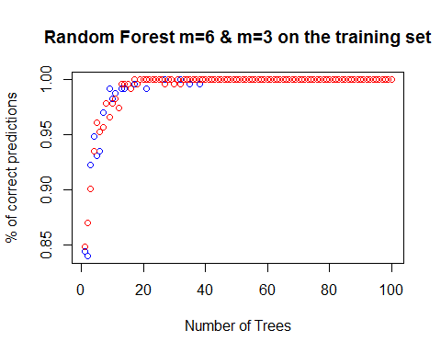

plot(x, test.errors1, xlab="Number of Trees", ylab="% of correct predictions", type="p", main="Random Forest m=6 & m=3 on the validation set", col="blue")  
points(x, test.errors2, col="red")

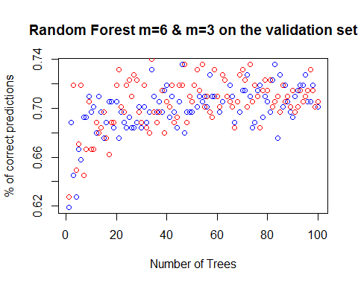 ##### (4c iii)

This is similar as in Bagging. As we can see the training set accuracy is quickly increasing towards to 100%. However, it also cause overfit which doesn't improve accuracy of valid set prediction much after B > 20.

##### (4d)

# i & ii  
library(gbm)

## Warning: package 'gbm' was built under R version 3.3.3

## Loading required package: survival

##   
## Attaching package: 'survival'

## The following object is masked from 'package:caret':  
##   
## cluster

## Loading required package: splines

## Loading required package: parallel

## Loaded gbm 2.1.3

pows = seq(-3, -1, by=0.1)  
lambdas = 10^pows  
length.lambdas = length(lambdas)  
train.errors3 = rep(0, length.lambdas)  
test.errors3 = rep(0, length.lambdas)  
SAheart_train <- SAheart[train,]  
SAheart_train <- SAheart_train[,-11]  
SAheart_validation <- SAheart[valid,]  
SAheart_validation <- SAheart_validation[,-11]  
for (i in 1:length.lambdas) {  
 tree.boost = gbm(chd~., data = SAheart_train, distribution = "bernoulli", n.trees = 1000, shrinkage = i, verbose = F)  
 yhat.boost = predict(tree.boost, SAheart_train, n.trees = 1000, type="response")  
 yhat.boost.test = predict(tree.boost, SAheart_validation, n.trees = 1000, type="response")  
 yhat.boost1 = ifelse(yhat.boost>=0.5, 1, 0)  
 yhat.boost1.test = ifelse(yhat.boost.test>=0.5, 1, 0)  
 train.errors3[i] = confusionMatrix(yhat.boost1, SAheart_train$chd)$overall[1]  
 test.errors3[i] = confusionMatrix(yhat.boost1.test, SAheart_validation$chd)$overall[1]  
}

## Warning in confusionMatrix.default(yhat.boost1, SAheart_train$chd): Levels  
## are not in the same order for reference and data. Refactoring data to  
## match.

## Warning in confusionMatrix.default(yhat.boost1.test, SAheart_validation  
## $chd): Levels are not in the same order for reference and data. Refactoring  
## data to match.

## Warning in confusionMatrix.default(yhat.boost1, SAheart_train$chd): Levels  
## are not in the same order for reference and data. Refactoring data to  
## match.

## Warning in confusionMatrix.default(yhat.boost1.test, SAheart_validation  
## $chd): Levels are not in the same order for reference and data. Refactoring  
## data to match.

## Warning in confusionMatrix.default(yhat.boost1, SAheart_train$chd): Levels  
## are not in the same order for reference and data. Refactoring data to  
## match.

## Warning in confusionMatrix.default(yhat.boost1.test, SAheart_validation  
## $chd): Levels are not in the same order for reference and data. Refactoring  
## data to match.

## Warning in confusionMatrix.default(yhat.boost1, SAheart_train$chd): Levels  
## are not in the same order for reference and data. Refactoring data to  
## match.

## Warning in confusionMatrix.default(yhat.boost1.test, SAheart_validation  
## $chd): Levels are not in the same order for reference and data. Refactoring  
## data to match.

## Warning in confusionMatrix.default(yhat.boost1, SAheart_train$chd): Levels  
## are not in the same order for reference and data. Refactoring data to  
## match.

## Warning in confusionMatrix.default(yhat.boost1.test, SAheart_validation  
## $chd): Levels are not in the same order for reference and data. Refactoring  
## data to match.

## Warning in confusionMatrix.default(yhat.boost1, SAheart_train$chd): Levels  
## are not in the same order for reference and data. Refactoring data to  
## match.

## Warning in confusionMatrix.default(yhat.boost1.test, SAheart_validation  
## $chd): Levels are not in the same order for reference and data. Refactoring  
## data to match.

plot(train.errors3, xlab="Shrinkage parameter lambda", ylab="% of correct predictions", main="Boosting on the training set")

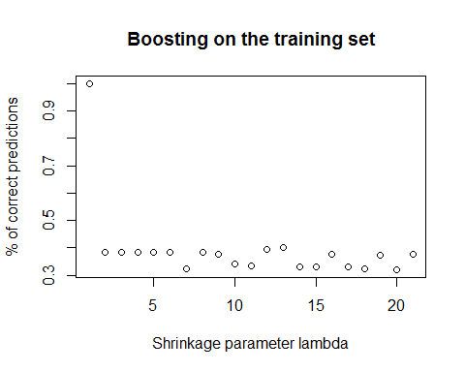

plot(test.errors3,xlab="Shrinkage parameter lambda", ylab="% of correct predictions", main="Boosting on the validation set")

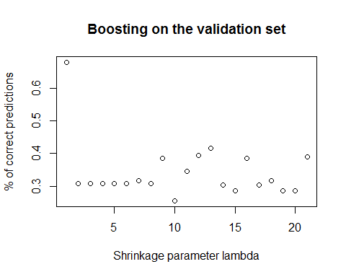

#While the lambda increases from 0.001 to 0.1, the accuracy is decresing, this is because the slower the tree grows, the more accuracy the prediction would be.

##### (4c)

tree.boost = gbm(chd~., data = SAheart_train, distribution = "bernoulli", n.trees = 1000, shrinkage = 0.01, verbose = F)  
summary(tree.boost)

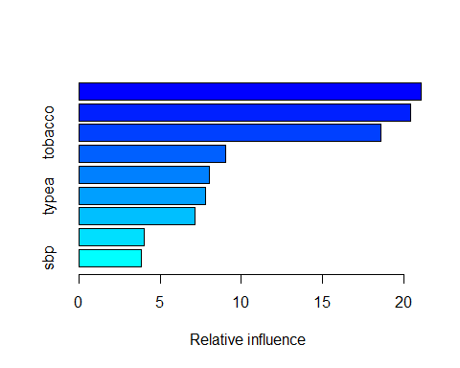

## var rel.inf  
## ldl ldl 21.074627  
## age age 20.436518  
## tobacco tobacco 18.572606  
## adiposity adiposity 9.043009  
## obesity obesity 8.035933  
## typea typea 7.792631  
## famhist famhist 7.136053  
## alcohol alcohol 4.034260  
## sbp sbp 3.874363

ldl, age and tobacco are highly correlated to chd.

#### Problem 5

##### (a)

x1 = c(3, 2, 4, 1, 2, 4, 4)  
x2 = c(4, 2, 4, 4, 1, 3, 1)  
colors = c("red", "red", "red", "red", "blue", "blue", "blue")  
plot(x1, x2, col = colors, xlim = c(0, 5), ylim = c(0, 5))

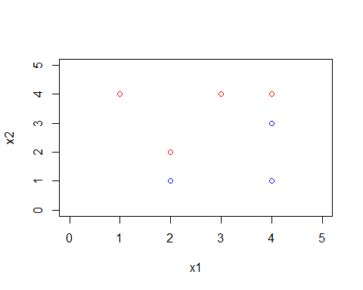

##### (b)

(2,2), (4,4)  (2,1), (4,3)  => (2,1.5), (4,3.5)  b = (3.5 - 1.5) / (4 - 2) = 1  a = X2 - X1 = 1.5 - 2 = -0.5

plot(x1, x2, col = colors, xlim = c(0, 5), ylim = c(0, 5))  
abline(-0.5, 1)

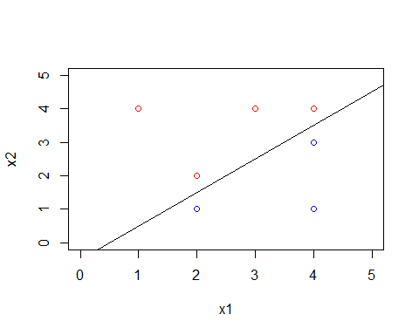

##### (c)

0.5 - X1 + X2 > 0

##### (d)

plot(x1, x2, col = colors, xlim = c(0, 5), ylim = c(0, 5))  
abline(-0.5, 1)  
abline(-1, 1, lty = 2)  
abline(0, 1, lty = 2)

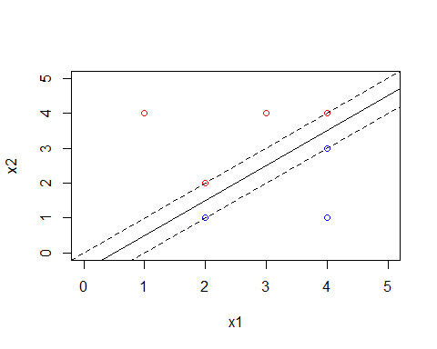

##### (e)

plot(x1, x2, col = colors, xlim = c(0, 5), ylim = c(0, 5))  
abline(-0.5, 1)  
arrows(2, 1, 2, 1.5)  
arrows(2, 2, 2, 1.5)  
arrows(4, 4, 4, 3.5)  
arrows(4, 3, 4, 3.5)

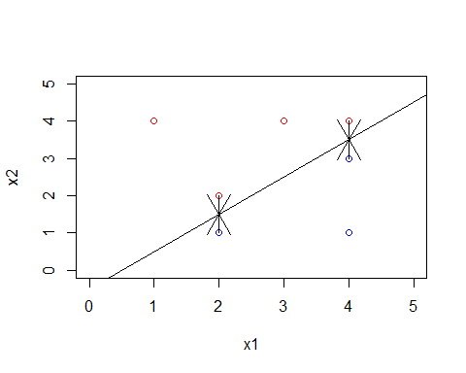

##### (f)

A slight movement of observation #7 (4,1) blue would not have an effect on the maximal margin hyperplane because it is out of margin and far from it.

##### (g)

plot(x1, x2, col = colors, xlim = c(0, 5), ylim = c(0, 5))  
abline(-0.8, 1)

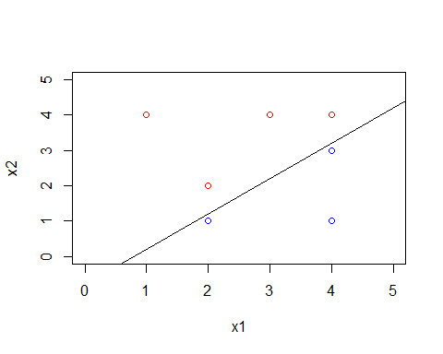 -0.8 - X1 + X2 > 0

##### (h)

plot(x1, x2, col = colors, xlim = c(0, 5), ylim = c(0, 5))  
points(c(4), c(2), col = c("red"))

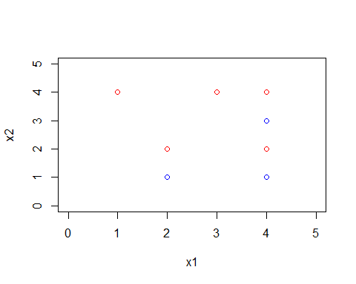

#### Problem 6

##### (a)

data= read.table("http://www-stat.stanford.edu/~tibs/ElemStatLearn/datasets/SAheart.data", sep=",",head=T,row.names=1)  
data$chd <- factor(data$chd)  
set.seed(1)  
sub <- sample(nrow(data), floor(nrow(data)/2))  
train<-data[sub,]  
valid<-data[-sub,]  
head(train)

## sbp tobacco ldl adiposity famhist typea obesity alcohol age chd  
## 123 120 0.00 5.01 26.13 Absent 64 26.21 12.24 33 0  
## 172 118 0.75 2.58 20.25 Absent 59 24.46 0.00 32 0  
## 265 136 5.00 4.19 23.99 Present 68 27.80 25.86 35 0  
## 418 158 16.00 5.56 29.35 Absent 36 25.92 58.32 60 0  
## 93 143 0.46 2.40 22.87 Absent 62 29.17 15.43 29 0  
## 412 178 20.00 9.78 33.55 Absent 37 27.29 2.88 62 1

library(caret)  
library(ggplot2)  
library(e1071)

## Warning: package 'e1071' was built under R version 3.3.3

library(MASS)  
control <- trainControl(method="cv", number=12)  
metric <- "Accuracy"

# Linear Kernel  
# Train  
model.svm <- train(chd~., data=train, method="svmLinear", metric=metric, trControl=control)

## Loading required package: kernlab

##   
## Attaching package: 'kernlab'

## The following object is masked from 'package:ggplot2':  
##   
## alpha

prediction.svm <- predict(model.svm, train)  
confusionMatrix(prediction.svm, train$chd)$overall[1]

## Accuracy   
## 0.7272727

# Valid  
model.svm <- train(chd~., data=train, method="svmLinear", metric=metric, trControl=control)  
prediction.svm <- predict(model.svm, valid)  
confusionMatrix(prediction.svm, valid$chd)$overall[1]

## Accuracy   
## 0.7099567

# Radial Kernel  
# Train  
model.svm <- train(chd~., data=train, method="svmRadial", metric=metric, trControl=control)  
prediction.svm <- predict(model.svm, train)  
confusionMatrix(prediction.svm, train$chd)$overall[1]

## Accuracy   
## 0.8225108

# Valid  
model.svm <- train(chd~., data=train, method="svmRadial", metric=metric, trControl=control)  
prediction.svm <- predict(model.svm, valid)  
confusionMatrix(prediction.svm, valid$chd)$overall[1]

## Accuracy   
## 0.7402597

# ROC  
#Tainning  
library(ROCR)

## Loading required package: gplots

##   
## Attaching package: 'gplots'

## The following object is masked from 'package:stats':  
##   
## lowess

rocplot=function(pred, truth, ...){  
 predob = prediction(pred, truth)  
 pref = performance(predob, "tpr", "fpr")  
 plot(pref,...)  
}  
  
svmfit.opt=svm(chd~., data=train, kernel="radial", gamma=0.01, cost=1, decision.values=T)  
fitted=attributes(predict(svmfit.opt, train, decision.values=TRUE))$decision.values  
par(mfrow=c(1, 2))  
  
rocplot(fitted, valid$chd, main="Test Data")  
pred = prediction(fitted, valid$chd)  
unlist(attributes(performance(pred, "auc"))$y.values)

## [1] 0.5710387

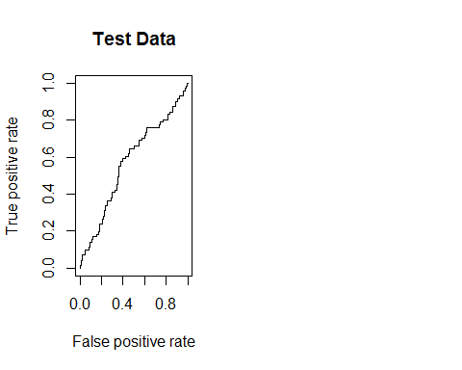

data= read.table("http://www-stat.stanford.edu/~tibs/ElemStatLearn/datasets/SAheart.data", sep=",",head=T,row.names=1)  
data$famhist = as.numeric(data$famhist)  
maxs <- apply(data, 2, max)  
mins <- apply(data, 2, min)  
  
scaled.data <- as.data.frame(scale(data, center = mins, scale = maxs - mins))  
set.seed(1)  
sub <- sample(nrow(scaled.data), floor(nrow(scaled.data)/2))  
train<-scaled.data[sub,]  
valid<-scaled.data[-sub,]  
head(train)

## sbp tobacco ldl adiposity famhist typea obesity  
## 123 0.1623932 0.00000000 0.2808362 0.5423776 0 0.7846154 0.3610414  
## 172 0.1452991 0.02403846 0.1114983 0.3779021 0 0.7076923 0.3061481  
## 265 0.2991453 0.16025641 0.2236934 0.4825175 1 0.8461538 0.4109159  
## 418 0.4871795 0.51282051 0.3191638 0.6324476 0 0.3538462 0.3519448  
## 93 0.3589744 0.01474359 0.0989547 0.4511888 0 0.7538462 0.4538896  
## 412 0.6581197 0.64102564 0.6132404 0.7499301 0 0.3692308 0.3949184  
## alcohol age chd  
## 123 0.08315782 0.3673469 0  
## 172 0.00000000 0.3469388 0  
## 265 0.17569128 0.4081633 0  
## 418 0.39622257 0.9183673 0  
## 93 0.10483049 0.2857143 0  
## 412 0.01956655 0.9591837 1

feats <- names(scaled.data[,c(1:9)])  
  
# Concatenate strings  
f <- paste(feats,collapse=' + ')  
f <- paste('chd ~',f)  
  
# Convert to formula  
f <- as.formula(f)  
  
f

## chd ~ sbp + tobacco + ldl + adiposity + famhist + typea + obesity +   
## alcohol + age

library(neuralnet)

## Warning: package 'neuralnet' was built under R version 3.3.3

##   
## Attaching package: 'neuralnet'

## The following object is masked from 'package:ROCR':  
##   
## prediction

nn <- neuralnet(f,data=train,hidden=c(10, 10, 10),linear.output=FALSE)  
# Compute Predictions off Test Set  
predicted.nn.values <- compute(nn,valid[,c(1:9)])  
  
# Check out net.result  
print(head(predicted.nn.values$net.result))

## [,1]  
## 1 0.9999999937234249625  
## 2 0.9869098296607109466  
## 3 0.0405459177880382535  
## 4 0.9999903811227067729  
## 7 0.0000000001823047063  
## 8 0.0000000372967220780

plot(nn)  
predicted.nn.values$net.result <- sapply(predicted.nn.values$net.result,round,digits=0)  
table(valid$chd,predicted.nn.values$net.result)

##   
## 0 1  
## 0 119 41  
## 1 30 41

# Accuracy = (125+38)/231 = 70.56%

#### Problem 7

Because our training and valid sets is randomly picked, we can't directly compare the accuracy of this homework to the one in homework3. roughly Speaking, they are performed similar because this problem is a simple 2 class classiﬁcation. I believe one of the reasons to cause them slightly diﬀerent is the random training and validation dataset.

•Logistic regression and Nearal Network doesn't perform well because we didn’t check the correlationship between predictors.Andfrom the pair(train), we can see there are correlation between parameters.

•One drawback of diagonal LDA, Naive Bayes and SVM is that it depends on all of the features. This is the reason it can’tperform better in this problem.

•Logistic with Lasso shrunk the dataset to ﬁlter out the less related predictorswith zero coef. If we test diﬀerent number of predictors, the result possibly become even better.

• Nearest shrunken centroids only depends on a subset of the features, for reasons of accuracy andinterpret ability. With an accurate threshold with less err rate, it performs well in this problem

#### Appendix

import csv  
import random  
import math  
import operator  
import numpy as np  
from sklearn.discriminant_analysis import LinearDiscriminantAnalysis as LDA  
  
  
random.seed(123)  
  
  
# loadDataset and create training set and test set  
def load_data(filename, split, trainingSet, testSet):  
 with open(filename, 'rb') as csvfile:  
 lines = csv.reader(csvfile)  
 dataset = list(lines)  
 for x in range(len(dataset) - 1):  
 for y in range(9):  
 dataset[x][y] = float(dataset[x][y])  
 if random.random() < split:  
 trainingSet.append(dataset[x])  
 else:  
 testSet.append(dataset[x])  
  
  
# separate class of chd for '0' & '1'  
def separate(dataset):  
 separated = {}  
 for i in range(len(dataset)):  
 vector = dataset[i]  
 if (vector[-1] not in separated):  
 separated[vector[-1]] = []  
 separated[vector[-1]].append(vector)  
 return separated  
  
  
# find euclidean distance between two instances (rows)  
def get_distance(instance1, instance2, length):  
 distance = 0  
 for x in range(length):  
 distance += pow((instance1[x] - instance2[x]), 2)  
 return math.sqrt(distance)  
  
  
# find prior probability for each class  
def priorProb(dict, dataset):  
 total = len(dataset)  
 prior = {}  
 for k in dict:  
 if (k == '1'):  
 class1 = len(dict[k])  
 prior1 = float(class1) / float(total)  
 prior[k] = prior1  
 print(prior1)  
 else:  
 class0 = len(dict[k])  
 prior0 = float(class0) / float(total)  
 prior[k] = prior0  
 print(prior0)  
 return prior  
  
  
# get the most similar neighbors for a test instance  
def get_neighbours(train, test, width):  
 distances = []  
 length = len(test) - 1  
 for x in range(len(train)):  
 dist = get_distance(train[x], test, length)  
 distances.append((train[x], dist))  
  
 distances.sort(key=operator.itemgetter(1))  
 # print(distances)  
 neighbours = []  
  
 for x in range(len(distances)):  
 if (distances[x][1] < width):  
 neighbours.append(distances[x][0])  
  
 return neighbours  
  
  
# Gaussian product kernel  
def kernel(neighborsDic, testInstance, width):  
 difference1 = []  
 difference0 = []  
 length = len(testInstance) - 1  
 n1 = 0  
 n0 = 0  
 for k in neighborsDic:  
 if (k == "1"):  
 for neighbor in neighborsDic[k]:  
 diff1 = get_distance(neighbor, testInstance, length)  
 difference1.append((neighbor, diff1))  
 n1 += 1  
 print("difference is 1" + "\n")  
 print(difference1)  
 print(n1)  
 else:  
 for neighbor in neighborsDic[k]:  
 diff0 = get_distance(neighbor, testInstance, length)  
 difference0.append((neighbor, diff0))  
 n0 += 1  
 print("difference is 0" + "\n")  
 print(difference0)  
 print(n0)  
  
 sum1 = 0  
 sum0 = 0  
 for d in difference1:  
 sum1 += math.exp(-(math.pow(d[1] / width, 2)) / 2)  
 print("sum1 is: " + "\n")  
 print(sum1)  
  
 for d in difference0:  
 sum0 += math.exp(-(math.pow(d[1] / width, 2)) / 2)  
 print("sum0 is: " + "\n")  
 print(sum0)  
  
 width2 = math.pow(width, 2)  
 print("width2 is: ", width2)  
 nValue1 = n1 * math.pow(2 * width2 * math.pi, length / 2)  
 print("nValue1 is: ", nValue1)  
 if (nValue1 == 0):  
 product1 = 0  
 else:  
 product1 = 1 / nValue1 * sum1  
  
 nValue0 = n0 * math.pow(2 * width2 * math.pi, length / 2)  
 print("nValue0 is: ", nValue0)  
 if (nValue0 == 0):  
 product0 = 0  
 else:  
 product0 = 1 / nValue0 * sum0  
  
 print(product1)  
 print(product0)  
  
 prob = {}  
 prob["1"] = product1  
 prob["0"] = product0  
  
 return prob  
  
  
# make prediction for the test set  
def get_response(prior, prob, testInstance):  
 r = []  
 prob1 = prior["1"] * prob["1"]  
 prob0 = prior["0"] * prob["0"]  
  
 totalProb = prob1 + prob0  
 if (totalProb == 0):  
 freq1 = prob1  
 freq0 = prob0  
 else:  
 freq1 = prob1 / totalProb  
 freq0 = prob0 / totalProb  
  
 print(freq1)  
 print(freq0)  
 if (freq1 <= freq0):  
 response = "0"  
 r.append((testInstance, response))  
  
 else:  
 response = "1"  
 r.append((testInstance, response))  
  
 print(r)  
 return r  
  
  
if __name__ == "__main__":  
 trainingSet = []  
 testSet = []  
 split = 0.5  
 # data.csv is the dataset "South African Heart Disease";  
 # however, it doesn't contain a header line and non-continous value such as famhist  
 load_data('data.csv', split, trainingSet, testSet)  
 print 'Train set: ' + repr(len(trainingSet))  
 print 'Test set: ' + repr(len(testSet))  
 # print trainingSet  
  
 separatedClass = separate(trainingSet)  
 # print('separatedClass instances: {0}').format(separatedClass)  
 prior = priorProb(separatedClass, trainingSet)  
  
 width = 50  
  
 # make prediction for each test set  
 responses = []  
 correct = 0  
 print(testSet)  
 for x in range(len(testSet)):  
 neighbors = get_neighbours(trainingSet, testSet[x], width)  
 print("neighbors" + "\n")  
 print(neighbors)  
  
 neighborsClass = separate(neighbors)  
 print("neighborsClass" + "\n")  
 print(neighborsClass)  
  
 prob = kernel(neighborsClass, testSet[x], width)  
  
 response = get_response(prior, prob, testSet[x])  
 print("testSet[x] is:")  
 print(testSet[x])  
  
 if (testSet[x][-1] == response[0][1]):  
 correct += 1  
 responses.append(response)  
 print("responses is " + "\n")  
 print(responses)  
  
 accuracy = (correct / float(len(testSet))) * 100.0  
  
 # LDA analysis  
 trainingSetX = []  
 trainingSetY = []  
 testSetX = []  
 testSetY = []  
 for trainx in trainingSet:  
 trainy = trainx.pop()  
 trainingSetX.append(trainx)  
 trainingSetY.append(trainy)  
 for testx in testSet:  
 testy = testx.pop()  
 testSetX.append(testx)  
 testSetY.append(testy)  
 X = np.array(trainingSetX)  
 Y = np.array(trainingSetY)  
 lda = LDA()  
 lda.fit(X, Y)  
 predict = lda.predict(testSetX)  
 print(predict)  
 testY = np.array(testSetY)  
 print(testY)  
 accuracyLDA = np.sum(predict == testY) / float(len(testSet)) * 100.0  
  
 print "Naive Bayes Accuracy: " + str(accuracy)  
 print "LDA Accuracy: " + str(accuracyLDA)