**Performance Analysis of TCP Variants**

Zhongxi Wang, Shiyu Wang

Professor: David Choffnes

Feb. 25th, 2017

**Introduction**

In this paper, we present the result of our study on the performances of different TCP variants. The NS-2 network simulator is used as the main tool for this study. We compared the performances of TCP Tahoe, Reno, New Reno and Vegas under different situations. In experiment 1, we analyze the performance of each one under different congestions. In experiment 2, we simulate two TCP flows to analyze how well they share bandwidth and their fairness to each other. In experiment 3, how queueing mechanism used in buffer impacts the TCP performance is studied. At the end of the paper, the key results from these experiments are highlighted.

**Methodology**

We conducted the simulation in NS-2. NS-2 is an object oriented network simulator which can simulate TCP, routing and multicast protocols over LANs and WANs. In terms of TCP’s performances, following properties are studied:

1. Throughput, the amount of successfully transferred data per second. The unit is in MB/s
2. Average RTT, the average round-trip delay time of packets. The unit is in second.
3. Drop rate, the percentage of package dropped.

The simulation of network topology, flow starting time, buffer size and queuing mechanism are set up by TCL scripts. The trace results given by NS-2 are exported to standard output and parsed by a Java program which also calculates throughput, average RTT and drop rate. We also conducted T-test for our results in order to check the significance of their statistical difference.

**Experiment 1**

In this experiment, we use a network topology as shown below. One TCP flow is sent from N1 to N4, and one CBR flow is sent from N2 to N3. The bandwidth of the links of N1-N2, N2-N3 and N3-N4 are all 10Mbps. The experiment starts with CBR flow rate at 1Mbps, it is increased in 1 Mbps every iteration until bottleneck capacity 10Mbps is reached. This experiment is conducted with following TCP variants: Tahoe, Reno, NewReno and Vegas. For each TCP variant, we run the experiment 10 times, in order to calculate T-value. The results of this experiment are the average results of 10 times. Fig 1.2-1.4 show the results in the form of throughput, drop rate and RTT.

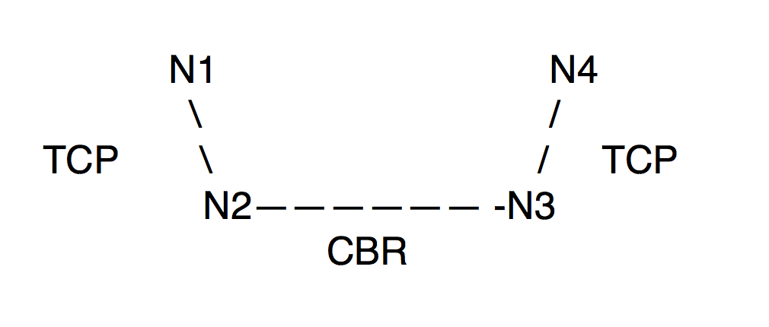

Fig. 1.1 Topology

Fig. 1.2 Throughput of all TCP variants vs. CBR rate

Fig. 1.3 RTT of all TCP variants vs. CBR rate

Fig. 1.4. DropRate of all TCP variant vs CBR rate

| T-Value | Tahoe | Reno | NewReno | Vegas |
| --- | --- | --- | --- | --- |
| Tahoe | 0 | 8.4079 | 5.8644 | 5.9734 |
| Reno | 8.4079 | 0 | 16.747 | 5.9188 |
| NewReno | 5.8644 | 16.747 | 0 | 21.955 |
| Vegas | 5.9734 | 5.9188 | 21.955 | 0 |

Table 1.1. T-Value for throughput

Table 1.1 shows the T-value of the experiment, which is produced by running the experiment than 10 times. With p-value at 0.001, and degree of freedom at 18, if T-value is larger than 3.92, then the null hypotheses that the two TCPs have the same throughput can be rejected. As the value in the above table shows, we can safely conclude all the TCPs in our experiment have significantly different throughput. In the following paragraphs of this section, we will discuss the causes of these differences.

***Tahoe***, from the experiment, it shows Tahoe has a relatively low throughput and high drop rate, especially when the CBR rate is high. This is due to the fact that Tahoe takes a full retransmission time out to detect a packet loss. This causes many packets to be transmitted in vain.

***Reno***, unlike Tahoe, Reno enters fast retransmit once it receives three duplicate ACKs. As a result, it would not waste many packets which would be discarded by the receiver. Therefore, we can see it has a much better drop rate than Tahoe. However, due to the fast retransmission of Reno, it can send packets at a fast rate even when the network is pretty congested, which can cause many packets to be stranded in buffer for a long time. Therefore, it has a longer RTT than other TCPs.

***NewReno***, pretty similar to Reno, NewReno has one major difference which is it does not exit fast retransmission until all the data in the pipeline has been acknowledged. Due to this difference, NewReno is generally more aggressive than Reno. As a result, we can see that it has a high RTT and high drop rate. However, when the congestion is low, its throughput is the best among all the TCPs.

***Vegas***, it uses a much more accurate mechanism to estimate RTT and decide the retransmission timeout. We can see this has an enormous benefit when congestion is high. Among all the TCPs, Vegas has the best performance in terms of drop rate and RTT. However, Vegas uses additive increases in the congestion window, which makes it less aggressive than the other TCPs. This is reflected in the relatively lower throughput of it when the congestion is low. Whereas, when the congestion is high, Vegas’ better RTT estimation mechanism makes it outperformed all the other TCP in throughput.

**Experiment 2**

This experiment mainly focuses on fairness between different TCP variants. As we expected, all of these variants should be fair to one another, so different TCPs share equal bandwidth. However, we know fairness is one of the problems of TCP variants in reality.

For this experiment, three flows are set in the network. In Fig. 2.1, one CBR is added at N2 and sink at N3. Then, two TCPs are from N1 to N4 and N5 to N6, respectively. The bandwidth of each link is set at 10Mbps. The performance of these TCP flows is measured by changing the CBR rate until it reaches the bottleneck capacity.

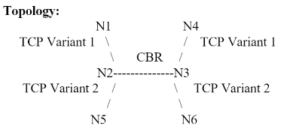

Fig. 2.1 Topology

In this experiment, we test and measure average data of four pairs of TCP variants, including:

1. Reno vs. Reno
2. NewReno vs. Reno
3. Vegas vs. Vegas
4. NewReno vs. Vegas

As in Experiment 1, we plot the average throughput, packet loss rate, and RTT of each TCP flow as a function of the bandwidth used by the CBR flow.

**Reno vs. Reno**

Fig. 2.2 Throughput of Reno vs. Reno

Fig. 2.3 Packet Drop Rate of Reno vs. Reno

From the Fig. 2.2 above, it shows the throughput of two TCP Reno are similar during the increasing of rate of CBR flow. The bottleneck capacity of bandwidth causes small difference in the middle of the test, but their throughput rebounds to the same level soon. This shows they share the bandwidth equally. Although the drop rate show Reno 2 has higher value than Reno 1, the difference is less than 5%.

**NewReno vs. Reno**

Fig. 2.4 Throughput of New Reno vs. Reno

NewReno has higher throughput than Reno when they are sharing the bandwidth. The Fig. 2.4 shows that this combination is unfair. As the rate of CBR increases, it is obviously that NewReno always has higher throughput. The T-test below produces a T-value which is high enough to reject null hypothesis.

|  |  |  |
| --- | --- | --- |
| T-Value | New Reno | Reno |
| New Reno | 0 | 16.747 |
| Reno | 16.747 | 0 |

Table 2.1 T-Value of New Reno vs. Reno

Fig. 2.5 Packet Drop Rate of NewReno vs. Reno

In another aspect, New Reno has lower drop rate in the Fig. 2.5. It is because New Reno has the advantage of fast retransmission which does not need to waste time for retransmission of packet as in the case of Reno. This gives NewReno priority in bandwidth sharing.

**Vegas vs. Vegas**

Fig. 2.6 Throughput of New Reno vs. Reno

Fig. 2.7 Packets Drop Rate of New Reno vs. Reno

From the Fig. 2.6, although two variants have similar latency and drop rate, Vegas 1 has slightly higher throughput in the bandwidth sharing. Vegas is different from other TCP variants that it applies delay-based congestion avoidance. It adjusts the sending rate based on queue building rather than loss of segment for congestion detection. Hence, when it notices the rate is lower than the expected rate, it increases its rate of transmissions to utilize the bandwidth. Conversely, transmission rate becomes lower when rate is close to the expected rate, which helps avoiding saturation of the bandwidth of the network. This is the reason that both of them have amazingly low Drop rate shown in Fig. 2.7.

In this case, one Vegas increases the sending rate. And the other one detects it and reduces the transmission rate correspondingly. As shown in Fig. 2.6, the difference value between two Vegas are changing over time. As soon as they get closer, one starts trying to increase rate and the other acts oppositely. However, it does not influence the RTT and Drop rate. Therefore, we conclude two Vegas variants are fair in bandwidth sharing.

**NewReno vs. Vegas**

Fig 2.8 Throughput of New Reno vs. Vegas

Fig 2.9 Packet Drop Rate of New Reno vs. Vegs

In compassion between NewReno and Vegas, the former is more aggressive, since no matter which variants starts early, NewReno always takes most of the capacity. Because of the congestion avoidance algorithm talked in the last section, Vegas always calculates the bandwidth while NewReno is in the slow-start stage. During this period, Vegas reduces its transmission rate after every RTT, meanwhile, New Reno takes the majority of the capacity. Therefore, New Reno has a better throughput in Fig. 2.8. Therefore, in this pair, TCP New Reno is unfair to Vegas. The T-test below produces a T-value which is high enough to reject null hypothesis

|  |  |  |
| --- | --- | --- |
| T-Value | New Reno | Vegas 2 |
| New Reno | 0 | 17.964 |
| Vegas | 17.964 | 0 |

Table 2.2 T-Value of New Reno vs. Vegas

**Experiment 3**

In this experiment we compare the influence of queuing disciplines of two algorithms, DropTail and Random Early Drop (RED). As shown in Fig. 3.1 below, One TCP is set up from N1 to N4 and started in the beginning. After the TCP flows runs steadily, the CBR flow will start running from N5 to N6.

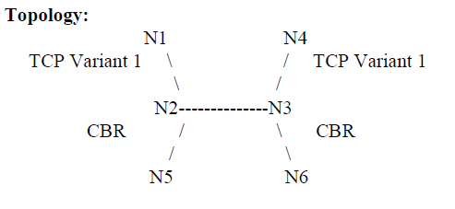

Fig. 3.1 Topology

With twenty times experiments, we vary starting time of CBR flow randomly between 1s and 2s. Average throughput, packet drop rate and latency are recorded every 0.5 seconds and used to analyze different queue disciplines algorithms.

**Does each queuing discipline provide fair bandwidth to each flow?**

For this experiment, it is obvious the queuing discipline does not provide fair bandwidth to each flow, because the CBR flow does not care about the packet drops. However, the TCP flow is affected because of the retransmission of dropped packages.

**How does the end-to-end latency for the flows differ between DropTail and RED?**

Fig. 3.2 RTT of DropTail vs RED for Reno

Fig. 3.3 RTT of DropTail vs RED for Sack

From the Fig. 3.3 and Fig. 3.4, RED algorithm takes more time during transmission for both Sack and Reno. The reason is RED monitors the queue size and drops packets based on the queue capacity. Hence, there is a small delay as the packet transmitted in the flow. By contrast, DropTail increases the buffer size over time until reaching the limitation.

**How does the TCP flow react to the creation of the CBR flow?**

Fig. 3.4 Throughput of DropTail vs RED for Reno

Fig 3.5 Throughput of DropTail vs RED for Sack

According to the Fig. 3.4 and Fig. 3.5, the throughput of TCP decreases dramatically when CBR flow is added into the network. After the starting of the CBR flow, the packets start dropping because of the limited queue size. However, after a short time, DropTail brings higher throughput, then decreases again with both Sack and Reno. By contrast, the throughput using RED algorithm keeps the low rate of throughput. The is because DropTail only drops packets when the buffer is full, so it can keep the high throughput when there is still space in the buffer. However, RED drops packets randomly when it detects congestion based on its calculation. And the probability of dropping packets is proportional to the queue length.

**Is RED a good idea while dealing with SACK?**

As shown in Fig. 3.5, although using RED still has lower throughput than using DropTail algorithm, applying RED algorithm with Sack is better than it is with Reno in Fig 3.4, The reason is RED requires random retransmission during data sending. In comparison between Sack and Reno, Sack has a special way of responding selective ACKs, which includes received, out-of-order sequence numbers in TCP header. Hence it is able to tell the sender about holes in the sequence, and perfectly match the needs of RED algorithm. Therefore, it is much easier for Sack variant to resend randomly dropped data. Based on the observation and the reason, we can conclude RED is a good idea while dealing with SACK.

**Conclusion**

From the experiments we conducted, following conclusions can be drawn. First, under high congestion, TCP Vegas has a superior performance than all the other variants in every aspect. However, under low congestion, Vegas is less aggressive and therefore has a lower throughput. Second, when TCP variant pairs are competing against each other in bandwidth share, Reno/Reno pair treat each other fairly, so do the Vegas/Vegas pair. In contrast, in both NewReno/Reno pair and NewReno/Vegas pair, NewReno displays dominance over the other variant. Finally, applying queuing discipline will influence TCP flow, but not CBR flow. In another aspect, RED algorithm will cause lower throughput because it randomly drops packets during transmission. However, RED is a good idea to deal with SACK because of the selective ACKs from Sack.

In real life, the observed result would be much more complex due to the number of nodes, flows and noise. By doing this experiment, it helps us understand ing the property of different TCP variants, and the bandwidth sharing condition of them. These knowledges will be useful for us to build or modify network structure in the future. It also helps guide us finding the hidden troubles or problems. In the future, it would be interesting to see how Vegas and NewReno perform with RED algorithm. Moreover, bandwidth sharing by more than two TCP variants will be complex and meaningful to analyze.

**References**

R. Braden, V. Jacobson and L. Zhang, “TCP extensions for highspeed

TCP Vegas: New Techniques for Congestion Detection and Avoidance L. Brakmo, S. O'Malley and L. Peterson Proceedings of the SIGCOMM '94 Symposium, August 1994, pg. 24-35.

Fall, Kevin, and Sally Floyd. "Simulation-based comparisons of Tahoe, Reno and SACK TCP." *ACM SIGCOMM Computer Communication Review* 26.3 (1996): 5-21. Web.

"RED (Random Early Detection) Queue Management." *RED (Random Early Detection) Queue Management*. N.p., n.d. Web. 28 Feb. 2017.