**G39高速项目接口**

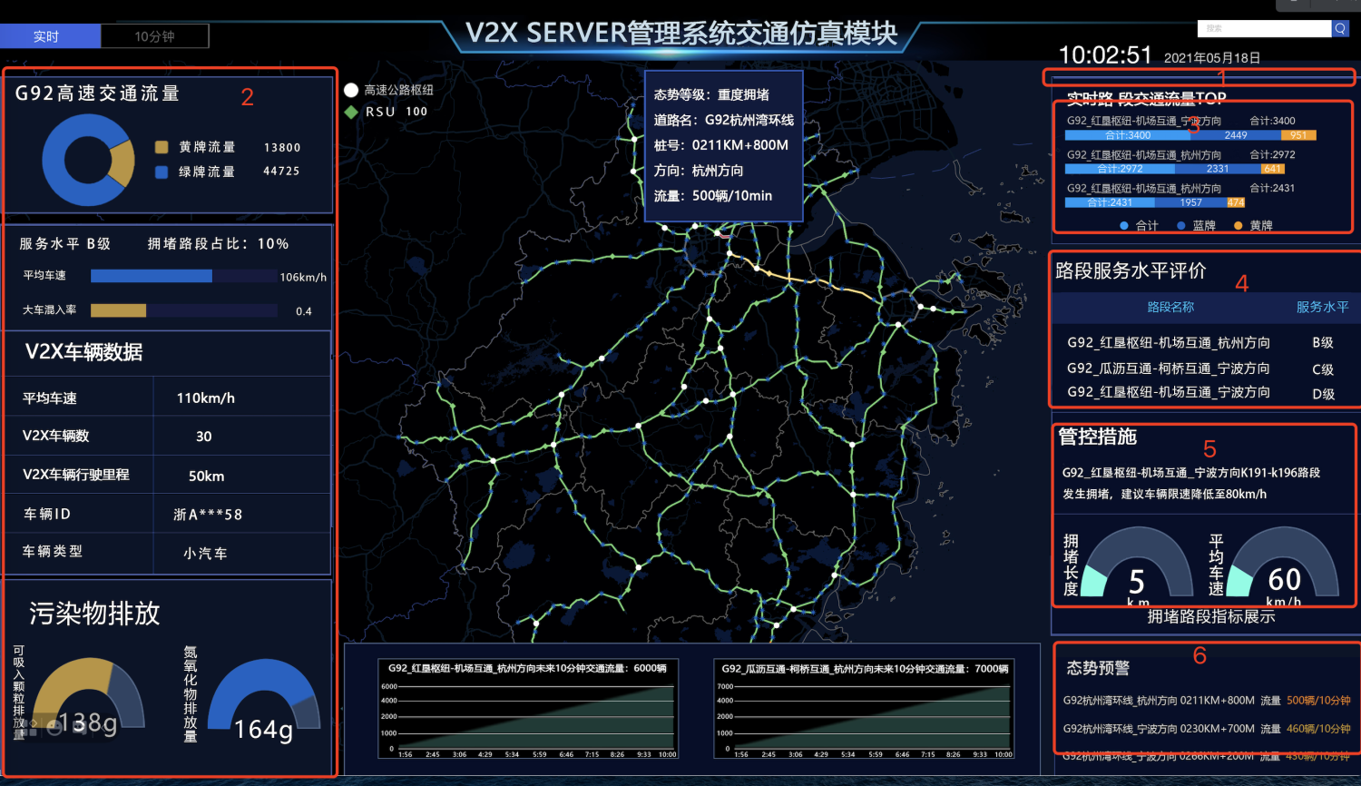

1. 获取所有路段名称 [GET]

<http://localhost:8081/v1/traffic/core-data/roads>

|  |
| --- |
| { "code": 200,  "message": "Success",  "data": [  "红垦枢纽_机场互通_杭州方向",  "红垦枢纽_机场互通_杭州方向2"  ]  } |

1. 获取此路段一些明细信息 [GET]

[http://localhost:8081/v1/traffic/core-data/](http://localhost:8081/v1/traffic/core-data/%E7%BA%A2%E5%9E%A6%E6%9E%A2%E7%BA%BD_%E6%9C%BA%E5%9C%BA%E4%BA%92%E9%80%9A_%E6%9D%AD%E5%B7%9E%E6%96%B9%E5%90%91)${路段名}

[http://localhost:8081/v1/traffic/core-data](http://localhost:8081/v1/traffic/core-data/$%7b)?roadname=${路段名}

|  |
| --- |
| { "code": 200,  "message": "Success",  "data": {  "id": 3,  "roadSectionName": "红垦枢纽_机场互通_杭州方向", //路段名  "avgSpeed": 60.0, //平均时速  "situationPrediction": null,  "congestionLength": 12.0,//拥堵距离  "numsBlueCar": 280.0, //蓝牌车数量  "numsYellCar": 300.0,//黄牌车数量  "avgHeadway": null,  "cartMixRate": 0.61,//大车混入率  "serviceLevel": "A", //服务等级  "carbonMonoxideEmissions": null, //一氧化氮  "inhalableEmissions": 528.0, //可摄入排放物  "noxEmissions": 174.0, //氮氧化物排放物  "meausreInfo": null,  "v2xAvgSpeed": 91.0, //v2x平均时速  "v2xDrivenDistance": 187.0, //v2x行驶距离  "v2xAvgHeadway": null,  "v2xNoxEmissions": null,  "vc": null,  "total": 2780.0, // 总计  "recTime": "2021-06-11T18:33:43", //记录时间  "v2Xcls": 30.0  }  } |

1. 获取top 车速 <http://localhost:8081/v1/traffic/core-data/topRate> [GET]

|  |
| --- |
| "code": 200,  "message": "Success",  "data": [  {  "id": null,  "roadSectionName": "红垦枢纽_机场互通_杭州方向",  "avgSpeed": 0.0,  "situationPrediction": 0.0,  "congestionLength": 0.0,  "numsBlueCar": 280.0,  "numsYellCar": 300.0,  "avgHeadway": 0.0,  "cartMixRate": 0.0,  "serviceLevel": null,  "carbonMonoxideEmissions": 0.0,  "inhalableEmissions": 0.0,  "noxEmissions": 0.0,  "meausreInfo": null,  "v2xAvgSpeed": 0.0,  "v2xDrivenDistance": 0.0,  "v2xAvgHeadway": 0.0,  "v2xNoxEmissions": 0.0,  "vc": 0.0,  "total": 0.0,  "recTime": null,  "formatedTime": null,  "totalCars": 580.0,  "v2Xcls": 0.0  },  {  "id": null,  "roadSectionName": "红垦枢纽_机场互通_杭州方向2",  "avgSpeed": 0.0,  "situationPrediction": 0.0,  "congestionLength": 0.0,  "numsBlueCar": 280.0,  "numsYellCar": 300.0,  "avgHeadway": 0.0,  "cartMixRate": 0.0,  "serviceLevel": null,  "carbonMonoxideEmissions": 0.0,  "inhalableEmissions": 0.0,  "noxEmissions": 0.0,  "meausreInfo": null,  "v2xAvgSpeed": 0.0,  "v2xDrivenDistance": 0.0,  "v2xAvgHeadway": 0.0,  "v2xNoxEmissions": 0.0,  "vc": 0.0,  "total": 0.0,  "recTime": null,  "formatedTime": null,  "totalCars": 580.0,  "v2Xcls": 0.0  }  ]  } |

1. 获取路段服务水平评价 [GET]

<http://localhost:8081/v1/traffic/service-quality>

<http://localhost:8081/v1/traffic/service-quality>/${路段名}

<http://localhost:8081/v1/traffic/service-quality>?roadname=${路段名}

|  |
| --- |
| {  "code": 200,  "message": "Success",  "data": [  {  "recRoadSectionName": "红垦枢纽_机场互通_杭州方向",  "serviceLevel": "A",  "recTime": "2021-06-11T21:07:08"  },  {  "recRoadSectionName": "红垦枢纽_机场互通_杭州方向2",  "serviceLevel": "B",  "recTime": "2021-06-11T21:07:08"  }  ]  } |

1. 获取管控措施 [GET]

<http://localhost:8081/v1/traffic/service-todo>

<http://localhost:8081/v1/traffic/service-todo>/${路段名}

[http://localhost:8081/v1/traffic/service-todo](http://localhost:8081/v1/traffic/service-todo/$%7b)?roadname=${路段名}

|  |
| --- |
| { "code": 200,  "message": "Success",  "data": [  {  "recRoadSectionName": "红垦枢纽_机场互通_杭州方向",  "needTodo": "垦枢纽_机场互通_杭州方向发生拥堵，建议将限速降低到80km/h",  "recTime": "2021-06-11T21:25:08"  }  ]  } |

1. 获取态势预警 [GET]

<http://localhost:8081/v1/traffic/situation-warning>

<http://localhost:8081/v1/traffic/situation-warning>/${路段名}

<http://localhost:8081/v1/traffic/situation-warning>?roadname=${路段名}

|  |
| --- |
| { "code": 200,  "message": "Success",  "data": [  {  "recRoadSectionName": "红垦枢纽_机场互通_杭州方向",  "numsRate": 6300.0,  "recTime": "2021-06-11T21:20:28"  },  {  "recRoadSectionName": "红垦枢纽_机场互通_杭州方向2",  "numsRate": 6300.0,  "recTime": "2021-06-11T21:20:28"  }  ]  } |

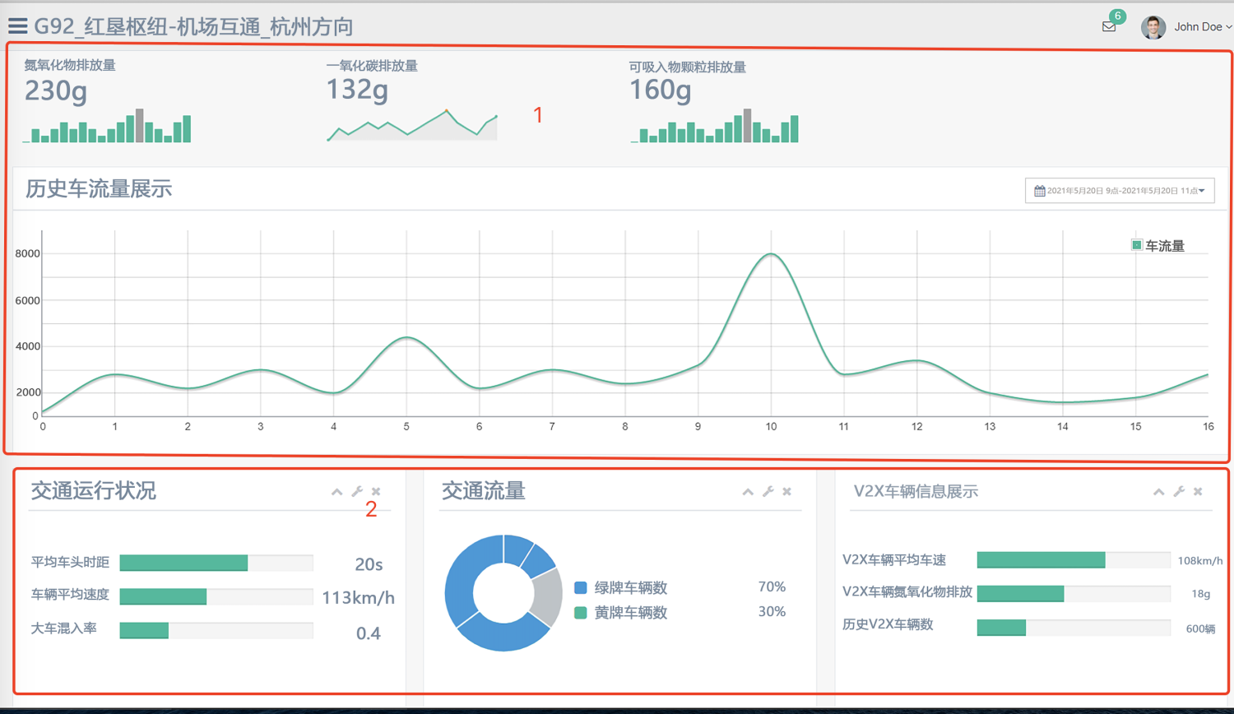

1. 获取氢氧化物、二氧化氮、可吸入颗粒排放量、历史车流量展示

[http://localhost:8081/v1/traffic/core-data/${路段名称}/all](http://localhost:8081/v1/traffic/core-data/%E7%BA%A2%E5%9E%A6%E6%9E%A2%E7%BA%BD_%E6%9C%BA%E5%9C%BA%E4%BA%92%E9%80%9A_%E6%9D%AD%E5%B7%9E%E6%96%B9%E5%90%91/all)  [GET]

[http://localhost:8081/v1/traffic/core-data](http://localhost:8081/v1/traffic/core-data/$%7b)/all?roadname=${路段名称}

|  |
| --- |
| "code": 200,  "message": "Success",  "data": [  {  "id": null,  "roadSectionName": null,  "avgSpeed": 0.0,  "situationPrediction": 0.0,  "congestionLength": 0.0,  "numsBlueCar": 0.0,  "numsYellCar": 0.0,  "avgHeadway": 0.0,  "cartMixRate": 0.0,  "serviceLevel": null,  "carbonMonoxideEmissions": 0.0,  "inhalableEmissions": 0.0,  "noxEmissions": 0.0,  "meausreInfo": null,  "v2xAvgSpeed": 0.0,  "v2xDrivenDistance": 0.0,  "v2xAvgHeadway": 0.0,  "v2xNoxEmissions": 0.0,  "vc": 0.0,  "total": 0.0,  "recTime": null,  "formatedTime": "2021-06-11 16:00:00",  "v2Xcls": 0.0  },  {  "id": null,  "roadSectionName": null,  "avgSpeed": 0.0,  "situationPrediction": 0.0,  "congestionLength": 0.0,  "numsBlueCar": 0.0,  "numsYellCar": 0.0,  "avgHeadway": 0.0,  "cartMixRate": 0.0,  "serviceLevel": null,  "carbonMonoxideEmissions": 0.0,  "inhalableEmissions": 0.0,  "noxEmissions": 0.0,  "meausreInfo": null,  "v2xAvgSpeed": 0.0,  "v2xDrivenDistance": 0.0,  "v2xAvgHeadway": 0.0,  "v2xNoxEmissions": 0.0,  "vc": 0.0,  "total": 0.0,  "recTime": null,  "formatedTime": "2021-06-11 17:00:00",  "v2Xcls": 0.0  },  {  "id": 3,  "roadSectionName": "红垦枢纽_机场互通_杭州方向",  "avgSpeed": 60.0,  "situationPrediction": 0.0,  "congestionLength": 12.0,  "numsBlueCar": 280.0,  "numsYellCar": 300.0,  "avgHeadway": 0.0,  "cartMixRate": 0.61,  "serviceLevel": "A",  "carbonMonoxideEmissions": 0.0,  "inhalableEmissions": 528.0,  "noxEmissions": 174.0,  "meausreInfo": null,  "v2xAvgSpeed": 91.0,  "v2xDrivenDistance": 187.0,  "v2xAvgHeadway": 0.0,  "v2xNoxEmissions": 0.0,  "vc": 0.0,  "total": 2780.0,  "recTime": "2021-06-11T18:33:43",  "formatedTime": "2021-06-11 18:00:00",  "v2Xcls": 30.0  },  {  "id": null,  "roadSectionName": null,  "avgSpeed": 0.0,  "situationPrediction": 0.0,  "congestionLength": 0.0,  "numsBlueCar": 0.0,  "numsYellCar": 0.0,  "avgHeadway": 0.0,  "cartMixRate": 0.0,  "serviceLevel": null,  "carbonMonoxideEmissions": 0.0,  "inhalableEmissions": 0.0,  "noxEmissions": 0.0,  "meausreInfo": null,  "v2xAvgSpeed": 0.0,  "v2xDrivenDistance": 0.0,  "v2xAvgHeadway": 0.0,  "v2xNoxEmissions": 0.0,  "vc": 0.0,  "total": 0.0,  "recTime": null,  "formatedTime": "2021-06-11 19:00:00",  "v2Xcls": 0.0  },  {  "id": null,  "roadSectionName": null,  "avgSpeed": 0.0,  "situationPrediction": 0.0,  "congestionLength": 0.0,  "numsBlueCar": 0.0,  "numsYellCar": 0.0,  "avgHeadway": 0.0,  "cartMixRate": 0.0,  "serviceLevel": null,  "carbonMonoxideEmissions": 0.0,  "inhalableEmissions": 0.0,  "noxEmissions": 0.0,  "meausreInfo": null,  "v2xAvgSpeed": 0.0,  "v2xDrivenDistance": 0.0,  "v2xAvgHeadway": 0.0,  "v2xNoxEmissions": 0.0,  "vc": 0.0,  "total": 0.0,  "recTime": null,  "formatedTime": "2021-06-11 20:00:00",  "v2Xcls": 0.0  },  {  "id": null,  "roadSectionName": null,  "avgSpeed": 0.0,  "situationPrediction": 0.0,  "congestionLength": 0.0,  "numsBlueCar": 0.0,  "numsYellCar": 0.0,  "avgHeadway": 0.0,  "cartMixRate": 0.0,  "serviceLevel": null,  "carbonMonoxideEmissions": 0.0,  "inhalableEmissions": 0.0,  "noxEmissions": 0.0,  "meausreInfo": null,  "v2xAvgSpeed": 0.0,  "v2xDrivenDistance": 0.0,  "v2xAvgHeadway": 0.0,  "v2xNoxEmissions": 0.0,  "vc": 0.0,  "total": 0.0,  "recTime": null,  "formatedTime": "2021-06-11 21:00:00",  "v2Xcls": 0.0  },  {  "id": null,  "roadSectionName": null,  "avgSpeed": 0.0,  "situationPrediction": 0.0,  "congestionLength": 0.0,  "numsBlueCar": 0.0,  "numsYellCar": 0.0,  "avgHeadway": 0.0,  "cartMixRate": 0.0,  "serviceLevel": null,  "carbonMonoxideEmissions": 0.0,  "inhalableEmissions": 0.0,  "noxEmissions": 0.0,  "meausreInfo": null,  "v2xAvgSpeed": 0.0,  "v2xDrivenDistance": 0.0,  "v2xAvgHeadway": 0.0,  "v2xNoxEmissions": 0.0,  "vc": 0.0,  "total": 0.0,  "recTime": null,  "formatedTime": "2021-06-11 22:00:00",  "v2Xcls": 0.0  },  {  "id": null,  "roadSectionName": null,  "avgSpeed": 0.0,  "situationPrediction": 0.0,  "congestionLength": 0.0,  "numsBlueCar": 0.0,  "numsYellCar": 0.0,  "avgHeadway": 0.0,  "cartMixRate": 0.0,  "serviceLevel": null,  "carbonMonoxideEmissions": 0.0,  "inhalableEmissions": 0.0,  "noxEmissions": 0.0,  "meausreInfo": null,  "v2xAvgSpeed": 0.0,  "v2xDrivenDistance": 0.0,  "v2xAvgHeadway": 0.0,  "v2xNoxEmissions": 0.0,  "vc": 0.0,  "total": 0.0,  "recTime": null,  "formatedTime": "2021-06-11 23:00:00",  "v2Xcls": 0.0  },  {  "id": null,  "roadSectionName": null,  "avgSpeed": 0.0,  "situationPrediction": 0.0,  "congestionLength": 0.0,  "numsBlueCar": 0.0,  "numsYellCar": 0.0,  "avgHeadway": 0.0,  "cartMixRate": 0.0,  "serviceLevel": null,  "carbonMonoxideEmissions": 0.0,  "inhalableEmissions": 0.0,  "noxEmissions": 0.0,  "meausreInfo": null,  "v2xAvgSpeed": 0.0,  "v2xDrivenDistance": 0.0,  "v2xAvgHeadway": 0.0,  "v2xNoxEmissions": 0.0,  "vc": 0.0,  "total": 0.0,  "recTime": null,  "formatedTime": "2021-06-12 00:00:00",  "v2Xcls": 0.0  },  {  "id": null,  "roadSectionName": null,  "avgSpeed": 0.0,  "situationPrediction": 0.0,  "congestionLength": 0.0,  "numsBlueCar": 0.0,  "numsYellCar": 0.0,  "avgHeadway": 0.0,  "cartMixRate": 0.0,  "serviceLevel": null,  "carbonMonoxideEmissions": 0.0,  "inhalableEmissions": 0.0,  "noxEmissions": 0.0,  "meausreInfo": null,  "v2xAvgSpeed": 0.0,  "v2xDrivenDistance": 0.0,  "v2xAvgHeadway": 0.0,  "v2xNoxEmissions": 0.0,  "vc": 0.0,  "total": 0.0,  "recTime": null,  "formatedTime": "2021-06-12 01:00:00",  "v2Xcls": 0.0  },  {  "id": null,  "roadSectionName": null,  "avgSpeed": 0.0,  "situationPrediction": 0.0,  "congestionLength": 0.0,  "numsBlueCar": 0.0,  "numsYellCar": 0.0,  "avgHeadway": 0.0,  "cartMixRate": 0.0,  "serviceLevel": null,  "carbonMonoxideEmissions": 0.0,  "inhalableEmissions": 0.0,  "noxEmissions": 0.0,  "meausreInfo": null,  "v2xAvgSpeed": 0.0,  "v2xDrivenDistance": 0.0,  "v2xAvgHeadway": 0.0,  "v2xNoxEmissions": 0.0,  "vc": 0.0,  "total": 0.0,  "recTime": null,  "formatedTime": "2021-06-12 02:00:00",  "v2Xcls": 0.0  },  {  "id": null,  "roadSectionName": null,  "avgSpeed": 0.0,  "situationPrediction": 0.0,  "congestionLength": 0.0,  "numsBlueCar": 0.0,  "numsYellCar": 0.0,  "avgHeadway": 0.0,  "cartMixRate": 0.0,  "serviceLevel": null,  "carbonMonoxideEmissions": 0.0,  "inhalableEmissions": 0.0,  "noxEmissions": 0.0,  "meausreInfo": null,  "v2xAvgSpeed": 0.0,  "v2xDrivenDistance": 0.0,  "v2xAvgHeadway": 0.0,  "v2xNoxEmissions": 0.0,  "vc": 0.0,  "total": 0.0,  "recTime": null,  "formatedTime": "2021-06-12 03:00:00",  "v2Xcls": 0.0  },  {  "id": null,  "roadSectionName": null,  "avgSpeed": 0.0,  "situationPrediction": 0.0,  "congestionLength": 0.0,  "numsBlueCar": 0.0,  "numsYellCar": 0.0,  "avgHeadway": 0.0,  "cartMixRate": 0.0,  "serviceLevel": null,  "carbonMonoxideEmissions": 0.0,  "inhalableEmissions": 0.0,  "noxEmissions": 0.0,  "meausreInfo": null,  "v2xAvgSpeed": 0.0,  "v2xDrivenDistance": 0.0,  "v2xAvgHeadway": 0.0,  "v2xNoxEmissions": 0.0,  "vc": 0.0,  "total": 0.0,  "recTime": null,  "formatedTime": "2021-06-12 04:00:00",  "v2Xcls": 0.0  },  {  "id": null,  "roadSectionName": null,  "avgSpeed": 0.0,  "situationPrediction": 0.0,  "congestionLength": 0.0,  "numsBlueCar": 0.0,  "numsYellCar": 0.0,  "avgHeadway": 0.0,  "cartMixRate": 0.0,  "serviceLevel": null,  "carbonMonoxideEmissions": 0.0,  "inhalableEmissions": 0.0,  "noxEmissions": 0.0,  "meausreInfo": null,  "v2xAvgSpeed": 0.0,  "v2xDrivenDistance": 0.0,  "v2xAvgHeadway": 0.0,  "v2xNoxEmissions": 0.0,  "vc": 0.0,  "total": 0.0,  "recTime": null,  "formatedTime": "2021-06-12 05:00:00",  "v2Xcls": 0.0  },  {  "id": null,  "roadSectionName": null,  "avgSpeed": 0.0,  "situationPrediction": 0.0,  "congestionLength": 0.0,  "numsBlueCar": 0.0,  "numsYellCar": 0.0,  "avgHeadway": 0.0,  "cartMixRate": 0.0,  "serviceLevel": null,  "carbonMonoxideEmissions": 0.0,  "inhalableEmissions": 0.0,  "noxEmissions": 0.0,  "meausreInfo": null,  "v2xAvgSpeed": 0.0,  "v2xDrivenDistance": 0.0,  "v2xAvgHeadway": 0.0,  "v2xNoxEmissions": 0.0,  "vc": 0.0,  "total": 0.0,  "recTime": null,  "formatedTime": "2021-06-12 06:00:00",  "v2Xcls": 0.0  },  {  "id": null,  "roadSectionName": null,  "avgSpeed": 0.0,  "situationPrediction": 0.0,  "congestionLength": 0.0,  "numsBlueCar": 0.0,  "numsYellCar": 0.0,  "avgHeadway": 0.0,  "cartMixRate": 0.0,  "serviceLevel": null,  "carbonMonoxideEmissions": 0.0,  "inhalableEmissions": 0.0,  "noxEmissions": 0.0,  "meausreInfo": null,  "v2xAvgSpeed": 0.0,  "v2xDrivenDistance": 0.0,  "v2xAvgHeadway": 0.0,  "v2xNoxEmissions": 0.0,  "vc": 0.0,  "total": 0.0,  "recTime": null,  "formatedTime": "2021-06-12 07:00:00",  "v2Xcls": 0.0  },  {  "id": null,  "roadSectionName": null,  "avgSpeed": 0.0,  "situationPrediction": 0.0,  "congestionLength": 0.0,  "numsBlueCar": 0.0,  "numsYellCar": 0.0,  "avgHeadway": 0.0,  "cartMixRate": 0.0,  "serviceLevel": null,  "carbonMonoxideEmissions": 0.0,  "inhalableEmissions": 0.0,  "noxEmissions": 0.0,  "meausreInfo": null,  "v2xAvgSpeed": 0.0,  "v2xDrivenDistance": 0.0,  "v2xAvgHeadway": 0.0,  "v2xNoxEmissions": 0.0,  "vc": 0.0,  "total": 0.0,  "recTime": null,  "formatedTime": "2021-06-12 08:00:00",  "v2Xcls": 0.0  },  {  "id": null,  "roadSectionName": null,  "avgSpeed": 0.0,  "situationPrediction": 0.0,  "congestionLength": 0.0,  "numsBlueCar": 0.0,  "numsYellCar": 0.0,  "avgHeadway": 0.0,  "cartMixRate": 0.0,  "serviceLevel": null,  "carbonMonoxideEmissions": 0.0,  "inhalableEmissions": 0.0,  "noxEmissions": 0.0,  "meausreInfo": null,  "v2xAvgSpeed": 0.0,  "v2xDrivenDistance": 0.0,  "v2xAvgHeadway": 0.0,  "v2xNoxEmissions": 0.0,  "vc": 0.0,  "total": 0.0,  "recTime": null,  "formatedTime": "2021-06-12 09:00:00",  "v2Xcls": 0.0  },  {  "id": null,  "roadSectionName": null,  "avgSpeed": 0.0,  "situationPrediction": 0.0,  "congestionLength": 0.0,  "numsBlueCar": 0.0,  "numsYellCar": 0.0,  "avgHeadway": 0.0,  "cartMixRate": 0.0,  "serviceLevel": null,  "carbonMonoxideEmissions": 0.0,  "inhalableEmissions": 0.0,  "noxEmissions": 0.0,  "meausreInfo": null,  "v2xAvgSpeed": 0.0,  "v2xDrivenDistance": 0.0,  "v2xAvgHeadway": 0.0,  "v2xNoxEmissions": 0.0,  "vc": 0.0,  "total": 0.0,  "recTime": null,  "formatedTime": "2021-06-12 10:00:00",  "v2Xcls": 0.0  },  {  "id": null,  "roadSectionName": null,  "avgSpeed": 0.0,  "situationPrediction": 0.0,  "congestionLength": 0.0,  "numsBlueCar": 0.0,  "numsYellCar": 0.0,  "avgHeadway": 0.0,  "cartMixRate": 0.0,  "serviceLevel": null,  "carbonMonoxideEmissions": 0.0,  "inhalableEmissions": 0.0,  "noxEmissions": 0.0,  "meausreInfo": null,  "v2xAvgSpeed": 0.0,  "v2xDrivenDistance": 0.0,  "v2xAvgHeadway": 0.0,  "v2xNoxEmissions": 0.0,  "vc": 0.0,  "total": 0.0,  "recTime": null,  "formatedTime": "2021-06-12 11:00:00",  "v2Xcls": 0.0  },  {  "id": null,  "roadSectionName": null,  "avgSpeed": 0.0,  "situationPrediction": 0.0,  "congestionLength": 0.0,  "numsBlueCar": 0.0,  "numsYellCar": 0.0,  "avgHeadway": 0.0,  "cartMixRate": 0.0,  "serviceLevel": null,  "carbonMonoxideEmissions": 0.0,  "inhalableEmissions": 0.0,  "noxEmissions": 0.0,  "meausreInfo": null,  "v2xAvgSpeed": 0.0,  "v2xDrivenDistance": 0.0,  "v2xAvgHeadway": 0.0,  "v2xNoxEmissions": 0.0,  "vc": 0.0,  "total": 0.0,  "recTime": null,  "formatedTime": "2021-06-12 12:00:00",  "v2Xcls": 0.0  },  {  "id": null,  "roadSectionName": null,  "avgSpeed": 0.0,  "situationPrediction": 0.0,  "congestionLength": 0.0,  "numsBlueCar": 0.0,  "numsYellCar": 0.0,  "avgHeadway": 0.0,  "cartMixRate": 0.0,  "serviceLevel": null,  "carbonMonoxideEmissions": 0.0,  "inhalableEmissions": 0.0,  "noxEmissions": 0.0,  "meausreInfo": null,  "v2xAvgSpeed": 0.0,  "v2xDrivenDistance": 0.0,  "v2xAvgHeadway": 0.0,  "v2xNoxEmissions": 0.0,  "vc": 0.0,  "total": 0.0,  "recTime": null,  "formatedTime": "2021-06-12 13:00:00",  "v2Xcls": 0.0  },  {  "id": null,  "roadSectionName": null,  "avgSpeed": 0.0,  "situationPrediction": 0.0,  "congestionLength": 0.0,  "numsBlueCar": 0.0,  "numsYellCar": 0.0,  "avgHeadway": 0.0,  "cartMixRate": 0.0,  "serviceLevel": null,  "carbonMonoxideEmissions": 0.0,  "inhalableEmissions": 0.0,  "noxEmissions": 0.0,  "meausreInfo": null,  "v2xAvgSpeed": 0.0,  "v2xDrivenDistance": 0.0,  "v2xAvgHeadway": 0.0,  "v2xNoxEmissions": 0.0,  "vc": 0.0,  "total": 0.0,  "recTime": null,  "formatedTime": "2021-06-12 14:00:00",  "v2Xcls": 0.0  },  {  "id": null,  "roadSectionName": null,  "avgSpeed": 0.0,  "situationPrediction": 0.0,  "congestionLength": 0.0,  "numsBlueCar": 0.0,  "numsYellCar": 0.0,  "avgHeadway": 0.0,  "cartMixRate": 0.0,  "serviceLevel": null,  "carbonMonoxideEmissions": 0.0,  "inhalableEmissions": 0.0,  "noxEmissions": 0.0,  "meausreInfo": null,  "v2xAvgSpeed": 0.0,  "v2xDrivenDistance": 0.0,  "v2xAvgHeadway": 0.0,  "v2xNoxEmissions": 0.0,  "vc": 0.0,  "total": 0.0,  "recTime": null,  "formatedTime": "2021-06-12 15:00:00",  "v2Xcls": 0.0  }  ]  } |