**CI/CD Project**

**Rivne 2022**

**Task: create automated system of building project and push it on target server**

**Stages:**

* **Running job “finalProject(freeStyle)” on Jenkins master which making next stages on Jenkins node :**

1. **Using Terraform create two AWS EC2 instance**
2. **Using Ansible plugin aws_ec2, ansible find out ip addresses of two aws ec2 instances created before**
3. **Using Ansible to installing infrastructure on dev_server and put there simple website**
4. **Triggering to the next job**

* **Running job “Deploy_Prod” on Jenkins master which making next stages on Jenkins node:**

1. **Using Ansible plugin aws_ec2, ansible find out ip addresses of two aws ec2 instance created before**
2. **Using Ansible to installing infrastructure on prod_server and put there simple website**
3. **Creating image and pushing it to docker hub**

**Terraform**

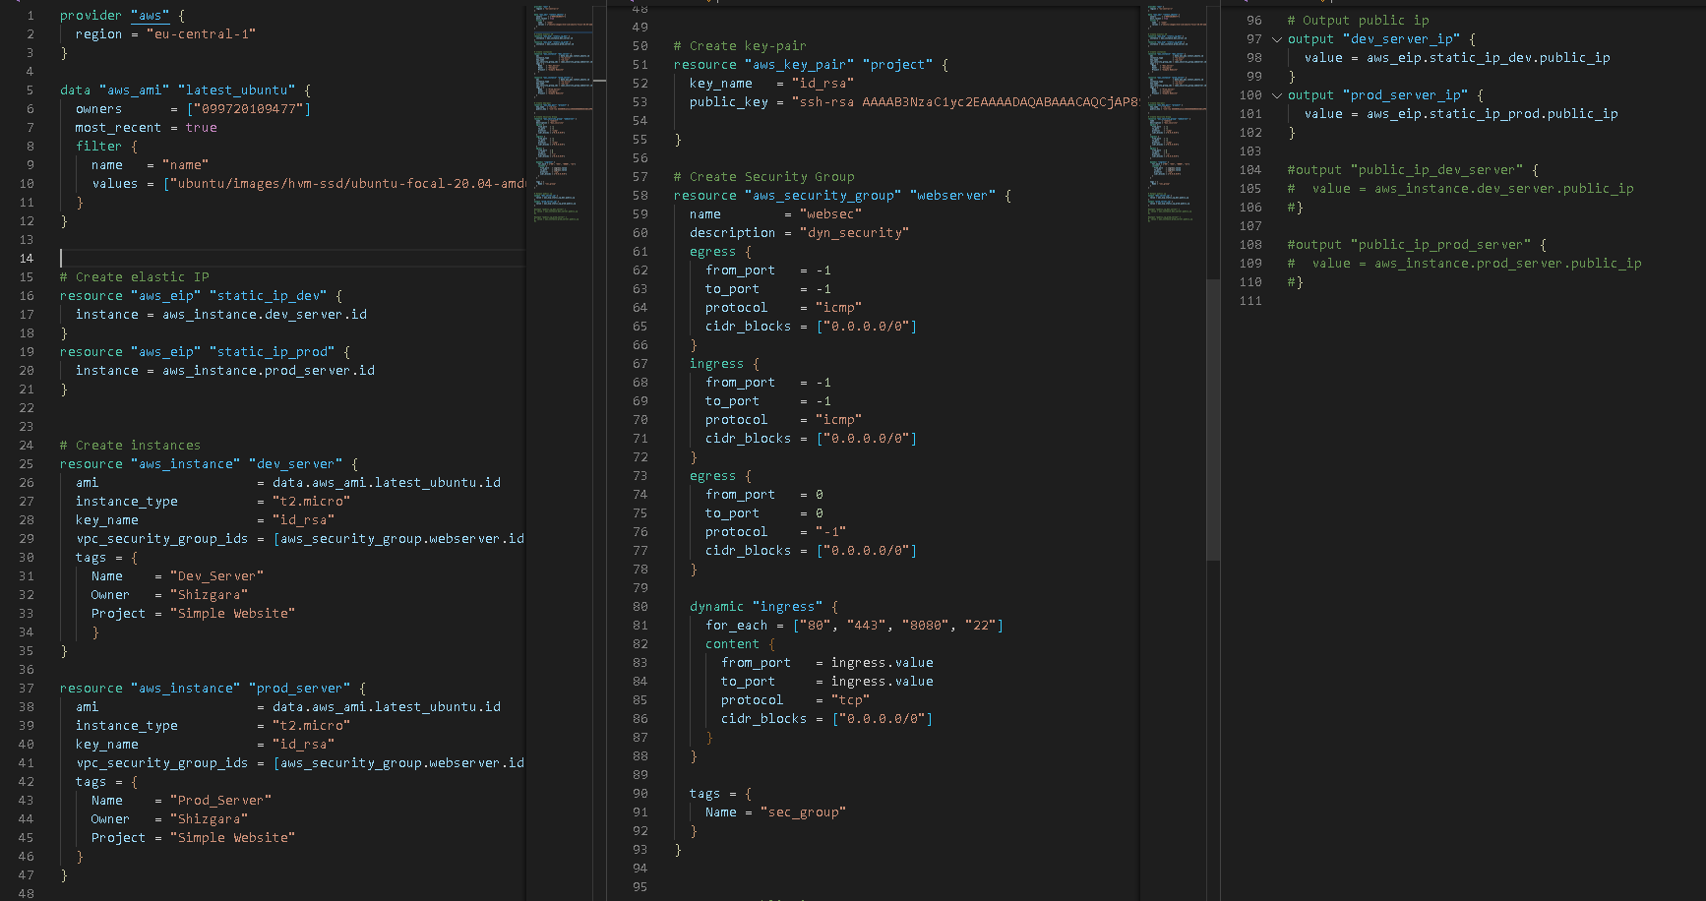Here is my Terraform script creating two AWS EC instances

**Ansible**

This is Ansible plugin aws_ec2

Here I am using credentials from aws cli

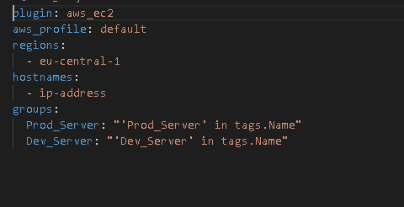

I run next command to find out ip addresses of created two aws ec2 instances:

**ansible-inventory -i aws_ec2.yaml --graph**

Using dev_playbook installing Apache and pushing WebSite to dev server

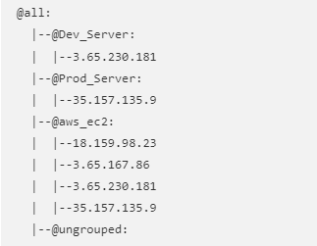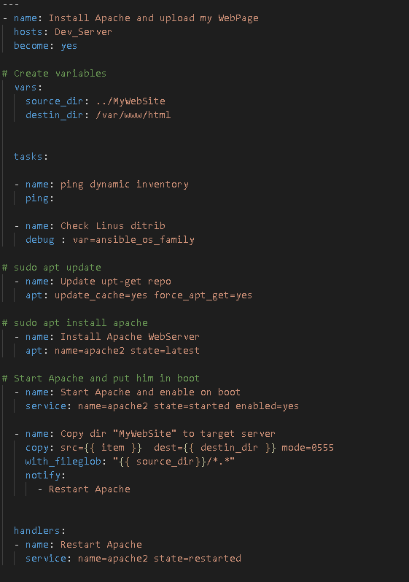

When job finished successful, job Triggering a new build of [Deploy_Prod](http://3.65.167.86:8080/job/Deploy_Prod/)

Then Ansible find out ip address of created prod server before and run playbook for prod server:

**ansible-inventory –i aws_ec2.yaml –graph**

**ansible-playbook –i aws_ec2.yaml prod_playbook.yaml**

Using prod_playbook installing Apache and pushing WebSite to prod server

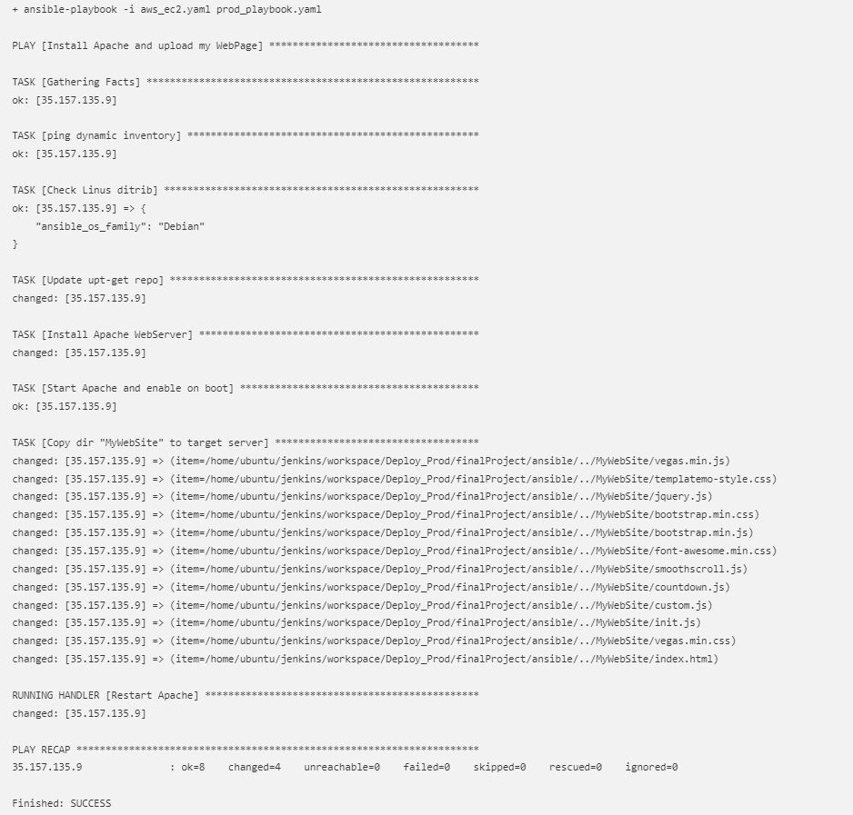

**Docker**

Making image with artefact and pushing to docker hub

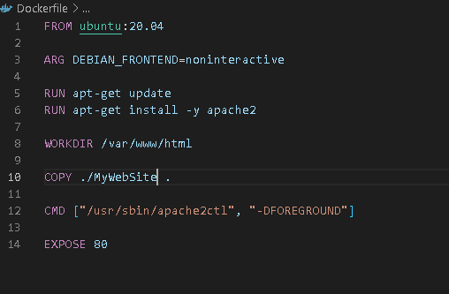

In Jenkins I set up build that picks up files from GitHub after receiving notifications by webhook

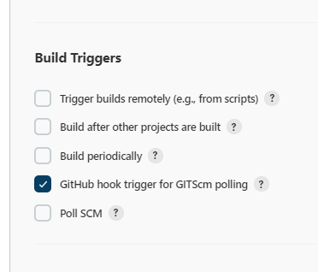

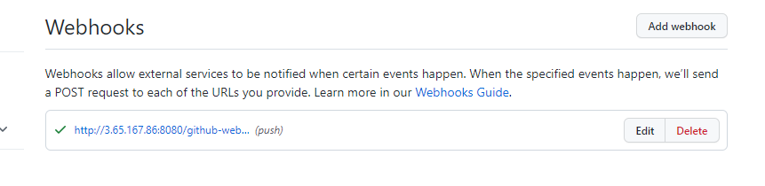

We can see the result of my work on the webserver, which is configured on the AWS EC2 instances

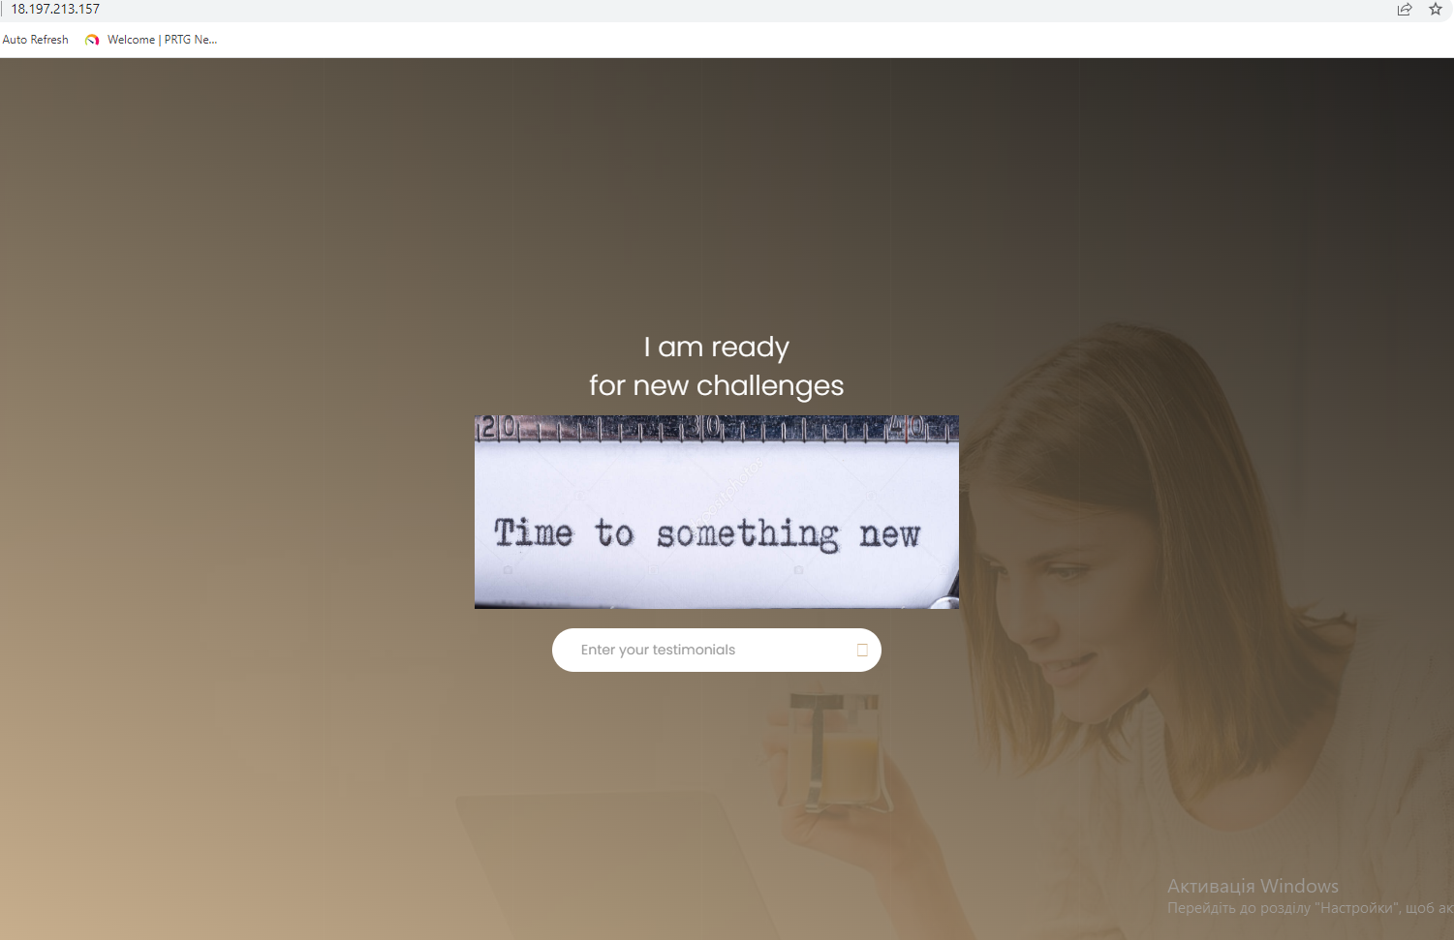

That’s all

May the force be with you

