实验分数：



本科生课程作业

课程名称 数值分析
课程代码 22MA31025F
作业内容 数值实验报告
开课学期 2025秋
专 业 计算机科学与技术
姓 名 刘宇轩
学 号 2023112455

一、实验题目
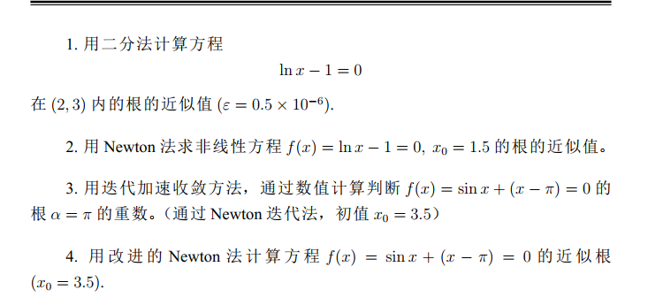
二、数学原理

三、实验代码
问题1
代码：
import numpy as np
from numpy import log

def f(x):
return log(x)-1

def bisection_method(a,b,tol):
if f(a)*f(b)>=0:
print("No root in the interval")
return None
while (b-a)/2>tol:
c=(a+b)/2
if f(c)==0:
return c
elif f(a)*f(c)<0:
b=c
else:
a=c
return (a+b)/2

print(bisection_method(2,3,0.5*1e-6))

结果：2.7182822227478027

问题2：
代码：
import numpy as np
from numpy import log

def f(x):
return log(x)-1;

def f_prime(x):
return 1/x;

def newton_method(x0,tol):
x=x0
while abs(f(x))>tol:
x = x - f(x)/f_prime(x)
return x

print(newton_method(1.5,0.5*1e-6))

结果：2.718281827366902

问题3：
代码：
import numpy as np

def f0(x):
return np.sin(x)+(x-np.pi)

def f1(x):
return np.cos(x)+1

x=3.5
k=1

y=x-k*f0(x)/f1(x)
z=y-k*f0(y)/f1(y)

print("Initial step =",x)
print("First step =", y)
print("Second step =",z)

theta= (x*z - y**2) / (z-2*y+x)
r = (theta - y)/(z-y)

print("r=",r)
输出结果：
(d2l) PS C:\Users\86159\Desktop\Num_Analysis\Code_of_lab_1> python .\prob_3.py
Initial step = 3.5
First step = 3.380016977467359
Second step = 3.300391302000702
r= 2.9730156032424113
可以判断根的重数为3

问题4：
代码：
import numpy as np

def f0(x):
return np.sin(x) + (x-np.pi)

def f1(x):
return np.cos(x) + 1

def newton_method(x0,r,tol=1e-6,max_iter=100):
x=x0
for i in range(max_iter):
print('step :', i+1)
f1_value = f1(x)
if np.abs(f1_value)<1e-12:
print("The derivative is 0, so the method is not applicable")
return x
y=x-r*f0(x)/f1(x)
print(y)
if np.abs(y-x)<tol:
x=y
break
x=y
return y
print("Numerical solution of root =")
print(newton_method(3.5,3.0))
输出结果：
(d2l) PS C:\Users\86159\Desktop\Num_Analysis\Code_of_lab_1> python .\prob_4.py
Numerical solution of root =
step : 1
3.1400509324020764
step : 2
3.141592653402754
step : 3
The derivative is 0, so the method is not applicable
3.141592653402754

