实验分数：



本科生课程作业

课程名称 数值分析
课程代码 22MA31025F
作业内容 数值实验报告
开课学期 2025秋
专 业 计算机科学与技术
姓 名 刘宇轩
学 号 2023112455

一、实验题目
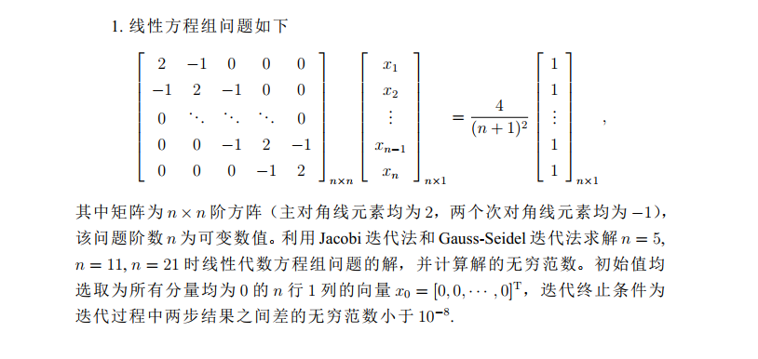
二、数学原理

三、实验代码
实验代码：
import numpy as np

def create_tridiagonal_matrix(n):
A = np.zeros((n,n))
for i in range(n):
A[i,i] = 2
if i > 0:
A[i,i-1] = -1
if i < n-1:
A[i,i+1] = -1
return A

def create_rhs_vector(n):
return np.full(n,4.0/(n+1)**2)

def jacobi_iteration(A,b,x0,tol=1e-8,max_iter = 10000):
n = len(b)
x = x0.copy()
x_new = np.zeros(n)
iterations = 0
for iterations in range(max_iter):
for i in range(n):
sum_ax = 0
for j in range(n):
if j!= i:
sum_ax += A[i,j]*x[j]
x_new[i] = (b[i] - sum_ax) / A[i,i]

if np.linalg.norm(x_new - x, np.inf) < tol:
break

x = x_new.copy()

return x, iterations + 1

def gauss_seidal_iteration(A,b,x0,tol=1e-8,max_iter = 10000):
n = len(b)
x = x0.copy()
iterations = 0

for iterations in range(max_iter):
x_old = x.copy()

for i in range(n):
sum_ax = 0
for j in range(i):
sum_ax += A[i,j] * x[j]

for j in range(i+1,n):
sum_ax += A[i,j] * x_old[j]
x[i] = (b[i] - sum_ax) / A[i,i]

if np.linalg.norm(x-x_old,np.inf)<tol:
break

return x,iterations+1

def solve_for_different_n():
n_values = [5,11,21]

print("=" * 80)
print("线性方程组求解结果")
print("=" * 80)

for n in n_values:
print(f"\n当 n = {n} 时:")
print("-" * 50)

A = create_tridiagonal_matrix(n)
b = create_rhs_vector(n)
x0 = np.zeros(n)

x_jacobi,iter_jacobi = jacobi_iteration(A,b,x0)
norm_jacobi = np.linalg.norm(x_jacobi,np.inf)

x_gs, iter_gs = gauss_seidal_iteration(A,b,x0)
norm_gs = np.linalg.norm(x_gs,np.inf)

print(f"Jacobi迭代法:")
print(f"迭代次数: {iter_jacobi}")
print(f"解的无穷范数: {norm_jacobi:.10f}")
print(f"解向量: {x_jacobi}")

print(f"\nGauss-Seidal迭代法:")
print(f"迭代次数:{iter_gs}")
print(f"解的无穷范数: {norm_gs:.10f}")
print(f"解向量: {x_gs}")

if __name__ == "__main__":
solve_for_different_n()

实验结果：
(d2l) PS C:\Users\86159\Desktop\Num_Analysis\Code_of_lab_2> python code.py
================================================================================
线性方程组求解结果
================================================================================

当 n = 5 时:
--------------------------------------------------
Jacobi迭代法:
迭代次数: 110
解的无穷范数: 0.4999999204
解向量: [0.27777774 0.44444437 0.49999992 0.44444437 0.27777774]

Gauss-Seidal迭代法:
迭代次数:59
解的无穷范数: 0.4999999761
解向量: [0.27777776 0.44444442 0.49999998 0.44444443 0.27777777]

当 n = 11 时:
--------------------------------------------------
Jacobi迭代法:
迭代次数: 417
解的无穷范数: 0.4999997187
解向量: [0.1527777 0.27777764 0.3749998 0.4444442 0.48611084 0.49999972
0.48611084 0.4444442 0.3749998 0.27777764 0.1527777 ]

Gauss-Seidal迭代法:
迭代次数:219
解的无穷范数: 0.4999998660
解向量: [0.15277774 0.2777777 0.37499989 0.44444432 0.48611098 0.49999987
0.48611099 0.44444434 0.37499991 0.27777772 0.15277775]

当 n = 21 时:
--------------------------------------------------
Jacobi迭代法:
迭代次数: 1288
解的无穷范数: 0.4999990130
解向量: [0.08677672 0.16528898 0.23553678 0.29752013 0.35123902 0.39669347
0.43388347 0.46280902 0.48347013 0.49586679 0.49999901 0.49586679
0.48347013 0.46280902 0.43388347 0.39669347 0.35123902 0.29752013
0.23553678 0.16528898 0.08677672]

Gauss-Seidal迭代法:
迭代次数:679
解的无穷范数: 0.4999995196
解向量: [0.08677678 0.16528911 0.23553697 0.29752038 0.35123933 0.39669383
0.43388388 0.46280947 0.4834706 0.49586729 0.49999952 0.4958673
0.48347062 0.46280949 0.43388391 0.39669387 0.35123937 0.29752042
0.23553701 0.16528913 0.0867768 ]

