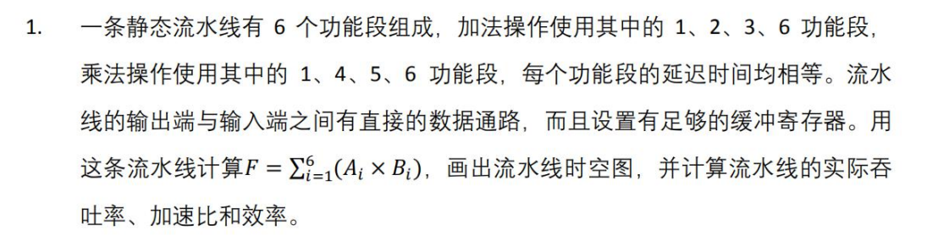

分析：

加法和乘法的流水线时空图分别为

加法

|  |  |  |  |  |
| --- | --- | --- | --- | --- |
|  | 1 | 2 | 3 | 4 |
| 1 | √ |  |  |  |
| 2 |  | √ |  |  |
| 3 |  |  | √ |  |
| 4 |  |  |  |  |
| 5 |  |  |  |  |
| 6 |  |  |  | √ |

乘法

|  |  |  |  |  |
| --- | --- | --- | --- | --- |
|  | 1 | 2 | 3 | 4 |
| 1 | √ |  |  |  |
| 2 |  |  |  |  |
| 3 |  |  |  |  |
| 4 |  | √ |  |  |
| 5 |  |  | √ |  |
| 6 |  |  |  | √ |

下面分情况讨论公式 $F=\sum_{i=1}^{6}{A_{i}×B_{i}}$ 执行时的时空图

情况1：对于公式 $F=\sum_{i=1}^{6}{A_{i}×B_{i}}$ 按照如下代码计算，即加法和乘法交替进行

1. **for**(**int** i=1;i<=6;++i)
2. F+=Ai*Bi;

则流水线的时空图为（m表示乘法，a表示加法）

|  |  |  |  |  |  |  |  |  |  |  |  |  |  |  |  |
| --- | --- | --- | --- | --- | --- | --- | --- | --- | --- | --- | --- | --- | --- | --- | --- |
|  | 1 | 2 | 3 | 4 | 5 | 6 | 7 | 8 | 9 | 10 | 11 | 12 | 13 | 14 | 15 |
| 1 | m | a | m | a | m | a | m | a | m | a | m | a |  |  |  |
| 2 |  |  | a |  | a |  | a |  | a |  | a |  | a |  |  |
| 3 |  |  |  | a |  | a |  | a |  | a |  | a |  | a |  |
| 4 |  | m |  | m |  | m |  | m |  | m |  | m |  |  |  |
| 5 |  |  | m |  | m |  | m |  | m |  | m |  | m |  |  |
| 6 |  |  |  | m | a | m | a | m | a | m | a | m | a | m | a |

此时吞吐率= $\frac{12}{15×△t}=\frac{4}{5△t}$

加速比= $12×\frac{4}{15}=3.2$

效率= $\frac{12×4}{6×15}=\frac{8}{15}$

情况2：对于公式 $F=\sum_{i=1}^{6}{A_{i}×B_{i}}$,如果按照先执行6次乘法，之后执行6次加法，则流水线的时空图如下所示：（m表示乘法，a表示加法）

|  |  |  |  |  |  |  |  |  |  |  |  |  |  |  |  |  |  |  |
| --- | --- | --- | --- | --- | --- | --- | --- | --- | --- | --- | --- | --- | --- | --- | --- | --- | --- | --- |
|  | 1 | 2 | 3 | 4 | 5 | 6 | 7 | 8 | 9 | 10 | 11 | 12 | 13 | 14 | 15 | 16 | 17 | 18 |
| 1 | m | m | m | m | m | m |  |  |  | a | a | a | a | a | a |  |  |  |
| 2 |  |  |  |  |  |  |  |  |  |  | a | a | a | a | a | a |  |  |
| 3 |  |  |  |  |  |  |  |  |  |  |  | a | a | a | a | a | a |  |
| 4 |  | m | m | m | m | m | m |  |  |  |  |  |  |  |  |  |  |  |
| 5 |  |  | m | m | m | m | m | m |  |  |  |  |  |  |  |  |  |  |
| 6 |  |  |  | m | m | m | m | m | m |  |  |  | a | a | a | a | a | a |

此时吞吐率= $\frac{12}{18×△t}=\frac{2}{3△t}$

加速比= $12×\frac{4}{18}=\frac{8}{3}$

效率= $\frac{12×4}{6×18}=\frac{4}{9}$

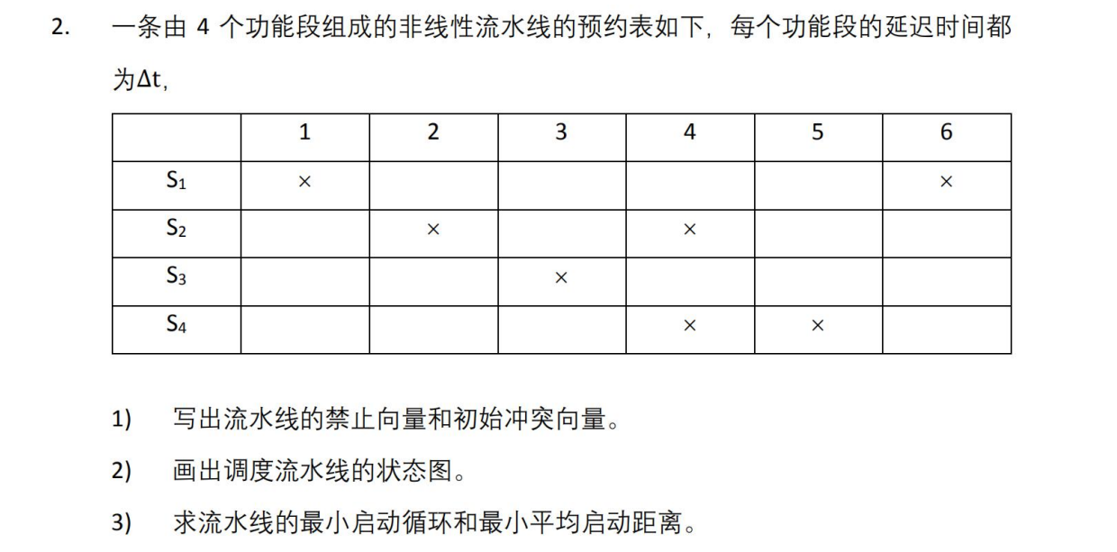

1. 根据题中流水线执行的时空图可知，禁止向量 $C=(5,2,1)$

初始冲突向量 $v_{0}=\left(1,0,0,1,1\right)$

1. 将初始冲入向量不断向右移位，并与初始冲突向量进行按位或运算，如下所示

|  |  |  |  |  |  |  |  |  |  |  |  |  |  |  |  |  |  |
| --- | --- | --- | --- | --- | --- | --- | --- | --- | --- | --- | --- | --- | --- | --- | --- | --- | --- |
| 右移位数 | 5 | 4 | 3 | 2 | 1 | Op | 5 | 4 | 3 | 2 | 1 | = | 5 | 4 | 3 | 2 | 1 |
| 3 | 0 | 0 | 0 | 1 | 0 | V | 1 | 0 | 0 | 1 | 1 | = | 1 | 0 | 0 | 1 | 1 |
| 4 | 0 | 0 | 0 | 0 | 1 | V | 1 | 0 | 0 | 1 | 1 | = | 1 | 0 | 0 | 1 | 1 |
| 6 | 0 | 0 | 0 | 0 | 0 | V | 1 | 0 | 0 | 1 | 1 | = | 1 | 0 | 0 | 1 | 1 |

因此可以画出流水线的状态转化图

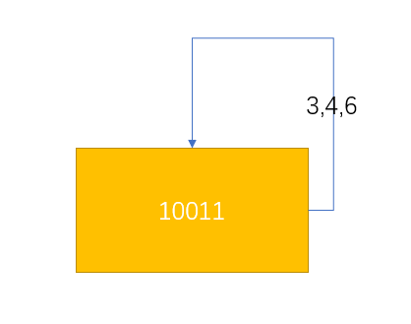

1. 调度方案如下

|  |  |
| --- | --- |
| 调度方案 | 启动距离 |
| 3 | 3 |
| 4 | 4 |
| 3,4 | 3.5 |
| 3,4,3 | 3.3 |
| 3,3,4 | 3.3 |
| 4,3,3 | 3.3 |
| 6 | 6 |
| … | … |

因此，最小启动循环为（3），最小启动距离为3，此时流水线执行的时空图为

|  |  |  |  |  |  |  |  |  |  |  |  |
| --- | --- | --- | --- | --- | --- | --- | --- | --- | --- | --- | --- |
|  | 1 | 2 | 3 | 4 | 5 | 6 | 7 | 8 | 9 | 10 | 11 |
| 1 | F1 |  |  | F2 |  |  | F3 |  |  |  |  |
| 2 |  | F1 |  | F1 | F2 |  | F2 | F3 |  | F3 |  |
| 3 |  |  | F1 |  |  | F2 |  |  | F3 |  |  |
| 4 |  |  |  | F1 | F1 |  | F2 | F2 |  | F3 | F3 |

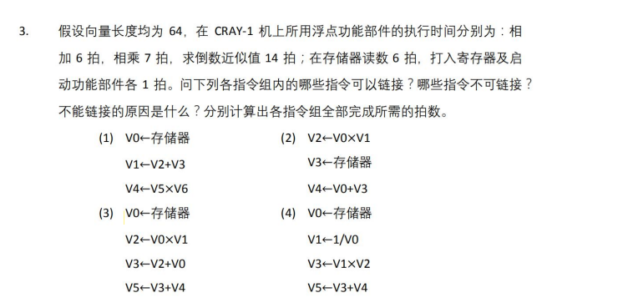

分析：

1. 不可以，因为三条指令之间不存在写入相关，因此可以三条指令同时并行执行,如下所示：

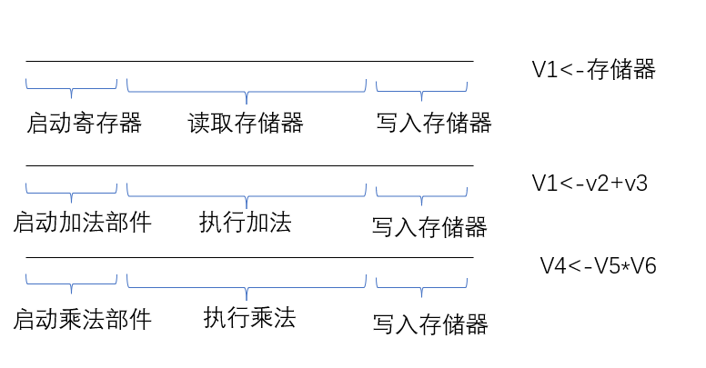

此时需要花费的时间为

$$t=\max\left\{1+6+1+\left(64-1\right),1+6+1+\left(64-1\right),1+7+1+\left(64-1\right)\right\}=72$$

1. 可以，第三条指令需要用到第二条指令的执行结果，存在写入相关，因此可以连接成为一个大的流水线。执行示意图如下

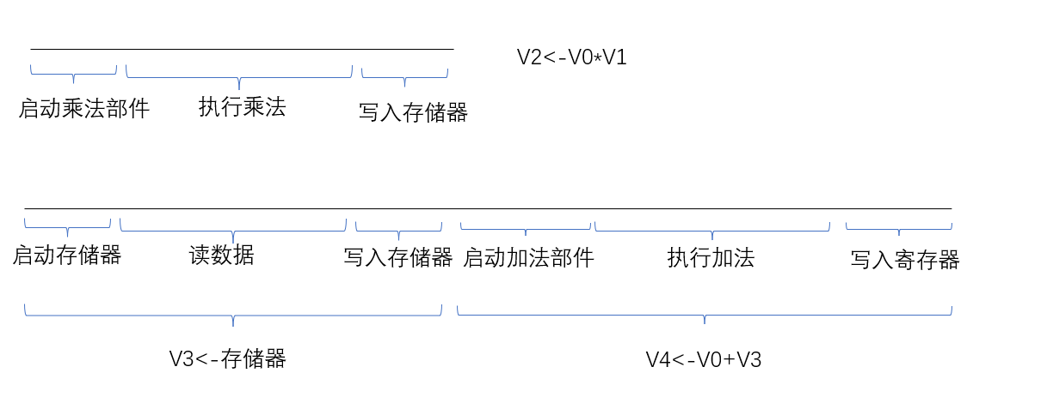

此时执行时间

$$t=\max\left\{1+7+1+\left(64-1\right),1+6+1+1+6+1+\left(64-1\right)\right\}=79$$

1. 可以，指令1，2,3可以链接执行，但是指令4也需要使用加法器，因此无法与指令1,2,3同时链接执行。因此指令执行示意图为

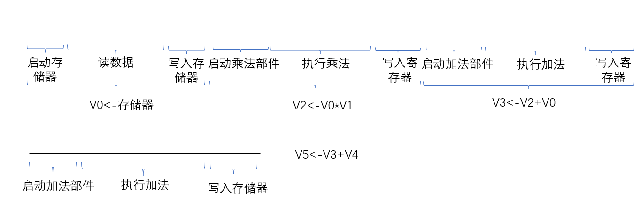

此时执行时间为 $t=1+6+1+1+7+1+1+6+1+\left(64-1\right)+1+6+1+\left(64-1\right)=88+71=159$

1. 指令1到指令4可以链接为一个大的流水线，此时示意图为

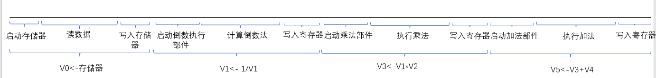

此时执行时间为

$$t=\left(1+6+1\right)+\left(1+14+1\right)+\left(1+7+1\right)+\left(1+6+1\right)+64-1=104$$