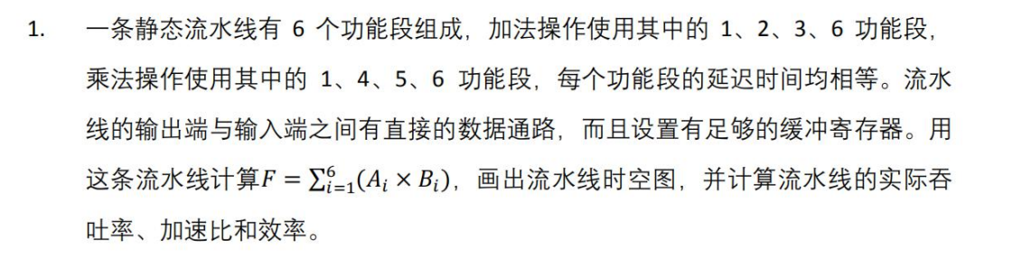

分析：

加法和乘法的流水线时空图分别为

加法

|  |  |  |  |  |
| --- | --- | --- | --- | --- |
|  | 1 | 2 | 3 | 4 |
| 1 | √ |  |  |  |
| 2 |  | √ |  |  |
| 3 |  |  | √ |  |
| 4 |  |  |  |  |
| 5 |  |  |  |  |
| 6 |  |  |  | √ |

乘法

|  |  |  |  |  |
| --- | --- | --- | --- | --- |
|  | 1 | 2 | 3 | 4 |
| 1 | √ |  |  |  |
| 2 |  |  |  |  |
| 3 |  |  |  |  |
| 4 |  | √ |  |  |
| 5 |  |  | √ |  |
| 6 |  |  |  | √ |

下面分情况讨论公式 $F=\sum_{i=1}^{6}{A_{i}×B_{i}}$ 执行时的时空图

情况1：对于公式 $F=\sum_{i=1}^{6}{A_{i}×B_{i}}$ 按照如下代码计算，即加法和乘法交替进行

1. **for**(**int** i=1;i<=6;++i)
2. F+=Ai*Bi;

则流水线的时空图为（m表示乘法，a表示加法）

|  |  |  |  |  |  |  |  |  |  |  |  |  |  |  |  |
| --- | --- | --- | --- | --- | --- | --- | --- | --- | --- | --- | --- | --- | --- | --- | --- |
|  | 1 | 2 | 3 | 4 | 5 | 6 | 7 | 8 | 9 | 10 | 11 | 12 | 13 | 14 | 15 |
| 1 | m | a | m | a | m | a | m | a | m | a | m | a |  |  |  |
| 2 |  |  | a |  | a |  | a |  | a |  | a |  | a |  |  |
| 3 |  |  |  | a |  | a |  | a |  | a |  | a |  | a |  |
| 4 |  | m |  | m |  | m |  | m |  | m |  | m |  |  |  |
| 5 |  |  | m |  | m |  | m |  | m |  | m |  | m |  |  |
| 6 |  |  |  | m | a | m | a | m | a | m | a | m | a | m | a |

情况1：对于公式 $F=\sum_{i=1}^{6}{A_{i}×B_{i}}$,如果按照先执行6次乘法，之后执行6次加法，则流水线的时空图如下所示：（m表示乘法，a表示加法）

|  |  |  |  |  |  |  |  |  |  |  |  |  |  |  |  |  |  |  |
| --- | --- | --- | --- | --- | --- | --- | --- | --- | --- | --- | --- | --- | --- | --- | --- | --- | --- | --- |
|  | 1 | 2 | 3 | 4 | 5 | 6 | 7 | 8 | 9 | 10 | 11 | 12 | 13 | 14 | 15 | 16 | 17 | 18 |
| 1 | m | m | m | m | m | m |  |  |  | a | a | a | a | a | a |  |  |  |
| 2 |  |  |  |  |  |  |  |  |  |  | a | a | a | a | a | a |  |  |
| 3 |  |  |  |  |  |  |  |  |  |  |  | a | a | a | a | a | a |  |
| 4 |  | m | m | m | m | m | m |  |  |  |  |  |  |  |  |  |  |  |
| 5 |  |  | m | m | m | m | m | m |  |  |  |  |  |  |  |  |  |  |
| 6 |  |  |  | m | m | m | m | m | m |  |  |  | a | a | a | a | a | a |