Database Systems: The Complete Book

▼ ❑ Chapter 16
▼ ❑ Section 1
▼ ❑ 1
• ❑ a <Query> ::= SELECT <SelList> FROM <FromList> WHERE <Condition>
<SelList> ::= DISTINCT <Attribute>
• ❑ b <Query> ::= SELECT <SelList> FROM <FromList> WHERE <Condition> GROUP BY <GBList> HAVING <Condition>
<GBList> ::= <Attribute> , <GBList>
<GBList> ::= <Attribute>
• ❑ c <Query> ::= SELECT <SelList> FROM <FromList> WHERE <Condition> ORDER BY <OBList>
<OBList> ::= <Attribute> , <OBList>
<OBList> ::= <Attribute>
• ❑ d <Query> ::= SELECT <SelList> FROM <FromList>
▼ ❑ 2
• ❑ a <Condition> ::= <Condition> OR <Condition>
<Condition> ::= NOT <Condition>
• ❑ b <Condition> ::= <Attribute> > <Attribute>
<Condition> ::= <Attribute> >= <Attribute>
<Condition> ::= <Attribute> < <Attribute>
<Condition> ::= <Attribute> <= <Attribute>
• ❑ c <Condition> ::= ( <Condition> )
• ❑ d <Condition> ::= EXISTS ( <Query> )
▼ ❑ 3
• ❑ a 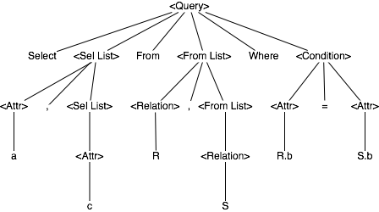
• ❑ b 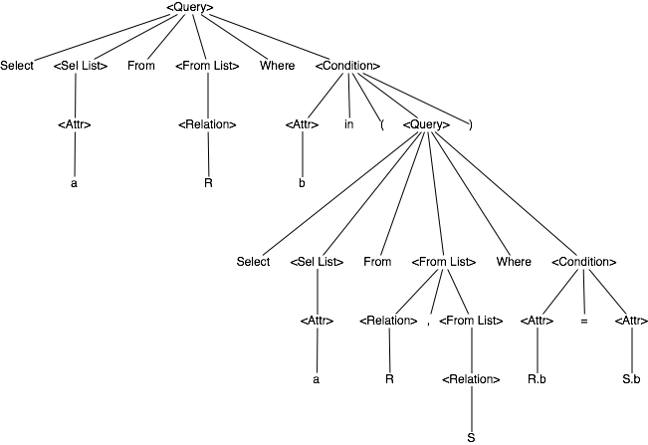
▼ ❑ Section 2
• ❑ 1 σ_{c}(R∩S) and there is an index on S. Assuming that there C attributes in both R and S, the options are:
σ_{c}(R∩S) -- Larger intermediate set to select, likely to scan more data doing intersect, then selection on the intermediate result (no index available).
σ_{c}(R)∩σ_{c}(S) -- Smaller set to intersect.
▼ ❑ 2
• ❑ a π_{L}(R∪S) ≠ π_{L}(R)∪π_{L}(S)
R(C1, C2) = {(1,1) (1,2) (1,2)}
S(C1, C2) = {(1,3) (1,4) (1,5)}
L = C1
• ❑ b π_{L}(R-S) ≠ π_{L}(R)-π_{L}(S)
R(C1, C2) = {(1,1) (1,2) (1,5)}
S(C1, C2) = {(1,1) (1,3) (1,4)}
L = C1
• ❑ c δ(π_{L}(R) ≠ π_{L}(δ(R)
R(C1, C2) = {(1,1) (1,2) (2,3) (3,4) (1,1)}
L = C1
• ❑ d δ(R∪_{B}S) ≠ δ(R)∪_{B}δ(S)
R(C1, C2) = {(1,1) (1,2)}
S(C1, C2) = {(1,1) (1,3)}
• ❑ 3 π_{L}(R∪_{B}S) = π_{L}(R)∪_{B}π_{L}(S)
Attributes eliminated do not appear in results. Attributes eliminated are not used in operators above, and their absence does not affect the results (by definition of bag union).
▼ ❑ 4
• ❑ a Counterexample: R(C1) = {1}
• ❑ b Every record in R has a corresponding record in R. The intersection is the same.
• ❑ c Same as 16.2.4b
• ❑ d Adding the elements from R before or after ∩_{B} doesn't matter. If applied to both S and T, they will appear in both intermediate sets, and appear in the results.
▼ ❑ 5
• ❑ a If R ⊆ S, then R ∪ S = S
True. Every R element has a corresponding S element that appear at least more times than the R element. Thus, the U operator does not add anything to the S set.
• ❑ b If R ⊆ S, then R ∩ S = R
True. Every R element has a corresponding S element that appear at least as many times as the R element. Any excess element will not be included in the intersection, leaving only R.
• ❑ c If R ⊆ S and S ⊆ R, then R = S
True. Every R element has a corresponding S element that appears as many times as the R element, and vice versa. This leaves the only possibility that the sets are equal.
▼ ❑ 6
• ❑ a π_{L}(π_{b,c}(R) JOIN π_{b,c,d}(S))
• ❑ b π_{L}(R JOIN π_{b,c,d}(S))
• ❑ 7 Push the aggregation before the join.
▼ ❑ 8
• ❑ a Counterexample: R(a,b) = {(1,50) (1,50) (2,100) (2,100)}
• ❑ b Counterexample: R(a,b) = {(1,50) (1,50) (2,100) (2,100) (3,100) (3,150) (4,100)}
▼ ❑ 9
• ❑ a True. Any records eliminated by the selection can be done before or after the semi-join. Doing it before will reduce the intermediate result.
• ❑ b Counterexample:
R(C1,C2) = {(1,2) (1,3)}
S(C1,C3) = {(1,2) (2,3)}
• ❑ c True. The record selected could be:
1. Dangling: Will still be dangling if selection is pushed down.
2. Matched. Will still be a match if selection is pushed down.
Conditions for match or dangle haven't changed.
• ❑ d Counterexample:
R(C1,C2) = {(1,2) (1,3) (3,3)}
S(C1,C3) = {(1,2) (2,2)}
• ❑ e Counterexample:
R(C1,C2) = {(1,2) (1,3) (2,2)}
S(C1,C3) = {(1,2) (2,2)}
• ❑ f True. Full outer join is associative. No data is lost.
• ❑ g True. Full outer join is commutative. No data is lost.
• ❑ h Counterexample:
R(C1,C2) = {(1,2) (1,3) (2,2)}
S(C1,C3) = {(1,3)}
• ❑ i Counterexample:
R(C1,C2) = {(1,2) (2,2)}
S(C1,C3) = {(1,3)}
• ❑ 10 The SUM function will skip over null values. Let a_{k} = null. SUM(a₁,a₂,...,a_{n}). a₁ + a₂ + ... + a_{n} = null. The law doesn't hold.
▼ ❑ Section 3
▼ ❑ 1
• ❑ a ( (π_{a,b,c}( R(a,b) JOIN R.b = S.b S(b,c)) ) JOIN _{S.c = T.c} T(c,d) )
• ❑ b π_{a,b,c,d,e}( (π_{a,b,c -> x}( R(a,b) JOIN _{R.b = S.b} S(b,c) ) ) JOIN _{x.c = y.c} ( π_{c,d,e -> y}( T(c,d) JOIN _{T.d = U.d} U(d,e) ) ) )
• ❑ c π_{a,b,c,d}( (π_{a,b,c -> x}( R(a,b) JOIN _{R.b = S.b} S(b,c) ) ) JOIN _{x.a = y.a} ( π_{a,c,d -> y}( T(c,d) JOIN _{T.d = U.d} U(a,d) ) ) )
▼ ❑ 2
• ❑ a π_{a,c}( R JOIN S)
• ❑ b π_{a}( σ( R(1), (<Attr> IN π_{a}( R(2) JOIN S ) ) )
π_{a}( R JOIN (δ (π_{a}( R(2) JOIN S ) ))
▼ ❑ 3
• ❑ a π_{R}(σ_{count}( R CROSS JOIN ɣ_{count}(<Query>)))
• ❑ b π_{R}( R JOIN δ(π_{a}(<Query>)) )
• ❑ c σ_{count(a)=1}( R JOIN ɣ(δ(π_{a}(<Query>))))
▼ ❑ 4
• ❑ a π_{R}(σ_{count>0}(ɣ_{count}(R CROSS JOIN <Query>)))
• ❑ b π_{a,b,c}(δ(π_{a}(R JOIN <Query>)))
• ❑ c σ_{count(a)=1}(δ(π_{a}(R JOIN <Query>)))
• ❑ 5 4! x 3! x 4! x 3!
▼ ❑ Section 4
▼ ❑ 1
• ❑ a 8000
• ❑ b 5
• ❑ c 6
• ❑ d 48
• ❑ e 30000
• ❑ f 133
• ❑ g 0
• ❑ h 2
• ❑ i 20000
• ❑ 2 0
• ❑ 3 T(R)/V(S)
• ❑ 4 V(R,a) = 100. V(S,a) = 100.
▼ ❑ Section 5
• ❑ 1 245. This is a more accurate estimate.
• ❑ 2 56842
▼ ❑ 3
• ❑ a Better than (b) as long as:
50000/max(V(R,b),200) > 100000/max(V(R,b),200)
• ❑ b Same as (a)
▼ ❑ 4
• ❑ a 832
• ❑ b 12
• ❑ c R,S,T,V
• ❑ d R,S,T,V
▼ ❑ 5
• ❑ a 700
• ❑ b 100
• ❑ c R,S,T,V
• ❑ d R,S,T,V
• ❑ 6 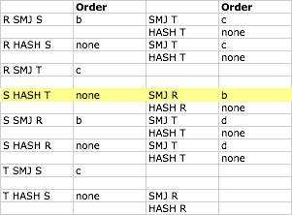
The query plan that uses the fewest I/O's is highlighted in yellow.
• ❑ 7 The best plan for E or F may not provide sorted output, but the join method selected (e.g. SMJ) may required sorted input.
▼ ❑ Section 6
• ❑ 1 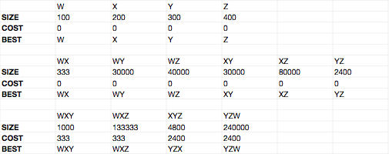
• ❑ 2 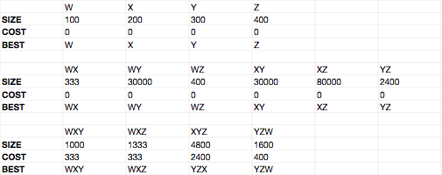
• ❑ 3 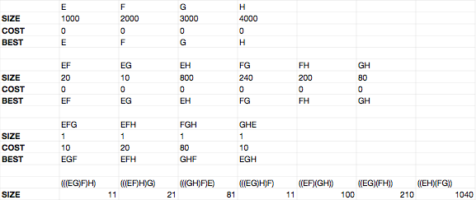
▼ ❑ 4
• ❑ a ((SR)T)U). Cost: 10000.
• ❑ b Optimal: ((RS)(TU)). Cost: 2000.
▼ ❑ 5
• ❑ a 7! x (T(1)T(7) + T(2)T(6) + T(3)T(5) + T(4)T(4) + T(5)T(3) + T(6)T(2) + T(7)T(1)
Left-deep: 7!
Right-deep: 7!
• ❑ b 8! x (T(1)T(8) + T(2)T(7) + T(3)T(6) + T(4)T(5) + T(5)T(4) + T(6)T(3) + T(7)T(2) + T(8)T(1)
Left-deep: 8!
Right-deep: 8!
▼ ❑ 6
• ❑ a B(R JOIN S) + B((R JOIN S) JOIN U)
• ❑ b B(R JOIN S) + B(T JOIN U)
• ❑ c B(T JOIN U) + B(S JOIN (T JOIN U))
• ❑ 7 Left deep only: k!
All: 2^{k} x k!
▼ ❑ Section 7
▼ ❑ 1
• ❑ a access method: index on b
• ❑ b access method: index on b
• ❑ c access method: index on a
▼ ❑ 2
• ❑ a T(R)/V(R,x) < T(R)/V(R,y)
• ❑ b R(T)/V(R,x) < B(R)/V(R,y)
• ❑ c T(R)/V(R,x) < B(R)/3
▼ ❑ 3
• ❑ a 100 buckets. 2 blocks per bucket. Pipelining OK.
• ❑ b 100 buckets. 100 blocks per bucket. Pipelining not possible.
• ❑ c 2 buckets. 50 blocks per bucket. Pipelining OK.
▼ ❑ 4
• ❑ a B(T) <= 99
• ❑ b B(T) >= 100

