Database Systems: The Complete Book

▼ ❑ Chapter 17
▼ ❑ Section 1
▼ ❑ 1
• ❑ a Yes
• ❑ b No
• ❑ c Yes
▼ ❑ 2
• ❑ a Read(A, t)
Read(b, u)
t = t + u
Write(A, t)
u = t + u
Write(B, u)
Output(B)
crash here ok
Output(A)
• ❑ b Read(A, t)
Read(B, u)
u = + u
Write(B, u)
Output(B)
crash here ok
t = t + u
Write(A)
Output(A)
• ❑ c Read(A, t)
Read(B, u)
t = u + 1
Write(A)
u = t + 1
Write(B)
Output(B)
crash here ok
Output(A)
▼ ❑ Section 2
▼ ❑ 1
• ❑ a 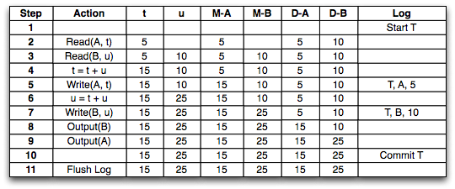
• ❑ b 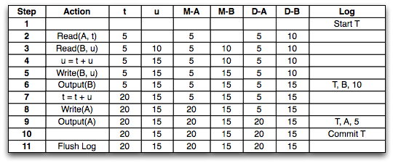
• ❑ c 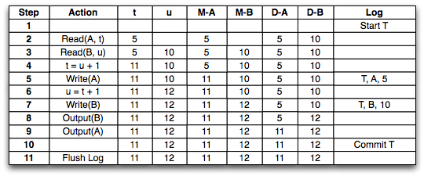
▼ ❑ 2
• ❑ a 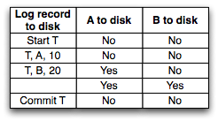
• ❑ b 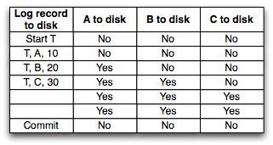
• ❑ 3 n!
▼ ❑ 4
• ❑ a T is undone.
• ❑ b U is not undone.
T is undone.
• ❑ c U is not undone.
T is undone.
• ❑ d Nothing is undone.
▼ ❑ 5
▼ ❑ a
▼ ❑ T
• ❑ must: { }
• ❑ might: {A}
▼ ❑ U
• ❑ must: { }
• ❑ might: { }
▼ ❑ b
▼ ❑ T
• ❑ must: { }
• ❑ might: {A, C}
▼ ❑ U
• ❑ must: {B, D}
• ❑ might: { }
▼ ❑ c
▼ ❑ T
• ❑ must: { }
• ❑ might: {A, C, E}
▼ ❑ U
• ❑ must: {B, D}
• ❑ might: { }
▼ ❑ d
▼ ❑ T
• ❑ must: all
▼ ❑ U
• ❑ must: all
• ❑ 6 If a crash occurs before <U, D, 40>, A is recoverable for transaction T. If a cash occurs after, A is recoverable for transaction U. Logging does not preserve atomicity.
▼ ❑ 7
• ❑ a 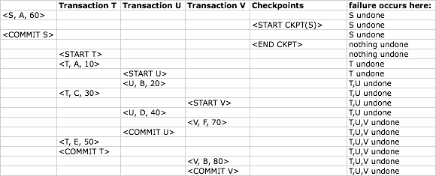
• ❑ b 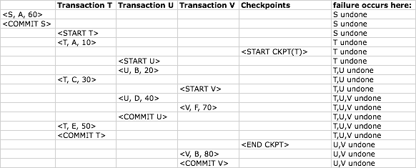
• ❑ c 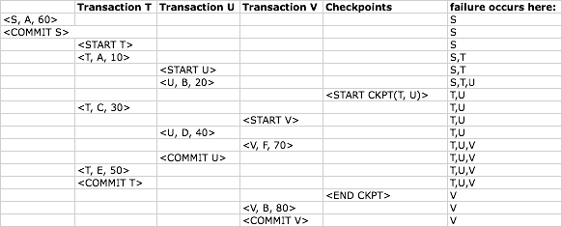
• ❑ d 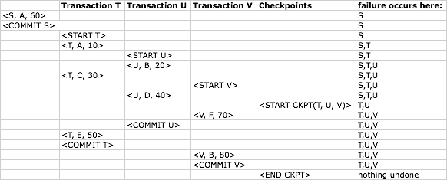
• ❑ e 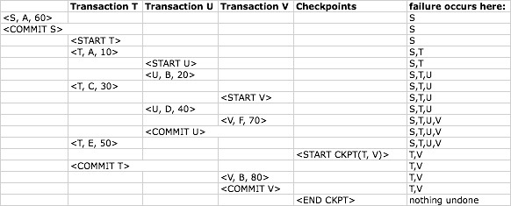
▼ ❑ Section 3
▼ ❑ 1
• ❑ a 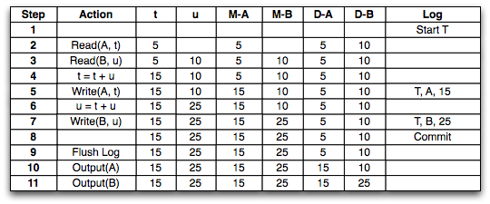
• ❑ b 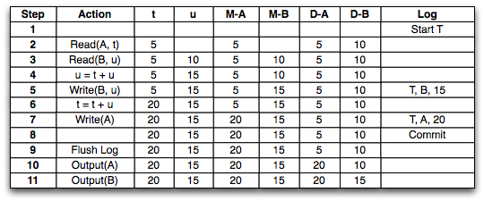
• ❑ c 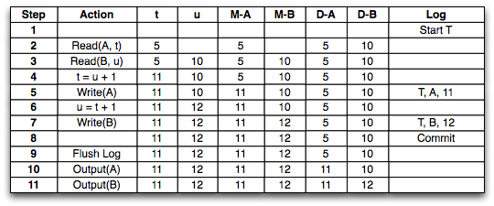
▼ ❑ 2
• ❑ a 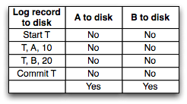
• ❑ b Same as 17.3.2a
▼ ❑ 3
• ❑ a Write: Abort T
• ❑ b Write: Abort T
Redo: U, B, 20
Redo: U, D, 40
• ❑ c Same as 17.3.3b
• ❑ d Redo: T, A, 10
Redo: U, B, 20
Redo: T, C, 30
Redo: U, D, 40
Redo: T, E, 50
▼ ❑ 4
▼ ❑ a
▼ ❑ T
• ❑ must: { }
• ❑ might { }
▼ ❑ U
• ❑ must: { }
• ❑ might { }
▼ ❑ b
▼ ❑ T
• ❑ must: { }
• ❑ might: { }
▼ ❑ U
• ❑ must: { }
• ❑ might: {B, D}
▼ ❑ c
▼ ❑ T
• ❑ must: { }
• ❑ might { }
▼ ❑ U
• ❑ must: { }
• ❑ might: {B, D}
▼ ❑ d
▼ ❑ T
• ❑ must: { }
• ❑ might: {A, C}
▼ ❑ U
• ❑ must: { }
• ❑ might: {B, D}
▼ ❑ 5
• ❑ a 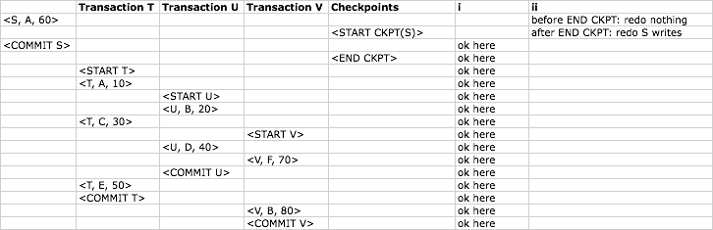
• ❑ b 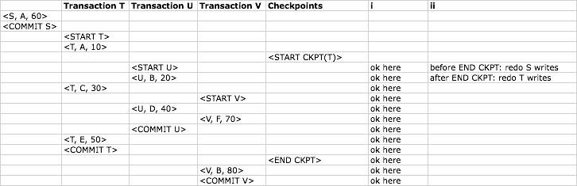
• ❑ c 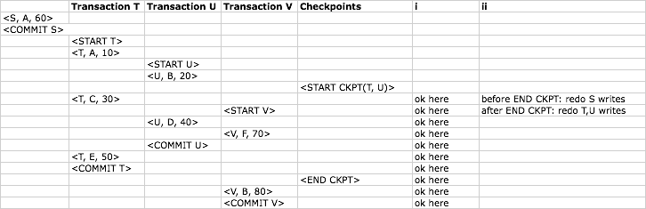
• ❑ d 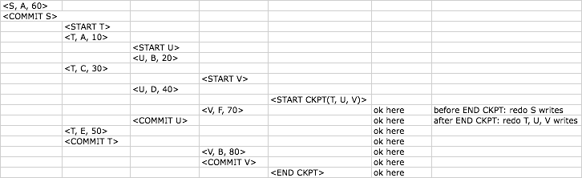
• ❑ e 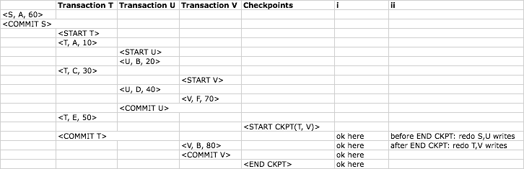
▼ ❑ Section 4
▼ ❑ 1
• ❑ a 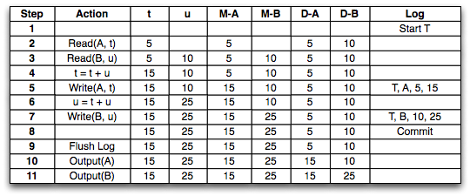
• ❑ b 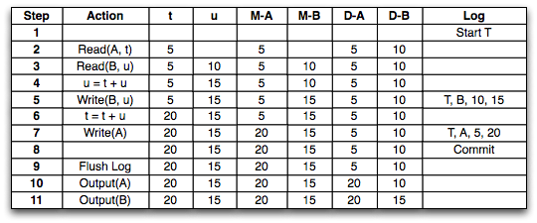
• ❑ c 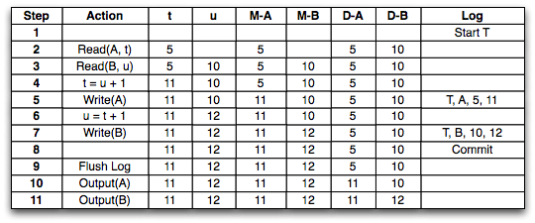
• ❑ 2 Same as 17.2.2
▼ ❑ 3
▼ ❑ a
• ❑ T undone
▼ ❑ b
▼ ❑ U redone
• ❑ Write: B, 21
• ❑ Write: D, 41
• ❑ T undone
• ❑ c Same as 17.4.3b
• ❑ d Both T and U redone
• ❑ 4 Same as 17.2.5
▼ ❑ 5
• ❑ a 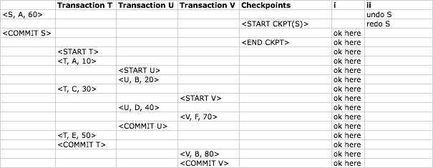
• ❑ b 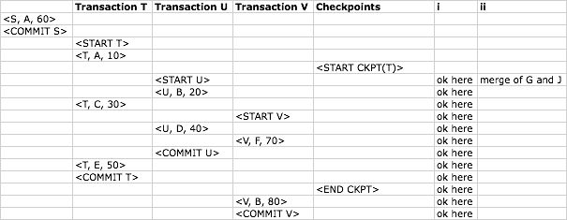
• ❑ c 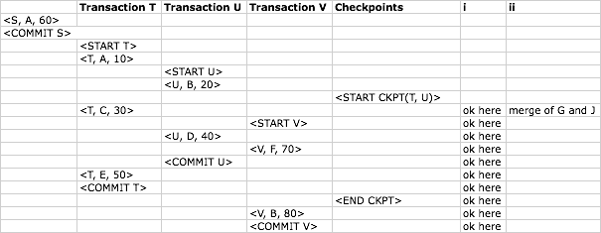
• ❑ d 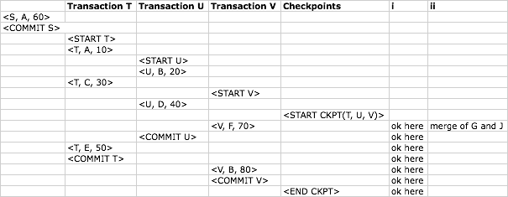
• ❑ e 