Database Systems: The Complete Book

▼ ❑ Chapter 22
▼ ❑ Section 1
▼ ❑ 1
• ❑ a 25%
• ❑ b 0%
• ❑ c 33%
• ❑ d 40%
• ❑ e 50%
• ❑ f {milk, beer}
{milk, pepsi}
{beer, pepsi}
• ❑ g {milk, beer}
• ❑ h {pepsi} => milk
has confidence 75%
▼ ❑ Section 2
• ❑ 1 F₁ = {milk, coke, beer, pepsi, juice}
F₂ = {milk, beer}, {milk, pepsi}, {beer, pepsi}
F₃ = { }
▼ ❑ 2
• ❑ a a[n], where n = i₁ + n*i₂ + 2*n*i₃ + 3*n*i₄ + ...
• ❑ b n²
• ❑ c Hash the tuple (i₁, i₂, ... , i_{n}) to locate the entry to store the count.
• ❑ d pn
▼ ❑ 3
• ❑ a (1/10)^{(sb)} + (1/100)^{(sb)}
• ❑ b (1/10)^{2(sb)} + (1/1000)^{(sb)} + (1/10000)^{(sb)}
▼ ❑ 4
• ❑ a (1/10)^{(sb)} + (1/100)^{(sb)}
• ❑ b (1/10)^{2(sb)} + (1/1000)^{(sb)} + (1/10000)^{(sb)}
▼ ❑ 5
• ❑ a (1/10)^{2(sb)} + (1/1000)^{(sb)} + (1/10000)^{(sb)}
• ❑ b (1/1000)^{(sb)} + (1/10000)^{(sb)} + (1/10000000)^{(sb)} + (1/1000000)^{(sb)}
▼ ❑ 6
• ❑ a Map: Each processor counts all local items.
Reduce: Each processor is assigned to count a single item.
• ❑ b Map: Each processor counts all local items.
Reduce: Each processor is assigned to count pairs for a bucket.
▼ ❑ Section 3
• ❑ 1 {1, 2, 3, 4, 5} {1, 6, 7} => 2/7
{1, 6, 7} {2, 4, 6, 8} => 1/6
{1, 2, 3, 4, 5} {2, 4, 6, 8} => 1/7
• ❑ 2 ‘abc ‘
‘bc d’
‘c de’
‘ def’
‘def ‘
‘ef g’
‘f gh’
‘ ghi’
▼ ❑ 3
• ❑ a {3, 3, 9}
• ❑ b {2, 5, 0}
• ❑ c {2, 7, 4}

 | Estimated | Jaccard similarity
{a,b} | 1/5 | 1/6
{b,c} | 1/5 | 2/5
{a,c} | 0 | 1/5

▼ ❑ 4
• ❑ a {3, 6, 3}
• ❑ b {7, 5, 5}
• ❑ c {7, 5, 5}
• ❑ 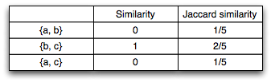
▼ ❑ 5
• ❑ a Map: Compute minhash for each row.
Reduce: Process results locally.
• ❑ b Map: Each processor computer minhash-so-far. Do until all data has been processed.
▼ ❑ Section 4
▼ ❑ 1
• ❑ a 890,000
• ❑ b 70%
• ❑ c 30%
▼ ❑ 2
• ❑ a 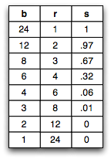
• ❑ b 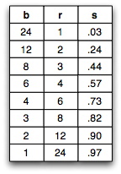
▼ ❑ Section 5
▼ ❑ 1
• ❑ a 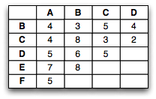
• ❑ b 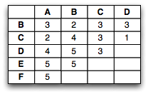
• ❑ 2 1. d(x,y) >= 0 for all x,y
summation of positive numbers are always postive

2. d(x,y) = 0 if x=y
if (x,y) = 0, then every xi - yi = 0 => xi = yi

3. d(x,y) = d(y,x)
|x-y| = |y-x|

4. d(x,y) <= d(x,z) + d(z,y)

(|x₁ - y₁|^{r} + ... + |x_{n} - y_{n}|^{r})^{1/r} <= (|x₁ - z₁|^{r} + ... + |x_{n} - z_{n}|^{r})^{1/r} + (|z₁ - y₁|^{r} + ... + |z_{n} - y_{n}|^{r})^{1/r}
Let z_{n} = y_{n} + a_{n}.
(|x₁ - y₁|^{r} + ... + |x_{n} - y_{n}|^{r})^{1/r} <= (|x₁ - y₁ - a₁|^{r} + ... + |x_{n} - y_{n} - a_{n}|^{r})^{1/r} + ...
Notice that |x_{i} - y_{i}|^{r} < |x_{i} - y_{i} - a_{i}|^{r}
Therefore, 4 is true.
▼ ❑ 3
• ❑ a 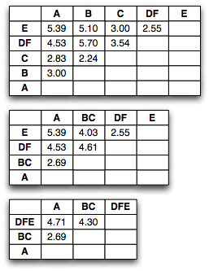
Clusters: {ABC, DFE}
• ❑ b 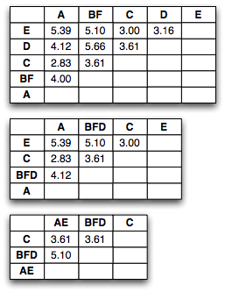
Clusters: {BFDAE, C}
• ❑ 4 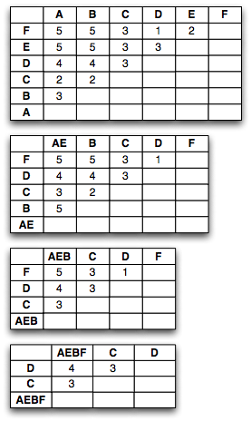
Clusters: {AEBFC, D}
▼ ❑ 5
• ❑ a B, F, A
• ❑ b C, F, A
• ❑ 6 N = 4
SUM_{i} = (6, 12)
SUMSQ_{i} = (14, 46)
▼ ❑ 7
• ❑ a 2.12
• ❑ b 3.20

