1. What is the IP address and TCP port number used by the client computer (source) that is transferring the file to gaia.cs.umass.edu? To answer this question, it’s probably easiest to select an HTTP message and explore the details of the TCP packet used to carry this HTTP message, using the “details of the selected packet header window” (refer to Figure 2 in the “Getting Started with Wireshark” Lab if you’re uncertain about the Wireshark windows



客户端电脑的IP地址是192.168.1.109 使用的TCP端口是2538

1. What is the IP address of gaia.cs.umass.edu? On what port number is it sending and receiving TCP segments for this connection

gaia.cs.umass.edu的IP地址是128.119.245.12 使用的TCP端口是80

1. What is the IP address and TCP port number used by your client computer (source) to transfer the file to gaia.cs.umass.edu? 

我的客户端电脑的IP地址是172.23.214.128 使用的TCP端口是63344

4. What is the sequence number of the TCP SYN segment that is used to initiate the

TCP connection between the client computer and gaia.cs.umass.edu? What is it

in the segment that identifies the segment as a SYN segment?

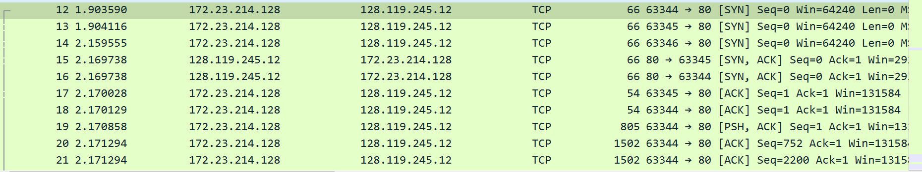

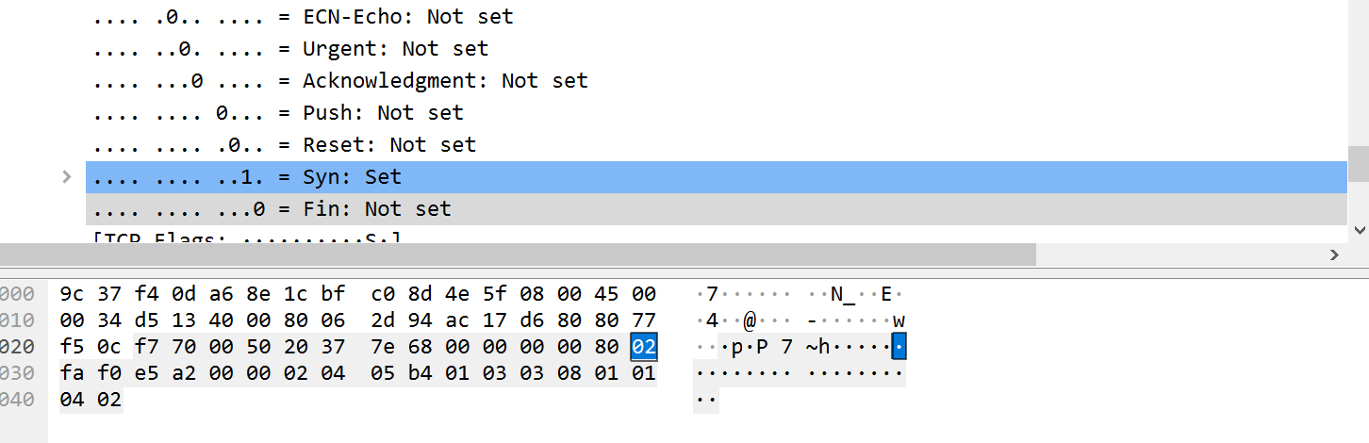

Seq=0属于初始化TCP连接到SYN报文，双击该报文弹出详细信息发现在TCP报文段中第二张图片的位置那一位字节对应了该报文是否属于SYN报文。

5.What is the sequence number of the SYNACK segment sent by gaia.cs.umass.edu to the client computer in reply to the SYN? What is the value of the Acknowledgement field in the SYNACK segment? How did gaia.cs.umass.edu determine that value? What is it in the segment that identifies the segment as a SYNACK segment?

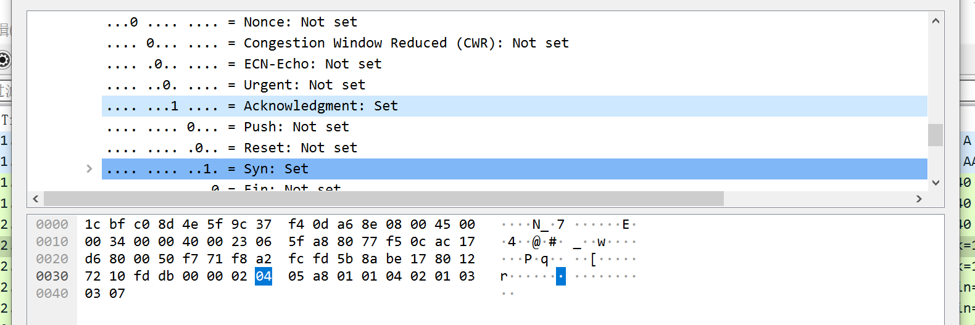

Seq=0是网站返回的SYNACK报文，Acknowledgement field的值是一，1就属于ACK，0不是。

Acknowledgment的值和Syn的值决定了该报文段是否为SYNACK。

6. What is the sequence number of the TCP segment containing the HTTP POST command? Note that in order to find the POST command, you’ll need to dig into the packet content field at the bottom of the Wireshark window, looking for a segment with a “POST” within its DATA field.

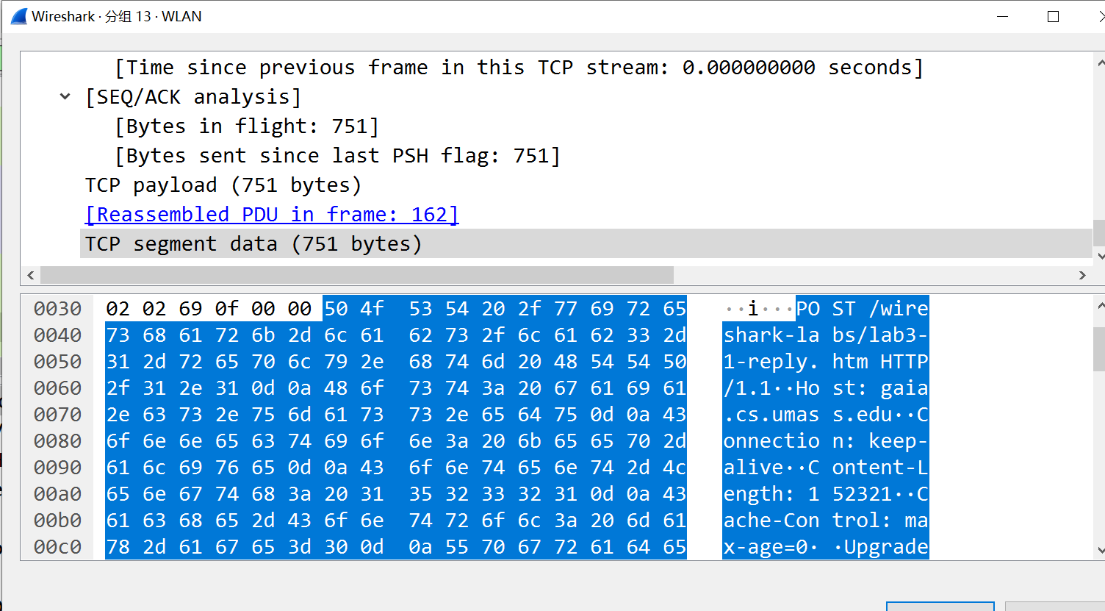

Seq=1是HTTP POST请求

7. Consider the TCP segment containing the HTTP POST as the first segment in the TCP connection. What are the sequence numbers of the first six segments in the TCP connection (including the segment containing the HTTP POST)? At what time was each segment sent? When was the ACK for each segment received? Given the difference between when each TCP segment was sent, and when its acknowledgement was received, what is the RTT value for each of the six segments? What is the EstimatedRTT value (see Section 3.5.3, page 242 in text) after the receipt of each ACK? Assume that the value of the EstimatedRTT is equal to the measured RTT for the first segment, and then is computed using the EstimatedRTT equation on page 242 for all subsequent segments. Note: Wireshark has a nice feature that allows you to plot the RTT for each of the TCP segments sent. Select a TCP segment in the “listing of captured packets” window that is being sent from the client to the gaia.cs.umass.edu server. Then select: Statistics->TCP Stream Graph- >Round Trip Time Graph.

由于刚才闪退了，可能与前文不一致

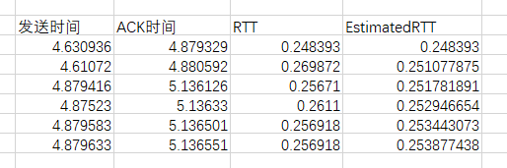

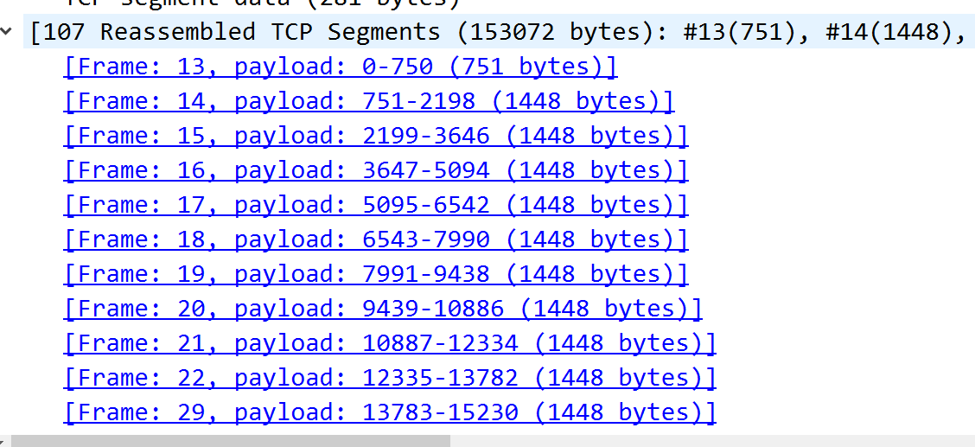

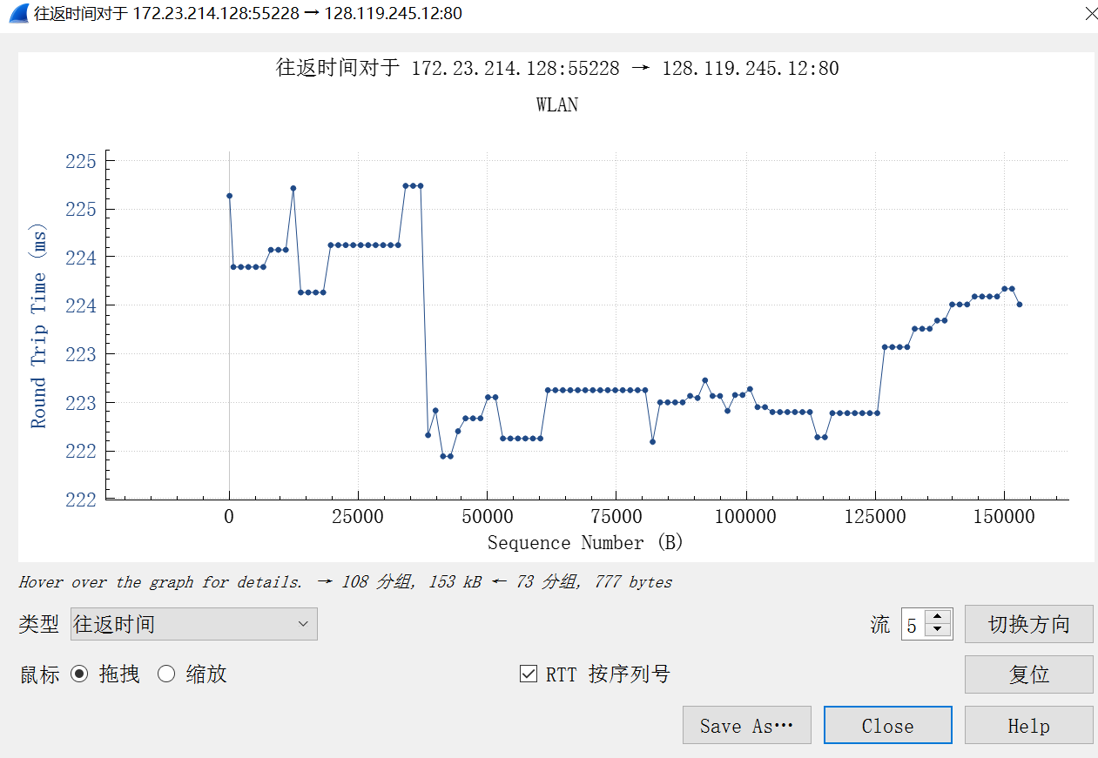

Seq= 1 752 2200 3648 5096 6544

8. What is the length of each of the first six TCP segments?

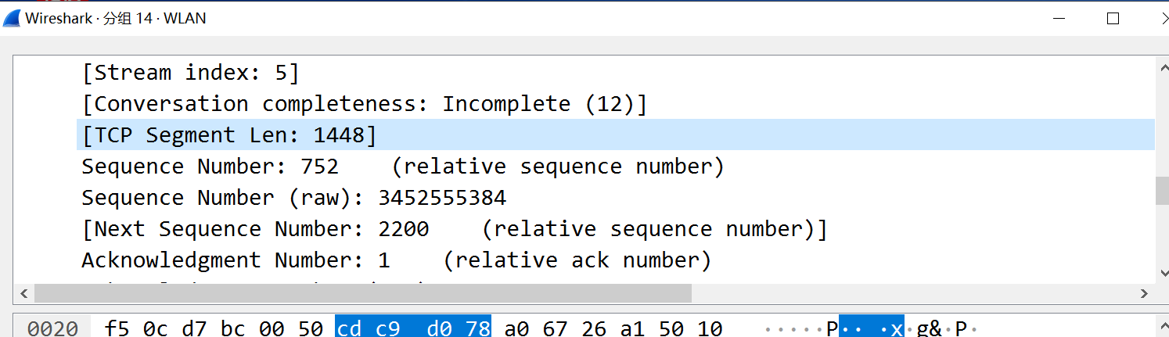

751bytes 1448bytes 1448bytes 1448bytes 1448bytes 1448bytes

9. What is the minimum amount of available buffer space advertised at the received for the entire trace? Does the lack of receiver buffer space ever throttle the sender? 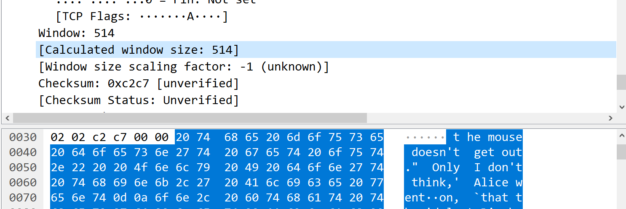

窗口大小最小为514.

发送方不会因为接受方缓冲区空间不足而阻塞。

10. Are there any retransmitted segments in the trace file? What did you check for (in the trace) in order to answer this question?

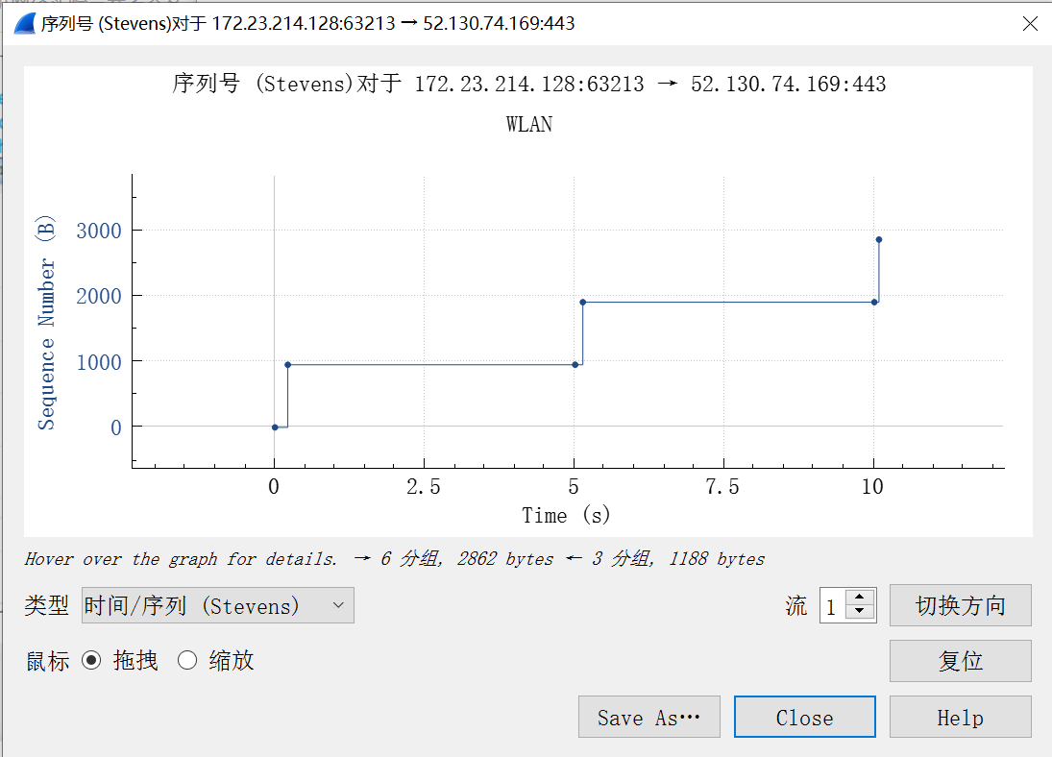

没有重新发送的报文段，因为seq序列递增

11. How much data does the receiver typically acknowledge in an ACK? Can you identify cases where the receiver is ACKing every other received segment (see Table 3.2 on page 250 in the text).



1448bytes，

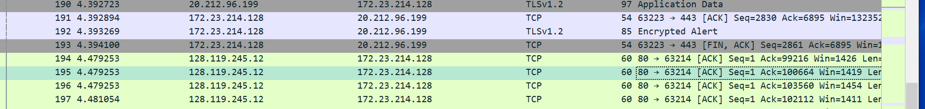

2896bytes

12. What is the throughput (bytes transferred per unit time) for the TCP connection? Explain how you calculated this value





总发送的数据153073-1=153072bytes

总时间4.483424-3.582010=0.901414s

Throughput=169813bytes/s

13. Use the Time-Sequence-Graph(Stevens) plotting tool to view the sequence number versus time plot of segments being sent from the client to the gaia.cs.umass.edu server. Can you identify where TCP’s slowstart phase begins and ends, and where congestion avoidance takes over? Comment on ways in which the measured data differs from the idealized behavior of TCP that we’ve studied in the text.

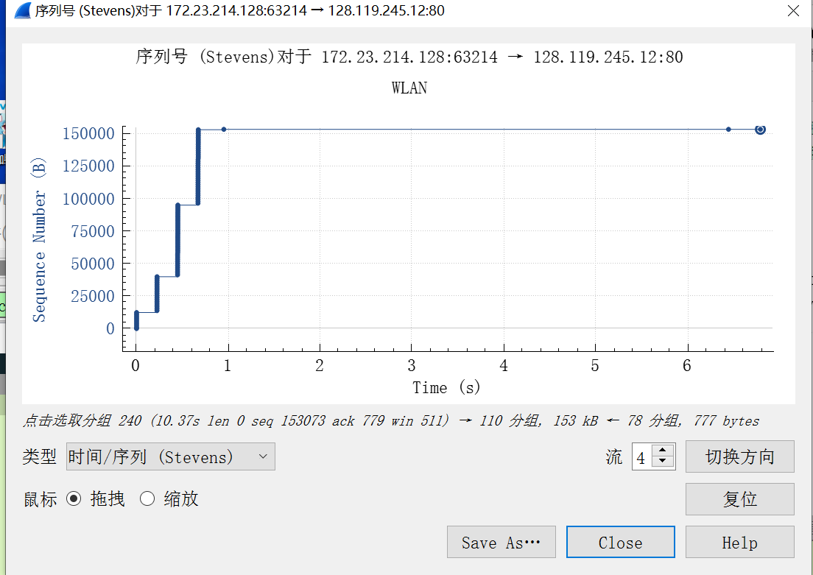

慢启动当HTTP的POST段开始，不知道什么时候停止，也不知道什么时候拥塞避免开始。

14. Answer each of two questions above for the trace that you have gathered when you transferred a file from your computer to gaia.cs.umass.edu

慢启动当HTTP的POST段开始，不知道什么时候停止，也不知道什么时候拥塞避免开始。