1. Are DHCP messages sent over UDP or TCP?

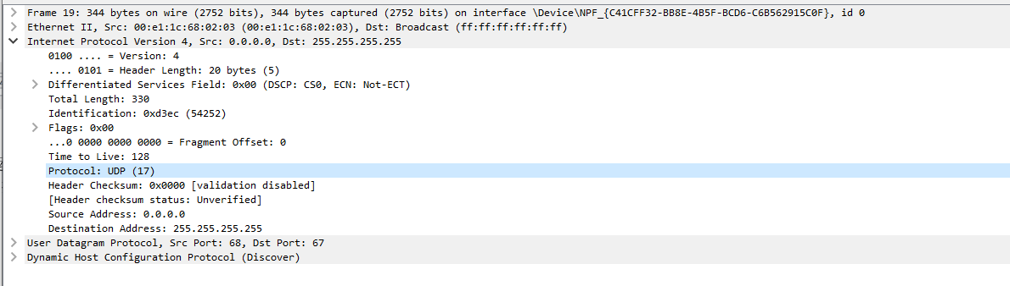

DHCP消息传输使用的协议时UDP；

2. Draw a timing datagram illustrating the sequence of the first four-packet Discover/Offer/Request/ACK DHCP exchange between the client and server. For each packet, indicated the source and destination port numbers. Are the port numbers the same as in the example given in this lab assignment?

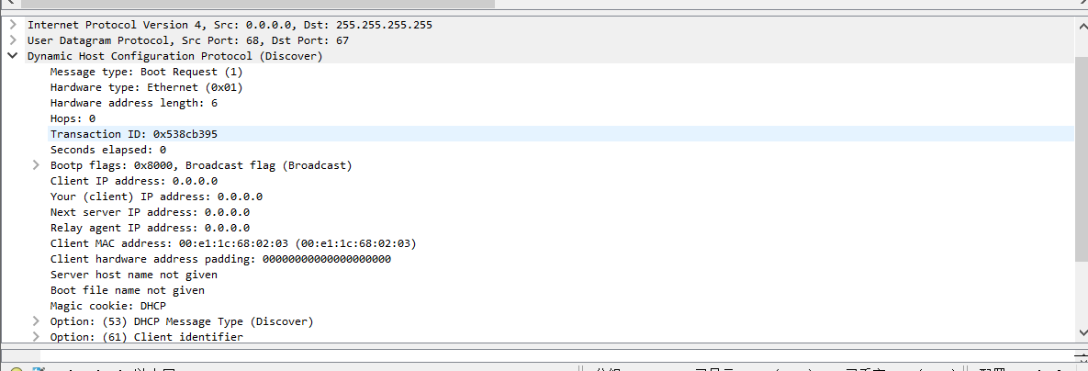

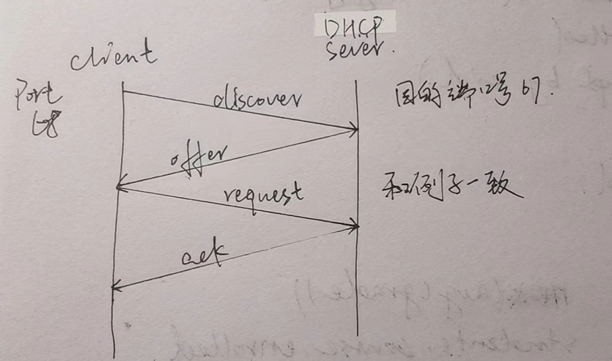

3. What is the link-layer (e.g., Ethernet) address of your host?

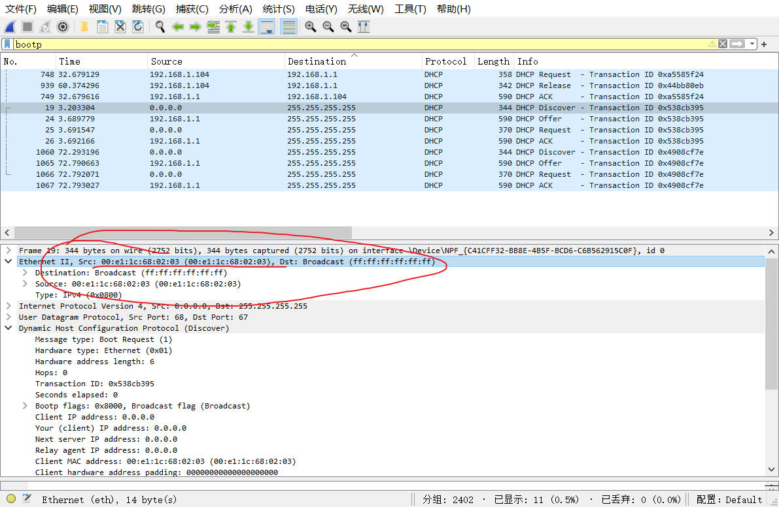

4. What values in the DHCP discover message differentiate this message from the DHCP request message?

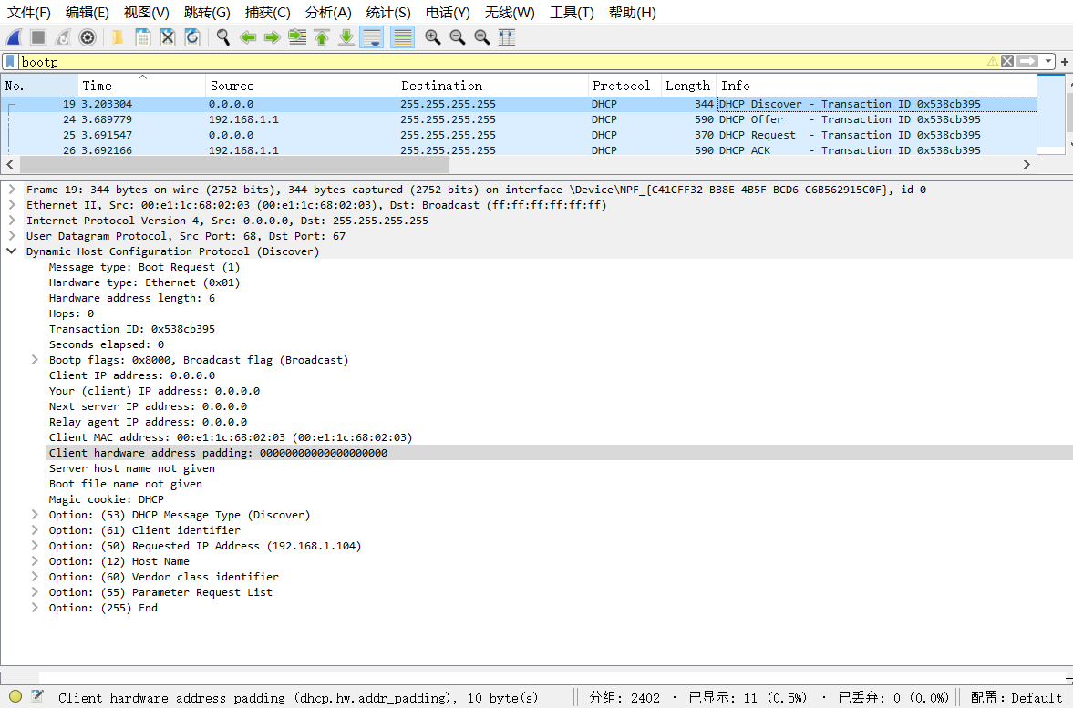



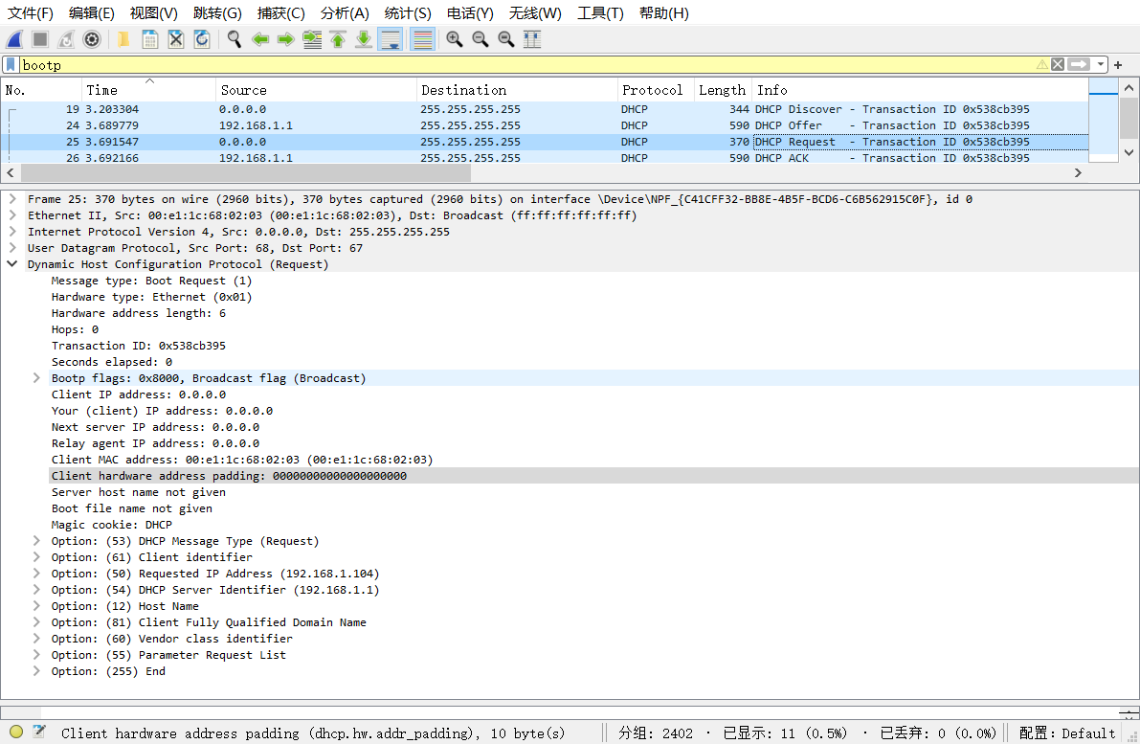



其中的option列表不同

5. What is the value of the Transaction-ID in each of the first four (Discover/Offer/Request/ACK) DHCP messages? What are the values of the Transaction-ID in the second set (Request/ACK) set of DHCP messages? What is the purpose of the Transaction-ID field?

前四个：

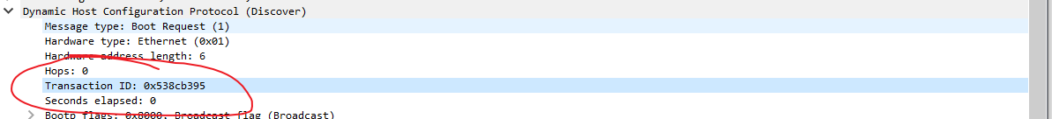

后两个：

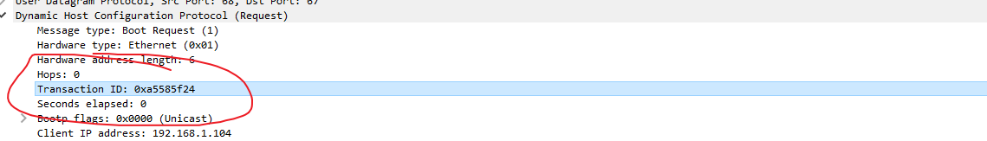

Transaction-ID的作用是识别相应的客户机，区分不同的DHCP请求标识。

6. A host uses DHCP to obtain an IP address, among other things. But a host’s IP address is not confirmed until the end of the four-message exchange! If the IP address is not set until the end of the four-message exchange, then what values are used in the IP datagrams in the four-message exchange? For each of the four DHCP messages (Discover/Offer/Request/ACK DHCP), indicate the source and destination IP addresses that are carried in the encapsulating IP datagram.

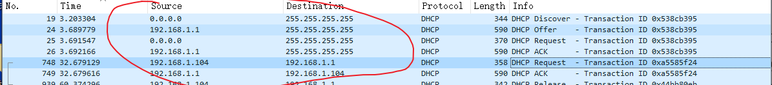

以上即为这四种情况的源地址目的地址的变化

7. What is the IP address of your DHCP server?

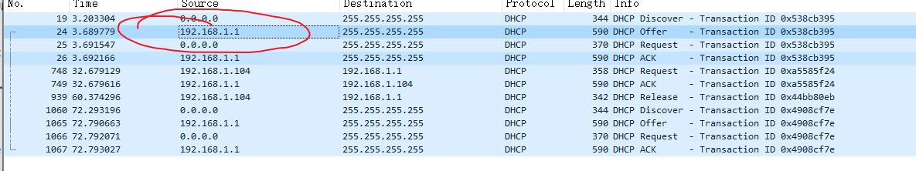

8. What IP address is the DHCP server offering to your host in the DHCP Offer message? Indicate which DHCP message contains the offered DHCP address.

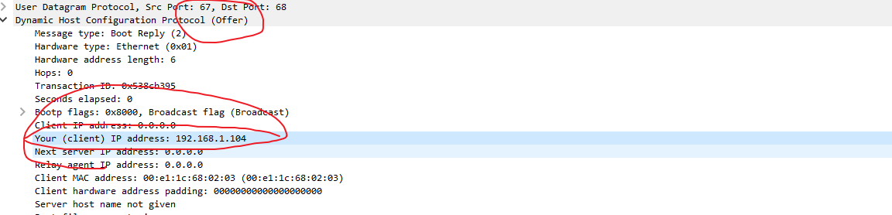

在offer和ACK DHCP messages中包含这个IP地址

9. In the example screenshot in this assignment, there is no relay agent between the host and the DHCP server. What values in the trace indicate the absence of a relay agent? Is there a relay agent in your experiment? If so what is the IP address of the agent?

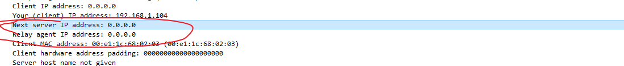

0.0.0.0意味着没有代理客户端在我的实验中。

10. Explain the purpose of the router and subnet mask lines in the DHCP offer message.

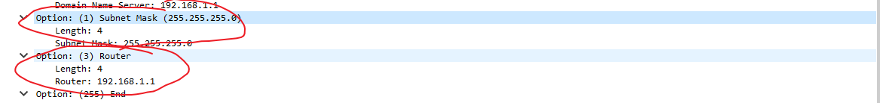

路由器起到网关作用，向客户端指示其默认网关应是什么，而子网掩码告诉客户端应使用哪个子网掩码。

11. In the DHCP trace file noted in footnote 2, the DHCP server offers a specific IP address to the client (see also question 8. above). In the client’s response to the first server OFFER message, does the client accept this IP address? Where in the client’s RESPONSE is the client’s requested address?

客户端接受了服务器的offer包中的ip地址

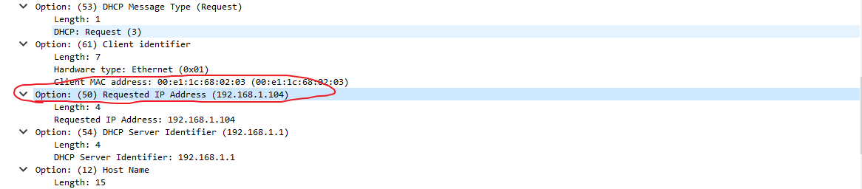

12. Explain the purpose of the lease time. How long is the lease time in your experiment?



两个小时

在租用期间，DHCP 服务器不会将提供给客户端的 IP 分配给另一个客户端，除非客户端释放该 IP。 租约时间到期后，DHCP 服务器可以重复使用该 IP 地址，将其提供给另一个客户端。

13. What is the purpose of the DHCP release message? Does the DHCP server issue an acknowledgment of receipt of the client’s DHCP request? What would happen if the client’s DHCP release message is lost?

DHCP的释放消息是为了和DHCP服务器取消租赁，让DHCP服务器回收该ip地址。

DHCP服务器不会向客户端发送关于release的ack；

如果来自客户端的 DHCP 释放消息丢失，则 DHCP 服务器必须等到该 IP 地址的租用期结束，然后才能将其重新用于另一个客户端。

14. Clear the bootp filter from your Wireshark window. Were any ARP packets sent or received during the DHCP packet-exchange period? If so, explain the purpose of those ARP packets

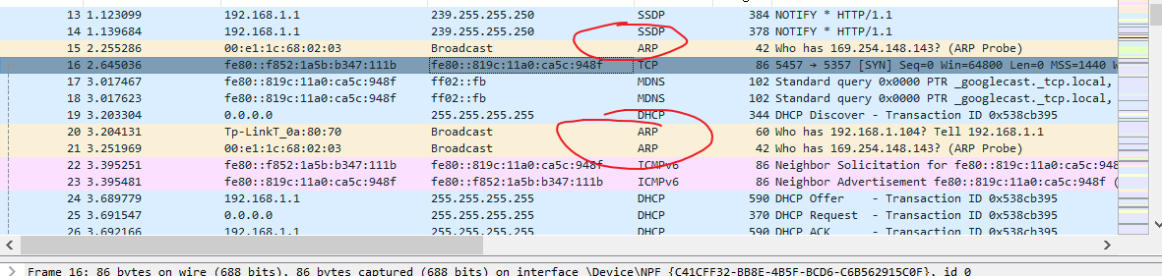

会有ARP请求地址解析协议。在向客户端提供IP地址之前，DHCP 服务器会对提供的 IP 发出 ARP 请求，以确保该 IP 地址尚未被使用